LEVEL 1 – MANUAL NETWORKING
DOCUMENTATIONS:
1. BUILD
TOPOLOGY
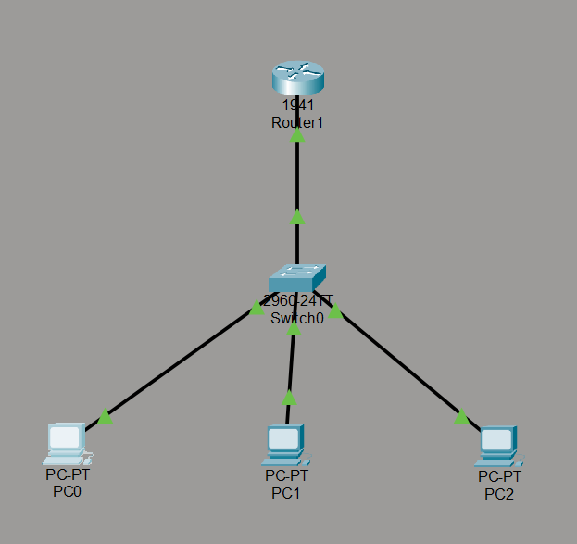

ROUTER CONFIGURATION
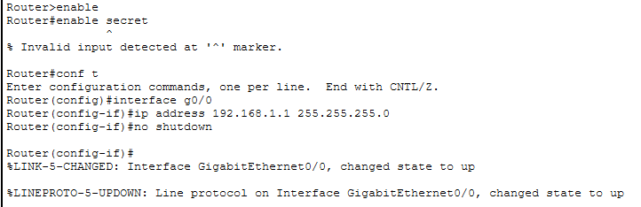
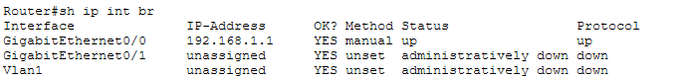

PC0 IP CONFIGURATION
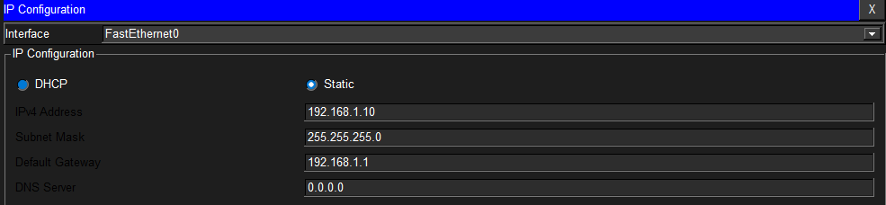
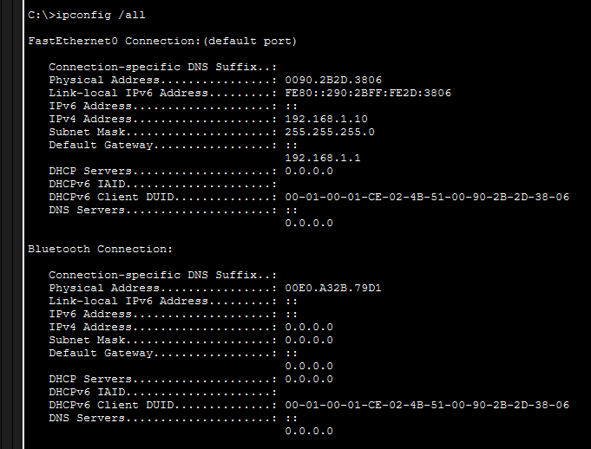
PC1 IP CONFIGURATION
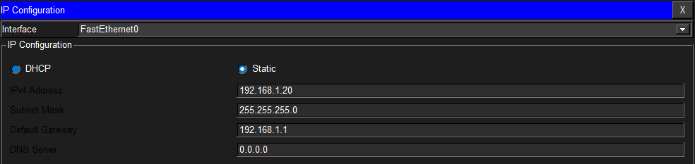
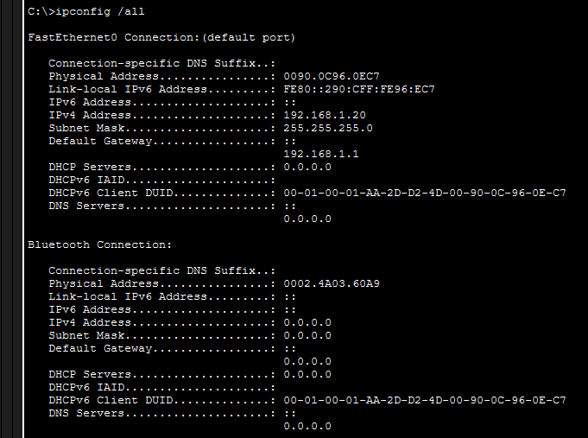
PC2 IP CONFIGURATION
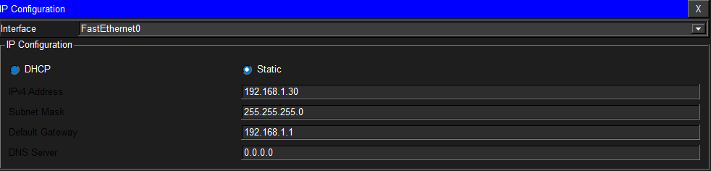
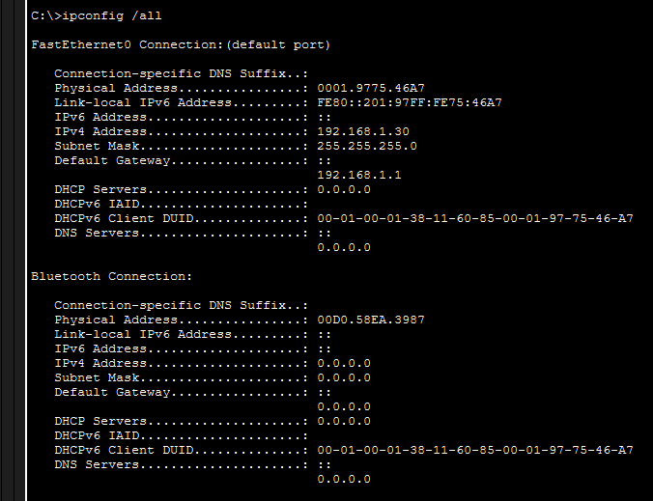

PING TEST AND ARP TABLE (shows ICMP echo request and reply using ping, and ARP table before and after ping)
PC0
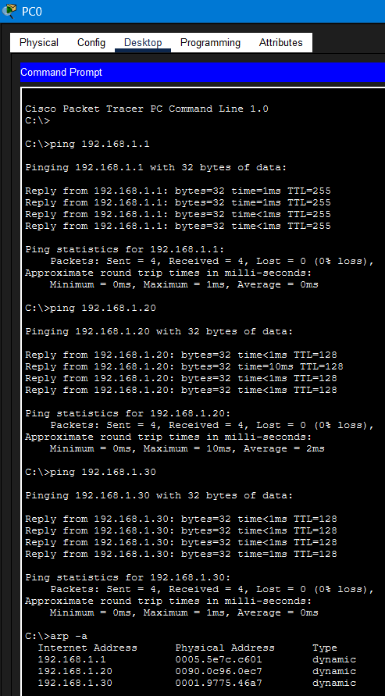

PC1
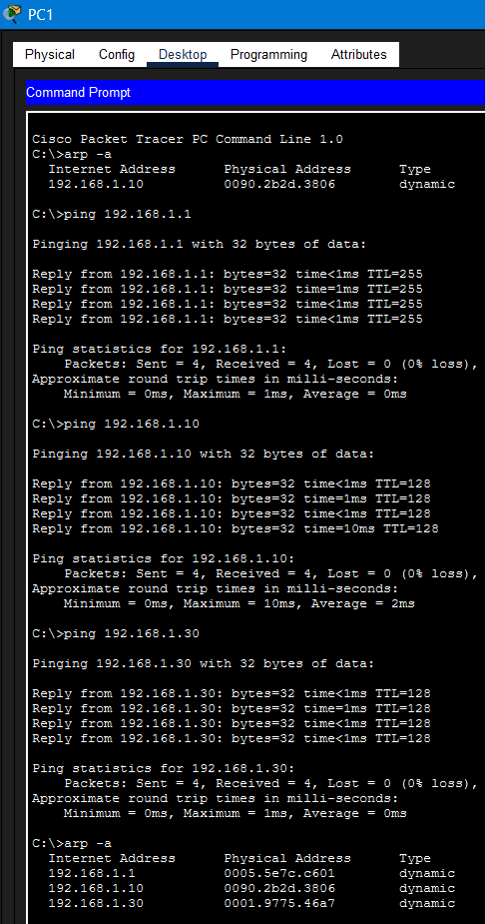

PC2
