Random Progress Report:
James Brandewie
Dr. Brinton
Ramsey Numbers

I saw this video:
https://youtu.be/4HHUGnHcDQw?si=Y20jP_Z5Pttq4FSC&t=98

Discussing ramsey numbers, and I thought it didn’t look too hard to get higher ramsey numbers, so over the last couple days I tried to give it a shot. Current progress can be found at:
https://github.com/jbrandew/randomThoughts/blob/ramseyStuff/cliqueCalculator.py

The repo is not super organized right now, and really the only worthy progress is found in this file.

So, what is my understanding of the problem?
Problem: We have a set of nodes in a fully connected graph. Each edge has a weight of -1 or 1. What is the min number of nodes (n) in which a graph must have a clique of size k? A clique in this context is defined as a subset of fully connected neighbors in which all edges have the same weight.

Initial approach:
What can this be reframed as? I’m going to reframe it to contain similar logic to how Djikstra’s algorithm proved the existence of a minimum spanning tree in a graph. So, what is the general approach?

1. Create an algorithm that minimizes the # of cliques of a certain size.
2. If the algorithm gives a connection set that has a clique of a certain size, then no connection set exists in which a clique of that size does not exist.

How do we then approach this algorithm? We will approach it from iteratively adding edges until we have all edges necessary, and then examine the # of cliques of a certain size. Random thoughts/intuition in this algorithm:

Preemptive definition: let us define a subgraph in this context just as a clique that may or may not be fully connected.

1. (see Figure 1) The left graph represents a possible state of a graph, while the right two represent possible next states. Please note that the bottom right one is “worse” because no more edges can be added without a clique of size 3 forming. The top right one still has 3 possible edges to add before a clique forms.

Why is this? It’s because the bottom one is more “centralized.” I think in the context of this problem, its useful to think of “adding an edge to two nodes,” as “adding an edge to all subgraphs that contain either node on either side of the edge.”

In figure 1:
Left graph has:
10 subgraphs with 0 edges
4 subgraphs with 1 edge
6 subgraphs with 2 edges

Top right graph has:
7 subgraphs with 0 edges
6 subgraphs with 1 edge
7 subgraphs with 2 edges

Bottom right graph has:
10 subgraphs with 0 edges
0 subgraphs with 1 edge
10 subgraphs with 10 edges

This is because the subgraphs that the “central node” is a part of is a part of more subgraphs with higher edge counts, as it is supplying those edges for a subgraph to be closer to a clique. (All “results” of above can be easily computed using the functions “create nodes” and “count subgraphs”)

Figure 1
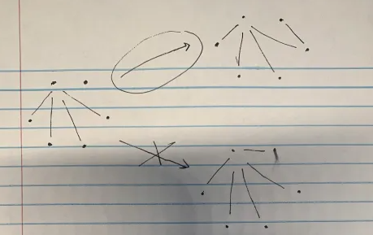

Now observe figure 2. The question mark designates a candidate edge we might add. Obviously on the left, if we add that edge, a clique that is very close to forming will be even closer to forming. As opposed to the right image, in which adding this edge does not make a nearly formed clique.

Why is this? Its because the two nodes that the considered edge would connect share more common edges (as in, have more edges with the same destination) in the left image compared to the right image.

Figure 2:
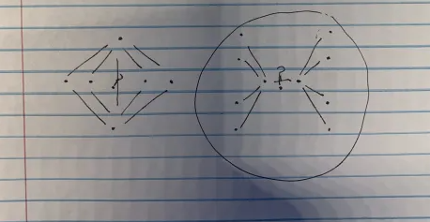

Okay, so we have the general logic about how to decide what edge to add. What next? We need to decide how many “edges” we have to add. Note that in a fully connected graph of n nodes, there are n*(n-1)/2 possible edges. (n choose 2).

Now, its important to note that in this approach of creating an algorithm to minimize the # of cliques in a generated graph, we haven’t really discussed its complement. That is, in the prompt, a clique is a set of neighbors with the same value. If we minimize the # of cliques with respect to the number 1, it may give a very greedy output where the output has very little cliques, but its complement (so the graph with edges of value -1) may have many cliques.

This next part turns out to be wrong, but I thought intuitively that if I create an algorithm that spreads out new edges as evenly as possible among nodes, that the complement would also be as evenly spread out as possible. That is, if I create a graph with adding ceil(n*(n-1)/4) edges (so half of all possible edges), the complement ( with floor(n*(n-1)/4) edges) would be as evenly spread out as well.

So, in following this logic, I decided to implement this approach using the following process:

1. get all pairs of possible edges.
2. sort pairs by the max # edges between the two nodes
3. sort pairs by the # common edges between the two nodes
4. add the first pair to the graph
5. repeat steps 1->4 until we have added sufficient edges

I used this process with ceil(n*(n-1)/4) edges. The results of this can be seen below. This is with a size graph numNodes = 18, and observing subgraphs of size 4. The first line in results corresponds to the original graph, that is, the graph output following the algorithm above. The second line in results corresponds to the complement graph.

Each line of results is formatted as:
-first array = # of edges in the subgraph
-second array = # of that type of subgraph.
So the first entry of the first array represents the subgraph of size 4 with 0 edges. The first entry of the second array represents the fact that there are 252 subgraphs of size 4 with 0 edges present in this graph.

Num edges in each subgraph of size 4
(array([0., 1., 2., 3., 4.]), array([ 252, 7, 223, 1525, 1053]))
(array([2., 3., 4., 5., 6.]), array([1053, 1525, 223, 7, 252]))

Obviously from the results above, the algorithm is very greedy, and there are many subgraphs with a higher number of edges in the second graph compared to the first (there are 252 graphs in the second graph with 6 edges each, and none in the first one)

Also note, the results are mirror images of each other, because the concept of the complement graph can be applied to subgraphs as well. That is, the 252 subgraphs with 6 edges each in graph 2 correspond to the 252 subgraphs with 0 edges in graph 1, as they are complements of each other :).

So, we need a way to balance the process among the graph and its complement. The modified algorithm is found below:

1. Set up two graphs of nodes.
2. Get 2 sets of all possible edges.
3. Sort both sets by max # edges in each respective graph.
4. Sort both sets by # common edges between the two nodes in each respective graph.
5. Add first edge of first set to first graph, remove the added edge from both sets
6. Add first edge of second set to second graph, remove the added edge from both sets
7. Repeat steps 3-6 until all edges done

This is effectively running the algorithm in tandem on two graphs. This improves the evenness of clique distribution between the two graphs tremendously. Running the same experiment from before, we have:

Num edges in each subgraph of size 4
(array([0., 1., 2., 3., 4., 5., 6.]), array([ 29, 164, 756, 1156, 723, 188, 44]))
(array([0., 1., 2., 3., 4., 5., 6.]), array([ 44, 188, 723, 1156, 756, 164, 29]))

As you can see, this is much, much more balanced.

Future steps and questions:

Is this approach of balancing two complement graphs valid? Is it valid to evenly split the # of edges in half between the two graphs?
Or is there a possible trade off between how many edges to distribute and what policy there Is? As in, maybe the first graph can have a greedier policy, but must use more edges than the complement graph. (That probably wouldn’t work, but just an idea)
We should probably just rank the possible edges by the # of edges in each of the subgraphs they are a part of. That would probably do pretty well.
Whats the structural relationship between the generated graph and complement graph when using the original method that only optimized a single graph?
We can improve the results of the last algorithm somewhat by swapping steps 5 and 6 every iteration I believe.

Obviously I would seek to prove optimality of any approach I use, but it feels more efficient to try things I think would be right, and then if they give optimal results, then prove their optimality.

