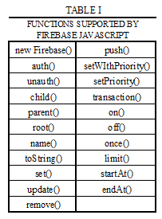
Firepath: A Querying API for Firebase
Jason Brelloch, Georgia State University
Index Terms—Databases, No-SQL, Cloud services, Firebase

INTRODUCTION
APPLICATION development has become a huge industry with the development of mobile devices and mobile telecommunications devices. People are always connected to the internet and companies want to make sure their consumers always have access to their product. This in turn has increased the development speed required of software application developers.
In response to this new demand for fast development and deployment of applications, developers have started to modularize certain aspects of applications that can be packaged and given to other developers to save development time. Examples of this are Paypal's payment API's, Google's Map API, and Twitter's follow button.
Firebase attempts to speed up application development by removing the need for developers to worry about servers or backend code. No setup and rapid development

Firebase

Overview
Firebase is a scalable real-time backend. Scalable backend means that Firebase as a company handles all the server maintenance and also scales the available bandwidth and server resources as needed by your application. Firebase is real-time because it is designed to handle multiple users reading and writing the same data at the same time. It has client libraries for Javascript, Objective-C, Java and also has a REST API.

Data Structure
All data in firebase is stored in JSON key/value format and is accessible by a unique URL. When a firebase is created it is assigned a address to access the data with (ex: https://firepath-fb.firebaseIO.com/). This address is the root node for the JSON string. Firebase has the same data-types as JSON, so it can store strings, numbers, Booleans, arrays and objects. Each key's value is individually accessible by adding the key onto the end of the root URL (ex: https://firepath-fb.firebaseIO.com/a1/b1). Firebase calls each unique URL a location.

Javascript Library
This project will focus on Firebase's Javascript client library. The Javascript library contains functions to read and write to a Firebase database location. It also contains functions that allow a user to subscribe to a database location and perform an action when a change occurs at that location. Some advanced functionality exists including range querying and authentication for security. Table 1 contains a list of all of the functions supported by Firebase, and there purpose will be described in the next several sections.

References
References are the base access point for Firebase locations in code. Firebase references are extremely lightweight, so there is no concern about garbage collection or creating too many. All other functions exposed by the API are executed on a Firebase data reference. They are created by calling the Firebase constructer function and passing in a URL. There are also some functions that help to create new references from existing ones. The child function is executed on an existing reference and takes in a key as a parameter, then returns a new reference to the child location with that key. The parent function returns a reference to the parent of the current location. The root function returns a reference to the root node of the Firebase.
There are two other functions that do not return Firebase references, but are useful for coding. The name function returns the key for the current location as a string. The toString function returns the full URL of the location that the reference refers to.
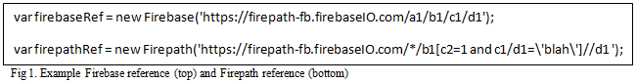
Writing Data
Writing data in Firebase is performed by executing one of three functions on a Firebase reference. The first function is set. Set takes in a value and writes it to that particular Firebase reference. It will also overwrite any data that exists there currently. Update is used in the same way, but it will not overwrite any data other that the what is referenced in the function call. Push is used to add a new child to a Firebase location. The key for that location will be a randomly generated unique string. Remove is not used to write data, but obviously to remove all data that is at a specific Firebase reference.

Reading Data
Reading Data in Firebase is performed by attaching a callback function to a Firebase reference. There are 5 types of events available in Firebase. They are value, child_added, child_removed, child_changed, child_moved. Value fires in the event that the value of that firebase reference changes in anyway. The child events perform exactly as expected.
The events are attached to Firebase references using one of two functions. The on function takes is a event type and a callback function and will execute the callback function whenever the event occurs. The once function does that same thing, except it only executes the callback a single time. The off function is used to remove an event listener from a reference location. It can be used to remove a specific listener, all listeners of a specific type, or just all listeners depending on the parameters passed to it.

Querying
Data in Firebase is ordered lexicographically based off of the locations name. This order can be customized by setting a priority value to a reference. Querying in Firebase is based off of that locations ‘priority’ value.
The priority can be set either when the location is written by using the setWithPriority function, or any time after by using the setPriority function. Queries can then be executed by using a combination of the reading data functions, and three functions used to limit what data is read. The startAt function limits the data read to data that has a priority value greater than a specific value. The end at function limits the data read to data that has a priority value less than a specific value. Finally the limit function limits the number of locations that will be read to a specific number

Advanced Functions
There are two other types of functions that are useful in Firebase. The first is auth and unauth functions. These are used to authenticate a specific user to access and modify a Firebase location.
The second is the transaction function. This function takes in a callback function that is executed just before a change is made in the database. The function checks to make sure that the data is as it should be, and if it is not it can abort the change, or attempt to execute it again. This is called an atomic transaction.

The Problem
One disadvantage faced by Firebase is the lack of extensive querying capabilities. The only way to find a specific Firebase location is to either pull all the data down and search for it manually, or to structure the data in such a way that the location is already known. The first method can be slow and costly, and the second method is not always possible.

Firepath
Firepath is a querying API for Firebase that extends its querying capabilities. The project has several design constraints and goals. First, the Firebase API should be left alone, so Firebase and Firepath can both be used in conjunction with one and another. Second, Firepath should have extensive querying support similar to a relational database language like SQL. Third, Firepath's API should be intuitive to someone who is familiar with Firebase's API. Finally, Firepath should be add little or no overhead to Firebase calls.
The querying support was added by adding syntax similar to XPath to define queries in Firebase URL's. XPath is a querying language for Extensible Markup Language (XML) that allows a user to query and XML document. It's compact notation, without any query's, looks very similar to Firebase's location URL's, so it will be familiar to users that are familiar with Firebase. Figure 1 shows and example of a Firebase location reference and the same reference with an example XPath style query on it. XPath adds querying by inserting in bracket selectors next to a location string. Inside the brackets rules can be written that restrict which locations will be selected by the query. It also adds wildcards that can be used to select every location, or a location that exists anywhere.
Two versions of Firepath where created that follow different algorithms to achieve the same querying results. Version one of Firepath focused on keeping the Firepath objects lightweight, while version two was focused on fast response times for the queries. Figure 2 shows the basic flow of each algorithm and the numbers will be used in the next section to explain each algorithms execution.

Version 1
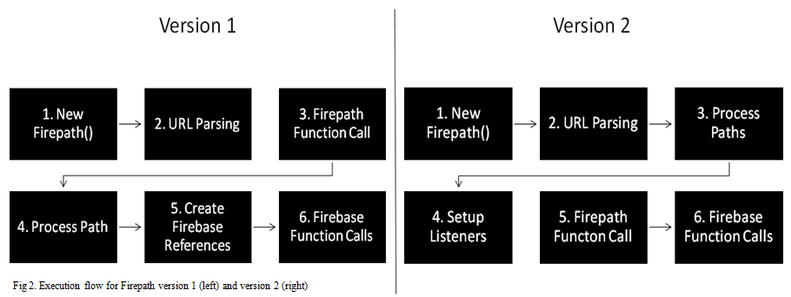
Version one of Firepath focused on keeping Firepath as lightweight as possible. This meant that pre-processing URL's had to be efficient and quick.
- New Firepath() is the constructer function for a Firepath reference. It functions the same way as the Firebase constructer, except it takes in a URL that has been modified with an XPath style query.
- When the constructer is called the URL is immediately parsed into an array of path sections. A path section contains a section name and a rule. A rule is an object that contains several rule parts. Figure 3 shows the results of parsing an example URL.
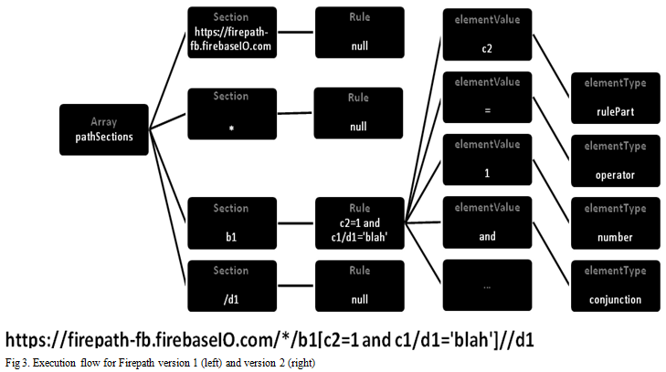
- At this point Firepath v1 will wait for the user to initiate a function call. All functions are exactly the same as Firebase, with a few notable exceptions. The child function now accepts child path that contains rules in the XPath style in the same way as the constructer. Firepath also does not support the query functions from Firebase, nor does it support transactions or authentication.
- When the user executes a Firepath call an internal function called processPath is executed. It is function that recursively goes through the path sections created by the parser and begins to create Firebase paths from the Firepath query.
- Once the Firepath processPath function has finished, all of the valid Firebase URL's are contained in a local array. Firepath then creates regular Firebase references from these URL's.
- Finally Firepath executes the requested Firebase call across all of the Firebase references that were created in step 5.

Version 2
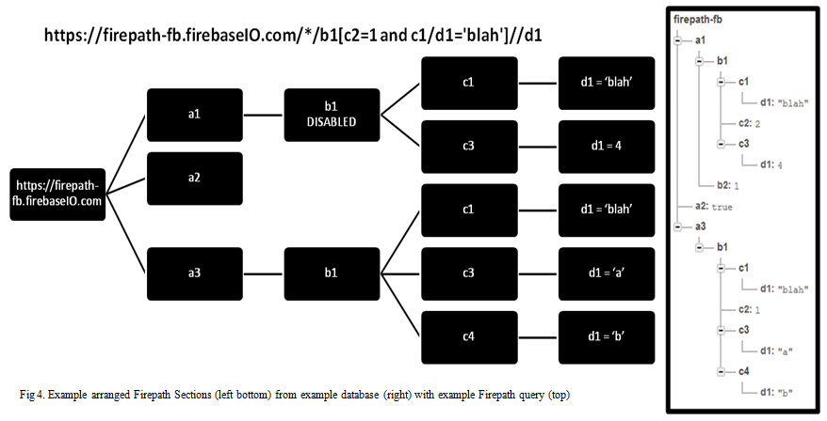
Version two of Firepath was focused on execution speed, which means as much pre-processing as possible was done so that when the Firepath calls where executed, there was little delay before they were turned into Firebase calls and executed.
- Same as version 1
- Same as version 1
- Firepath version 2 functions in a very different way from version 1 for the rest of the steps. In an effort to speed up the process a ‘valid’ path tree is maintained by Firepath. This tree starts to be constructed as soon as the Firepath is created immediately following the parsing in step 2. The tree is made up of objects called Arranged Firepath Sections, and these arranged sections are constructed from the pathSections that are produced by the parser.
- Each Arranged Section is essentially a regular Firepath Sections, but each section keeps track of its parent section as well as all child sections it has. There are two other key parts to each Arranged Section. Child listeners check to see if a valid child has been added below the current node, or if one has been removed. It then updates the tree with this information. Rule listeners only applies to sections that have rules, but it checks to see if the section is still valid based on the rule. This forms a tree that builds and maintains itself. Figure 4 shows an example of the arranged Firepath section built from an example database and an example Firepath query.
- When a Firepath function is called the API begins to search the tree for valid complete paths. Each node on the tree has two important flags that are checked by the search algorithm. The terminus flag set to true indicates a valid path has been found and the current nodes complete path is added to the path list. The terminusBelow flag indicates a terminus has been found below this node on the tree at some point and the search should continue.
- Once the complete and valid paths have been found, Firebase function calls can be made in the same way as Firepath version 1 .

Analysis
Each version of Firebase had its advantages and disadvantages. Looking at the design goals, version one left the Firebase API the same, added querying support by using XPath style queries, used functions that were very similar to Firebase, and added very little memory overhead with each Firepath reference. Unfortunately it is also painfully slow. Every single section of a Firepath URL requires a call to the Firebase servers. When a Firepath URL section has a rule, it can require multiple calls to the Firebase servers. This makes a version one Firepath call's speed very dependent on the depth of the Firebase tree, and also the complexity of the query.
Firepath version two attempted to solve the speed issue presented by version one. Version two accomplished all of the same design goals as version one, except for the low memory overhead. Version two is always active, which allows it to perform much faster, but also comes with a overhead cost. Memory usage is dependent on both the size of the Firebase database being queried, and also the complexity of the Firepath query. The CPU is also utilized whenever a listener detects a change, which makes it dependent on how active the Firebase database is. The final disadvantage of version two is its complexity. It can be very difficult to debug and understand the exact state of the local Firepath data.
Both version where unable to completely convert all Firebase functions into Firepath functions. Transactions are a very important feature of Firebase, but could not be implemented in Firepath for several reasons. One reason is that all Firebase calls are asynchronous, so when a transaction executes a function to check before a commit that function cannot contain another Firebase function call. Javascript 1.7 added the ability to await an asynchronous call, but this lead to another problem. Firebase transactions appear to timeout after a certain amount of time. With longer queries this meant that the transaction would timeout and fail before the check function could be completed. Rule complexity also made transactions extremely difficult to implement

Future Work
There are several ways this project could be improved and extended. One way is to extend support to all XPath style queries. This project only contains a basic subset of XPath, but could easily be extended to include all of it's functionality. Another way to improve this project would be to shift this querying process to the backend database. This would take away much of the overhead concerns from the user, but still allow the same capabilities. Extending the backend side of things would also allow more advanced optimizations such as user pre-defined indexes which could speed up the queries.

Conclusion
The value of this project largely depends on the project it is used in. It provides a useful abstraction of querying for Firebase that can save a developer time and effort. However it is important that the developer clearly understands the costs and limitations of using this API. Thought should be put into whether or not querying is truly necessary for the project at hand. Can data be structured in a way to make querying unnecessary? Can the built in range querying, which is much more efficient and faster, be used to perform the same tasks? If sufficient thought is given to these questions then perhaps the benefits gained from using this abstraction of querying is worth the costs.

