3.1. DHIT Problem Statement

3.1.1. Governing equations. The governing equations for an LES of the incompressible turbulent flow read as follows:

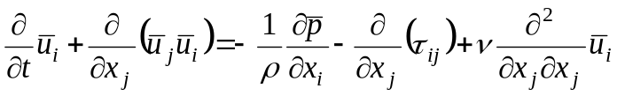,
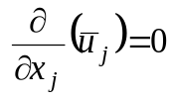 (3.1)

Here 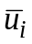 are the “large scale” (filtered or resolved) velocity components and 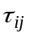 is the subgrid stress tensor

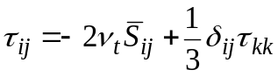, (3.2)

where 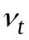 is the subgrid eddy viscosity and 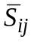 is the strain tensor.
A conventional approach to numerical study of DHIT by an LES assumes a solution of the system (3.1) closed with the use of some subgrid model for the time evolution of turbulence in a cubic box of the size of 2π×2π×2π with the periodic boundary conditions in all the three space directions.
In order to finalize the problem set up an appropriate initial velocity field should be specified. For generation of such a field we have developed a procedure outlined below.
3.1.2. Flow initialization. Let us consider a grid with the number of nodes N×N×N. Then, an arbitrary periodic (with the period 2π) velocity field, 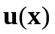, can be presented on that grid via its discrete Fourier Transform (FT), 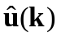, as follows:

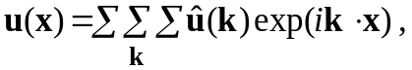 (3.3.)

where 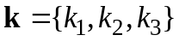 is a wave vector, 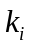 are the integers varying within the range -N/2<<N/2 and is the amplitude of -th mode (velocity vector in the Fourier space) defined as

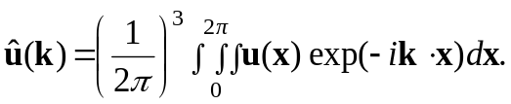 (3.4)

Now, let us assume that an energy spectrum of DHIT, 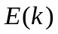, is prescribed at the integer values of (=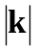) in the range 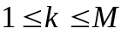, 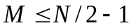. Then, it can be shown that the components of a solenoidal velocity vector with the energy spectrum we are looking for, can be computed as:
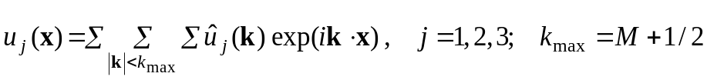, (3.5)

where the velocity component amplitude in the Fourier space, 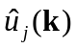, reads as:
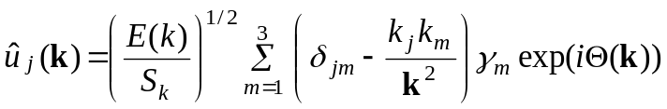. (3.6)

Here 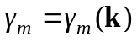 are the random real numbers with the Gaussian distribution 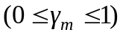, 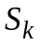 is the number of the Fourier modes in the wave-number spherical shell of a unit width centered at 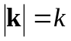, i.e., 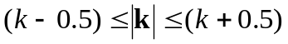, and 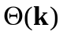 is a random phase with a uniform distribution in the range 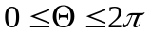.
Substituting (3.6) for 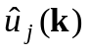 in (3.5) one gets:
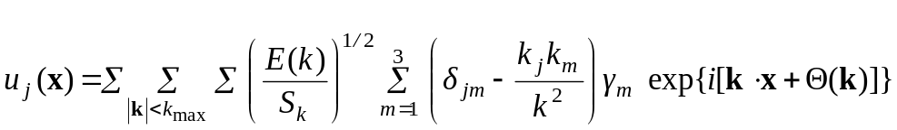. (3.7)

In order to use (3.7) for computations with real numbers, it should be presented explicitly as a real expression. After some algebra, an appropriate final expression can be presented as:

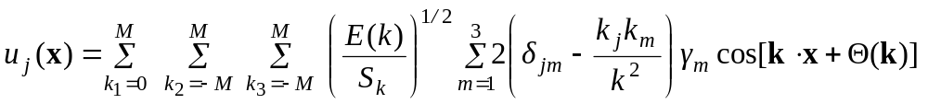.
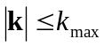 (3.8)

For an LES with the use of the developed subgrid models, along with the initial velocity field (3.8), we need some initial fields of the subgrid turbulent quantities (subgrid eddy viscosity, kinetic energy, and specific dissipation rate) as well. To obtain those fields we get a steady solution of the corresponding subgrid models’ equations with the prescribed (given by (3.8)) velocity field.
3.1.3. Post-processing. In order to analyze solutions obtained in the framework of the problem statement outlined above and to compare them with the experiments [11], we need to solve the inverse problem, i.e., to compute an energy spectrum for a given (obtained in the course of simulation) velocity field. This is performed as follows.
First we compute the FT of the velocity field

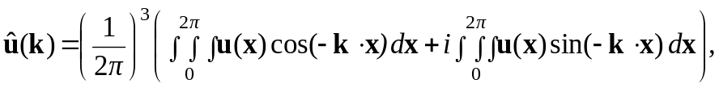 (3.9)
and then obtain the energy spectrum for 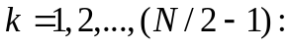
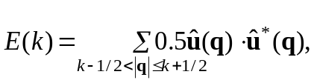 (3.10)
where 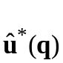 is a complex conjugated of 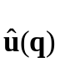.

3.1.4. Testing of the flow initialization and post-processing. In order to test the software developed for implementation of the procedure outlined above we have performed computations of the initial velocity field (3.8) by a given energy spectrum and then computed the energy spectra corresponding to the obtained velocity field with the use of (3.10). Results obtained are presented in Fig.3.1, where we show the input energy spectra, computed velocity fields (cuts at z=π plane) generated on the basis of those spectra, and the energy spectra computed on the basis of the generated velocity fields. Computations are conducted on uniform grids 16³, 32³, and 64³. One can see that the prescribed (input) and computed (output) spectra are virtually identical.
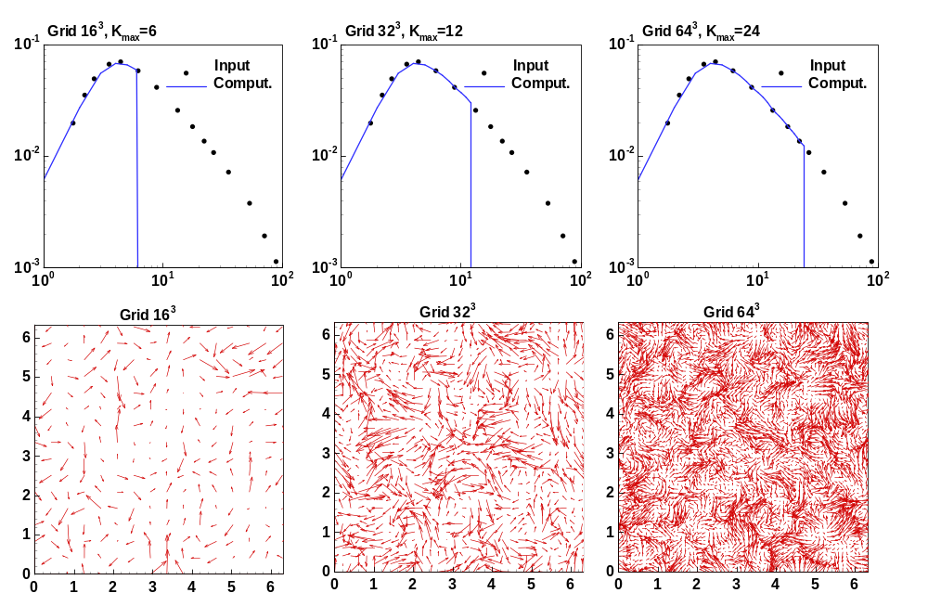
Fig.3.1. Results of testing of the initialization procedure for DHIT process:-input (experimental) energy spectrum; - energy spectra computed for the velocity fields generated on the basis of the input spectra (three lower frames)

