CS 255 System Design Document Template

UML Diagrams

UML Use Case Diagram
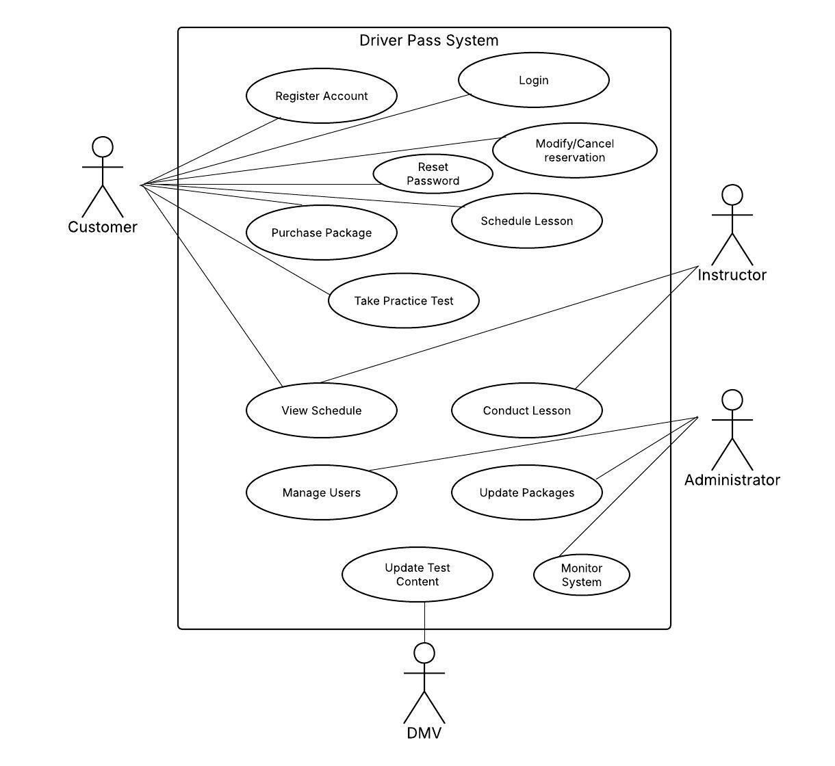

UML Activity Diagrams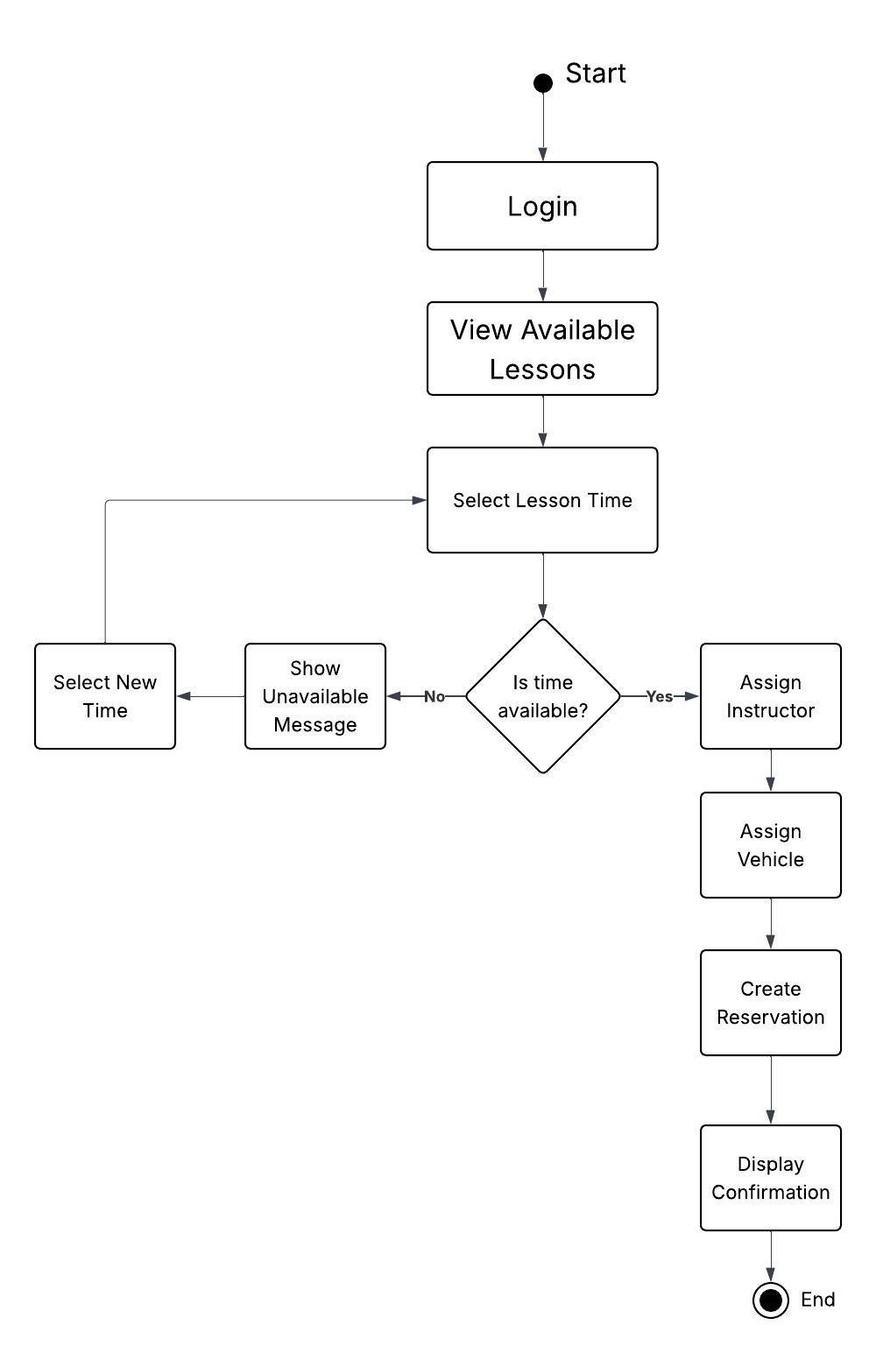
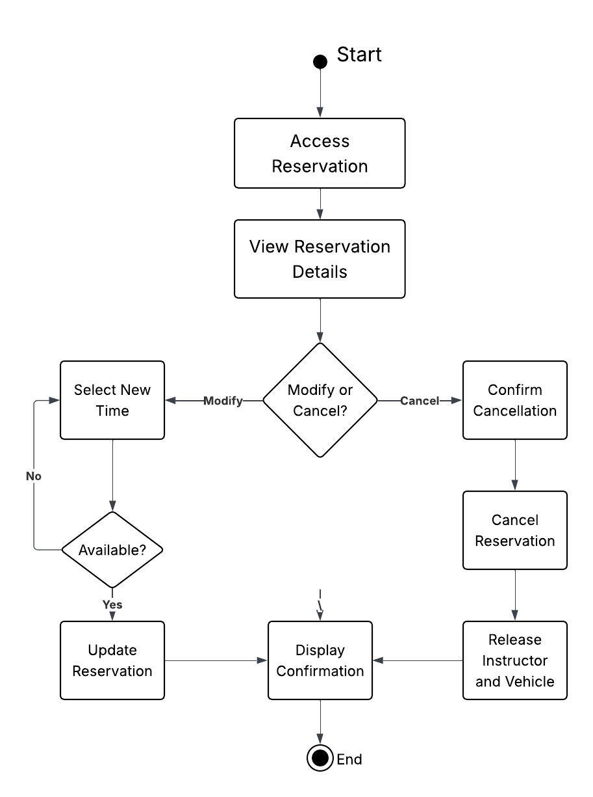

UML Sequence Diagram

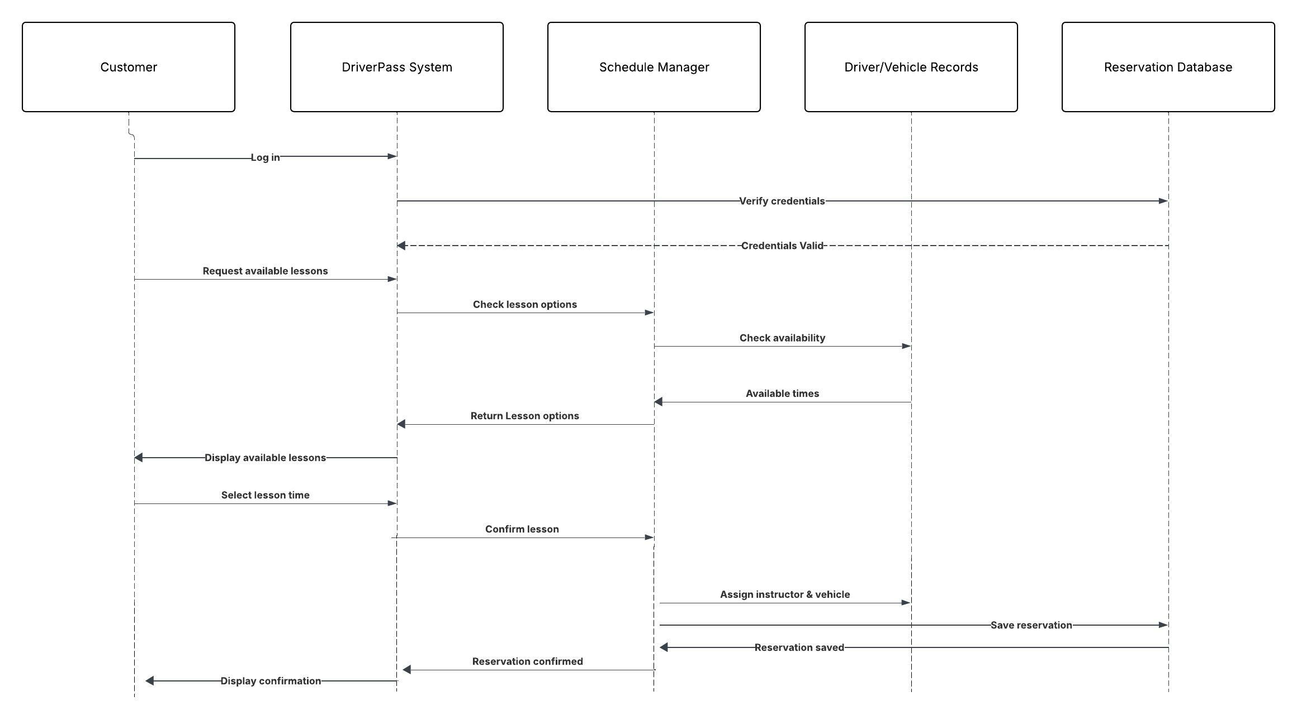

UML Class Diagram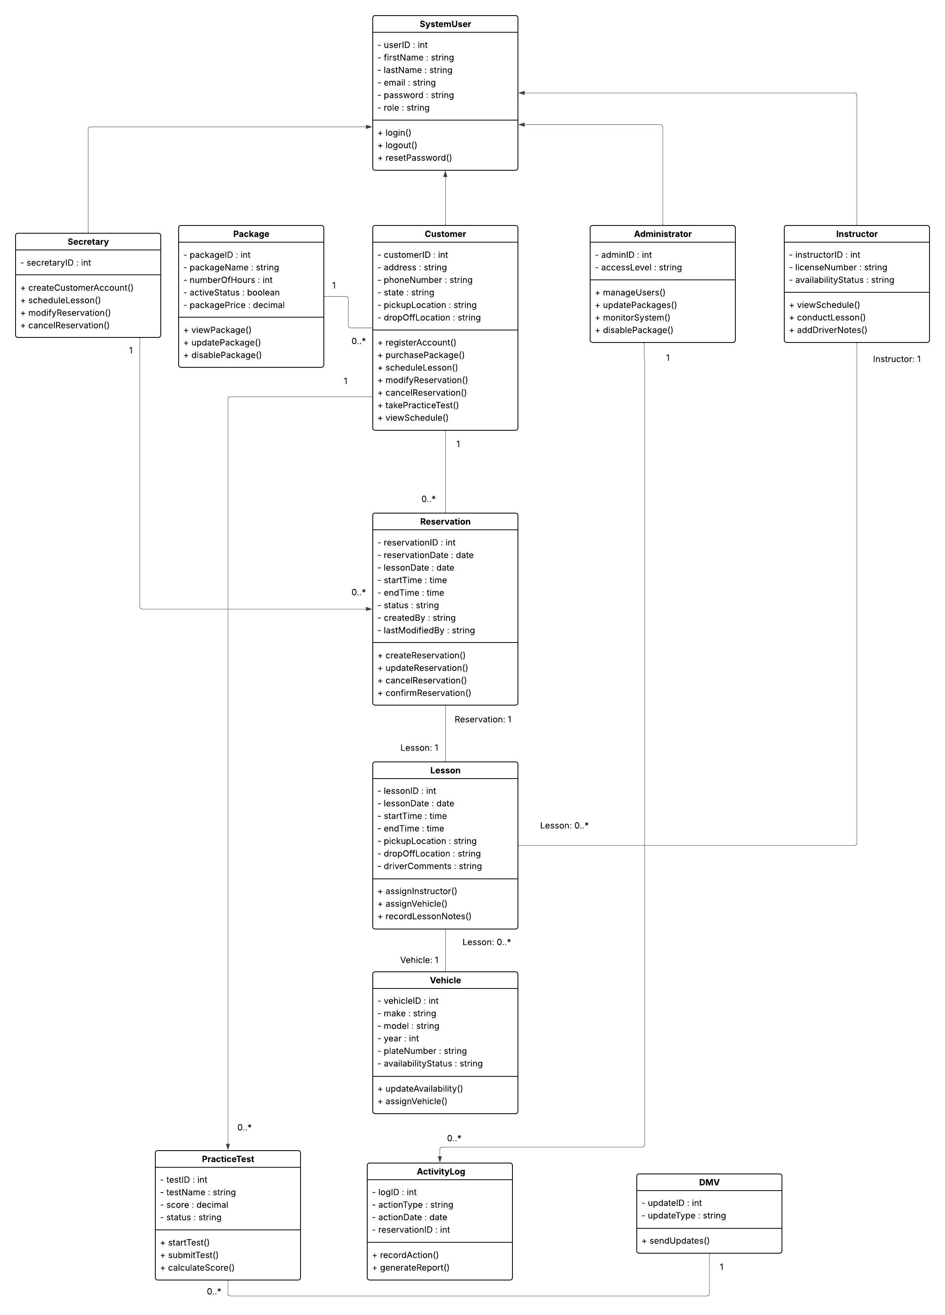

Technical Requirements

The DriverPass system requires a combination of hardware, software, tools, and infrastructure to support its functionality. The system will operate as a web-based application accessible to customers, instructors, and administrators.

From a hardware perspective, users will need a device such as a desktop computer, laptop, tablet, or smartphone with internet access. The system will be hosted on secure servers capable of handling user requests, storing data, and maintaining system performance during peak usage times.

From a software standpoint, the system will require a web browser for users to access the platform. The backend will include a server-side application responsible for processing requests, managing scheduling logic, and handling user authentication. A database management system will be used to store customer information, reservations, lesson data, and package details.

The system will also rely on tools such as Lucidchart for modeling and design, as well as development tools and frameworks used by developers to implement the system. Security tools will be necessary to protect user data, including encryption for login credentials and secure communication protocols.

In terms of infrastructure, the system will require a reliable internet connection, cloud or server hosting, and integration with external systems such as DMV data sources for practice test content. The system must also support scalability to accommodate increasing numbers of users and ensure consistent performance.

