Software Development Plan
Example from:
https://code.google.com/p/uni-workflow-mgt-sys/downloads/list

University Workflow Management System

Project Code: UWMS – FAST – NU

Internal Advisor: Mr. Waqas Zyad

Submitted By:

Project Team
Rabia Akhtar | L10-5082
Bushra Maqbool | L10-5111
Nida Sarwar | L10-5106
Mahwish Sonia | L10-5021
Muhammad Aamir | L10-5032

Submission Date: November 26, 2011

___________________
Project Manager’s Signature
Revision History
Date | Version | Description | Author
11-Nov-2011 | 1.0 | This document contain the plan of UMWS. How many resources, time spent on this project. Road map of UMWS | Team Work
30-Nov-2011 | 2.0 | Map the expected with actual plan | Team Work
06-Dec-2011 | 3.0 | Formating

Table of Contents
1. Introduction 4
1.1 Purpose 4
1.2 References 4
2. Project Overview 4
2.1 Project Purpose, Scope, and Objectives 4
2.2 Assumptions and Constraints 5
2.3 Project Deliverables 5
2.4 Evolution of the Software Development Plan 5
3. Project Organization 5
3.1 Organizational Structure 5
3.2 External Interfaces 6
4. Management Process 6
4.1 Project Estimates 6
4.2 Project Plan 7
4.2.1 Work break Down Structure 7
4.2.2 Gantt Chart 8
4.2.3 Releases 9
Table 05: Project Releases 9
4.2.4 Project Schedule 9
4.2.5 Project Resourcing 10
4.3 Project Feasibility Report 13
4.3.1 Technical Feasibility 13
4.3.2 Operational Feasibility 13
4.3.3 Schedule Feasibility 13
4.3.4 Economic Feasibility 14
4.3.5 Specification Feasibility 14
4.3.6 Motivational Feasibility 14
4.3.7 Legal and Ethical Feasibility 14
4.4 Tools and Technologies 15
4.4.1 Programming Language 15
4.4.2 Development Application 15
4.4.3 Web Development 15
4.4.4 Web server 16
4.4.5 Database Server 16
4.4.6 Designing Software 16
4.4.7 Operating System 16
4.5 Project Monitoring and Control 17
4.5.1 Quality Control Plan 17
4.6 Risk Management Plan 17
4.7 Close-out Plan 17
5. Project Characteristics Analysis 17
5.1 Process 17
6. Technical Process Plans 17
6.1 Methods, Tools, and Techniques 17
6.2 Infrastructure Plan 18
6.3 Product Acceptance Plan 18
7. Supporting Process Plans 18
7.1 Evaluation Plan 18
7.2 Quality Assurance Plan 18
8. Additional Plans 18
9. Annexes 18
10. Index 18

Software Development Plan

Introduction
FAST – NU is one top most institutes providing the high standard education of computer and emerging sciences. Currently university’s workflow is totally manual in which student has to submit a form for every request. The point persons receives the request and the forwards it to the concerning department. The department processes the request and forwards the request to the next concerning department for further processing. O department send it back to the initiator.
The student generate number of request varying from course add / drop to degree clearance. Also in manual system the requester has no idea about the current status of the request. Due to the manual work the overhead and time to process a request is very high. So we are aiming to automate this request processing system. This automated system will facilitates the student and concerning authorities to process the requests faster and with ease.

Purpose
The purpose of a software development plan is to lay out the entire plan that is required in order to develop, modify or upgrade a software system whilst chalking-out details on how each step needs to be delivered. It covers every aspect- right from the project’s process of software development implementation, documentation through to the software testing lifecycle and launch.

References
Document Title | Abbreviation | Date | Version
Risk Management Plan | RMP |  | 2.0
Software QA Plan | SQAP |  | 2.0
Test Plan | TP |  | 1.0
Configuration Management Plan | CMP |  | 1.0
Table 01: References

Project Overview

Project Purpose, Scope, and Objectives
The software product to be produced is the University Workflow Management System. The scope of the project is limited to FAST-NU Lahore. This system will be working in the premises of the institution and will also be accessible over the Internet.

The system shall allow online users to submit different requests in order to get their Academic activities smooth. A large list of request types has been collected, with respect to almost all sections of the institutions. The request will therefore be limited due to restricted time span of 1 year for the project implementation. It will allow the users to generate new requests and see the status (approved/disapproved/cancelled) for the submitted requests. This new system will have an intuitive and user friendly graphical user interfaces.

The proposed system will eliminate the problems with the old system and also remove the limitation because of its enhanced scope.

- Manual request forms will be replaced with electronic forms
- The flow of request forms for approval and remarks from different sections of the institution will be done automatically through the implemented business processes
- Every part of the application will be available to the authorized person only.

UWMS will provide web based interfaces for users through which they will be able to perform user management, request levels management and request forwarding and approvals/rejections.

Currently the circulation of request forms have time problem and the request status is not clear to anyone who has either generated the request or has forwarded one. Therefore this system will help the users to keep track of requests for their status and take immediate actions on whatever is required by the students.

Assumptions and Constraints
[A list of assumptions that this plan is based and any constraints, for example. budget, staff, equipment, schedule, that apply to the project.]
Fast_Nu will provide computers to developers, QA for development of this project

Project Deliverables
No. |  | Deliverable
Deliverable 1 | Proposal
Deliverable 2 | SRS, Software Development Plan
Deliverable 3 | Functional Specification, Quality Plan (SQAP, RMP)
Deliverable 4 | Design Document, Prototype
Deliverable 5 | Implementation in Sprints (1-5)
Table 02: Project Deliverables

Evolution of the Software Development Plan
Version | Date | Author | Summary of changes
v 1.0 | 30-oct-2011 | UWMS Team | Initial Release
v 2.0 | 17-dec-2011 | MS Team | Final release
Table 03: Revision History

Project Organization

Organizational Structure

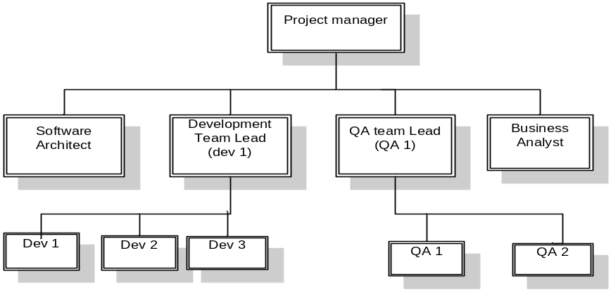
Fig 01: Organizational Structure

External Interfaces
Name | Role
Waqas Zyed | Project Advisor
Aftab Hussain | Academic Coordinator
 | Accounts
 | Library
 | Manager Academics
 | Student Co-coordinator
 | Departmental secretary
Dr. Qaiser Durani | HoD
 | Radix team
 | Lab Assistant
 | Director office
Table 04: External Interface

Management Process

Project Estimates
For the estimation purpose, we have chosen “Bottom up” technique because it will give us:
    - Estimates of staff efforts
    - Reconcialation of bottom-up estimate with top-down estimation
    - Estimates elapsed time
    - Individual activity estimates
Project Schedule is displayed below : Fig 04: Project Schedule

Project Plan

4.2.1 Work break Down Structure
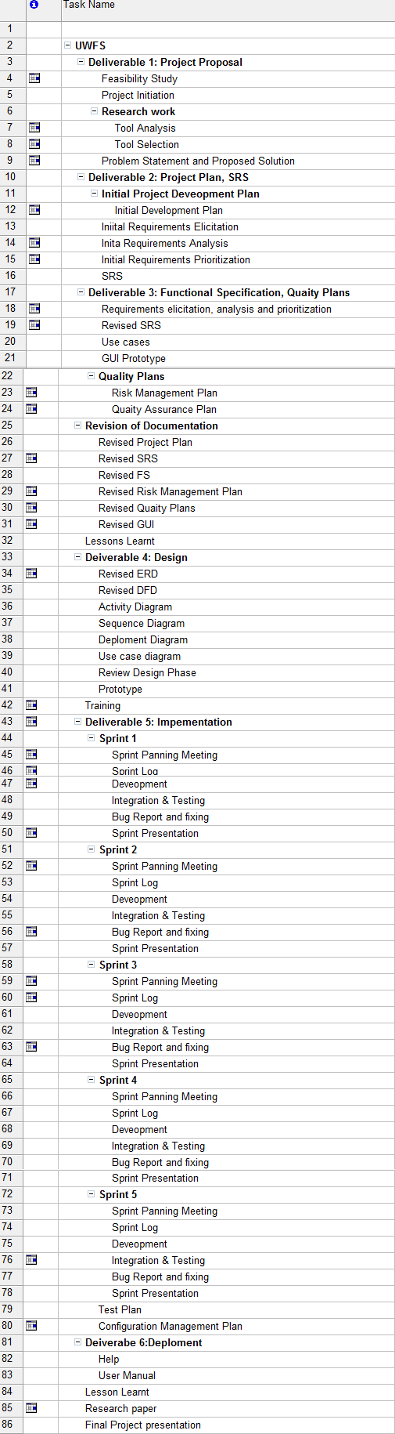
Fig 02: WBS

4.2.2 Gantt Chart
[List the objectives to be accomplished for each of the iterations.]

Fig 03: Gantt Chart

4.2.3 Releases

Release | Contains
First Sprint: | Functional Prototype
Second Sprint: | User Login, Request Submission & Listings
Third Sprint: | Workflow implementation phase I
Forth Sprint | Workflow implementation phase II
Final | Final deployment

Table 05: Project Releases

4.2.4 Project Schedule
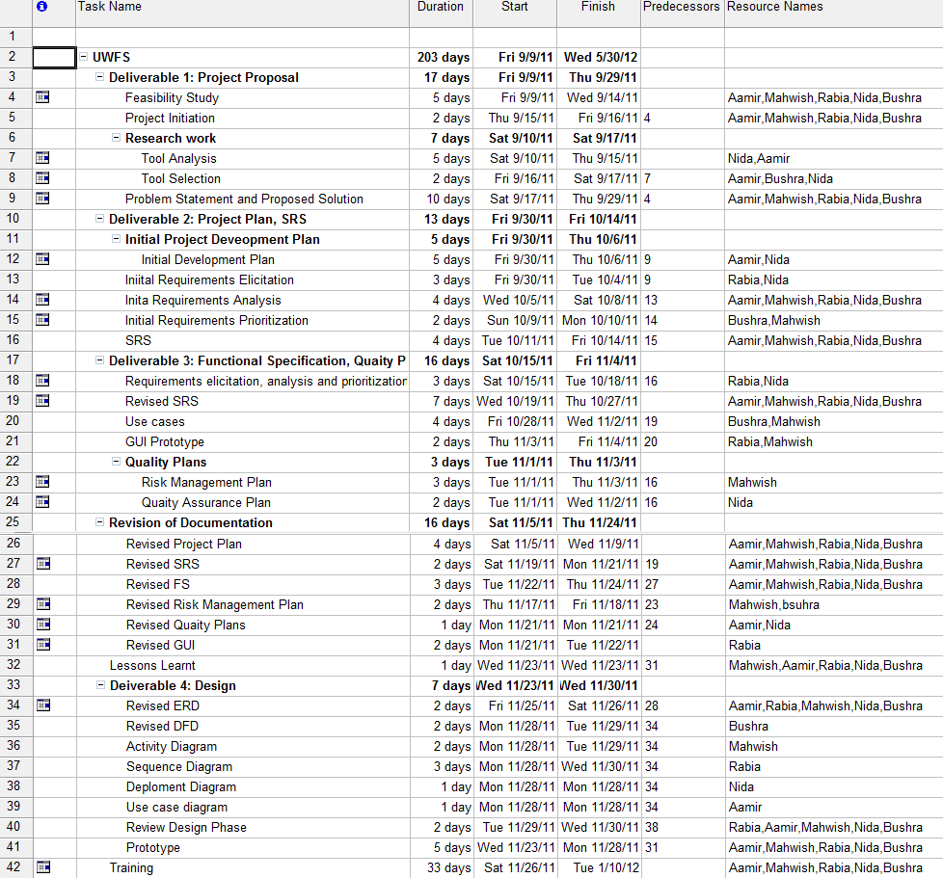

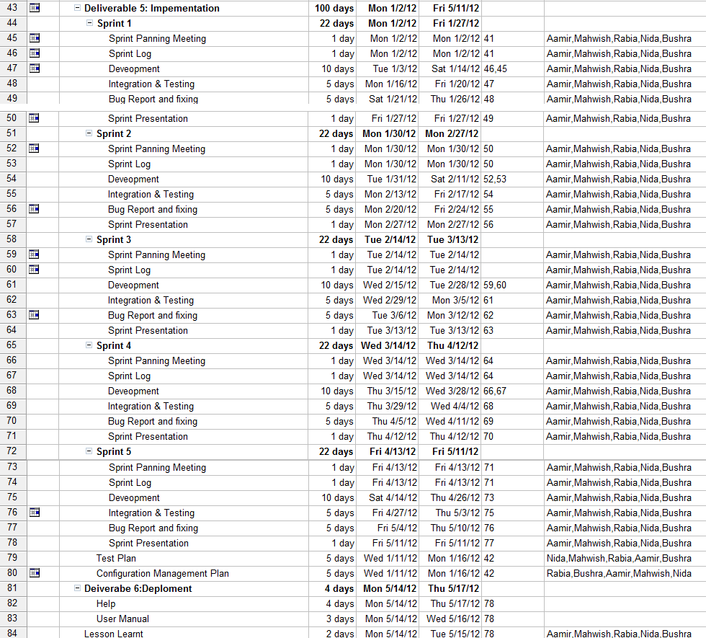
Fig 04: Project Schedule

Project Resourcing

Staffing Plan
No. | Category | Skills Required
3 | Developer | RoR Framework understanding
1 | Quality Assurance | Testing & Bug reporting, Documentation skills
1 | Business Analyst/ Requirement Engineer | Requirements analysis
Table 06: Staffing Plan

Resource Allocation
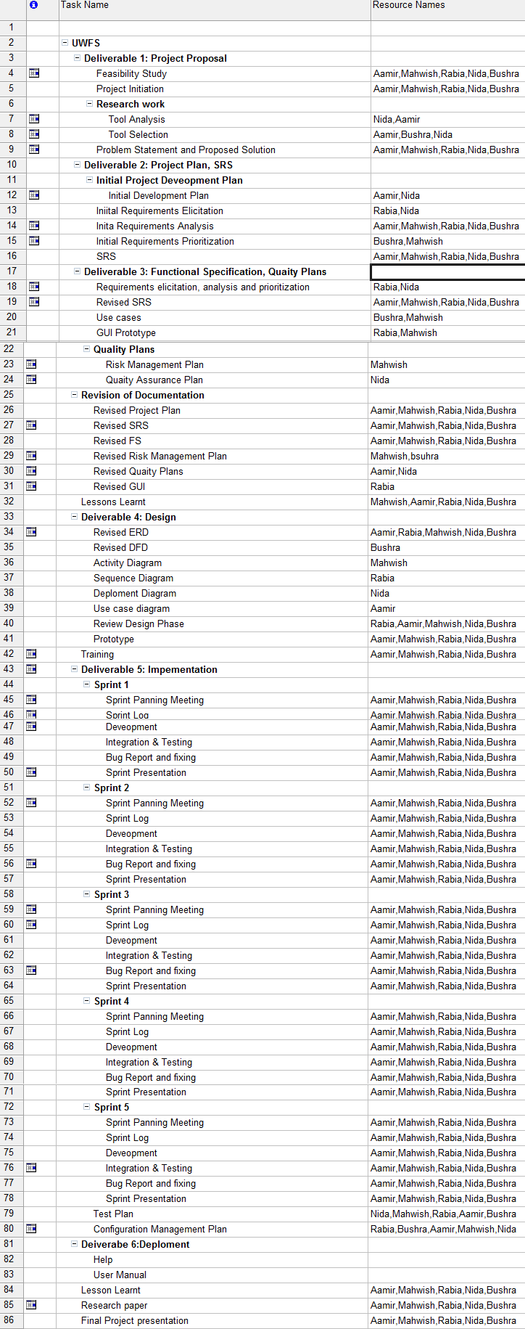
Fig 05: Resource Allocation

Training Plan

Category | Tool /framework/development Language
Development Framework | RoR
Tool | MS Project Professional
Language | Ruby
Table 07: Training Plan

Budget
As it is the very initial stage so we have done costing on the base of Expert’s Judgment. By the time, we will be able to drill down the requirements and will be able to apply any formal technique to do so then the plan will be revised. Basically, the cost will be:
- Resources
Human Resources Cost |  |  | Hardware Resources Cost
Total Resources | Rate/Hour | Total | Deployment Cost (Hardware) | Total
Software Engineer (3) | $12/hour | $10500 | Application Server: Windows 2008 | $7400
Software QA Engineer (1) | $10 /hour | $4400 | Database Server: Windows 2008 | $7400
Business Analyst(1) | $12/hour | $6432 | Total Hardware cost (client side deployment) | $10,000
Table 08: Human/ Hardware Cost

Hardware/Software Cost (Rs.)
Web server Hardware Cost | 60,000
Database Server Hardware Cost | 60,000
Workstation Cost | 30,000
Misc Equipment (Cables etc.) | 10,000
Development Cost (Approximate Measures) (Rs.)
Total Project Development Cost | 100,000
Deployment Costs (Rs.)
Software Installation & Configuration | 18,000
User Training (Manuals & material availability, etc) | 10,000
Operations & Maintenance Cost (per month) (Rs.)
Manager | 12,000
TOTAL | 300,000

Table 09: Software Cost

Project Feasibility Report

4.3.1 Technical Feasibility

- Technologies
The proprietary tools that will be used during project development phase are Microsoft Project, Microsoft Office, Microsoft Visio, Dreamweaver and Rational Rose. MySQL, Netbeans, Ruby on rails frame work will be used as open source tool during development. Therefore, it is completely viable to develop the project. These tools and technologies are widely used all over the world.

- System Performance
Three tier architecture is a benchmark for many of the famous application these days. As our system is similar and can be sub-divided into three tiers hence, we will be using it as basis of our application.
With a strong database backend, and internal users connected through Internet/Intranet, the system will be able to produce maximum throughput with minimum response times. Database consistency will be ensured through proper and timely backups.

- Development Process
The system is being developed using the latest project management and software engineering approaches. With the use of these techniques, and with guided and experienced supervision available, the development process will work fully in accordance with project management.

- Risk Assessment
All technical aspects are evaluated in means of risks associated with them and are stated in the risk list along with proper mitigation and contingency actions.

4.3.2 Operational Feasibility

The university is currently dealing with their operations through manual collaboration of different departments that share information by physical transfer of documents. So there is a real need of an automated system. The automated system will be able to facilitates its users with faster processing and ease of use.

4.3.3 Schedule Feasibility

The project consists of five team members and all of them are comfortable working with all the technologies used. Also, the project is of simple nature and requires no complex algorithm design or implementation that can take unexpected time. So, there are no visible factors at this time which can hinder development process.
During this project it will be ensured that all deliverable and/or milestones will be developed and delivered as per their deadlines mentioned in Gantt Chart.

4.3.4 Economic Feasibility
Costs
Hardware/Software Cost (Rs.)
Web server Hardware Cost | 60,000
Database Server Hardware Cost | 60,000
Workstation Cost | 30,000
Misc Equipment (Cables etc.) | 10,000
Development Cost (Approximate Measures) (Rs.)
Total Project Development Cost | 100,000
Deployment Costs (Rs.)
Software Installation & Configuration | 18,000
User Training (Manuals & material availability, etc) | 10,000
Operations & Maintenance Cost (per month) (Rs.)
Manager | 12,000
TOTAL | 300,000

Table: 01

4.3.5 Specification Feasibility

All stakeholders/users of the system are based in the university therefore continuous collaboration and communication through the requirements engineering phase is possible.

4.3.6 Motivational Feasibility

As the current system is totally manual and time taking so users are a little bit frustrated with it. There is a potential need of new automated system
The new computerized system will be a purpose of motivation for the university management as well as university students. For this purpose, very few efforts will be required from the user to adapt to the new system as it has very attractive user interfaces. These interfaces will reduce user frustration. There will be authorization checks which will enable the system to do not allow any invalid user to intiate/process a request. The system will make day to day operations a lot easier with minimized work and good efficiency hence proving to be a high motivation for its users.

4.3.7 Legal and Ethical Feasibility

Out of all the technologies, the FAST-NU does not need to purchase any license so far. The project team will use open source softwares. Also this automated system will be open for modifications in future. There are no legal and ethical issues that arise with the development, deployment or operations of this system.

Tools and Technologies

4.4.1 Programming Language

We have selected Ruby on Rails framework for development. It is open source and most widely used language for web develoment. It provides complete solution for Web Development and is more extendible to accommodate future changes.

4.4.2 Development Application

- NetBeans IDE Bundle for Ruby
The NetBeans IDE Bundle for Ruby Versions prior to 7.0 includes a Ruby editor (with code completion, and syntactic and semantic highlighting), debugger, and full support for the Ruby on Rails framework. NetBeans supports development with Ruby and JRuby, as well as Rails for these two implementations of Ruby.
- Faster time to markets
- Cross platform compatibility
- User interface management
- Reuse of existing components
- Accessibility and user interface development
- Generating documentation pages for your applications
- Customizing your development environment.

4.4.3 Web Development

Tool
Dream Weaver / Front Page

Client-side Technology

HTML, CSS, Java Scripting, Ajax,

Server-side Technology

Ruby

Designing Language

- UML (Unified Modeling Language)

Designing Approach

- Object-oriented Analysis & Design

The principals of objects, encapsulation, inheritance, and polymorphism are the foundation for object-oriented systems development. To understand and express the essential and interesting features of an application in the complex real world, an object-oriented model is built around objects. An object encapsulates both data and behavior, implying that analysts can use the object-oriented approach for both data modeling and process modeling.

4.4.4 Web server

- Apache HTTP Server:
The Apache HTTP Server, commonly referred to as Apache, is web server software notable for playing a key role in the initial growth of the World Wide Web. In 2009 it became the first web server software to surpass the 100 million website milestone. Apache was the first viable alternative to the Netscape Communications Corporation web server (currently named Oracle iPlanet Web Server), and since has evolved to rival other web servers in terms of functionality and performance. Typically Apache is run on a Unix-like operating system

4.4.5 Database Server

- MySQL

4.4.6 Designing Software

- Microsoft Project 2007

Microsoft Project 2000 is the world's most popular project management software. It represents a new milestone for Microsoft's project management offerings. Microsoft Project's installed base includes a wide variety of user types, ranging from general knowledge workers to expert project managers. Microsoft Project 2000 is the result of an enormous research and development effort focused on this entire spectrum of customers and offers major feature additions and enhancements. Microsoft Project 2000 provides knowledge workers with the flexibility to collaboratively plan and track projects and deliver the results their business demands. It is the single planning tool needed in an organization.

- Microsoft Visio

Microsoft Visio is most popular software used in the development of the system. This software is largely used in the development of software engineering diagrams.

- Microsoft Office Suite

Microsoft office is most famous suite for documentation and presentation purposes. It is widely used all over the world and provides ease to perform any task.

- Rational Rose

- Define reusable, fully encapsulated architectures
- Faster development, better quality of generated
- Supports customer's chosen platform
- Minimizes test effort; allows testing from very beginning
- Useful for analysis

- UMLet

UMLet is a plugin to Eclipse tool. Its the most famous open source tool for UML diagrams. So we will be using it as well in order to create some of the diagrams like use cases, sequence diagrams etc.

4.4.7 Operating System

    - Linux for Database server
    - Windows XP/Linux for Web server and Workstation

Project Monitoring and Control

4.5.1 Quality Control Plan
Quality Plan is explained in SQAP v2.0 (included in project repository)

Risk Management Plan
Risk Plan is explained in RMP v2.0 (included in project repository)

Close-out Plan
Deployment and Installation
  - User Manual
  - Final Presentation

Project Characteristics Analysis

Process
- Scrum-Agile Model
The Scrum agile model is a method of software development where the model is designed, implemented and tested incrementally (a little more is added each time) until the product is finished. It involves both development and maintenance. The product is defined as finished when it satisfies all of its requirements. This model combines the elements of the waterfall model with the iterative philosophy of prototyping. As we have found that our system can be decomposed on the basis of request so we had consensus that we can build the system in increments, so we can have a running application as soon as possible.
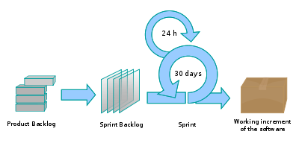
Fig 06: Scrum Model

Technical Process Plans

Methods, Tools, and Techniques
[List the documented project technical standards, etc., by reference:
- Business Modeling Guidelines
- User Interfaces Guidelines
- Use-Case-Modeling Guidelines
- Design Guidelines
- Programming Guidelines
- Test Guidelines
- Manual Style guide]

Infrastructure Plan
[Enclosed by reference]

Product Acceptance Plan
[Enclosed by reference]

Supporting Process Plans

Evaluation Plan
[As part of the Software Development Plan, this describes the project’s plans for product evaluation, and covers the techniques, criteria, metrics, and procedures used for evaluation— this will include walkthroughs, inspections, and reviews. Note that this is in addition to the Test Plan, which is not enclosed in the Software Development Plan.]

Quality Assurance Plan
Quality Plan is explained in SQAP v2.0 (included in project repository)

Additional Plans
- Risk Plan is explained in RMP v2.0 (included in project repository)
- Configuration Management is explained in CMP v1.0 (included in project repository)
- Test Management Plan is explained in TMP v1.0 (included in project repository)

Annexes
[Additional material of use to the reader of the Software Development Plan.]

Index

