

Walk-through Review Kit
Version 1

Content

Activities for: Author, reviewers, recorder.

Checklist: Generic

Form: Walk-through form, Issue form

Goal. To find defects, omissions, and contradictions to improve the product and to consider alternative implementations.

Responsibilities.
- Author.
  - The author is the person responsible for the product being examined, selects the peers to participate in the review, and presents the product.
- Walk-through Team.
  - A walk-through may have one or more reviewers. Each member is responsible for reviewing any input material prior to the walk-through meeting, if held, and participating during the walk-through meeting to ensure that it meets its objective.
- Recorder.
  - The author may request or assign a team member to perform the duties of a recorder. If assigned, the recorder is responsible for writing all comments made during the walk-through meeting that pertain to errors found, questions of style, omissions, contradictions, suggestions for improvement, or alternative approaches.
100
Plan
the walk-through
.. . . .
.
Request
110
Conduct
Kickoff
Meeting
120
Conduct
Document
Checking
130
Conduct
Logging
Meeting
140
Edit
Document
150
Complete
Follow-up
Exit &
Release
Source
Checklists
Change
requests
Product
document
Process
improvements
Figure 1. Walk-through Process (adapted from Holland, 1998)

Entry Criteria
- Product is ready for a walk-through
- Applicable standards, guidelines, and checklists are available
- Source documents from which the product is derived are available.

Activities

WT 100. Plan the Walk-through
The author completes the following activities using the Walk-through Form:
- Identifies the walk-through team by selecting one or more people. If a recorder is needed, the author assigns this role.
- Schedules a kick-off meeting, if one is to be held, and selects the meeting place.

WT 110. Conduct a kick-off Meeting (optional)
The author:
  - Distributes to the reviewers the product and all necessary material, such as checklists or standards to facilitate the review of the product.
  - Conducts an overview of the product to educate the reviewers of the product.
  - Allows enough time for the reviewers to review the material.

WT 120. Conduct Document Checking (individually)
Reviewers:
- Prepare for the walk-through meeting by becoming thoroughly familiar with standards, checklists and any other information that was provided.
- Examine the product and prepare to discuss their comments, recommendations, questions, and redlines on the product prior to the walk-through meeting.

WT 130. Conduct the Logging Meeting
- The author walks-through the product.
  - The team member(s) may ask questions or raise issues on the product, and/or document their concerns.
  - If a recorder is assigned, the recorder writes comments and decisions for inclusion in the Walk-through Issue Form. If a recorder is not assigned, the author gathers this information.
- The reviewer(s) may recommend another walk-through be performed if a large number of issues or defects were discovered.
- The author and the reviewer(s) resolve defects discovered in the walk-through. Issues may be referred to the project lead for resolution.
- The author and reviewer(s) review defects discovered in the walk-through to determine the probable cause and to recommend steps to prevent similar defects from being injected in the future. If a defect was caused by an error in another baselined product, follow the appropriate configuration management process to correct that product.
- The author documents that a walk-through was conducted on the product using Issue Form.
- At a minimum, this should include identification of the product reviewed, the names of the reviewer(s), the date of the walk-through, an overview or summary of deficiencies, omissions, contradictions, and suggestions for improvement.
- Causal analysis findings should be documented if a causal analysis was conducted.
- Ownership of action items and status should also be documented.

WT 140. Edit the Document
The author edits (i.e. rework) the product as recorded during the logging meeting.

WT 150. Complete Follow-up and Exit
The author:
- Ensures issues and action items are tracked to closure.
- Completes the Walk-through Form (effort to review and edit document)\
Exit Criteria
- Product reworked
- Summary of deficiencies, omissions, efficiency issues, results of causal analysis (if done), and suggestions for improvement has been documented.
- Completed Walk-through Form
- Completed Walk-through Issue Form.
Output
- Completed Walk-through Issue Form.
- Completed Walk-through Form
- Reworked product.

Improvement
The IEEE 1028-2008 standard imposes some improvement activities as follow:
Walk-through data:
- should be analyzed regularly in order to improve the inspection process itself,
- should be used to improve the activities used to produce software products.
- Frequently occurring anomalies may be included in the checklists or role assignments.
- The checklists themselves should also be evaluated regularly for superfluous or misleading questions.
- The preparation times, meeting times, and number of participants should be analyzed to determine connections
  - between preparation (checking) rate, meeting rate, and number and severity of anomalies found.

Check list
Generic Document Checklist
Version 1.0, Dated July 2003.
Adapted from: Gilb, Tom, Graham, Dorothy, Software Inspection, Addison-Wesley, 1993.
These rules specify the requirements that must be satisfied by any document that is subject to inspections.
- GD1 (COMPLETE). All information relevant to the purpose of the document must be included or referenced.
- GD2 (RELEVANT). All information must be relevant to the purpose of the document and the section in which it resides.
- GD3 (BRIEF). Information must be stated succinctly.
- GD4 (CLEAR). Information must be clear to all checkers.
- GD5 (CORRECT). Information must be free of technical errors.
- GD6 (CONSISTENT). Information must be consistent with all other information in the document and its source documents.
- GD7 (UNIQUE). Ideas should be stated once only and thereafter referenced.
- GD8 (REFERENCE). References must be cited for non-original or derived statements.
- GD9 (COMMENT). All form of comment, note, suggestion, or idea that does not form an official part of the document must be clearly distinguished as such.

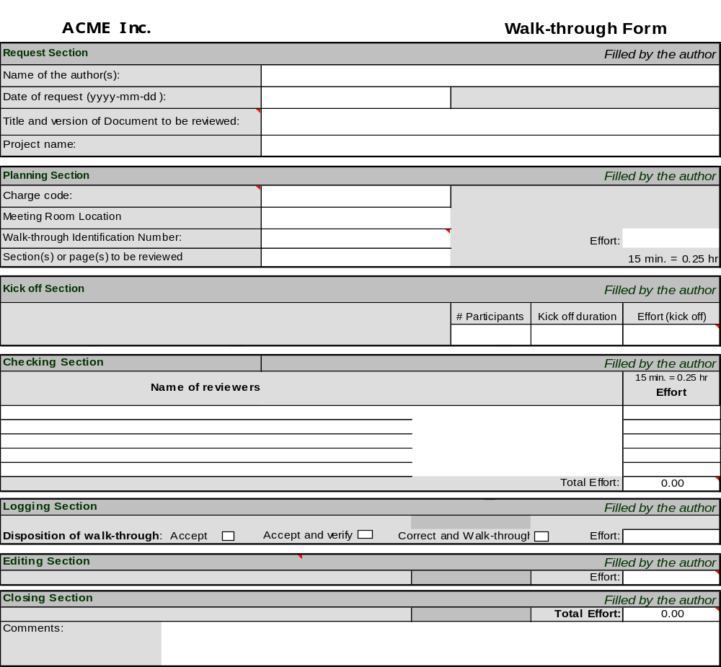

Walk-through Issue Form
Name of author: ___________________________________ Date (YYYY-MM-DD):__________________
Document Title:______ |  | ____________ | _____________________________________________ | Name of Reviewer: | ____________________
Document Version:___ |  | ____________
Comment No. | Document Page | Line Number / Location | Comments | Disposition of comments * | Remarks
1
2
3
4
5
6
7
8

Effort to review document: _________

Effort to correct document: ________
* Disposition: Inc: Incorporate as is; NOT: Not incorporate, MOD: Incorporate with modification

Holland, D. (1998). Document inspection as an agent of change. In A. Jarvis & L. Hayes (Eds.), Dare to be excellent. Upper Saddle River, NJ: Prentice Hall.

