Golds v1.0 Project Report
Version: Draft
May 8, 2005
[Christopher ruhl, daniel tsai, doe-hyun song, juan vasquez, madhuvanti pawar]
0000.doc
Revision Chart
Version | Primary Author(s) | Description of Version | Date Completed
Draft | Madhu, Chris | Initial draft created for distribution and review comments 1 & part of 2 | April 3, 2005
2nd Initial Draft | Madhu, Chris | Initial draft with section 3,7 created for distribution and review comments | April 5, 200
3rd Initial Draft | Madhu, Chris | Initial draft with section 2.3 and 2.4 added. Some screenshots needed. Reviewed sections 3 and 7 – some edits. | April 7, 2004
4th Initial Draft | Madhu, Chris | Reviewed for 1st formal team review. | Apri1 8, 2004
5th Draft | Madhu, Chris | Proofread all sections. Added Section 8.1 and 8.2. | May 3, 2005
6th Draft | Madhu, Chris | Revised Section 2.3 with new screenshots. Updated Sections 8.4.1 through 8.4.4. | May 5, 2005
7th Draft | Madhu, Chris, Juan | Proofread and revised the whole report | May 7, 2005
8th Draft | Team | Final version of report | May 8, 2005
executive summary
The GOLDS Project is a collaboration between the Masters of Information Systems Management (MISM) program at Carnegie Mellon University and the Hematology/Oncology division of the Western Pennsylvania Cancer Institute (WPCI) at the Western Pennsylvania Hospital. The project involved the migration of the division’s current predominantly paper-based clinical documentation system to an advanced digital solution that is better aligned with their goals of improving quality of care with increased efficiency and accuracy.
GOLDS (Graphical Oncological Layered Display System) strides to achieve these goals by providing a Web-based, database driven prototype system designed to meet the stated needs of the division’s specialists to document, summarize, and view a patient’s clinical history that is relevant to their treatment for cancer. This history takes the form of a chronologically ordered list of episodes that include diagnosis (es), the treatment(s) he or she has undergone, and the corresponding response(s). Each episode (“event”) is represented by a unique shape and color scheme for quick visual recognition of the event type. This primary functionality of GOLDS is included in a module called View/Edit Patient Record.
Additional modules include:
- Login – Authenticates GOLDS’ Users
- Search for Patient Record – Robust Search with Wildcard Ability for Patient Records
- Create Patient Record – Allows for the Input of New Patients into GOLDS
- Patient Record Report – Provides a Printer Friendly HTML Report of the Patient’s Clinical History
- Log Out
We hope that the GOLDS prototype developed in this 16 week semester provides WPCI with the basic functionality they require so that it can be deployed within the department soon after delivery of the source code. In addition, we would not only like to see GOLDS in use, but we believe that GOLDS can continue to be improved to include additionally functionality including:
- Additional Modules:
  - User Administration
  - Reporting
  - Online Help
- More Flexible Event Chains and Objects:
  - Linking Multiple Events to a Single Event
  - Chronological Aligning of Multiple Chains
  - Chronological Ordering of Patient Chains
- Speech Recognition
  - VoiceXML
Acknowledgements
The GOLDS team would like to thank Dr. John Lister for sharing his vision of developing a tool to clearly represent a cancer patient’s clinical history and providing us with the opportunity to bring his vision to fruition.
We could not have completed this project without Professor Rema Padman’s guidance particularly in helping us maintain course and understand the needs of the healthcare industry.
Additionally, Professor Mike McCarthy provided us with the building blocks and the understanding of VoiceXML technologies that we implemented in VoiceGOLDSv1.0.
Finally, we would also like to thank Tim Ruff and Judy Pampena and the rest of the Staff at WPCI for their support and enthusiasm in helping us complete this project.

Contents
1. Introduction 7
1.1 GOLDS Objectives 7
1.2 Scope 7
1.3 Document Overview 8
1.4 Definitions and Acronyms 8
2. Project Overview 9
2.1 Current Process & Its Limitations 9
2.2 Proposed Solution & Its Benefits 10
2.3 GOLDS v1.0 Features 11
2.3.1 Login 11
2.3.2 Search for Patient Record 11
2.3.3 Create Patient Record 13
2.3.4 View/Edit Patient Record 14
2.3.5 Patient Record Report 17
2.3.6 Log Out 18
2.4 System Architecture 18
2.5 Project Deliverables 20
3. Project Organization 21
3.1 Process Model 21
3.2 Project Responsibilities 22
4. Managerial Process 23
4.1 Management Objectives 23
4.2 Monitoring and Controlling Mechanisms 23
4.3 Risk Management 24
5. Work Schedule 25
5.1 Schedule 25
5.2 Phase 1: Requirements Development 25
5.2.1 Issues 26
5.2.2 Deliverables 26
5.3 Phase 2: Software Design 26
5.3.1 Issues 26
5.3.2 Deliverables 26
5.4 Phase 3: Software Implementation 27
5.4.1 Issues 27
5.4.2 Deliverables 27
5.5 Phase 4: Software Testing 27
5.5.1 Issues 27
6. Recommendations For Future 28
7. Appendices 30
7.1 GOLDS Speech Recognition Capability – VoiceXML 30
7.1.1 Speech Recognition History and Challenges 30
7.1.2 Voice Extensible Markup Language (VoiceXML) and GOLDS 31
7.1.3 GOLDS VoiceXML Architecture 32
7.1.4 VoiceXML References 36
7.2 Software Design Documents 37
7.2.1 GOLDS Use Cases 37
7.2.2 GOLDS Class Diagrams 38
7.2.3 GOLDS Interaction Diagrams 41
7.3 Database Design Documents 46
7.3.1 Entity Relationship Diagram 46
7.3.2 Data Model Assumptions 48
7.3.3 Data Dictionary 50
7.3.4 Table Creation Script 50
7.3.5 Load Scripts 50
7.3.6 Application to Database Mapping 51
7.4 GOLDS Setup 51
7.4.1 Setup Instructions for Tomcat users 51
7.4.2 Setup Instructions for non-Tomcat users 52
7.5 Software Requirement Specification Document 52

List of Figures
Figure 1: Current Process 9
Figure 2: Proposed Process 10
Figure 3: Benefits of GOLDS 11
Figure 4: Login 11
Figure 5: Search for Patient Record 12
Figure 6: Search for Patient Results 13
Figure 7: Create Patient Record 14
Figure 8: View/Edit Patient Record – View Patient 14
Figure 9: View/Edit Patient Record – View Event (Diagnosis) 15
Figure 10: View/Edit Patient Record – Options Menu 16
Figure 11: View/Edit Patient Record – Edit Event (Diagnosis) 16
Figure 12: View/Edit Patient Record – Add Event (Diagnosis) 17
Figure 13: Patient Record Report 17
Figure 14: Left-hand Navigation Bar 18
Figure 15: GOLDS’ 3-tier Architecture 18
Figure 16: Project Lifecycle 21
Figure 17: GOLDS Team 22
Figure 18: Project Schedule 25

Introduction
The GOLDS Project is collaboration between the MISM (Master of Information Systems Management) program at Carnegie Mellon University (CMU) and the Hematology/Oncology division of the Western Pennsylvania Cancer Institute (WPCI) at the Western Pennsylvania Hospital.
GOLDS stands for Graphical Oncological Layered Display System and the GOLDS Project involves a transformation of the division’s current predominantly paper-based clinical documentation system to a Web-enabled solution that is better aligned with their goals of improving quality of care with increased efficiency and accuracy. GOLDS v1.0 was prototyped as a first step towards demonstrating what such a digital solution would involve.
A team of five MISM students designed and developed GOLDS v1.0 as part of their four month Information Systems (IS) Project requirement under guidance from a faculty member at CMU and close interactions with the Client at WPCI.

GOLDS Objectives
- To architect and implement a prototype visualization application that summarizes and documents a cancer patient’s Diagnosis(es), Treatment(s), and Response(s) in chronological order
- To facilitate efficient and effective information capture, representation, and navigation using the application, as well as report generation, auditing and user access control

Scope
GOLDS v1.0 is a proof of concept. It is not intended to be a production quality application which can be deployed without additional testing and review by the end users and IT staff at WPCI. This version includes the following modules:
- Login
- Search for Patient Record
- Create Patient Record
- View/Edit Patient Record
- Patient Record Report
- Log Out
The features included in GOLDS v1.0 may be subject to further enhancements and/or improvements in subsequent versions.

Document Overview
This document describes the GOLDS project and the approach taken by the GOLDS project team to deliver GOLDS v1.0. It begins with an introduction of the project, its scope and the definitions and acronyms used in the document.
The “Project Overview” section documents the business need for GOLDS and the proposed solution that GOLDS offers. It gives a brief overview of the features included in GOLDS v1.0, its architecture, and the deliverables GOLDS Project.
The “Project Organization” section details the process, organization and responsibilities allocation adopted by the GOLDS team to fulfill the project objectives.
The “Managerial Process” details the management objectives, priorities, risk management techniques, and the monitoring and controlling mechanisms.
The “Work Schedule” covers the schedule of the tasks and details of the tasks accomplished and the deliverables delivered at the end of each phase of the work plan.
This report ends with “Recommendations for Future” and “Appendices” containing supporting information.

Definitions and Acronyms
Term | Description
GOLDS | Graphical Oncological Layered Display System
HIPAA | Health Insurance Portability & Accountability Act of 1996
IS Project | Information Systems Project
MISM | Master of Information Systems Management
WPCI | Western Pennsylvania Cancer Institute
WPH | Western Pennsylvania Hospital

Project Overview

Current Process & Its Limitations
Currently, a WPCI patient’s medical history of cancer (including a series of past and current diagnoses, treatments, and responses) is reviewed by WPCI doctors upon the acceptance of a new patient. The doctors then dictate their findings with a possible new diagnosis and suggested treatment for the patient. References to the electronic versions of these dictations, intake notes as well as patient demographic information are stored in the CIPIS database. Paper copies of the intake notes, supporting documents and together with the patient’s demographic information from CIPIS are consolidated in a ‘Patient File’. (Figure 1: Current Process)
The Patient File is then used for analyses and discussions, and is updated as changes occur to the patient’s clinical information.
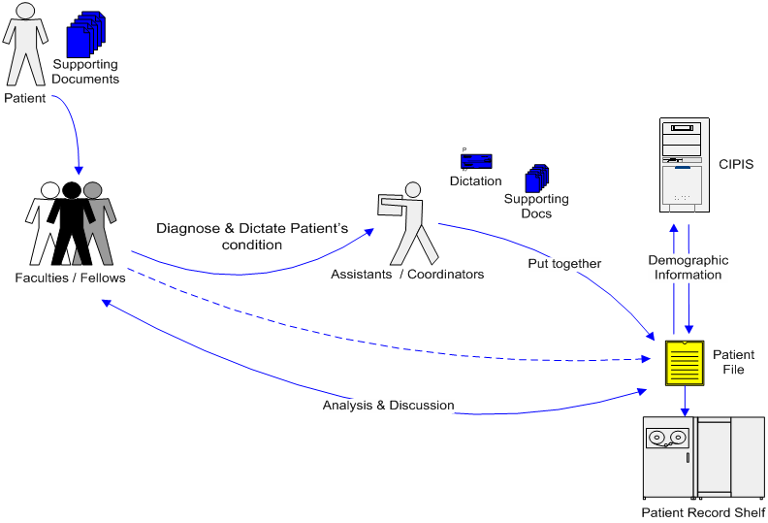
Figure 1: Current Process
Such a system has the following limitations:
- Paper-based system makes discussion and communication about patient care difficult: Retrieval of patient’s information becomes difficult since a paper file cannot be accessed remotely. Understanding a patient’s condition involves shuffling through the various, and sometime voluminous, sheets of paper in the file and hence it is difficult to get a clear overview of the patient’s condition.
- Inefficient process for synthesis and analysis of patient information: A system that stores information in a single, inaccessible paper file has inherent inefficiencies which can be addressed by making the system paperless. Electronic systems are easier to maintain, update and access and hence more efficient than paper-based systems.
- Lack of centralized data repository: Since the patient’s information is not stored in a central location and accessible remotely it introduces the danger of inconsistencies and inaccuracies between multiple records.

Proposed Solution & Its Benefits
The GOLDS Project intends to introduce a high level of efficiency into the current process of treating patients. Through this new process a patient’s clinical information and demographics will be entered into GOLDS (by the physicians or their assistants). Softcopies of documents supporting the patient’s history can also be uploaded.
All subsequent changes to the patient record will be made on the system which will be able to track changes to sensitive patient data. Through its web interface, the system will facilitate remote viewing, updating reporting and will facilitate analysis and discussions through an enhanced presentation of patient information.
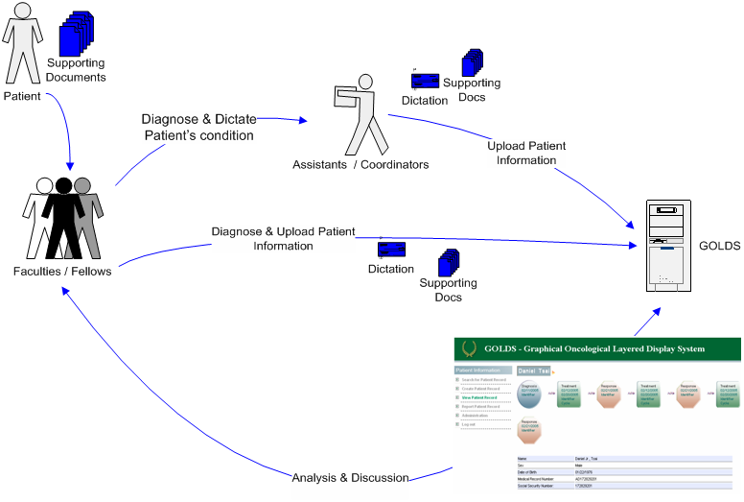
Figure 2: Proposed Process
The benefits of these improvements will be as follows:
- Visual Representation: Facilitates comprehension and discussion through an intuitive and dynamic graphical representation.
- Accessible and updatable: Update and maintenance of accurate and integrated patient information. Easy access to multiple sources and types of patient information.
- Centralized data: A centralized data repository allows for patient information to be retrieved from one location, limiting the need to consult other repositories. In addition, a centralized database allows for a one-step correction process in correcting data as needed.

As a result, GOLDS facilitates the easy retrieval of accurate information which can be used to perform detailed analysis and make faster and more accurate decisions that ultimately lead to enhanced service to WPCI’s patients (Figure 3: Benefits of GOLDS).
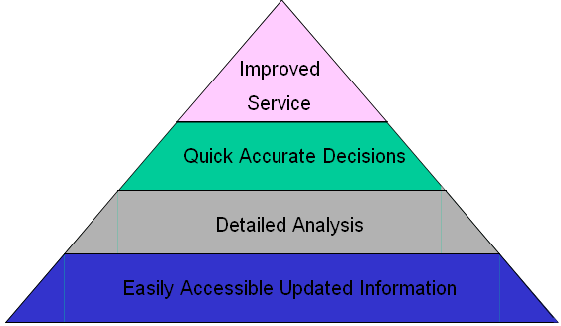
Figure 3: Benefits of GOLDS

GOLDS v1.0 Features

Login
Users will be required to log into GOLDS to be permitted to access any of the modules in the application. Each user will be assigned a unique User Name and Password by the administrator. The administrator will also assign a User Role to each user which will define the user’s ability to view, add, update, and delete information throughout the different modules in GOLDS.
Currently GOLDS has only one user role which enables viewing/editing. However, it is capable of supporting any number of user roles that WPCI requires in its future versions.
A screen shot of the Login user interface is shown as Figure 4.
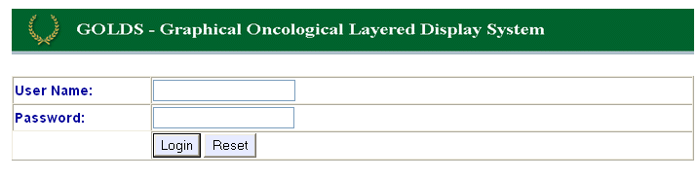
Figure 4: Login

Search for Patient Record
Search for Patient Record provides an interface for users to find patient records. GOLDS v1.0 allows searching for a patient record on the patient’s:
- Last Name
- First Name
- Sex
- Date of Birth
- Medical Record Number
- Social Security Number
- Diagnosis – Category and Identifier
A screen shot of the Search for Patient Record user interface is shown as Figure 5.
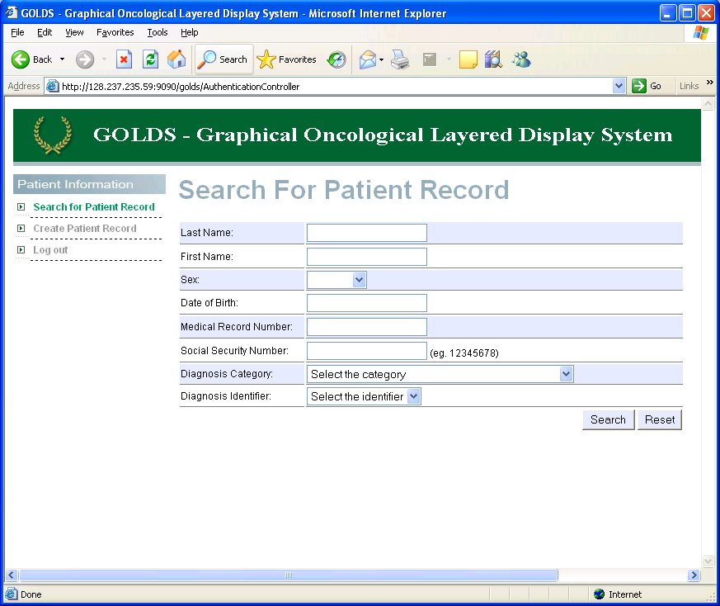
Figure 5: Search for Patient Record
After entering information on at least 1 search criteria, the user selects the Search button and a list of matching patients is returned (screen shot shown in Figure 6). The user then would select the patient he/she desires to view and then he/she would be navigated to the View/Edit Patient Record module.
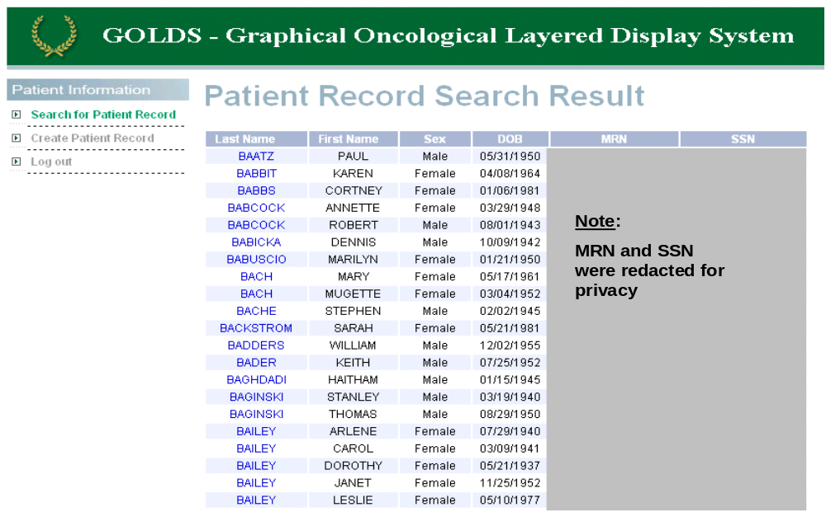
Figure 6: Search for Patient Results

Create Patient Record
Create Patient Record allows a user to create a new patient record in GOLDS. The following patient attributes are available when adding a new patient:
- First Name
- Last Name
- Sex
- Date of Birth
- Medical Record Number (Optional)
- Social Security Number (Optional)
A screen shot of the Create Patient Record user interface is shown as Figure 7.
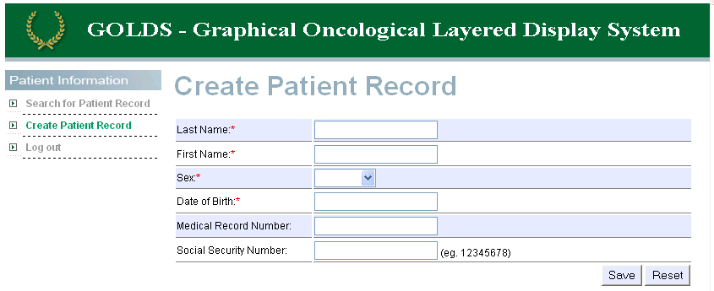
Figure 7: Create Patient Record

View/Edit Patient Record
View/Edit Patient Record allows a user with the appropriate level of permission to view and/or edit patient records.
View/Edit Patient Record displays a patient’s clinical history as a series of events (Diagnosis, Treatment, and Response) in chronological order. Details about the selected event object are displayed underneath the clinical history. A screen shot of the View/Edit Patient Record user interface with the patient’s personal information selected is shown as Figure 8.
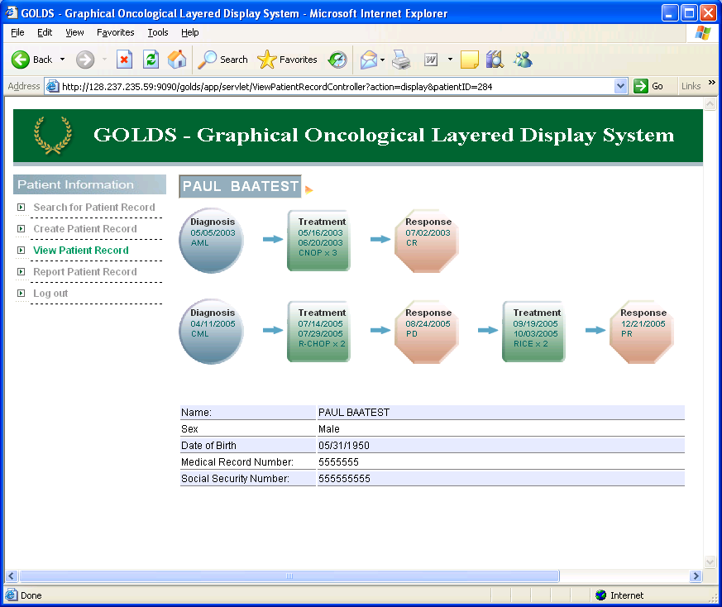
Patient’s Clinical History Represented as a Series of Events
Patient’s Name Selected: Patient Personal Information Displayed
Figure 8: View/Edit Patient Record – View Patient
Each event object has a unique shape and color scheme for quick visual recognition of the event type as summarized in the table below.
Event | Shape | Color | Example
Diagnosis | Circle | Blue
Treatment | Square | Green | Event Type  Start Date  End Date (Optional)  Identifier x Cycle
Response | Octagon | Red

Clicking on an event object will cause a full description and supporting details of a particular event to be displayed. Figure 9 shows the patient’s clinical history when the Diagnosis event is selected.
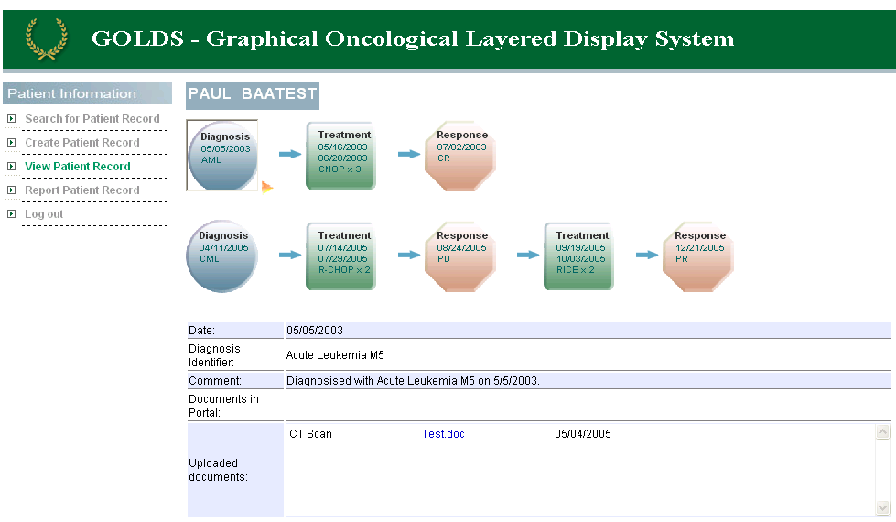
Diagnosis Event Selected: Full Description and Supporting Details
Figure 9: View/Edit Patient Record – View Event (Diagnosis)
An event can be edited by selecting Edit from the event object’s options menu as depicted in Figure 10.
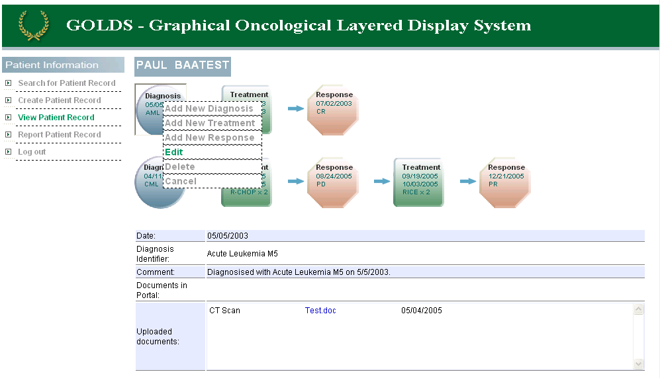
Event object’s options menu
Figure 10: View/Edit Patient Record – Options Menu
A form will be displayed below the patient’s clinical history to allow the user to edit the event. Figure 11 depicts the form portion of the user interface that is used to edit a diagnosis event.
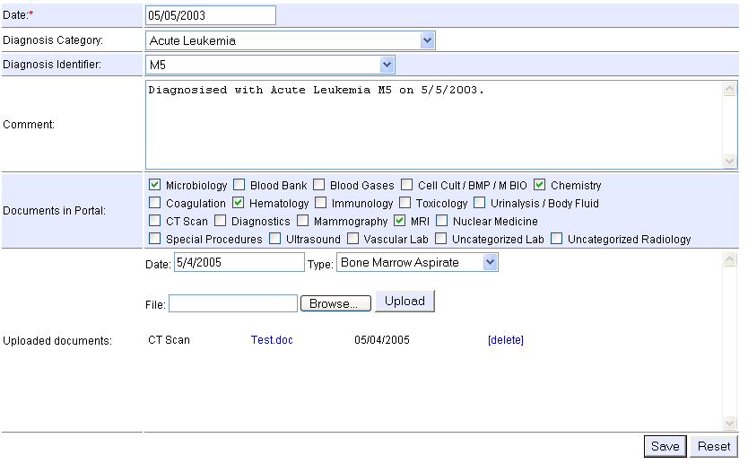
Figure 11: View/Edit Patient Record – Edit Event (Diagnosis)
Similarly, an event can be added by selecting Add New (Diagnosis, Treatment, or Response) from the event objects options menu. A form will be displayed below the patient’s clinical history to allow the user to add the event. A screen shot showing the Add New (Diagnosis, Treatment, or Response) user interface for a diagnosis is shown as Figure 12.
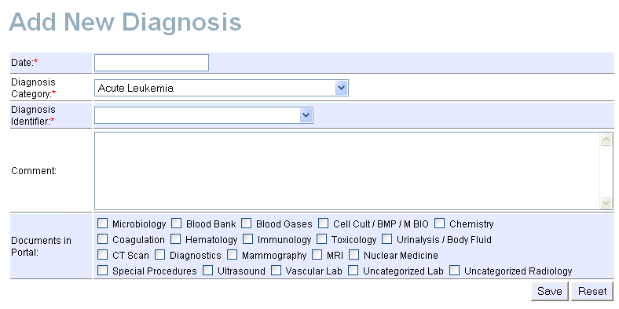
Figure 12: View/Edit Patient Record – Add Event (Diagnosis)

Patient Record Report
Patient Record Report allows a user to print out a patient’s clinical history in a printer friendly format. A screen shot of the Patient Record Report is shown as Figure 13.
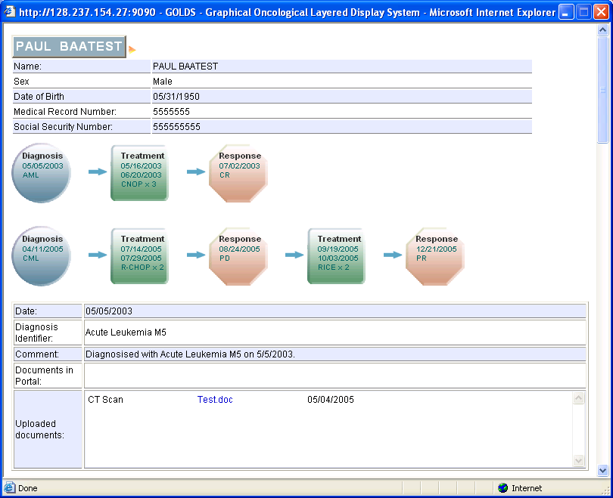
Figure 13: Patient Record Report

Log Out
The Log Out module allows the user to logout of GOLDS by ending the user’s session. Log Out does not have a separate user interface; instead it appears on the Left-hand Navigation Bar. The Left-hand Navigation Bar is shown as Figure 14.

Figure 14: Left-hand Navigation Bar

System Architecture
GOLDS will deploy a 3-tier model. The 1st tier (“database tier”) will run a MySQL 4.1 database that will be accessed through JDBC served by a Tomcat 5.0.28 web server residing in the 2nd tier (“business logic tier”). The 3rd tier (“presentation tier”) uses JSTL (JavaServer Pages Standard Tag Library) and Java Server Pages (JSP) that present GOLDS user interface. The JSPs will be integrated with other technologies such as JavaScript and Cascading Style Sheets. The system architecture is summarized in Figure 15.
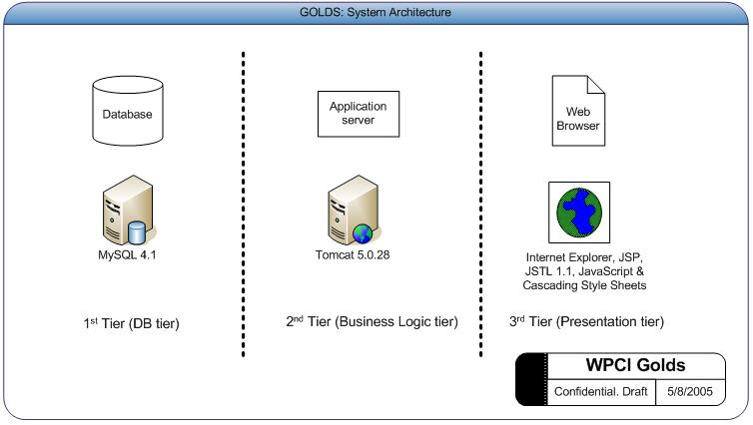
Figure 15: GOLDS’ 3-tier Architecture
This architecture is similar to that deployed at WPH as we hope to minimize the barriers for the WPH IT staff to rapidly deploy GOLDS at the hospital.
However, we did discuss the benefits of using other technologies before making our decision to align our architecture with WPH’s. Specifically, we considered the following options:
- Microsoft .NET (C# or VB .NET) instead of Java
Some of the GOLDS team members are more familiar with programming in C# or VB .NET vs. Java. However, as the tasks were distributed it was clear that the bulk of the programming was going to be done by those with significant Java experience. Therefore, we saw no significant benefits to justify using a different programming language then WPH.
- Sun Application Server instead of Tomcat
There was some debate as to whether or not we should use Sun Application Server when developing GOLDS. Actually the underlying Servlet Container that Sun Application Server is using is Tomcat. The difference is that Sun Application Server provides more functions and administration tools for the developers. There might not be much difference between this two for this project and the main reason we finally chose Tomcat is to use the same version of Tomcat that our client currently uses.
- Database: ORACLE instead of MySQL
Many of the GOLDS team members are more familiar with ORACLE’s database products and ORACLE also provides a richer set of features that MySQL does not currently support in MySQL version 4.1. For example, ORACLE supports the use of stored procedures and triggers while MySQL does not. The benefits of storing procedural SQL in the database as stored procedures allows for:
  - Separation of Development Tasks: Using stored procedures is elegant in that it separates the presentation logic from the data manipulation tasks. This allows different application programmers to divide the programming tasks into more modular units that ultimately make for less complex and reusable code.
  - Better Performance: Since stored procedures are compiled by the database and can be pinned into the database’s memory (SGA in ORACLE), data access is faster.
  - Greater Audit Functionality By Using Triggers: Although audit functionality can be written in the application code (using Java), triggers would have allowed the GOLDS team to execute code to track changes to fields in tables regardless of how the data was modified. In other words, writing audit code in Java would have only have tracked changes through the GOLDS user interface. Using triggers, we could have tracked changes issued by a user with direct access to the database. In addition, the trigger code is stored centrally whereas the audit code would have to be repeated throughout the GOLDS application.
    - Note: Current audit functionality in GOLDS is limited to tracking the user, date, and time a record was created and last modified in tables TB_DOCTOR, TB_PATIENT, TB_USER, TB_PATIENT_EVENT_GROUP, and TB_PATIENT_EVENT_JOIN.

Project Deliverables
The project deliverables for the GOLDS Project were as follows:
- GOLDS v1.0 Source code and Executables
- GOLDS v1.0 Final Report & Presentation Slides
- GOLDS v1.0 Software Requirement Specifications
- GOLDS v1.0 Java documentation
All of the above will be delivered to the project faculty advisor and Dr. Lister of WPCI on a CD by May 10, 2005.

Project Organization
This section describes the process model, the organizational structure, and responsibilities of individuals on the project. These will give a better understanding of how the GOLDS project team worked.

Process Model
The GOLDS project team used the evolutionary prototyping philosophy of prototype design over the revolutionary philosophy. We adopted the evolutionary philosophy because our aim was to build a prototype which can be modified by WPCI, and is of reasonably high quality. With evolutionary prototyping it is quite unsuitable to limit the amount of work by rapidly producing undocumented code. Instead, it is preferable to limit the scope of the prototype. The prototype will then solve a smaller problem, but, on the other hand, the implementation will be more fundamentally tested and documented.
Two factors contributed to this decision:
- A primary objective of the GOLDS project was to design its graphical user interface for enhanced graphical representation of a patient’s oncological data. The GOLDS graphical design was a major consideration in the Software Requirement Specification and would need to be reused.
- The evolutionary prototyping philosophy was also chosen based on consideration of external factors such as time, tools, and personnel. Reuse of executable code, after exhaustive system testing, results in lower short term costs than re-creation of code.
During the course of Prototyping, the team moved through four distinct phases: Requirements Gathering, Design, Development and Testing (Figure 16: Project Lifecycle). The end of each phase represented a milestone and the content and dates of these are detailed in Section 5: Work Schedule of this report.
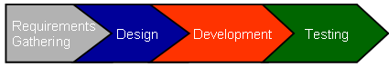
Figure 16: Project Lifecycle

Project Responsibilities
The organizational structure of the GOLDS team is illustrated in Figure 17: GOLDS Team. Each team member’s primary responsibility is listed under their name, but each team member’s participation wasn’t limited to their primary responsibility. The team was advised by a member of the Carnegie Mellon University faculty, Dr. Rema Padman, and worked directly with the Chief of the Division of Hematology/Oncology at WPCI, Dr. John Lister.
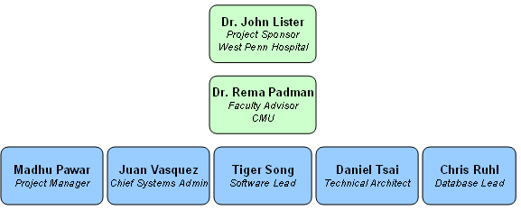
Figure 17: GOLDS Team

Managerial Process

Management Objectives
The objectives in the management of the GOLDS project were:
- To complete the prototype on-schedule
- To develop a prototype with a compelling feature-set
- To provide an enriching experience to the team members
The primary goal of the project was to develop the GOLDS prototype within the tight schedule so that at the end of the semester long project the team may be able to demonstrate to WPH that the GOLDS was the answer to their needs. Next, the team intended to create a compelling prototype with a feature-set that would excite the WHP staff through its relevance. Lastly, the project team was keen on making the project a meaningful learning experience for themselves.
The team organized and managed itself to best fulfill these objectives. Subsequent sections will detail how the project activities were carried out in accordance with the priorities set out by the team; highest priority was attributed to functionality, then to schedule, and only last to budget.

Monitoring and Controlling Mechanisms
The GOLDS project team was relatively small in size but because of complexity introduced by the differing team member schedules and time constraints, it needed a tailored mechanism to monitor and control its progress. Project activities were monitored based on this mechanism and a number of controls were put in place to ensure that the project objectives were met. The mechanisms that were employed towards this end were:
- Documentation and status tracking: Minutes of meetings were created and distributed and served as a means of confirming communication and aligning expectations of the tasks to be performed.
- Project internal website/server: The GOLDS project team set up and maintained a SharePoint server as a common platform of communication, document access and version control and task update. The team used the task feature of SharePoint to obtain a weekly offline status update.
- Weekly internal meetings: The GOLDS project team met every Thursday for a team meeting wherein issues faced, tasks for the coming week we discussed and decisions were made about the direction of the project. Status update meetings with the faculty adviser were held every Friday to ensure that all issues were visible and to obtain the faculty advisor’s counsel.
- Frequent client meetings: The team held frequent meetings with Dr. Lister especially during the requirements gathering phase to be in sync with the needs of the target user. Throughout the course of the project, the staff at WPH was sought out for their feedback including a mid-term presentation introducing the system usability testing for physicians.

Risk Management
Managing and minimizing the risks inherent in GOLDS was the key function of GOLDS project management. At each step of the project, requirements gathering, design to the implementation any hidden risks were anticipated, their severity evaluated and a decision to deal with them was made accordingly. A list of some of the risks and how they were mitigated are listed here:
- Unclear understanding of requirements: The team managed this risk by holding weekly meetings with Dr. Lister in the requirements gathering phase
- Spilling over the schedule: A detailed breakdown of tasks along with time allocation was made and adhered to. Tasks were reassigned before the project schedule slipped as necessary.
- HIPAA violation: GODLS v1.0 is a prototype and thus the HIPAA Guidelines have not been reviewed by the team. The WPH IT staff will have to conduct a thorough review of the application before deploying it for production.
- Improper disclosure of patient data: Similar concern was felt for the privacy of patient information. During the course of the project patient sensitive information was dealt with the utmost care and was only accessed if needed.
- Loss of project related documents: Centralized document maintenance and version control software, SharePoint, was used to ensure proper document management. SharePoint is Web based which allows for easy access and use by the team to check out, modify, or upload documents. SharePoint was also utilized as the team’s bug tracking repository, where any observed bug or change request was tracked. This permitted the testers and developers to be located in different locations and collaborate almost real-time.

Work Schedule

Schedule
GOLDS was implemented within a relatively short time of 16 weeks compared to industry standards. Thus, there was a need to adhere to a well-defined scope and close monitoring of tasks accomplished. To minimize rework a significant portion of the project (4 weeks) were spent in requirements development. Delivery of a quality application within a tightly defined scope was ensured through dedicating a third of the project time to implementation (5 weeks).
Working in a fast paced project meant that GOLDS team members had to be focused in their respective functions but also be agile and responsive to changes in other areas of the prototype. For instance, changes in database design were needed to be reflected in the system component design, user interface design and the system expectations of the testers. A summarized project schedule appears below as Figure 18.

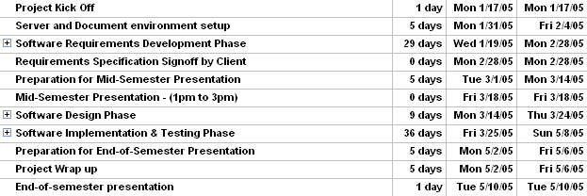
Figure 18: Project Schedule
The project was completed in four phases: Requirements Development, Software Design, Software Implementation & Software Testing phase. Each phase, the issues that were faced involved and the deliverables expected at the end of each phase are detailed below. Most of these deliverable documents have been attached as appendices.

Phase 1: Requirements Development
Requirements Development was the first and perhaps most important phase of our project. During this phase we conducted weekly meetings with Dr. Lister to find out requirements of the project in detail. Main tasks in this phase included requirement determination, risk analysis, setting up schedules, and deciding deliverables. A Use Case document and System Requirement Specification Document was prepared at the end of this phase to properly document the user’s requirements. These documents were later reviewed by Dr. Lister at mid-term and before programming GOLDS.

Issues
- Communication: There was a clear need in this phase to clearly understand the client’s needs. The team used different ways of handling this such as asking the same question in different ways to confirm the message, writing minutes of every client meeting and distributing internally for consensus and clarity.
- Choice of Technologies: The decision over which technologies to use for the prototype was made after taking a number of factors into account. Discussions regarding the choice of database, application server and development language covered the performance issues, feature-set available for each available technology and so on. Eventually, client’s current infrastructure environment was agreed to be the overriding decision factor.

Deliverables
The end of this phase was marked by the creation of the following documents:
- Use Case Document: The Use Case document is attached as GOLDS_Use_Cases.doc
- Software Requirements Specification: The Software Requirements Specification document is attached as GOLDS_SRS.doc
- Mid-semester Presentation: The mid-semester presentation slides are attached as GOLDS Mid-Term Presentation.ppt.

Phase 2: Software Design
After reviewing the users’ requirements, the team started work on system design. System architecture, database design and test cases were determined during this phase. Additionally, a detailed design was generated at the end of requirements analysis during this phase which was to be used to develop GOLDS.

Issues
- Choice of design pattern/design principles: With a team having multiple members with strong software engineering backgrounds and related experience, differences of opinions over design patterns existed naturally. These needed to be resolved and an approach agreeable to all the parties concerned needed to be developed.

Deliverables
- Entity Relationship Diagram: this diagram is attached in the section “Entity Relationship Diagram” in the Appendix.
- System design: the class diagrams and the interaction diagrams representing the system design are included in the section “Software Design Documents” of the Appendix.
The implementation and testing phases ran concurrently and were also iterative. We developed GOLDS in 4 weekly cycles . At the end of every cycle a newer version of GOLDS was released and tested.

Phase 3: Software Implementation
The GOLDS team developed the software using the detailed design created in the Design phase. The progress was monitored through weekly meetings and use of the SharePoint server. Features were included in the software incrementally. After the first version release of GOLDS, testing began and bugs discovered were documented. After releasing one version of the software, the team worked on feature additions and bug fixing to be released in the subsequent version. Thus the implementation process was iterative and interacted heavily with the testing process.

Issues
- Team communication and accurate understanding of client requirements was needed to prioritize bugs discovered during the testing phase.

Deliverables
- Executables & Source Code: The software and the executables is mid-semester presentation slides are attached as GOLDS Mid-Term Presentation.ppt.
- Final Presentation: The final semester presentation slides are attached as GOLDS Final-Term Presentation.ppt.

Phase 4: Software Testing
Testing was performed in parallel with code development. The developers performed unit testing to ensure a functioning code prior to a release and then an exhaustive system testing was performed by other members of the team. User Acceptance Testing was also conducted at WPCI to obtain further feedback about the expectations of the users and to gauge the level at which they were being met.

Issues
- Communication: A lot of team interaction and meticulous documentation was needed to ensure that bugs discovered were fixed or addressed. It was also important to closely watch the scope of the project during testing and bug fixing. It is easy to overlook the scope of a project and enhance the feature set offered in the quest for the perfect application during testing.

Recommendations For Future
This section outlines desirable features for a system like GOLDS that were not included in GOLDS v1.0 primarily due to time constraints. We recommend at least the following extensions for future GOLDS versions as they would significantly enhance GOLDS’ usability and appeal:
Additional Modules
- User Administration: This module will allow the system administrator to perform various administrative tasks through the web interface. Administrative tasks may include user registration and rights management, and change in application settings such as look and feel.
- Reporting:
  - Customizable Reporting: Users of GOLDS will be able to drag and drop report elements that they would want to be generated in the report. Currently, there is only one standard report format (to view a patient’s clinical history) which is generated.
  - Audit Reports: An administrator logs into the system with his/her username and password and then sees audit logs. The administrator can then generate reports to see the activities of all the users (or selected users).
  - List of Documents: GOLDS users will be able to see all the documents that are related to a specific patient. This will facilitate direct access to a patient’s test results, etc. without having to click through each of the events in the patient’s clinical history.
- Online Help: GOLDS users will be able to seek help from the system through accessing a “Help” module which will be available to them through the GOLDS website.
More Flexible Event Chains and Objects
- Linking Multiple Events to a Single Event: Currently, an event can be linked to only one other event (which leads to the formation of chains). There may be a need for a single event object to be linked to more than one event objects, forming branches to the main chain.
- Chronological Aligning of Multiple Chains: It will be visually very helpful to align multiple chains chronologically. Additionally, it will be easier, with such a representation, to analyze a patient’s condition and possibly relate occurrences of events across multiple chains.
- Chronological Ordering of Patient Chains: Order patient chains by diagnosis start date such that the oldest chain displays topmost on the website.
- Extending Events Beyond Diagnosis/Treatment/Responses: It will be useful for physicians as well as potential users from other industries to be able to edit/add the kinds of events that may be facilitated in GOLDS.
- Link to additional documents in Portal: Links to the following documents which are not yet on the portal should be included in future versions of GOLDS: Bone Marrow, Flow Bone Marrow Aspirate, Bone Marrow Biopsy, Chimerism after they become available
- Hanging event object: If Treatment is earlier than Diagnosis it shows as a hanging event object. This is currently treated as a feature but future GOLDS implementation teams may want to make it extensible to allow beginning with a non-Diagnosis event object.
- Documents can only be uploaded after event object creation: User cannot upload documents to an event object during creation of an event object. Documents can only be uploaded into an event object once an event object has been created. This is a feature of GOLDS - but could be changed to include addition of related of documents at the same time as event object creation.
- Ability to include non-standard event identifiers: This is purposefully included in design to prevent data corruption during data entry.
- Ability to cater to patients with DVT: Addition of Diagnoses, Treatments, Responses for Dr. Kennedy's requirements

VoiceXML
- VoiceXML: Currently, events in a patient’s clinical history can be viewed, added, edited, and deleted through the web browser using a mouse and keyboard. It would be beneficial for GOLDS to support a “hands-free” approach to traverse the chain allowing for the displaying, adding, updating, and deleting of event objects through voice commands.
GOLDSv1.0 will be released with an optional add-on using VoiceXML technology to allow a user to use voice commands to traverse the chain. However, this additional feature will only allow for limited editing capabilities and contain minimal error handling. These limitations should be explored further and overcome in future versions.

Appendices

GOLDS Speech Recognition Capability – VoiceXML
Early on in our discussions with Dr. Lister, we realized that there is a great deal of dictation and transcription that occurs in the medical field. With this is mind we thought that it may be useful to incorporate speech recognition in the GOLDS application. Therefore, GOLDS v1.0 has been implemented with limited speech recognition capabilities using VoiceXML technology.

Speech Recognition History and Challenges
Bell Labs invented the first speech recognition system in 1952 that recognized the spoken form of single digit numbers with an amazingly high 97% accuracy. It wasn’t until the 1970s with Terry Winograd’s SHRDLU, did a system exist that could “… answer questions, executes commands, and accept information in an interactive English dialog”. Twenty years later, speech recognition expanded to the Internet. Notably in 1996, California State University at Northridge demonstrated a voice controlled Web interface. Since then there have been many advancements in speech recognition technology and its development for use over the Internet.
However, many of the challenges faced by researchers and developers since the 1950s continue to be problematic today. Some of these challenges areError: Reference source not found:
- Variability of Speech Patterns – People speak naturally with different accents and at a variety of rates which makes it difficult for a computer to recognize and understand words spoken by different people. As a result many systems require user’s to train the system to recognize their voice before the system can be used.
- Continuous Speech Recognition – People can easily communicate verbally and comprehend at high rates of speed, however computers have difficulty translating voice into text (and ultimately binary) form to process and respond in real time.
- Extracting Meaning – People frequently and naturally use different words to express the same meaning. As a result, computers not only need to be able to understand the meaning of many words, but they need to be able to understand the context of the spoken words to more accurately extract the user’s true meaning.
- Background Noise – Background noise refers to the noise that is picked up by the computer’s microphone that wasn’t spoken by the user. It has been quite a challenge require computers to intentionally ignore portions of what it “hears” especially since its first priority is to interpret and understand the meaning of words it “hears”.
- Processing Power – Speech recognition requires significant computer power to better handle and overcome the challenges listed above. With the continued advancement in processing power, computers will be able to process voice pattern algorithms, interpret, and respond to input much quicker than currently possible.
Given these challenges, the fact that speech recognition is still a field where further development is required to provide rich and robust functionality, the time constraints of the GOLDS project, and the limited technical expertise in speech recognition by the team members, GOLDS v1.0 has been implemented with limited speech recognition capabilities using VoiceXML technology.

Voice Extensible Markup Language (VoiceXML) and GOLDS
Voice Extensible Markup Language (VoiceXML) is a technology that builds upon the rich foundation of Extensible Markup Language (XML). The goal of VoiceXML is to “…bring the advantages of Web-based development and content delivery to interactive voice response applications”. Given the relatively low learning curve of VoiceXML and the team’s development experience with XML, we believed VoiceXML provided us with an appropriate platform to fulfill our desire to incorporate speech recognition technology into GOLDS while enabling us to learn a new and exciting technology.
GOLDS v1.0 uses VoiceXML technology to allow a user to verbally give commands within the View/Edit Patient module. Specifically, a user can ask GOLDS to perform the following:
View an Event – Given the command to view an event object in a patient’s clinical history, GOLDS will display the details of the event object similar to a user clicking on an event object.
Edit an Event – Given the command to edit an event object, GOLDS will display the Edit Event form.
Add an Event – Given the command to add an event object, the type of event to add, and where to add the event in the patient’s history, GOLDS will display the appropriate Add Event form.
Delete an Event – Given the command to delete an event object, GOLDS will confirm the command with the user audibly and then remove the event object.

GOLDS VoiceXML Architecture
GOLDS is able to process audible commands in the View/Edit Patient module by communicating with BeVocal’s VoiceXML Platform. BeVocal is a provider of managed voice application solutions dedicated to applications developed in VoiceXML. Their VoiceXML Platform allows for the VoiceXML interpreter (the speech recognition engine that converts speech to text) to reside at BeVocal while GOLDS is hosted on servers owned and controlled by West Penn Hospital. The figure below depicts the GOLDS VoiceXML architecture.
.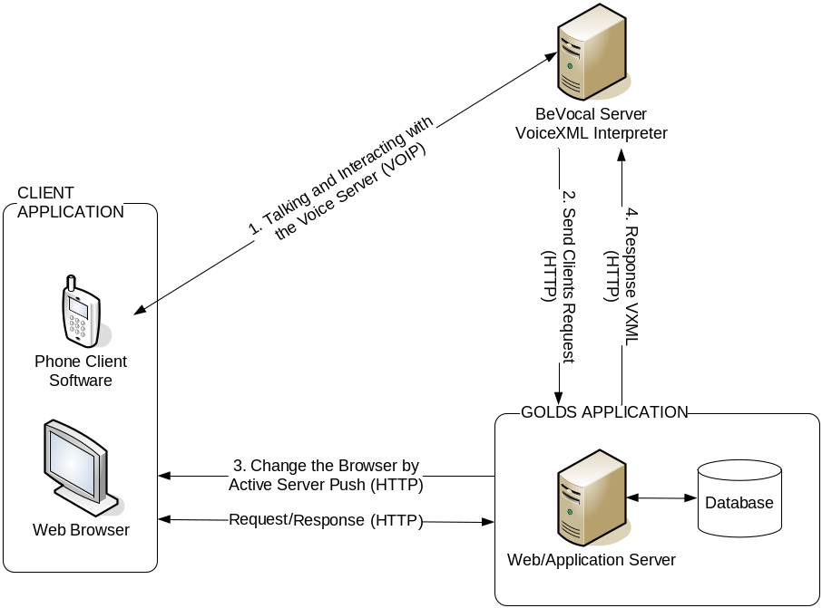

As depicted in the figure above, a user’s client computer must have a VoIP soft phone installed in addition to a Web Browser. The VoIP soft phone is a software application that resembles a telephone that actually uses the computer’s network connection to connect to BeVocal. When a GOLDS user wants to use verbal commands in the View/Edit Patient module, they must create a connection to BeVocal either via phone or their VoIP soft phone (recommended by BeVocal and shown in the figure above). Once connected to BeVocal a VoiceXML document (“script”) will be interpreted by the VoiceXML Interpreter on the BeVocal server. Similar to a Web browser that interprets HTML to display visually, the VoiceXML interpreter interprets VoiceXML document tags to audibly convey information to the user. A sample dialog between a user and GOLDS to view an event object in a patient’s clinical history appears below:
BeVocal VoiceXML Interpreter (B): What is your access key?
User(U): (username)150357
B: Welcome. What would you like to do? Please say View, Edit, or Delete.
U: View
B: Which event object would you like to view? Please say the number.
U: 4
In this interaction the VoiceXML interpreter begins reading the script to the user and waits for the user to respond with a valid access key. The access key is found on the bottom left of the View/Edit Patient module interface. Then the system asks what action the user would like GOLDS to perform. Once the user responds with “View”, the interpreter then reads the portion of the script associated with viewing events. After the user tells the interpreter to view event object 4, the interpreter finishes reading the view script and sends a message to the GOLDS server to reload the user’s browser to display event object 4. Once the screen is reloaded, GOLDS sends a message back to the interpreter to confirm that the message has been received.
Using this type of distributed VoiceXML solution requires managing the interaction between the user, the user’s browser, BeVocal’s VoiceXML Interpreter, and the GOLDS server and presents a significant challenge to the application developer.
The developer must develop a script and a state mechanism that accounts for the various ways the user could respond to each request made by the interpreter as a user could respond with a verbal command or by using his/her mouse and keyboard interacting with the Web interface. For example, in the script given above the user might not reply verbally with “Event object (number) 4” in response to which event object they would like to view. Instead the user could click on event object 4 and thus the interpreter must know that the user has responded with a valid command and thus should reset itself to the initial question of “What would you like to do?” rather than continue to prompt the user for an event object to view. This requires the GOLDS server to maintain a history of voice and Web requests by a user. Currently, GOLDS v1.0 only maintains a history of voice requests and thus if a user responds via a mouse click, the interpreter will not know to change its state.
It is also challenging to develop a script that asks for user input in a manner that is both natural for a human and easily understood by the interpreter. BeVocal has many grammars that are predefined that allow for more natural interactions between the user and the interpreter. Since the speech recognition ability is limited in GOLDS v1.0, we did not use BeVocal’s predefined libraries. However, further review of these libraries is recommended before making future enhancements of GOLDS since the current GOLDS script relies on a “responsible” user giving the interpreter an exact key term that constitutes a valid response. For example, the script given above requires the user to say “View”, “Add”, “Edit”, or “Delete” when the user begins a voice session in GOLDS. Of course, a human may respond with “View an event object”, “I would like to view an event object”, or even “I think I want to view and then edit an event object”. Currently, the interpreter in GOLDS v1.0 would not understand these responses. Using some of BeVocal’s speech libraries and grammars may allow for these valid variations, enhancing the natural conversational ability of GOLDS.
On the other hand, a significant advantage of having such a distributed architecture is that there is no required investment by the hospital in the purchasing and administration of a speech to text interpreter as BeVocal has already invested in creating a rich and robust product. Instead, the hospital will have to purchase a hosting solution from BeVocal (VoiceXML Hosting Premier or Lite) which will require a monthly fee. This architecture does require the installation of a VoIP soft phone or VoIP adapter to send voice over the Internet, but Xten’s X-Lite product is both free and recommended by BeVocal.

VoiceXML References
This section provides a listing of some of the resources we found useful in our exploration of VoiceXML.
Web site | URL | Comments
BeVocal | http://www.bevocal.com | - BeVocal’s Web site provides additional information about their VoiceXML applications and services including information about BeVocal’s Hosting services: VoiceXML Hosting Premier and VoiceXML Hosting Lite. (See attached BeVocal_VoiceXML_Hosting_Solutions.pdf for more information).
BeVocal Café | http://cafe.bevocal.com | - BeVocal Café is a Web site developed by BeVocal specifically for VoiceXML developers  - The site contains many helpful documents including a VoiceXML tutorial, tools and other resources to help developers develop VoiceXML applications
W3C Recommendation: VoiceXML version 2.0 | http://www.w3.org/TR/voicexml20 | - This site provides the official specifications for VoiceXML version 2.0 by the W3C
Xten VoIP Soft Phone X-Lite | http://www.xten.com | - Xten’s X-Lite Soft Phone is a free VoIP soft phone recommended to user’s of BeVocal’s VoiceXML services by BeVocal

Software Design Documents
GOLDS class diagrams and the interaction diagrams can be found in this section.

GOLDS Use Cases
GOLDS v1.0 use cases are attached as GOLDS_Use_Cases.doc.

GOLDS Class Diagrams
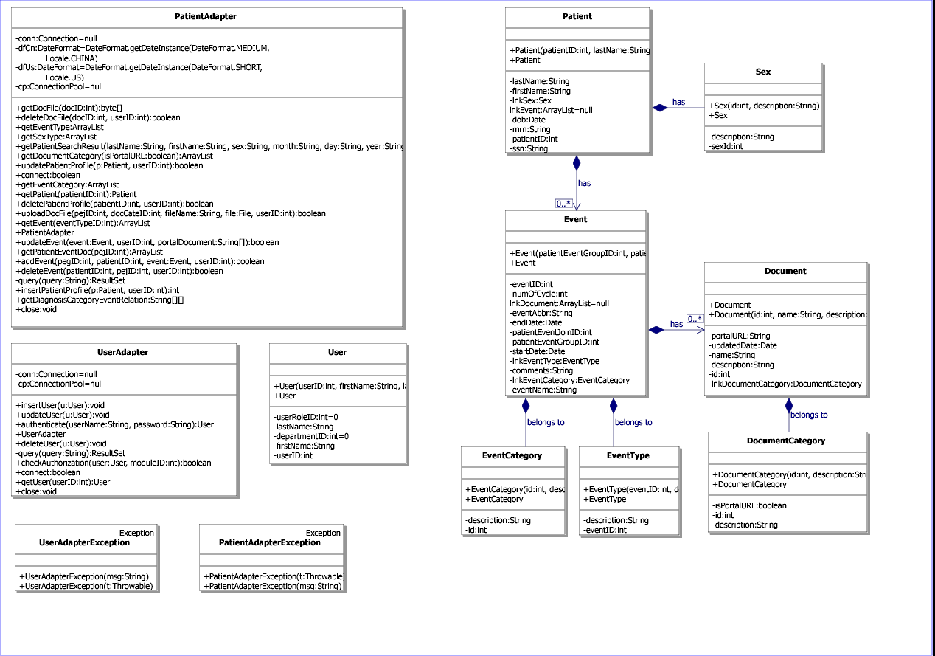
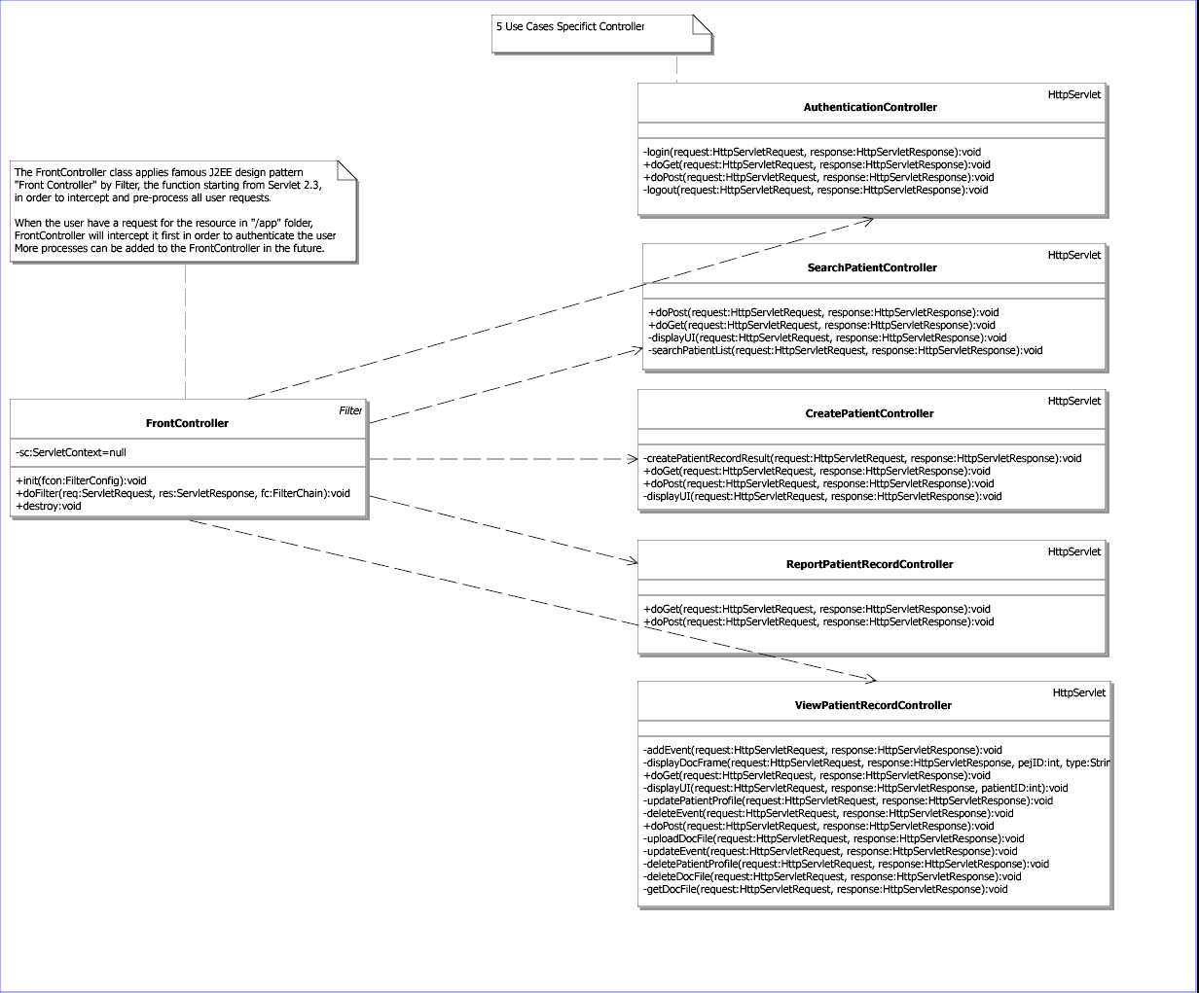
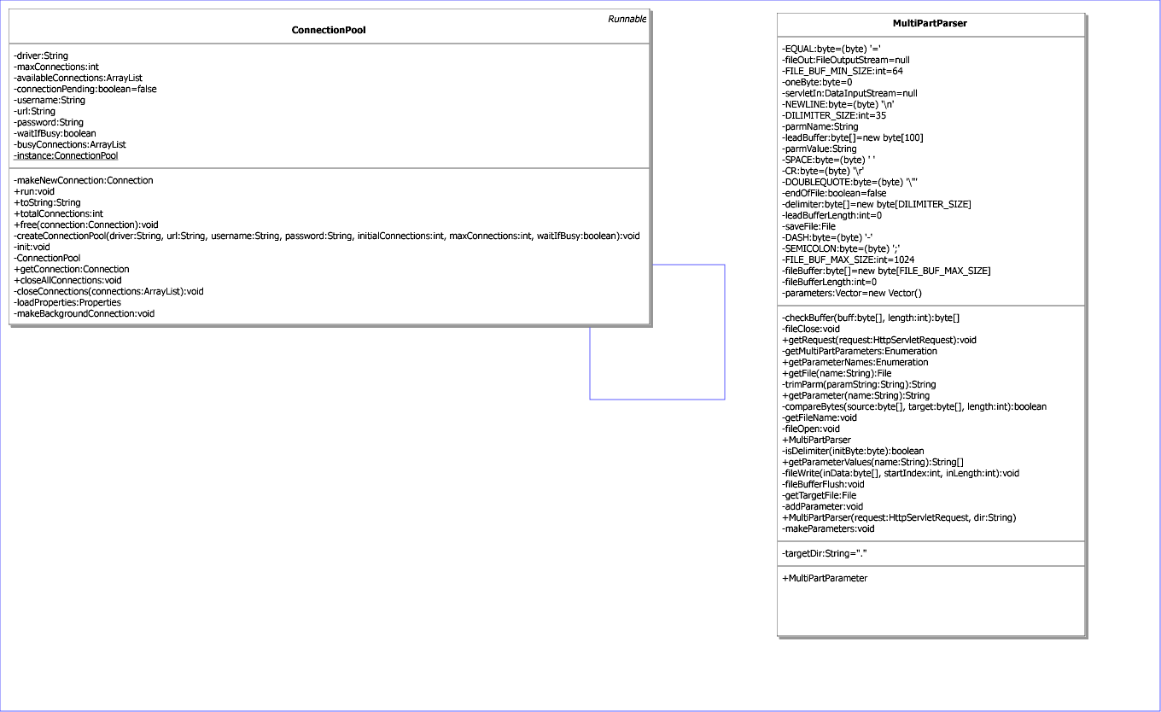

GOLDS Interaction Diagrams
The sequence diagrams and collaboration diagrams below together show the interaction model used in GOLDS and explore the logic of operations.
Authentication Sequence Diagram
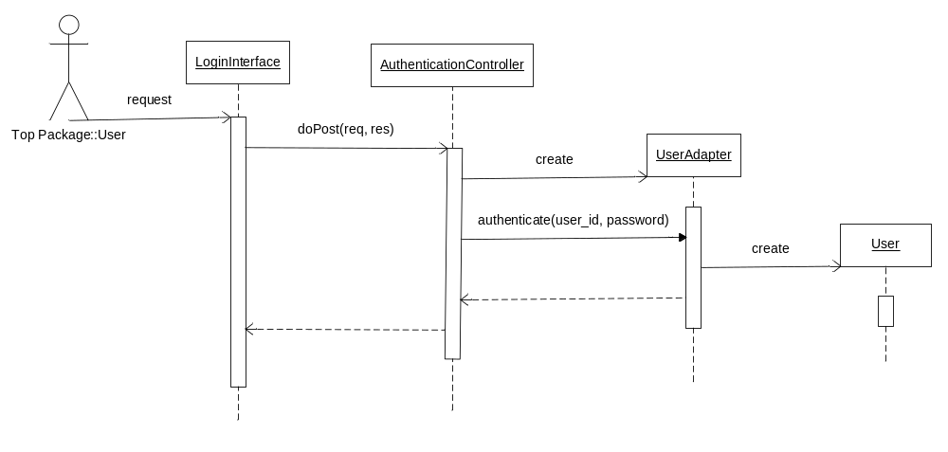
Search Patient Collaboration Diagram
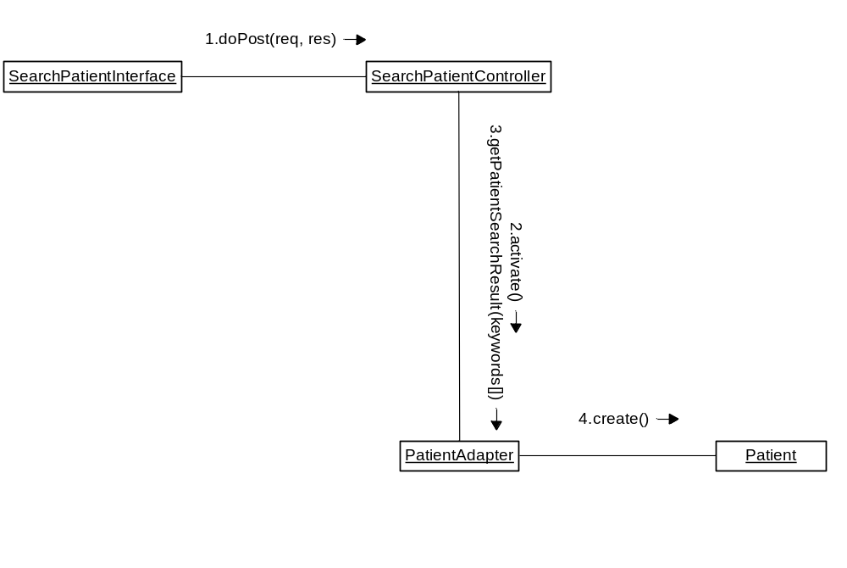

View Patient Record Sequence Diagram
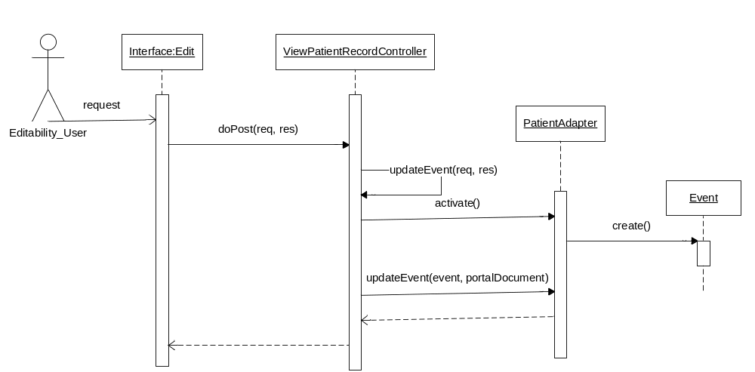

Edit Patient Record Sequence Diagram
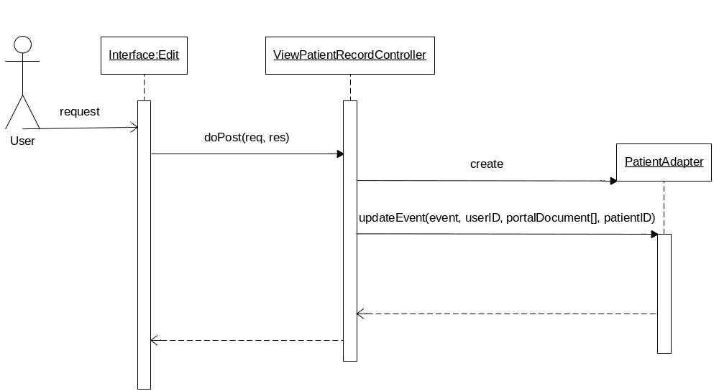
Report Patient Record Sequence Diagram
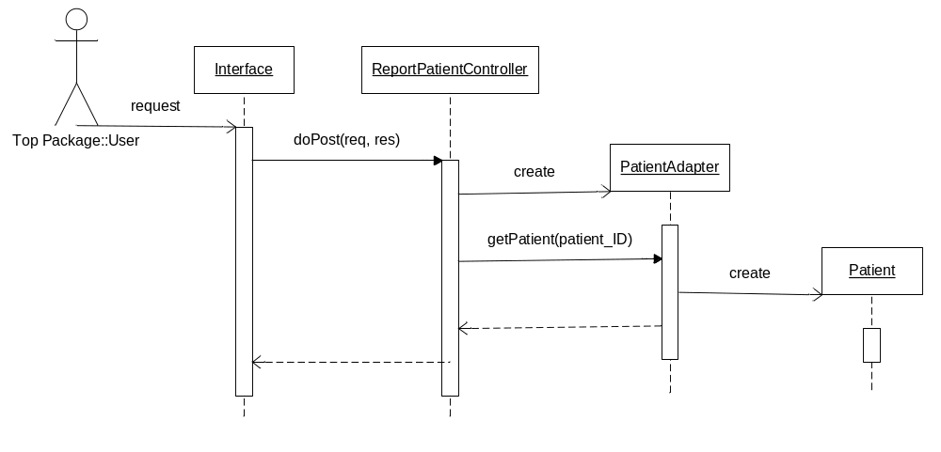

Database Design Documents

Entity Relationship Diagram
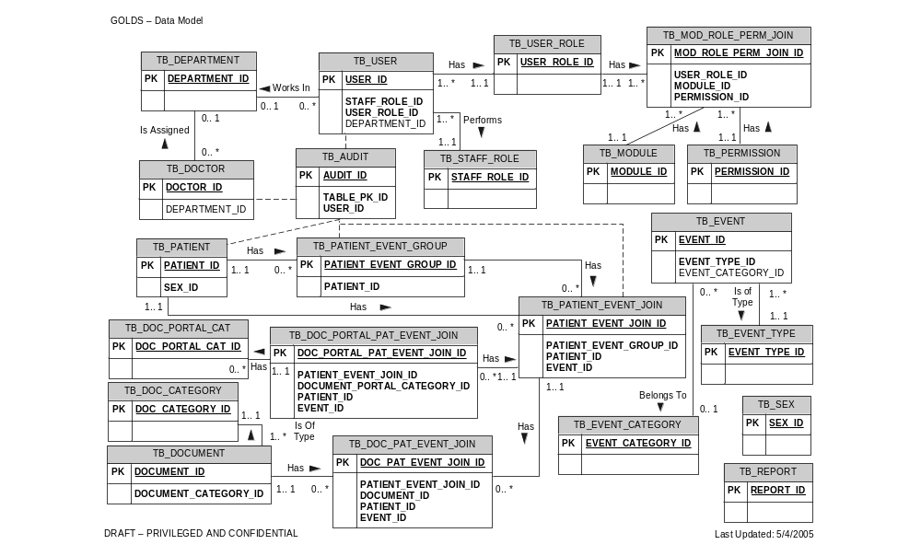
Note: The entity relationship diagram above shows the relationships among all the tables in the GOLDS database. Only the primary key (PK) and foreign key fields are listed in each table. TB_DOC_CATEGORY and TB_DOC_PORTAL_CAT have been abbreviated to save space on the diagram as their names in the database are TB_DOCUMENT_CATEGORY and TB_DOCUMENT_PORTAL_CATEGORY, respectively. Additionally, the link from TB_PATIENT to TB_SEX has been omitted to save space.

Data Model Assumptions
TB_USER
- A user must have 1 and only 1 staff role (TB_STAFF_ROLE)
- A user must have 1 and only 1 user role (TB_USER_ROLE)
- A user can be assigned to at most 1 department (TB_DEPARTMENT)

TB_MOD_ROLE_USER_ROLE
- Different levels of permission (TB_PERMISSION) such as add and edit functionality are assigned to each module (TB_MODULE) and user role (TB_USER_ROLE) in TB_MOD_ROLE_USER_ROLE

TB_DOCTOR
- A doctor can be assigned to at most 1 department (TB_DEPARTMENT)

TB_PATIENT
- Patient information is stored in this table

TB_EVENT
- An event can be assigned at most 1 event category (TB_EVENT_CATEGORY) and must have 1 and only 1 event type (TB_EVENT_TYPE)
  - An event is a specific description of an event type
  - An event type is a diagnosis, treatment, or response
  - An event category primarily serves to describe groupings of diagnosis classifications

TB_PATIENT_EVENT_JOIN
- Each patient event and specific event information (date, comments, etc.) is stored separately as 1 record in TB_PATIENT_EVENT_JOIN
- Each record in TB_PATIENT_EVENT_JOIN belongs to a clinical history chain (TB_PATIENT_EVENT_GROUP)

TB_PATIENT_EVENT_GROUP
- Patients can have multiple clinical history chains of diagnosis, treatment, and response events. Each chain is defined as a separate record in TB_PATIENT_EVENT_GROUP

TB_DOCUMENT
- Uploaded documents are not assigned to patients but rather specific patient events (TB_PATIENT_EVENT_JOIN) through TB_DOC_PAT_EVENT_JOIN.
- Each uploaded document must have at most 1 document category (TB_DOCUMENT_CATEGORY) to define the type of document being stored

TB_DOC_PORTAL_PAT_EVENT_JOIN
- Links to documents (or the type of documents defined in TB_DOCUMENT_PORTAL_CATEGORY) stored in the hospital’s portal can be associated with specific patient events. This relationship is defined in TB_DOC_PORTAL_PAT_EVENT_JOIN.

TB_AUDIT
- Serves to track changes to users (TB_USER), doctors (TB_DOCTOR), patients (TB_PATIENT) and patient events (TB_PATIENT_EVENT_JOIN)

TB_REPORT and TB_SEX
- Lookup tables to store the types of reports and options for patient sex, respectively

Data Dictionary
The data dictionary is attached as Data Dictionary.xls.

Table Creation Script
The table creation script is attached as GOLDS_Table_Creation.sql.

Load Scripts
The table below lists those tables, along with the name of the data file and load script, in which data has been provided to be loaded into GOLDS:
Table Name | Data File Name | Load Script
TB_USER_ROLE | TB_USER_ROLE.csv | Load_TB_USER_ROLE.sql
TB_MOD_ROLE_PERM_JOIN | TB_MOD_ROLE_PERM_JOIN.csv | Load_TB_MOD_ROLE_PERM_JOIN.sql
TB_MODULE | TB_MODULE.csv | Load_TB_MODULE.sql
TB_PERMISSION | TB_PERMISSION.csv | Load_TB_PERMISSION.sql
TB_STAFF_ROLE | TB_STAFF_ROLE.csv | Load_TB_STAFF_ROLE.sql
TB_DEPARTMENT | TB_DEPARTMENT.csv | Load_TB_DEPARTMENT.sql
TB_DOCTOR | TB_DOCTOR.csv | Load_TB_DOCTOR.sql
TB_EVENT | TB_EVENT.csv | Load_TB_EVENT.sql
TB_EVENT_CATEGORY | TB_EVENT_CATEGORY.csv | Load_TB_EVENT_CATEGORY.sql
TB_EVENT_TYPE | TB_EVENT_TYPE.csv | Load_TB_EVENT_TYPE.sql
TB_REPORT | TB_REPORT.csv | Load_TB_REPORT.sql
TB_SEX | TB_SEX.csv | Load_TB_SEX.sql
TB_DOCUMENT_PORTAL_CATEGORY | TB_DOCUMENT_PORTAL_CATEGORY.csv | Load_TB_DOCUMENT_PORTAL_CATEGORY.sql
TB_DOCUMENT_CATEGORY | TB_DOCUMENT_CATEGORY.csv | Load_TB_DOCUMENT_CATEGORY.sql
To load data into the database, each load script should be run from a MySQL SQL prompt. Currently, the load script assumes that the data files are stored in C:\GOLDS_DB\Data\.
The other database tables are transactional tables and will be populated as users begin to use GOLDS. However, WPH IT staff must populate TB_USER to create user accounts for GOLDS users. The IT staff may also want to migrate patient data from existing systems into GOLDS (TB_PATIENT) so that users don’t have to create all existing patient records through the GOLDS Web interface.

Application to Database Mapping
The application to database mapping is attached as Application to Database Mapping.ppt.

GOLDS Setup
GOLDS v1.0 is a web application which has been tested to work on Tomcat 5.0.28 and MySQL 4.1. All users will need to configure their browsers to enable printing background images. In Internet Explorer this can be done by checking the “enable printing background images” option on the “TOOLS→/INTERNET OPTIONS→ADVANCED→PRINTING” menu.

Setup Instructions for Tomcat users
These instructions are for system administrators who intend to install GOLDS v1.0 on a system which has Tomcat v5.0.28 installed. Instructions for non-tomcat users are in the next section 8.5.2.
- Install MySQL Database: If MySQL version 4.1 or later is already in your target, you can skip to instruction #2. If it is not present on the target server do the following to install the database:
  - Use the MySQL installer file “mysql-4.1.11-win32.exe” placed in the “Related Software” folder.
  - Create a database instance called “GOLDS”
  - Create the GOLDS database schema through running table creation scripts
  - Create a user with DBA full privileges on the GOLDS database.
  - It will also be useful to install MySQL Query Browser and MySQL Administrator
- Deploy the “golds” web application: Copy the folder “GOLDSv1.0→Executables→golds” into the “webapp” directory of the Tomcat server. For installing Voice-enabled GOLDS, please copy the folder “VoiceGOLDSv1.0→Executables→golds” instead.
- Restart Tomcat server. GOLDS is now ready to be accessed by the URL: http://tomcat _IP: tomcat_Port/golds

Setup Instructions for non-Tomcat users
These instructions are for system administrators who intend to install GOLDS v1.0 on a system which does not have Tomcat v5.0.28 installed.
- Install Tomcat: Install Tomcat by using the installer file “Jakarta-tomcat-5.0.28.exe” placed in the “Related Software” folder.
- Install MySQL Database: If MySQL version 4.1 or later is already in your target, you can skip to instruction #2. If it is not present on the target server do the following to install the database:
  - Use the MySQL installer file “mysql-4.1.11-win32.exe” placed in the “Related Software” folder.
  - Create a database instance called “GOLDS”
  - Create the GOLDS database schema through running table creation scripts
  - Create a user with DBA full privileges on the GOLDS database.
  - It will also be useful to install MySQL Query Browser and MySQL Administrator
- Deploy the “golds” web application: Copy the folder “GOLDSv1.0→Executables→golds” into the “webapp” directory of the Tomcat server. For installing Voice-enabled GOLDS, please copy the folder “VoiceGOLDSv1.0→Executables→golds” instead.
- Restart Tomcat server. GOLDS is now ready to be accessed by the URL: http://tomcat _IP: tomcat_Port/golds

Software Requirement Specification Document
The software requirement specification document is attached as GOLDS_SRS.doc.

The difference between the two philosophies is how much of the code from the prototype is reused in the product. Revolutionary prototyping only reuses small parts or no parts of the prototype code, whereas evolutionary prototyping reuses large parts. During revolutionary prototyping, rapid feedback to the formulated problem is given priority over the stability and quality of the prototype. The prototype is abandoned when the prototyping has been completed. Only the gained knowledge is transferred to the product. The final system is built according to the usual work flow, based on validated requirements specifications, and will be of high quality but also more expensive. (source: http://www.deltamethod.net/9PrototypeDesign_ProtoPhilos.htm)
Steve Jacob, A History of Technology Advances Inspired by Disability, Section 255: Fueling the Creation of New Electronic Curb Cuts, retrieved from: http://www.infinitec.org/learn/learningaboutat/ATYTT/techhistory.htm
SHRDLU resurrection , retrieved from http://www.semaphorecorp.com/misc/shrdlu.html
The Benefits of a Conversational Voice User Interface in a Voice Portal , International Engineering Consortium, retrieved from http://www.iec.org/online/tutorials/cvui/topic04.html?Next.x=45&Next.y=5
VoiceXML version 1.0 was released publicly in 2000 by the VoiceXML Forum which was formed in 1998 by AT&T, IBM, Lucent, and Motorola. Currently, the standard is VoiceXML 2.0 (World Wide Web Consortium (W3C)) and is the version used in GOLDS.
http://www.w3.org/TR/voicexml20/
BeVocal recommends that the Xten’s free X-Lite soft phone product be used. X-Lite is available at the Xten Web site http://www.xten.com
For more information on hosting solutions, see attached bevoval_voicexml_hosting_solutions.pdf.

