Performing a manual pattern update for an Apex One server

This document describes how to perform a manual pattern update for an Apex One server without connecting to the internet.

(based on [Manually update server pattern without internet - OfficeScan/Apex One (trendmicro.com)](https://success.trendmicro.com/dcx/s/solution/000243463-Performing-a-manual-pattern-update-for-an-OfficeScan-Apex-One-server?language=en_US))

1. Create a folder and then share it with Read & Write permission. For example:

\\IGELI5AV03\Update\

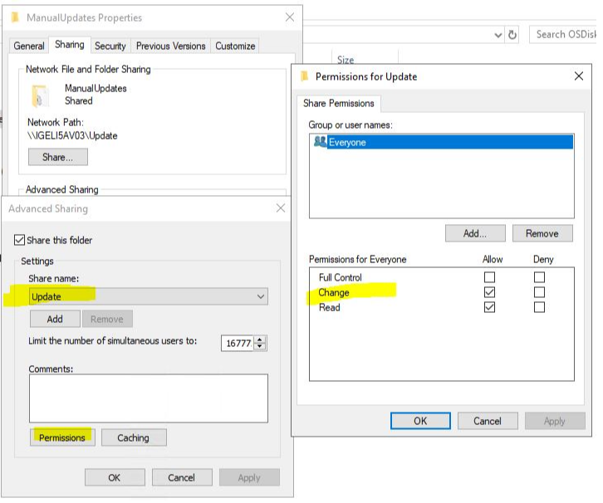

1. Go to the Active Update server by typing the following link in a web browser:

<http://osce14-p.activeupdate.trendmicro.com/activeupdate/server.ini>

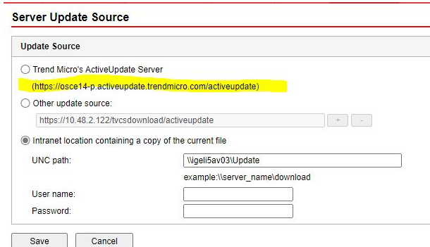

The Active Update server will vary depending on the version of Apex One server. Just go to **Updates** > **Server** > **Update Source**, and then copy the Active Update Server link and add /server.ini to the end of the link.

1. For Conventional Scan (Virus Pattern), search for "vsapi" in the server.ini file.

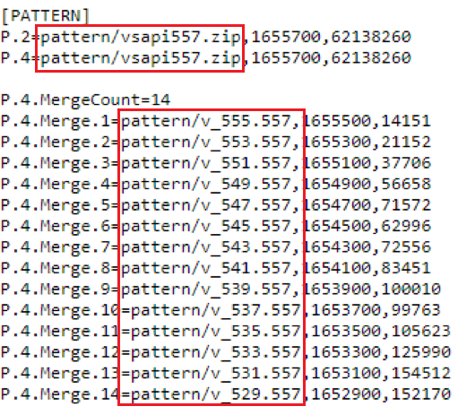

1. Download all the vsapi files by adding a path on the Active Update server link.

For example:

* + Virus Pattern:
  + http://osce14-p.activeupdate.trendmicro.com/activeupdate/pattern/vsapi557.zip
  + http://osce14-p.activeupdate.trendmicro.com/activeupdate/pattern/v_555.557
  + http://osce14-p.activeupdate.trendmicro.com/activeupdate/pattern/v_553.557
  + http://osce14-p.activeupdate.trendmicro.com/activeupdate/pattern/v_551.557
  + http://osce14-p.activeupdate.trendmicro.com/activeupdate/pattern/v_549.557
  + http://osce14-p.activeupdate.trendmicro.com/activeupdate/pattern/v_547.557
  + http://osce14-p.activeupdate.trendmicro.com/activeupdate/pattern/v_545.557
  + http://osce14-p.activeupdate.trendmicro.com/activeupdate/pattern/v_543.557
  + http://osce14-p.activeupdate.trendmicro.com/activeupdate/pattern/v_541.557
  + http://osce14-p.activeupdate.trendmicro.com/activeupdate/pattern/v_539.557
  + http://osce14-p.activeupdate.trendmicro.com/activeupdate/pattern/v_537.557
  + http://osce14-p.activeupdate.trendmicro.com/activeupdate/pattern/v_535.557
  + http://osce14-p.activeupdate.trendmicro.com/activeupdate/pattern/v_533.557
  + http://osce14-p.activeupdate.trendmicro.com/activeupdate/pattern/v_531.557
  + http://osce14-p.activeupdate.trendmicro.com/activeupdate/pattern/v_529.557

1. Download all the .sig files for the vsapi files that downloaded by replacing all the extensions with .sig.

For example:

* + Virus Pattern:
  + http://osce14-p.activeupdate.trendmicro.com/activeupdate/pattern/vsapi557.sig
  + http://osce14-p.activeupdate.trendmicro.com/activeupdate/pattern/v_555.sig
  + http://osce14-p.activeupdate.trendmicro.com/activeupdate/pattern/v_553.sig
  + http://osce14-p.activeupdate.trendmicro.com/activeupdate/pattern/v_551.sig
  + http://osce14-p.activeupdate.trendmicro.com/activeupdate/pattern/v_549.sig
  + http://osce14-p.activeupdate.trendmicro.com/activeupdate/pattern/v_547.sig
  + http://osce14-p.activeupdate.trendmicro.com/activeupdate/pattern/v_545.sig
  + http://osce14-p.activeupdate.trendmicro.com/activeupdate/pattern/v_543.sig
  + http://osce14-p.activeupdate.trendmicro.com/activeupdate/pattern/v_541.sig
  + http://osce14-p.activeupdate.trendmicro.com/activeupdate/pattern/v_539.sig
  + http://osce14-p.activeupdate.trendmicro.com/activeupdate/pattern/v_537.sig
  + http://osce14-p.activeupdate.trendmicro.com/activeupdate/pattern/v_535.sig
  + http://osce14-p.activeupdate.trendmicro.com/activeupdate/pattern/v_533.sig
  + http://osce14-p.activeupdate.trendmicro.com/activeupdate/pattern/v_531.sig
  + http://osce14-p.activeupdate.trendmicro.com/activeupdate/pattern/v_529.sig

1. Copy all of the content in the Active Update site (http://osce14-p.activeupdate.trendmicro.com/activeupdate/server.ini) and then save it as "server.ini" and paste it in the shared folder created.

For example:

\\IGELI5AV03\Update\server.ini

1. Modify the server.ini as following in order to comment out [Server] settings:

From:

[Server]

AvailableServer=1

Server.1=http://osce14-p.activeupdate.trendmicro.com/activeupdate

AltServer=http://osce14-p.activeupdate.trendmicro.com/activeupdate

Https=https://osce14-p.activeupdate.trendmicro.com/activeupdate

To:

[Server]

*;*AvailableServer=1

*;*Server.1=http://osce14-p.activeupdate.trendmicro.com/activeupdate

*;*AltServer=http://osce14-p.activeupdate.trendmicro.com/activeupdate

*;*Https=https://osce14-p.activeupdate.trendmicro.com/activeupdate

1. Change the Update Source on the web console for the server to the newly created local one:

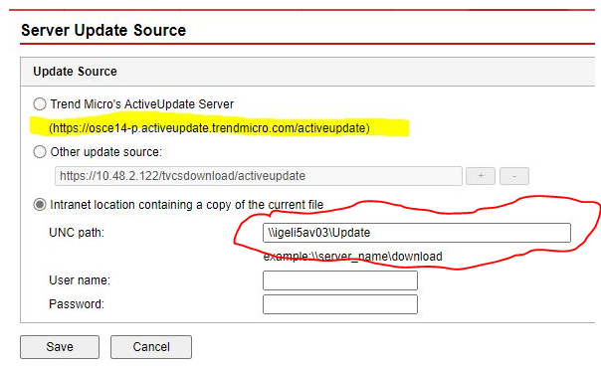

Management Console > [Updates] > [Server] > [Update Source]> Check Intranet and set UNC path to the sharing folder (e.g. \\igeli5av03\Update)

1. Go to Updates > Server > Manual Update and then select the target pattern you need to update.

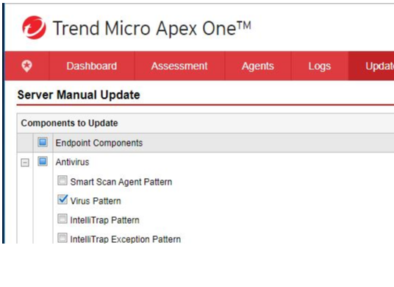

1. Click the Update button to start the update process.
2. Check if the desired pattern has already been updated to the latest version.

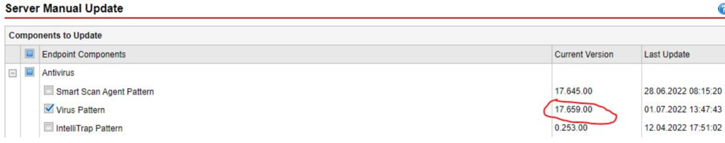

1. Change the Update Source on the web console for the server to the original one