OBSrange v1.0 README

DRAFT

Table of Contents

1 SCOPE …………………………………………………………………………………………………
2 GETTING STARTED …………………………………………………………………………………
2.1 Preliminaries ………………………………………………………………………………………
2.2 Survey File Format ……………………………………………………………………………….
2.3 Coordinate Systems ...……………………………………………………………………………..
2.4 Setting Parameters ………………………………………………………………………………..
2.5 Structure …………………………………………………………………………………………..
3 EXAMPLE ……………………………………………………………………………………………..
3.1 General Output …………………………………………………………………………………….
3.2 The .txt Files ………………………………………………………………………………………..
3.3 The .pkl and .mat Files ..……………………………………………………………………………
3.4 Figures ………………………………………………………………………………………………
3.4.1 Model Parameter Histograms …………………………………………………………………..
3.4.2 Survey Maps ……………………………………………………………………………………..
3.4.3 Final Model Misfit ………………………………………………………………………………
3.4.4 Two-Way Travel-Time Residuals by Survey Point ……………………………………………...
3.4.5 F-Test Derived Location Uncertainty …………………………………………………………...
3.4.6 Final Model Resolution and Covariance ……………………………………………………….
REFERENCES …………………………………………………………………………………………

1 SCOPE

The primary goal of OBSrange is to provide a robust, efficient, open-source OBS location code to the marine geophysical community.

OBSrange is a set of scripts written in both MATLAB and PYTHON for precisely locating ocean bottom seismometers (OBSs). The starting point for the code are sets of acoustic ranging survey files obtained during deployment. Using these survey files, the code inverts for instrument locations, turn-around times, and depth averaged sound speeds in water. Additionally, OBSrange generates several figures visualizing these results as well as estimates of parameters uncertainties. For a more detailed description of the algorithms we use for our inversion, synthetic tests, and our results, please refer to our paper (put reference here).

2 GETTING STARTED

2.1 Preliminaries – Dependencies and Versions
Note that the MATLAB implementation of OBSrange is completely self-contained, meaning that the MATLAB scripts don’t require any toolboxes beyond those available with the standard installation. In the case of the PYTHON implementation, the scripts have been written for PYTHON 3 and require the following open-source libraries (it’s recommended to have versions at least as great as the versions listed):
- numpy v1.13.1
- scipy v0.19.1
- matplotlib v2.2.2
- pymap3d v1.7.4

2.2 Survey File Format
Since acoustic ranging survey files are the input for OBSrange, in its current incarnation, these files must follow the format shown in the figure below.

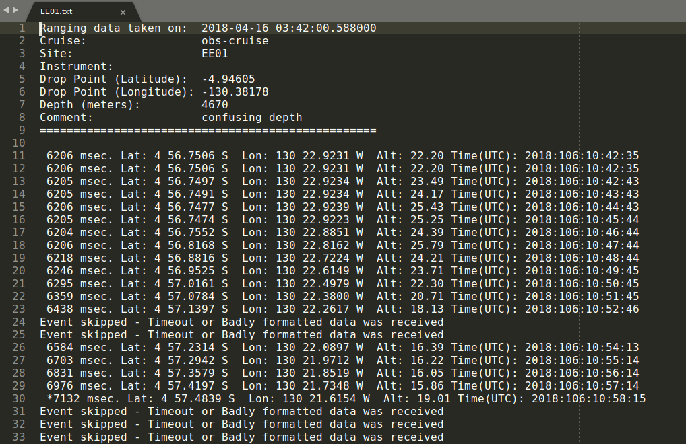
Note that the survey file in this example is a .txt file that has been generated by a Scripps Institute of Oceanography (SIO) PYTHON script (Ernest Aaron, pers. comm.). In practice the acoustic ranging survey is conducted using an EdgeTech 8011M acoustic command and ranging deck box or a similar instrument. The header information is contained in exactly 9 lines followed by a blank line at the 10th line. From the 11th line onward the results of individual “pings” (sonar sends and receives) are logged. The necessary data obtained from the header of these .txt files by OBSrange are the site name, drop coordinates, and estimated drop depth. And below the header, OBSrange reads in the two-way travel time of each ping, the ship coordinates when each ping was received, as well as the UTC time at which each ping was received. Finally, in the figure of the example .txt file shown above, we see that bad results either begin as “Event skipped ...” or are flagged by an asterisk. OBSrange can handle both of these cases, in that it does not read in such results, but note that bad results must be designated in this exact manner for the time being.

2.3 Coordinate Systems

2.4 Setting Parameters
Slight design differences exist between the MATLAB and PYTHON versions of the code, but the main usage remains the same between the two. In both cases parameters are set in a single main script which will run and execute every other aspect of the code. Ideally, the only edits users ever need make are in editing the parameters of these main scripts. In the case of the MATLAB version, this script is called OBSrange.m and these parameters are set in the top lines of that script. In the case of the PYTHON version, the main script is similarly called OBSrange.py, and parameters are set in that script. The parameters to be set by users are described and compared in the following table (sorted alphabetically by MATLAB parameter names):

MATLAB Parameter | PYTHON Equivalent | Description
datapath | survey_fles | Path to the directory containing the survey files.
ifplot | - | Option to plot results. In PYTHON plots are created and saved by default but not displayed when OSBrange.py is run. In MATLAB plots are created, saved, and displayed while running OBSrange.m only if this parameter is set to 1.
ifQC_ping | QC | Option to perform quality control on ping results obtained from the survey files. Pings with two-way travel times beyond a certain threshold are filtered out of any analysis (see res_thresh below).
ifsave | - | By default the MATLAB version will write single station results to .txt files. If this parameter is set to 1, then it will additionally write single station results to .mat files. PYTHON writes single station results to both .pkl and .txt files by default.
onesta | - | Option to process a single station. PYTHON will process whatever survey files (.txt files) are located in the directory represented by survey_fles.
outdir | output_dir | Path to output directory.
par.dampdvp | dampdvp | Normal damping for water sound speed.
par.dampTAT | damptat | Normal damping for turn-around time.
par.dampx | dampx | Normal damping for station x-coordinate.
par.dampy | dampy | Normal damping for station y-coordinate.
par.dampz | dampz | Normal damping for station z-coordinate.
par.epsilion | eps | Global norm damping for stabilization.
par.if_twtcorr | twtcorr | Option to apply a correction to two-way travel times due to the ship’s radial velocity.
par.N_bs | N_bs | Number of bootstrap iterations.
par.E_thresh | E_thresh | RMS reduction threshold for the inversion.
par.npts_movingav | npts | Number of points in an N-point moving average smoothing filter applied to the ship’s velocity. Note that if this parameter is set to “1” that no smoothing is applied.
par.TAT_bounds | bounds | Bounds for turn-around times (msec).
par.TAT_start | tat | Turn-around time (msec).
par.vp_w | vpw | Water velocity (m/s).
projpath | - | Directory for both input and output (MATLAB only).
res_thresh | res_thresh | Residual threshold for pings if applying quality control (msec, see ifQC_ping/QC above).

Again, in both the MATLAB and PYTHON versions, once these parameters have been set, these scripts may be run and will produce results.

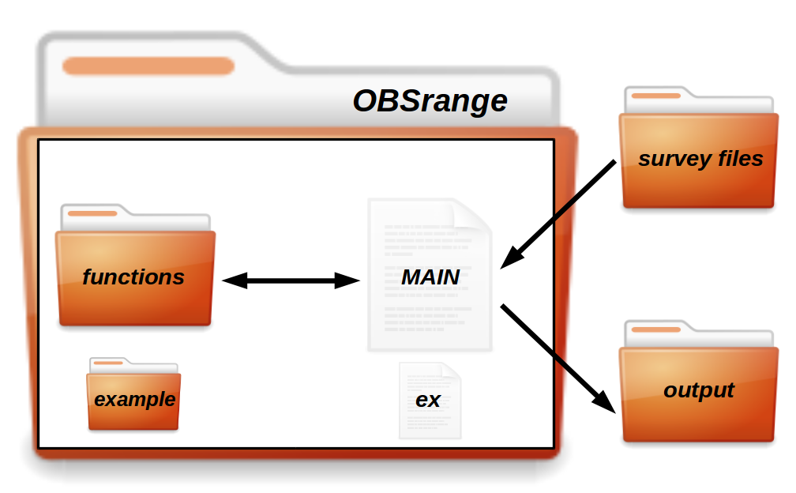
2.5 Structure
In this section we briefly describe the general structure of OBSrange, illustrated in the above figure. In both the MATLAB and PYTHON versions of the code, the top-level directory of OBSrange includes the main script (OBSrange.m or OBSrange.py, respectively), in which the parameters for running the code are set by the user (see previous section). Once parameters have been set, the main script can be run; it will loop through files in the survey files directory, calling functions contained within the functions directory. All results will be written into an output directory. Note that paths to the directories for the survey files and output are specified by the user in the main script. In the case of the MATLAB version, these directories are themselves contained within a single folder, set via the projpath variable. Finally, OBSrange includes a single station example which will be discussed in the next section.

3 EXAMPLE

3.1 General Output
The example provided with OBSrange locates the OBS package deployed at site WC03 of the PacificORCA array (reference). Simply run the example script for your corresponding version of the code, either OBSrange_example.py or OBSrange_example.m. These scripts will read the example survey .txt file contained within OBSrange’s example directory (see previous figure) and will also write the output into that directory. In the case of the PYTHON version, the output will consist of a .pkl file named WC03_location.pkl, a .txt file similarly named WC03_location.txt, and six figures. In the case of the MATLAB version the output will consist of a .txt also named WC03_location.txt, a .mat file called WC03_data.mat, and the same figures.

3.2 The .txt files
The .txt files created by the MATLAB and PYTHON versions are formatted slightly differently, but the results are the same. In the figure below we show the first 40 lines of WC03_location.txt created by the PYTHON example and describe the general features of this file.

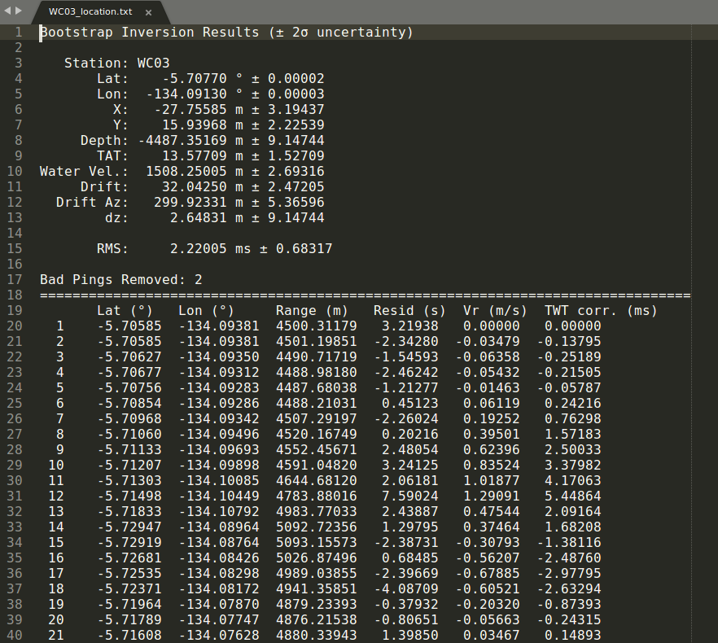
In both versions, the header of WC03_location.txt summarizes the main results of the inversion performed by OBSrange on this station. Shown in the header are the final estimates for the X and Y coordinates of the package relative to the drop point, as well as their converted latitude and longitude, the sensor turn-around time (TAT), and the final depth estimate (Depth). Additionally, the header contains the total package drift distance (Drift) and azimuth (Drift Az.), the difference between the initial estimated depth and final depth estimate (dz), and the depth averaged velocity of sound in water (Water Vel.). Finally, the header contains the overall RMS misfit for this site and also displays the number of pings that were removed via the ping quality control. Below line 18 of WC03_location.txt the details of each ping are logged, namely, the ship latitude, longitude, estimated distance to the sensor, two-way travel-time residual, the ship’s radial velocity and corresponding travel-time correction (whether it was applied or not).

3.3 The .pkl and .mat Files
In this example PYTHON will also create a .pkl file called WC03_out.pkl and MATLAB will create a .mat file called WC03_out.mat. In essence, both of these files are simply containers which hold various results of the bootstrap inversion. The .pkl file contains a PYTHON dictionary object of various results and values and the .mat file contains a 1x1 struct object called datamat. Both data structures contain many of the same fields, all of which are listed in the table below (sorted alphabetically by MATLAB parameter names):

MATLAB | PYTHON | Description of Field
- | vrs | Ship’s radial velocity at each survey point
- | Nbad | The number of pings removed via quality control
- | dzs | The depth difference after each bootstrap iteration
azi_bs | azs | Sensor drift azimuth after each bootstrap iteration
Cm_mat | cov | Model covariance matrices after each bootstrap iteration
drift_bs | drifts | Sensor drift distance after each bootstrap iteration
drop_lonslatz | drop_geo | Geographic drop coordinates
dtwt_bs | dtwts | Final twtt residuals at each survey point
dtwtcorr_bs | corrs | Final twtt corrections at each survey point (whether applied or not)
E_rms | E_rms | RMS after each bootstrap iteration
Ftest_res | Ftest_res | F-test grid search results
lat_sta_bs | lat_sta | Sensor latitude after each bootstrap iteration
lats_ship | svy_lats | Latitudes of survey points
loc_lolaz | loc_geo | Final sensor location (geographic coordinates)
loc_xyz | loc_xyz | Final sensor location (Cartesian reference frame)
lon_sta_bs | lon_sta | Sensor longitude after each bootstrap iteration
lons_ship | svy_lons | Longitudes of survey points
mean_drift_az | drift_az | Final sensor drift distance and azimuth
R_mat | resol | Model resolution matrices after each bootstrap iteration
sta | sta | Station name
TAT_bs | tats | Sensor turn-around time after each bootstrap iteration
twtcorr_bs | twts | Final two-way travel-times (twtts) at each survey point
v_ship | svy_vs | Ship velocity vectors at survey points
V_w_bs | vpws | Average speed of sound in water after each bootstrap iteration
x_ship | svy_xs | x-coordinates of survey points
x_sta_bs | x_sta | Sensor x-coordinate after each bootstrap iteration
y_ship | svy_ys | y-coordinates of survey points
y_sta_bs | y_sta | Sensor y-coordinate after each bootstrap iteration
z_ship | svy_zs | z-coordinates of survey points
z_sta_bs | z_sta | Sensor z-coordinate after each bootstrap iteration

3.4 Figures
We now show the figures produced after running OBSrange.py.

3.4.1 Model Parameter Histograms
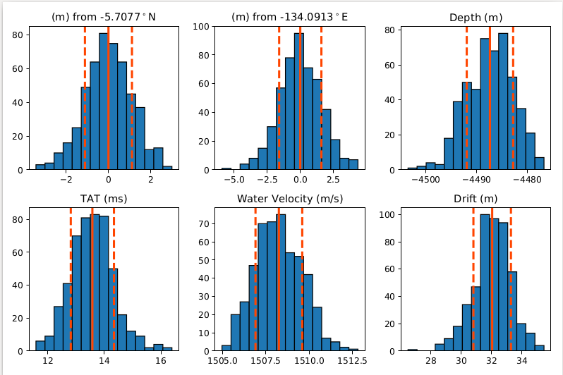

3.4.2 Survey Maps
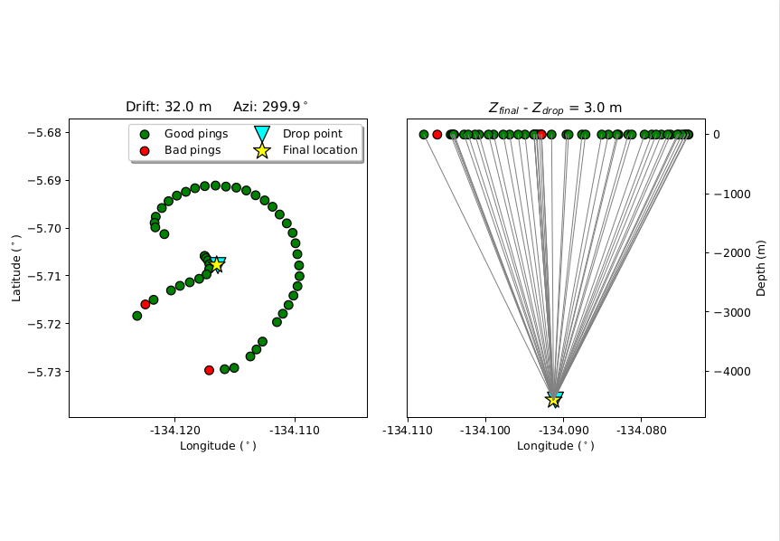
3.4.3 Final Model Misfit
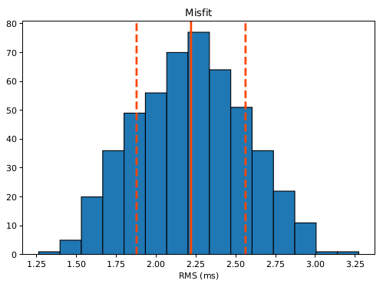

3.4.4 Two-Way Travel-Time Residuals by Survey Point

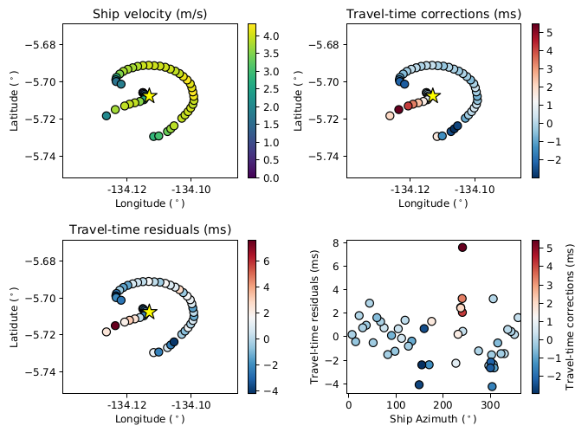
3.4.5 F-Test Derived Location Uncertainty

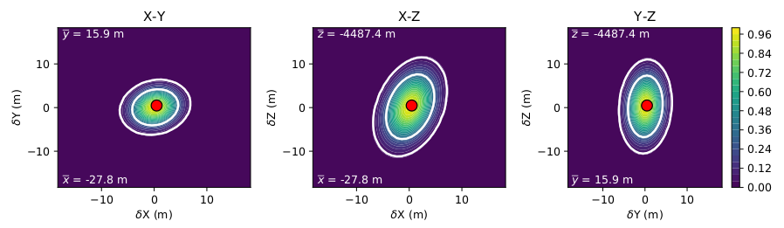

3.4.6 Final Model Resolution and Covariance
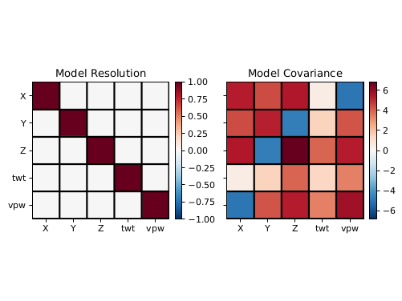

REFERENCES
Our Paper

