A National Study Comparing Charter and Traditional Public Schools Using Propensity Score Analysis

by

Jason M. Bryer

A Dissertation Proposal
Submitted to the University at Albany, State University of New York
In Partial Fulfillment of
the Requirements for the Degree of
Doctor of Philosophy

School of Education
Department of Educational and Counseling Psychology
Division of Educational Psychology & Methodology
2011 draft

1 Abstract
The concept of school choice within the United States is not new. Private schools have been educating students since the founding of the United States. However, in 1988, Ray Budde proposed an alternative approach to school choice that has come to be known as charter schools (Kolderie, 2005). Unlike their private school counterparts, charter schools receive public funding, but they are relieved of many of the bureaucratic and regulatory constraints public schools adhere to, but are still held accountable for student performance. Despite claims by charter school advocates that charter schools are performing as well if not better than the public school counterparts (see e.g. Allen, Consolettie, & Kerwin, 2009), studies provide mixed results with regard to charter school performance (see e.g. Braun, Jenkins, & Grigg, 2006, Center for Research on Education Outcomes, 2009, Hubbard & Kulkarni, 2009). Ultimately, there is agreement that more research is necessary to address the question of whether charter schools provide substantially better academic experiences for students.
This study uses new methods designed for observational data analysis to investigate the question of whether students who attend charter schools outperform their public school counterparts on two key academic domains: reading and mathematics. The new methods aim to reduce if not eliminate selection bias. Charter schools are, by definition, schools of choice, and this means that observational data methods are preferred for comparing such schools with others. In observational data contexts, simple comparisons of two groups such as traditional public and charter schools cannot help but ignore the inherent and systematic differences between the two groups. However, given well designed observational studies, and appropriate analysis methods, the effects of the selection bias can be reduced, if not eliminated. The end result is that the usual simple comparisons of two independent groups are replaced by comparisons that make adjustments for covariate differences.
This is done utilizing a class of statistical procedures introduced by Rosenbaum and Rubin (1983) called propensity score analysis. Propensity score analysis has seen considerable increased use in the social sciences within the last few years (Arpino & Mealli, 2008). However, its use in situations where multilevel, or clustered data are of interest, have been limited (Thoemmes & Kim, 2011). Using data from the 2007 National Assessment of Educational Progress (NAEP) for mathematics and reading at grades four and eight, estimates of the differences between charter and public schools will be calculated at two levels, namely state and national. Given the variability of charter schools laws across states, it is important to consider the impact of clustering. Analyses will be conducted using the newly developed multilevelPSA package (Bryer, 2011) in R (R Development Core Team, 2008). Specifically, propensity scores will be estimated within each state and these will be used for matching or stratification of students within each state. Comparisons of specific students, or groups of students, will in all cases be done within states. Effects will then aggregated to provide state and national effect estimates.
As with all propensity score analyses, it is preferable to utilize multiple methods for estimating propensity scores (see e.g. Stuart, 2010). Doing so can help to provide confidence that results reflect what the data have to say, and is not merely an artifact of model specification or method choice. This study will utilize three overall approaches to propensity score analysis, namely stratification, matching, and multilevel stratification. Lastly, the use of graphics will be employed to evaluate balance and outcome differences using methods (functions) found in Helmreich and Pruzek (2009).

2 Introduction
Since the opening of the first charter school in Minnesota in 1991, the United States has increasingly embraced charter schools as an option for educational reform. In the last 10 years for which data are available, the number of charter schools grew from 507 in the 1998-1999 school year to 4,561 in the 2007-2008 school year (see figure 1; Center for Education Reform, 2010). Currently, 40 states and the District of Columbia have charter school laws (see appendix A for enrollment by state & Appendix B for a thematic map of the U.S. depicting the number of operating charter schools as of 2008). And, given charter school supporter Arne DuncanÕs appointment as Secretary of Education by President Barack Obama, charter school growth seems likely to continue in the near future.
In principle, charter schools have opted out of bureaucratic rules and union contracts in order to gain administrative autonomy. The standard argument has become that this autonomy will lead to higher student test scores and better academic environments (Wells, 2002). because in the charter framework, teachers, administrators, students and the community that comprise charter schools are free to innovate. Proponents argue that charter schools are more likely than their conventional counterparts to serve as experimental schools where the innovations can inform reform of public education at large. However, some charter supporters envision a time when most traditional public schools will be replaced by charter schools. This is exemplified by the attempted school voucher legislation during the second G.W. Bush Administration.
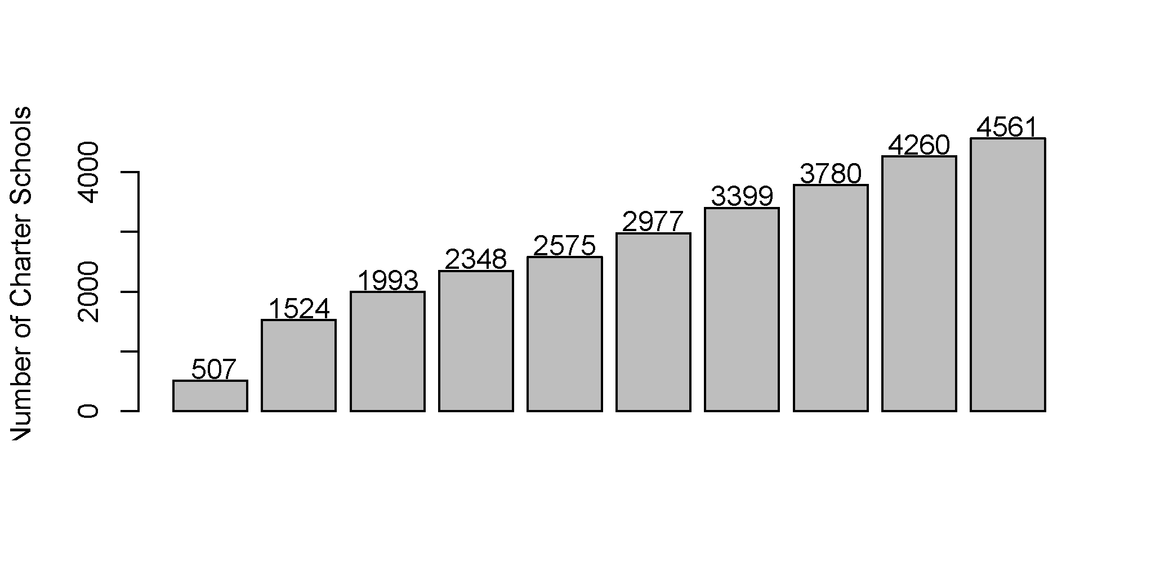
Figure 1: Charter School Growth 1999-2008
Clearly charter schools have become a popular vehicle for educational reform among parents. The Center for Education Reform (2008) reports that 59% of charter schools have waiting lists averaging 198 students.
Clearly charter schools have become a popular vehicle for educational reform among parents. The Center for Education Reform (2008) reports that 59% of charter schools have waiting lists averaging 198 students. Charter schools seem to have provided an apparent choice to parents and are congruent with the United State’s individualistic (see e.g., Hofstede & Hofstede, 2004, Maccall, 1847, Swart, 1962) culture.
Whatever the generic arguments concerning charter schools in the U.S., it is clear that sound empirical evidence is needed to evaluate this class of schools in relation to their traditional counterparts. Several studies have shown that charter schools are not only failing to increase student performance, that in fact, they often perform well below their traditional public school counterparts in terms of achievement test scores (see e.g., Center for Research on Education Outcomes, 2009, Braun et al., 2006, Nelson, Rosenberg, & Meter, 2004). Others still argue whether charter schools may be a solution in search of a problem. Carnoy, Jacobsen, Mishel, and Rothstein (2005) in summarizing the controversy that ensued after the Nelson et al. (2004) study argue that:
If, however, charter schools are not improving the achievement of disadvantaged children, it may be that the cause of low student performance is not bureaucratic rules but something else. When a treatment is based on a diagnosis, and the treatment doesn’t work, it is prudent to examine not only whether the treatment should be improved, but also whether the diagnosis might be flawed. (Carnoy et al., 2005)

2.1 Issues with Charter School Research
A large number of issues surround the topic charter schools, including their nature or form, their settings and especially their curricula. Given the numbers of current and future generations of students for which decisions about charter schools have central implications, one key concern must certainly be that of comparative outcomes of charter in relation to traditional public schools. Clearly, this issue should be explored using the best and most comprehensive data and methods available. As Betts and Hill (2006) point out, there are three major obstacles to addressing the question of “whether students in charter schools are learning more or less than they would have learned in conventional schools" (p. 1), namely:
1. The issue of selection bias.
2. The variation in types or kinds of charter schools (and the rules under which they operate in different states).
3. The nature of student achievement. Research has shown there are numerous factors that contribute to student success including, but not limited to, social economic status, parental education, motivation, etc. The ability to decipher how school choice contributes to student learning in the context of all the other factors cannot help but be difficult.
All of these issues are significant, but some are not all are amenable to empirical study, and some must be addressed in future research. We shall in fact focus on only a subset of these issues, and will do so only with respect to one large archival data set. Given the need for evidence regarding the relative performance of charter schools in relation to their conventional public school counterparts, we will focus on how effectively to use a large archival data set to ameliorate the effects of selection bias in the comparison of these two kinds of schools. The limitations of such study should also become clear, and will be discussed in some detail.
As noted above, selection bias will be examined in some detail. However, the central point is easy to state: statistical methods that incorporate propensity scores can provide ways to adjust for manifest selection bias in observational studies. It follows that under certain conditions, treatment comparisons, such as the comparison of charter and conventional public schools, can be clarified by reducing confounding effects through the use of covariates. In idealized conditions, interpretations of observational group comparisons can approach the qualities of randomized experiments with respect to the key goal of supporting causal inferences. To the extent that idealized conditions fail to exist or be reached, results of observational study comparisons will tend to become unclear, which is to say that confounding effects may continue to play a notable role. (While observational study comparisons may fail to provide sound causal evidence the same can be said for for true experiments, that is for studies where random assignments to groups have been employed. Of course the fundamental problem of causal inference remains (Holland, 1986). That is, it is impossible to observe treatment and non-treatment on the same unit of analysis.
The second issue noted above, that the term “charter school" means different things in different contexts, is often cited in critiques of national or large-scale charter school studies. TThe same of course is also true of public schools! However, to suggest that such variations obviate meaningful comparisons of these two fundamentally different kinds of schools would be an extreme judgment, one that when generalized would preclude or at least hinder all school (type) comparisons. It is a key assumption of the proposed dissertation that meaningful comparisons of charter and public schools does not require that each type be in any sense ‘pure’.
Given that the charter school debate is national, and has implications at the Federal level, large scale studies are not only likely to be useful, they are necessary because charter schools are routinely being offered, with few exceptions, as alternatives to traditional public schools, throughout the nation. For the few states that don’t currently have charter schools, incentives at the federal level for states to have charter schools have been put forth (e.g. the Race to the Top Initiative). In the case of this work the aim is not to focus on particular charter schools, or types of charter schools, but rather to compare these kinds of schools under one broad umbrella using government sponsored archival data that derives from carefully developed tests. The specific focus is on outcomes for the subjects reading and mathematics, using data aggregated at the level of the states.
Lastly, the roles of environmental, social, community, and cultural factors that contribute to a student’s academic achievement are often ignored or underestimated. Often educational reform, as exemplified most recently by the No Child Left Behind Act, places the responsibility solely on the school without consideration of the context in which the school operates.
Although educators acknowledge that schools, in their various forms, are only part of what contributes to student academic achievement, they are nevertheless important parts and it behooves educators to evaluate school effects quite generally. The particular approach used there is to compare school effects using a class of statistical methods that should make it possible to make clearer, less qualified conclusions, than is usually has been possible.

2.2 Research Questions & Objectives
Given that charter schools are regularly being offered as solutions for needed educational reform nationally, it is imperative that they be evaluated from a national perspective. This study proposes to compare the academic performance in two domains of charter and traditional public schools using the National Assessment of Educational Progress (NAEP) using multiple propensity score methods. More specifically, this study proposes to address the questions:
1. Given appropriate adjustments based on available student data, is there a discernible difference between charter and traditional public schools with regard to math and reading scores at grades 4 and 8?
2. If so, what is the nature and magnitude of this difference for the two outcomes reading and mathematics (for two grade levels)?
3. And finally, do identified differences differ between states with differing charter school laws?
In addition to the educational policy implications this study addresses, it will also make important methodological contributions. Research questions two and three above can not be adequately addressed if not for the methods and graphics developed and described in this study. That is, the development of the multilevelPSA package for R provides a reproducible means of estimating and visualizing propensity score analyses with clustered data (these procedures are discussed more fully below; see also Figure 2). Moreover, the use of pre-existing visualization procedures such as Loess regression plots, density plots, as well as the PSA balance and assessment plots introduced by Helmreich and Pruzek (2009) provide critical insight into the analysis and eventual interpretation of results. Or more succinctly, the presentation of graphics in this study are not merely provided for diagnostic or descriptive purposes, but are a critical component of presenting, analyzing, and interpreting results. For instance, related to research questions two and three above, the differences, if any, will not be revealed through numerical analysis (though numerical analyses are provided), but through visual displays.

3 Method
In this section I outline methods that will be utilized to describe and analyze the data in order to address the research questions central to this study. Given the strong political interests in the question of charter school effectiveness and the implications for educational policy both at the state and national level, obtaining sound and interpretable empirical evidence, preferably with support for causal inferences, is most desirable.
The gold standard of applied scientific research is the randomized experiment. A research design that addresses the charter school question proposed here would require that students be randomly assigned, possibly with blocking on key covariates, to either a charter or traditional public school. The theoretical justification for such a scheme is that any systematic differences between the two groups would be balanced through the randomization process. However, in practice, randomization is rarely feasible, and may not be ethical, in the context of comparing charter and traditional public schools. This introduces a phenomenon called selection bias, which means that systematic differences generally exist between the groups being compared, differences that tend to confound interpretations of comparative results. That is, any comparison of the two groups is likely to be biased given the fact that the units of study, are likely to be systematically different from one another on one or more covariates; such differences, in turn, generally make it impossible to interpret effects due to this confounding.
Propensity score analysis (Rosenbaum & Rubin, 1983) is a statistical methodology whereby the covariate differences between the two groups are, in large measure, taken into account. This is done through use of a method that uses available covariate information to construct propensity scores for each unit (student); comparisons are then made between the groups, conditional on the derived propensity scores.
In the case of this study the general approach being used is based on archival data, so it is retrospective, not prospective approach (where covariates are defined and measured by the investigator at the outset). In retrospective studies the investigator is limited to covariate data that was collected and included in the archive. Fortunately, in the case of the NAEP archive, extensive covariate information is available, which strengthens the case for using propensity score methods. Furthermore, the general procedure lends itself well to secondary analysis of the available observational data.

3.1 Overview of NAEP
The source of the data that will be utilized in this study is provided by the National Center for Educational Statistics (NCES) which is within the U.S. Department of Education’s Institute of Education Sciences (IES). The National Assessment of Educational Progress (NAEP) was started in 1971 and has regularly provided national measures of student achievement in many subjects including mathematics, reading, science, writing, history, civics, and the arts since its inception. In 2003 NAEP began assessing charter schools as well as private and public schools. This study will utilize the 2007 administering of the NAEP assessments in mathematics and reading within grades four and eight. The 2007 assessment included over 6,000 public schools and over 200 charter schools comprising of over 145,000 and 3,000 students, respectively. Given this relatively large, nationally representative sample, analysis of NAEP assessments utilizing propensity score analysis may provide valuable insights into the academic differences between charter and traditional public schools.
More than simply providing large samples, another key advantage of NAEP is the fact that it is not designed to assess individual students or schools, but instead to inform broadly about subject-matter achievement, instructional experiences, and school environments for states and regions in the U.S. (Braun, Jenkins, & Grigg, 2006). To achieve this goal, NAEP utilizes a complex item-sampling design such that individual students are presented a subset of the total items, thereby reducing the burden on individual participants. Though not appropriate for assessing individual student achievement, in aggregate the NAEP measures provide statistically and psychometrically sound estimates of aggregate student achievement.
In addition to subject area measures, NAEP includes student, teacher, and school questionnaires that provide contextual information about the students’ environment. In addition to typical demographic items such as gender and race, students are asked about computers, books, magazines, and encyclopedias in the home; parents education level; and the level of interaction with academics within the home (see Appendix C for complete list of items).
The answers to items on these questionnaires provide the covariate information that will be used in PSA to adjust for selection bias. Propensity scores will be derived from the covariates to construct student propensity scores (e(x)), these being estimates of the probability of being in the treatment group (i.e. charter school in the context of this study). The complement of each propensity score, 1 - e(x), estimates the probability of being in a traditional public school, based on available covariates. The responsibility for developing the assessment objectives and test specifications lies with the National Assessment Governing Board that was created by Congress in 1988. The governing board is charged with deciding what are appropriate achievement goals, nationally, and state-by-state, for each age and grade. The following two sections provide the framework for mathematics and reading assessments.

3.2 Analysis
Most of the studies conducted using PSA involve analysis in two phases where phase one involves the calculation of propensity scores or matching for both treatment and control units of analysis; and phase two involves the comparison of those two groups. However, there is little research with regard to situations where data is multilevel. As such, this study will be organized as follows:
1. Propensity score analysis using stratification. This method ignores state assignment as a clustering variable. Under this broader method three statistical methods for stratification will be used:
(a) Full logistic regression. This method will estimate propensity scores using logistic regression with all available covariates.
(b) Logistic regression with step AIC. The stepAIC in the MASS package (Venables & Ripley, 2002) will select the best logistic model based upon the Akaike Information Criterion (Akaike, 1974).
(c) Conditional inference trees.
2. Propensity score matching. This method implicitly accounts for clustering. That is, the method used will find matches between treated and control units that first match exactly on state, ethnicity, and gender, then finds a best match based upon the propensity scores estimated using logistic regression. As suggested by Stuart (2010), multiple matched sets will be formed using (charter-to-traditional public school students):
(a) One-to-one
(b) One-to-five
(c) One-to-ten.
A dependent sample analysis will be performed on the resulting matched pairs (Austin, 2011).
3. Multilevel propensity score analysis. This method will utilize the same stratification methods as described in method one above, namely:
(a) Full logistic regression.
(b) Logistic regression with step AIC.
(c) Conditional inference trees.
However, where this method differs from method one is that separate models will be estimated for each state separately. Results from each state are then aggregated to provide an overall, national estimate of the differences between charter and traditional public school. Moreover, this method provides an approach whereby differences between meaningful subgroups (states in this study) can be explored, especially with the use of graphics as described below.
It is generally recommended that multiple methods for the estimation of propensity scores be used (see e.g. Stuart & Rubin, 2008, Stuart, 2010). The choices of methods for this study were chosen first to provide estimations disregarding clustering, to utilize clustering implicitly, and to utilize clustering explicitly. Then secondly, within each of these three approaches with respect to clustering, multiple methods are used in accordance to the recommendations provided by Stuart and Rubin (2008) and Stuart (2010).

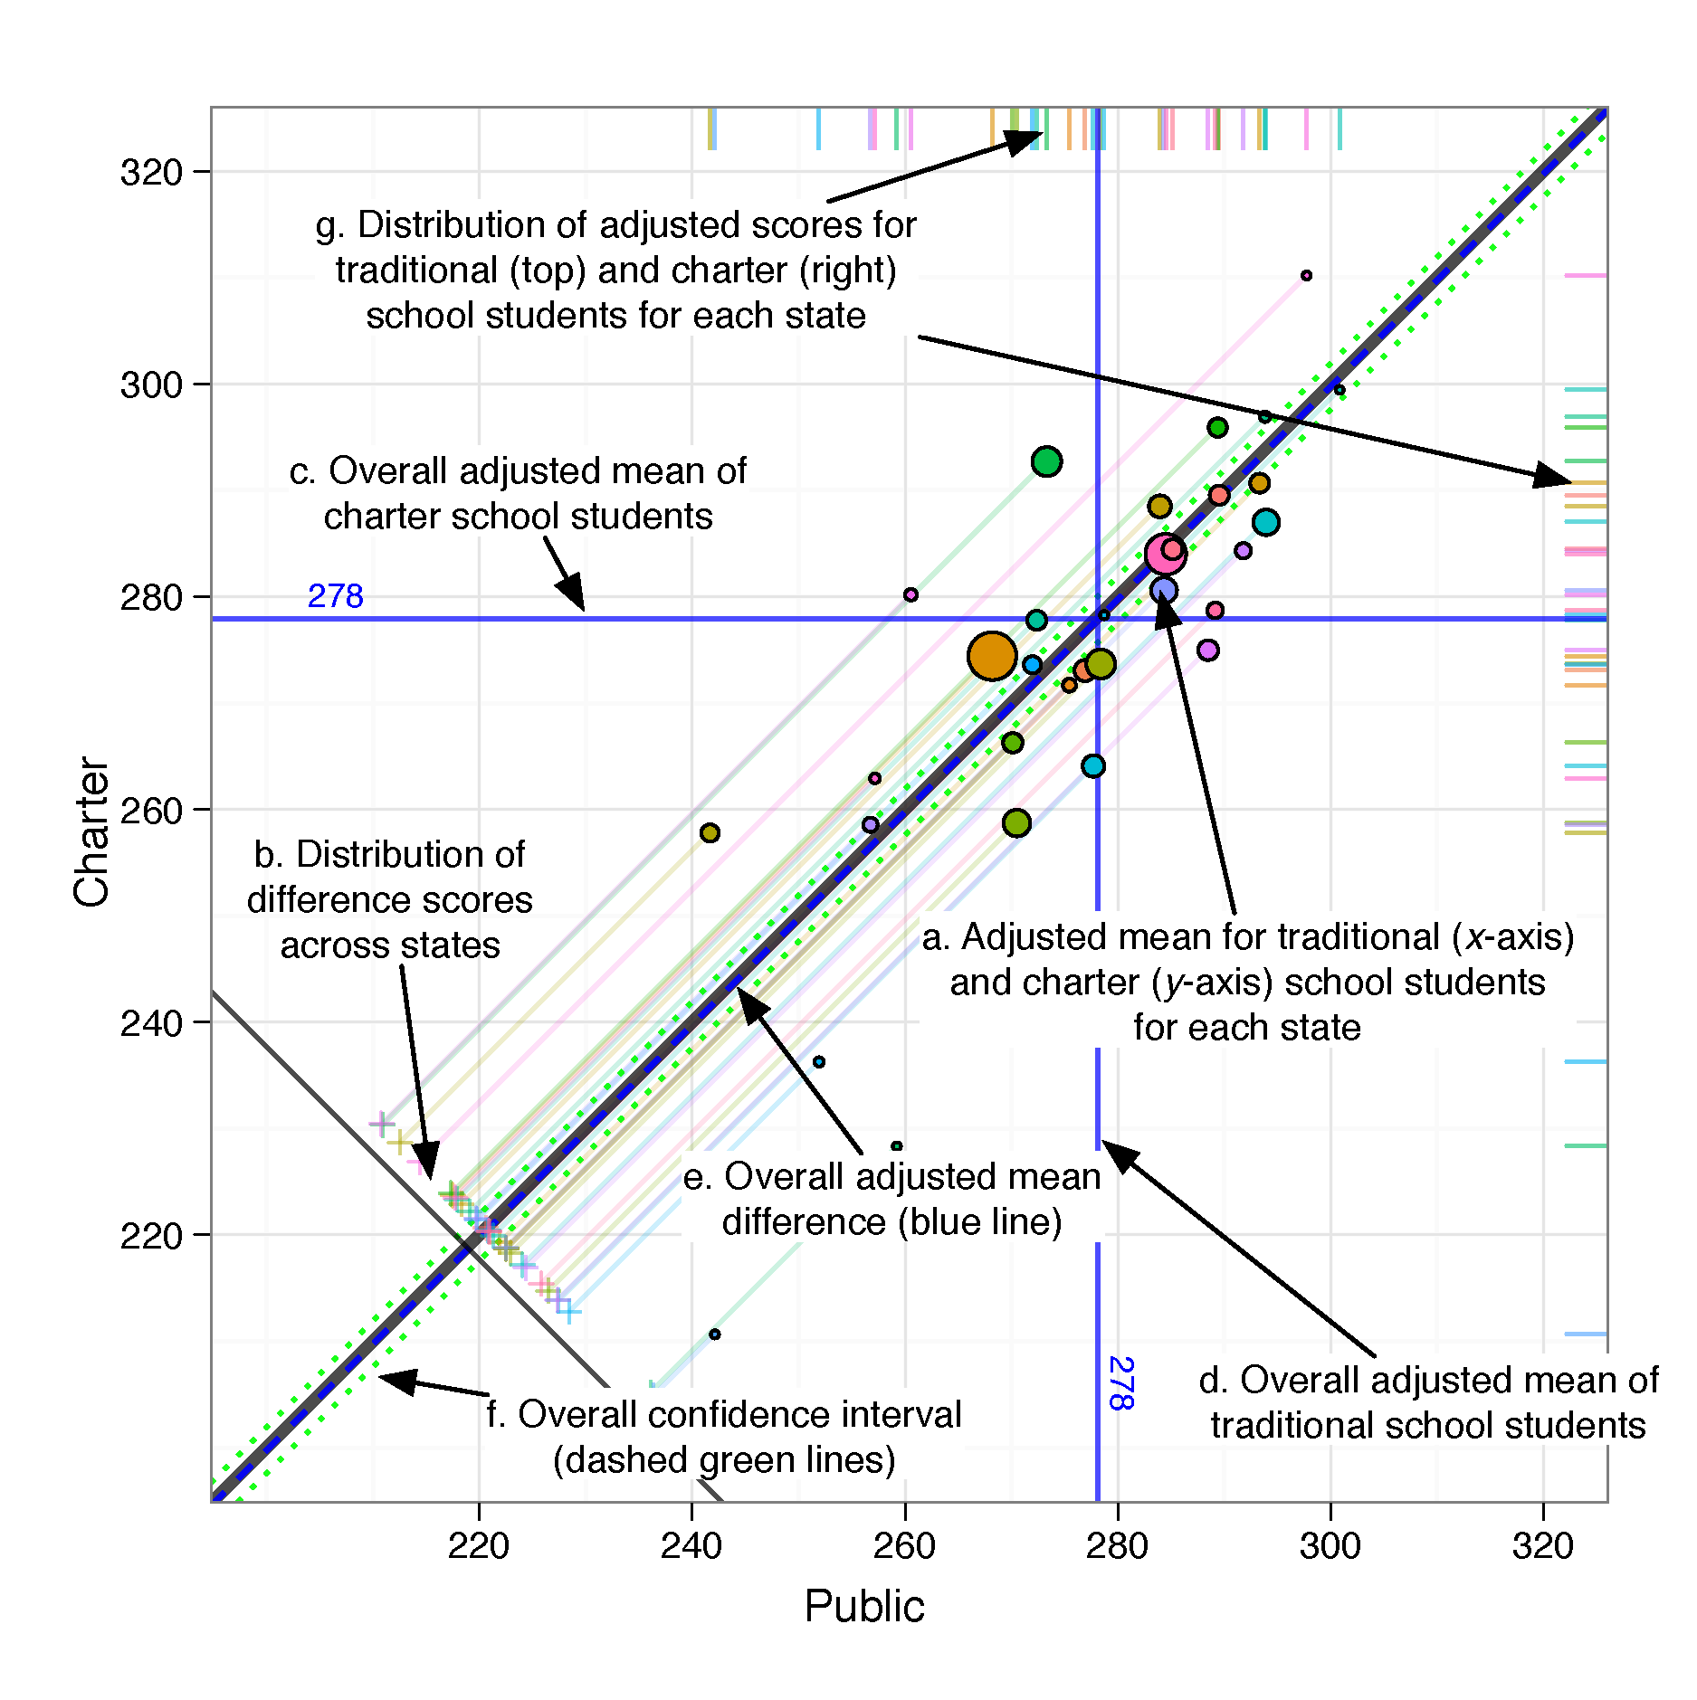
Figure 2: Multilevel PSA Assessment Plot

3.3 Visualizing Multilevel PSA
Given the large amount of data that needs to be summarized, the use of graphics will be an integral component of representing the results. The multilevelPSA package provides a number of graphing functions that extend the framework introduced by Helmreich and Pruzek (2009) for multilevel PSA. Figure 2 represents a multilevel PSA assessment plot with annotations. In this graphic, the x-axis corresponds to traditional public school grade 8 NAEP scores and the y-axis corresponds to charter school grade 8 NAEP scores. Each colored circle (a) is a state with its size corresponding the number of students within each state. Each state is projected to the lower left, parallel to the unit line, such that a tick mark is placed on the line with slope -1 (b). These tick marks represent the distribution of differences between charter and traditional public schools across states. Differences are aggregated (and weighted by size) across states. For grade 8 math, the overall adjusted mean for charter school students is 278 and the overall adjusted mean for traditional public school student is 278 and represented by the horizontal (c) and vertical (d) blue lines, respectively. The dashed blue line parallel to the unit line (e) corresponds to the overall adjusted mean difference and likewise, the dashed green lines (f) correspond to the confidence interval. Lastly, rug plots along the right and top edges of the graphic (g) correspond to the distribution of each state’s overall mean charter and traditional public school NAEP scores, respectively.

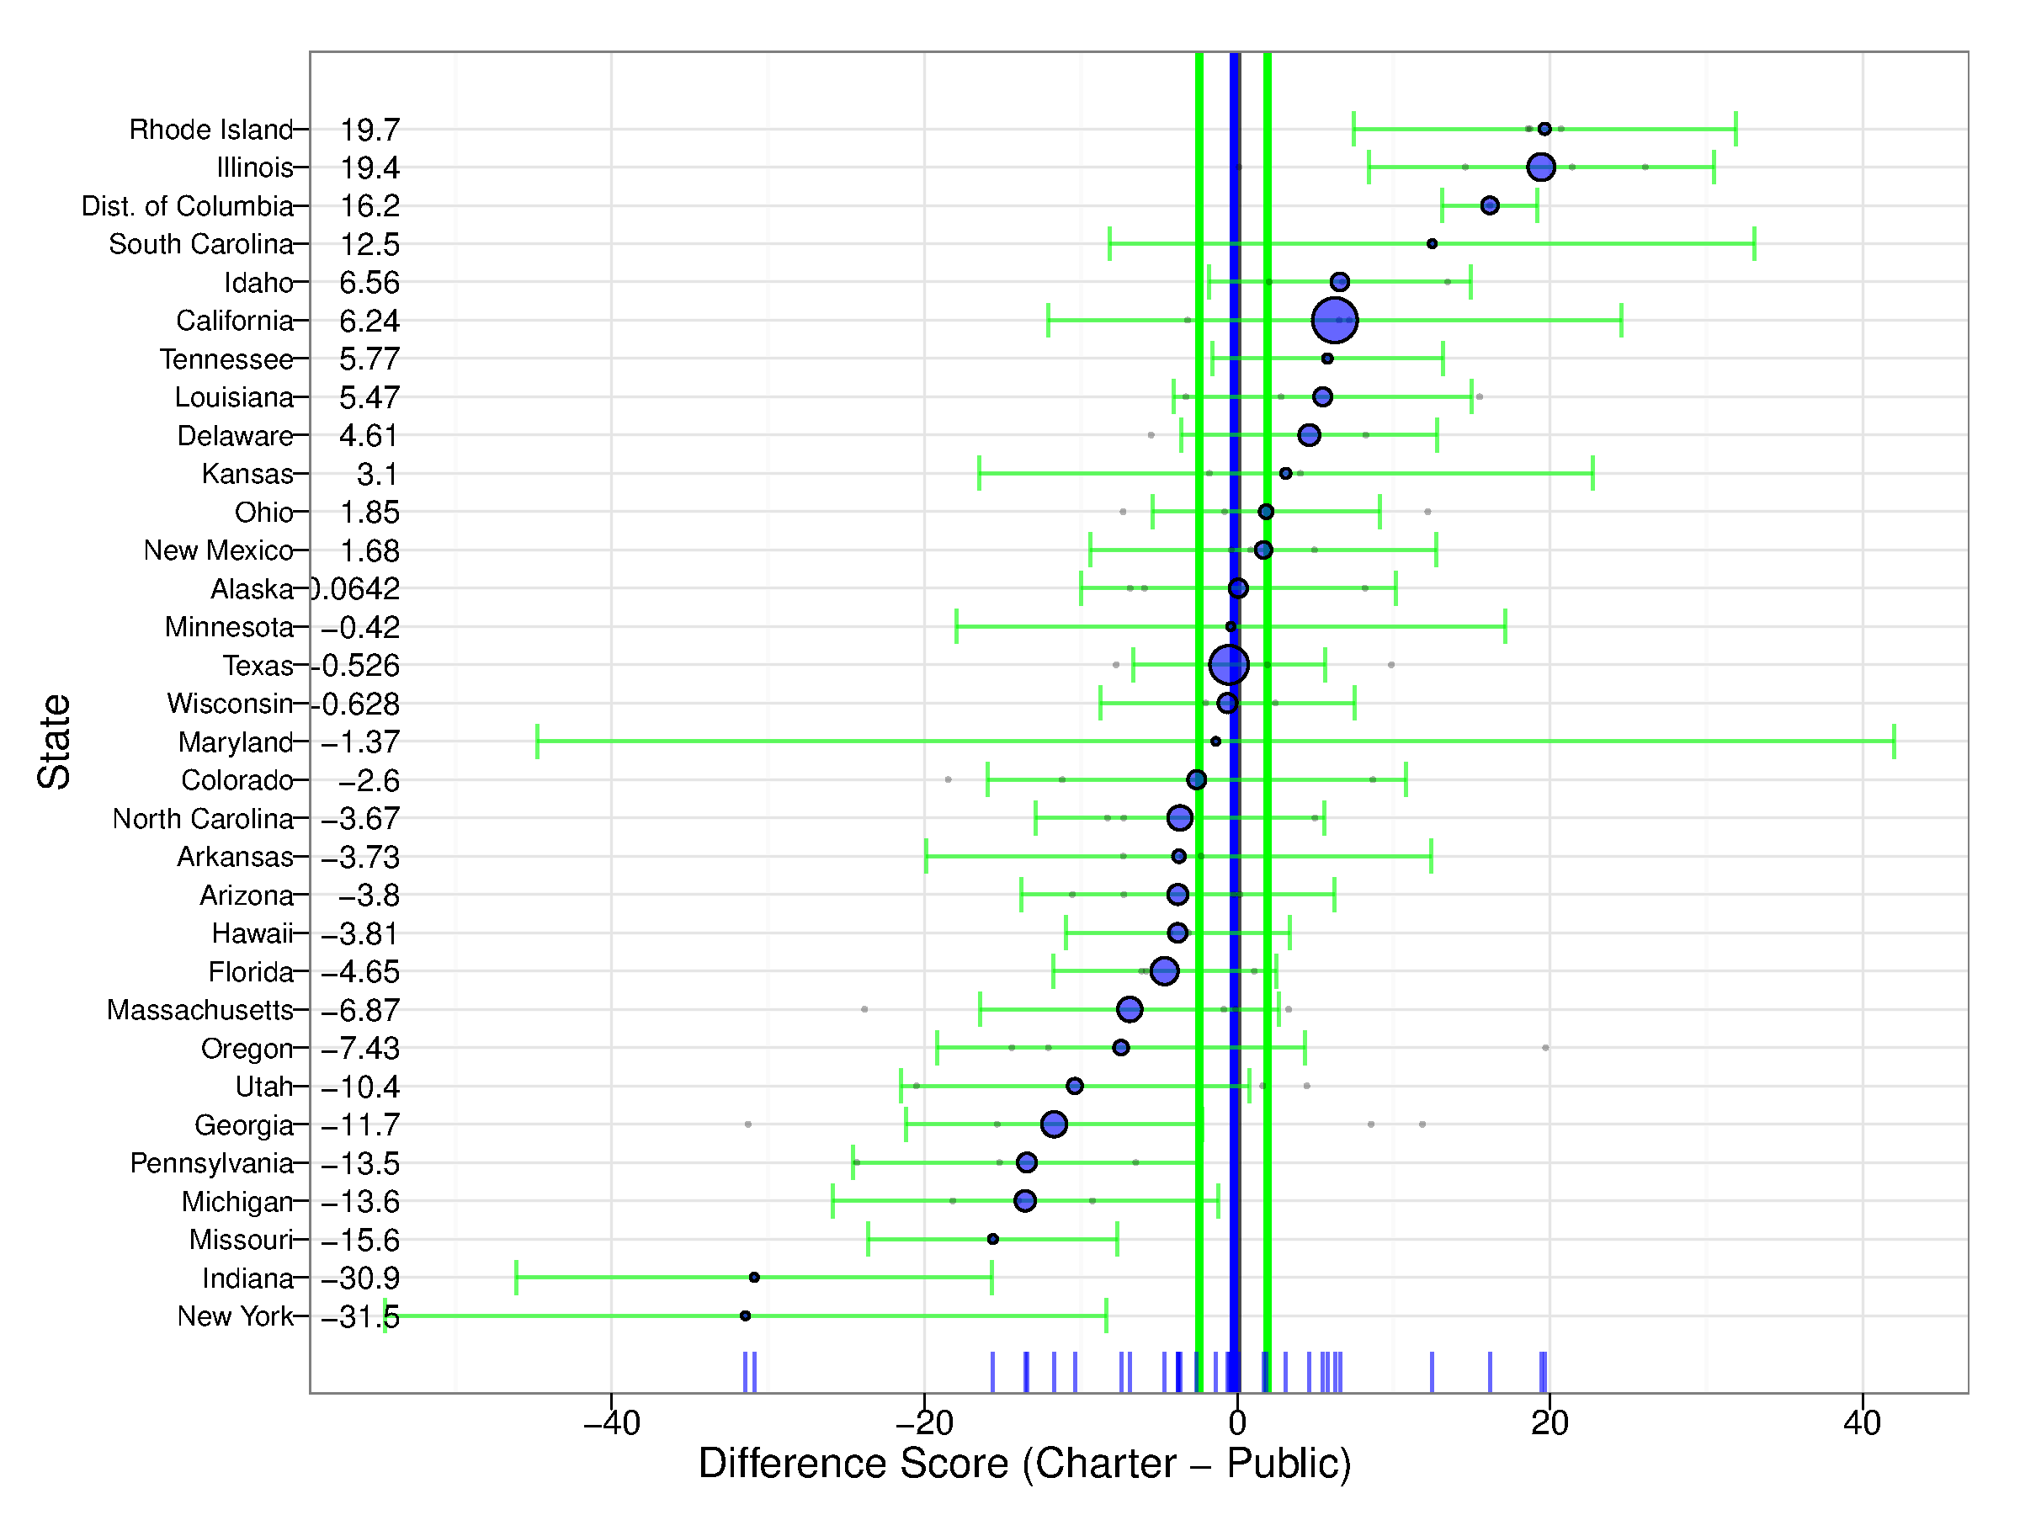
Figure 3: Multilevel PSA Difference Plot: Grade 8 Math
Figure 3 provides a more nuanced depiction of the differences both between and across states. Similar to the mutlielvel PSA assessment plot, each blue dot corresponds to a state and is sized relative to the number of students within each state. The light gray dots correspond to each strata within each state. The graphic also provides confidence intervals for each state as well as the overall adjusted mean difference (the vertical blue line) and confidence interval (the vertical green lines).

4 (Preliminary) Results
The tables and figures in this section represent the preliminary results of the analysis outlined in the methods section. Though these results will likely differ than the results reported in the final dissertation, they provide sufficient approximations.
Figure 4 provides a summary of all the results across the four dependent variables. This graphic displays the mean adjusted differences as blue dots with the confidence interval in green. Therefore, any instance where the confidence interval does not cross zero (as represented by the vertical black line) indicates there is a statistical significant difference. Tables 10, 11, and 12 in Appendix K provide the overall numerical results, that provide the basis for Figure 4, for each dependent variable (i.e. math and reading at grades 4 and 8) using stratification, matching, and multilevel PSA, respectively.
Examining Figure 4, I see there is general agreement across the nine different methods used. That is, given the various approaches to adjusting selection bias with the available student information provides consistent conclusions. Specifically, these results suggest there is no statistical difference between charter and traditional public school students in grade 4 math and reading. Grade 8 math provides mixed results whereby five of the nine methods have confidence intervals that do not span zero. For grade 8 reading however, there is a clear statistical difference as all nine methods result in confidence intervals that do not span zero (effect size ≤ .20).

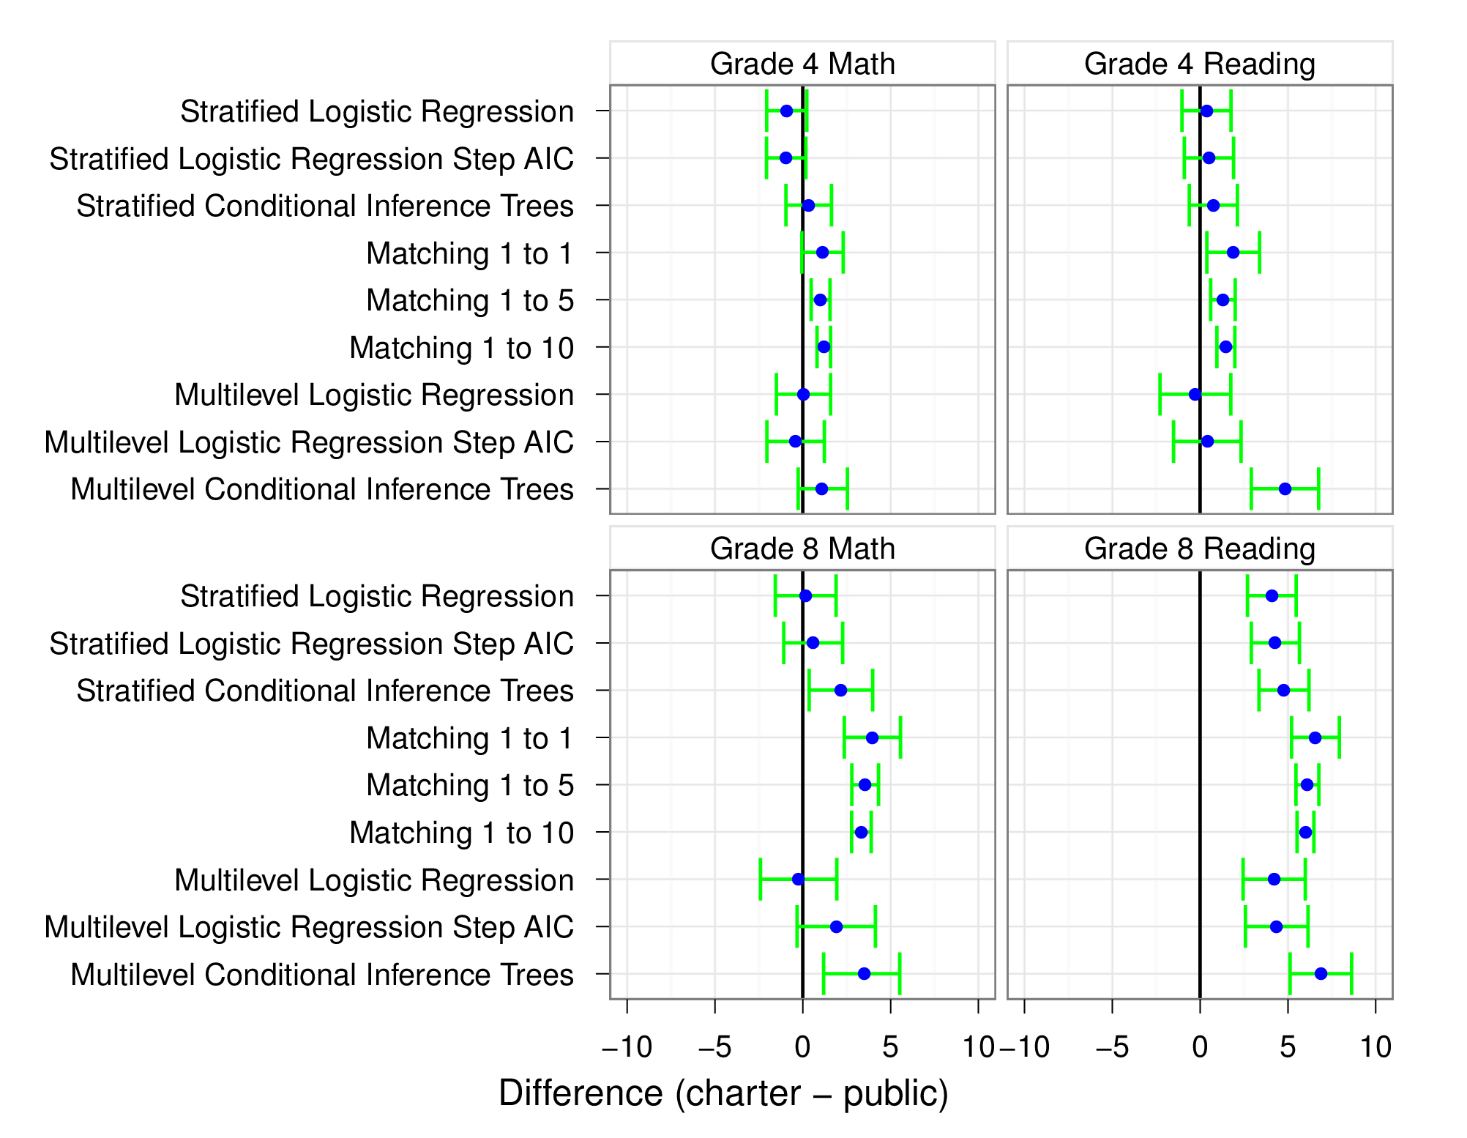
Figure 4: Summary of Overall Results
References
Akaike, H. (1974). A new look at the statistical model identification. IEEE Transactions on Automatic Control, 19, 716-723.
Allen, J., Consolettie, A., & Kerwin, K. (2009). The accountability report: Charter schools. The Center for Education Reform.
Arpino, B., & Mealli, F. (2008). The specification of the propensity score in multilevel observational studies. Munich Personal RePEc Archive.
[Sorry. Ignored \begin{APACrefURL} ... \end{APACrefURL}]
Austin, P. C. (2011). Comparing paired vs non-paired statistical methods of analyses when making inferences about absolute risk reductions in propensity-score matched smaples. Statistical in Medicine, 30, 1292-1301.
Betts, J. R., & Hill, P. T. (2006). Key issues in studying charter schools and achievement: A review and suggestions for national guidelines. National Charter School Research Project, Center on Reinventing Public Education, University of Washington Bothell.
Center for Education Reform. (2008). Annual survey of america’s charter schools.
[Sorry. Ignored \begin{APACrefURL} ... \end{APACrefURL}]
Center for Education Reform. (2010). National charter school & enrollment statistics.
[Sorry. Ignored \begin{APACrefURL} ... \end{APACrefURL}]
Center for Research on Education Outcomes. (2009). Multiple choice: Charter school performance in 16 states. Stanford University.
Foundations for the Future Charter Academy. (2007, May). Charter document.
[Sorry. Ignored \begin{APACrefURL} ... \end{APACrefURL}]
R Development Core Team. (2008). [computer software]. R: A language and environment for statistical computing. r foundation for statistical computing. Vienna, Austria: .
Braun, H., Jenkins, F., & Grigg, W. (2006). A closer look at charter schools using hierarchical linear modeling. U.S. Government Printing Office.
Bryer, J. (2011). multilevelpsa: Multilevel propensity score analysis [].
[Sorry. Ignored \begin{APACrefURL} ... \end{APACrefURL}]
(R package version 1.0)
Carnoy, M., Jacobsen, R., Mishel, L., & Rothstein, R. (2005). The charter school dust-up: Examining the evidence on enrollment and achievement. Teacher College Press & Economic Policy Institute.
Helmreich, J. E., & Pruzek, R. M. (2009). PSAgraphics: An R package to support propensity score analysis. Journal of Statistical Software, 29(6).
Herbst, J. (2006). School choice and school governance: A historical study of the United States and Germany. Palgrave Macmillan.
Hofstede, G., & Hofstede, G. J. (2004). Cultures and organizations: Software of the mind (2nd ed.). New York, NY: McGraw Hill.
Holland, P. W. (1986). Statistics and causal inference. Journal of the American Statistical Association, 81, 945-960.
Hubbard, L., & Kulkarni, R. (2009). Charter schools: Learning from the past, planning for the future. Journal of Educational Change, 10, 173-189.
Kolderie, T. (2005). Ray budde adn the origins of the charter school.
Lander, M. (2001). School chice, Kiwi-style: When New Zealand abolished school boards. (Tech. Rep.). : Frontier Centre for Public Policy.
Larrañaga, O. (2004). Competencia y participación privada: la experiencia chilena en educación. (Tech. Rep.). : Estudios Publicos.
Maccall, W. (1847). The elements of individualism. London: John Chapman.
Nelson, F. H., Rosenberg, B., & Meter, N. V. (2004). Charter school achievement on the 2003 national assessment of educational progress. Washington, DC: American Federation of Teachers.
[Sorry. Ignored \begin{APACrefURL} ... \end{APACrefURL}]
Rosenbaum, P. R., & Rubin, D. B. (1983). The central role of the propensity score in observational studies for causal effects. Biometrika, 70, 41-55.
Stuart, E. A. (2010). Matching methods for causal inference: A review and a look forward. Statistical Science, 25, 1-21.
Stuart, E. A., & Rubin, D. B. (2008). Best practices in quantitative methods. In J. Osborne (Ed.), (p. 155-176). Sage Publications.
Swart, K. W. (1962). "Individualism" in the mid-nineteenth century. Journal of the History of Ideas, 23(1), 77-90.
Thoemmes, F. J., & Kim, E. S. (2011). A systematic review of preonsity score methods in the social sciences. Multivariate Behavioral Research, 46, 90-118.
Venables, W. N., & Ripley, B. D. (2002). Modern applied statistics with s (Fourth ed.). New York: Springer.
[Sorry. Ignored \begin{APACrefURL} ... \end{APACrefURL}]
(ISBN 0-387-95457-0)
Wells, A. S. (Ed.). (2002). Where charter school policy fails: The problems of accountability and equity. New York, NY: Teachers College Press.
Wohlstetter, P., & Anderson, L. (1994). What can U.S. charter schools learn from England’s grant-maintained schools. Phi Delta Kappan, 75(6), 486-491.

Appendix A

Charter Schools & Student Enrollment by State
[Sorry. Ignored \begin{singlespace} ... \end{singlespace}]

Appendix B

Thematic Maps of Number of Charter Schools by State in 2009
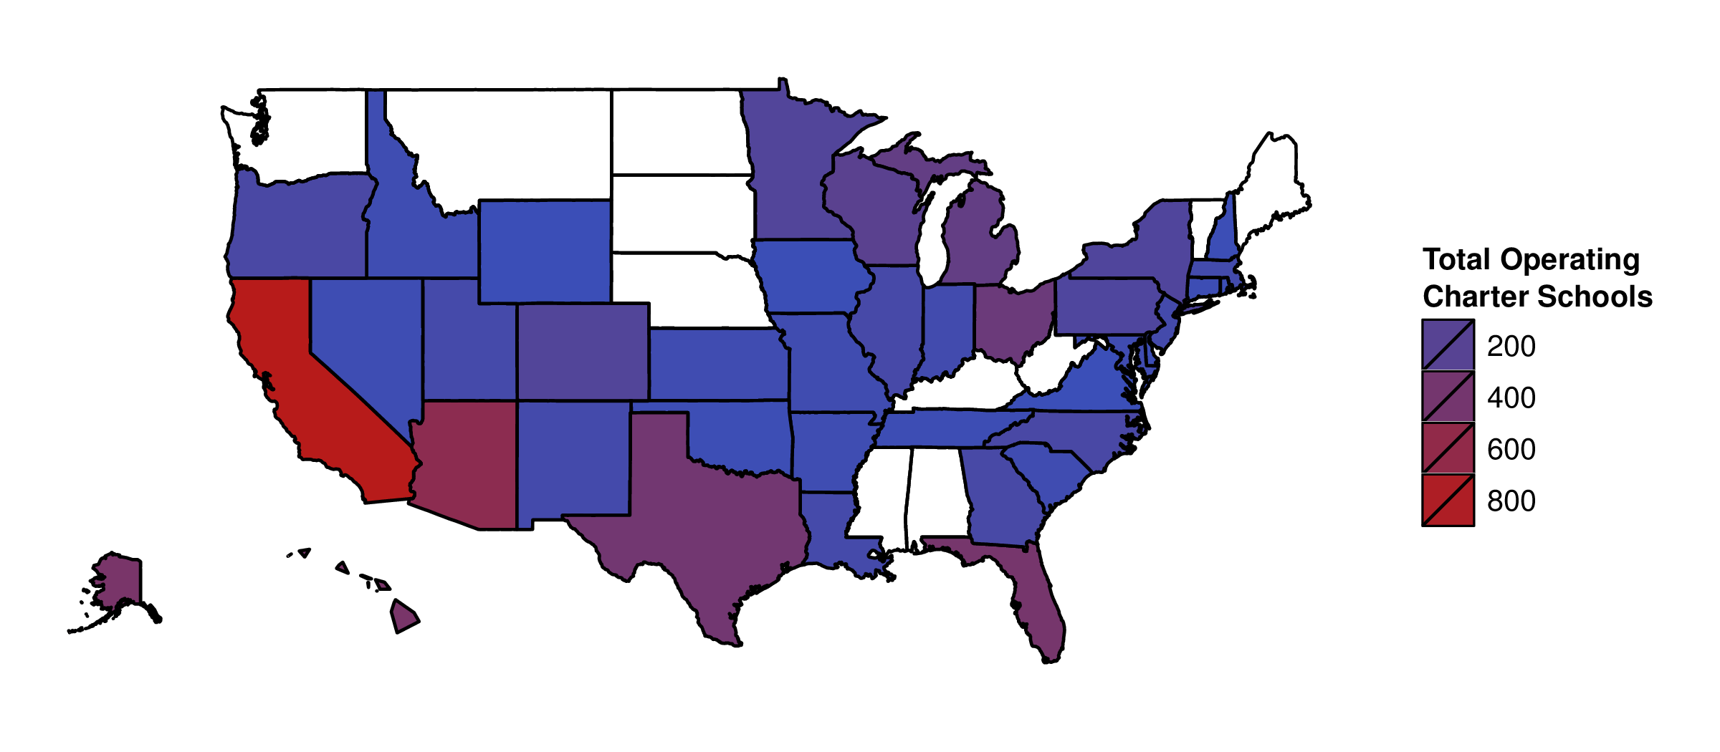
Figure 5: Thematic Map of Number of Operating Charter Schools by State in 2009
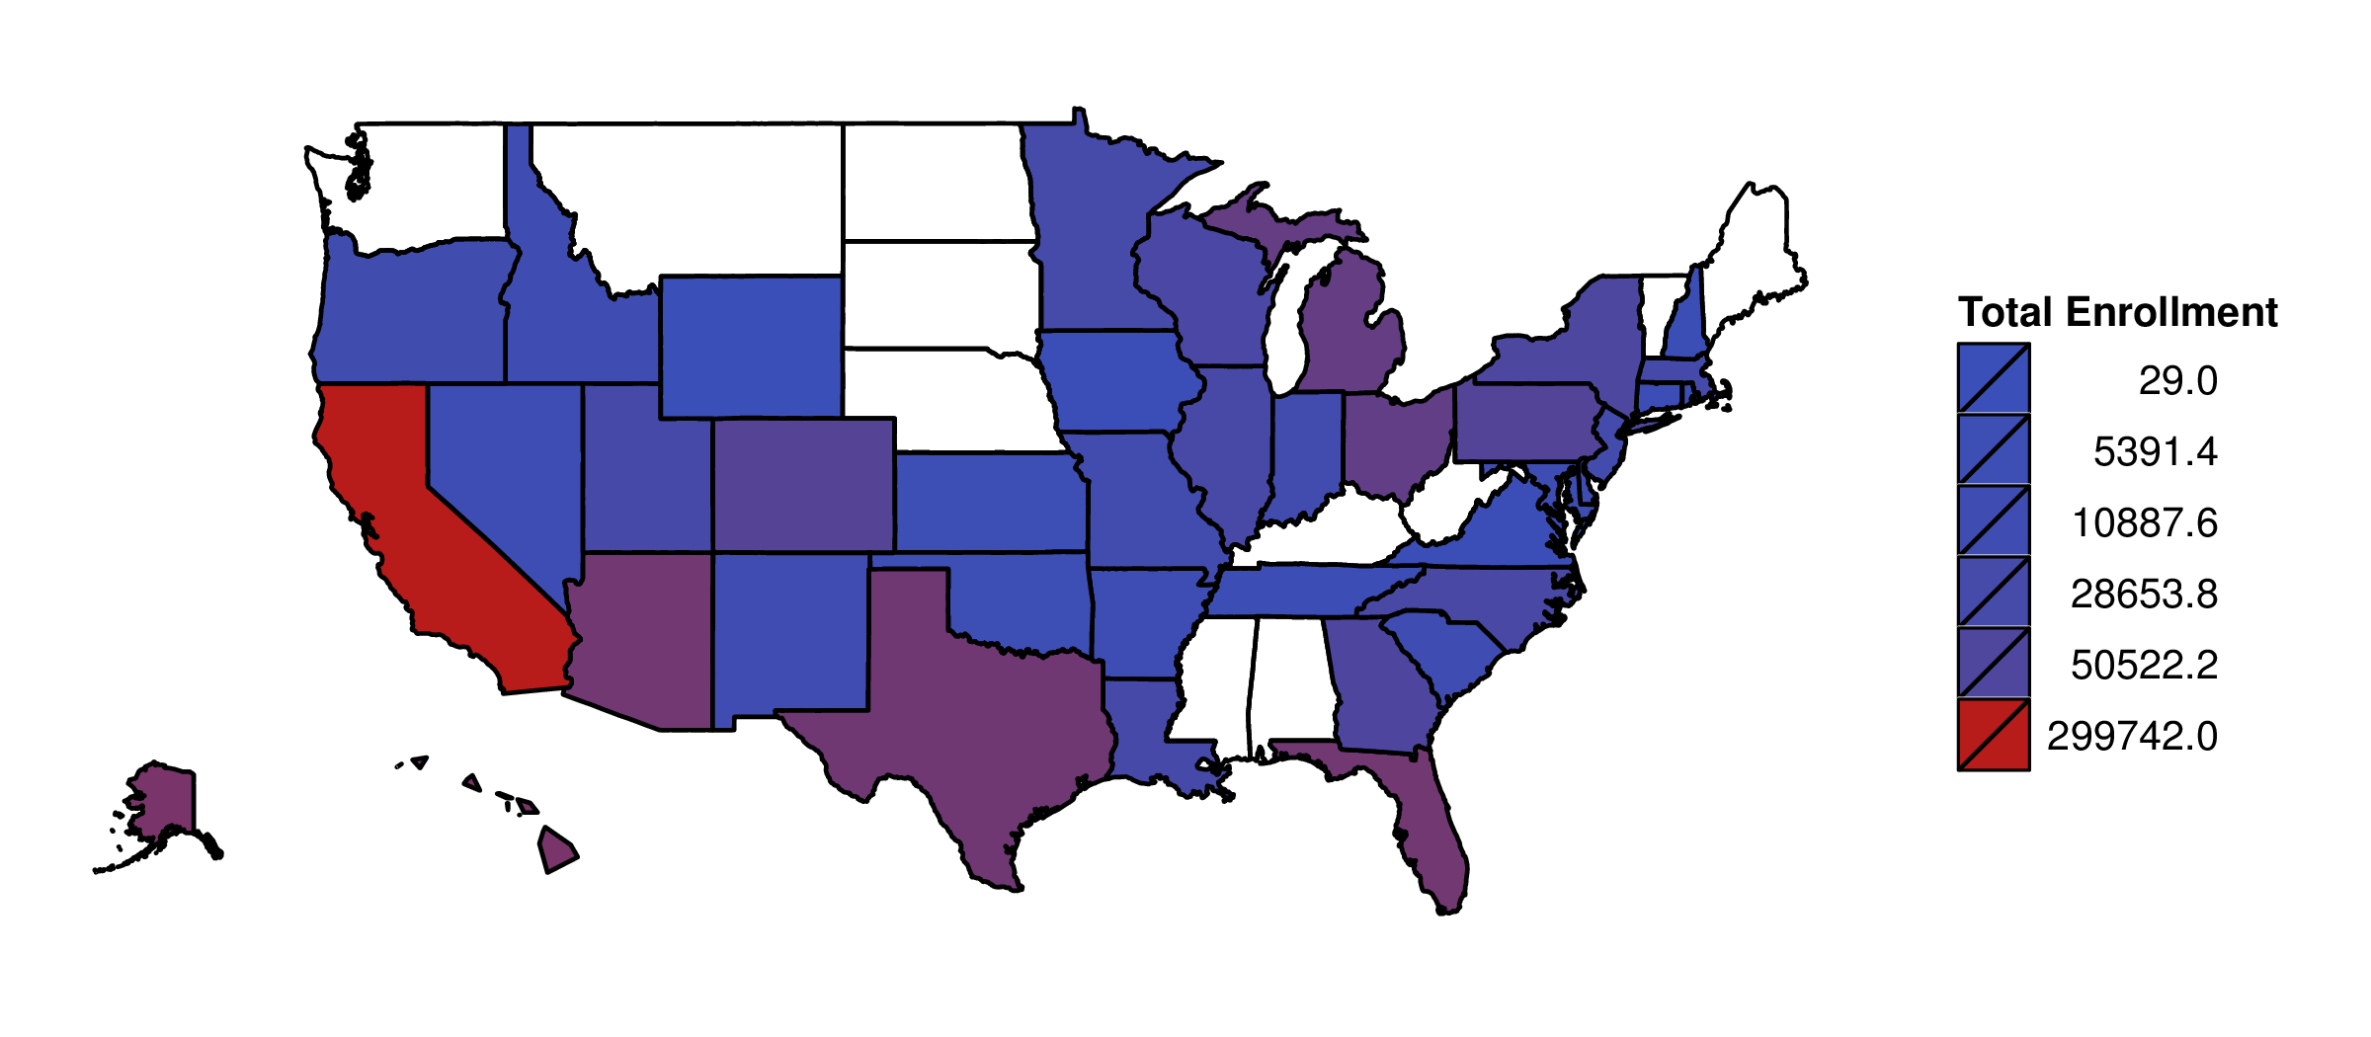
Figure : Thematic Map of Charter School Enrollments by State in 2009

Appendix C

NAEP Student Background Questionnaire

4.0.1 Core Questions
[Sorry. Ignored \begin{singlespace} ... \end{singlespace}]

4.0.2 Grade 4 Math Related Questions
[Sorry. Ignored \begin{singlespace} ... \end{singlespace}]

4.0.3 Grade 4 Reading Related Questions
[Sorry. Ignored \begin{singlespace} ... \end{singlespace}]

4.0.4 Grade 8 Math Related Questions
[Sorry. Ignored \begin{singlespace} ... \end{singlespace}]

4.0.5 Grade 8 Reading Related Questions
[Sorry. Ignored \begin{singlespace} ... \end{singlespace}]

Appendix D

Descriptive Statistics
[Sorry. Ignored \begin{singlespace} ... \end{singlespace}]

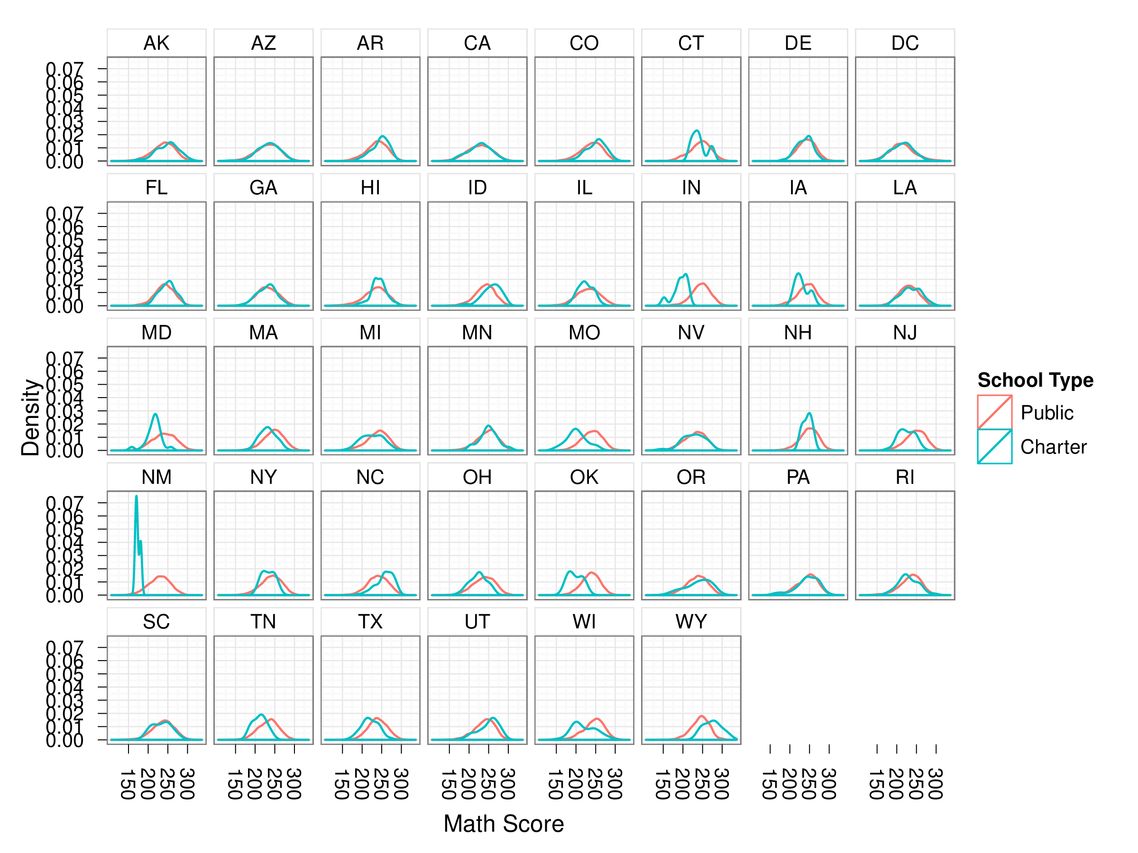
Figure 7: Density Distribution of Grade 4 Math Scores by State

Appendix E

Covariate Missingness

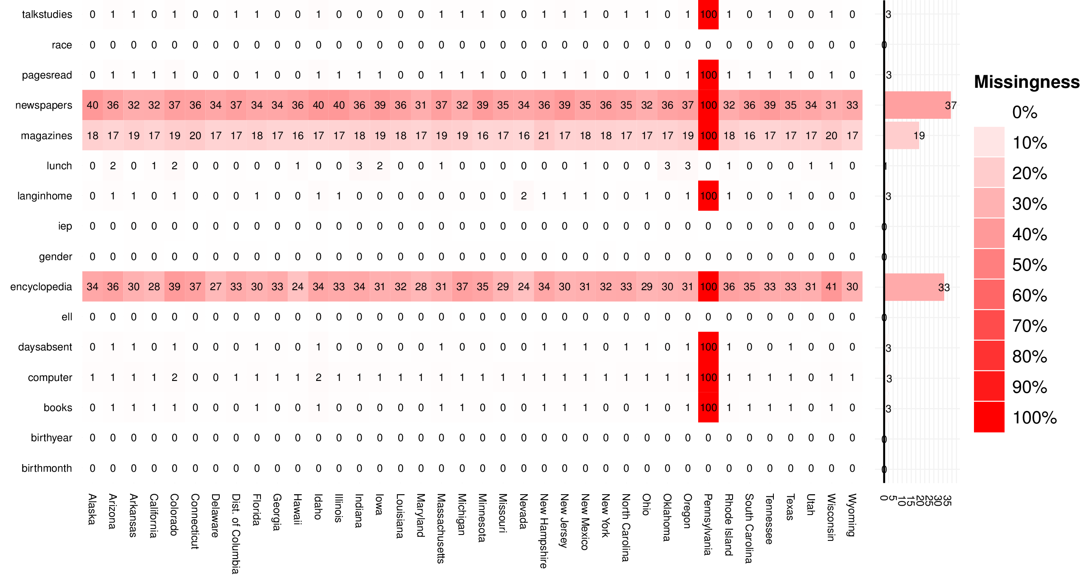
Figure 8: Covariate Missingness for Grade 4 Math

Appendix F

Logistic Regression Full Model
[Sorry. Ignored \begin{singlespace} ... \end{singlespace}]

Appendix G

Logistic Regression Step AIC Model
[Sorry. Ignored \begin{singlespace} ... \end{singlespace}]

Appendix H

Conditional Inference Trees
[Sorry. Ignored \begin{singlespace} ... \end{singlespace}]

Appendix I

Heat Maps of Relative Importance of Covariates Identified from Conditional Inference Tree Analysis

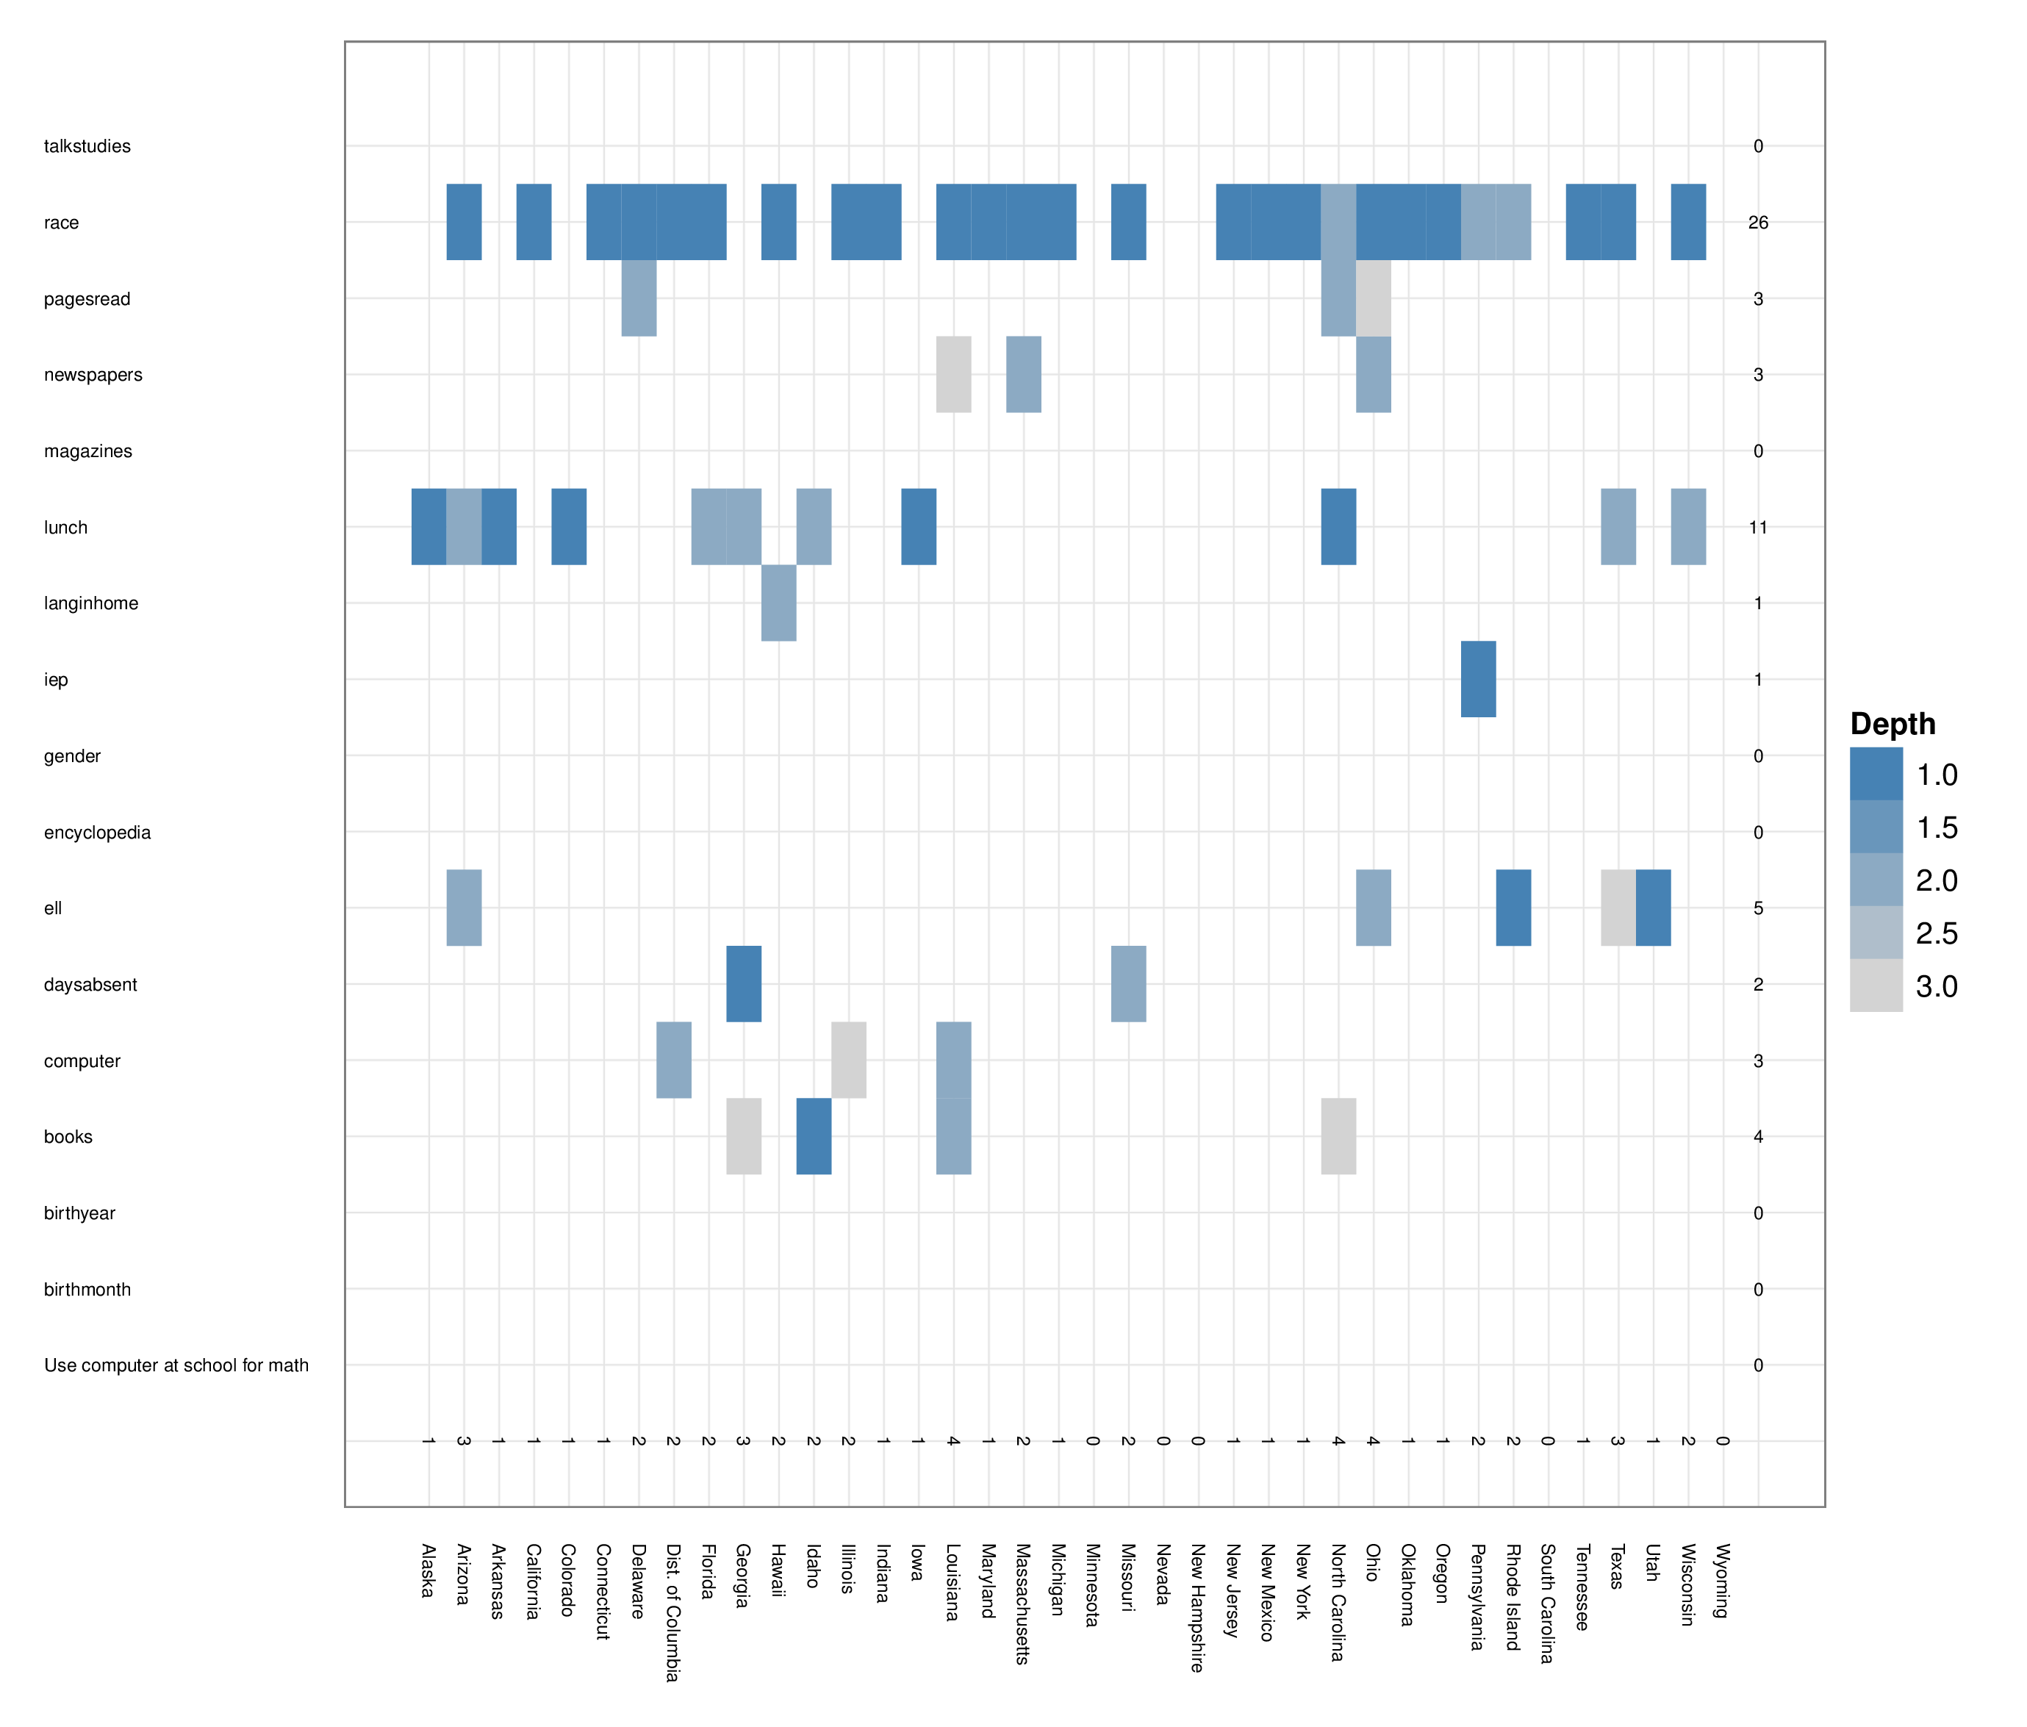
Figure 9: Heat Map of Relative Importance of Covariates for Phase I: Grade 4 Math

Appendix J

Distribution of NAEP Scores for Matched vs. Unmatched Traditional Public School Students
The figures in this appendix represent the distributions of matched and unmatched public school students as identified by the full logistic regression model. These models were chosen since they resulted in the largest number of unmatched traditional public school students vis-à-vis stratification. It should be noted that for some states there may be only one density line. This indicates that all traditional public school students within that state were either all matched or all not matched.

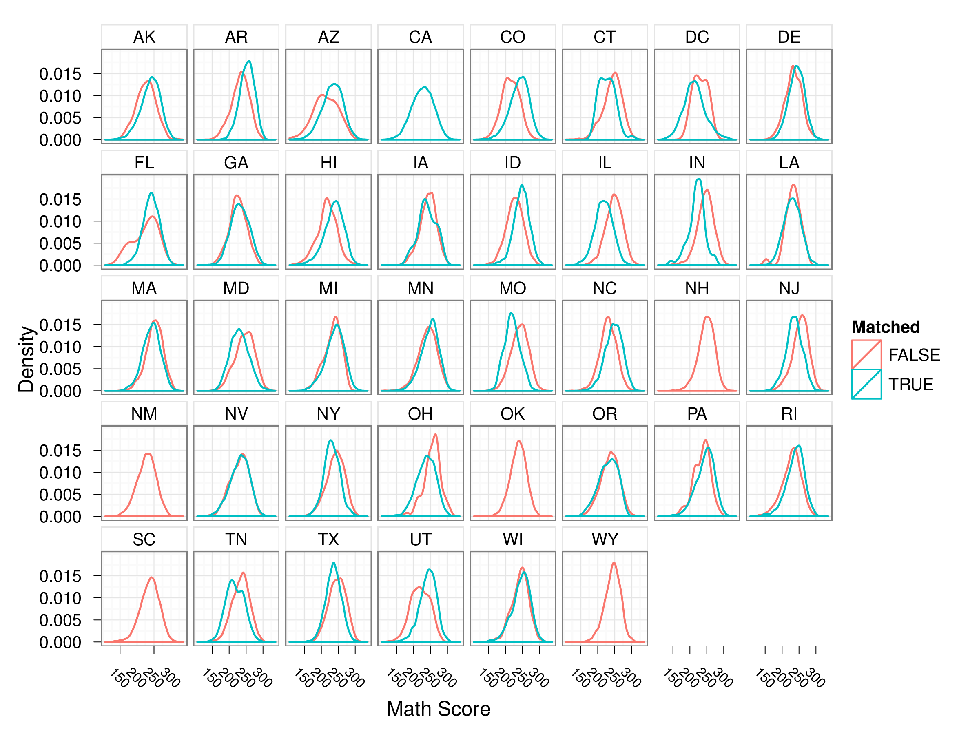
Figure 10: Density Distribution of Grade 4 Math: Matched vs. Unmatched Traditional Public School Students

Appendix K

Tables of Overall Results

Table 1: Summary Propensity Score Analysis using Stratification

 | Adjusted Mean
 | Public | Charter | Diff | ATE | n | 95% CI
 | Grade 4 Math
Logistic Regression | 237.95 | 237.38 | -0.57 | -0.57 | 146656.00 | -1.72 | 0.57
Logistic Regression Step AIC | 237.96 | 237.35 | -0.60 | -0.60 | 146656.00 | -1.73 | 0.52
Conditional Inference Trees | 237.93 | 238.27 | 0.34 | 0.34 | 146638.00 | -0.96 | 1.64
 | Grade 4 Reading
Logistic Regression | 218.27 | 218.96 | 0.70 | 0.70 | 141352.00 | -0.71 | 2.11
Logistic Regression Step AIC | 218.26 | 219.22 | 0.96 | 0.96 | 141352.00 | -0.44 | 2.37
Conditional Inference Trees | 218.26 | 219.01 | 0.75 | 0.75 | 141340.00 | -0.62 | 2.12
 | Grade 8 Math
Logistic Regression | 278.77 | 279.10 | 0.33 | 0.33 | 97563.00 | -1.40 | 2.06
Logistic Regression Step AIC | 278.77 | 279.54 | 0.77 | 0.77 | 97563.00 | -0.91 | 2.46
Conditional Inference Trees | 278.72 | 280.89 | 2.17 | 2.17 | 97521.00 | 0.36 | 3.98
 | Grade 8 Reading
Logistic Regression | 259.80 | 262.82 | 3.02 | 3.02 | 105486.00 | 1.55 | 4.49
Logistic Regression Step AIC | 259.80 | 262.67 | 2.87 | 2.87 | 105486.00 | 1.36 | 4.38
Conditional Inference Trees | 259.75 | 265.39 | 5.65 | 5.65 | 105468.00 | 4.36 | 6.93

Table 2: Summary of Propensity Score Matching

M | Charter | Public | Diff |  | ES | 95% CI
 | Grade 4 Math
1 | 233.10 | 231.92 | 1.17 |  | 0.04 | -0.01 | 2.36
5 | 233.94 | 232.88 | 1.06 | *** | 0.04 | 0.53 | 1.60
10 | 235.58 | 234.40 | 1.18 | *** | 0.04 | 0.79 | 1.57
 | Grade 4 Reading
1 | 213.33 | 212.09 | 1.24 |  | 0.04 | -0.26 | 2.74
5 | 214.35 | 213.06 | 1.29 | *** | 0.04 | 0.60 | 1.99
10 | 215.89 | 214.45 | 1.44 | *** | 0.04 | 0.93 | 1.95
 | Grade 8 Math
1 | 273.64 | 269.94 | 3.70 | *** | 0.10 | 2.11 | 5.29
5 | 276.14 | 272.56 | 3.58 | *** | 0.10 | 2.83 | 4.34
10 | 277.42 | 274.11 | 3.31 | *** | 0.09 | 2.75 | 3.87
 | Grade 8 Reading
1 | 259.93 | 254.63 | 5.30 | *** | 0.16 | 3.92 | 6.68
5 | 261.50 | 255.63 | 5.87 | *** | 0.17 | 5.21 | 6.52
10 | 262.22 | 256.76 | 5.46 | *** | 0.16 | 4.97 | 5.94
*p < .05; **p < .01; ***p < .001

Table : Summary of Multilevel PSA

 | Adjusted Mean
 | Public | Charter | Diff | ATE | n | 95% CI
 | Grade 4 Math
Logistic Regression | 236.51 | 236.55 | 3.40 | 0.04 | 83241 | -1.50 | 1.58
Logistic Regression Step AIC | 237.25 | 236.83 | 4.22 | -0.41 | 95290 | -2.05 | 1.23
Conditional Inference Trees | 236.70 | 237.78 | 3.89 | 1.10 | 118812 | -0.26 | 2.54
 | Grade 4 Reading
Logistic Regression | 217.14 | 216.87 | 4.65 | -0.27 | 80465 | -2.29 | 1.75
Logistic Regression Step AIC | 217.05 | 217.46 | 4.71 | 0.41 | 86885 | -1.52 | 2.33
Conditional Inference Trees | 216.09 | 220.92 | 5.99 | 4.83 | 108938 | 2.91 | 6.75
 | Grade 8 Math
Logistic Regression | 278.13 | 277.90 | 5.31 | -0.23 | 61795 | -2.41 | 1.94
Logistic Regression Step AIC | 278.62 | 280.52 | 6.07 | 1.90 | 69535 | -0.33 | 4.13
Conditional Inference Trees | 277.61 | 281.11 | 5.28 | 3.50 | 80594 | 1.48 | 5.52
 | Grade 8 Reading
Logistic Regression | 258.97 | 263.19 | 4.14 | 4.22 | 71270 | 2.45 | 5.99
Logistic Regression Step AIC | 259.25 | 263.61 | 4.25 | 4.36 | 77513 | 2.58 | 6.14
Conditional Inference Trees | 258.10 | 264.97 | 4.37 | 6.87 | 84352 | 5.12 | 8.63

Though this study focuses on charter schools in the U.S., Canada (Foundations for the Future Charter Academy, 2007), Chile (Larrañaga, 2004), England (Wohlstetter & Anderson, 1994), Germany (Herbst, 2006), and New Zealand (Lander, 2001) also have charter schools.
Betts and Hill (2006) cite counterfactuals as the issue. Though the issue of counterfactals is an important concept in defining causal inference, it is problematic from a practical viewpoint. Specifically, it is impossible to observe two treatment conditions (or treatment and non-treatment) on the same individual (i.e. “the fundamental problem of causal inference", Holland, 1986).
The multilevelPSA package was written by the author and is available from http://multilevelpsa.r-forge.r-project.org.

