**Hackathon Agent-Based Modeling:   
Apple Trading Hackathon for Beginning Programmers**

This hackathon is open to anyone, any major. In this hackathon, you will be experimenting with agent-based modeling in a simulated apple trading economy – setting up independent agents who then trade appples (or other items, depending on your plans) with each other. After the trading has ended, you then plot the distribution of the apples for the agents – how has the trading gone? We will be using the Mesa library for agent-based modeling <https://github.com/projectmesa/mesa>

You'll be using Python and Google CoLab and practicing strong programming fundamentals here (loops, lists, if/else statements, and functions). In terms of assumed knowledge, as long as you know some basic Python, you should be able to participate. We will provide instructions to set up Google Colab, but if you want, you can do that ahead of time. Light snacks will be provided.

This material is based in part on on <https://cs4all.cs.unm.edu/cs108.html> and on

<https://mesa.readthedocs.io/en/stable/tutorials/intro_tutorial.html>

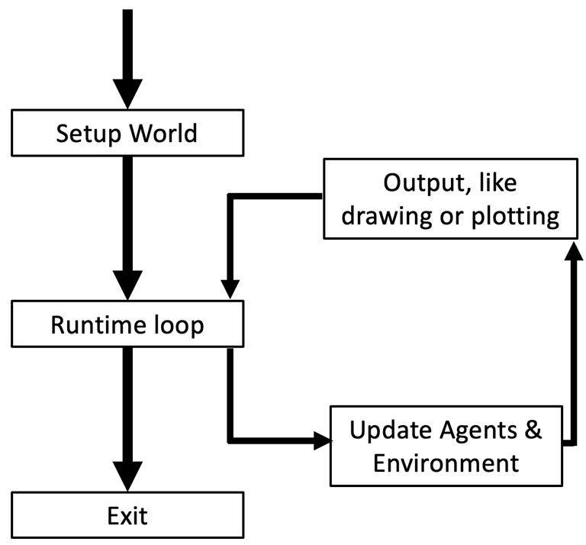

Figure 1. Agent-Based Modeling Depiction

**Date and Time:** Tuesday, April 30 from 6:00pm until 8:00pm, DSH 141

**Questions:** Profs. Amanda Bienz ([bienz@cs.unm.edu](mailto:bienz@cs.unm.edu)) and Jacob Schroder ([jbschroder@unm.edu](mailto:jbschroder@unm.edu))