Deliverables
- Architecture diagram (draw.io / Lucidchart / hand-drawn)
- 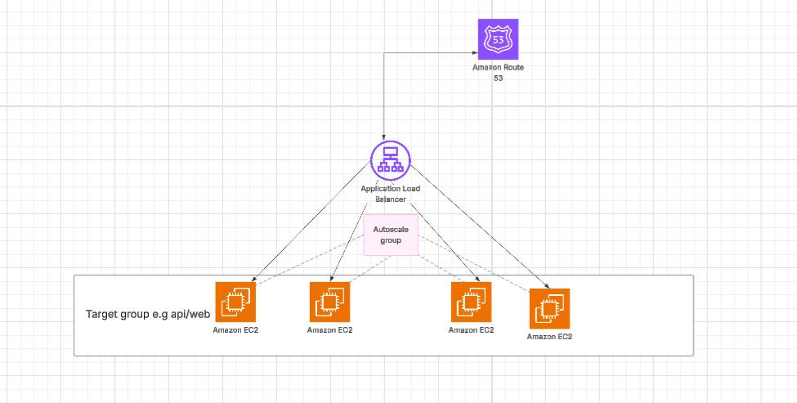
- Shell script to automate launch template and ASG creation
attached as template.sh and automaticsg.sh on the github link
- Screenshot of:
  - Route 53 record

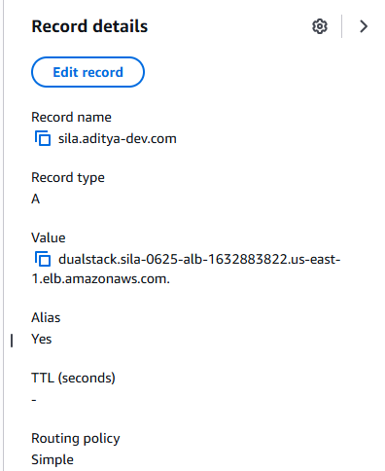

  - ALB DNS and health check

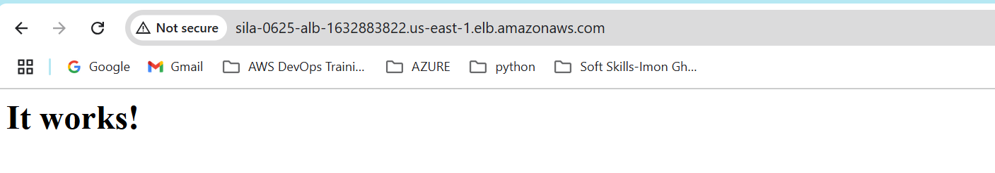
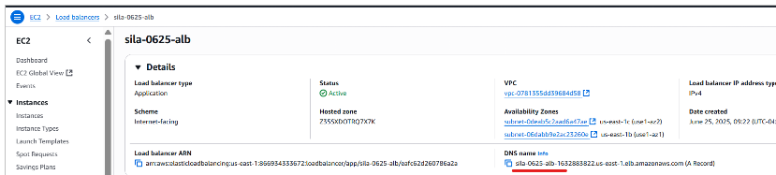

  - ASG scaling activity

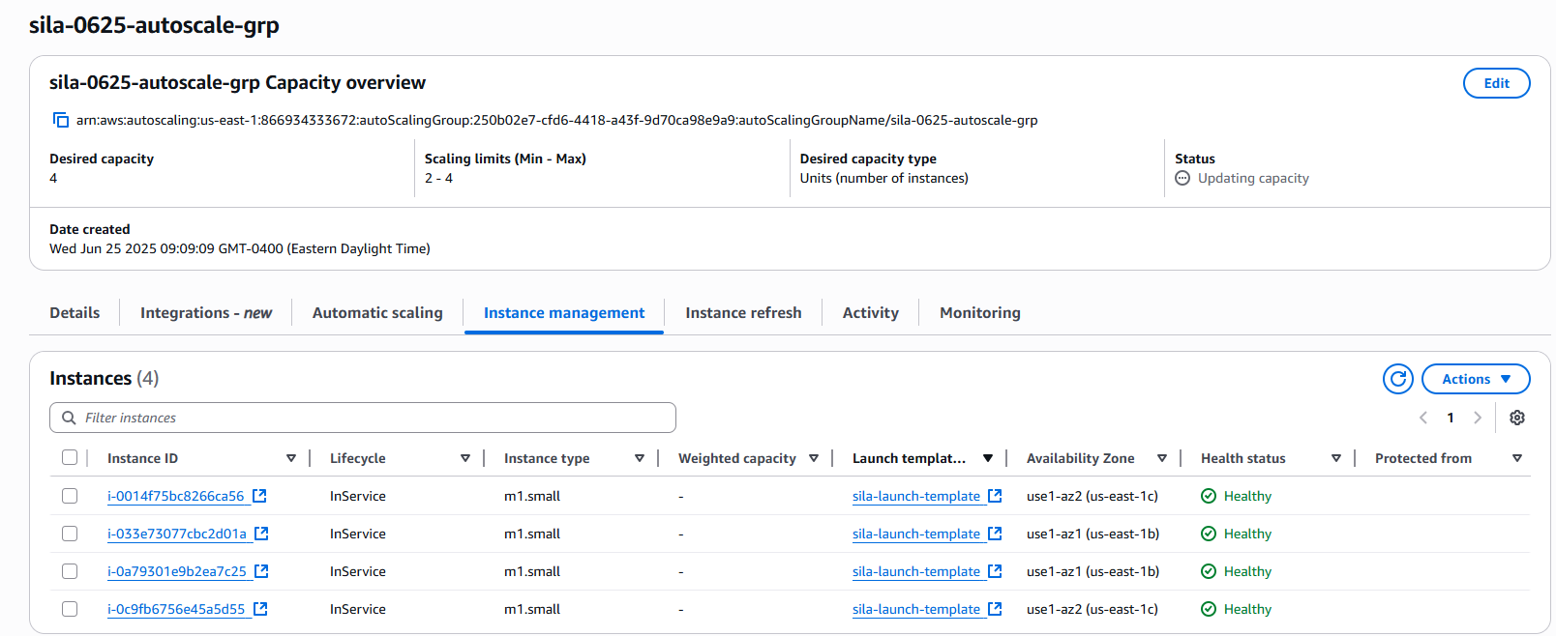
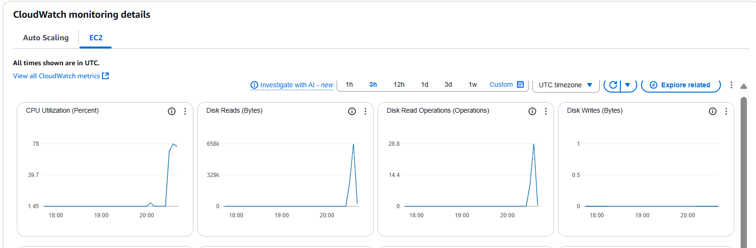

4. top output during stress
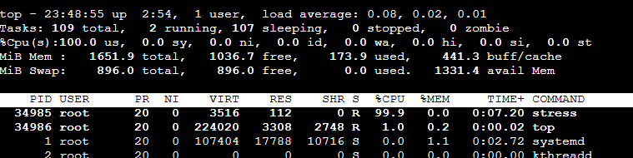

- Answers to:
  - What termination policy did you use and why? I used CPU resource utilization threshold to terminate older instances and also replace unhealthy instances

  - How does warm-up time affect your scaling behavior? The longer the warm up time the longer it took to instantiate new ec2 and therefore gave ample time for CPU usage to stabilize before new instances were processed. A shorter warm up time would cause alot of activity in creating and termination of new instances with spikes in cpu utilization

  - How would you migrate this to a Spot/On-Demand mix
I would add more weight to the spot instances so that they are not terminated faster

- Google doc with github repo link
https://github.com/jbsila/assignment-3

