SAM ROBOT
Smart Autonomous Mover
USER MANUAL
[ INSERT PRODUCTION SCREENSHOT / PHOTOGRAPH ]
Final assembled production SAM — normal / light-mode photograph

Product | SAM – Smart Autonomous Mover
Product Model / Code | [MATCH UKCA DoC]
Hardware Revision | [MATCH UKCA DoC]
Software / Firmware Version | [MATCH UKCA DoCv2.0.0 (Release Alpha)
Manual Document No. | UM-SAM-R1-001
Manual Revision | v1.0.0
Publication Date | October 2026

Manufacturer: JBS Capacitors Pvt. Ltd., India
UK Authorised Representative: JBS Applied A.I & Robotics Research Ltd
Contents
Important Safety Information 3
Technical Specifications at a Glance 4
PART I — Hardware, Chassis & Electronics Guide 5
1. Introduction to SAM 5
2. What's in the Box 6
3. Getting to Know Your SAM 6
4. Technical Specifications 7
5. Chassis & Mechanical Components 8
6. Internal Electronics 9
7. SAM PCB Overview 10
8. Power System & Battery Requirements 11
9. Sensors, LEDs & Peripheral Connections 11
10. Hardware Safety & Maintenance 12
PART II — Software & User Setup Guide 13
11. First-Time Setup 13
12. Starting SAM 13
13. Connecting Directly to SAM Wi-Fi 13
14. Connecting SAM to an Existing Wi-Fi Network 14
15. SAM Web Dashboard 15
16. Driving & Controls 15
17. Camera, LEDs, Horn & Sensors 16
18. Safety & Emergency Stop Functions 16
19. SAM SDK & Developer Access 17
20. Troubleshooting 17
21. Shutdown, Storage & Maintenance 17
22. Support, Documentation & Version Information 18
Important Safety Information
Read this manual before using SAM. Keep it for future reference. This manual combines the hardware, chassis and electronics guide with the software and user setup guide for the shipped SAM Robot.
WARNING — USER-SUPPLIED POWER SOURCE
SAM is supplied without a battery or charger. Provide your own 12 V lithium or lead-acid battery (or a regulated 12 V DC source) and observe the correct polarity when connecting it. See Section 8.

WARNING — 5 V POWER INPUT
Use only one approved 5 V supply source for the SAM 5 V rail. Do not simultaneously supply the rail from both the onboard buck converter and the Raspberry Pi power interface. Incorrect configuration may damage the Raspberry Pi or other electronics.
The factory configuration should not be altered unless the user understands the SAM power-distribution architecture.

CAUTION — MOVING PARTS
Keep hands, loose clothing and cables away from the wheels and motors. Switch the drive/motor system OFF before lifting, opening or servicing the robot.

General safety rules
- Operate SAM on a stable, flat, clear surface.
- Do not connect independent battery packs in parallel unless explicitly approved in JBS documentation for your SAM revision.
- Do not modify power rails, jumpers or internal wiring unless you understand the SAM power architecture.
- Keep the chassis and electronics dry unless the product revision is expressly rated otherwise.
- Charge your battery only with a charger intended for that battery type, following the battery and charger manufacturers' instructions.
- Do not use SAM near stairs, roads, water or people who are not aware of the robot.
Technical Specifications at a Glance
Product | SAM – Smart Autonomous Mover
Dimensions (L × W × H) | [TECH TEAM COMPLETE – mm]
Weight (unladen, without battery) | Approx. 10 kg [estimate – confirm by weighing production unit]
Voltage requirement | 12 V DC nominal (user-supplied 12 V lithium or lead-acid battery) [confirm approved range]
Operating modes | Manual drive via web dashboard · Programmable / autonomous operation via SAM SDK · Observer (view-only) mode [confirm modes shipped]
Computing platform | Raspberry Pi 4
Sensing | Camera, four ultrasonic sensors (front / rear / left / right), IMU
Connectivity | Wi-Fi via Raspberry Pi 4 – browser-based dashboard
A full specification table is given in Section 4.
PART I
Hardware, Chassis & Electronics Guide
1. Introduction to SAM
SAM – Smart Autonomous Mover – is a programmable mobile robotics platform built around a Raspberry Pi 4, motor-drive electronics and onboard sensing. It is designed for education, research, software development, robotics experimentation and mobile payload demonstrations.
SAM is supplied fully assembled. Control is through a browser-based dashboard on a phone, tablet or laptop, and the platform can also be programmed through the SAM SDK.
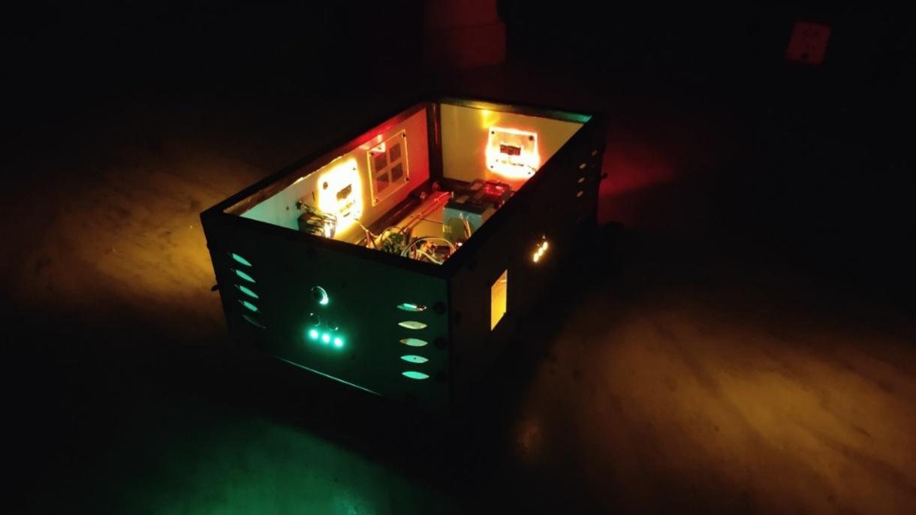
Figure 1 — SAM Robot — normal / light-mode photograph
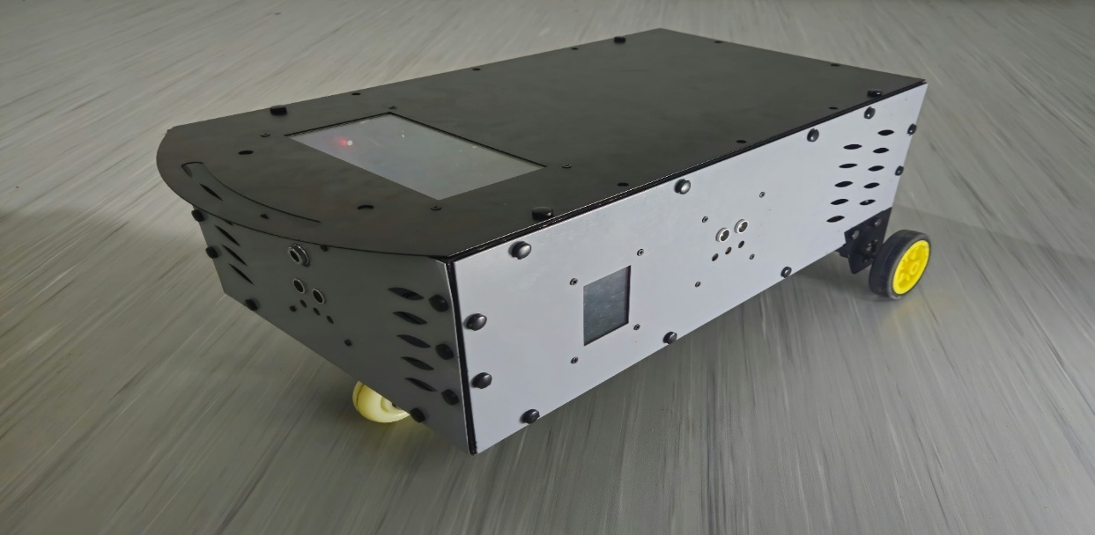

Figure 2 — SAM Robot — illuminated LED lighting, dark-environment photograph
2. What's in the Box
Your SAM Robot is supplied fully assembled and ready for initial setup. Before use, check that the package contains:
- 1 × SAM Robot, fully assembled, wheels fitted
- 1 × Raspberry Pi 4, installed
- 1 × Camera, installed
- Installed ultrasonic sensors, IMU, LEDs and associated electronics
- Battery holder / battery connection hardware [confirm exact supplied configuration]
- 1 × SAM Quick Start Guide
- Any model-specific accessories listed on the packing slip

NOT INCLUDED
Battery cells, external battery packs and mains-powered battery chargers are not supplied unless expressly stated on the applicable product packing list.
3. Getting to Know Your SAM
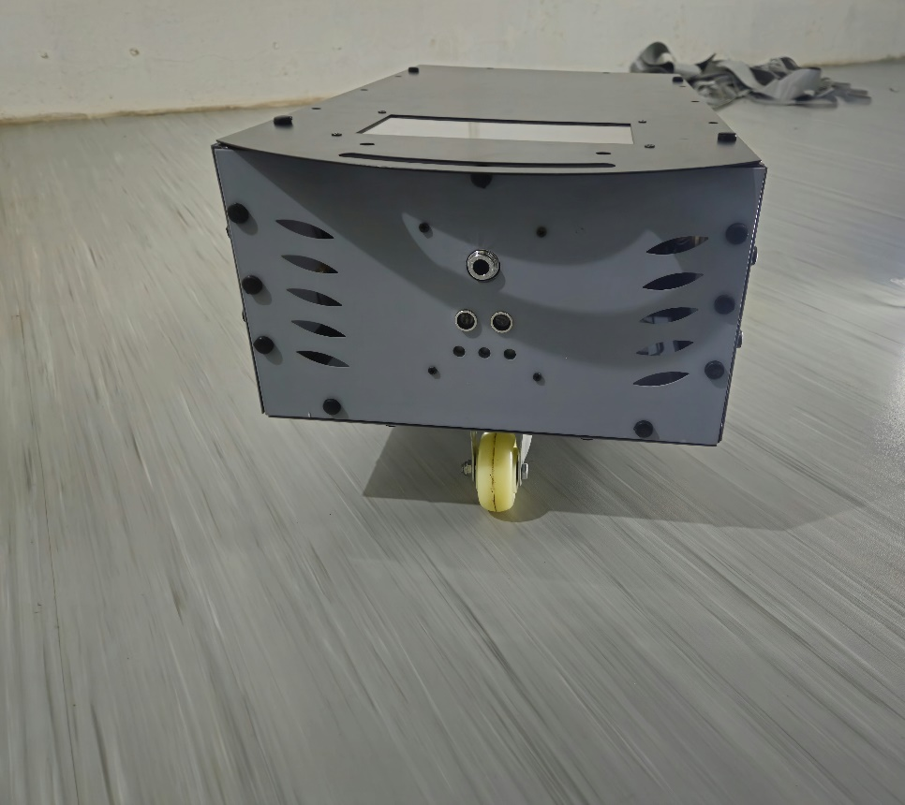
The photographs below identify the main externally accessible parts of SAM.
Castor Wheel
Camera
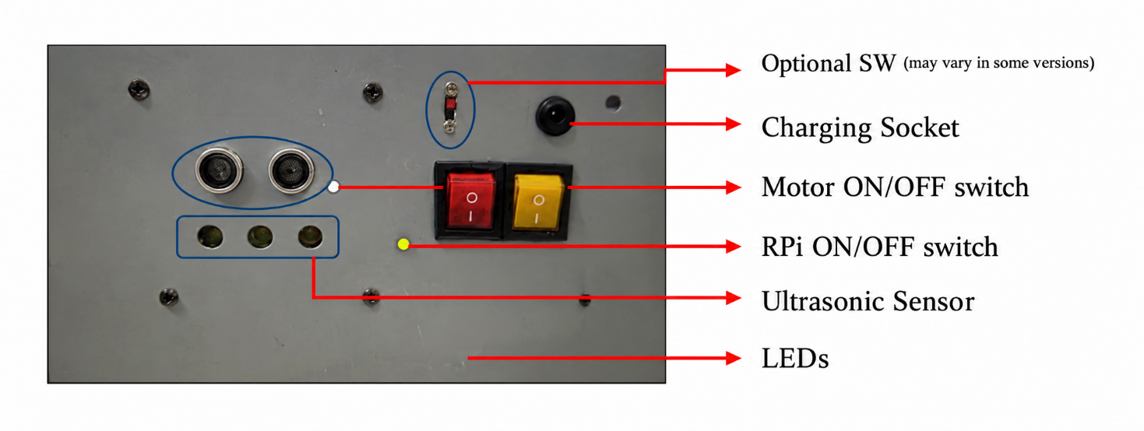

Figure 3 — External components — switches, charging socket, ultrasonic sensors, LEDs, camera and caster wheel
Part | Description
Camera | Front-mounted camera providing the live view on the dashboard.
Ultrasonic sensors | Distance sensors on the front, rear, left and right sides.
LEDs | Lighting at the front, rear, left and right [TECH TEAM CONFIRM final configuration].
Motor ON/OFF switch | Switches power to the drive system (yellow switch in photograph) [VERIFY label].
RPi ON/OFF switch | Switches power to the Raspberry Pi onboard computer (red switch in photograph) [VERIFY label].
Charging socket | External socket on the chassis [TECH TEAM CONFIRM function on shipped model].
Optional switch | Auxiliary switch – may vary between product versions [CONFIRM or REMOVE].
Caster wheel | Rear balance caster. The two driven wheels carry the drive motors.
4. Technical Specifications
Product name | SAM – Smart Autonomous Mover
Computing platform | Raspberry Pi 4 Raspberry Pi 4 Model B (Ubuntu 26.04.1 LTS ARM64, Python 3.14.4, FastAPI, lgpio)
Dimensions (L × W × H) | [TECH TEAM COMPLETE – mm]
Weight | Approx. 10 kg unladen, without battery [estimate – confirm]
Voltage requirement | 12 V DC nominal [TECH TEAM CONFIRM approved operating range and maximum input]
Battery type | User-supplied 12 V lithium or lead-acid battery (not included)
Logic rail | 5 V DC via onboard buck converter
Operating modes | Manual drive (web dashboard) · Programmable / autonomous (SDK) · Observer / view-only [confirm]
Drive | Two driven wheels with DC geared motors [TECH TEAM CONFIRM encoder configuration]
Caster | Rear balance caster
Ultrasonic sensing | Four directions: front, rear, left and right
IMU | Installed [TECH TEAM CONFIRM model]
Camera | Installed [TECH TEAM CONFIRM model / resolution]
LEDs | Front / rear / left / right [TECH TEAM CONFIRM final configuration]
Rated payload | [TECH TEAM CONFIRM]
Wi-Fi / Bluetooth | Via Raspberry Pi 4 [TECH TEAM CONFIRM shipped radio configuration]
5. Chassis & Mechanical Components
SAM is supplied assembled with its wheels fitted. The chassis provides mounting locations for the drive system, caster, electronics, sensors and the user-supplied power source. Chassis-mounted components are secured with M3 fasteners [confirm against final production revision].
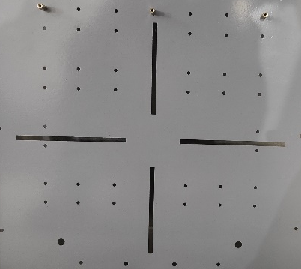

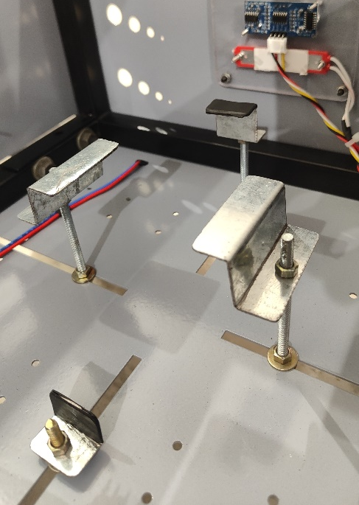
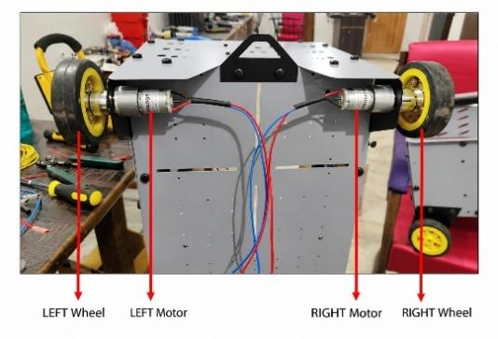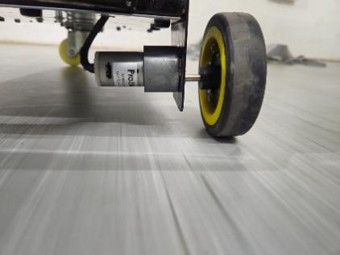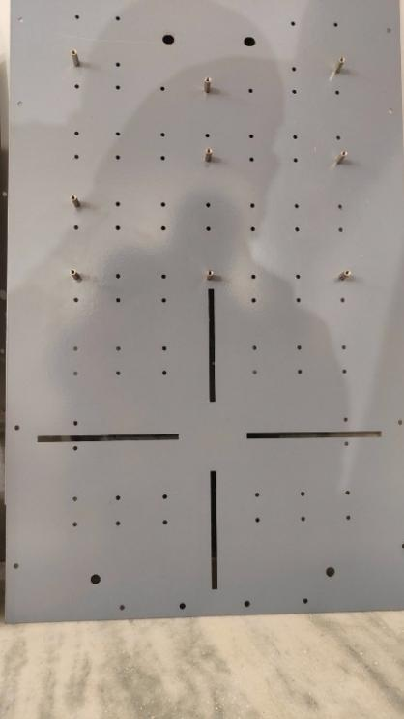
Figure 4 — Production chassis — top, front, rear and underside views with numbered component callouts
6. Internal Electronics
The internal assembly includes the Raspberry Pi 4, SAM PCB, motor driver, buck converter, IMU/buzzer and the sensor/LED modules at the front, rear, left and right of the chassis. The 12 V battery is user-supplied.
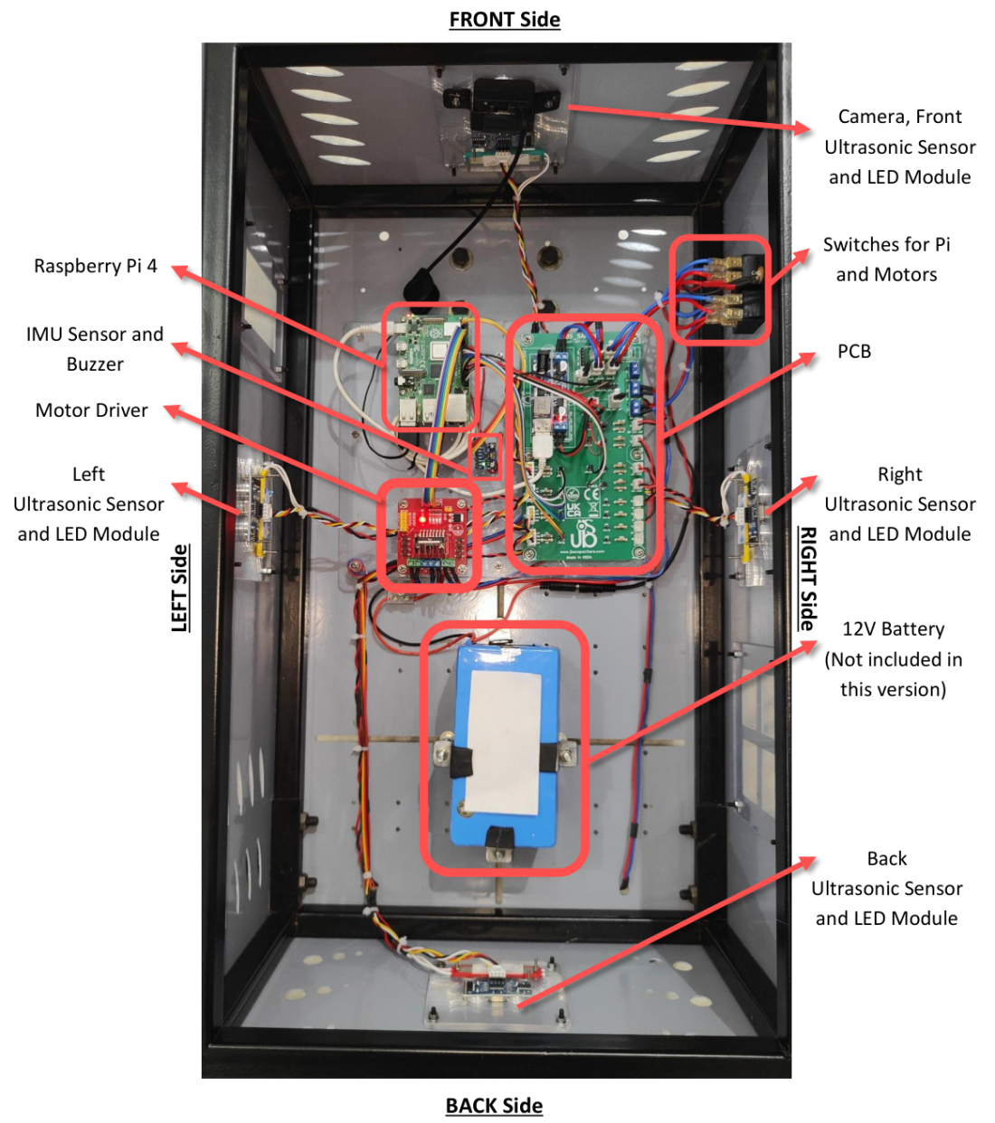

Figure 5 — Internal layout of SAM — top view with components identified
7. SAM PCB Overview
The SAM PCB provides dedicated connectors for the robot's sensors, LEDs, power distribution and peripheral devices. The numbered interfaces shown below are described in the table that follows.
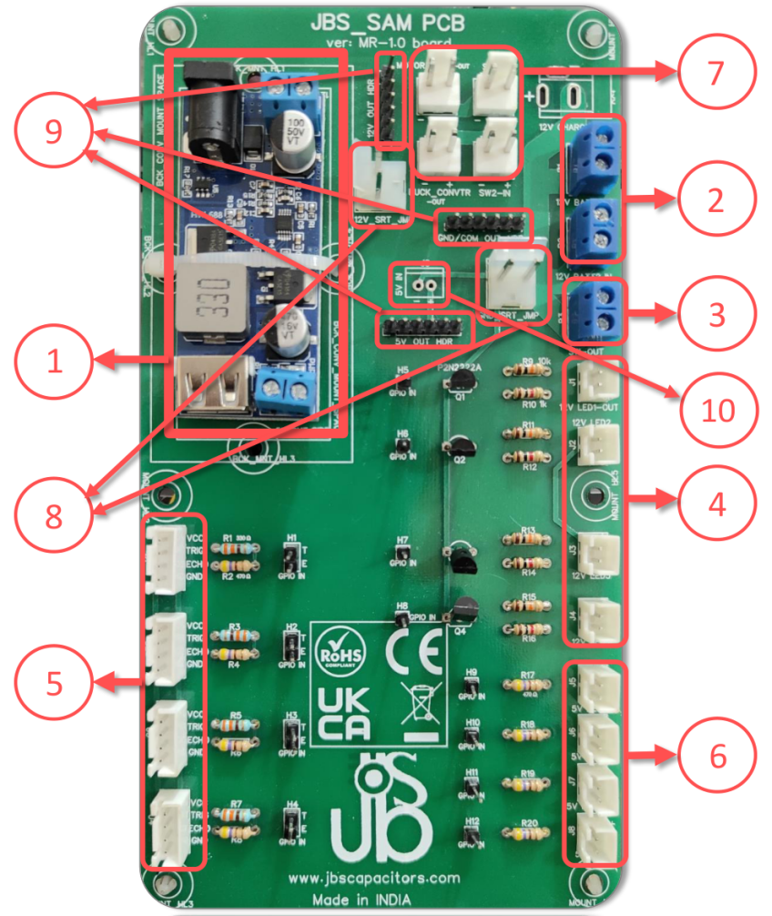

Figure 6 — SAM PCB overview with numbered interfaces
Ref. | Function
1 | Buck converter – 12 V to 5 V conversion for the Raspberry Pi and 5 V peripherals.
2 | Battery / input terminal blocks.
3 | Switch output terminal block.
4 | Four 4-pin JST connectors for ultrasonic sensors.
5 | Four 2-pin JST 12 V LED connectors.
6 | Additional 2-pin JST connections for approved 5 V peripherals.
7 | 12 V supply routing between switches, PCB, buck converter and motor driver.
8 | 12 V and GND/common power jumpers. Do not remove these jumpers during normal operation. Removing them will interrupt the associated power rail.
9 | 12 V, 5 V and GND/common distribution rails.
10 | 5 V input from the buck converter for the 5 V rail and peripherals.

WARNING — 5 V POWER INPUT
Use only one approved 5 V supply source for the SAM 5 V rail. Do not simultaneously supply the rail from both the onboard buck converter and the Raspberry Pi power interface. Incorrect configuration may damage the Raspberry Pi or other electronics.
The factory configuration should not be altered unless the user understands the SAM power-distribution architecture.

[VERIFY PCB revision and labels against the production board before release]
8. Power System & Battery Requirements
SAM does not include battery cells, an external battery pack or a charger. The user provides the power source. Any 12 V lithium or lead-acid battery may be used, provided it falls within the electrical limits below and is connected with the correct polarity.
Nominal system voltage | 12 V DC
Approved operating voltage range | [TECH TEAM CONFIRM]
Maximum permitted input voltage | [TECH TEAM CONFIRM – reconcile with UKCA DoC]
Continuous / peak current capability | [TECH TEAM CONFIRM]
Polarity / connector requirements | [TECH TEAM CONFIRM]

Charging is outside the SAM product scope. Charge the battery only with equipment intended for that battery chemistry and configuration, and follow the battery and charger manufacturers' instructions.
WARNING — BATTERIES
Do not connect independent battery packs in parallel unless that configuration is explicitly approved in JBS documentation for the shipped SAM revision.
9. Sensors, LEDs & Peripheral Connections
Four ultrasonic sensor connections are provided for front, rear, left and right sensing. Each uses a four-wire interface (5 V/VCC, trigger, echo and ground). Four 12 V LED outputs and additional approved 5 V peripheral outputs are also provided on the SAM PCB.
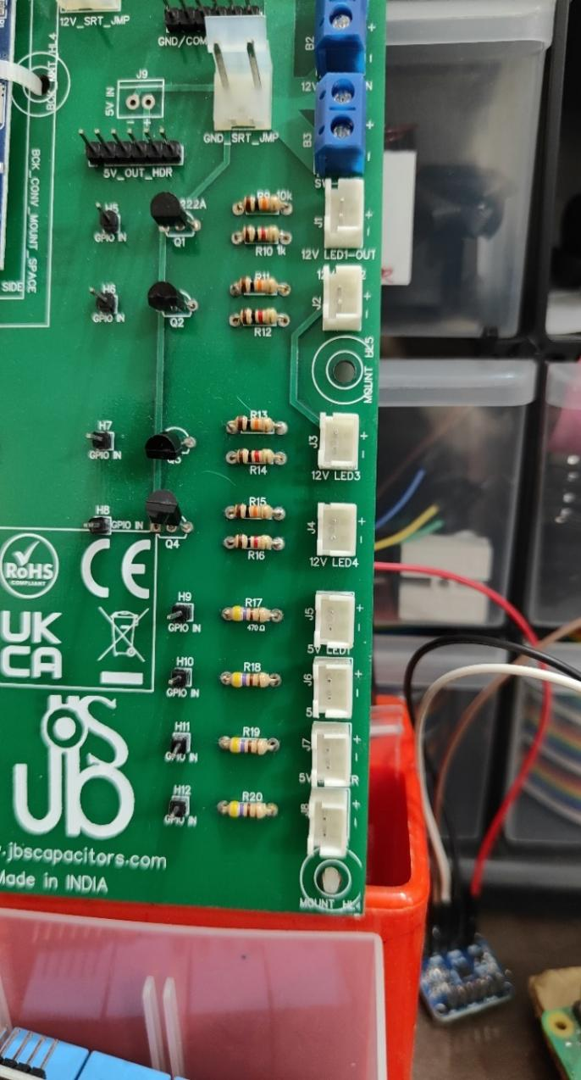
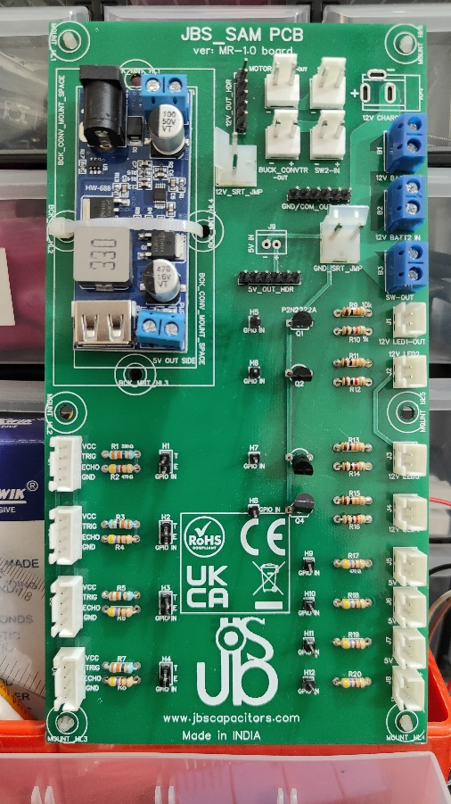
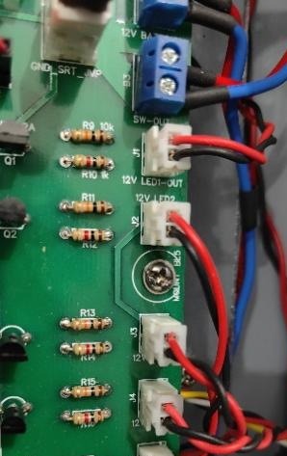

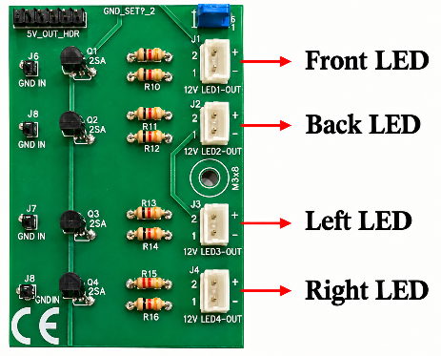
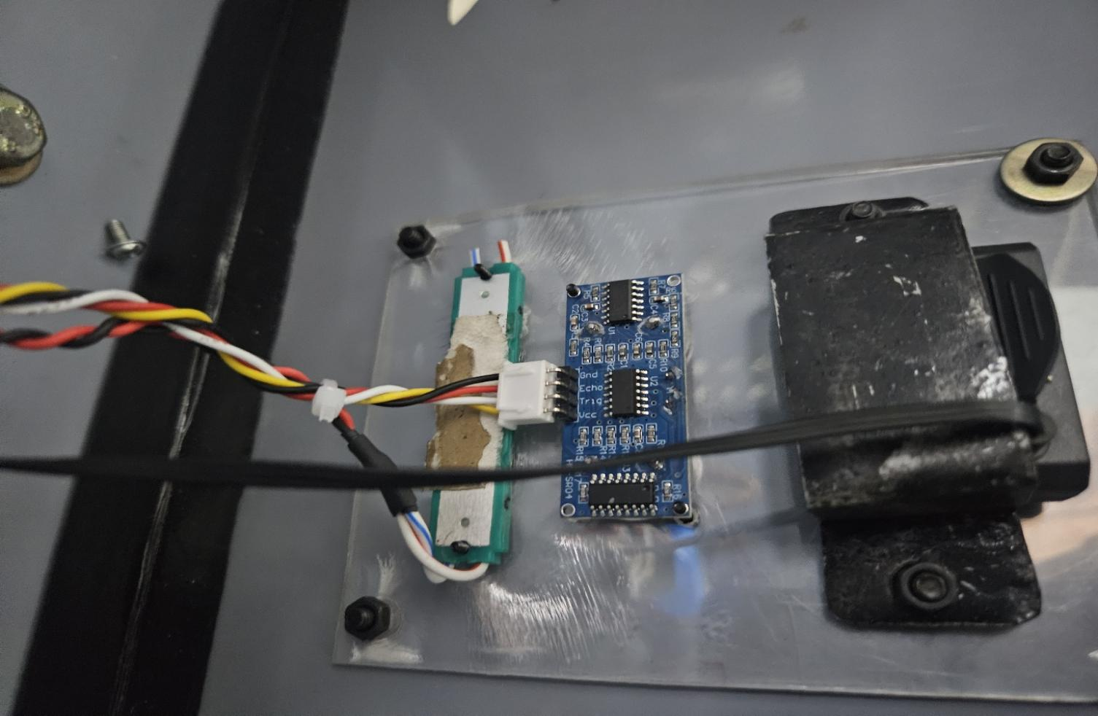

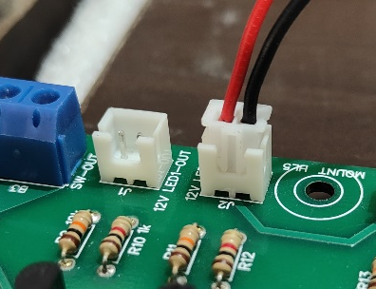
Figure 7 — Connector and pinout figure — production PCB and harness
[VERIFY connector pinout, wire colours and polarity against the production harness]
10. Hardware Safety & Maintenance
- Switch the drive/motor system off before lifting, opening or servicing the robot.
- Observe the marked polarity when connecting a user-supplied power source.
- Keep wiring clear of wheels, motor shafts and other moving components.
- Do not modify power rails, jumpers or internal wiring unless you understand the SAM power architecture.
- Use the robot on a stable surface and keep hands, loose clothing and cables away from moving wheels.
- Keep the chassis and electronics dry unless the applicable product revision is expressly rated otherwise.

[TECH TEAM ADD model-specific safety warnings, environmental limits and maintenance intervals]
PART II
Software & User Setup Guide
11. First-Time Setup
READY TO USE
SAM is supplied fully assembled with its wheels fitted. The only user requirement is to provide a 12 V battery.

Before first use you need only to provide and connect a power source, place the robot on a clear surface, power the onboard computer and connect a phone, tablet or laptop to the SAM network.
Battery requirement
Battery voltage required | 12 V DC
Accepted battery types | Lithium or lead-acid (user-supplied)

- Confirm the power source meets the electrical requirements in Section 8.
- Check polarity and secure the battery using the approved mounting/interface arrangement.
- Place SAM on a flat, clear surface before energising the drive system.
- Keep the drive/motor switch OFF while the onboard computer boots.
12. Starting SAM
SAM has two power switches: one for the onboard computer (RPi) and one for the drive system (Motor).
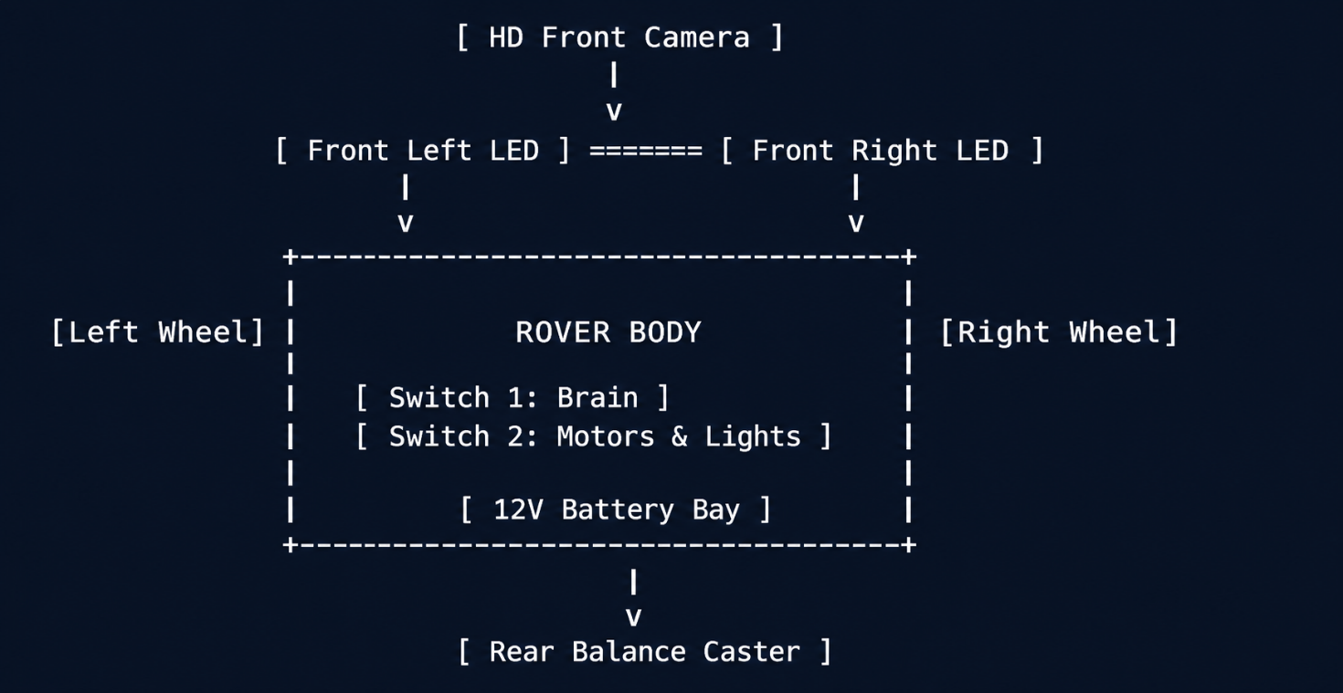
- Connect the 12 V battery.
- Turn ON the RPi switch.
- Wait for the onboard computer to finish booting 25–30 seconds (Ubuntu 26.04 & sam.service systemd daemon).
- Turn ON the Motor switch when you are ready to drive.
[ Step 1: Connect Battery ]
Plug 12V power jack
> [ Step 2: Turn ON Switch 1 ]
Computer starts (~25 sec)
> [ Step 3: Turn ON Switch 2 ]
Motors & lights ready!
C C
13. Connecting Directly to SAM Wi-Fi
SAM creates its own Wi-Fi network and a browser-based dashboard. No internet connection is needed.
Wi-Fi network name (SSID) | SAM-Rover-Setup
Initial password | raspberry
Dashboard address | http://sam.local (or http://sam.local:8000)
Fallback IP address | http://192.168.4.1 (or http://10.42.0.1:8000)
+ +
| FIRST- TIME WI- FI CONNECTION
|
| 1. Open Wi- Fi on Phone/Laptop
| 2. Enter Password: " raspberry"
| 3. Open Web Browser
-> Select " SAM_ROVER_WIFI"
|
|
|
|
-> Go to: http: /sam. local: 8000
|
+ +

Step 1: Connect to the Rover's Wi-Fi
- On your smartphone, iPad, tablet, or laptop, open your Wi-Fi Settings.
- Look for the network named:
SAM_ROVER_WIFI
- Tap it and enter the default password:
raspberry
- Wait 3–5 seconds until your device displays the Wi-Fi connected checkmark. (If your phone says "Internet not available", tap Keep Wi-Fi Connection — this is normal because the rover is communicating directly with your device).

Step 2: Open the Control Dashboard
- Open any web browser (Safari, Chrome, Firefox, or Edge).
- Type the following address into the URL bar and press enter:
http: /sam. local: 8000
(If sam. local doesn’t' t load on your device, type: http://10.42.0.1:8000)
- The SAM Rover Live Dashboard will immediately open on your screen showing your live HD camera feed!

14.Connecting Rover to Your Home or School Wi-Fi (Optional)

Once connected, you can easily link your rover to your home, office, or classroom Wi-Fi so that you don' t have to switch Wi-Fi networks every time you want to drive!
[ Top Toolbar ]
> [ Tap Wi- Fi Icon ]
> [ Select Your Wi- Fi & Enter Password ]
> [ Con
C C
- In the top navigation toolbar of the rover screen, tap the Wi-Fi Icon button (next to the camera snapshot icon).
- The Wi-Fi & Network Manager window will open.
- Tap to see all nearby Wi-Fi routers.
Scan Networks
- Select your home or school network from the list.
- Type your Wi-Fi password and tap .
Connect

- Within a few seconds, the rover will connect to your router and display its new network address.
- Now, any phone or laptop on your home Wi-Fi can open the rover by typing !
http: /sam. local: 8000

15. Connecting SAM to an Existing Wi-Fi Network
SAM can be linked to your home, office or classroom Wi-Fi so that you do not need to switch networks each time you drive.
- Open the Wi-Fi / Network settings on the dashboard.
- Scan for networks.
- Select your network.
- Enter its password and connect.
- Note the new address shown on the dashboard.
[ INSERT PRODUCTION SCREENSHOT / PHOTOGRAPH ]
Network manager — production screenshots showing each step
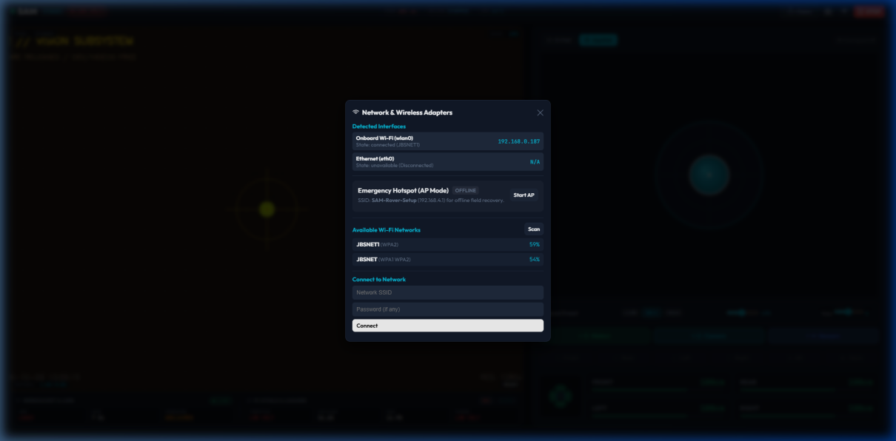
Figure 9 — Network manager — production screenshots showing each step
[VERIFY workflow against the shipped release; remove this section if the feature is not included]
16. SAM Web Dashboard
The dashboard is the main control screen for SAM. The numbered callouts on the screenshot correspond to the list below.
[ INSERT PRODUCTION SCREENSHOT / PHOTOGRAPH ]
SAM Control Dashboard — full-screen screenshot with numbered callouts
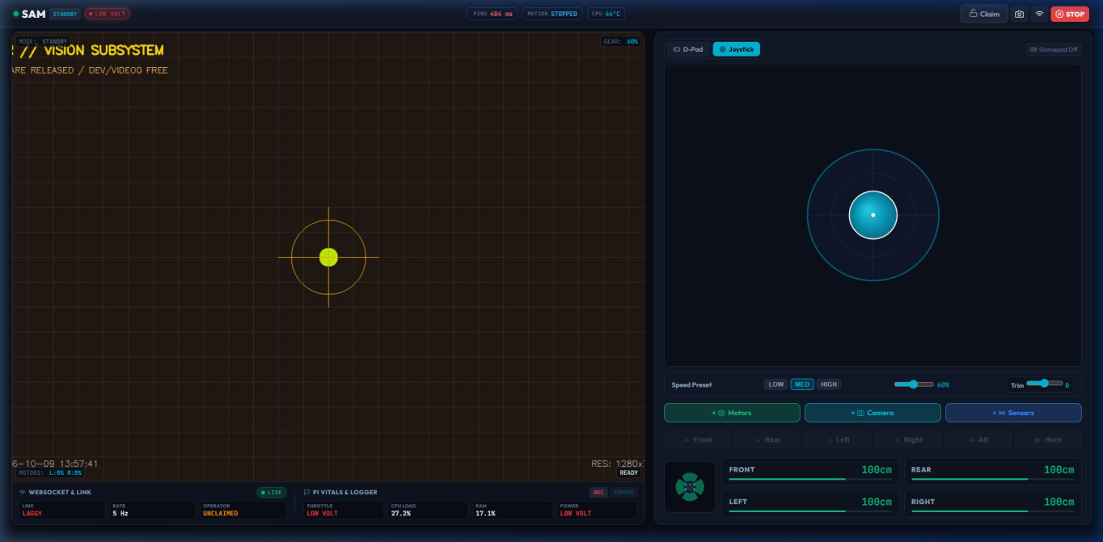
Figure 10 — SAM Control Dashboard — full-screen screenshot with numbered callouts
No. | Control | Function
1 | Connection status | Shows whether the dashboard is connected to SAM.
2 | Driver / observer status | Shows whether you are driving or only observing.
3 | Claim / Release | Takes or gives up control of the robot.
4 | Live camera | Live view from the front camera.
5 | Wi-Fi settings | Opens the network settings.
6 | Emergency Stop | Immediately halts the motors.
7 | Direction controls | Drive forward, reverse, left and right.
8 | Speed setting | Sets the driving speed.
9 | LED controls | Switches the robot lights.
10 | Horn | Sounds the buzzer.

[VERIFY every control name and behaviour against the shipped dashboard]
17. Driving & Controls
Use the on-screen controls to drive SAM. Only methods tested in the shipped software are listed in the final manual.
+ +
| [ o] LIVE | RTT: 11ms | MODE: DRIVER | [ Claim / Release ] | [ Camera] | [ WiFi] | [ STOP ] |
+------------------------------------------------------+ +
| [ MOTORS: L: 0% R: 0%]
[ HUD: READY] | [ Joystick Tab ] [ D- Pad Tab] |
+------------------------------------------------------+ +
| SPEED GEARS:
| LIGHTS:
| AUDIO:
[ 25% Crawl ]
[ 50% Normal ] [ 75% Fast ] [ 100% Max ]
[ FRONT ] [ REAR ] [ LEFT ] [ RIGHT ] [ ALL ON ]
[ HORN BEEP ]
CONTROLLER:
[ Gamepad Connected ]
|
|
|
+ +

Step 1: Claim Control Authority

To prevent two people from driving at the same time:
- When you open the page, tap the amber Claim button in the top bar.
- The badge turns bright green and says DRIVER (YOU) .
- You now have complete driving control!

Step 2: Choose Your Favorite Control Method

You can drive using any of these 4 methods:

Method A: On-Screen Touch D-Pad (Phones & Tablets)

- Tap the big directional buttons on your screen:
- Up Arrow: Drive Forward
- Down Arrow: Drive Backward
- Left Arrow: Spin Left
- Right Arrow: Spin Right
- Center Button: Stop

Method B: Touch Virtual Joystick (Thumb Control)
- Tap the tab above the controls.
Joystick
- Touch and drag the glowing cyan joystick knob with your thumb.
- Push forward to accelerate, pull back to reverse, and steer left/right smoothly with proportional turning.
- Release your thumb to stop instantly!

Method C: Keyboard (Laptops & Desktops)





- W or Up Arrow : Forward
- S or Down Arrow : Reverse
- A or Left Arrow : Spin Left
- D or Right Arrow : Spin Right
- Spacebar : Instant Emergency Brake
- H : Beep the Horn
- L : Toggle Headlights On/Off

Method D: Game Controller (Xbox, PlayStation, USB Gamepad)

Connect your favorite controller via Bluetooth or USB to your phone, tablet, or laptop:

* Right Trigger ( RT ): Accelerate forward (gentle pull = slow, full pull = fast).

* Left Trigger ( LT ): Brake / Reverse.

* Left Thumbstick: Steer left and right smoothly.

* A Button (Xbox) / Cross (PS): Beep Horn.

* X Button (Xbox) / Square (PS): Turn Headlights On/Off.

* B Button (Xbox) / Circle (PS): Emergency Stop.

* Bumpers ( LB / RB ) or D-Pad Up/Down: Shift speed gears up or down!

Step 3: Speed Gears (Choose Your Pace)

Tap any of the speed preset buttons to match where you are driving:
Gear | Speed | Best For
LOW(30%) | Super Slow & Gentle | Driving through tight doorways, indoor precision, cautious parking.
MED(60%) | Balanced Cruiser | Ideal default for living rooms, classrooms, and smooth floors.
HIGH(90%) | Speedy Patrol | Hallways, driveways, and open spaces.
SLIDER(25-100%) | Full 60 RPM Speed | Maximum hill climbing power, thick carpet, outdoor pavement.

Step 4: Lights & Horn

Headlights & Tail-lights: Tap Front , Rear , Left , Right , or All to light up the path ahead.
18. Camera, LEDs, Horn & Sensors
The dashboard shows the live camera feed and provides controls for the LEDs and horn, and displays sensor information.

19. Safety & Emergency Stop Functions
SAM includes software safety functions to help avoid collisions and loss of control.
Feature | Value | Status
Obstacle slowdown | 35 cm | Active
Obstacle stop | 15 cm | Active
Connection-loss watchdog | Stop within 500 ms (Heartbeat Watchdog) | Active
Dashboard STOP | Immediate motor halt | Instant Motor Cutoff
Automatic control release | 60 seconds (Auto-Lease Timeout) | Active

CAUTION
Software safety functions assist the operator but do not replace attentive supervision. Always keep the robot in view and be ready to press STOP or switch the Motor switch OFF.
19. SAM SDK & Developer Access
SAM can be programmed beyond the browser dashboard. Detailed API material is maintained in versioned online documentation rather than in this printed manual.
- SAM SDK and Python examples [CONFIRM release]
- API documentation [CONFIRM release]
- AI-enabled examples [CONFIRM release]
- ROS / ROS 2 bindings [INCLUDE ONLY IF shipped and supported]
- Versioned digital manual and release notes

[QR CODE / URL for official SAM documentation and software]
20. Troubleshooting
What you see | Why it happens | Easy Fix
Cannot find  SAM_ROVER_WIFI in Wi-Fi  list | Rover is still booting up or battery is disconnected. | Check that the 12V battery is plugged in and Switch 1 is turned ON. Wait a full 30 seconds for the Wi-Fi to appear.
Page says "Cannot open website" or times out | Device is not connected to the rover' s Wi-Fi. | Open your phone' s Wi-Fi settings. Confirm you are connected to SAM_ROVER_WIFI . Then go to http: /sam. local: 8000 (or  http: /10. 42. 0. 1: 8000 ).
Camera shows video, but wheels don't turn when I press buttons | - Control lease is not claimed.  - Switch 2 is turned OFF. | - Tap the amber Claim button in the top bar so it  turns green.  - Check that Switch 2 (Motors & Lights) is flipped ON.
Rover moves very slowly or stops on carpet | Speed gear is set to 25% or battery is getting low. | Tap the 50% or 100% speed button. If still sluggish,  plug the battery in to recharge.
"Observer Mode" message appears on screen | Another device is currently controlling the rover. | Have the other person tap Release , or tap Take  Control to switch the driver to your device.
Rover drives slightly crooked when going straight | Normal friction differences between the left and right motor. | Slide the Steering Trim slider slightly left or right on the dashboard until it drives straight.
Front lights or horn don't work | Rover is in Standby mode. | Tap Claim to claim driver authority. The lights and  horn will now toggle on demand.

Summary Quick Reference Card

Keep this summary handy for quick driving sessions:
- Turn ON Switch 1 (Brain) & Switch 2 (Drive)
- Connect phone/laptop Wi- Fi to: SAM_ROVER_WIFI (Password: raspberry)
- Open browser and visit: http: /sam. local: 8000 (or 10. 42. 0. 1: 8000)
- Tap the amber " Claim" button > Start driving!

Enjoy exploring with your SAM Rover!

Symptom | Check | Action
SAM Wi-Fi network is not visible | Computer power and boot state | Confirm power, turn on the RPi switch and wait for boot to complete.
Dashboard does not open | Network connection and dashboard address | Confirm your device is connected to SAM and use the production dashboard address.
Camera works but wheels do not move | Motor switch and control authority | Confirm the Motor switch is ON and press Claim.
Robot moves slowly | Speed setting and power source | Select a higher speed setting and check the battery is within the approved voltage and current range.
Lights or horn do not operate | Power and dashboard state | Confirm the applicable switch and dashboard control state.

[VERIFY all names, addresses and button labels against the shipped release]
22. Shutdown, Storage & Maintenance
- Stop the robot before shutdown.
- Turn the Motor switch OFF.
- Shut down the Raspberry Pi using the approved procedure [TECH TEAM VERIFY], then turn the RPi switch OFF.
- Disconnect the battery for storage.
- Store SAM in a dry, cool environment.
- Keep the camera lens clean and remove debris from wheels and axles.
- Follow the battery manufacturer's storage and charging instructions.
23 . Support, Documentation & Version Information
For support, software downloads, versioned manuals and release notes, use the official JBS / SAM support channel.
Support | [SUPPORT EMAIL / WEB PAGE / QR CODE]
Manufacturer | JBS Capacitors Pvt. Ltd., India [FULL ADDRESS – match UKCA DoC]
UK Authorised Representative | JBS Applied A.I & Robotics Research Ltd [FULL ADDRESS – match UKCA DoC]
Document | UM-SAM-R1-001
Revision | [X.X]

SAM Robot — Smart Autonomous Mover
User Manual | Document No. UM-SAM-R1-001 | Revision [X.X]

