**Jonathan Skaggs**

**CS 478 Perceptron**

**Arff Files**

Linearly separable data:

% 1. Title: Testing Not Linearly Separable Database  
  
@RELATION ls  
  
@ATTRIBUTE x Continuous  
@ATTRIBUTE y Continuous  
@ATTRIBUTE class {class1,class2}  
  
@DATA  
-0.8, 0.2, class1  
 0.8, -0.2, class2  
-0.5, -0.4, class1  
 0.6, 0.3, class2  
 0.1, -0.2, class1  
 0.2, -0.1, class2  
-1.0, -0.1, class1  
 1.0, 0.8, class2  
%  
%  
%

Not linearly separable data:

% 1. Title: Testing Linearly Separable Database  
  
@RELATION nls  
  
@ATTRIBUTE x Continuous  
@ATTRIBUTE y Continuous  
@ATTRIBUTE class {class1,class2}  
  
@DATA  
 0.3, 0.2, class1  
-0.4, 0.5, class2  
-0.6, -0.2, class1  
 0.7, -0.4, class2  
-0.3, -0.3, class1  
 0.9, -0.7, class2  
 0.4, 0.6, class1  
-0.4, 0.7, class2  
%  
%  
%

**Stopping Criteria**

I stopped when the sum of the log of the absolute value of each weight (sum(log(abs(weights)))) changed by less than a factor of .0001 over 5 iterations. I found that it was effective at stopping once it had converged but did not stop to early. (With different learning rates I needed to use a different change factor).

**Learning Rates**

As the training rate goes down the time taken increases as does the number of epochs. With c equal to 0.1 it would run consistently in about 20 epochs (there is a random aspect). When c was 0.01 and 0.001 it would take about 60 and 200 epochs respectively. Note: when the learning rate was so low I had to alter the stopping criteria because it began to stop prematurely. With c equal to 1 it would occasionally overcorrect and jump back and forth and not always converge correctly. (My linearly separable points are close together, see the figure above).

**Graphs**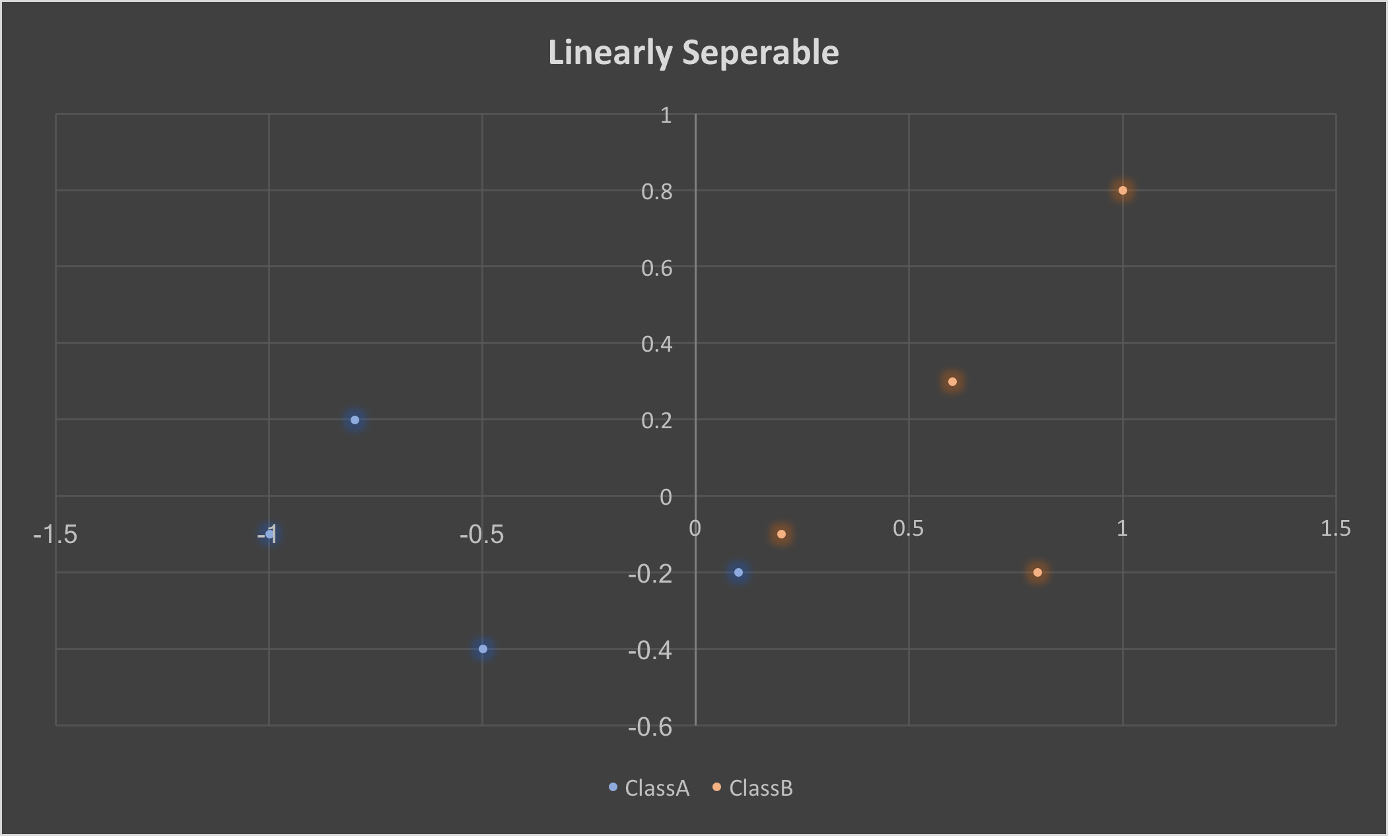

0.526162842463x 1.14647270173y = 0.106005948126

0.0543648335254x + 0.122098663595y = 0.0415516890012

**Voting Dataset**

|  |  |  |  |  |  |
| --- | --- | --- | --- | --- | --- |
| Percentage for training | 0.7 | 0.7 | 0.7 | 0.7 | 0.7 |
| Percentage for testing | 0.3 | 0.3 | 0.3 | 0.3 | 0.3 |
| Epochs | 11 | 11 | 21 | 21 | 3 |
| Time to train (in seconds) | 0.959627329 | 0.017128944 | 0.0332129 | 0.035296917 | 0.002919912 |
| Training set accuracy | 0.942446043 | 0.953416149 | 0.972049689 | 0.95652173913 | 0.931677019 |
| Test set accuracy | 0.920863309 | 0.971223022 | 0.913669065 | 0.964028777 | 0.942446043 |

**Average Testing Results**

|  |  |
| --- | --- |
| Percentage used for training | 0.7 |
| Percentage used for testing | 0.3 |
| Epochs | 13 |
| Time to train (in seconds) | 0.209637201 |
| Training set accuracy | 0.949897225 |
| Test set accuracy | 0.942446043 |
| handicapped-infants | -0.132931299 |
| water-project-cost-sharing | -0.440079435 |
| adoption-of-the-budget-resolution | -0.865280005 |
| physician-fee-freeze | 1.919873642 |
| el-salvador-aid | 0.61890204 |
| religious-groups-in-schools | -0.228061737 |
| anti-satellite-test-ban | 0.565439888 |
| aid-to-nicaraguan-contras | 0.997197118 |
| mx-missile | -0.859531055 |
| immigration | 0.45659763 |
| synfuels-corporation-cutback | -1.096486767 |
| education-spending | 0.047081398 |
| superfund-right-to-sue | 0.096323497 |
| crime | -0.070773242 |
| duty-free-exports | -0.649793822 |
| export-administration-act-south-africa | 0.389240253 |

How people voted on “physician-fee-freeze” was the most telling of whether they would vote Republican or Democrat. You can tell because its weight has the largest absolute value. Education-spending, superfund-right-to-sue, and crime were the least critical features. You can tell this because the average weights are the closest to zero.

**Iris Dataset**

I created 1 perceptron for each pair of output classes, where the training set only contains examples from the 2 classes. I ran all perceptrons on novel data and set the class to the label with the most wins (votes) from the perceptrons. In case of a tie, I used the net values to decide.

Dataset name: ../datasets/iris.arff

Number of instances: 150

Number of attributes: 5

Calculating accuracy on training set...

Time to train (in seconds): 11.1815319061

Training set accuracy: 0.966666666667