

Laboratory Directed Research and Development

Proposal Title

X-ray spectrometer for pulse by pulse full frame collection at 1 MHz

|  |  |
| --- | --- |
| **Lead INVESTIGATOR NAME:** | Angelo Dragone |
| **Phone:** | 650-926-2613 |
| **Email:** | dragone@slac.stanford.edu |
| **Date:** | 04/08/2019 |
| **Department/Division/ Directorate:** | TID-AIR Integrated Circuits Department |
| **Other Co-Leads:** | Jerome B. Hastings (LCLS) |
| **Proposal Category (1 or 2):** | 1 |
| **SLAC Agenda Critical Outcome:**  *Please select one primary critical outcome listed on the right that maps to your proposal.*  *If you select the third or fourth critical outcome, you* ***must*** *specify the area in the list below.* | ■ X-rays and ultrafast science   * Physics of the universe * Expanded portfolio of use-inspired programs and strategic partnerships: ***select what applies*** * Biosciences * Energy * National security * Quantum information science * State-of-the-art capabilities: ***select what applies*** * Advanced accelerator technology * Instrumentation * Scientific computing |
| **Total Budget:** | $799,669.00 |
| **Proposal Term:** | **From:** 10/2019 **Through:** 09/2021 |
| **Business Manager:** | Michael Gonzalez |
| **Phone:** | 650-926-3654 |
| **Email:** | gonzalez@slac.stanford.edu |

Published By:

SLAC National Accelerator Laboratory

2575 Sand Hill Road

Menlo Park, CA 94025

This document and the material and data contained herein were developed under the sponsorship of the United States Government. Neither the United States nor the Department of Energy, nor the Leland Stanford Junior University, nor their employees, makes any warranty, express or implied, or assumes any liability or responsibility for accuracy, completeness or usefulness of any information, apparatus, product or process disclosed, or represents that its use will not infringe privately owned rights. Mention of any product, its manufacturer, or suppliers shall not, nor it is intended to imply approval, disapproval, or fitness for any particular use. A royalty-free, non-exclusive right to use and disseminate it for any purpose whatsoever, is expressly reserved to the United States and the University.

I. Executive Summary

The future of LCLS-II and LCLS-II HE is focused on 1 MHz operations. There is a critical urgent need to develop detectors that could exploit fully the potentials of this unique machine. The challenge is to have detectors truly capable for pulse by pulse collection at the full rate and there are no existing direct detection 1 megaframe per second (Mfps) x-ray pixel cameras. The clear scientific return that a MHz FEL could provide will be dramatically reduced without cameras matching its repetition rate.

The goal of this proposal is to design, fabricate and characterize a prototype of a small area X-ray camera with spectroscopic performance capable of full frame operation at 1MHz by adopting an architecture with an extremely high level of parallel processing capabilities reading signals from the sensor pixels. This is a key building block whose successful implementation will provide the basis and a risk mitigation for the development of large area cameras capable of matching the full rate of the LCLS-II.

A successful prototype will constitute an additional milestone that will position our laboratory and TID-AIR as the leading place for the development of high rate X-ray detectors in US. It will be a breakthrough enabler for a critical subset of science experiments planned at LCLS-II and for several tools for diagnostics enabling advanced modes of operation of the accelerator in support the AD mission. A key scientific opportunity is the capture of “rare events”, ultimate goal of this proposal. It will be also an ideal test platform for Machine Learning (ML) algorithms critical for relaxing the burden on the LCLS-II data acquisition system.

This LDRD will also indirectly benefit projects requiring fast waveform digitization, key features in programs like Dune, nExo and follow-on HEP projects, and expand SLAC portfolio of technology IP available to external industry partners.

**NOTICE OF RESTRICTION ON DISCLOSURE AND USE OF DATA**

***Pages [4 through__] of this document may contain information that is privileged or confidential and exempt from public disclosure, such as novel scientific or technical ideas, technology or facility concepts, budgets for LDRD work, as well as sensitive strategies and sponsor information. Sharing of such information with 3rd parties is not permitted without express consent from the Lead Investigator of this proposal.***

Different approaches can be explored to solve the “MHz challenge” and those depend strongly on the specific category of experiments the camera will be used for. The cameras and the experiments need to be co-designed. Strict collaboration between photon scientists, machine controls specialists and camera designers is critical, thus the team behind the proposal pulls together experts across TID-AIR, LCLS and AD directorates.

II. Proposal Overview

X-rays and ultrafast science is the number one major initiative at SLAC. With its continuous wave (CW) 1MHz repetition rate LCLS-II and LCLS-II HE are going to enable unprecedented opportunities for new science. To fully exploit the potential of these machines it is critical to have X-ray cameras that can match their repetition rate. This is not only true for science experiments but also for beam diagnostics. As of today there are no direct detection pixel cameras that can operate at one million frames per second.

By focusing on a specific segment of applications, this category 1 LDRD proposal addresses a critical need of the lab without which we will not be able to exploit the full potentials of the superconducting LINAC.

Designing a pixel camera capable to capture one million frames every second is a complex problem that requires careful trade-offs between area, pixel size and energy resolution. Since the camera needs to be targeted for specific experimental needs, strict collaboration between photon scientists and machine controls and camera designers is critical. Working together, with science and engineering expertise across TID-AIR, LCLS and AD directorates, we aim at developing, in two years, the core components of a high rate camera matching the full potential of LCLS-II which will then lead in follow up proposals to the development of a breakthrough event-driven camera concept for the study of “rare events” and to the development of full rate pulse by pulse beam diagnostic tools.

The two key components, which constitute the risk elements of the project, are pixelated fast silicon sensors directly bonded on a fully parallel readout Application Specific Integrated Circuit (ASIC) with overlapping integration and readout phases. Such a design approach is completely orthogonal to the one used in the incremental 5-25 kfps designs planned for the initial experiments of LCLS-II. Results for the initial characterization of the sensor and ASIC and in particular their operating frame rate and energy resolution constitute our metric for success. We will reserve the possibility to seek additional LDRD funds for a third year extension in which we will characterize a prototype camera built with the core components for a real experiment at LCLS; the success being the key metric to then propose production projects.

III. Project Description

1. **INTRODUCTION**

The LCLS-II-HE First Experiments workshop held in July, 2017 identified the capture of “rare events” to be a key scientific opportunity. The specific problems highlighted as prototypical included: dielectric breakdown in polymers (i.e. how do capacitors fail), spatio-temporal defect dynamics in metals (i.e. how do materials break), and phase transitions including nucleation and martensitic transformations. These problems have the common feature of enormous technological importance and important nanoscale materials physics that is still relatively poorly understood after over a hundred years of study. Part of the challenging nature of these problems is that the interesting events happen at random, stochastic times that make observation difficult. LCLS-II-HE enables powerful new approaches to exploring the fundamental physics and mechanisms of these processes. In particular, capturing rare events with high fidelity requires the acquisition of a significant number of high-resolution images at closely spaced times triggered by the event. To enable such measurements, a detector with a rolling buffer could continuously acquire, but readout images only at a lower rate. Upon receipt of a trigger of a rare event from, for example, a simpler, full frame rate detector, the high-resolution detector would stop acquisition and the stored buffer would be read out. We note that x-ray scattering typically has inversion symmetry, I(q)=I(-q), meaning that the fast detector can observe one area of reciprocal space while a high resolution detector observes a symmetry equivalent area. Optimal position for the high rate detector, can be determined from the low rate images from the high resolution detector (fig. 1 left).

The focus of this proposal is on the development of the required fast but ‘low resolution’ triggering detector.

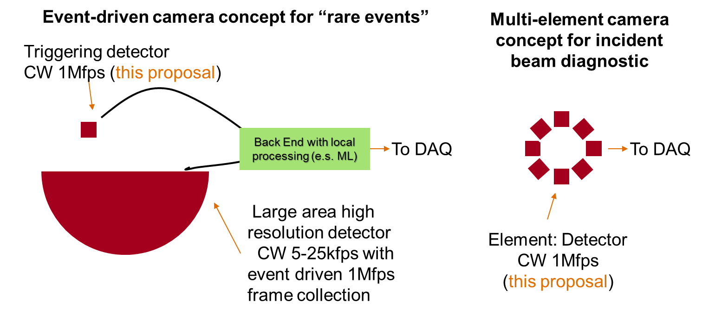Using the fast low resolution detector as a tile of a multi-element camera with different geometrical arrangements (ring, array etc.) pulse by pulse diagnostic tools at full rate can be conceived with applications that go from pulse by pulse analysis of the spectral content of the incident beam required for instance in two color experiments (fig.1 right), to the analysis of performance of beam kickers and potentially enabling advanced modes of operations like beam dithering or rastering, which require pulse by pulse monitoring.

1. **OBJECTIVES**

The first goal of this project is to develop the two core components of a direct detection x-ray camera capable of pulse by pulse full frame collection of the incident x-ray pulses and x-ray emission at one million frames per second with the following initial specs: 256 pixel Si sensor with 400 um pitch with good QE in the range between 5keV-12-keV bonded to a 256 channels ASIC with overlapping integration and readout capable of fully parallel 1MHz operation guarantying single photon sensitivity. The second goal is to assemble and characterize the two components. The results from the characterization are the metric for success.

1. **APPROACH/METHOD**

Designing a pixel camera capable of capturing one million frames every second is a complex problem that requires careful trade-offs between area, pixel size and energy resolution.

X-ray detector development plans (ex. ePix) have long term goals to achieve high frame rates up to 100 kHz with architectures that guarantee modularity and scalability and are tailored to large area cameras with millions of pixels. Limiting the number of pixels in the camera opens up an architectural path that is precluded when large area is instead critical. In that respect the approach adopted in this proposal relies on an architecture with a high level of parallelism (each pixel is readout with a dedicated signal path) and pipelining (the various phases of the signal processing overlap). This approach is thus orthogonal to the strategy adopted in the development of large area cameras ePixHR [1] and ePixUHR [2], where parallelism is limited by constrains imposed by area, fill factor and power density. Pipelining in particular is the major risk that if not implemented correctly could lead to excess electronic noise and thus poor resolution. Nevertheless we have used this approach in a previous design [3] demonstrating noise levels as low as 50 e- at integration times as small as 2 us.

The project will span two years. We will design, fabricate and characterize the architecture of the sensors and readout ASIC leveraging on the successful results from the eLine [3] and ePixS [4] projects and, more recently, ePixHR [1], ePixM [5] and CRYO [6] projects developed in TID-AIR. The first two projects are the low noise designs tailored to LCLS specifications implementing pipelining on large pixels, the third and fourth are the main high-rate detector developments for LCLS-II while the last is a waveform digitizer ASIC capable of 2 MHz operation. This approach mitigates risk and increases the chances of success.

To achieve spectroscopic capabilities at fast integration times, the sensing part of the camera will be based on a Si sensor directly bonded on top of a readout ASIC. The sensor will be engineered to minimize the capacitive load to the readout electronics performing a trade-off study between collection speed and area. A similar approach has been successfully implemented in the ePixS design. Potentially a CMOS Image Sensor (CIS) integrating amplifiers inside the sensing elements could be considered to meet more stringent energy resolution requirements. This alternative approach has been used in the design of ePixM which successfully demonstrated ultra-low noise at integration times of 4us.

The ASIC will be composed of fast waveform digitizers that will fully readout the array in parallel at intervals of one microseconds. An initial diagram of the architecture is presented in figure 2. Pixels are arranged in a 4x8 matrix of super pixels each one subdivided in 4x2 pixels and a fast waveform digitizer. The pixel operation is similar to the one adopted in ePix and eLine ASICs: a synchronous charge amplifier processes the charge from the sensor providing baseline subtraction and sampling on a set of two capacitors used at alternate intervals of 1 us. While a signal is integrated and stored on a capacitor the waveform digitizer will convert the data stored in the previous interval on the second capacitor. Each digitizer will run at 8Msps serving 8 pixels. Data from the digitizers will then be serialized and sent to the data acquisition systems. The architecture of the digitizers will be based on a successful design implemented in the CRYO ASIC.

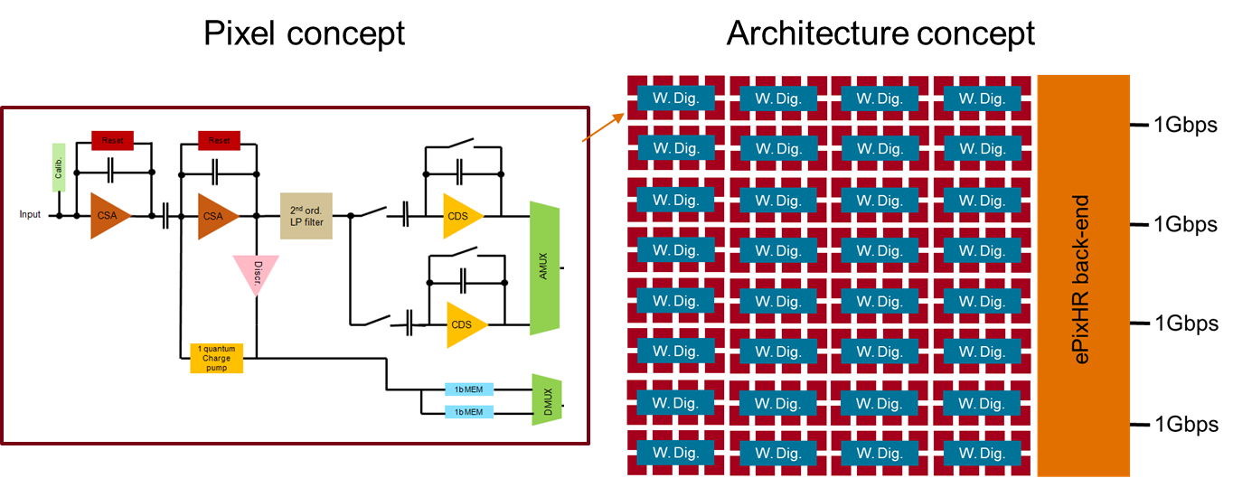

After the initials studies and simulations of the architectures based on the set of specifications described in the previous paragraph, the design team will review the results with LCLS and AD scientists aiming at finalizing an optimized set of specifications for the camera (noise, dynamic range, pixel size) as a compromise between application needs and design constraints. Designs will be then completed and devices will be fabricated. Two prototype runs are considered in the budget.

To contain the costs within LDRD limits the camera architecture will reuse data acquisition boards and housings developed for the ePixHR projects with the advantage that the prototype camera will be natively integrated with LCLS DAQ.

**D. ANTICIPATED RESULTS/ DELIVERABLES**

After the first six months of design and simulation, as a first milestone, we will review results and finalize optimal specifications. At the end of the first year the first prototypes of sensor and ASIC will be fabricated. During the first six months of the second year results from the characterization of the first devices will inform the design of the second iteration of the devices which will be then fabricated and tested during the last six months of the project. The sensor prototype and the readout ASIC will constitute the deliverable of the project. Their bench test performance will constitute the metric for success.

Successful results will allow us to seek additional funds either in the form of an LDRD third year extension or as an independent project, to build and characterize the sensor/ASIC module, assemble it in a prototype camera and characterize it with x-rays. Specifically we will look at the x-ray correlation scattering at small angles from a disordered glass with micron scale inhomogeneities using the 1 MHz 3-5keV LCLS-II capability to demonstrate the needed performance to look at small molecular systems.

IV. Management Plan

Julie Segal (TID-AIR) and Chris Kenney (TID-AIR) who bring extensive experience in the semiconductor industry and academic research to the project will be the responsible for the design of the silicon sensors. Camillo Tamma (TID-AIR) and Lorenzo Rota (TID-AIR) are experienced ASIC designers and will contribute to the circuit implementation of the readout ASIC. Dionisio Doering (TID-AIR) and Gabriel Blaj (TID-AIR) are experts in device characterization and will contribute during the testing phase. Paul Fuoss (LCLS) and Tim Maxwell (AD-LFD) are the leading scientists interested in the final applications and will inform the design guarantying the camera meets science requirements. Jerome B. Hastings (LCLS) is one of the world’s foremost experimental photon scientists and will contribute his deep and broad knowledge of science and instrumentation. Angelo Dragone is head of the TID-AIR Integrated Circuits department and is a globally-recognized expert on instrumentation electronics and photon-science detectors. He will define the architectures and manage the design of the ASIC, oversee the project, and coordinate the various components. The design work and characterization will be conducted in TID-AIR facilities. Regular meetings of the SLAC team will occur to monitor the course of the project. Documents will be kept on a website to facilitate information sharing. A resource-loaded schedule will be composed and utilized to keep the effort on track. A successful project will constitute proof of concept and mitigate risks in follow up projects. Follow-on support from the LCLS Detector program is expected to fund the development of the event-driven camera for “rare events” science and additional LCLS operation funds are expected to fund diagnostic tool projects. Opportunities to partner with companies who wish to commercialize this technology through SBIRs will be also explored.

V. Budget Explanation

The total LDRD budget requested over two years is $799 K. The following personnel will be supported: Angelo Dragone (PI) at 5% each year over the 2 year period. Specialized Sensors/ASIC/Electrical Engineers will be supported for designing and testing the sensors and the ASICs at 95% FTE in year 1, 80% FTE in year 2. The Sensors/ASIC/Electrical Engineers and the PI are billed at the Research Electrical and Software Engineer Rate Shop Rate. Furthermore, pay for M&S related to the fabrication of the devices. The remaining budget is required to support collaboration meetings with LCLS and AD scientists.

VI. References

*[1] P. Caragiulo, C. Tamma, B. Markovic, X. Xu, A. Dragone, F. Abu-Nimeh, A. Hussein Adel, D. Doering, M. Kwiatkowski, G. Haller, “Design and Characterization of a high-rate readout backend for ePix detectors at LCLS II”, IEEE Nuclear Science Symposium Conference Records (2018)*

*[2] A Dragone, et.al. “SLAC ePix Cameras Overview”, https://slacspace.slac.stanford.edu/sites/reviews/LCLS/ldac_2018/published_docs/LDAC-Dec-2018-ePixTender.pdf*

*[3] A. Dragone, P. Caragiulo, D. Freytag, P. Hart, R. Herbst, S. Herrmann, C. Kenney, J. Segal, G. Haller, “eLine100: A front end ASIC for LCLS detectors in low noise applications”,  IEEE Transactions on Nuclear Science 61(2):1001-1006 · April 2014.*

*[4] A. Dragone, P. Caragiulo, B. Markovic, et al., “ePixS: a High Channel Count X-Ray Spectroscopy Detector for X-Ray FELs,” IEEE Nuclear Science Symposium Conference Record (2015).*

*[5] A Dragone, et.al. , “Soft X-Ray Application: ePixM (CMOS Monolithic Sensor) for LCLS-II”, https://slacspace.slac.stanford.edu/sites/reviews/LCLS/ldac_2018/published_docs/LDAC-Dec-2018-ePixM.pdf*

*[6] A. Dragone, A. Pena Perez, A. Gupta, H. Ali, C. Tamma, P. Caragiulo, B. Markovic, “CRYO: A waveform digitizer/serializer for cryogenic TPC experiments”, https://indico.fnal.gov/event/15696/session/0/material/0/1.pdf.*

VII. Biographical Sketch

Dr. Dragone received his PhD in Microelectronics Engineering from the Polytechnic University of Bari, Italy and from the Scuola Interpolitecnica di Dottorato, Turin, Italy. Since 2000 he has been working in the field of radiation detectors where he is specialized in the design of low noise multi-channel front-end electronics and sensor interfaces. In 2004 he moved to the US and since then he has been working in the complex of the DOE National Laboratories, first at Brookhaven National Laboratory and then at SLAC National Laboratory where he now leads the Integrated Circuit Department within the Advanced Instrumentation for Research Division. During his years at the BNL Instrumentation Division he is been involved in major projects as a microelectronics designer of low noise analog and digital front end integrated circuits for applications in the fields of HEP, medical imaging, National security and most of all Photon Science. Among other he designed one of the ASIC used in the MAIA detector how won the R&D100 in 2011 and CSIRO Research Achievement Medal in 2012. During the last years he mostly worked at the design of high frame rate large dynamic range x-ray cameras for the Linac Coherent Light Source. Among the various systems developed he defined the series of ePix x-ray cameras for which he designed the architectures and implemented the core electronics with his group. At the moment he is mostly involved in the design of front end electronics for the high rate cameras at LCLS-II.

Selected Publications

*A. Dragone, et al, “ePix: a class of architectures for second generation LCLS cameras”, Journal of Physics Conference Series 493 (2014) 012012*

*A. Dragone, P. Caragiulo, B. Markovic, et al, “ePix: a class of front-end ASICs for second generation LCLS integrating hybrid pixel detectors”, NSS-MIC 2013 Conference records*

*P. Caragiulo, A. Dragone, B. Markovic, et al, “Design and Characterization of the ePix10k prototype: a High Dynamic Range integrating pixel ASIC for LCLS detectors”, NSS-MIC 2014 Conference records*

*B. Markovic, A. Dragone, P. Caragiulo, et al, “Design and Characterization of the ePix100a: a Low Noise integrating pixel ASIC for LCLS detectors”, NSS-MIC 2014 Conference records*

*A. Dragone, P. Caragiulo, D. Freytag, R. Herbst, C. Kenney, J. Segal, G. Haller, “eLine100: A Front End ASIC for LCLS Detectors in Low Noise Applications”, NSS-MIC 2012 Conference records.*

*A. Dragone, P. Caragiulo, G. A. Carini, R. Herbst, J.F. Pratte, P. O’Connor, P. Rehak, D. P. Siddons and G. Haller, “eLine10k: An High Dynamic Range Front End ASIC for LCLS Detectors”, NSS-MIC 2012 Conference records.*

*G. De Geronimo, E. Vernon, K. Ackley, A. Dragone, J. Fried, P. O’Connor, Z. He, C. Herman, and F. Zhang, ‘Readout ASIC for 3D Position-Sensitive Detectors’, IEEE Transactions on nuclear Science, Vol. 55, No. 3, June 2008*

*G. De Geronimo, A. Dragone, J. Grosholtz, P. O’Connor, E. Vernon, ‘ASIC with Multiple Energy Discrimination for High-Rate Photon Counting Applications’ IEEE Transactions on nuclear Science, Vol. 54, No. 2, April 2007.*

*D.P. Siddons, A. Dragone, D. De Geronimo, A. Kuczewski, J. Kuczewski, P. O’Connor, Z. Li, C.G. Ryan, G. Moorhead, R. Kirkham, P.A. Dunn, ‘A High-speed Detector System for X-ray Fluorescence Microprobes’ NSS 2006 conference records.*

*A. Dragone, G. De Geronimo, J. Fried, A. Kandasamy, P. O'Connor, E. Vernon, ‘The PDD ASIC: Highly Efficient Energy and Timing Extraction for High-Rate Applications’ NSS 2005 conference records Vol. 2, 914-918.*

Awards and Honors

|  |  |
| --- | --- |
| 2012 | CSIRO Research Achievement Medal - Maia X-ray Microprobe Detector and Imaging System Team (Team Member - Scepter a.k.a. PDD) |
| 2011 | R&D 100 The Maia X-ray Microprobe Detector System - (Team Member - Scepter a.k.a. PDD) |
| 2006 | IEEE Prime 2006 – IEEE Gold leaf for the publication “Pile Up Rejection and Multiple Simultaneous Events Acquisition with the PDD ASIC ” |
| 2006 | IEEE Prime 2006 – IEEE Bronze leaf for the publication “Parallel Chains Based Read-out System for a Compton Enhanced 3D PET Scanner” |

APPROVALS

Signing indicates you have reviewed the contents of this proposal, and support its submission to the LDRD process. Signatures are **required**.

__________________________________________ __________________

Administrative Supervisor Date

__________________________________________ __________________

Business Manager Date

__________________________________________ __________________

Associate Lab Director Date