Table 1
Minimum Detectable Pooled Direct Effects
 | Uncorrected |  |  |  |  |  | Corrected for unreliability
Method / heterogeneity | Actor a | Partner a | Actor b | Partner b | Actor c′ | Partner c′ | Actor a | Partner a | Actor b | Partner b | Actor c′ | Partner c′
rma(): CE (z)
I² = 0% | 0.10 | 0.10 | 0.11 | 0.11 | 0.11 | 0.11 | 0.14 | 0.14 | 0.17 | 0.17 | 0.17 | 0.17
I² = 25% | 0.11 | 0.11 | 0.12 | 0.12 | 0.12 | 0.12 | 0.15 | 0.15 | 0.17 | 0.18 | 0.18 | 0.18
I² = 50% | 0.12 | 0.12 | 0.12 | 0.13 | 0.13 | 0.13 | 0.16 | 0.16 | 0.19 | 0.20 | 0.19 | 0.19
I² = 75% | 0.14 | 0.14 | 0.14 | 0.15 | 0.15 | 0.14 | 0.18 | 0.18 | 0.22 | 0.24 | 0.22 | 0.21
rma(): RE (z)
I² = 0% | 0.12 | 0.12 | 0.13 | 0.12 | 0.13 | 0.13 | 0.16 | 0.16 | 0.19 | 0.19 | 0.19 | 0.19
I² = 25% | 0.13 | 0.13 | 0.14 | 0.14 | 0.14 | 0.14 | 0.18 | 0.18 | 0.22 | 0.22 | 0.22 | 0.21
I² = 50% | 0.16 | 0.15 | 0.17 | 0.17 | 0.17 | 0.16 | 0.21 | 0.21 | 0.27 | 0.27 | 0.26 | 0.24
I² = 75% | 0.22 | 0.22 | 0.23 | 0.23 | 0.24 | 0.22 | 0.29 | 0.30 | 0.36 | 0.38 | 0.36 | 0.33
rma(): RE (KH)
I² = 0% | 0.60 | 0.62 | 0.67 | 0.63 | 0.64 | 0.61 | 0.82 | 0.84 | > 1.00 | 1.00 | 0.97 | 0.93
I² = 25% | 0.69 | 0.70 | 0.74 | 0.74 | 0.74 | 0.72 | 0.95 | 1.00 | > 1.00 | > 1.00 | > 1.00 | > 1.00
I² = 50% | 0.84 | 0.86 | 0.92 | 0.93 | 0.94 | 0.89 | > 1.00 | > 1.00 | > 1.00 | > 1.00 | > 1.00 | > 1.00
I² = 75% | > 1.00 | > 1.00 | > 1.00 | > 1.00 | > 1.00 | > 1.00 | > 1.00 | > 1.00 | > 1.00 | > 1.00 | > 1.00 | > 1.00
rma(): RE (KH ad hoc)
I² = 0% | 0.60 | 0.62 | 0.67 | 0.63 | 0.64 | 0.61 | 0.82 | 0.84 | > 1.00 | 1.00 | 0.97 | 0.93
I² = 25% | 0.69 | 0.70 | 0.74 | 0.74 | 0.74 | 0.72 | 0.95 | 1.00 | > 1.00 | > 1.00 | > 1.00 | > 1.00
I² = 50% | 0.84 | 0.86 | 0.92 | 0.93 | 0.94 | 0.89 | > 1.00 | > 1.00 | > 1.00 | > 1.00 | > 1.00 | > 1.00
I² = 75% | > 1.00 | > 1.00 | > 1.00 | > 1.00 | > 1.00 | > 1.00 | > 1.00 | > 1.00 | > 1.00 | > 1.00 | > 1.00 | > 1.00
rma.mv(): multilevel (z)
I² = 0% | 0.11 | 0.11 | 0.12 | 0.12 | 0.12 | 0.12 | 0.15 | 0.15 | 0.17 | 0.17 | 0.18 | 0.18
I² = 25% | 0.13 | 0.13 | 0.13 | 0.13 | 0.14 | 0.13 | 0.17 | 0.17 | 0.20 | 0.20 | 0.20 | 0.20
I² = 50% | 0.15 | 0.15 | 0.16 | 0.16 | 0.16 | 0.16 | 0.22 | 0.22 | 0.24 | 0.25 | 0.24 | 0.24
I² = 75% | 0.22 | 0.22 | 0.22 | 0.22 | 0.22 | 0.22 | 0.31 | 0.31 | 0.34 | 0.34 | 0.34 | 0.33
rma.mv(): multilevel (CR2)
I² = 0% | 0.58 | 0.59 | 0.62 | 0.60 | 0.61 | 0.61 | 0.78 | 0.80 | 0.85 | 0.87 | 0.95 | 0.91
I² = 25% | 0.67 | 0.68 | 0.71 | 0.70 | 0.73 | 0.70 | 0.90 | 0.96 | 0.99 | > 1.00 | > 1.00 | > 1.00
I² = 50% | 0.82 | 0.84 | 0.86 | 0.90 | 0.92 | 0.88 | > 1.00 | > 1.00 | > 1.00 | > 1.00 | > 1.00 | > 1.00
I² = 75% | > 1.00 | > 1.00 | > 1.00 | > 1.00 | > 1.00 | > 1.00 | > 1.00 | > 1.00 | > 1.00 | > 1.00 | > 1.00 | > 1.00
Note. k = 2 (130 and 174 dyads). Entries are the smallest true pooled standardized effect detected with 80% power (two-sided α = 0.05), 1000 replications; "> 1.00" = not reached in the evaluated range. Uncorrected and corrected effects are on their own scales, so their entries are not directly comparable. CE = common effect; RE = random effects (REML); KH = Knapp–Hartung; CR2 = cluster-robust with Satterthwaite df. Heterogeneity refers to the study-level effects (τ² = I²/(1 − I²) × typical sampling variance).
Table 2
Observed Pooled Estimates and Critical Values for Significance
 |  | Critical |β| for p < .05
Effect | β | rma(): CE (z) | rma(): RE (z) | rma(): RE (KH) | rma(): RE (KH ad hoc) | rma.mv(): multilevel (z) | rma.mv(): multilevel (CR2)
Uncorrected
Actor a | 0.25 | 0.07* | 0.13* | 0.87 | 0.87 | 0.07* | 0.82
Partner a | 0.17 | 0.07* | 0.07* | 0.24 | 0.48 | 0.08* | 0.22
Actor b | 0.28 | 0.08* | 0.09* | 0.57 | 0.57 | 0.08* | 0.55
Partner b | 0.08 | 0.08* | 0.08* | 0.00* | 0.51 | 0.08* | 0.04*
Actor c′ | 0.09 | 0.08* | 0.08* | 0.03* | 0.50 | 0.08* | 0.04*
Partner c′ | 0.01 | 0.08 | 0.08 | 0.32 | 0.50 | 0.08 | 0.35
Corrected for unreliability
Actor a | 0.34 | 0.10* | 0.10* | 0.58 | 0.63 | 0.09* | 0.56
Partner a | 0.21 | 0.10* | 0.12* | 0.76 | 0.76 | 0.10* | 0.72
Actor b | 0.38 | 0.12* | 0.12* | 0.00* | 0.75 | 0.11* | 0.07*
Partner b | 0.09 | 0.12 | 0.12 | 0.09 | 0.78 | 0.11 | 0.10
Actor c′ | 0.09 | 0.12 | 0.12 | 0.08* | 0.75 | 0.12 | 0.07*
Partner c′ | −0.01 | 0.12 | 0.12 | 0.57 | 0.75 | 0.12 | 0.58
Note. β = observed pooled estimate (multilevel model; the point estimate is nearly identical across methods, see the CSV). Remaining columns give the smallest absolute pooled estimate that would have been significant under each method with these data (critical value × SE). * the observed β exceeds that value, i.e. the effect is significant under that method.
Table 3
Minimum Detectable Pooled Indirect Effects
 | Uncorrected |  |  |  | Corrected for unreliability
Indirect effect / method | I² = 0% | I² = 25% | I² = 50% | I² = 75% | I² = 0% | I² = 25% | I² = 50% | I² = 75%
Actor–actor
rma(): CE (z) | 0.016 | 0.018 | 0.021 | 0.029 | 0.032 | 0.036 | 0.044 | 0.062
rma(): RE (z) | 0.022 | 0.027 | 0.040 | 0.078 | 0.044 | 0.057 | 0.082 | 0.169
rma(): RE (KH) | — | — | — | — | — | — | — | —
rma(): RE (KH ad hoc) | — | — | — | — | — | — | — | —
rma.mv(): multilevel (z) | 0.017 | 0.022 | 0.032 | 0.065 | 0.034 | 0.046 | 0.070 | 0.144
rma.mv(): multilevel (CR2) | — | — | — | — | — | — | — | —
Partner–partner
rma(): CE (z) | 0.015 | 0.018 | 0.022 | 0.032 | 0.032 | 0.036 | 0.046 | 0.067
rma(): RE (z) | 0.021 | 0.028 | 0.040 | 0.078 | 0.044 | 0.061 | 0.087 | 0.171
rma(): RE (KH) | — | — | — | — | — | — | — | —
rma(): RE (KH ad hoc) | — | — | — | — | — | — | — | —
rma.mv(): multilevel (z) | 0.017 | 0.022 | 0.032 | 0.065 | 0.034 | 0.046 | 0.070 | 0.144
rma.mv(): multilevel (CR2) | — | — | — | — | — | — | — | —
Actor–partner
rma(): CE (z) | 0.016 | 0.018 | 0.022 | 0.031 | 0.032 | 0.037 | 0.046 | 0.067
rma(): RE (z) | 0.021 | 0.027 | 0.040 | 0.078 | 0.044 | 0.059 | 0.085 | 0.169
rma(): RE (KH) | — | — | — | — | — | — | — | —
rma(): RE (KH ad hoc) | — | — | — | — | — | — | — | —
rma.mv(): multilevel (z) | 0.017 | 0.022 | 0.032 | 0.065 | 0.032 | 0.046 | 0.070 | 0.148
rma.mv(): multilevel (CR2) | — | — | — | — | — | — | — | —
Partner–actor
rma(): CE (z) | 0.015 | 0.017 | 0.021 | 0.030 | 0.030 | 0.036 | 0.044 | 0.062
rma(): RE (z) | 0.022 | 0.027 | 0.040 | 0.078 | 0.046 | 0.057 | 0.086 | 0.169
rma(): RE (KH) | — | — | — | — | — | — | — | —
rma(): RE (KH ad hoc) | — | — | — | — | — | — | — | —
rma.mv(): multilevel (z) | 0.017 | 0.022 | 0.032 | 0.065 | 0.034 | 0.044 | 0.068 | 0.140
rma.mv(): multilevel (CR2) | — | — | — | — | — | — | — | —
Note. Smallest true indirect effect (product ab of pooled paths) over the evaluated grid (a, b ≤ 0.70) that is detected with 80% power by the joint significance test. — = not reached. The full (a, b) combinations are shown in Figures 6 and 7.
Table 4
Empirical Type I Error Rates
 | Uncorrected |  |  |  | Corrected for unreliability
Method | I² = 0% | I² = 25% | I² = 50% | I² = 75% | I² = 0% | I² = 25% | I² = 50% | I² = 75%
rma(): CE (z) | .046 | .088 | .167 | .335 | .049 | .093 | .180 | .348
rma(): RE (z) | .035 | .061 | .110 | .188 | .038 | .064 | .116 | .190
rma(): RE (KH) | .046 | .054 | .053 | .048 | .049 | .051 | .056 | .052
rma(): RE (KH ad hoc) | .000 | .000 | .000 | .000 | .000 | .000 | .000 | .000
rma.mv(): multilevel (z) | .033 | .054 | .079 | .100 | .036 | .061 | .085 | .104
rma.mv(): multilevel (CR2) | .031 | .035 | .038 | .043 | .026 | .038 | .039 | .045
Note. Proportion of replications with p < 0.05 when the true pooled effect is zero, averaged over the six direct effects. CR2 Satterthwaite df (median across conditions) = 1.01.
Figure 1
Power to Detect the Pooled Direct Effects: Uncorrected Paths
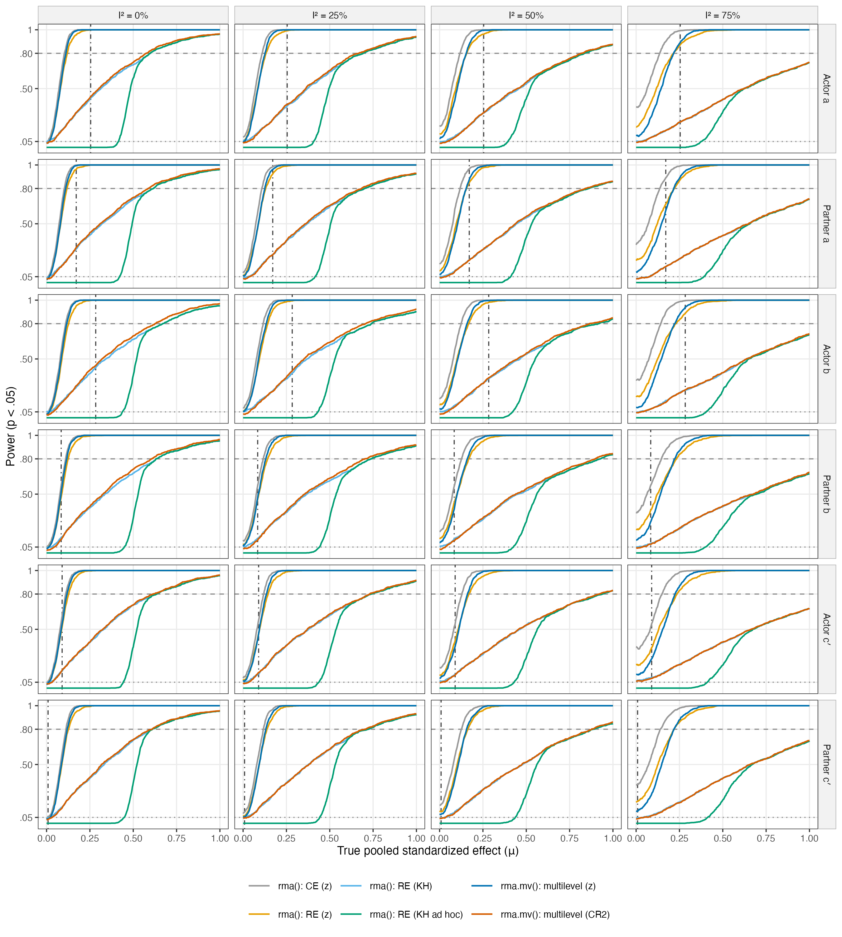
Note. k = 2. Dashed line = 80% power; dotted line = α = .05; dot-dashed line = observed pooled estimate (multilevel model). Power under the random-effects data-generating model; 1000 replications per condition.
Figure 2
Power to Detect the Pooled Direct Effects: Corrected for unreliability Paths
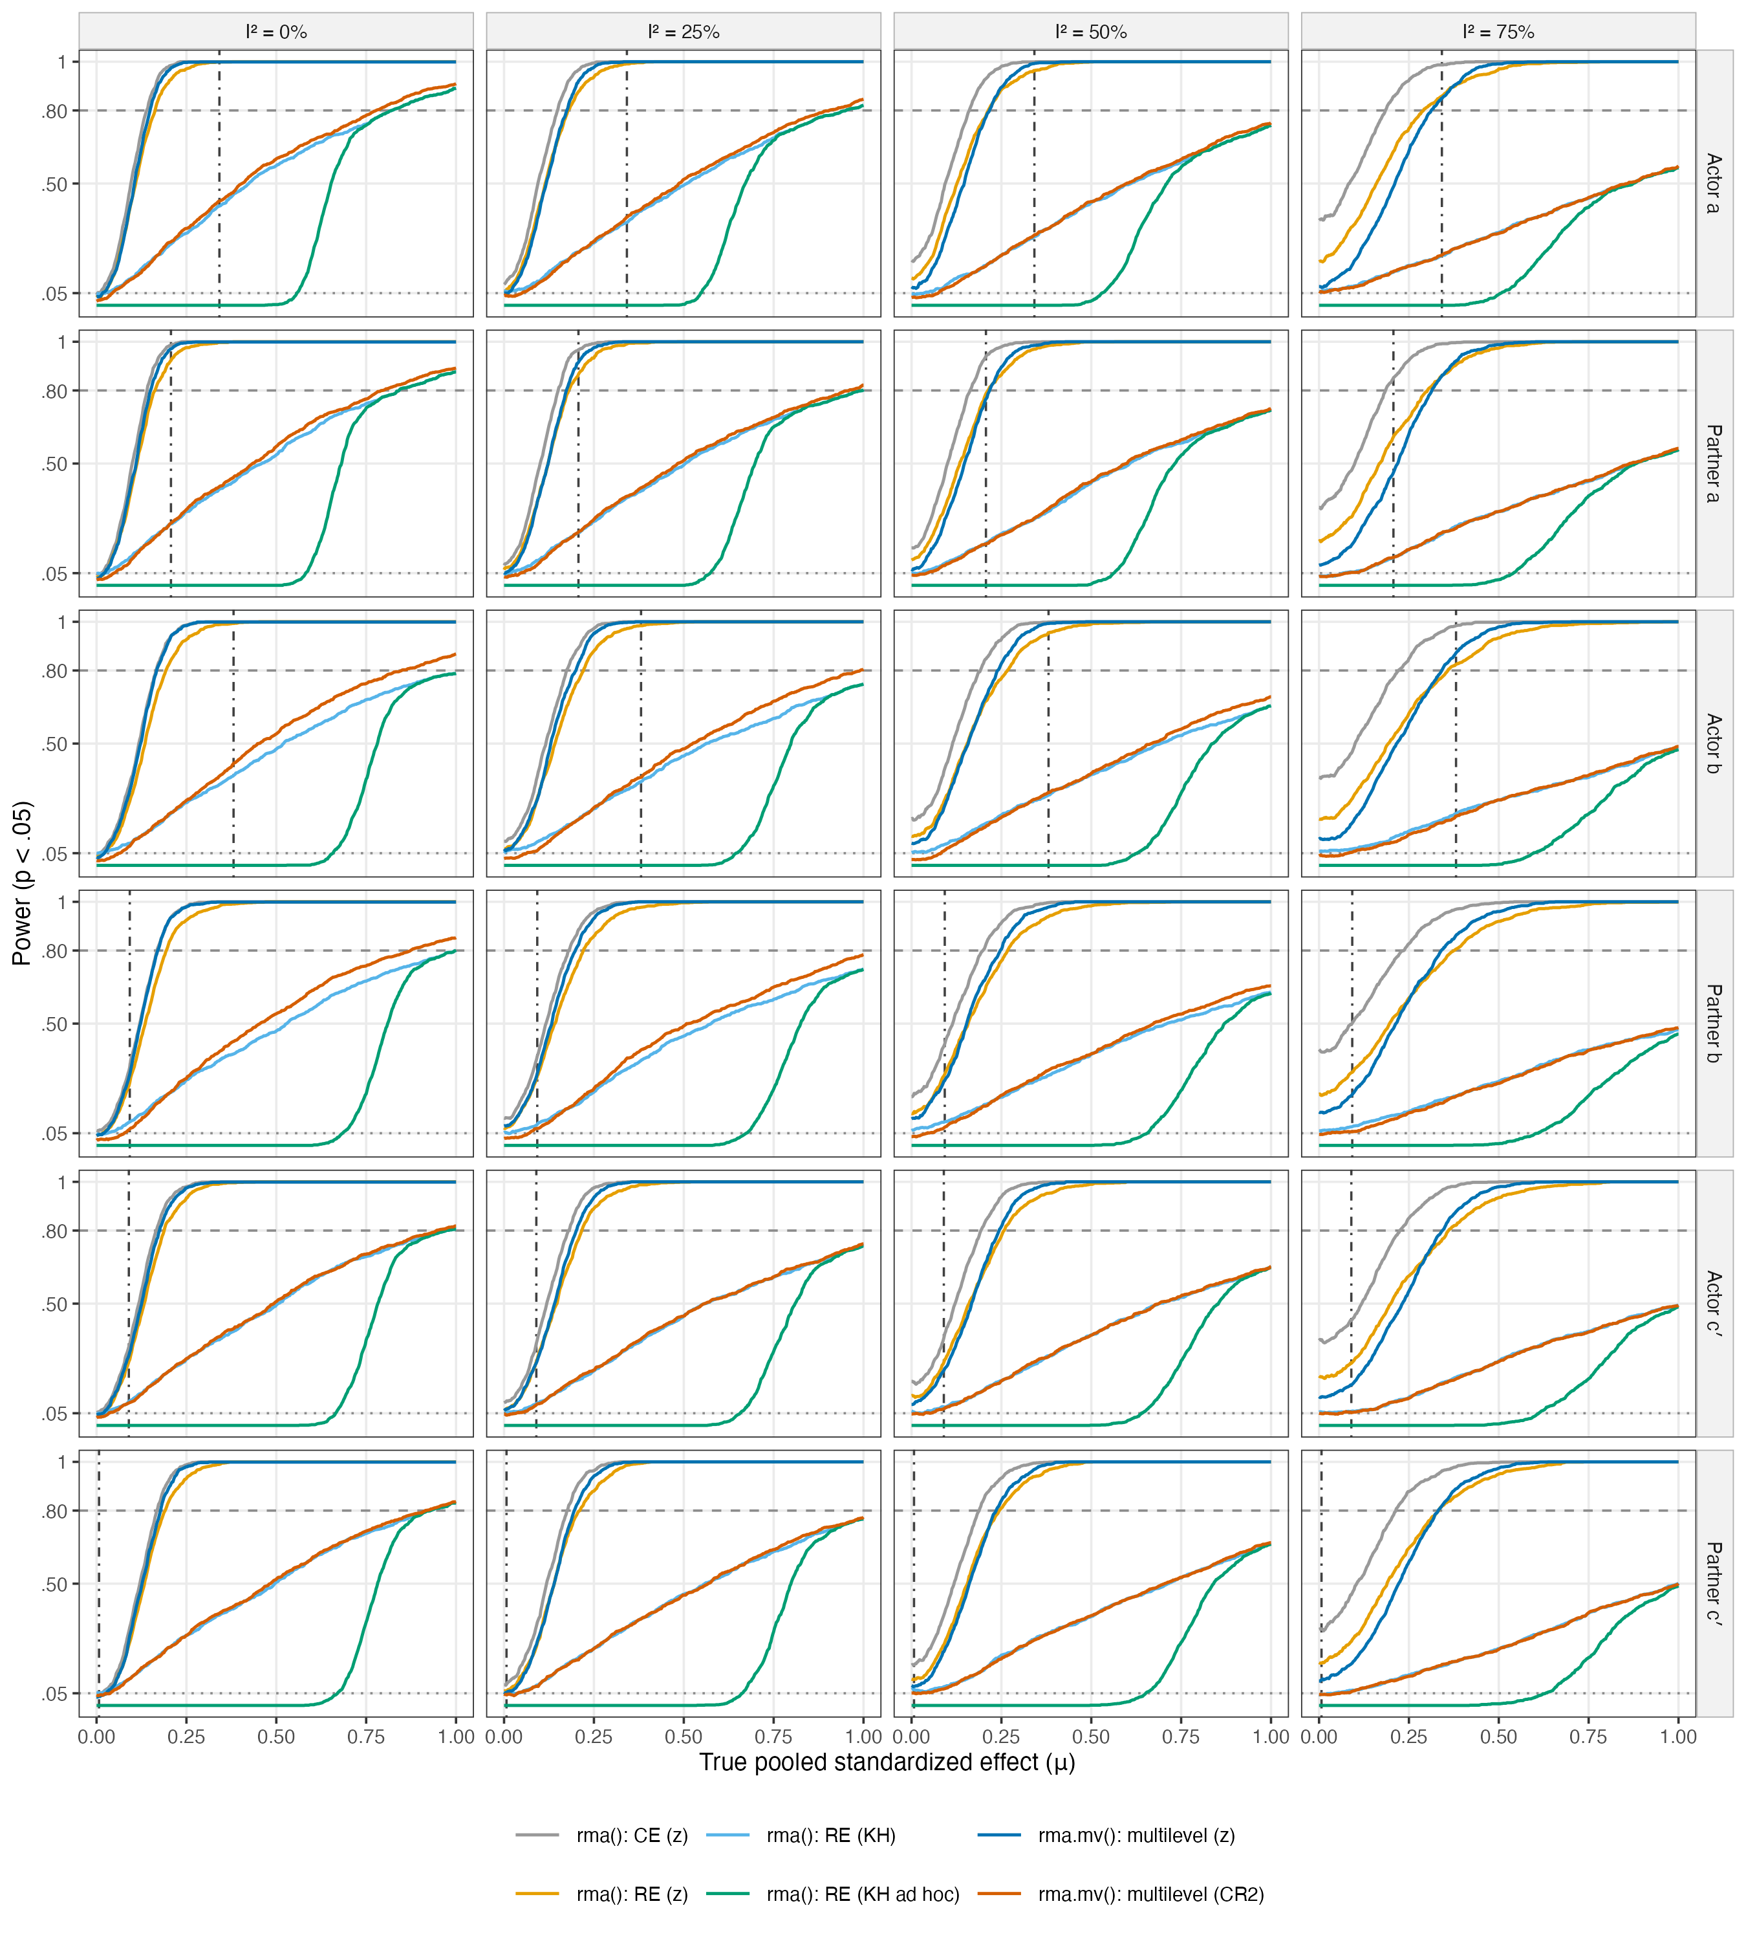
Note. k = 2. Dashed line = 80% power; dotted line = α = .05; dot-dashed line = observed pooled estimate (multilevel model). Power under the random-effects data-generating model; 1000 replications per condition.
Figure 3
Minimum Detectable Pooled Direct Effects by Heterogeneity and Method
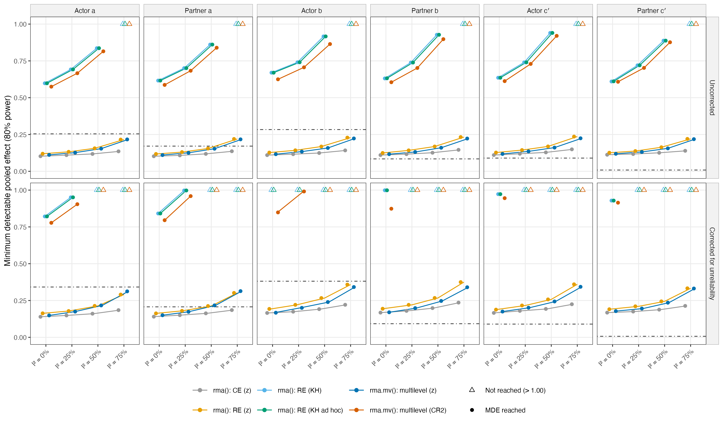
Note. k = 2. MDE = smallest true pooled effect with 80% power. Open triangles: not reached within the evaluated range (≤ 1.00). Dot-dashed line = observed pooled estimate.
Figure 4
Smallest Pooled Estimate That Would Be Statistically Significant
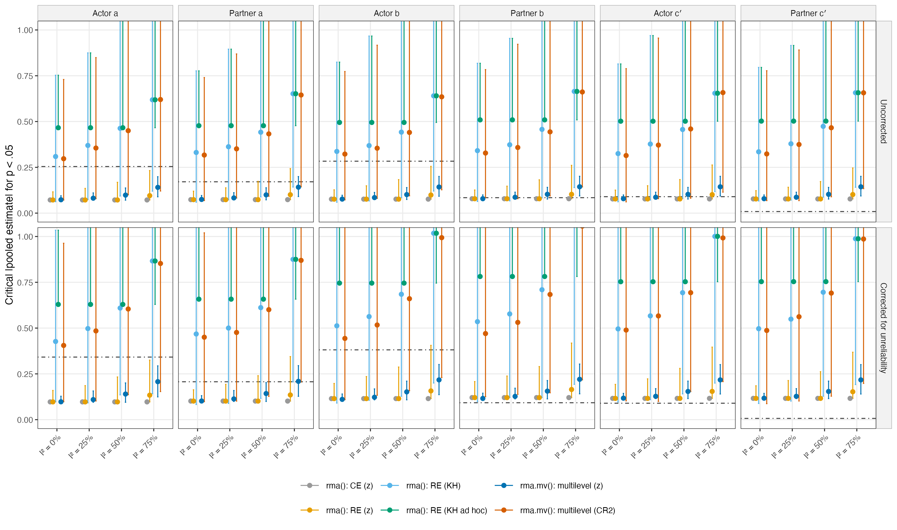
Note. k = 2. Points = median and bars = 10th–90th percentile of crit × SE across replications (upper bars truncated at the axis). For z tests with fixed V and τ² = 0 the value is constant; for random-effects, KH and CR2 it depends on the observed dispersion.
Figure 5
Empirical Type I Error Rate of the Test of the Pooled Mean Effect
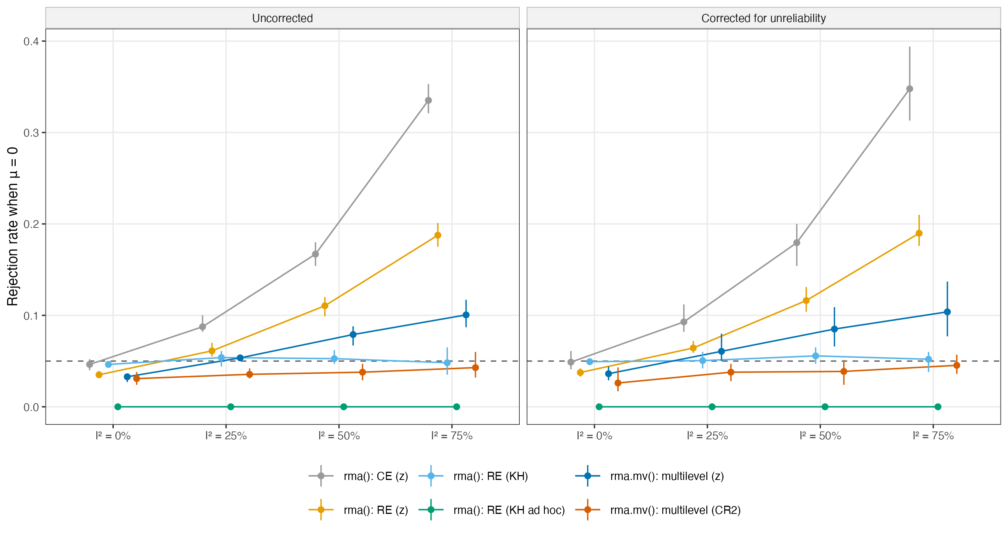
Note. k = 2. Mean (range) across the six direct effects. Under heterogeneity, the common-effect test answers a conditional question (the weighted average of these studies), so rejection rates above .05 reflect a different inferential target rather than a coding error.
Figure 6
Combinations of Pooled a and b Paths Giving 80% Power for the Indirect Effect: Uncorrected
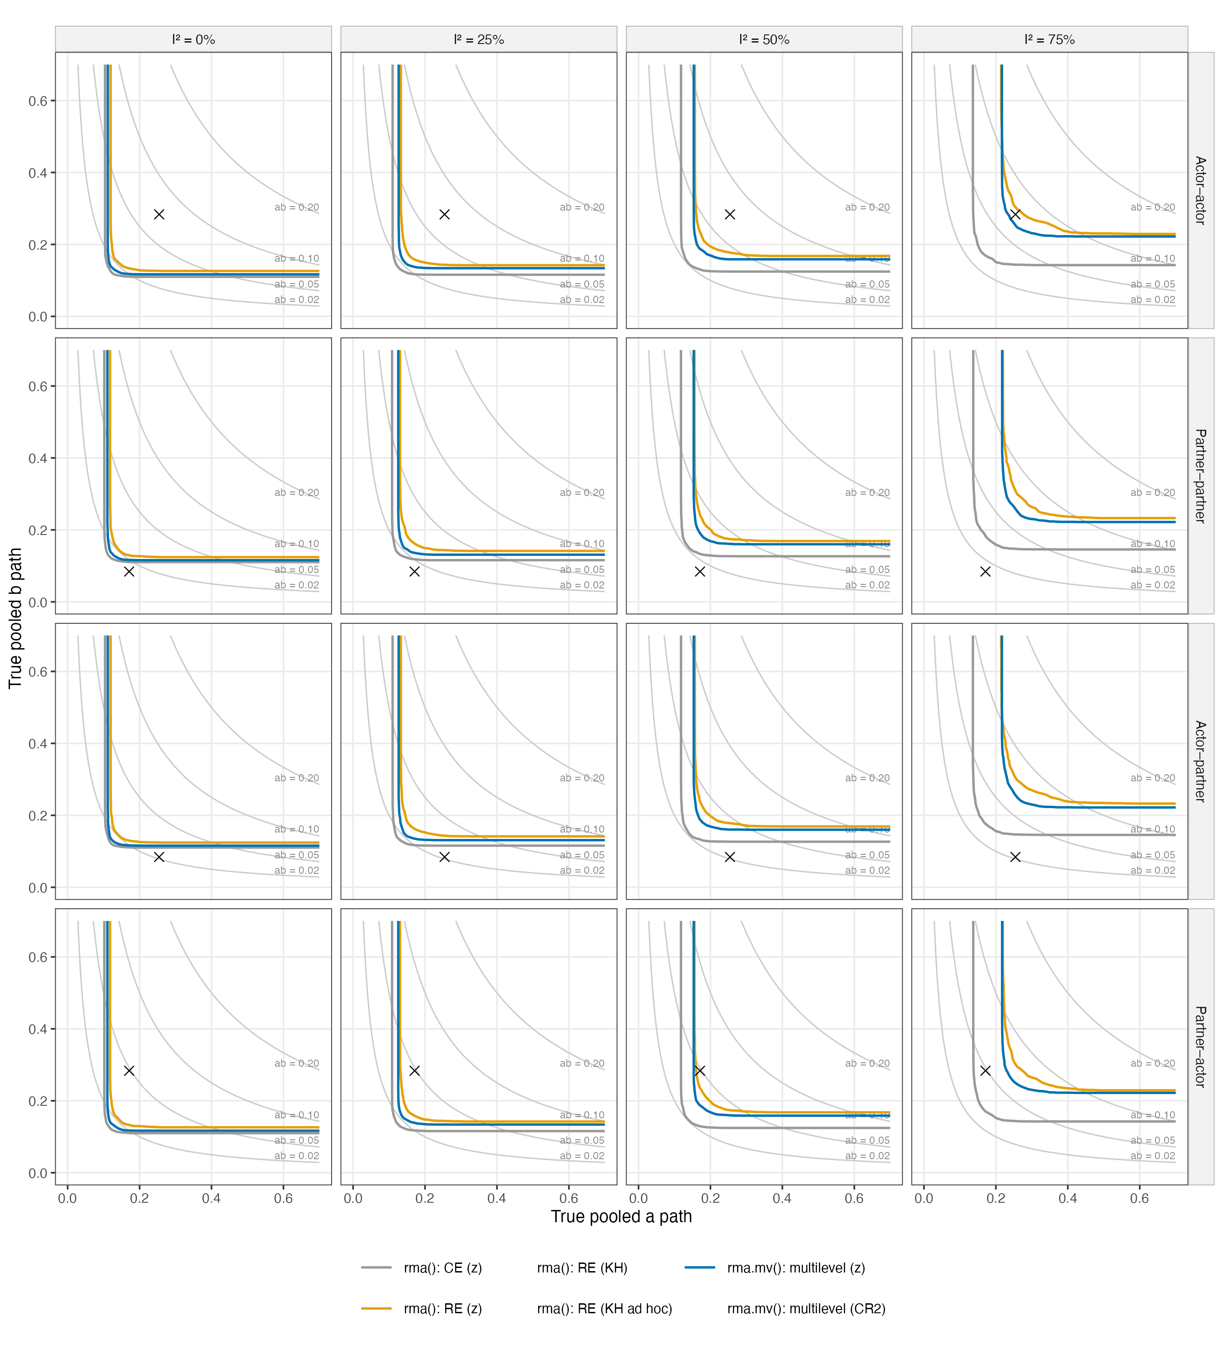
Note. k = 2. Lines = 80% power contours of the joint significance test (combinations above and to the right are detectable). Grey curves = constant indirect effect ab. × = observed pooled (a, b). Methods without a contour never reach 80% power in the plotted range.
Figure 7
Combinations of Pooled a and b Paths Giving 80% Power for the Indirect Effect: Corrected for unreliability
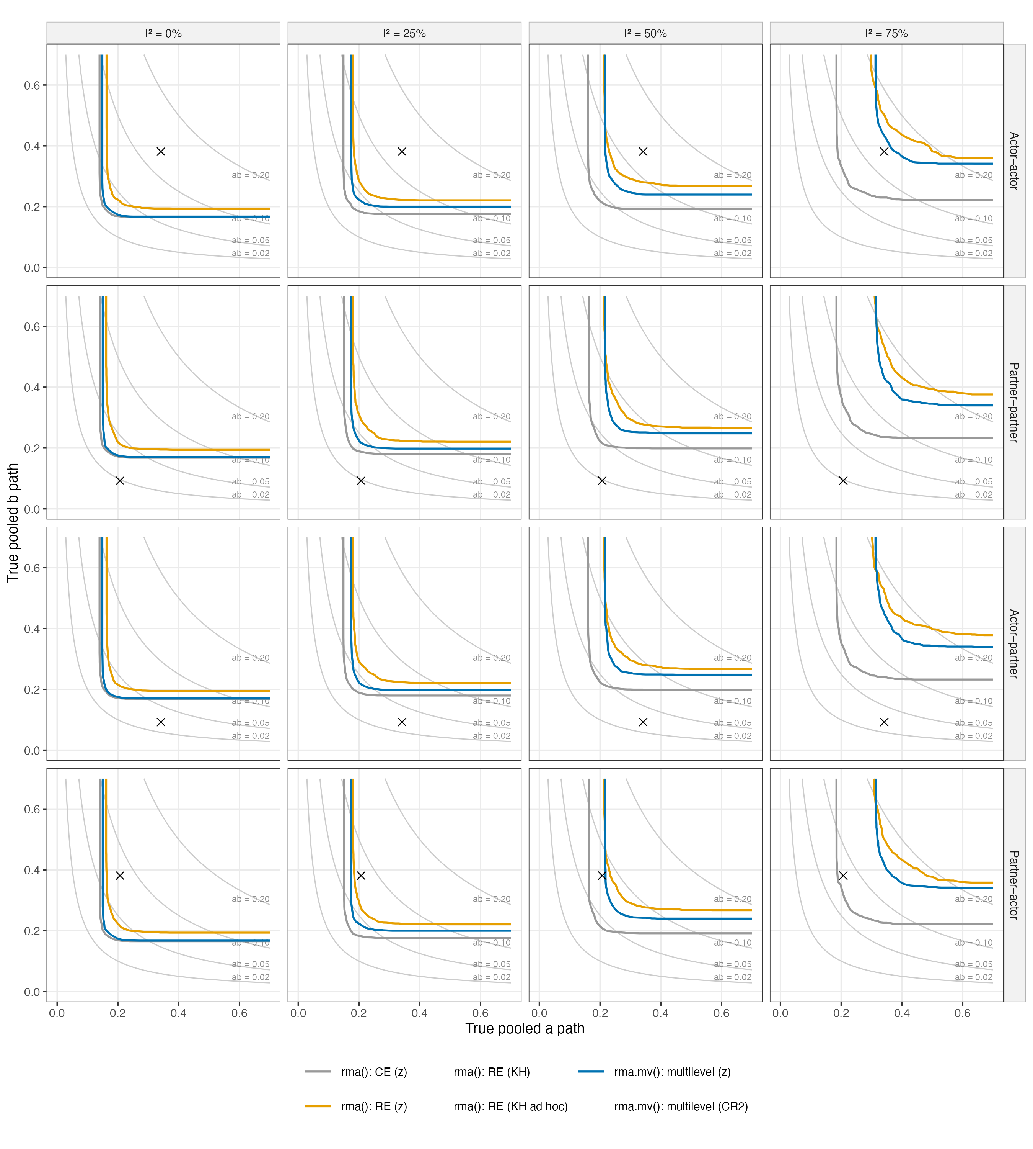
Note. k = 2. Lines = 80% power contours of the joint significance test (combinations above and to the right are detectable). Grey curves = constant indirect effect ab. × = observed pooled (a, b). Methods without a contour never reach 80% power in the plotted range.

