Jefferson Bui

CMPEN 271

5 December 2019

HW #10

# MOD-60 BCD Counter with 74163

Design and simulate a MOD 60 BCD counter that could be used in a DIGITAL CLOCK to display the minutes only. Use two, 74163 MSI counters in the solution. Assume the input is a clock of frequency = 1 ppm. Show and clearly label all important timing diagram features with annotations and labels. Solution should be professional and well-organized. Output of circuit should be two, 7-segment LEDs displaying minutes.

Circuit:

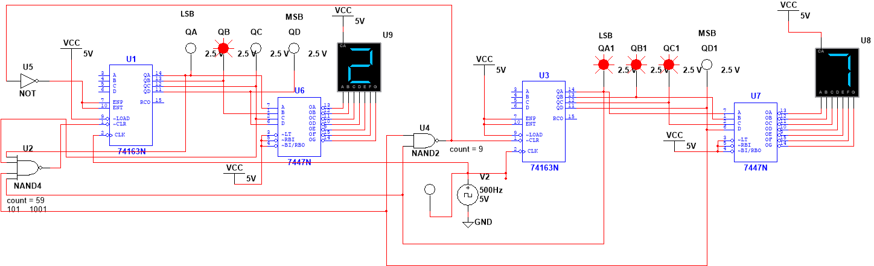

Logic Analyzer:

Reset when right counter hits 9 (1001):

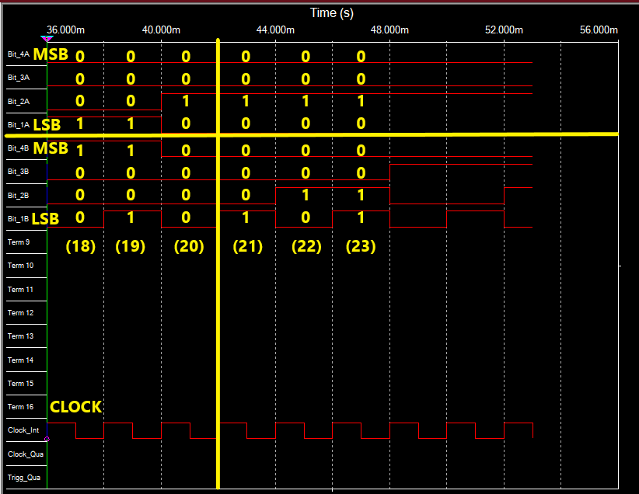

Reset when counter hits 59 (101 1001):

