Jefferson Bui

CMPEN 271

17 September 2019

HW #3A

# Car Alarm Circuit

Design a minimal circuit to implement the door alarm Boolean function. Include truth table, minimization, and circuit. Use Boolean algebra to minimize the circuit – must show all steps in solution. Simulate minimal circuit. Include 2 versions of each circuit: 1.) Use AND, OR, NOT gates only. 2.) Use NAND gates only. Calculate # of ICs for each version. All input and output wires must be labeled.

Truth Table

INPUTS: 1 = True / 0 = False Output:

|  |  |  |  |
| --- | --- | --- | --- |
| DOOR OPEN | ALARM ENABLED | MOTION SENSOR ACTIVE | ACTIVATE |
| 0 | 0 | 0 | 0 |
| 0 | 0 | 1 | 0 |
| 0 | 1 | 0 | 0 |
| 0 | 1 | 1 | 1 |
| 1 | 0 | 0 | 0 |
| 1 | 0 | 1 | 0 |
| 1 | 1 | 0 | 1 |
| 1 | 1 | 1 | 1 |

Boolean Expression:

ACTIVATE = doorOpen • alarmEnabled + doorOpen • alarmEnabled • motionSensorActive + alarmEnabled • motionSensorActive

Minimizing:

Activate = F / doorOpen = O / alarmEnabled = E / motionSensorActive = A

F = OEA’ + OEA + O’EA

F = OE (A’+ A) + O’EA

F = OE + O’EA

F = E (O + O’A)

F = E (O + A)(O + O’)

F = E (O + A)

F = OE + AE

Circuit:

Version 1 (AND, OR, NOT Gates):

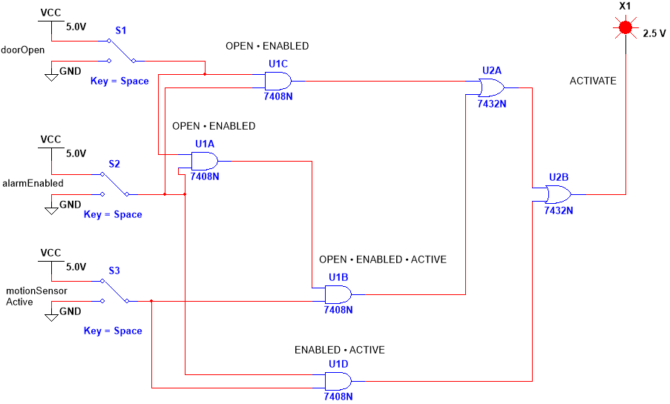

2 ICs for Version 1

Version 2 (NAND Gates):

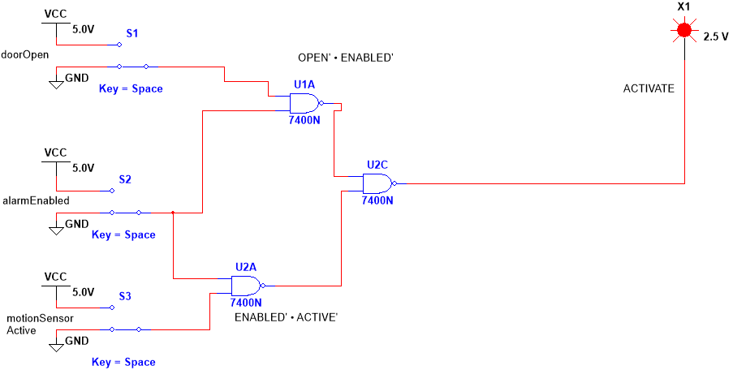

1 IC for Version 2