Jefferson Bui

CMPEN 271

17 September 2019

HW #3B

Majority Voting Circuit

Design a circuit with 3 inputs and 1 output. The output will be high when 2 or more of the inputs are high, otherwise the output will be low. Include truth table, minimization, and circuit. Use Boolean algebra to minimize the circuit – must show all steps in solution. Simulate minimal circuit. Include 2 versions of each circuit: 1.) Use AND, OR, NOT gates only. 2.) Use NAND gates only. Calculate # of ICs for each version. All input and output wires must be labeled.

Truth Table

INPUTS: 1 = True / 0 = False Output:

|  |  |  |  |
| --- | --- | --- | --- |
| Vote 1 (HIGH) | Vote 2 (HIGH) | Vote 3 (HIGH) | Vote Accepted |
| 0 | 0 | 0 | 0 |
| 0 | 0 | 1 | 0 |
| 0 | 1 | 0 | 0 |
| 0 | 1 | 1 | 1 |
| 1 | 0 | 0 | 0 |
| 1 | 0 | 1 | 1 |
| 1 | 1 | 0 | 1 |
| 1 | 1 | 1 | 1 |

Boolean Expression:

ACCEPTED = vote1High • vote2High + vote1High • vote3High + vote2High • vote3High + vote1High • vote2High • vote3High

Minimizing:

Accepted = F / Vote 1 = 1 / Vote 2 = 2 / Vote 3 = 3

F = 123 + 1’23 + 12’3 + 123’

F = 23 (1 + 1’) + 12’3 + 123’

F = 23 + 12’3 + 123’

F = 3 (2 + 12’) + 123’

F = 3 (2 + 1) (2 + 2’) + 123’

F = 3 (2 + 1) + 123’

F = 32 + 31 + 123’

F = 32 + 1 (3+ 23’)

F = 32 + 1 (3 + 2) (3 + 3’)

F = 32 + 1 (3 + 2)

F = 32 + 13 + 12

Circuit:

Version 1 (AND, OR, NOT Gates):

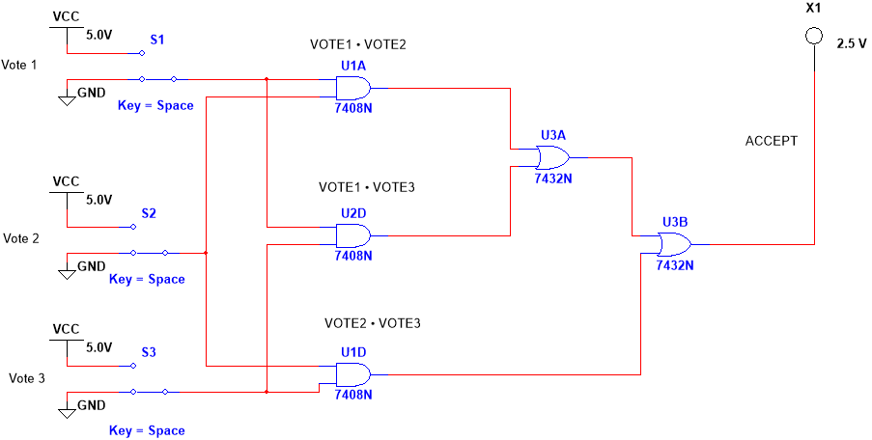

2 ICs in Version 1

Version 2 (NAND Gates):

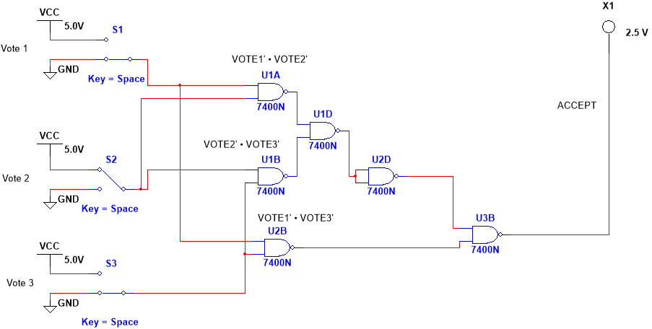

2 ICs in Version 2