Jefferson Bui

CMPEN 271

15 October 2019

HW #6

BCD values and 7-segm display

Design Problem: Design a circuit that accepts 2, 4-bit unsigned BCD values as inputs A3 A2 A1 A0, and B3 B2 B1 B0. The circuit will numerically compare the two BCD values, and display the greater value on a single 7-segment display. Use MSI devices when possible. Simulate circuit to verify operation. Include appropriate test cases.

Circuit:

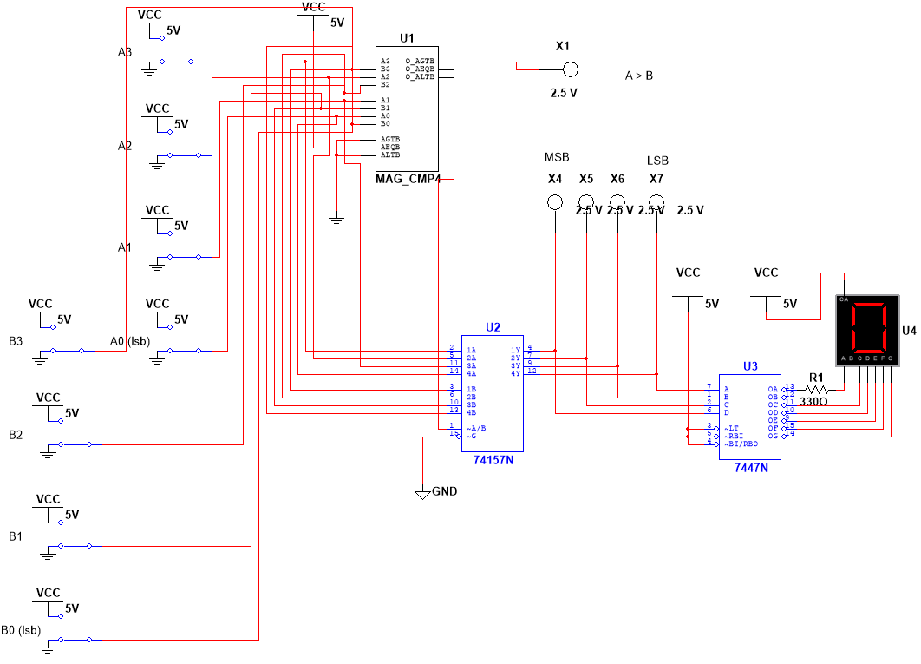

Test Cases:

Test Case 1 (A > B): A = 0101 = 5 / B = 0011 = 3

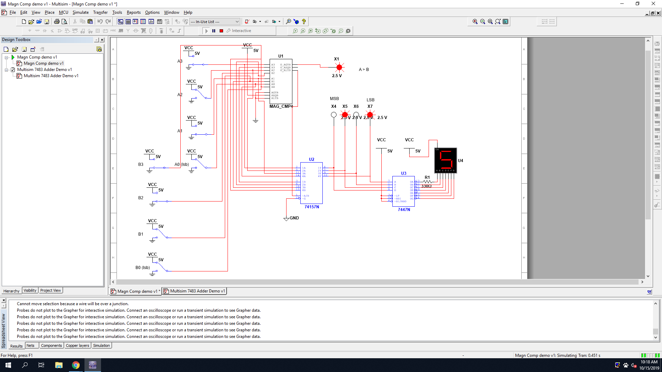

Test Case 2 (A > B): A = 1000 = 8 / B = 0111 = 7

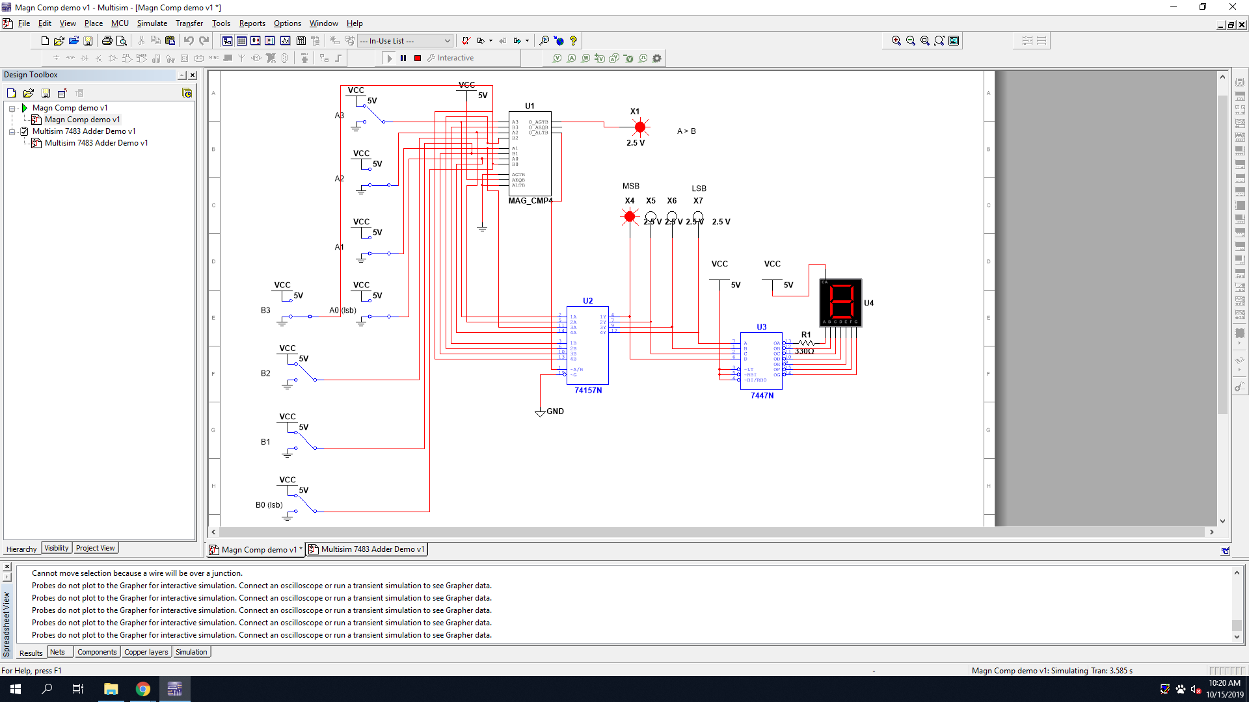

Test Case 3 (A < B): A = 0101 = 5 / B = 0110 = 6

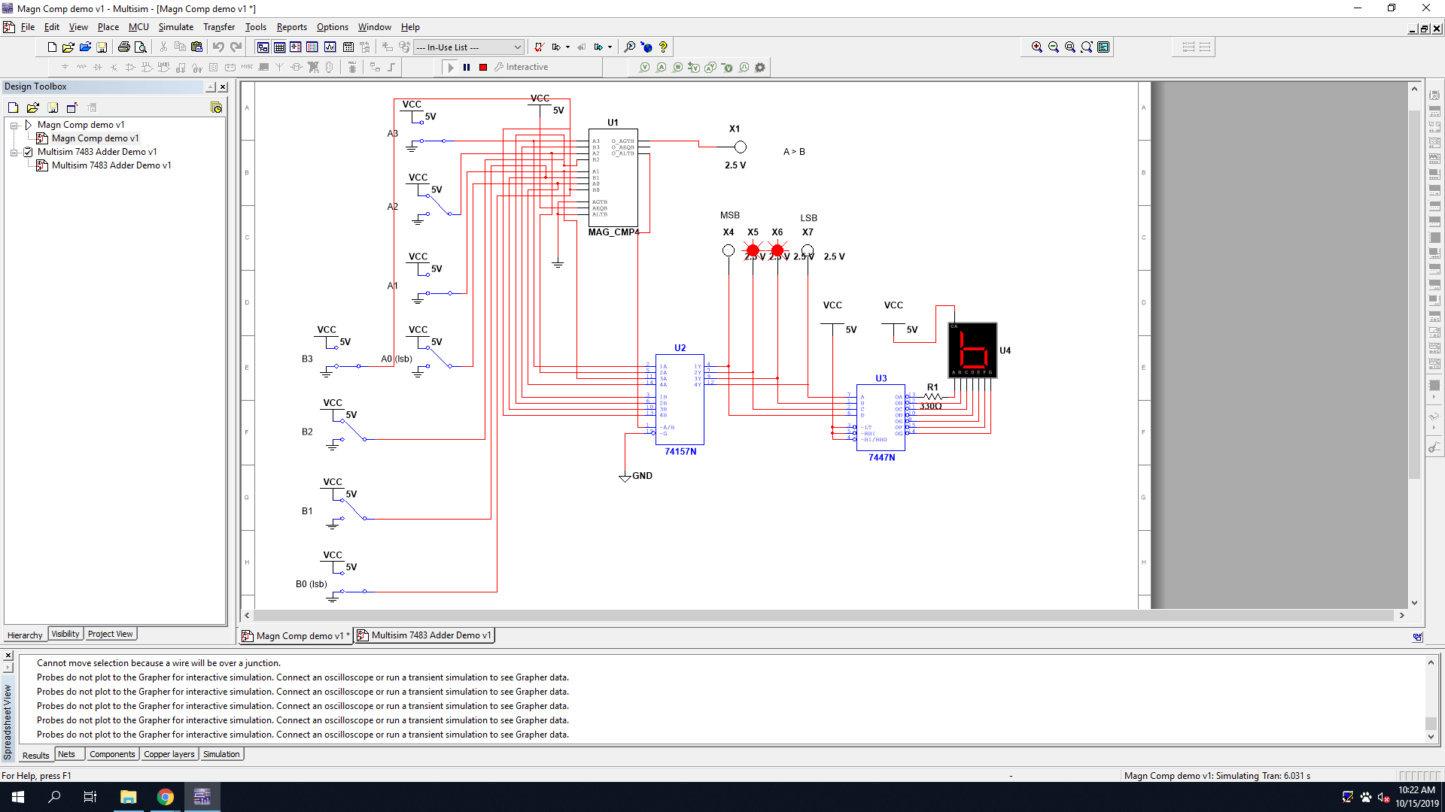

Test Case 4 (A < B): A = 0010 = 2 / B = 0101 = 5

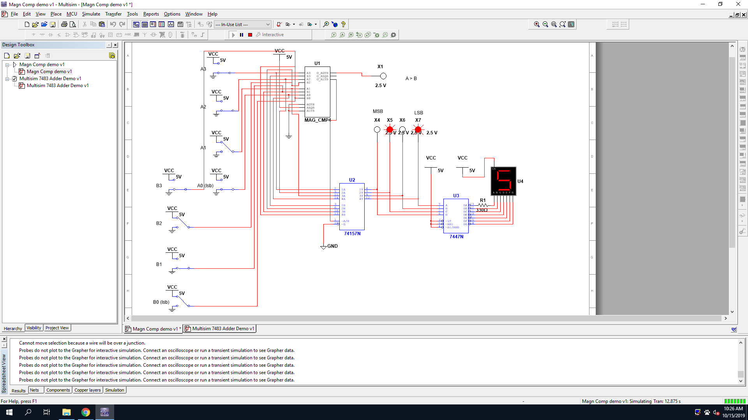

Test Case 5 (A = B): A = 0010 = 2 / B = 0010 = 2

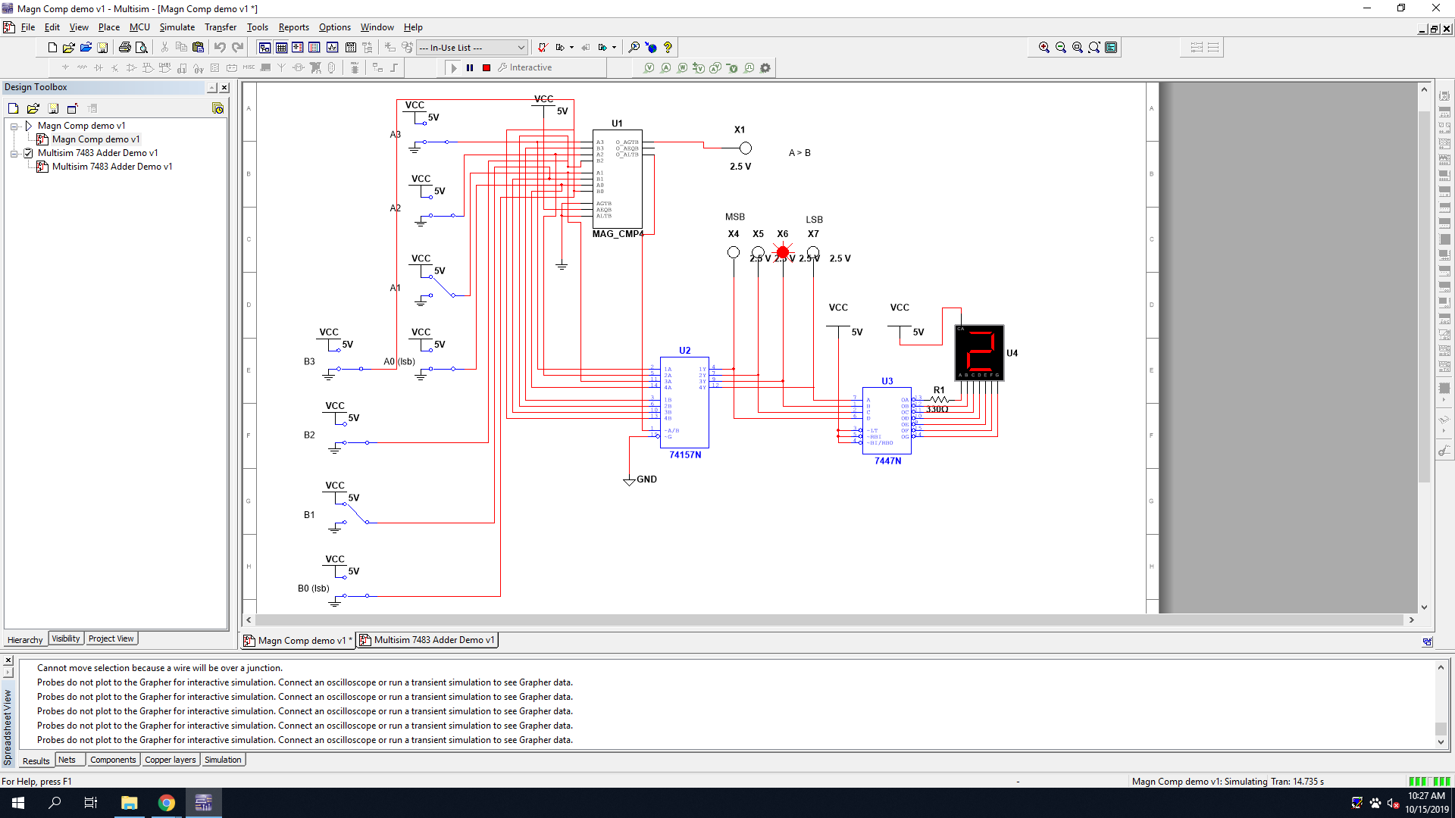

Test Case 6 (A = B): A = 0110 = 6 / B = 0110 = 6

