Jefferson Bui

CMPEN 271

31 October 2019

HW #7A

# Display Negative Number

Design a circuit to convert a 4-bit, 2’s complement number to display on a 7-segment LED with negative sign; use a separate 7-segment display to display the minus (neg.) sign (when appropriate); design and simulate using LogicWorks or MultiSIM. Pick appropriate test cases. There are 4 input switches (label lsb).

Circuit:

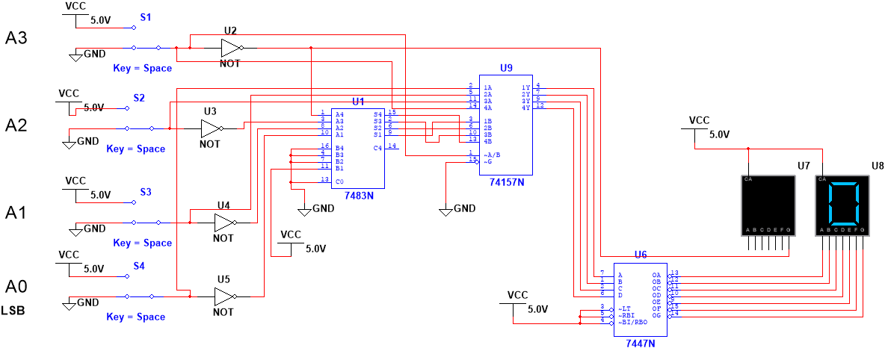

Test Cases:

input = 0001, outputs = blank, “1”

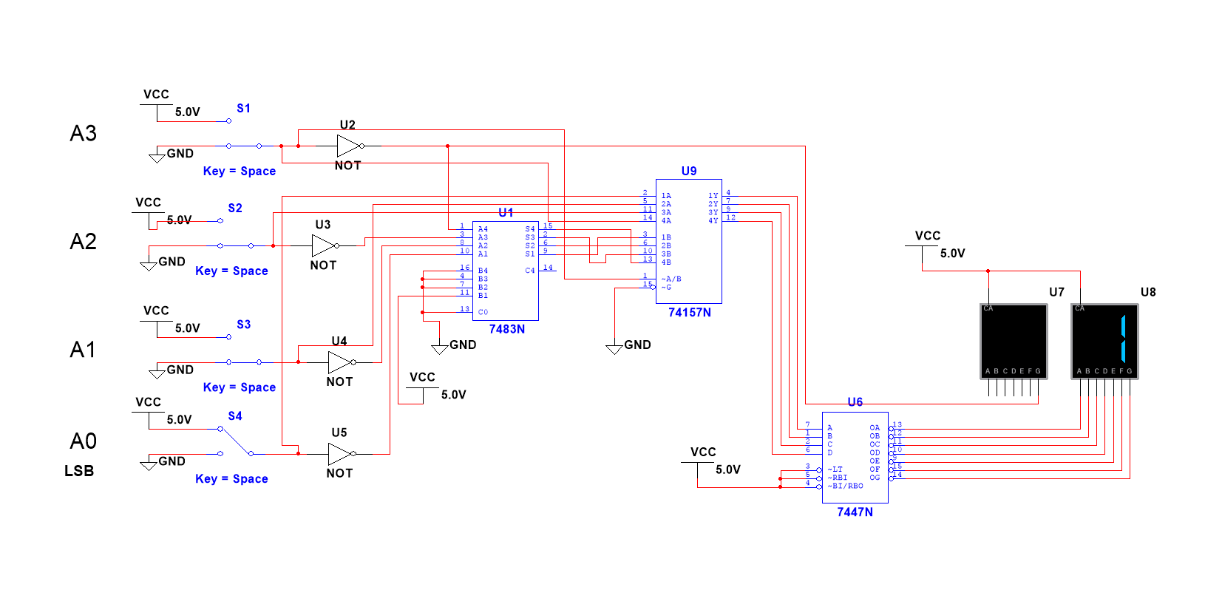

input = 0111, outputs = blank, “7”

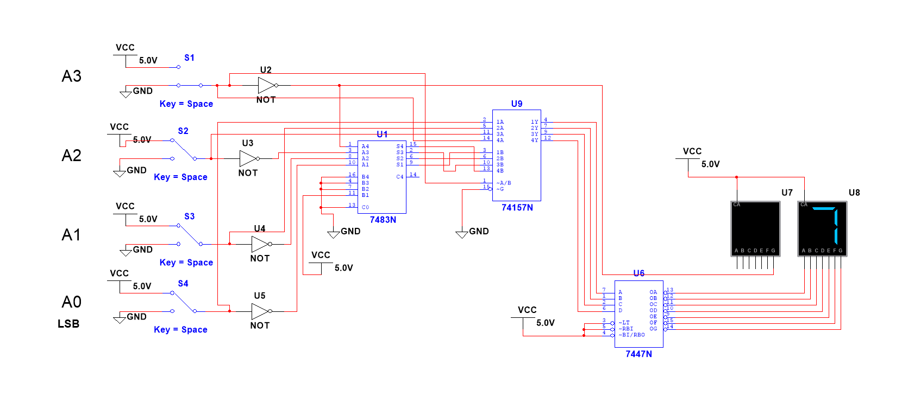

input = 1001, outputs = “-”, “7”

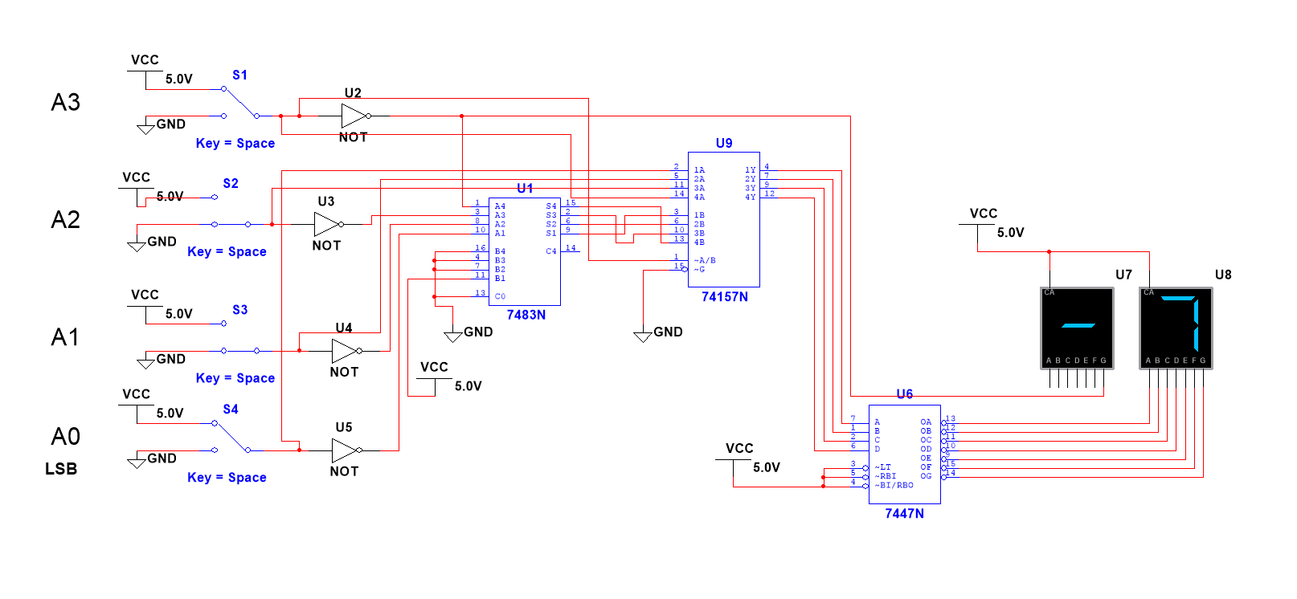

input = 1111, outputs = “-”, “1”

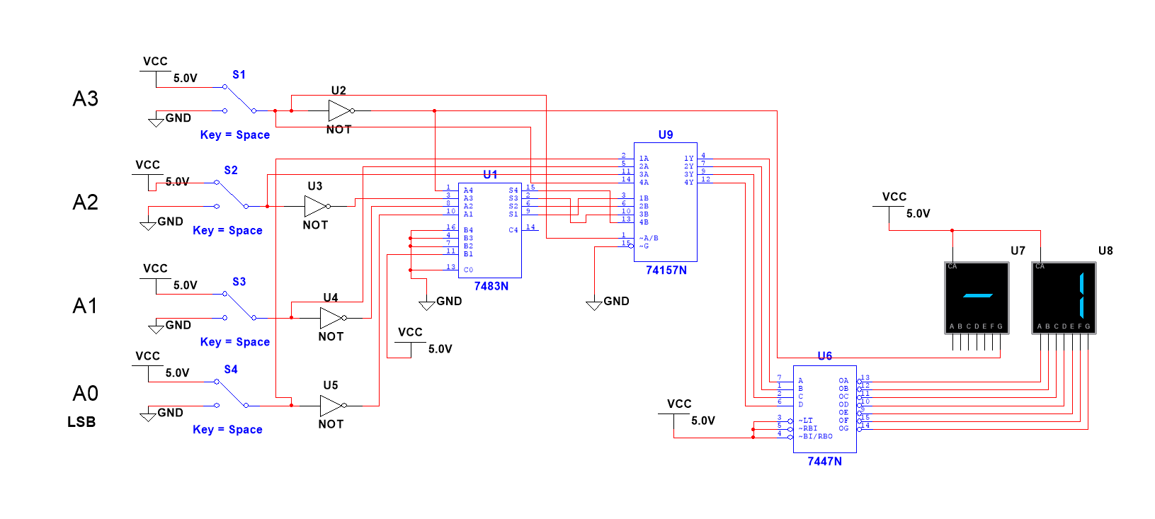

input = 0000, outputs = blank, “0”

