Jefferson Bui

CMPEN 271

31 October 2019

HW #7B

Binary Multiplication

Design, simulate and test a circuit to multiply a 3-bit number: A2, A1, A0 by a 2-bit numberB1, B0. Output is unsigned binary. Carefully label all inputs and outputs. Pick appropriate test cases. Use MultiSIM or LogicWorks. This solution has a total of 5 input switches. Include appropriate test cases.

Circuit:

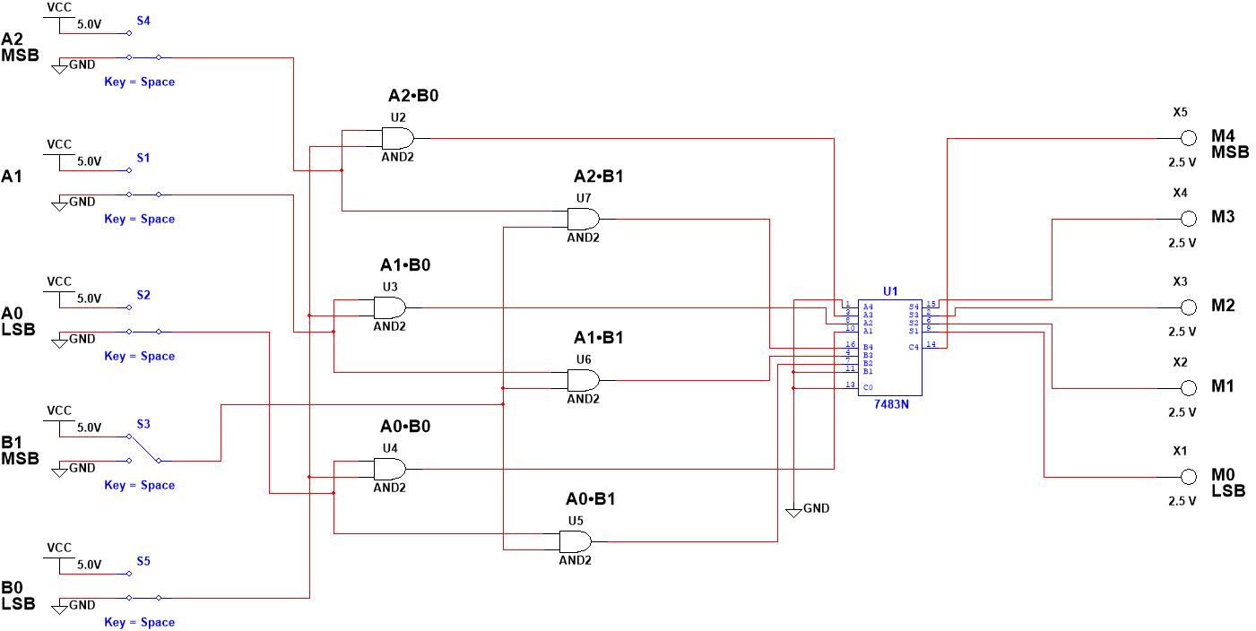

Test Cases:

Inputs = 101(5) x 11(3), Output = 01111(15)

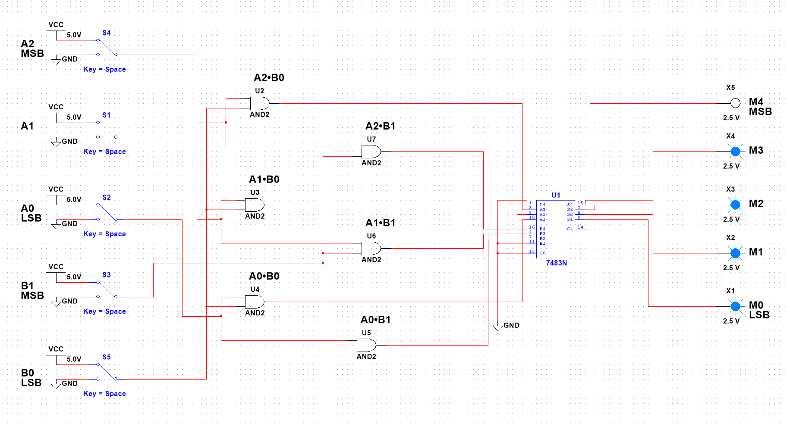

Inputs = 110(6) x 10(2), Output = 01100(12)

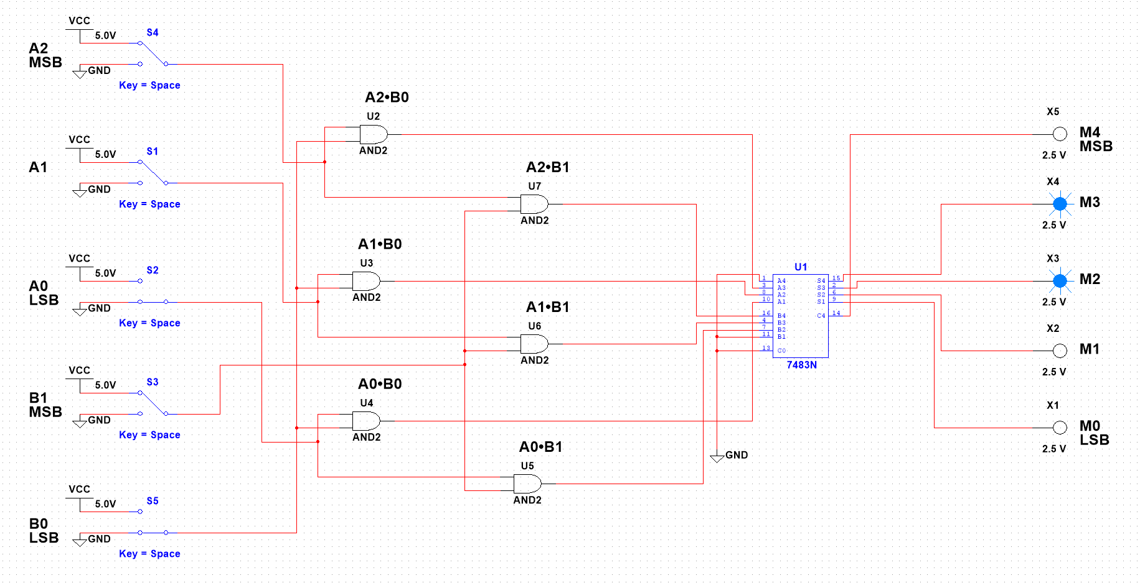

Inputs = 111(7) x 10(2), Output = 01111(14)

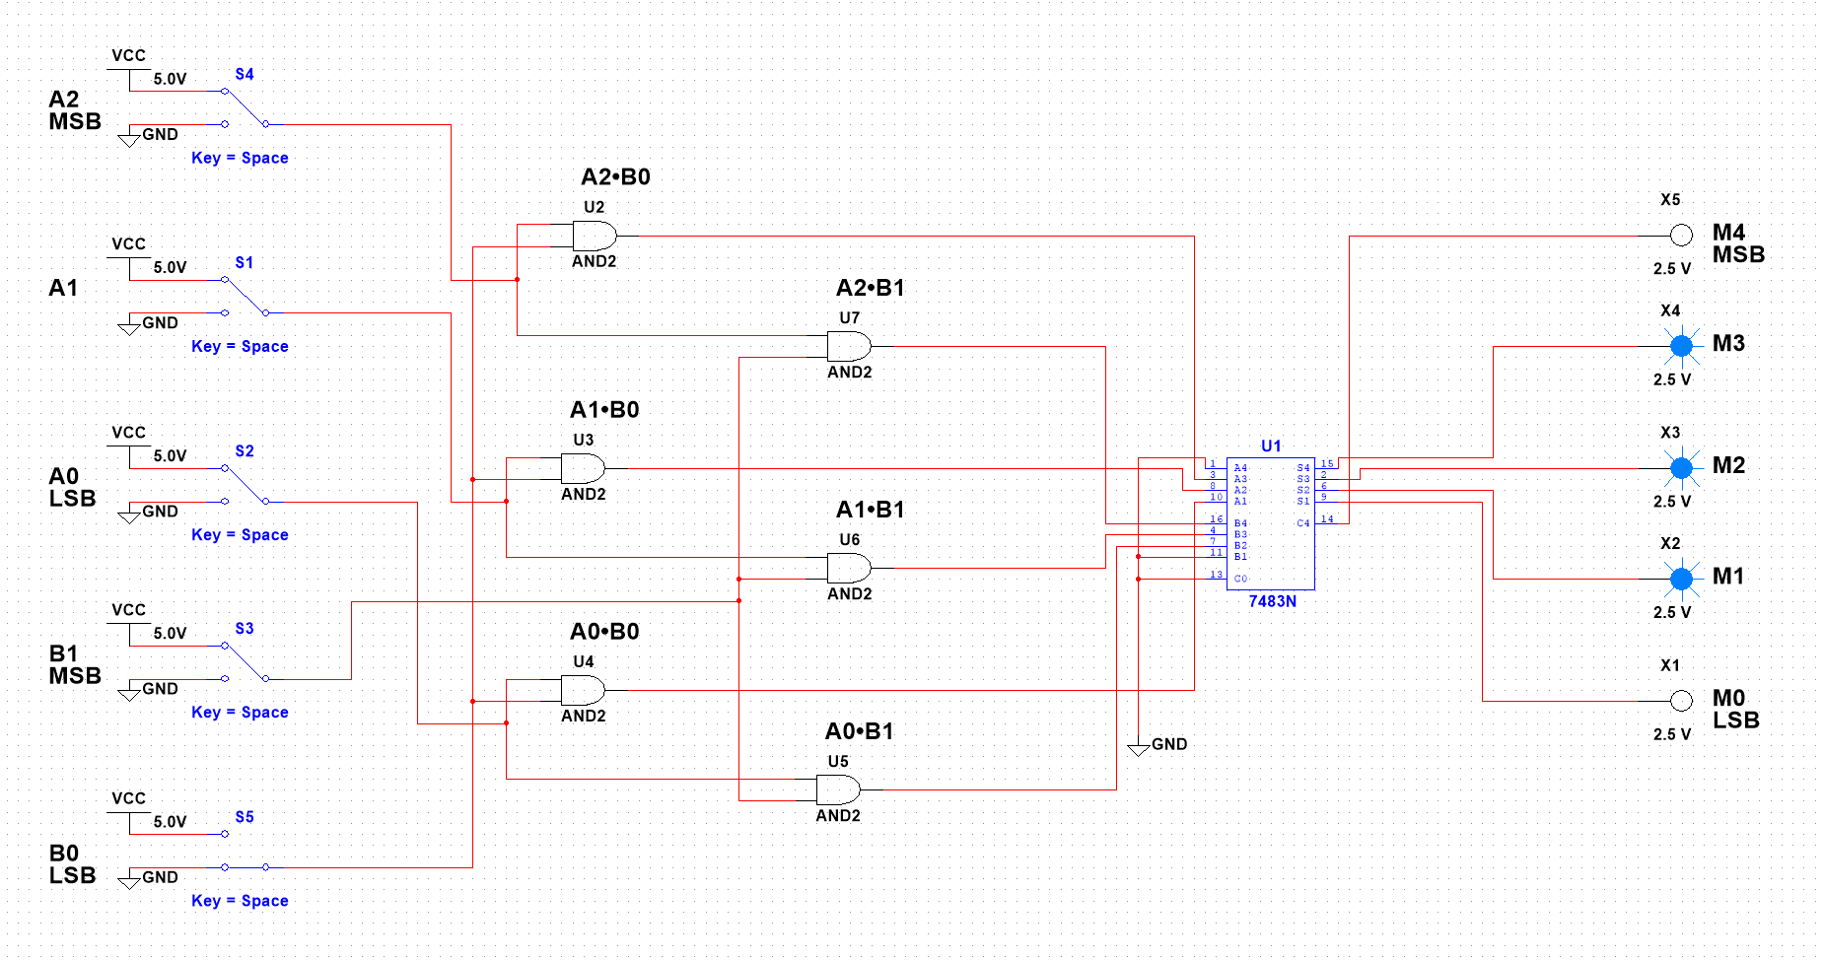

Inputs = 011(3) x 00(0), Output = 00000(0)

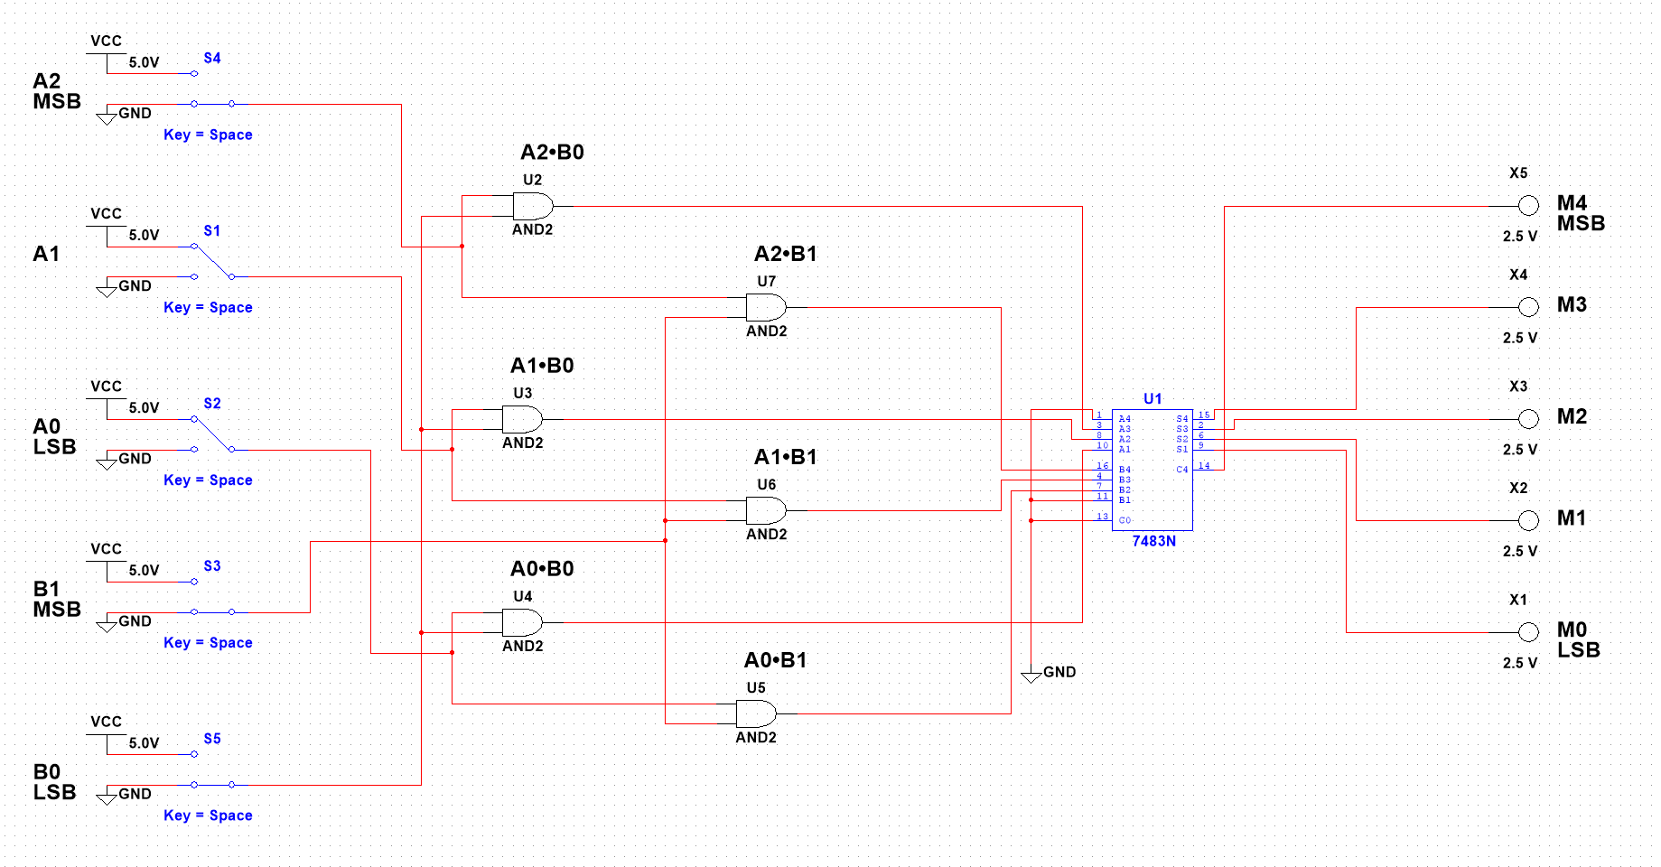

Inputs = 001(1) x 01(1), Output = 00001(1)

