Jefferson Bui

CMPEN 271

5 November 2019

HW #8

# Taillight Ring Counter

Design and simulate solutions to Thunderbird taillight turn signal. Include problem statement. Label all input and output.

Circuit:

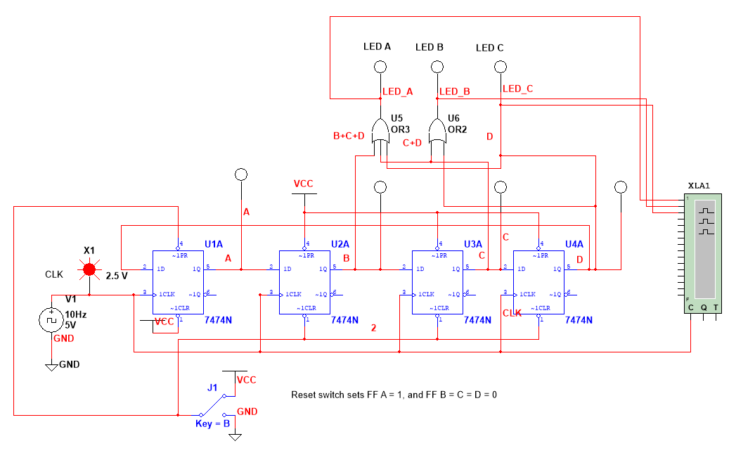

Timing Diagram:

