Jefferson Bui

CMPEN 271

17 September 2019

Lab 1

# Part 1:

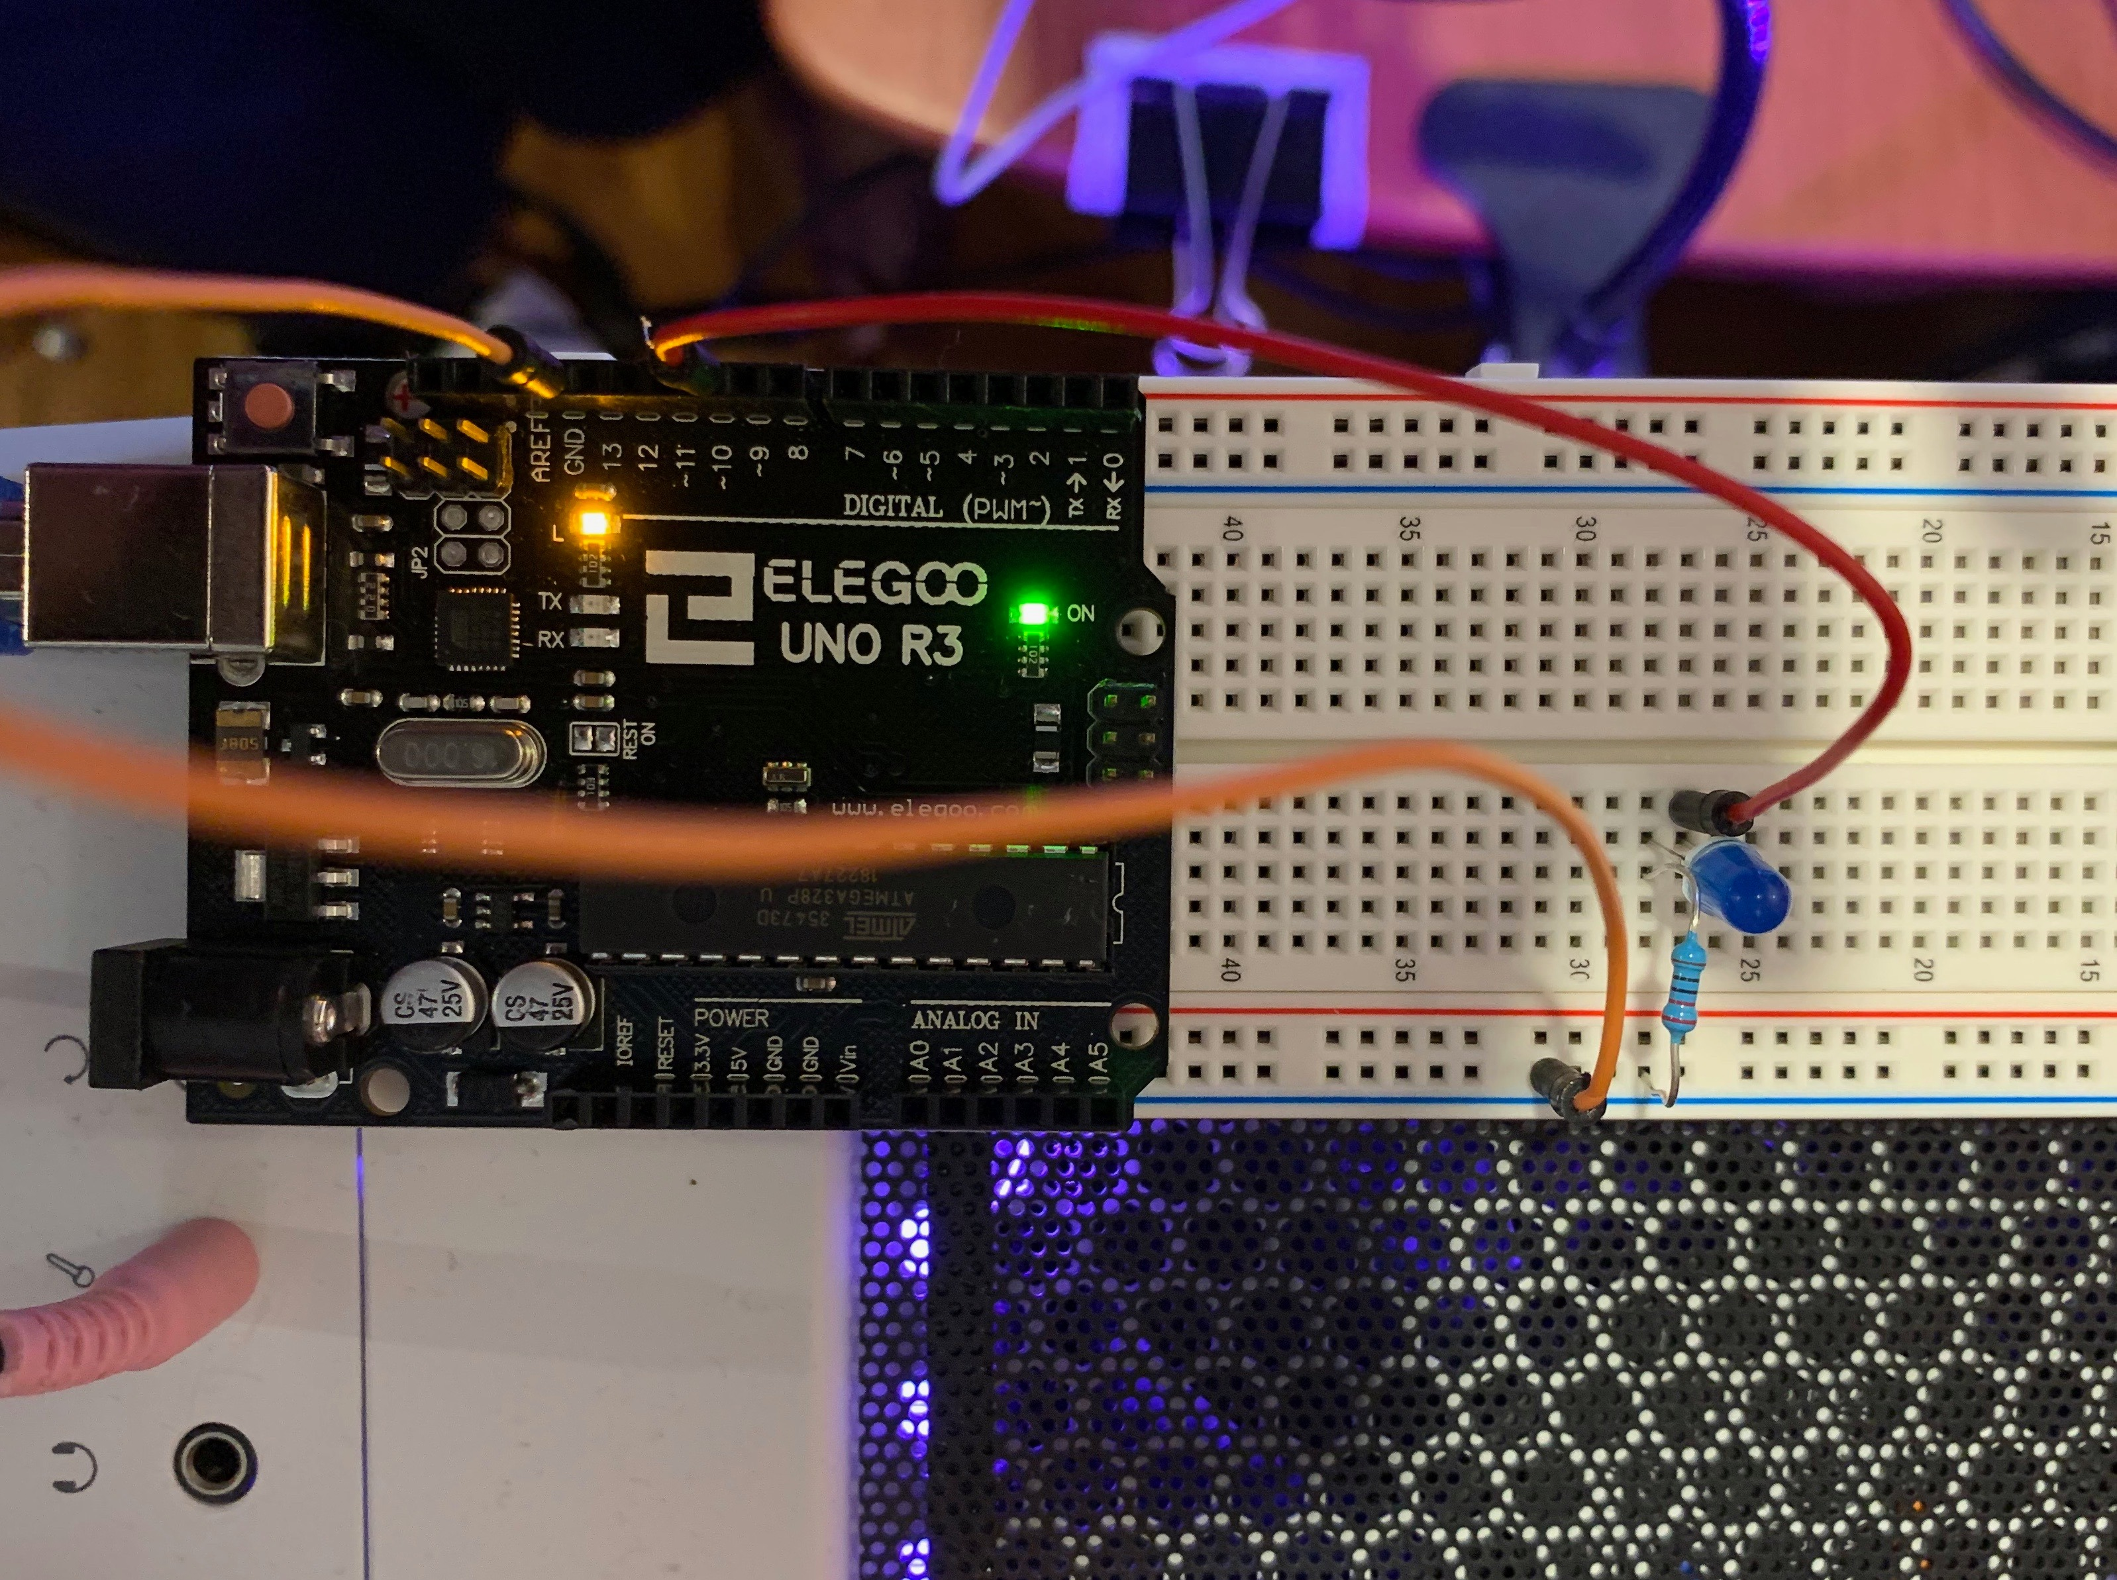

Questions:

1) What happens if you reverse the polarity (flip) the LED?

The LED does not light up when you reverse the polarity of the LED.

2) Should the resistor be in before the LED or after the LED? Try switching positions

It does not matter if the resistor goes before or after the LED, as long as the circuit has the resistor in it.

# Part 2:

Code given is modified by decreasing delay in code. Delay was 1000 changed to 500.

# Part 3:

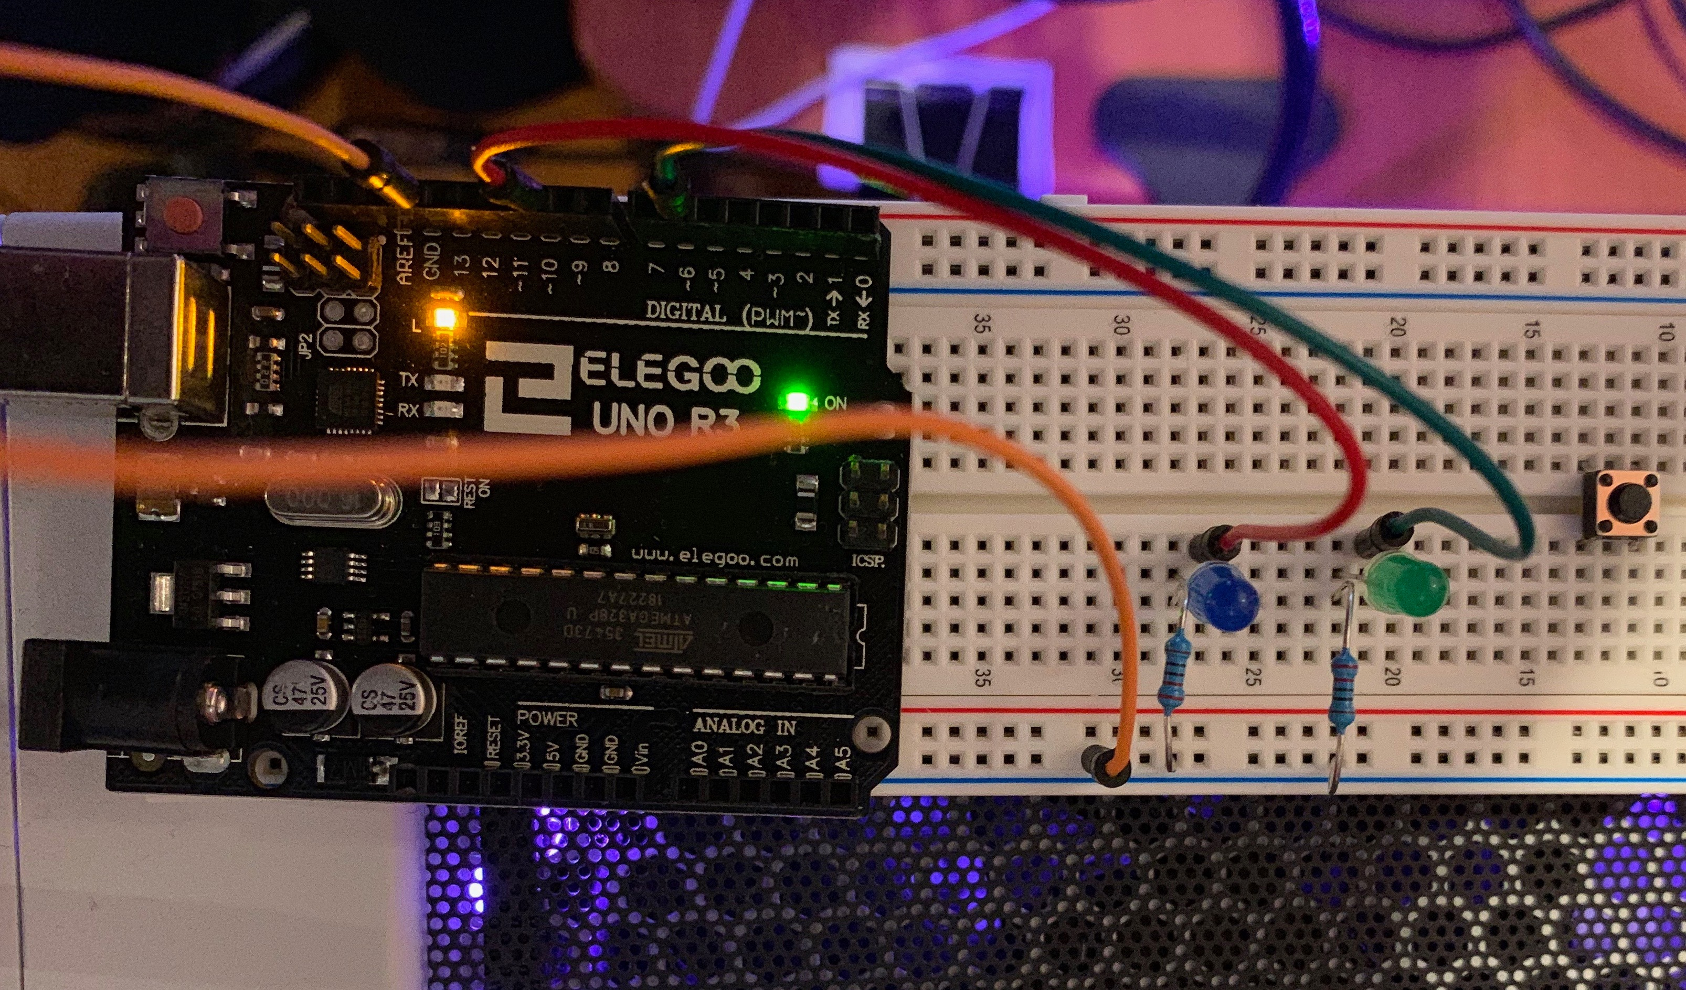

CODE:

int ledPin = 10;

int ledPin2 = 6;

void setup() {

pinMode(ledPin, OUTPUT);

pinMode(ledPin2, OUTPUT);

}

void loop() {

digitalWrite(ledPin, HIGH);

delay(500);

digitalWrite(ledPin, LOW);

delay(500);

digitalWrite(ledPin2, HIGH);

delay(500);

digitalWrite(ledPin2, LOW);

delay(500);

}