Jefferson Bui

CMPEN 271

1 October 2019

Lab 4

# Code:

int lightPin = 0;

int ledPin = 10;

void setup()

{

Serial.begin(9600);

pinMode(ledPin, OUTPUT);

}

void loop() {

int lightVal = analogRead(lightPin);

Serial.println(lightVal);

if(lightVal<512)

digitalWrite(ledPin, HIGH);

else

digitalWrite(ledPin, LOW);

}

# Circuit:

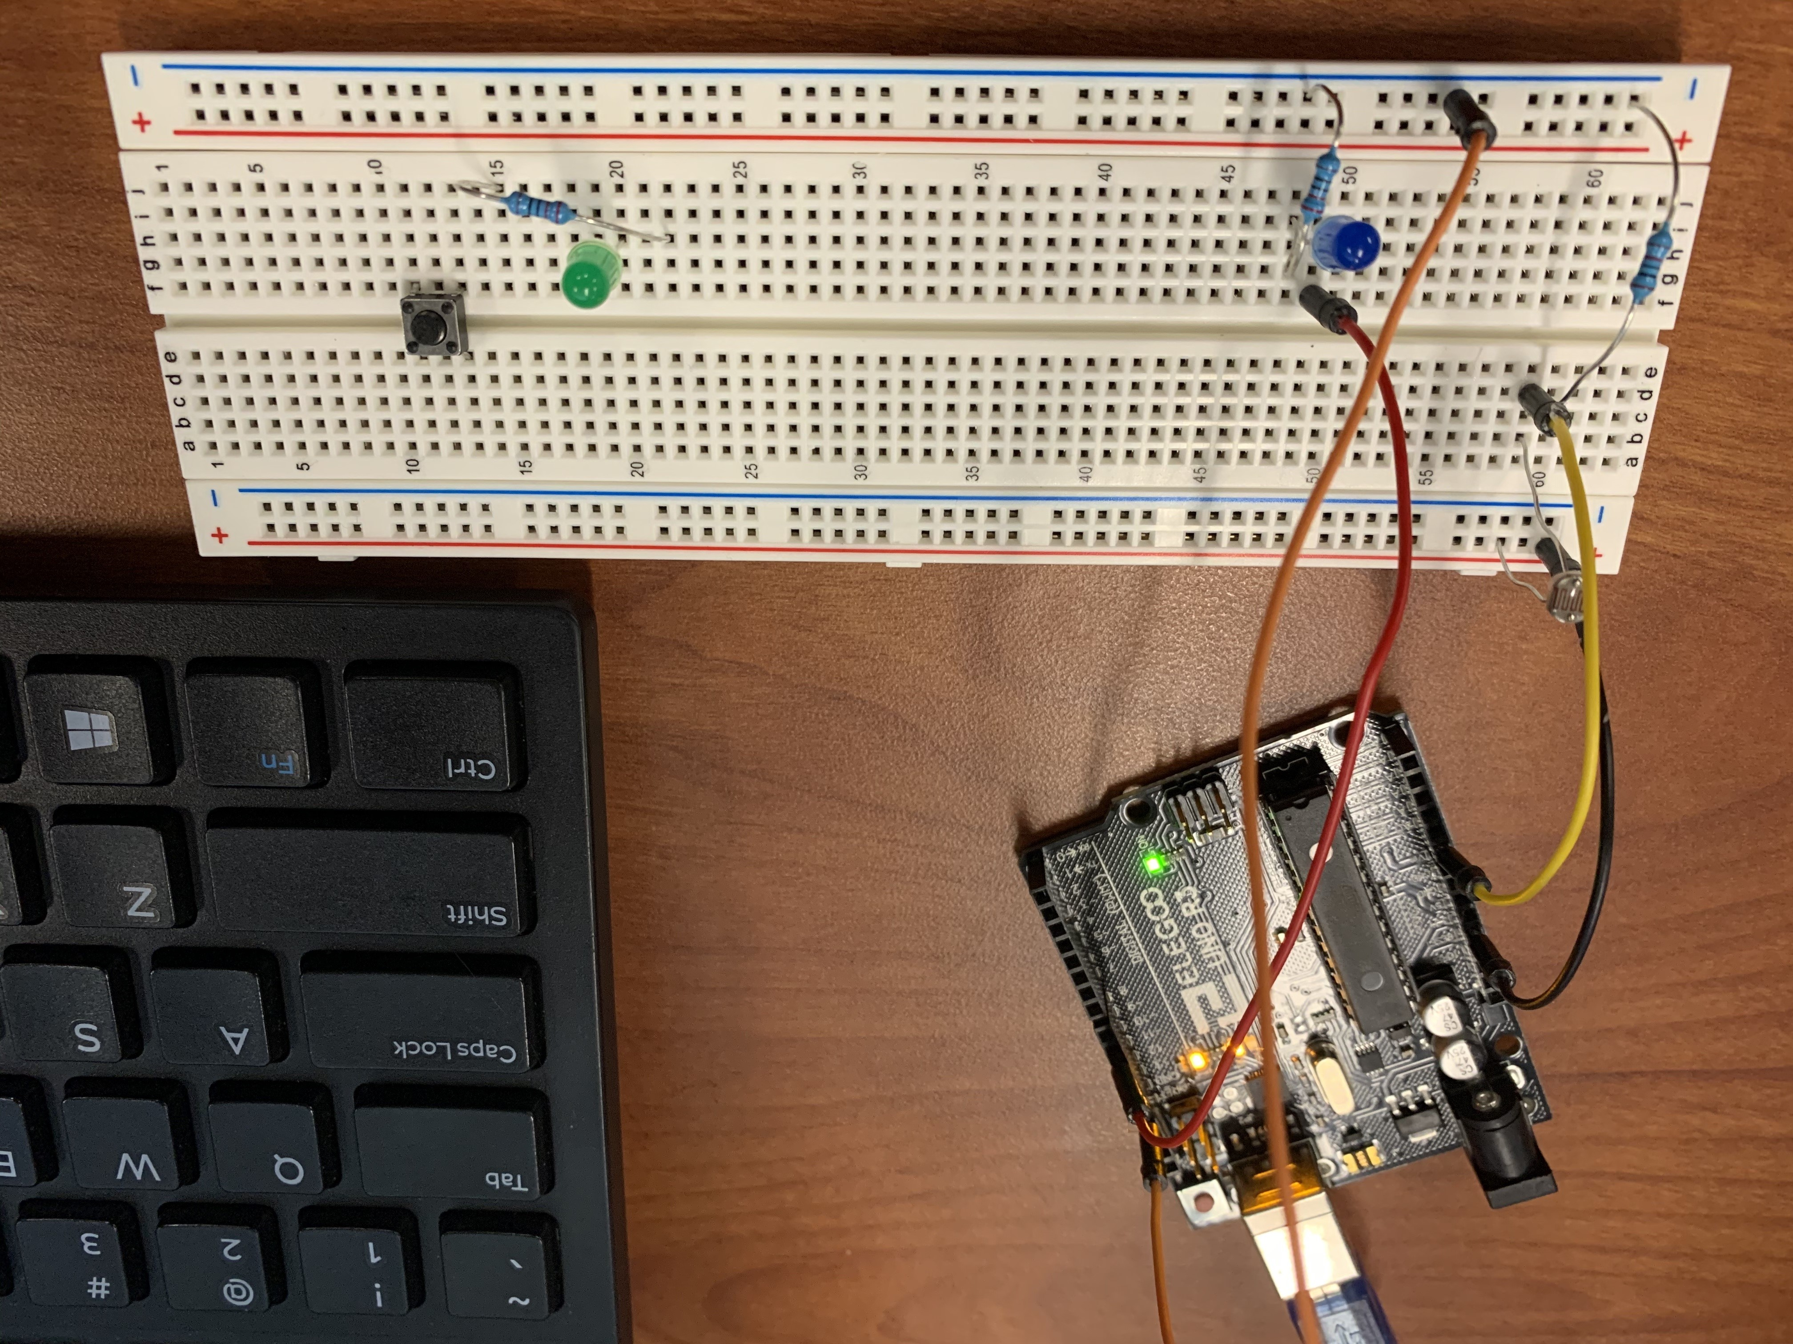

Serial Monitor Output when light intensity is high:

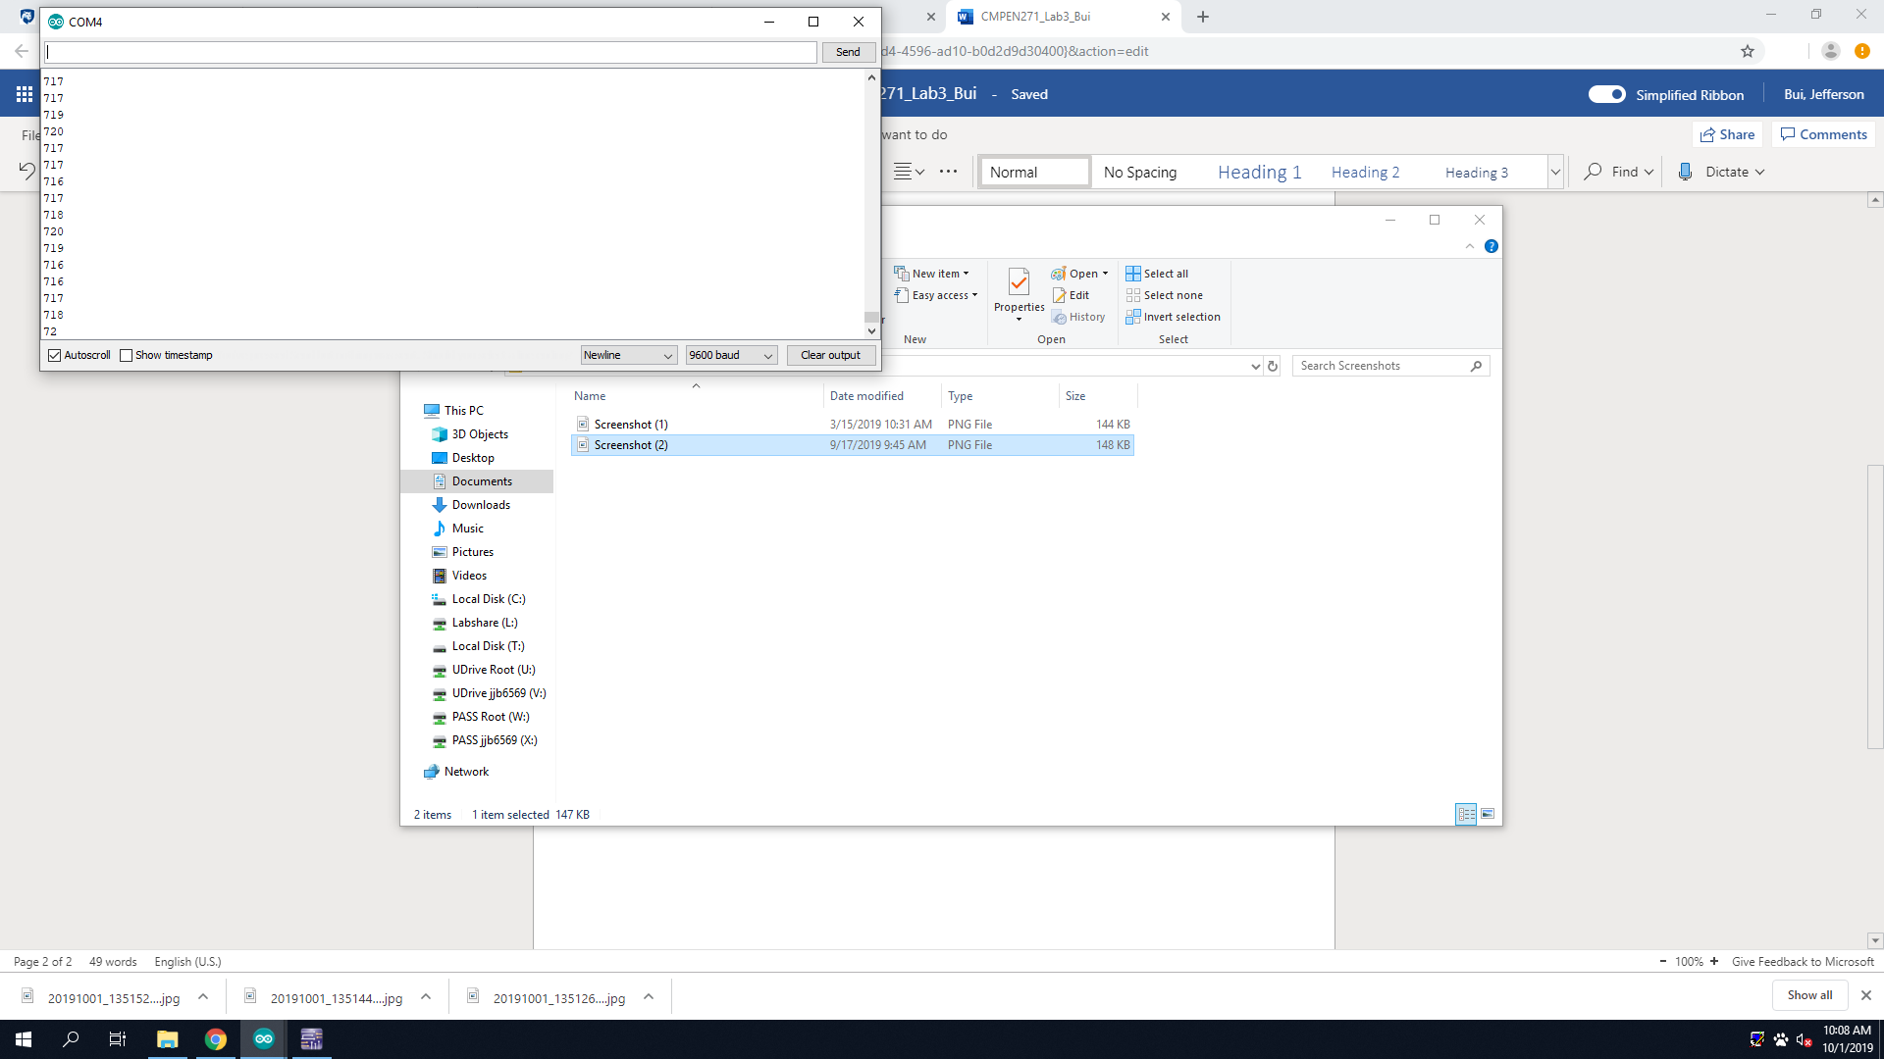

Serial Monitor Output when light intensity is low:

