Jefferson Bui

CMPEN 271

31 October 2019

Lab 4

# Thermistor and Led w/ Buzzer

Code:

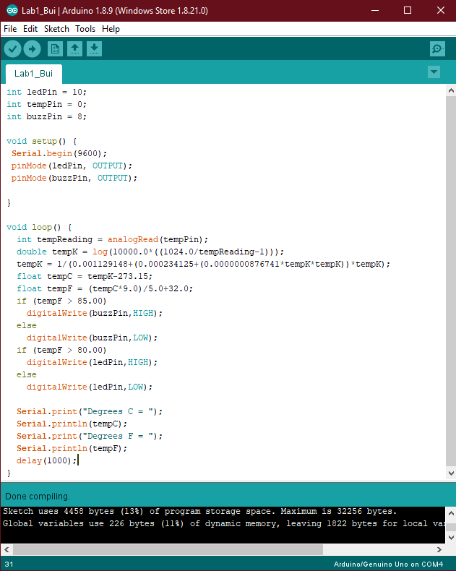

|  |
| --- |
| int ledPin = 10;  int tempPin = 0;  int buzzPin = 8;    void setup() {  Serial.begin(9600);  pinMode(ledPin, OUTPUT);  pinMode(buzzPin, OUTPUT);    }    void loop() {  int tempReading = analogRead(tempPin);  double tempK = log(10000.0*((1024.0/tempReading-1)));  tempK = 1/(0.001129148+(0.000234125+(0.0000000876741*tempK*tempK))*tempK);  float tempC = tempK-273.15;  float tempF = (tempC*9.0)/5.0+32.0;  if (tempF > 85.00)  digitalWrite(buzzPin,HIGH);  else  digitalWrite(buzzPin,LOW);  if (tempF > 80.00)  digitalWrite(ledPin,HIGH);  else  digitalWrite(ledPin,LOW);    Serial.print("Degrees C = ");  Serial.println(tempC);  Serial.print("Degrees F = ");  Serial.println(tempF);  delay(1000);  } |

Circuit:

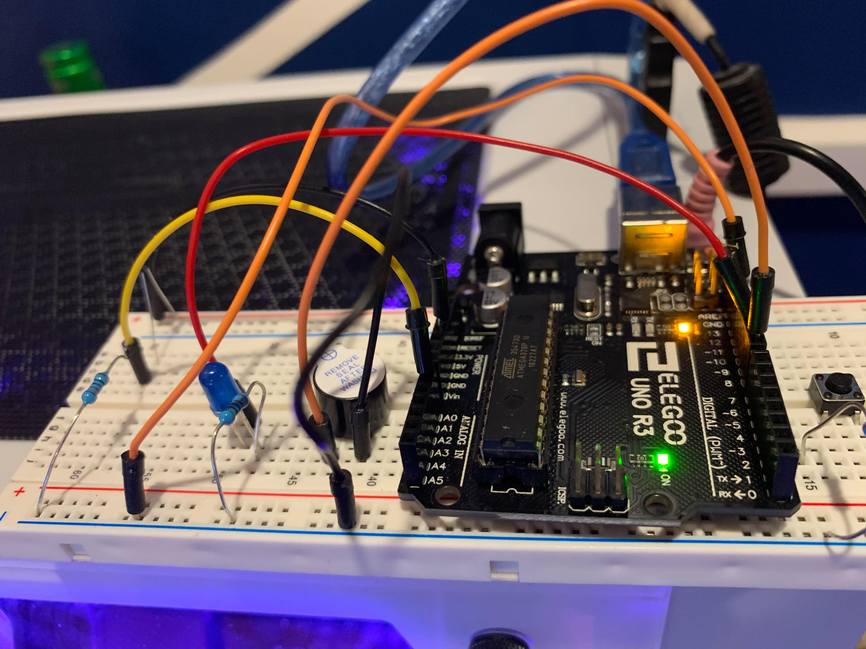

Serial Monitor Output:

