Jefferson Bui

CMPEN 271

14 November2019

Lab 5

Servomotor Control w/ Potentiometer

# Code:

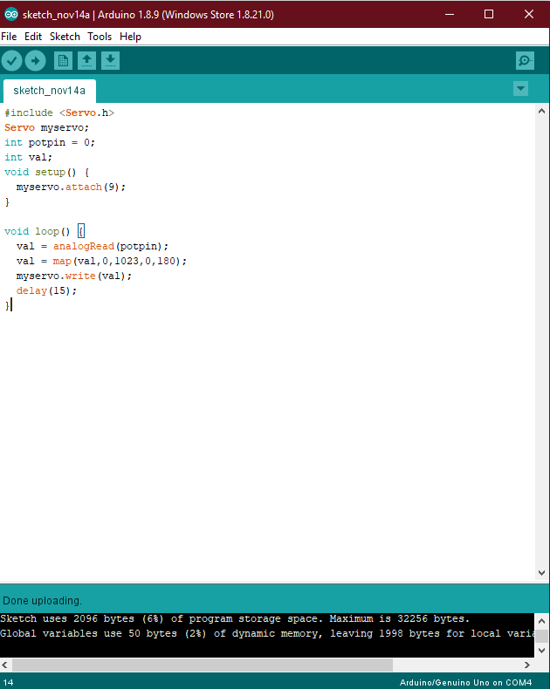

|  |
| --- |
| #include <Servo.h>  Servo myservo;  int potpin = 0;  int val;  void setup() {  myservo.attach(9);  }    void loop() {  val = analogRead(potpin);  val = map(val,0,1023,0,180);  myservo.write(val);  delay(15);  } |

# Circuit:

