Here is a dataset for lots and owners in Montreal in 1725. Some individuals are in the Dictionary of Canadian Biography. The street names could be linked to the Quebec place name database https://toponymie.gouv.qc.ca/.

Here is a brief description of the fields (the longer one is in French only).
id: unique indentifier
numero_dt: cadastral number according to the second “terrier” of the Sulpician Seminary
proprietai: name of the owner
acquisitio: start date of ownership
mode_acqui: mode of acquisition
dispositio : end date of ownership
mode_dispo: mode of disposition
origine : ethnic origin (F = French; C = Canadian)
occupation: occupational category
residence: place of residence (not always available)
sexe: M or F
type_propr: type of proprietor (individual, organization or estate of a deceased)

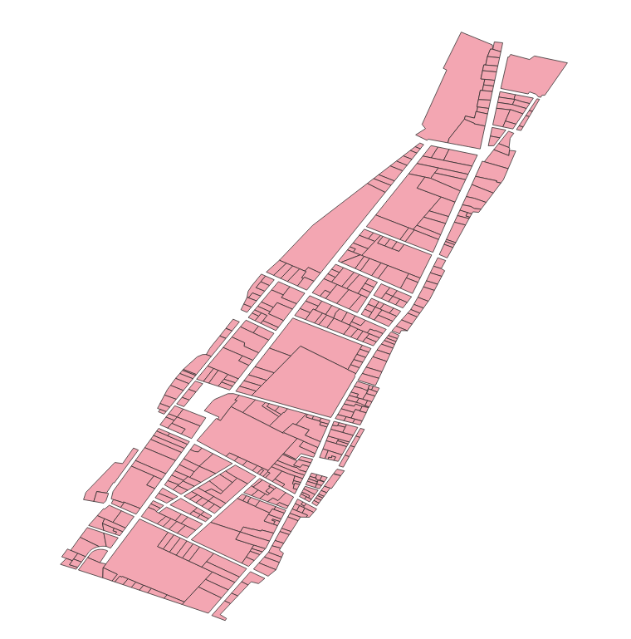

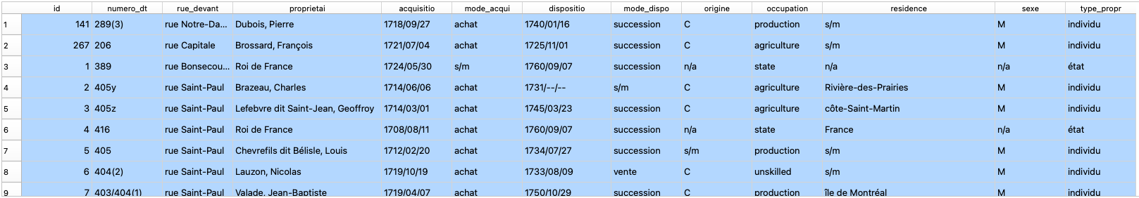

wkt_geom | id | numero_dt | rue_devant | proprietai | acquisitio | mode_acqui | dispositio | mode_dispo | origine | occupation | residence | sexe | type_propr
MultiPolygon (((-73.55495117656894877 45.50653207742458761, -73.55505246461267177 45.50638816074057047, -73.55527842790363025 45.50647526087882966, -73.55516757018789065 45.50662076938140643, -73.55495117656894877 45.50653207742458761))) | 141 | 289(3) | rue Notre-Dame | Dubois, Pierre | 1718/09/27 | achat | 1740/01/16 | succession | C | production | s/m | M | individu

