# Overview

The control was implemented as a ViewComponent inside an ASP.NET Core MVC application

The control uses IWeatherDataService (which gets the data from the OpenWeatherMap web API) and IWeatherAnalyticsService (which creates analytics based on the API data) as shown on the diagram below:

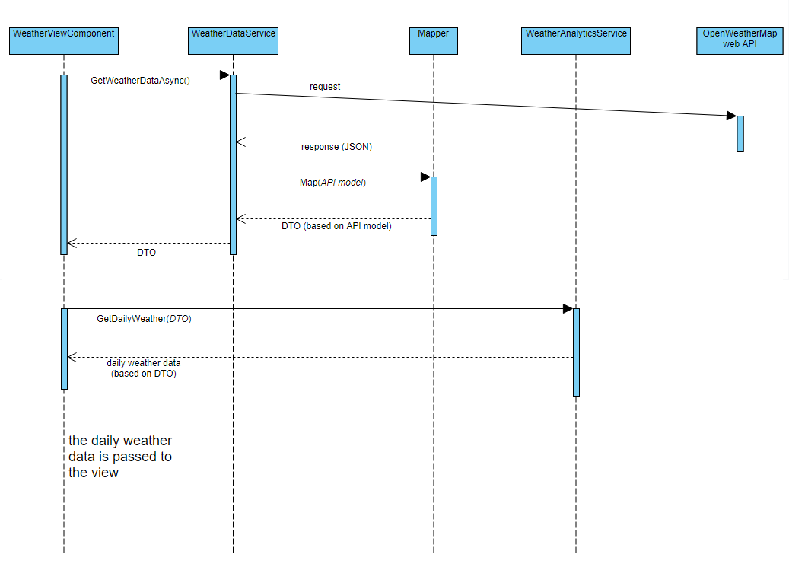

# Models and mapping

An API model (in the **Interview.Web.Weather.Models.Api** namespace) was created to represent the data coming from the OpenWeatherMap web api.

This API model is further transformed to a DTO model, which is used in all subsequent processing in the application.

To map the API model classes to the DTO model classes, a custom class named **Mapper** was created. AutoMapper was not used for this purpose, because the API model is significantly different from the DTO model, which would not allow for easy use of the automatic mapping feature.

# Application features

* the application uses SimpleInjector as a dependency injection framework
* the application uses bootstrap for responsive layout