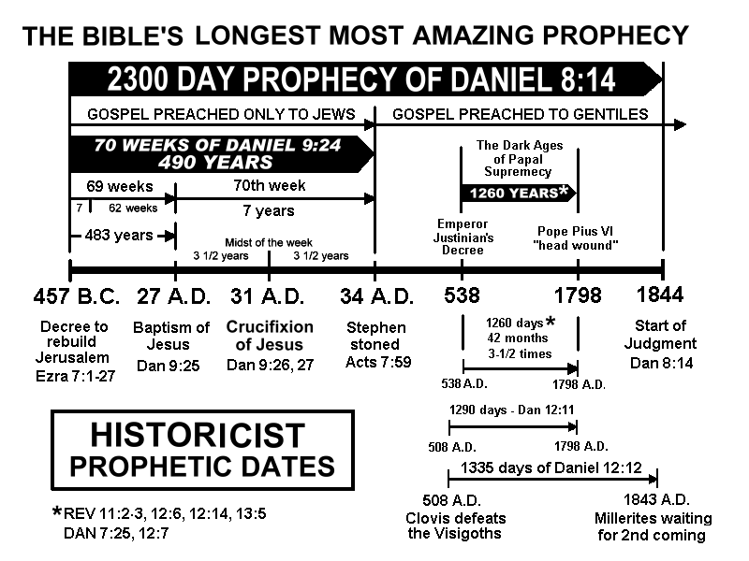

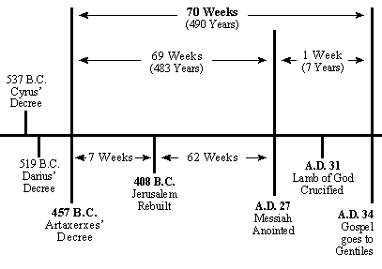

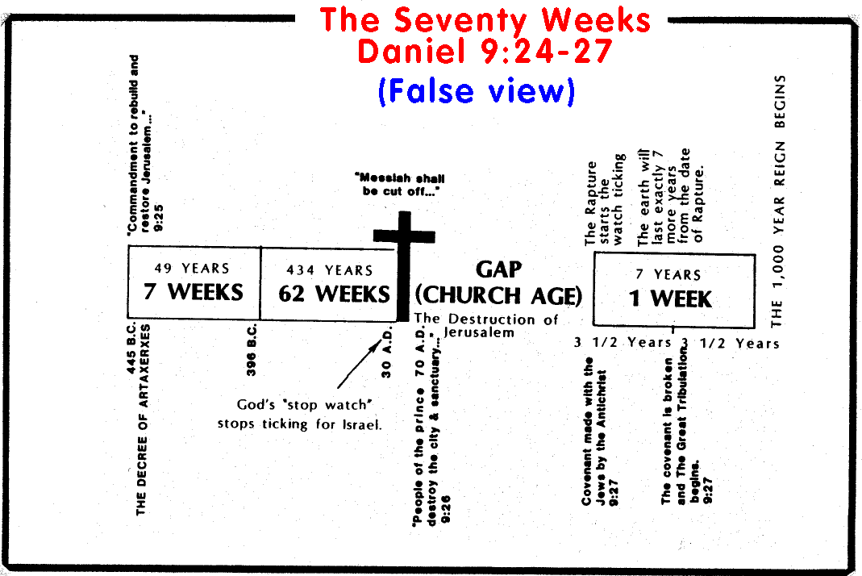

| Daniel 9:24-27  24**Seventy weeks** [ **= 490 years** "a day for a year"—Ezek. 4:6] are determined upon **thy people** [ **= the Jews**] and upon thy holy city, to finish the transgression, and to make an end of sins **to make an end of sins** [ **via Messiah's atonement;** "I will forgive…remember their sins no more"—Jer. 31:34 ], and to make reconciliation for iniquity, and to bring in everlasting righteousness, and to seal up the vision and prophecy **[Prophet]** , and to **anoint** [ **Messiah** is the Hebrew word for "anointed one" ] the most Holy. 25Know therefore and understand, [that] from the going forth of **the commandment to restore and to build Jerusalem** [ **approx. 457 B.C.**] unto the **Messiah the Prince** [ **baptized by John approx. 27 A.D.** "the fifteenth year of the reign of Tiberius Caesar"—Luke 3:1] [shall be] **seven weeks, and threescore and two weeks** [ **(7x7)+(62x7)=483 years** "a day for a year" ]: the street shall be built again, and the wall, even in troublous times. | 26And after threescore and two weeks shall Messiah be **cut off** [ **= killed, crucified**], but not for himself: and **the people of the prince that shall come** [ **= the Romans (prince Titus)** who destroyed Jerusalem and its Temple in 70 A.D.] shall destroy the city and the sanctuary; and the end thereof [shall be] with a flood, and unto the end of the war desolations are determined. 27And he shall confirm **the covenant** [ **= God's covenant with Israel** prior to welcoming in the Gentiles ] with many for **one week** [ **= 7 years** = Messiah's 3 1/2 year ministry + 3 1/2 years of Apostles converting Jews before widespread Gentile conversion began]: and **in the midst of the week** [ **= the midpoint of the 70th week of years**] **he shall cause the sacrifice and the oblation to cease** [ **= Messiah, as "the Lamb of God"—John 1:29** , was sacrificed "once for all"—Heb. 9:26-10:18 ], and for the overspreading of **abominations he shall make [it] desolate** [ **= Roman armies cause destruction** according to Jesus: "armies"—Luke 21:20 = "'the abomination that causes desolation,' spoken of through the prophet Daniel"—Matthew 24:15 ], even until the consummation, and that determined shall be poured upon the desolate. |
| --- | --- |

Historically, up till the mid 1800’s, Protestant Christians did not apply Daniel 9:27 to a future time of antichrist or tribulation. They applied the “he” in verse 27 to Jesus Christ and not antichrist. Some world famous Bible commentaries agree. Matthew Henry’s commentary says about Daniel 9:27: “By offering himself a sacrifice once and for all he [Jesus] shall put an end to all the Levitical sacrifices.” Another famous bible commentary by Adam Clarke says that during the “term of seven years,” Jesus would “confirm or ratify the new covenant with mankind.”

The following thoughts provide clear and convincing evidence that the “one week” in Daniel 9:27 does not apply to any future “so called” antichrist or seven year tribulation at all. But indeed, Daniel 9:27, which is perhaps the greatest verse of prophecy in the Bible, points to “The Christ” (Jesus the Messiah).

* The prophecy of Daniel 9:24-27 covers a period of “seventy weeks.” This applies to one complete, uninterrupted sequence of time, starting in the Persian era and ending during the time of Messiah.
* Logic and honest, scientific interpretation require that the 70th week immediately follow after the 69th week. If not, then it cannot be accurately called the 70th week! It is unreasonable, unscientific and illogical to insert a 2,000 year gap between the 69th and 70th week. No suggestion or hint of a gap is found in the prophecy. There is no gap between the first 7 weeks and the following 62 weeks, so why insert one between the 69th and 70th week?
* The prophecy in Daniel 9:27 focuses on the Messiah (The Christ), not the antichrist and says nothing about a seven year tribulation.
* Many modern prophecy teachers falsely claim that a future antichrist will “make” a covenant with the Jews. They then teach that he will “break” that covenant. Daniel 9:27 teaches “He shall “CONFIRM” the covenant. Jesus Christ, not the antichrist, came to “Confirm the promises made unto the fathers” (Romans 15:8). The words “make” or “break” are not found in Daniel 9:27.
* “He shall confirm the covenant with many.” Jesus said, “This is my blood of the new testament, which is shed for many” (Matt 26:28). Jesus used the same words because he knew that He was the fulfillment of Daniel 9:27.
* Gabriel said the 70 week prophecy applied to the Jewish people (Daniel 9:24). From A.D. 27 to A.D.34, the disciples, by Jesus command, went only “to the lost sheep of the house of Israel” (Matthew 10:6). Thus the everlasting covenant in Jesus’ blood was confirmed with the Jews for seven years before God turned to all nations.

One reason why the Jews failed to receive Jesus as the Messiah is that their teachers and spiritual leaders failed to correctly interpret the 70 week prophecy in Daniel Chapter 9. Today, the same thing is happening again! Sincere Christian leaders are misinterpreting the very same prophecy. All time and eternity hangs on what happened during Daniel’s 70th week (A.D. 27 – A.D. 34)! The enemy has attempted to cover up the greatest seven years in human history – the death and resurrection of Jesus Christ, and the coming of the Holy Spirit to empower the church, which are the basis of every New Covenant reality! No wonder why the enemy wants this period of time to be clouded and confused, for it was in the seventieth week of Daniel’s prophecy that Satan met his total defeat and demise. I challenge every disciple of Christ to arise and preach and teach what the Bible really says. In the spirit of true reformation, tell it like it is. Speak the truth in love. Pharisees will hate you, suppressing the truth in unrighteousness (Romans 1:18). But truth and love will prevail over lies and hatred. Light is greater than darkness and always overcomes it.