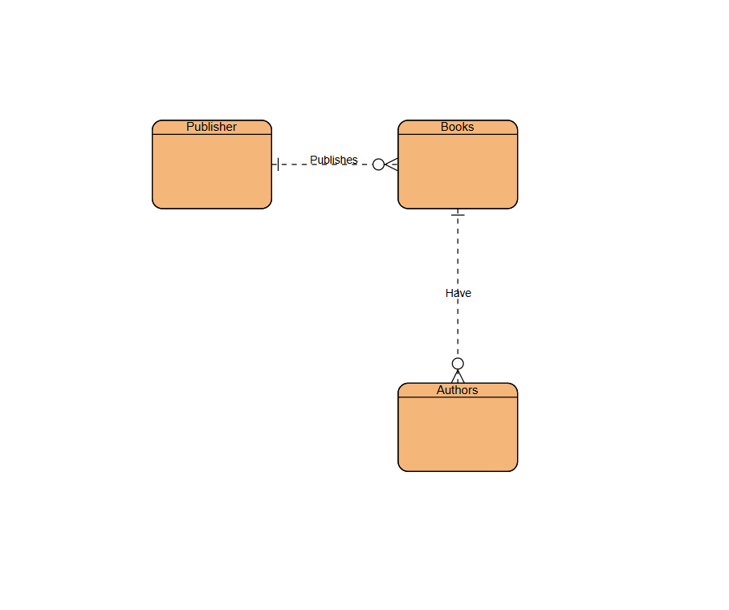
James Buzzell
11/8/2025
2.2 Assignment

