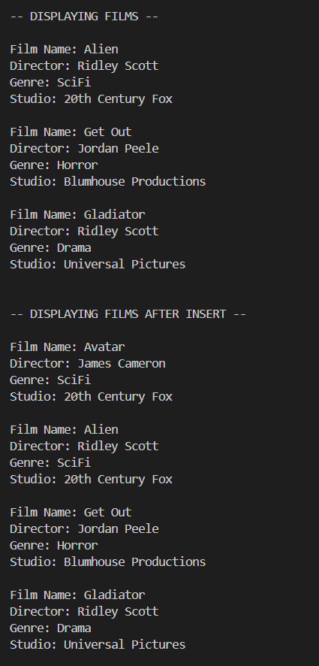
James Buzzell
12/21/2025
Assignment 8.2

James B's Repository

