James Buzzell
11/29/2025
Assignment 5.2

CONCAT might be used if you’re trying to concatenate different values and form them into a string. Part of this command is creating a column header as an alias. The concatenated values together will be displayed in the column.
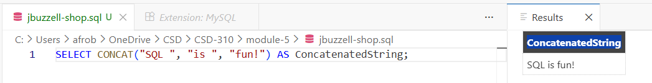

CURDATE is used to output today’s date. This might be useful if you are running reports and need to record the date on which they were run.

DATABASE will simply return the name of the current database. If there is no current database, this function returns NULL or "".
