James Buzzell
11/30/2025
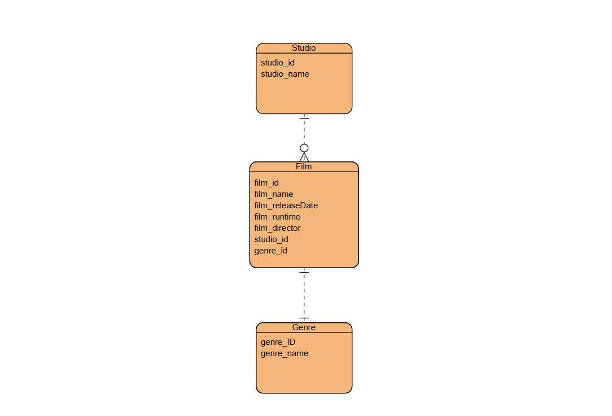
Assignment 5.3

