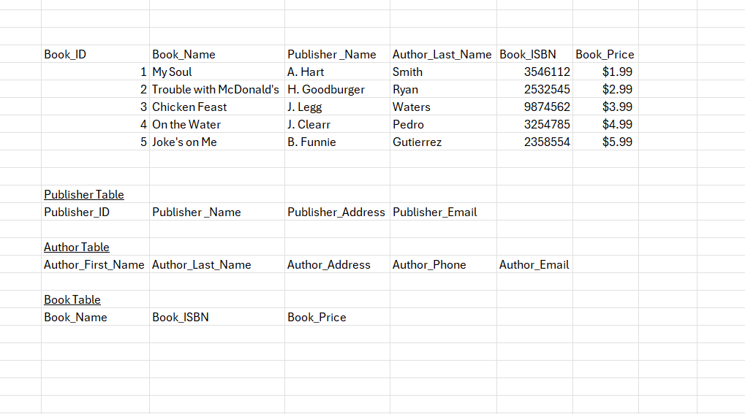
James Buzzell
11/15/2025
Assignment 3.2

