James Buzzell
6/7/2026
Assignment 1.3
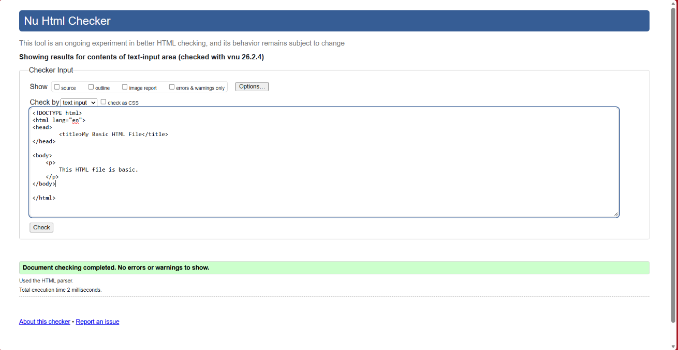
No errors were detected on 1st run:

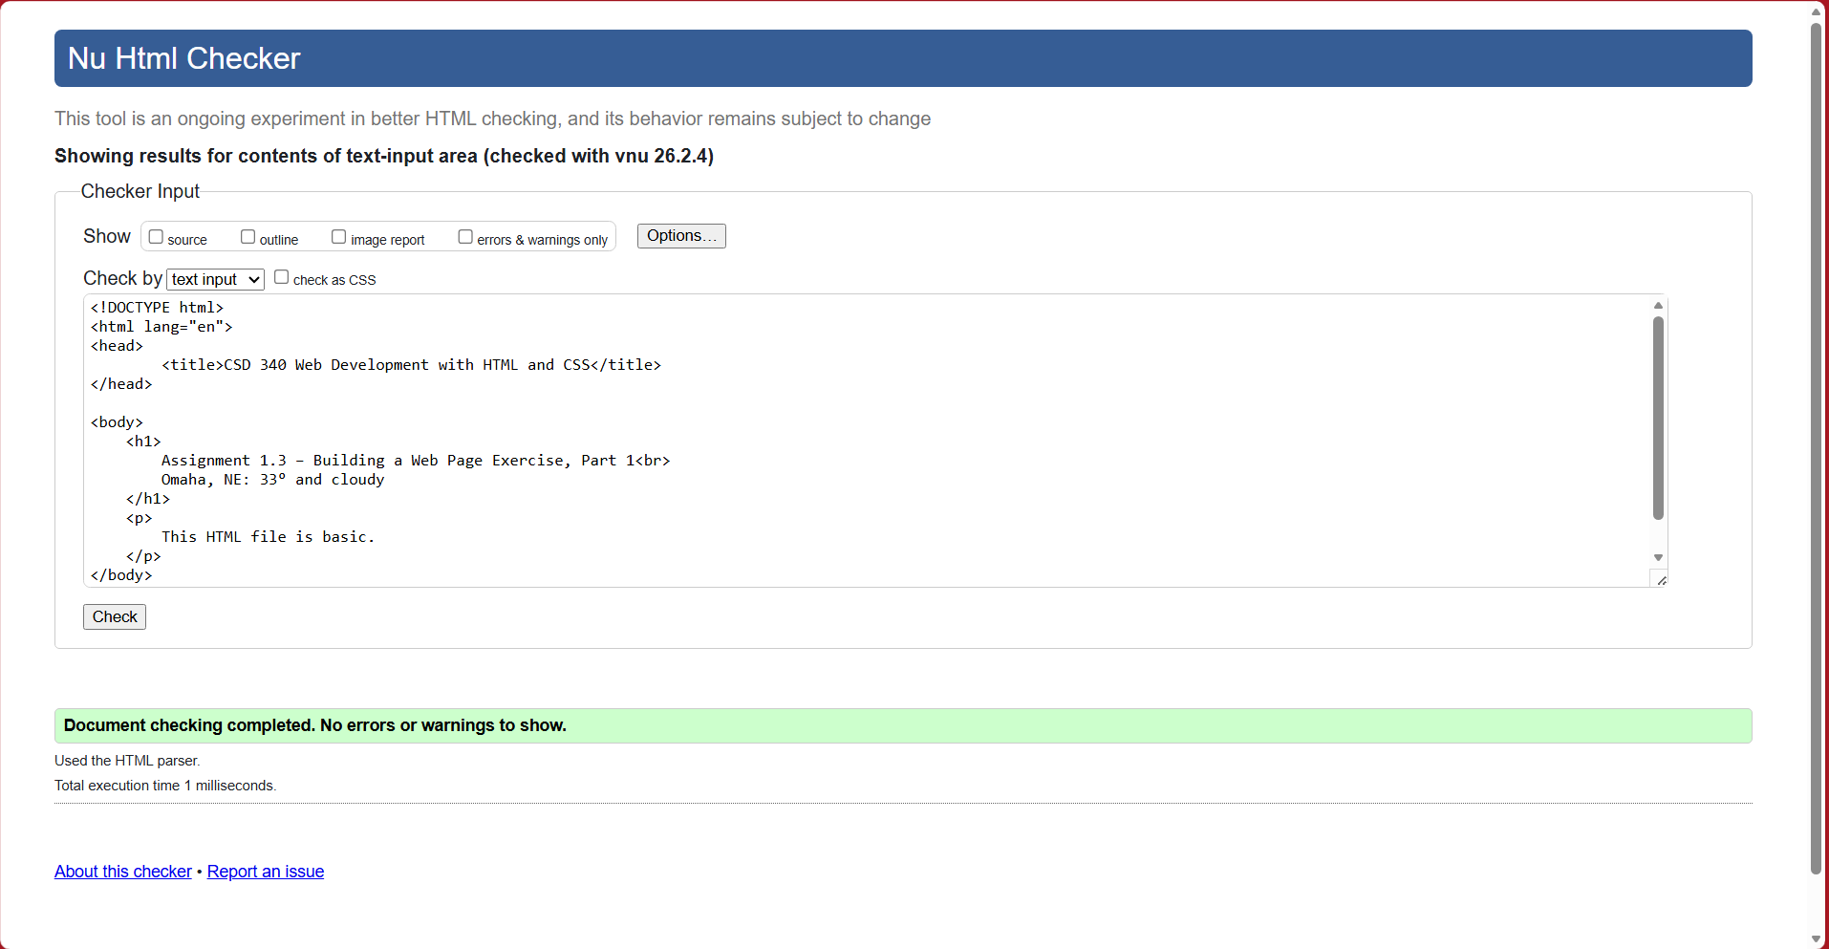
Final validation check:
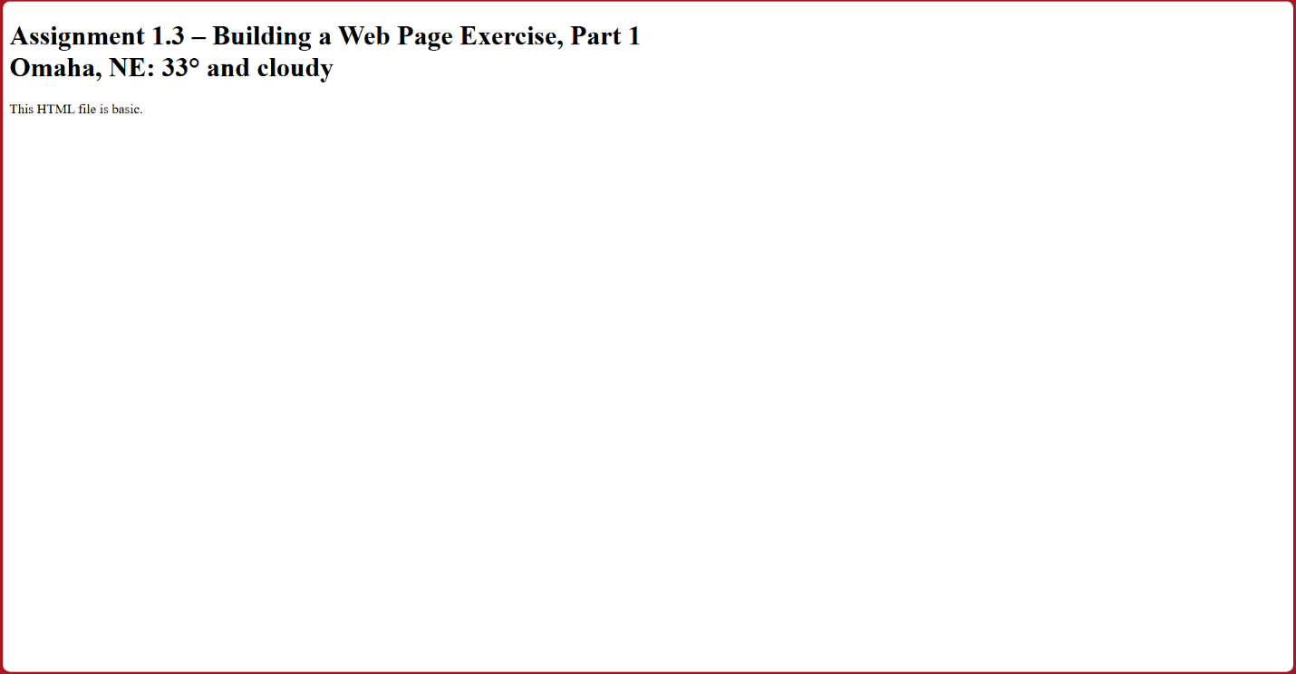
Output:

