HBox
JavaFX is a modern, state-of-the-art Java platform that provides a vast array of items that are clearly presented and utilized on interactive GUIs (graphical user interfaces). There is a plethora of styling options that can be applied via CSS (cascading style sheets). These items allow use of buttons that can be used for pretty much anything you can imagine, amongst many other things. There are a lot of other features that JavaFX offers. When it comes to windows that contain buttons, I will present and explain two JavaFX layout items, HBox and Flowpane.
Hbox sets its children in horizontal columns. If the HBox contains a border and/or set of padding, then its contents will be laid out within those insets. The HBox class extends the Pane class.
According to GeeksforGeeks, constructors of the class:
- HBox(): Creates an HBox object with no nodes.
- HBox(double s): Creates an HBox with spacing in between nodes.
With HBox, one commonly used method is getAlignment(), which returns the value of property alignment. Also, there is getSpacing(), which return children’s spacing between one another. There is setAlignment(enter positive value here), which will set alignment of your HBox. The last one I will explain is getChildren() and what that does is return the nodes in the HBox. These four method only scratch the surface, as there a ton of other methods that can be utilized within HBox classes.
Below is a demonstration of a HBox program:
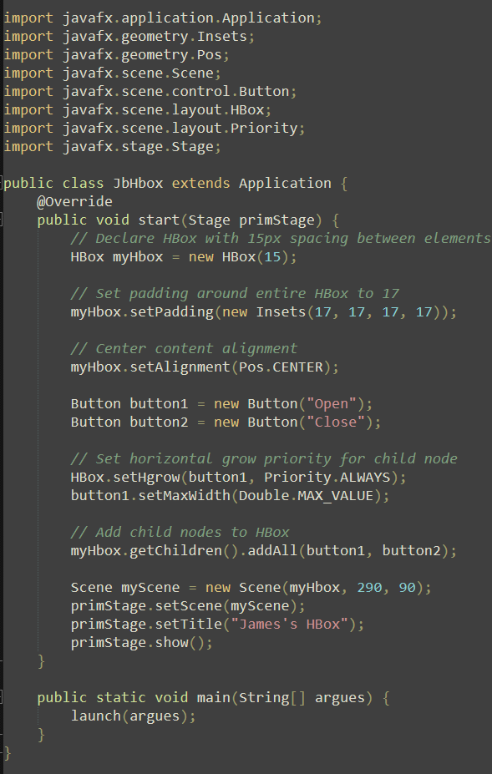

Output:
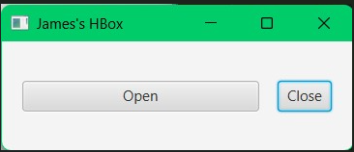

HBox resizes children (if resizable) to whatever widths they prefer and it uses the fillHeight property to see if their heights need resized to fill its own height or stay with their preferred height (fillHeight defaults to true). If an HBox is resized to a value larger than the width it prefers, by default, it will keep children to their preferred widths, leaving any excess space unused. If an application would like to have one or more children be allocated that space, an hgrow constraint on the child can be set optionally.

Flowpane
Flowpane lays out its children in a way that wraps at the boundary of the flowpane. A horizontal flowpane (default) will lay out nodes in rows, presenting wrapping at the flowpane's width. A vertical flowpane lays out nodes in column form, doing wrapping at the flowpane's height.
According to GeeksforGeeks, Some of Flowpane’s constructors include:
- FlowPane(): Creates a new Horizontal FlowPane layout.
- FlowPane(double h, double v): Creates a new Horizontal FlowPane layout, with specified horizontal and vertical gap.
- FlowPane(double h, double v, Node... c): Creates a new Horizontal FlowPane layout, with specified horizontal, vertical gap and nodes.
- FlowPane(Node... c): Creates a FlowPane with specified childrens.
The following is an example of Flowpane:
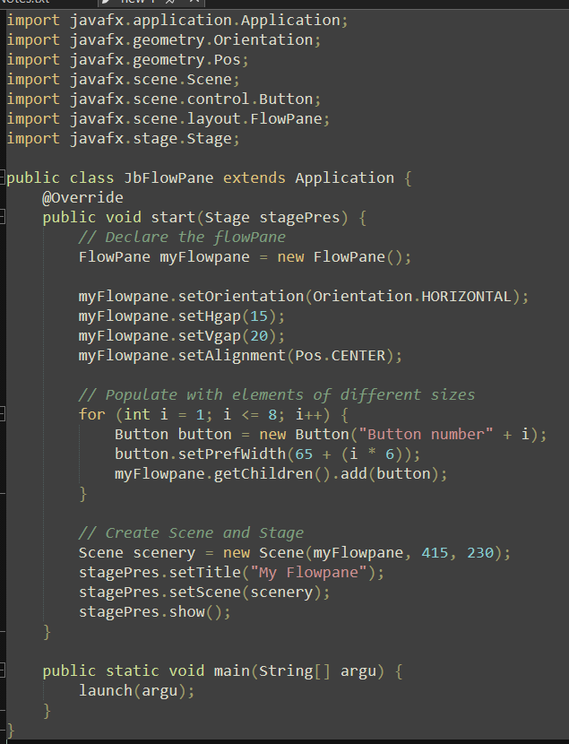

Output:
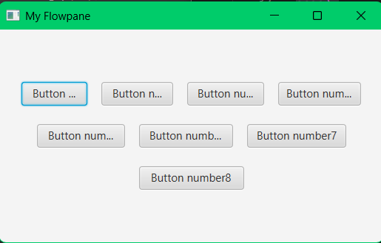

One popular method of Flowpane is getAlignment, and it will return the alignment’s value of the pane. Another one is getOrientation, which will return the pane’s orientation. There is also setHgap(double v), and what that will do is set the horizontal gap of the flow pane. There are so many other methods that can potentially be used, but these are among the most common ones.
A horizontal flowpane (the default) will layout nodes in rows, wrapping at the flowpane's width (FlowPane (JavaFX 8), 2026). A vertical flowpane places nodes in columns, performing wrapping at the height of the flowpane's. If the flowpane has a border and/or padding, its content will be flowed within those insets.
FlowPane's prefWrapLength property will establish the width it prefers (for horizontal) or preferred height (for vertical). Applications should set prefWrapLength if the default (400) isn’t satisfactory. Note: prefWrapLength can only be used for calculating the preferred size and might not reflect its wrapping dimension, which keeps track of the actual size of the flowpane. A flowpane's unbounded maximum width and height are an indication to the parent that it may be resized beyond the size it prefers to fill whatever space is assigned to it (FlowPane (JavaFX 8), 2026).

Links:
https://www.geeksforgeeks.org/java/javafx-hbox-class/
https://openjfx.io/javadoc/13/javafx.graphics/javafx/scene/layout/HBox.html
https://www.geeksforgeeks.org/java/javafx-flowpane-class/
https://docs.oracle.com/javase/8/javafx/api/javafx/scene/layout/FlowPane.html

References:
GeeksforGeeks. (2018, September 7). JavaFX | HBox Class. GeeksforGeeks. https://www.geeksforgeeks.org/java/javafx-hbox-class/
HBox (JavaFX 13). (n.d.). https://openjfx.io/javadoc/13/javafx.graphics/javafx/scene/layout/HBox.html
GeeksforGeeks. (2025a, July 11). JavaFX | FlowPane Class. GeeksforGeeks. https://www.geeksforgeeks.org/java/javafx-flowpane-class/
FlowPane (JavaFX 8). (2026, July 21). https://docs.oracle.com/javase/8/javafx/api/javafx/scene/layout/FlowPane.html

