Image 1 query using intensity + color code + RF

Initial result (before doing RF, with relevant image selected which will be used for RF analysis):

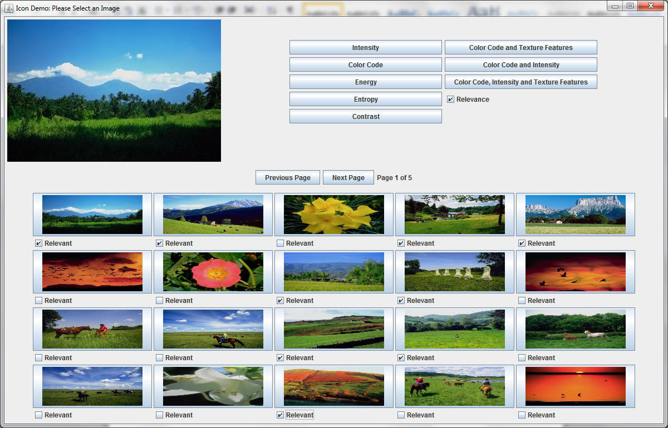

1st iteration result (1st RF analysis results, with new relevant images are selected for 2nd RF analysis):

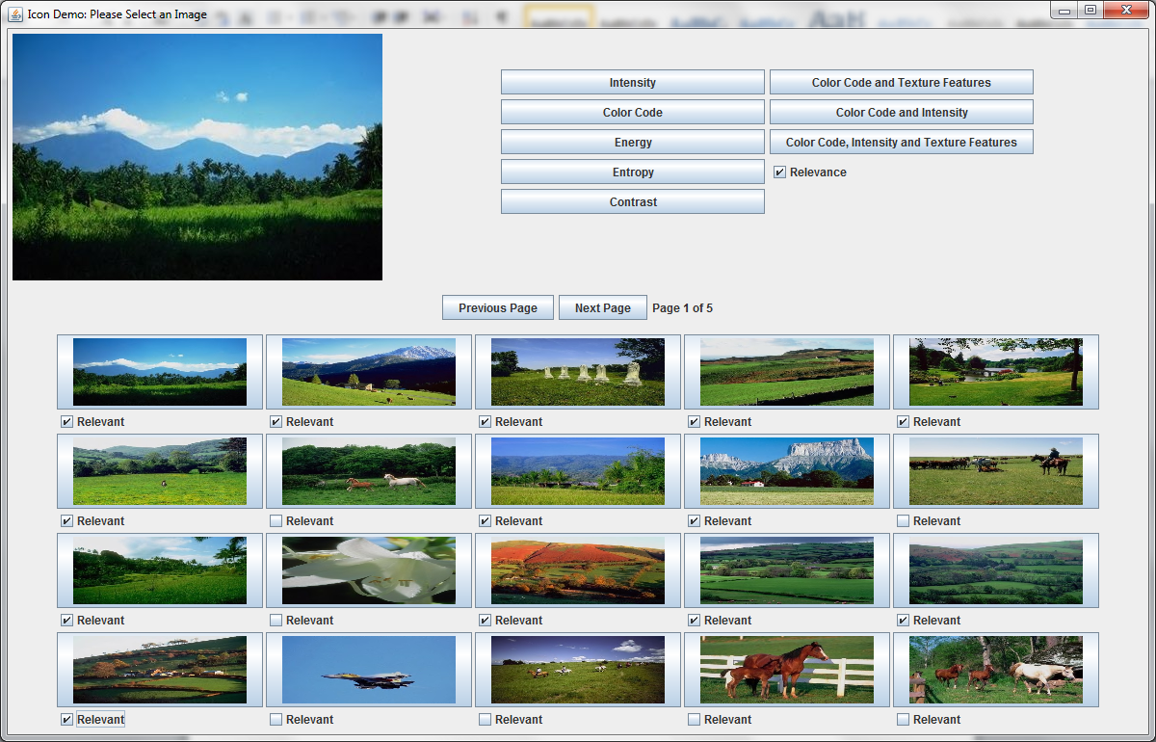

2nd iteration result:

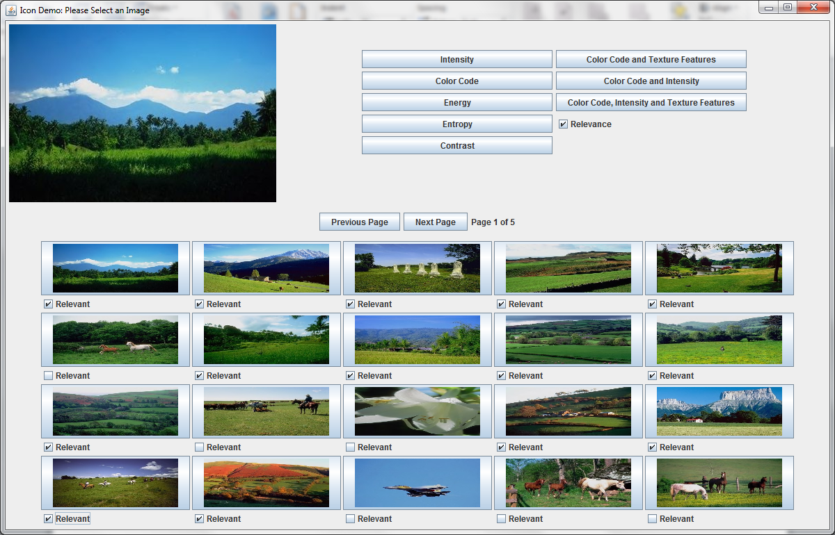

3rd iteration:

