One GUI example (This has more query options than required. You only need to provide Intensity, Color Code, Color Code and Intensity, Relevance)

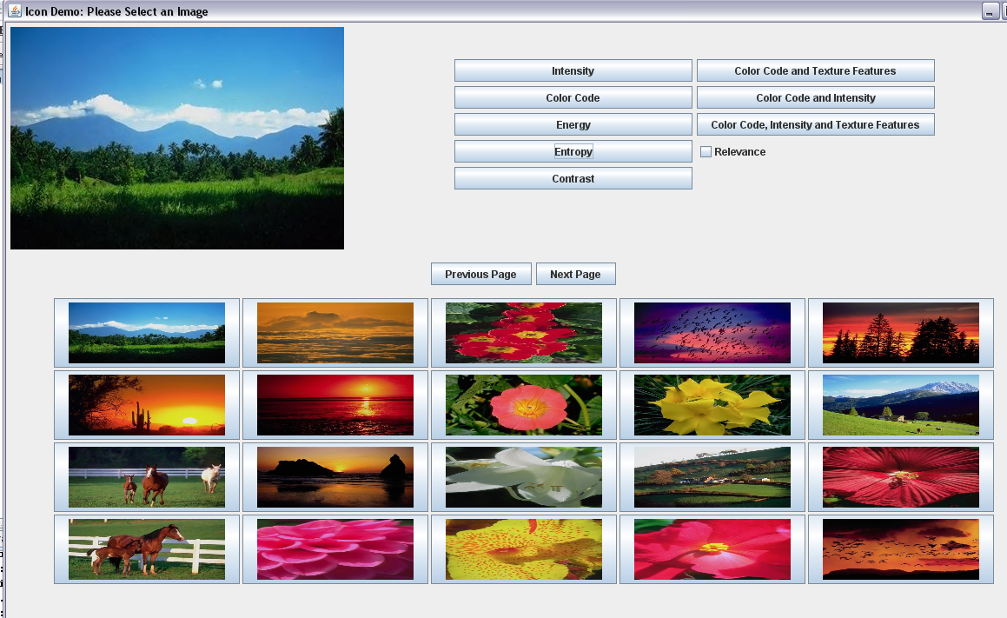

When Relevance Feedback is activated
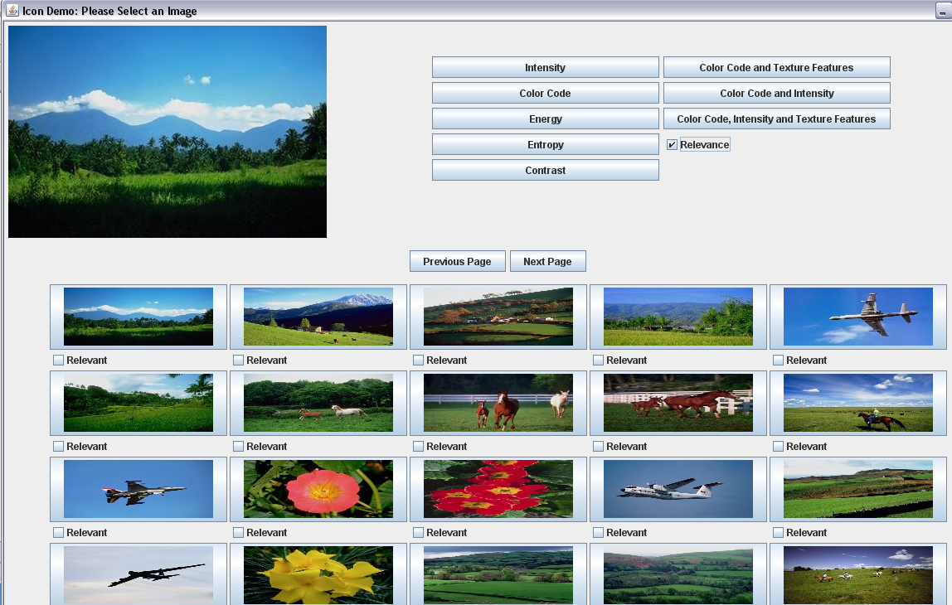

Another GUI example (This has more query options than required. You only need to provide Intensity, Color Code, Color Code and Intensity, Relevance)

