HAUTE & HAZARD
✦ ✦ ✦
OFFICIAL RULEBOOK
Version 3.1 - January 2026
Walk the runway. Claim the turf. Survive the evolution.
Players: 2-5  Time: 45-60 minutes  Age: 14+ | Genre: Deck-Building  Complexity: Medium  Win Condition: 30 SP

VERSION 3.1 BALANCE UPDATE
Critical balance fixes have been applied to improve game fairness and strategic diversity:
- Rat Tail Purse now restricted to ONCE PER TURN (prevents infinite loops)
- Necropolis brand buffed by +1 Appeal across all 5 cards
- Feather Boa capped at +3 Defense maximum
✦ ✦ ✦ ✦ ✦
Card Design Inspiration
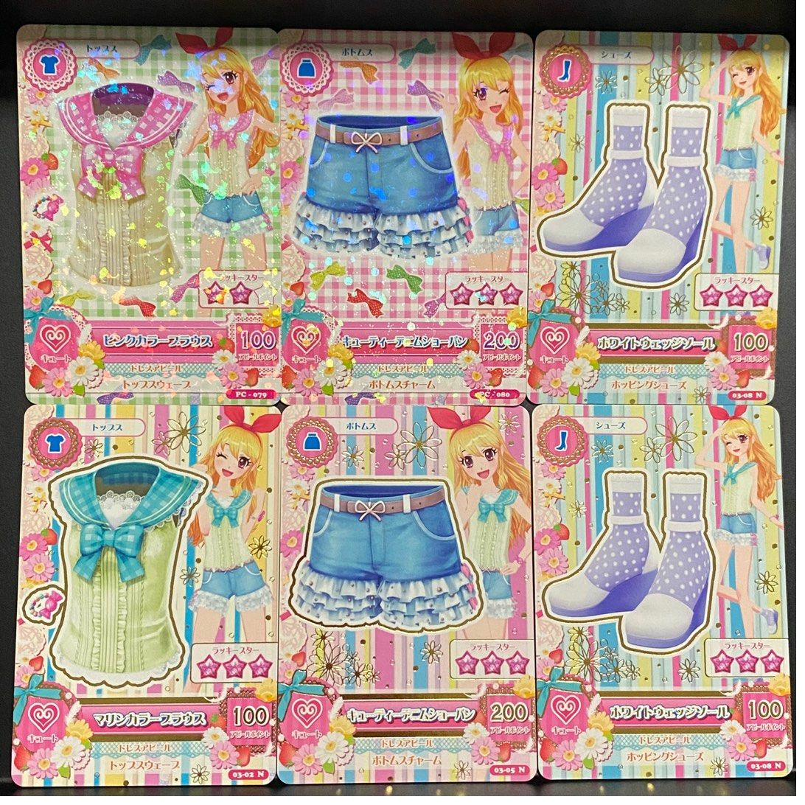
Haute & Hazard draws aesthetic inspiration from Aikatsu! data cards, combining fashion collectibility with strategic deck-building gameplay.

TABLE OF CONTENTS
1. Game Overview & Core Concepts
2. Components & Materials
3. Setup Instructions
4. Turn Structure (5 Phases)
5. Card Types & Abilities
6. Brand Synergies & Matching
7. Winning the Game
8. Advanced Rules & Combat
9. Glossary of Terms
10. Frequently Asked Questions

1. GAME OVERVIEW
Haute & Hazard is a competitive deck-building card game where players embody drag queens competing in high-stakes fashion challenges. Build your signature look by acquiring designer items from the Boutique, style yourself to perfection on your Player Mat, and accumulate enough Appeal to slay the Stage and earn precious Style Points.

Core Concepts
PINK TENET (Pop / Kawaii)
Sweet, energetic, and irresistibly cute. Pink builds focus on card advantage and overwhelming opponents with options. Sugar Rush brings adorable anime aesthetics while Hyper-Glitch offers cyberpunk neon vibes.

BLUE TENET (Horror / Edgy)
Dark, aggressive, and unforgiving. Blue excels at combat and disruption. Necropolis brings gothic horror, Slasher channels slasher films, and Void delivers alien cosmic terror.

PURPLE TENET (Glamour)
Elegant, seductive, and impenetrable. Purple specializes in defense and Style Point bonuses. Velvet Trap brings vampy film noir while Gilded Cage offers pageant-ready rhinestone opulence.

YELLOW TENET (Camp / Filth)
Chaotic, versatile, and surprisingly strategic. Yellow thrives on trashing mechanics and wild colors. Trash Can embraces punk fashion, Big Top brings circus energy, and Swamp Witch channels bog magic.

2. COMPONENTS
The game includes 236 poker-sized cards, tokens, and player materials.
- 60 Starter Cards (The Messy Closet)
- 125+ Boutique Cards (Fashion Items)
- 12 Stage Cards (Challenges)
- 25 Extermination Cards (Penalties)
- 11 Queen Cards (Characters)
- Tokens (SP, Tips, Defense)
- 5 Player Mats
✦ ✦ ✦ ✦ ✦
The runway is yours. Make it fierce.
For complete rules including turn structure, glossary, FAQ, and advanced strategies, see the complete digital rulebook.

