Requirements

- Openmeetings installation or account
- SugarCRM installation
- Openmeetings-Connector modul installation in SugarCRM.

Inhaltsverzeichnis
Openmeetings-Connector Modul Installation Guide 1
Sugar CRM Module Usage 6

Openmeetings-Connector Modul Installation Guide

Login as admin in SugarCRM.

Go to Admin- Modul Loader select Openmeetings_Connector.zip for Upload und upload the zip file.
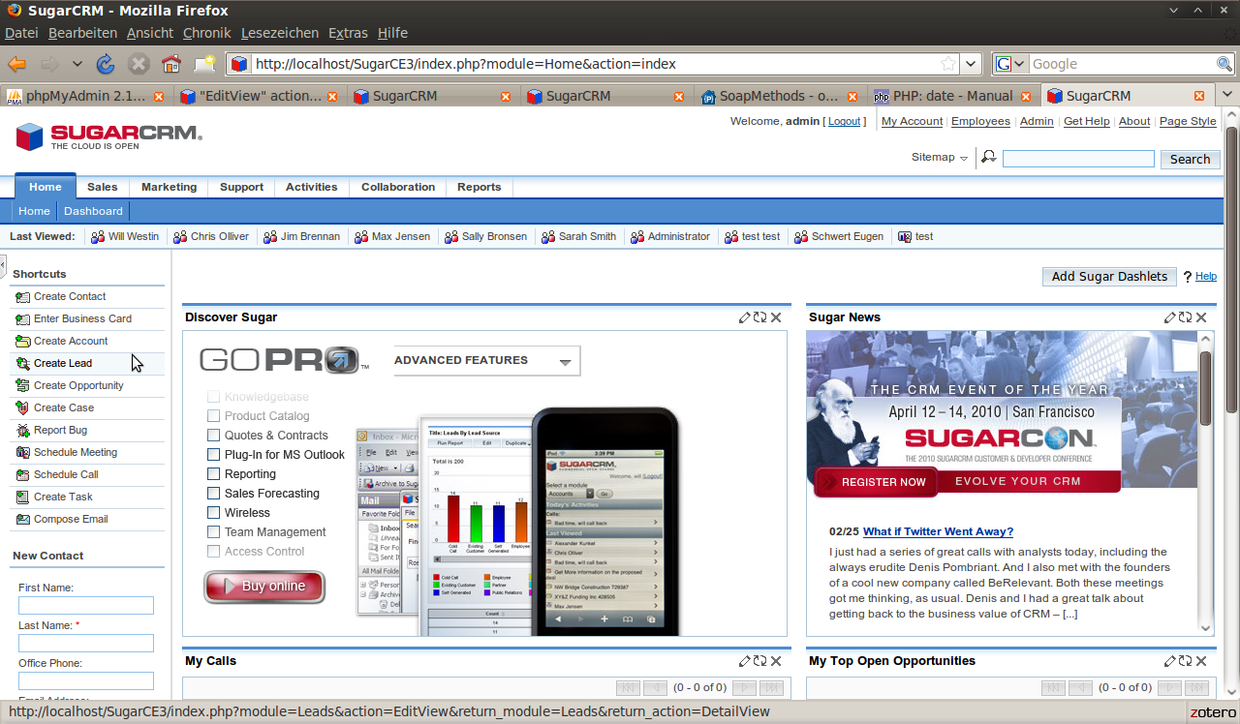
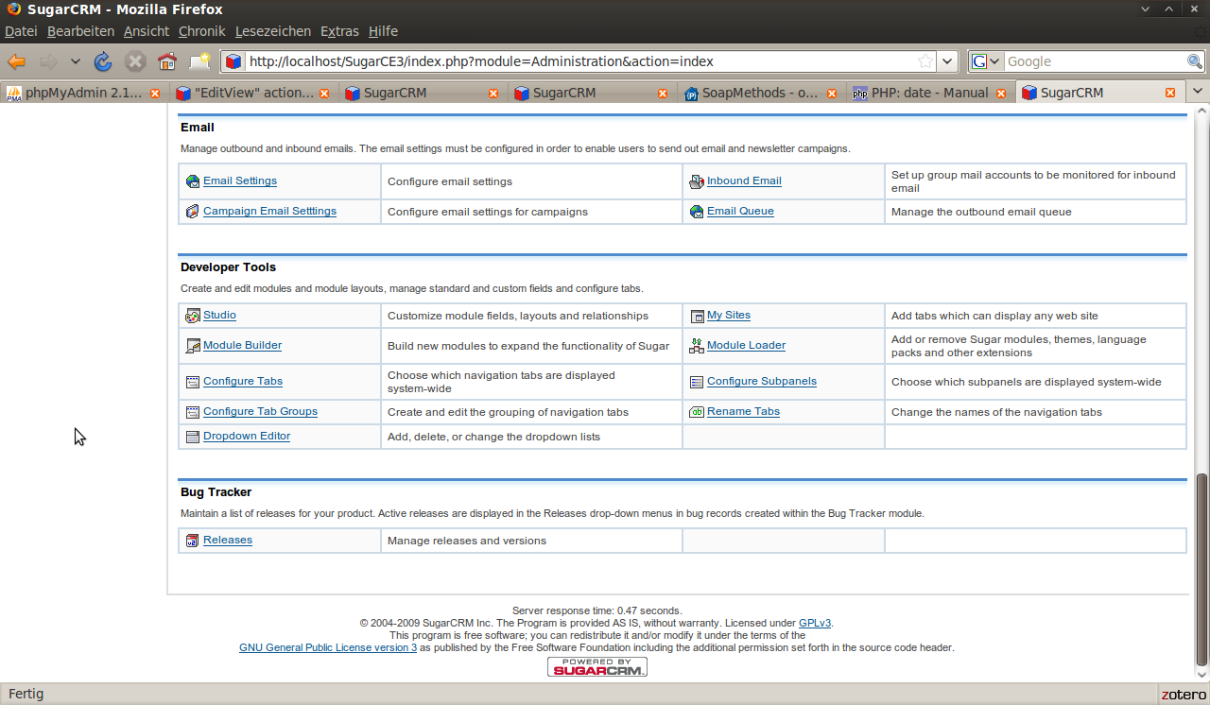

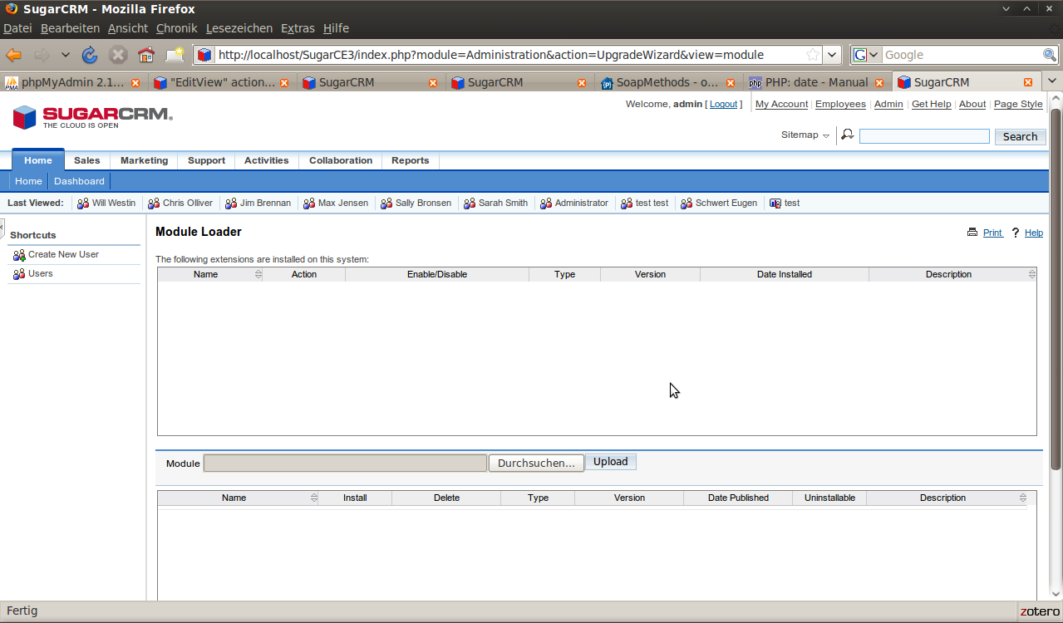

After upload you can install the Openmeetings_Connector module.
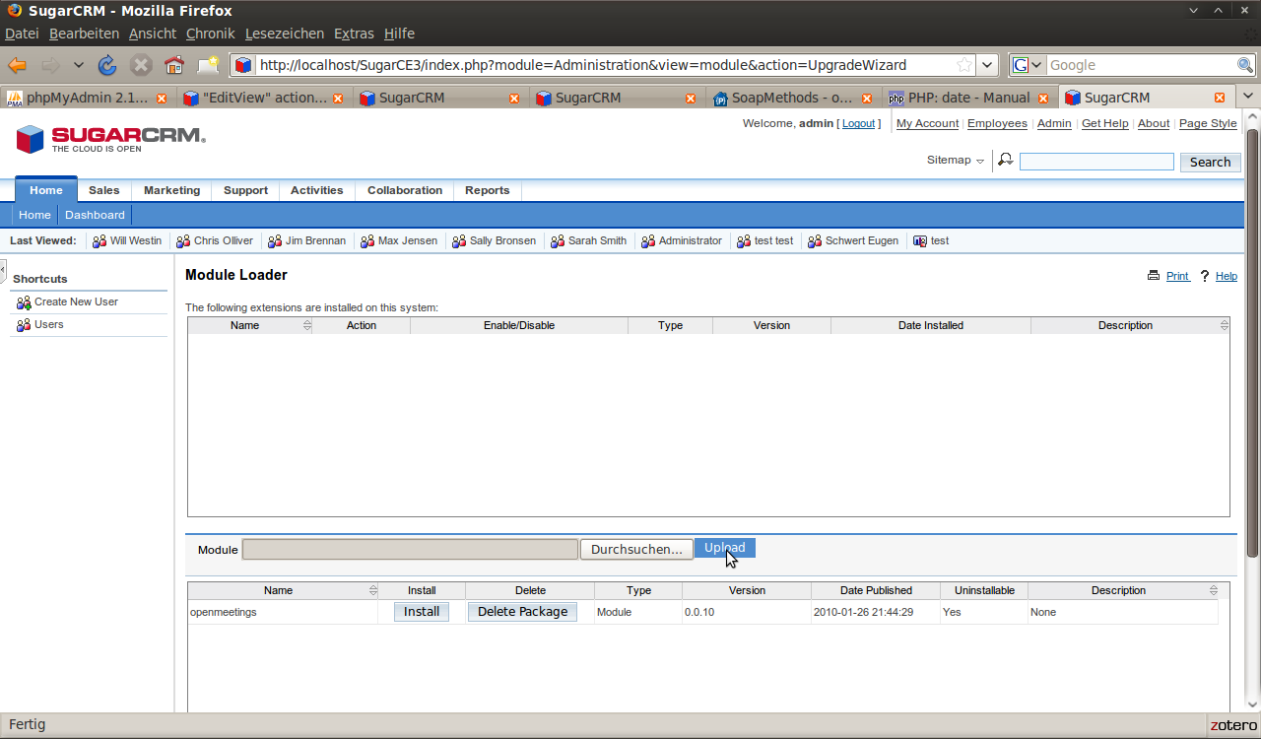

After installation a shortcut “Openmeetings Account” in Admin View is available.

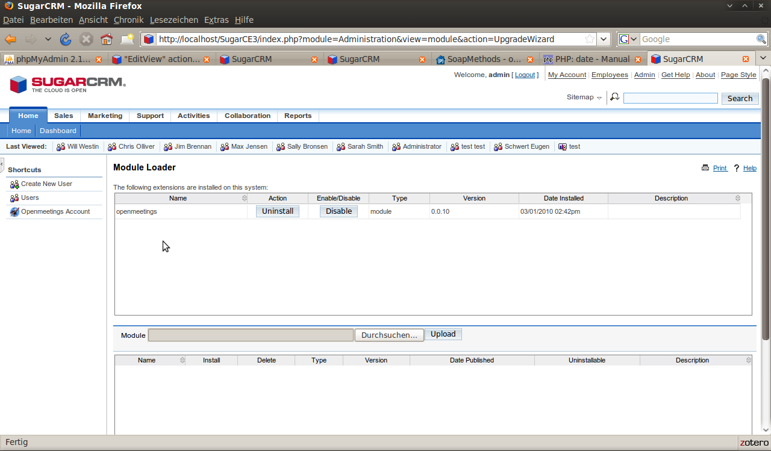

Configure the Openmeetings Account in the edit view.

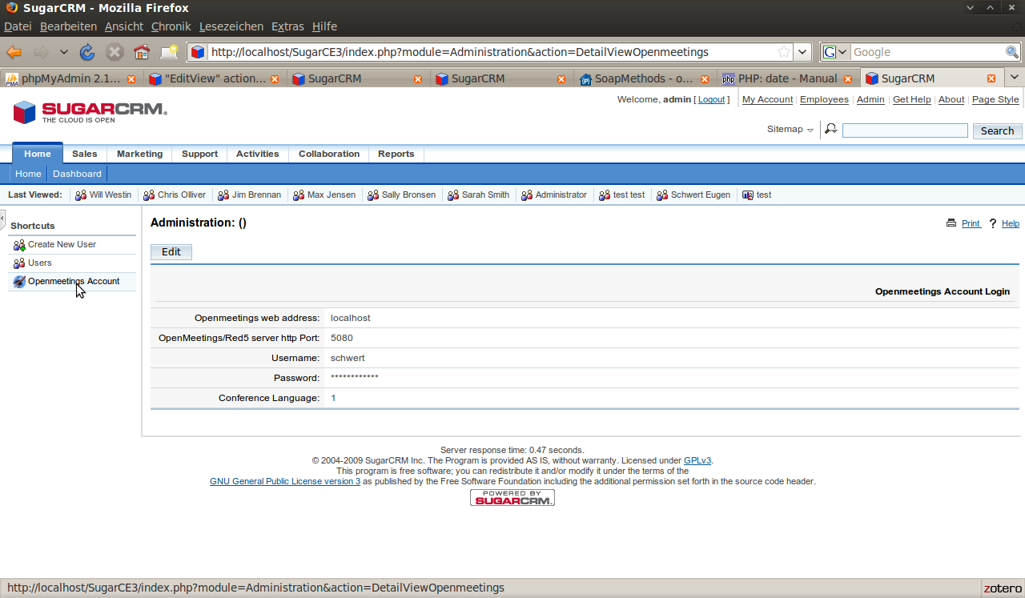

After installation and configuration you have to ad following Code manually.

Path: include/language/en_us_notify_template.html
Insert this two lines in the Meeting_Subject <!-- BEGIN: Meeting_Subject --> to modifikate the invitations E-mail tamplate after „Description: {MEETING_DESCRIPTION}“

Line | Code
119 | Meeting URL:
120 | <{MEETING_URl}>

Path: modules/Meetings/Meeting.php
insert in the function set_notification_body($xtpl, &$meeting) folowing line for add a Meeting-URL to E-mail template.

Line | Code
460 | $xtpl->assign("MEETING_URl", $meeting->current_notify_user->online_meeting_url_temp);

Path: /modules/DynamicFields/templates/Files/EditView.php

When including this file from modules/Users/EditView.php,
the variable handling the template isn't called $xtpl, but $sugar_smarty

insert following lines to in the
if(isset($focus->custom_fields)){} body.

Line | Code
44 | if (is_null($xtpl)) {  $xtpl = $sugar_smarty;  }

Sugar CRM Module Usage

After the Installation you have a Link to your personal Meeting Room in you activities section of sugarCRM

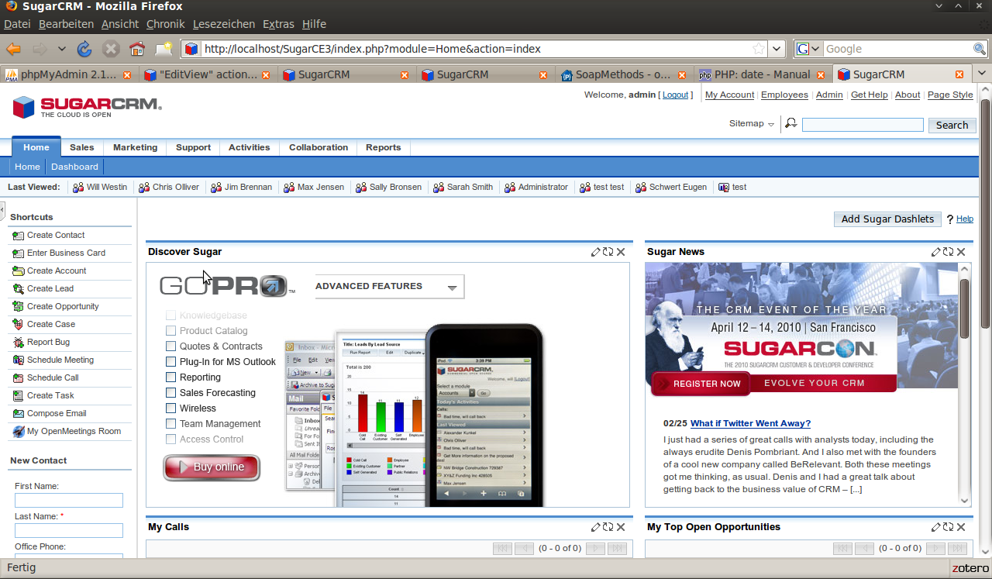

When you add a new Meeting you will have the possibility to add a OpenMeetings Conference Room for every Meeting. Every participant will receive a direct link to the Conference Room. The Link in the Mail for the invited users is only valid for the Time of the Meeting!

In the Meetings-Details View of SugarCRM you can access the Room at any time.

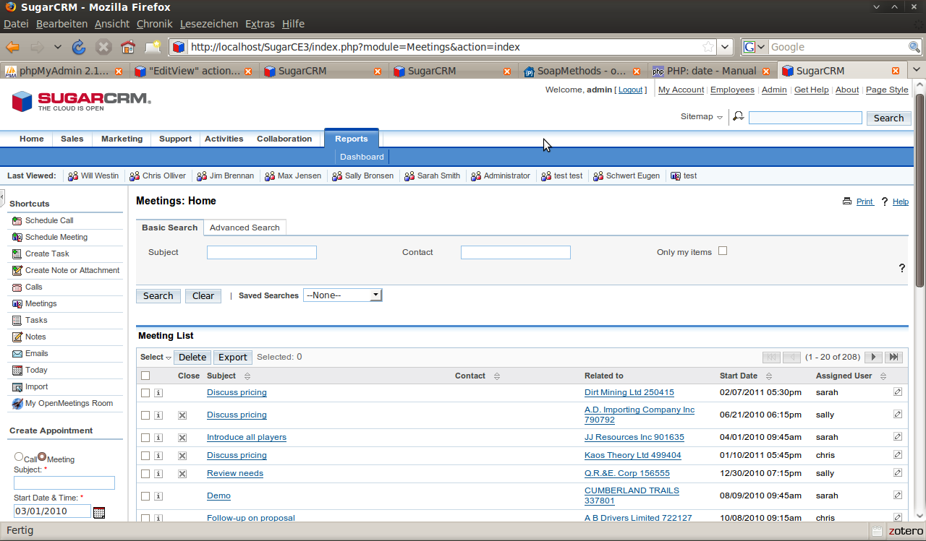

Schedule Onlinemeeting

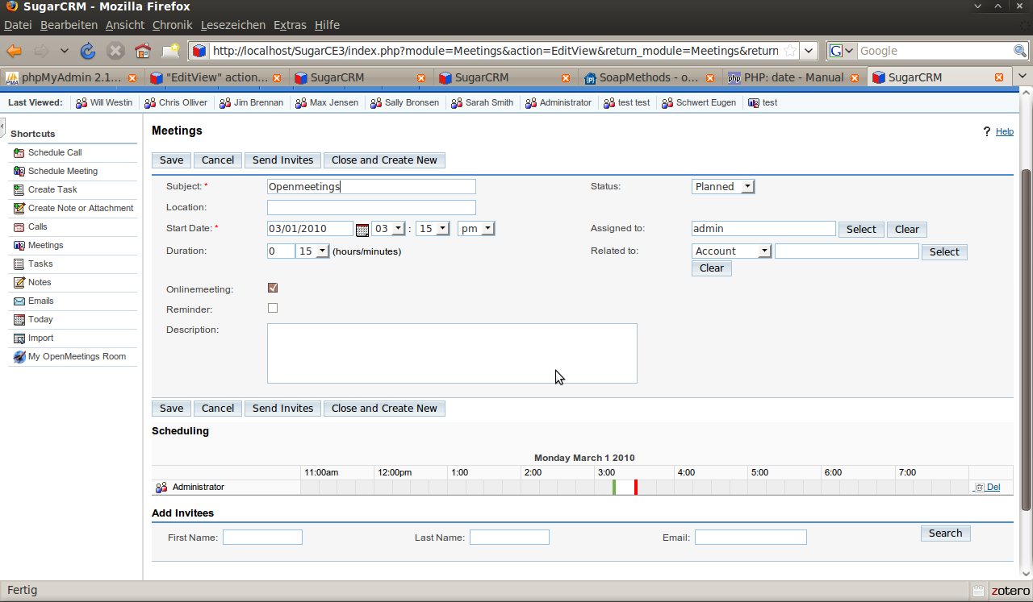
In the Schedule Meeting screen you can now select check-box (red arrow) for online-meeting with Openmeetings. After you add invitees (green arrow) you can send invites (blue arrow) and the invitee recive a E-mail with a link to a Openmeetings Room.

Example Link in the invitations mail.
Meeting URL:
http://localhost:5080/openmeetings/?invitationHash=d948f8977f33ccb31d77e9d08bf15403

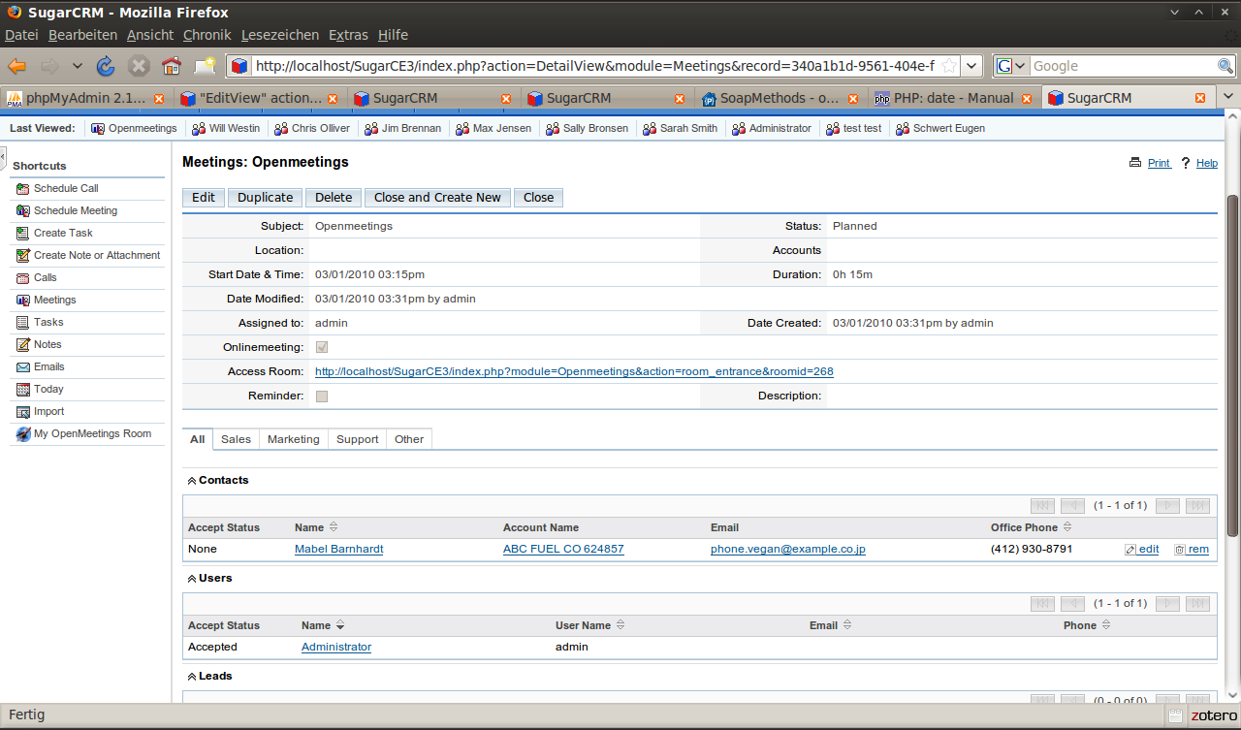
In the detail view you can access the openmeetings-room by the Link.

