Part A:

A color channel represents the brightness of a specific color in a image. A colored image usually has 3 channels R, G and B, representing red, green and blue. A grey image only has one channel. These channels can contain different number of bits. More bits can represent more and more precise colors. As shown below, the image that is represented by more bits has higher quality.

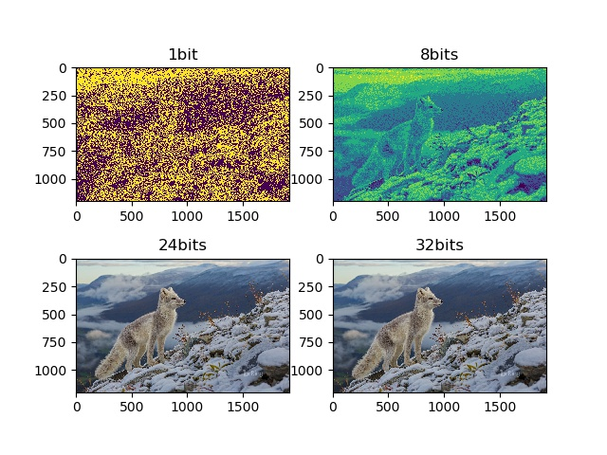

Part B:

Vector graphics are computer graphics images that are defined in terms of 2D points, which are connected by lines and curves to form polygons and other shapes. Vector graphs have no relevance to pixel, so it will always be clear no matter how you zoom it. In the graph below it can be seen that the vector graph on the left is much clearer than the bmp image on the right. Vector graphs do not have many colors, so they can only be used to show things like logos; however, bitmaps can present many colors, so they can show more detailed graphs. Since bitmaps are more detailed than vector graphs, they usually need more storage.

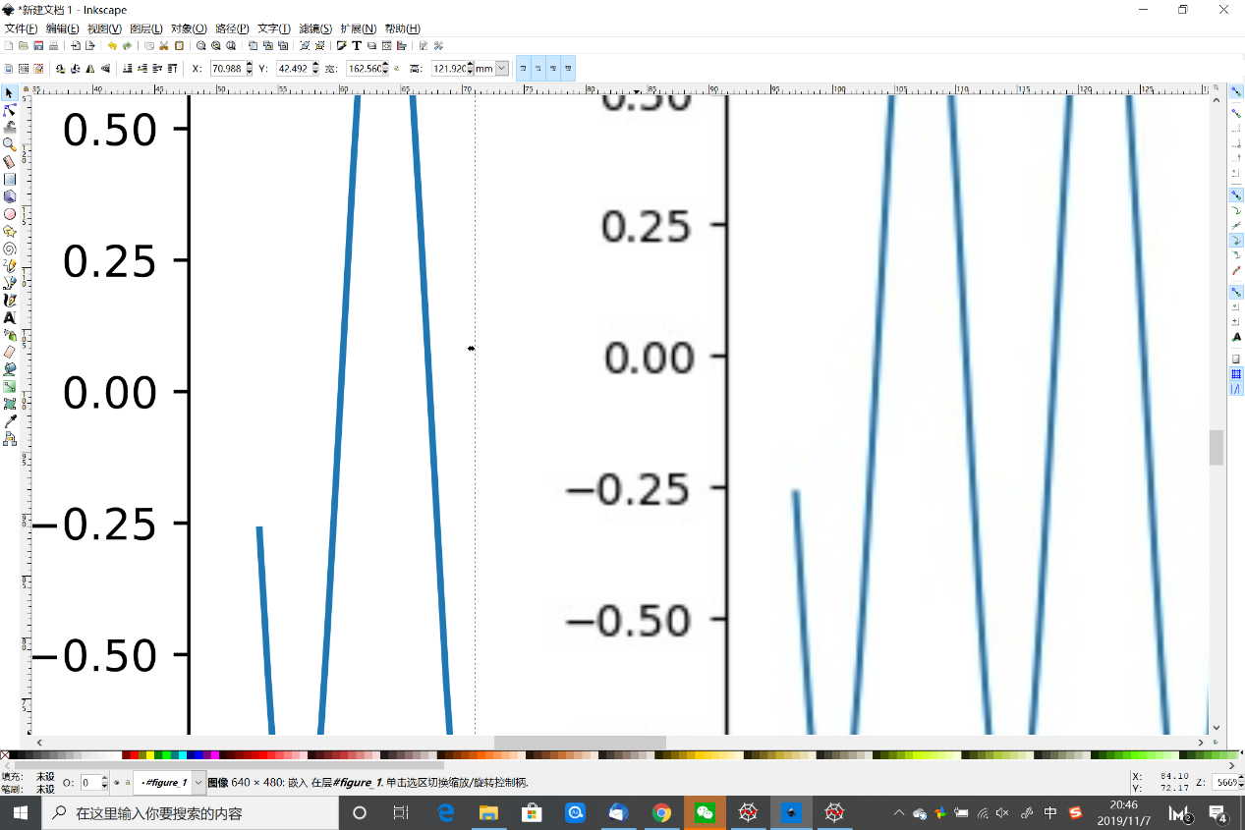

Part C:

|  |  |  |  |  |
| --- | --- | --- | --- | --- |
|  | 压缩程度 | 支持位数 |  |  |
| .bmp | 无压缩 | 1bit 4bit 8bit 24bit |  |  |
| .jpg | 有损压缩 | 24bit |  |  |
| .gif | 无损压缩 | 1bit 8bit |  |  |
| .webp | 有&无损压缩 | 32bit |  |  |
| .png | 无损压缩 | 8bit 24bit 32 bit |  |  |

File size:

The different in size is caused by the different extend of archive. BMP is not archived, so it needs biggest storage.

