**MEA 462 - Observational Methods and Data Analysis in Marine Physics**

Introduction to Python Programming

Joseph B. Zambon

jbzambon@ncsu.edu

*Session 1: 25 March 2022*

*Installation of Anaconda to Personal Computer and Your First Python Program*

Instructions have been written utilizing screenshots from Windows 10, as it is the most difficult OS to work natively with Python. This should be easily extended to other operating systems including Mac OS and Linux GUIs. Feel free to ask questions or get help if you run into any problems.

**Installation**

Open your favorite web browser and head to <http://www.anaconda.com/download/>, download and Install the appropriate client for your OS. I suggest Python 3.x for this tutorial, as we will not be using outdated codes that require Python 2.x. There are some older codes out there that are incompatible with Python 3.x. If you are using those in the future, also download Python 2.x. Be warned that in the future Python 2.x development is planned to cease and everyone will use 3.x+.

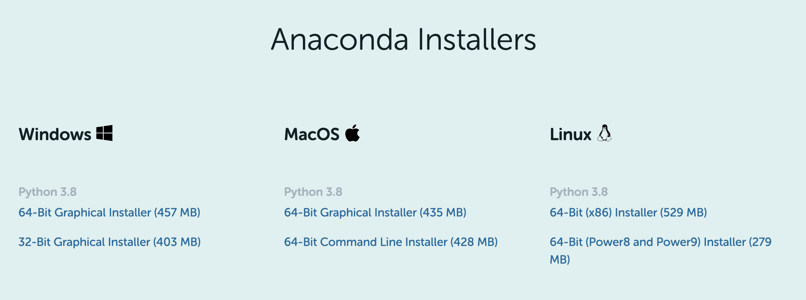

Windows-note: Also Install Microsoft Visual Studio Code if it prompts you to.

(Installing all of the packages may take a while.)

Open Anaconda Navigator. This GUI (Graphical User Interface) allows you to create environments, install/uninstall modules to that environment, and run Jupyter Notebook from inside of that environment. Everything in Anaconda Navigator can also be done from a CLI (Command Line Interface) called Conda, but you may prefer to use the GUI.

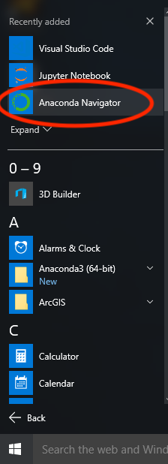 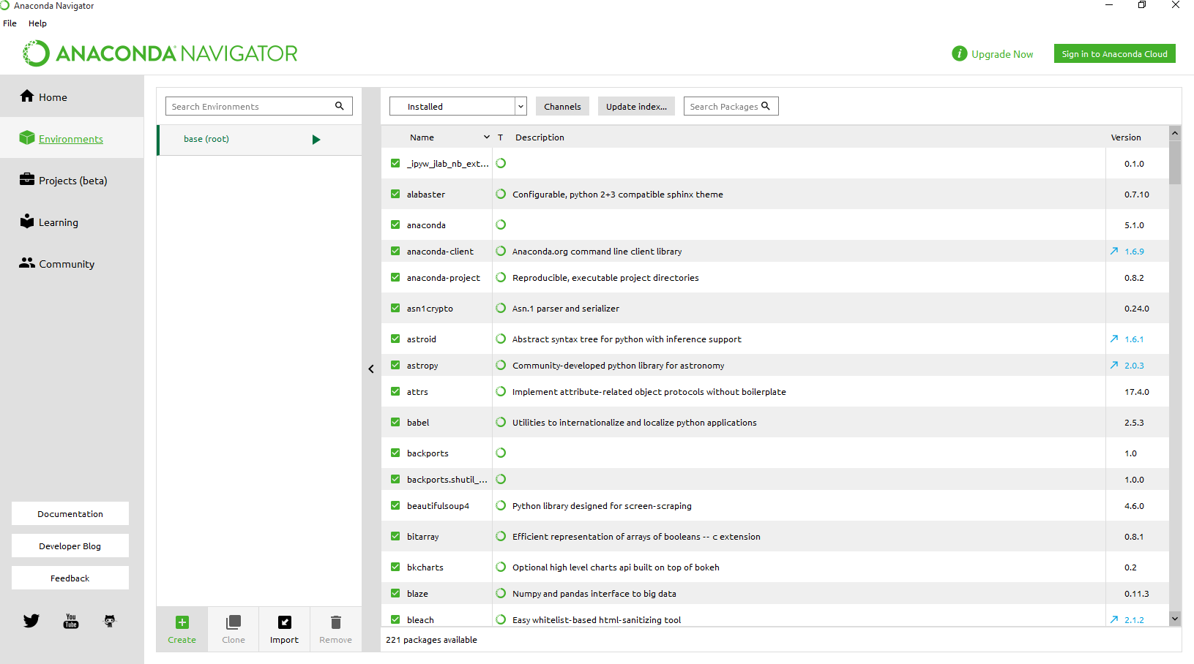

Environment – Acts as a partitioned space so that modules you install in one environment won’t impact other environments for specific uses. This is a MAJOR benefit to using Anaconda over simply installing Python.

Create an environment for this exercise called “Ex1\_HelloWorld”. This will take a few moments to build.

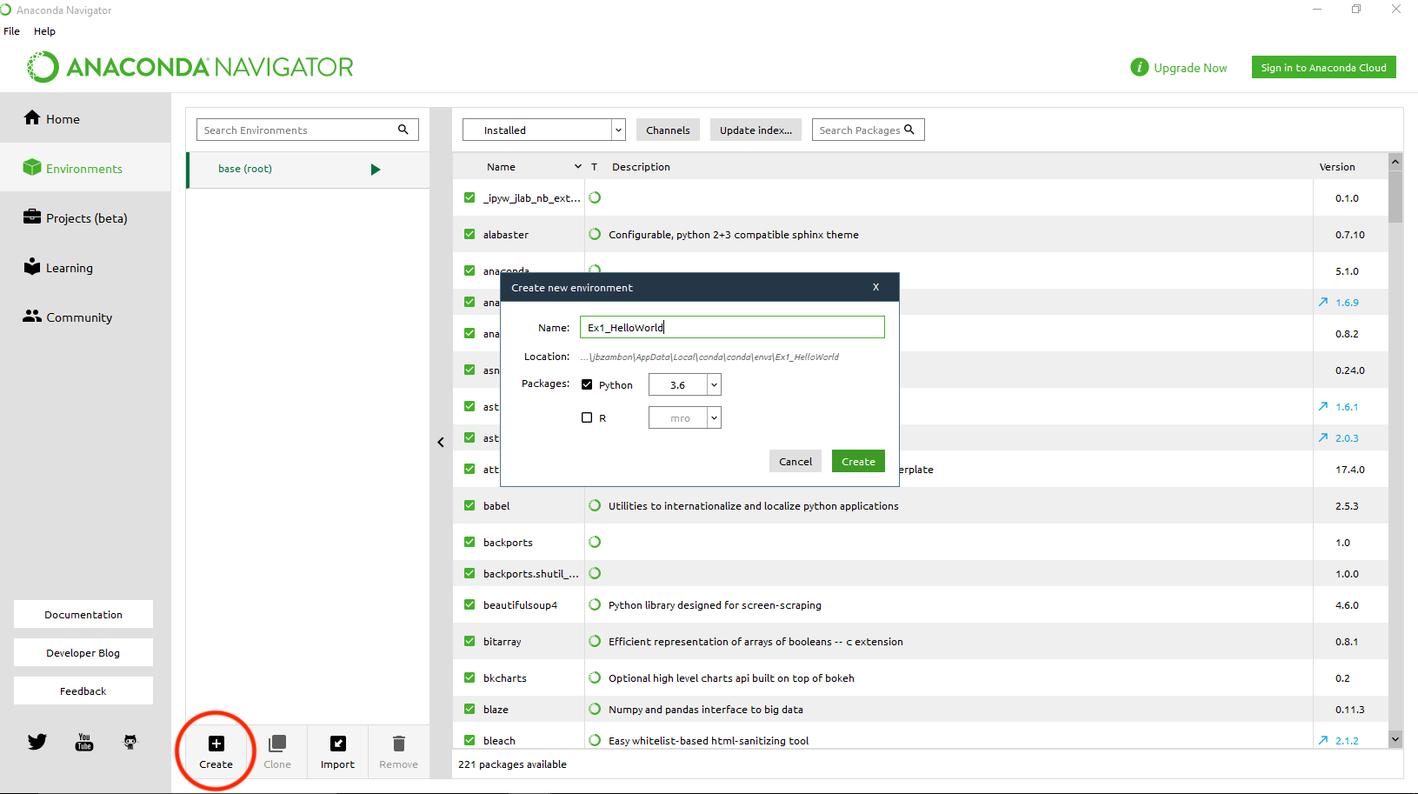 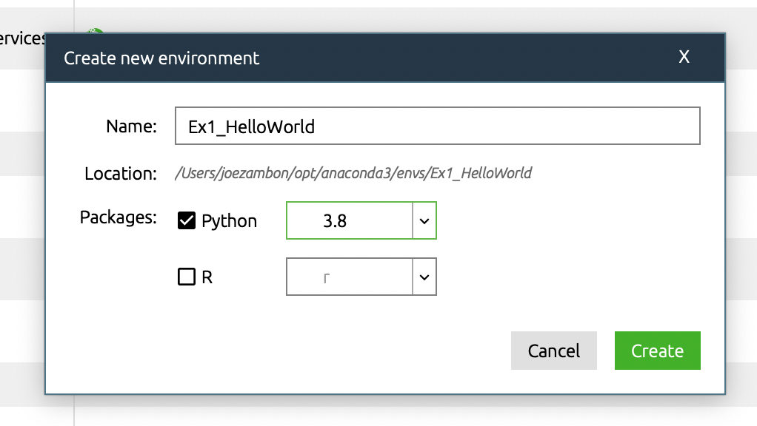

Right-click (Mac: Option-Click) the Play button next to your new environment. The choice we are looking for “Open with Jupyter Notebook” is not selectable. This is because we haven’t installed the necessary packages and will have to do so.

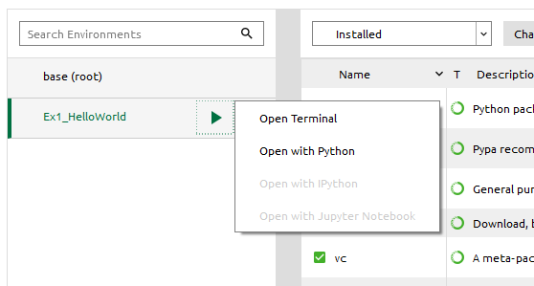

Click the selection menu currently labeled “Installed”, this lets you narrow packages down. Select “Not Installed” and type “notebook” in the search field.

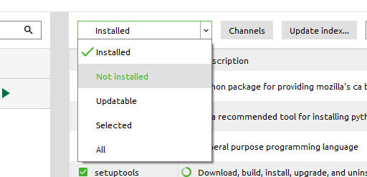

Check “notebook” and notice that there is a downward-facing arrow. This indicates that when you hit Apply, that this package will be installed.

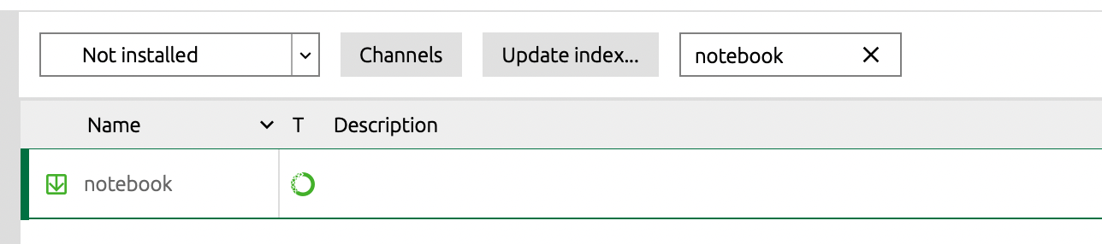

Hit Apply and a dialogue box will appear alerting you that several packages known as dependencies (55 in this case) are required for this (notebook) package to work.

Dependencies – installing a package will usually require other packages in order to function properly, these additional packages are called dependencies. Think of it this way… if you were to run package “Drive to the Beach”, you would first need to load dependencies “Driver’s License”, “Car”, “Gas”, etc. In this instance, to load notebook, there are a number of additional packages (wincertstore, sphinx, notebook, nbconvert, etc) to load that allow the program to run correctly.

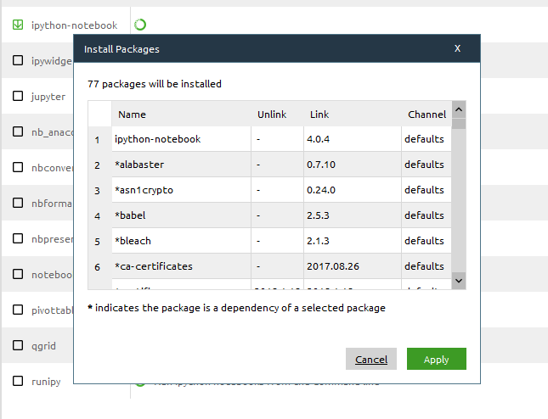

Load the appropriate modules (this may take a few minutes). Now, when you click the play button, it allows you to Open with Jupyter Notebook, so do that.

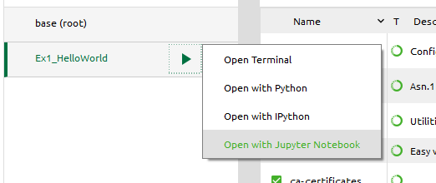

A few batch scripts (terminal on Mac/Linux) appear and your web browser is loaded to your default destination (usually My Documents or your Home directory). Create a New Python 3 notebook.

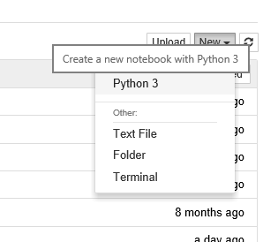

Some notes about the layout of this notebook. First, you notice that everything is arranged in cells. This is a huge advantage over running an entire python script (sample.py) because you can debug programs sequentially by picking and choosing cells to run. When a cell is selected as what you are working on, it appears green with other unselected cells blue. If you delete a cell, the selected cell will be the one that is deleted.

Scroll around the menus and check out the options that are there. Some important menu items…

File -> New Notebook: Creates a new notebook in a new tab

File -> Download As: Allows you to download your notebook to a number of formats including native ipynb

Edit: Related to manipulating cells

Insert: Puts cells above/below the active (green) cell

Cell: Menu to run cells

Kernel -> Restart: Restarts the kernel, use if you make changes to the program and need to clear memory space (i.e. if you change a variable and want your calculation based on the new program)

Help: Lots of reference pages

Also note that a lot of these options are included as icons just below the menus.

Rename your Untitled program to “ex1\_hello\_world”. Begin your first cell by writing comments (preceded in python by #) to note what the program is, who authored it, their email, and when. Writing well-commented code now will save you lots of trouble later!

In the cell below your program header, write your first python code. As is traditional in learning any programming language, your first code should spit out “Hello World.” It is simple enough to know that when you run it, it will indicate that your python compiler is running correctly.

To get python to print anything, you use the print() function. “Hello World.” is a string, so it must be constrained by single-quotes (‘’; more on this later).

Go to Cell -> Run All.

If “Hello World” appears, congratulations! You successfully installed, programed, and ran your very first python script!

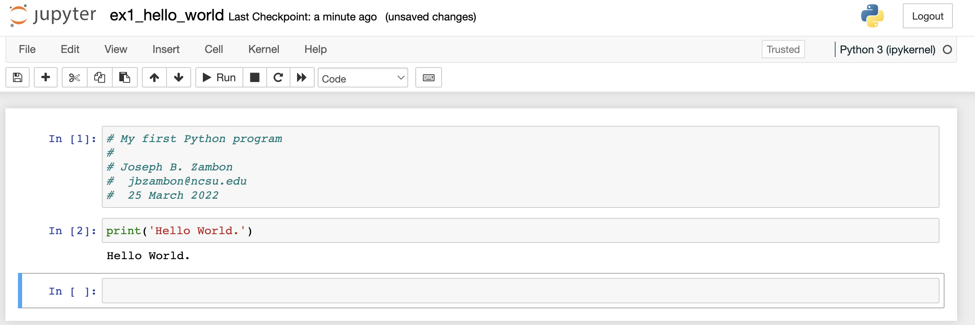

Running in the iPython Notebook web interface is one way to execute programs. Let’s try with the CLI now. Download your working script as a Python (.py) file.

File -> Download as -> Python (.py)

The script should have been downloaded to your default downloads folder with the name “ex1\_hello\_world.py”.

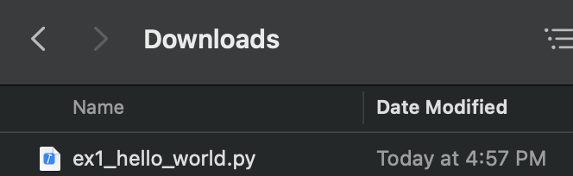

Go back to Anaconda Navigator and click the Play button next to your environment, this time select Terminal. Things get a bit different here depending on your OS…

*Windows*

We need to find the python program, type “where python”.

*Mac/Linux*

We need to find the python program, type “which python”.

Macintosh HD:Users:jbzambon:Desktop:where_python.png

For my installation it is in the environment directory created by conda (…\conda\envs\Ex1HelloWorld\python.exe). This is the correct python installation for the environment you created before. Notice that to the left of the console it also notes that you are currently in environment Ex1\_HelloWorld. This is a friendly reminder in case you’re running code that was designed for a different environment.

You can now run your python code using the python executable you just found. Reference the entire path to the python executable and then the file you just downloaded….

C:\Users\jbzambon\AppData\Local\conda\conda\envs\Ex1\_HelloWorld\python.exe Downloads\ex1\_hello\_world.py



When it runs you should see the same “Hello World.” output. Congratulations, you have now run a python script using the CLI.

One more thing… Instead of running on a web interface (iPython Notebook) or running as a script (C:\Users\jbzambon\AppData\Local\conda\conda\envs\Ex1\_HelloWorld\python.exe Downloads\ex1\_hello\_world.py), you can also run python interactively. Let’s try that.

You can do this one of two ways. First, simply enter in the full path the python executable…

C:\Users\jbzambon\AppData\Local\conda\conda\envs\Ex1\_HelloWorld\python.exe OR go back to Anaconda Navigator, click the Play button next to your environment and select “Open with Python”.

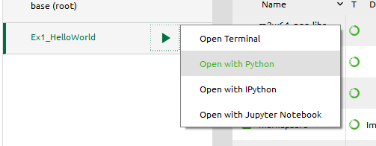

Now a command prompt (>>>) appears. Type the same line of code you had above and hit ENTER. Hello World. should be output to the screen.

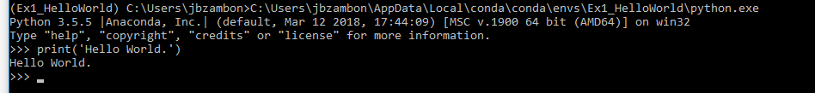

Congratulations, you have now mastered 3 different ways to execute python code! CTRL-C to exit python.

Next time we will begin getting into modules, variables, calculations, assignments, and arrays.

Additional:

* Review the Conda Cheat Sheet for helpful hints

<https://docs.conda.io/projects/conda/en/latest/user-guide/cheatsheet.html>

* Take the Getting Started with Conda online tutorial for better clarification working within the CLI.

<https://conda.io/projects/conda/en/latest/user-guide/getting-started.html>