Documentation Quality Pipeline Case Study

HTMLHint
Installed HTMLHint
Created a demo site containing html pages
Created .htmlhintrc with default rules
Ran HTMLHint on all HTML files in demo project
Added VS Code schema support to have config file recognized by editors with JSON schema support to enable autocompletion and validation for the .htmlhintrc file.
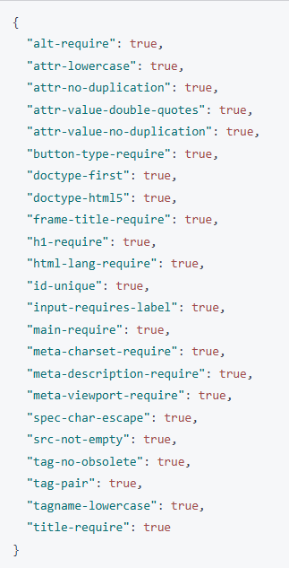
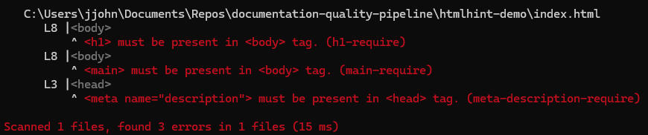

I created a custom HTMLHint configuration file which ensured no style tags cannot be used inside the html. Only references to an external css file can be used. D
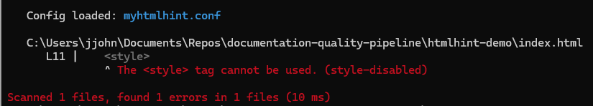
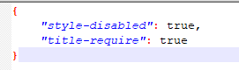
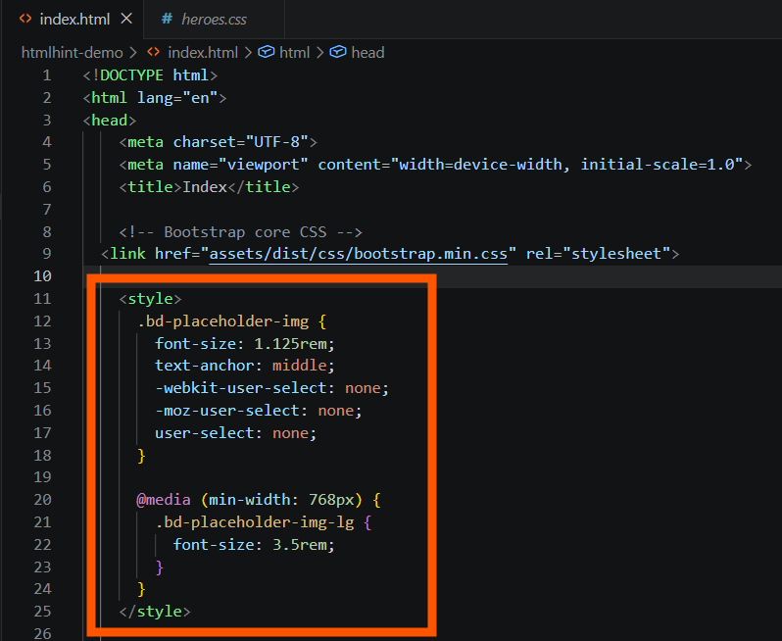
I removed the style section from the HTML file and put the css in a separate file and reran the HTMLHint command with no errors
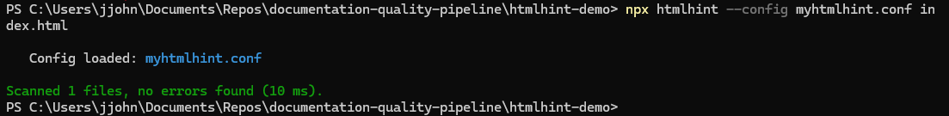
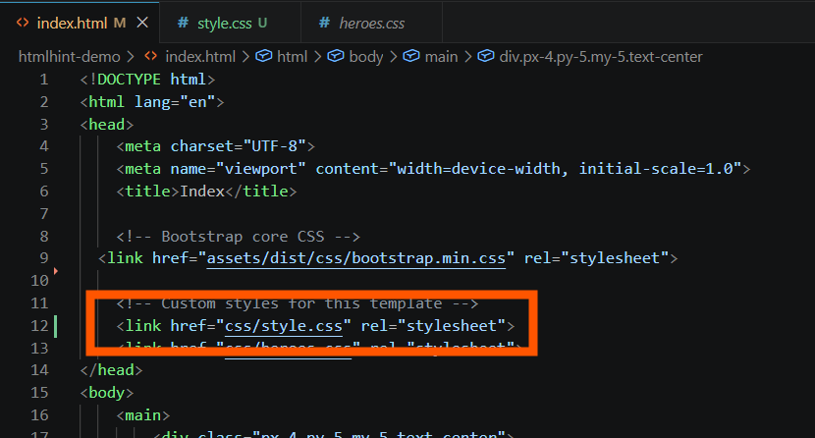

markdownlint/markdownlint-cli
I installed markdownlint and markdownlint-cli
I ran it over a directory of Markdown files and output the results into a text file
I counted the number of lines/errors in the file in PowerShell using (Get-Content markdownLintOutput.txt).Count
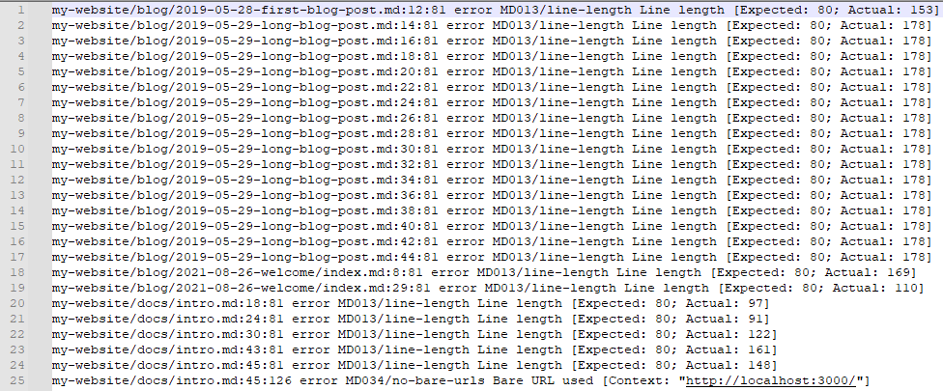

markdownlint-cli2
I installed markdownlint-cli2 as a global CLI. I copied over a repository containing markdown files and ran the linter over all the Markdown files with the following output.
