Hybris Lab Ideas and Helpful Trails
How to output back-end data values on a jsp page
find a jsp
output xml data on a jsp page (w3schools.com)
mainpulate xml data with jstl, xsl and display on jsp

HelloWorldCronJob w/ service (hybris wiki)

Servlets Tutorial
http://www.tutorialspoint.com/servlets/servlets-life-cycle.htm

Spring

DispatcherServlet – takes incoming URI and finds the correct handlers (usually controller methods) and views (usually JSPs) that combine to form the page/resource that's supposed to be found at that location. All incoming requests go through the dispatcher servlet.

Spring's implementation of front controller pattern.

Spring MVC
Controller populates Model (of type Map) with data and chooses a view name.
Controllers can also write directly to the response stream and complete a request.
Servlets can be initialized either in web.xml or through code via WebApplicationInitializer
Centers around a handful of special beans

Patterns

Front Controller Pattern – designed for centralized request handling. All requests handled by a single handler. The handler can do authentication/authorization/logging or tracking before passing the request to the handlers.
Entities:
1. Front Controller – Single handler for all kinds of requests coming to the application
2. Dispatcher – Front controller might use dispatcher object which can send the request to the proper handler
3. Views – the objects requests are made for
Centralized place to access views
A controller handles the initial requests

Dependency Injection Pattern
http://tutorials.jenkov.com/dependency-injection/index.html

Objects builds the dependencies they need from the inside out.

Problem: how to wire together different elements made by different teams with little knowledge of each other.
Lightweight containers such as Spring and PicoContainer try to solve this
-Component: piece of software meant to be used and extended but not fundamentally changed by an application that the software creators don't control
-Service: also used by foreign appliations, but instead of being used locally (jar file, assembly, dll, or source import). Service is used remotely via remote interface, synchronous or asynchronous( ex. Web service, messaging system, RPC, or socket)
How can you make a class ignorant of the implementation of an interface so that it can work with any implementation?
To deploy an interface in different ways, you need to use plugins to handle with such services to use different implementations in different deployments
-Plugins: let you implement an interface in different ways
How to assemble multiple plugins in an application? IoC – Inversion of Control

dependency – object that can be used(service/interface)
injection – passing of a dependency to a dependent object (client) that will use it
The service is made part of the client's state. Dependency injection is about passing a service to a client rather than letting the client build on implementation to the service

Basic idea of dependency injection is that a seperate object, an assembler, populates a field in the client class with a working implementation for the finder interface.

3 styles of dependency injection:
1. Constructor Injection
2. Setter Injection
3. Interface Injection

Constructor injection

Needed object is passed to an object's constructors
ex. a DAO object is passed instead of a using 'new' to instantiate the DAO

More specifically, dependency injection is effective in these situations:
- You need to inject configuration data into one or more components.
- You need to inject the same dependency into multiple components.
- You need to inject different implementations of the same dependency.
- You need to inject the same implementation in different configurations.
- You need some of the services provided by the container.
These situations have one thing in common. They often signal that the components wired together represent different or independent concepts or responsibilities, or belong to different abstraction layers in the system.

Dependency injection is not effective if:
- You will never need a different implementation.
- You will never need a different configuration.

Factory Pattern

The purpose of the factory patterns is to separate the use of a certain component, from the choice of implementation + instance management of that component

- A factory is a method that returns objects of different classes.
- Any method that returns a “new” object can be considered a factory
- A factory is an abstraction of constructors. While constructors are concrete and create objects as an instance of a single class, factories create objects from various classes
-Common in frameworks where library code needs to create objects that might be subclassed by applications
-Factory method is a method returns a 'new' object
- “Define an interface for creating an object but let subclasses decide which class to instantiate”
- The class that calls a factory method usually extends or implements another class

Prototype Pattern

Specify the kind of objects to create using a prototype object, and create new objects by copying this prototype.
Application hard wires an object's class to create each time “new” is used

Singleton
Ensure a class has only one instance, and provide a global point of access to it
Encapsulated “just-in-time initialization” or “initialization on first use”

Template Method Pattern

Structural patterns simplify the relationship between entities

Adapter Pattern
Convert interface into another interface a client expects. Let classeses work together that otherwise wouldn't due to incompatible interfaces.
Wrap an existing class with new interfaces
Match old component to a new system

Bridge Pattern

Decouple an abstraction from its implementation so the two change change independently

Cool Tools
Divy – Window manager
Ditto – Copy / paste manager
Flux
Skitch

Key Terms

Saas – Software as a service (cloud computing)

CRM – system that harnesses your customer data to gain insight into their behavior and habits

ERP – enterprise resource planning – integrates essential business processes (order management, accounting, human resources, etc.) into one complete system. Has central database that's used by different business units.

Lightweight Container – assembles different application components not originally designed to fit together

Marshalling – process of transforming memory representation of an object into a format for storage or sending to different parts of a computer program. Similar to serialization.

Groovy – agile and dynamic language for Java Virtual Machine. Make Java features available to programmers

Lazy loading – loading information upon specific request instead of loading automatically upon startup. May save space and time for large amounts of information

Eager Loading – loading upon startup instead of upon request

Coupling – dependency between two entities. Try to keep coupling loose as possible. You want to keep system modular so you can change one part without affecting another. Encapsulation is an important part of loose coupling (decoupling) where a class hides its internal details from another class

Decoupling – seeing if two things need to be dependent or independent. By loosening the coupling you're making sure each component knows as little as possible about other components.

Inheritance – Is-a

Interface – Must do

Sprint IoC – Also known as dependency injection, it's a process Spring objects use to define their dependencies

Beans – xml metadata for your vital application objects

Interceptors – Handles behavior for each step in a model's life cycle. During interception you can modify the model or raise an exception to interrupt the step. For example, you can check that certain values are set for a model before it's saved. After you implement an interceptor you must register it as a spring bean in ${myextension}-spring.xml.
  - Load interceptor – called when model is loaded from database
  - Init defaults interceptor– called when model is filled with default values
  - Prepare interceptor – called before model is saved and validated
  - Validate interceptor – called before model is saved and after it's prepared
  - Remove interceptor – called before model is removed from database

Hybris cluster – multiple installations of hybris that use a common set of data on one database

WCMS Cockpit – allows you to edit everything content related
Content
    - Structured content: data retrieved from database
    - Unstructured content: edited or free text content
    - Dynamic content: content retrieved from database and place on webpage only when requested
    - Static content: content that is always the same when retrieved by different users at different times
WCMS Components Contain:
    - Hybris item that extends AbstractCMS component from items.xml
    - Spring MVC controller which extends AbstractCMSComponentController or implements DefaultCMSComponentController
    - JSP

– renders component on a page with html, css and tag libraries as needed

Facade – provides a unified interface to a set of interfaces in a system. Defines higher-level interface that makes subsystem easier to use. Wraps complicated subsystem with a simpler interface. For example, when you call customer service the person is a facade for things like order fulfillment, billing, and shipping.

Polymorphism – ability of an object to take on many forms. Most common in OOP when you use a parent class to refer to a child class object. Any object that can pass more than one IS-A test is polymorphic. All objects in Java are polymorphic since they are all types and objects. An object can only be referenced via a reference variable. You can use polymorphic references via extending a class or implementing an interface.

ex.
public interface Vegetarian{}
public class Animal{}
public class Deer extends Animal implements Vegetarian{}

now, if you create and object, it can be refereced many different ways

Deer d = new Deer();
Animal a = d;
Vegetarian v = d;
Object o = d;

Singleton – Ensures a class has only one instance and provides a global access point to it. Initializes itself upon first use

DAO pattern – DAO contains all logic that accesses persistence layer. Often used by services to access database.

Abstract factory – provides an interface for creating families of related or dependent objects w/o specifying their concrete class. For example, stamping equipment has stamps for multiple hood models (i.e. model 1 hood, model 2 hood, etc.).

Impex – drag-and-drop template that lets users control import and export of data

.Jar – package file format that encapsulates java class files and associated metadata and resources into one file

.Properties – stores configurable parameters of an application.

CronJob – allows you to perform business logic at particular times and intervals

CockPit – provides user interface to your application

Servlet – an extension to a server that adds to its functionality. Class in Java that can respond to requests. Mostly used as a controller in an MVC app but can also render views. When a request comes in the servlet creates a request object which stores information about the request. The servlet also creates a response object, both need to be instantiated. Neither the request or response objects are persistent.

Programs that run on a web server that act at a middle layer between a browser request/other HTTP client and databases or applications on the HTTP server. Servlets let you get user input through web page forms, present records from a database, and create web pages dynamically. Platform independent since they're written in Java. Servlets have access to the full functionality of Java class libraries.

Major tasks:
1. Read data sent by clients(browsers) (i.e. forms
2. Read Http request data sent by clients
3. Process data and generate results
4. Send data to the clients(browsers)
5. Send HTTP response to browsers/clients

Servlet Life Cycle:
1. Servlet gets initialized via init() method
2. Servlet calls service() method to process a client's request
3. Service it terminated with destroy() method
4. Servlet is garbage collected by JVM

Servlet Life Cycle
Http requests that get sent to the server are delegated to the servlet container-managed
Servlet container loads servlet before calling service()
Servlet container handles multiple requests by creating multiple threads, each thread executes the service method of a single servlet instace

Servlets are Java classes that service http requests and implement the javax.servlet.Servlet interface

Business logic – core functionality of a web application

Persistence layer – maps metadata and a data source

Cockpit framework – allows you to make components that can be reused later in different applications

Extension – encapsulated piece of Hybris that contains business logic and type definitions

Widget – stand alone UI component for a clear purpose. Applications are made of widgets. Each widget has a controller and a view.

JSON – human-readable text that transfers data objects between a server and web-app. An alternative to xml

prototype pattern – new objects of a certain type are cloned from a prototypical instance

request-response pattern – requestor sends a request message to a replier system which receives and processes the request and returns a message in response

Abstract class – class you can't instantiate. Purpose is to provide a base for subclasses

Creational pattern – a creational pattern deals with how objects are created

session facade pattern – session keeps track of multiple calls required for a single transaction

web service – allows a web application to publish its function or message across the web. Use XML to code and decode data, and SOAP to transport it using open protocols. Two main uses: reusable application components and to connect existing software.

SOAP – Simple Object Access Protocol, protocol allows you to send and receive information via a web applications that run on different operating system with different technologies and programming languages

CRUD – create, read, update, delete. Refers to all major functions used in relational database applications

REST – Representational State Transfer. software architecture for building scalable web services. Allows you to send and receive information between a webpage and a server.

Deployment – Storing items and their values in a database table so Hybris knows how to use them during initialization.

HTTP long-polling – technique to push updates to a web client. A connection is help open between client and server so when the server has new information to push to the client, it can do so. After that, the connection is closed. A new connection is established and waits for another update from the server.

HTTP streaming – works similar to polling, but maintains the connection after an update is received. This is a persistent connection that would only drop due to network problems or through user action (e.g. navigating away from a web page)

Pagination – Total number of results allowed for each page

Apache Maven – builds projects based on a POM.xml file

.jar files – contain libraries, resources, and accessory files (like property files)

.war files – contains web application that can be deployed on any servlet/jsp container. Contains jsp, html, javascript and other files for web applications

asynchronous – timing control where an operation begins when it gets a signal that a previous operation has ended

Apache Lucene – open source retrieval software

Java
Everything in Java is an object

Java bean – reusable software component that can be manipulated visually in a builder tool. Java bean is simply an instance of a javabean class. Java beans have getter and setter methods. They must have a constructor with no parameters. Must implement java.io.Serializable or java.io.Externalizable.

Server Socket – waits for request to come in over the network. Performs some operation based on that request. Possibly returns a result to the requestor.

Socket – client socket. Endpoint for communication between two machines

Input Stream – super class of all classes that represent a stream of input bytes

Buffered Reader – reads text from a character input stream, and buffers the characters for easy reading

PrintWriter - Prints formated text-representations of objects and outputs them

File – abstract representation of file and directory pathnames

Schema – describes data type hierarchy for XML documents

Response –

Response Builder – builds response instances that contain metadata instead of or in addition to an entity

Ok() - creates a new response builder with an OK status

Event – change in the state of an object

Abstract class can't be instantiated but they can be subclassed.
Abstract method is a method declared with no implementation.
ex. Abstract void moveTo(double deltaX, double deltaY);
If class includes abstract methods then the class must be declared abstract
when abstract method is subclassed the subclass provides implementation for
abstract methods from parent class, if not, the subclass must be declared abstract
Abstract classes let you declare fields that aren't static and final, and define public, protected
and private concrete methods.
Abstract classes – contract for subclasses to use

Classpath – path that java runtime environment uses to search for classes and other resource files.

Jsp – puts java code in html pages. Jsps get turned into java files. <%= %> tag encloses java expressions.
<%= %> - for Java expressions – lets you call methods
<% %> - for blocks of java code – scriplet that runs when the jsp is called
<%@ %> - directive tag for imports
<%! %> - allows for variable and method declarations
Jsp tag documentation :
https://docs.oracle.com/cd/E13226_01/workshop/docs81/pdf/files/workshop/JSPTagsReference.pdf
http://www.javaranch.com/journal/200510/Journal200510.jsp#a1

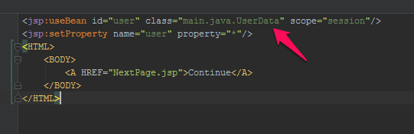
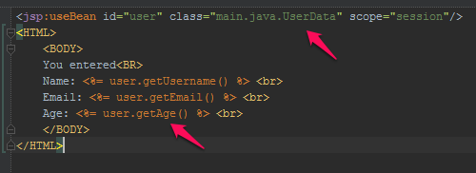

this class definition must match the hierarcy in ROOT/WEB-INF/classes/
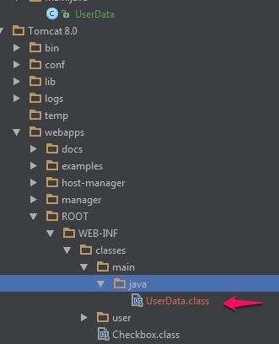
the class file of the java code you want to use must be placed here

Sometimes, some pre-processing needs to be done after the user has submitted a form. The result of this pre-processing decides where the control flow should go next. Such pre-processing code is frequently referred to as a "controller".

Passing an interface as an argument means that the method can use any class that implements that interface. You usually would do this as part of Constructor Injection.

Find ${} value in project – search whole project for controller with ${} value

Annotations
https://docs.oracle.com/javase/tutorial/java/annotations/declaring.html
@ represents a type definition
Annotations don't directly affect program logic, just the way programs are treated by tools and libraries, which can affect how programs are run.

Annotations are tags you put in your code so they can be processed by tools. Tools can be a compiler or some deployment tool, or run time tool.
Annotations can be applied to classes, fields, methods, or other program elements.
Annotations do nothing by themselves, need a tool to be useful

Java comes with standard annotations
@Override, @Deprecated, @SuppressWarnings

ex.
@AuthorDetails (
owner = “JohnSmith”
date=”9/11/2011”
)
class Mammal {}

@Retention – determines how the marked annotation is stored
@Documented – determines if specified annotations should be documented via the JavaDoc tool
@Target – restricts what kind of elements the annotation can be applied to
@Inherited – allows annotation type to be inherited from the super class
@Repeatable – marked annotation can be applied more than once to the same declaration or type use

-
http://tutorials.jenkov.com/dependency-injection/index.html

An object is configured from outside of a class instead of from the inside and is passed to the class's constructor or setter method

Dependency Injection Container (DI Container) – Object that knows about all of your application's dependencies and how they all fit together

DI Container starts by resolving dependencies
- Starts with inner most dependencies and builds out by injecting needed objects into parent objects
ex. if A → B → C
DI Container:
builds C
builds B and injects C into B,
builds A and injects B into A
An object's fields and collaborators are set by an external entity, as opposed to an object confiuring itself

When a class satisfies its own dependencies it becomes inflexible on those dependencies. If you change the dependencies you have to change the code

With a DI Container you define components you want to instantiate and what dependencies you want to inject into each component. Container also manages the life cycle of each component

Static singletons are evil. Don't use them if you can avoid it.

Tomcat

Tomcat Configuration Step-by-Step
https://www.mulesoft.com/tcat/tomcat-configuration

WEB-INF directory (tomcat) – contains hirarchy that holds configuration of your web application. Includes all the class files for servlets and classes that your JSPs call.

/WEB-INF/web.xml – describes servlets, initialization, and container-managed security

/WEB-INF/classes/ - java class files that your application needs

/WEB-INF/lib/ - JAR files for your application

Opening file in browser: https://developer.mozilla.org/en-US/Learn/Open_a_file_in_a_browser

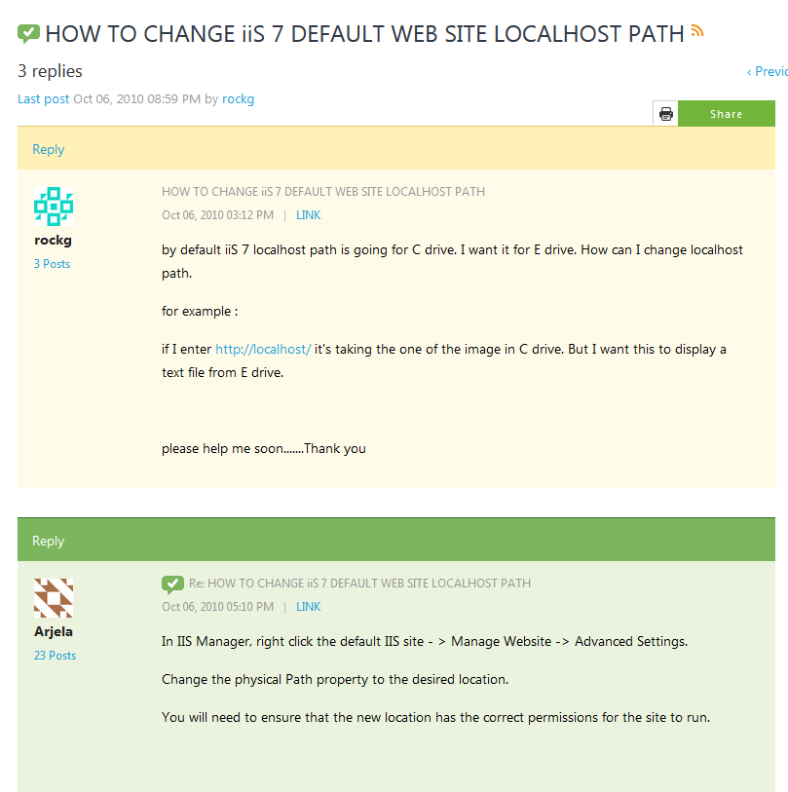

URL Structure
https://developer.mozilla.org/en-US/Learn/Understanding_URLs

HTTP and REST
http://code.tutsplus.com/tutorials/a-beginners-guide-to-http-and-rest--net-16340

Hybris Files
acceleratorcockpits-spring.xml – redefines beans used in all cockpit extensions

project.properties – specifies where the project gets its spring bean redefinitions for its cockpits

productcockpit-web.xml – allows you to redeclare beans for a specific cockpit extension. You must add this filename to project.properties file so it's included in the spring configuration.

Cockpit-config.xml – lets you configure widgets differently for different authorities

Misc.
Use Skitch to capture snapshots of your desktop and ask more detailed questions
Always run hybris in debug mode
Console buffer size – 5000
Learn your keyboard shortcuts!
Build iteratively – do ant build/all/clean and start hybrisserver after each change you make. This makes it easier to catch errors in your code
${} values in jsp are usually defined in controllers w/ @ModelAttribute

Debugging a Web Application
Web applications are usually centered around REST calls, MVC, and events/listeners.
On the back-end, usually you need to throw an event or hit a certain page to hit a breakpoint.
Hitting a particular page will activate a breakpoint in a controller class

Basic Troubleshooting
Server running?
Ant build, ant build all, ant
Stop server and ant clean all or ant build
Initialized?
Update?

Hybris Data Model
3 Catagories of classes generated from item types:
- Model classes – used in service layer for business logic
- Webservice related classes – supports CRUD logic via RESTful URLs
  - Only generated when optional extension platform webservices are included in your configuration
- Low-level Jalo classes – dont use

Create new extension
ant extgen
add new extension to localextensions.xml
define bean in ${newextension}-spring.xml
ant all
refresh workspace

Find a Controller's view
.jsp files go in web/webroot/WEB-INF

Build
ant build – builds all extensions
ant all – builds and configures server
ant clean – cleans up platform and extensions, deletes .class files
ant initialize – intializes system
ant -p – shows list of ant targest
ant extgen – runs extension-generation tool

Debug a Webpage
Run hybris in debug mode
Click element in browser using debug tool – network tab
Inspect element's resource path
Find element's controller via its resource path
Put a breakpoint in the controller
Reclick element in browser, so the breakpoint catches
Debug code, review variable data that gets passed
Ask questions to whoever wrote code if needed

Add a new model
Define a new item in items.xml
run ant clean all
new model is generated in bootstrap/gensrc
update the system

https://wiki.hybris.com/pages/viewpage.action?title=How+to+Add+a+New+Model&spaceKey=release5

Add a new service
Define a new model
Define an interface for the service
Implement the service
ex. If you create a service interface called ContactRequestService,
create a class called DefaultContactRequestService which implements
ContactRequestService.

Define logic for ContactRequestService methods in DefaultContactRequestService
Define a bean with the id=ContactRequestService (service name) and the
class=${path}.DefaultContactRequestService (service logic)
Create a controller with fields for your newly created service (ContactRequestService) and for a ModelService which gives you functionality for working with models
Register the controller as a bean with the bean name set as the controller would appear in a url.
ex. (bean name=”/contactRequest.html”)
Write the jsp view
goes in ${projectName}/web/webroot/${fileName}.jsp
(Implement a DAO)

https://wiki.hybris.com/pages/viewpage.action?title=How+to+Add+a+New+Service&spaceKey=release5

Implement a DAO
Create a new interface which extends DAO
Implement DAO as a class that extends AbstractItemDao and implements your DAO interface
Create a bean for the dao with the bean name being the name of your interface. And the bean class is the location where the DAO logic is held
Your service can now use the DAO instead of using flexSearch directly
Modify your service bean definition so that it has your dao listed as a property instead of flexibleSearchService

Creating a Cron Job
Cron Jobs Automate Certain script commands in your site

Create new extension
Declare cron job as an item in items.xml
Create JobPerformable class which defines logic for cronjob
Run Ant
Define the JobPerformable as a bean
Restart Hybris and run a system update

Run new Cron Job
Create a new ServiceLayerJobModel and set its SpringId to your Job Performable
Create an instance of your cron job defined in items.xml
Assign

Creating Events

HTML
<Form action> tag – tells page where to send the form-data when a form is submitted
<Form target> tag – defines name or keyword that indicates where to display the response you get after submitting the form

MVC
Models – maintain data
Controllers – handle events
Views – renders data
http://docs.spring.io/spring/docs/current/spring-framework-reference/html/mvc.html

Define Servlets
http://docs.oracle.com/cd/E13222_01/wls/docs92/webapp/configureservlet.html
http://www.tutorialspoint.com/servlets/servlets-life-cycle.htm

IntelliJ
Start a new hybris project
You want to import hybris as separate modules, not one large module
file – import project or module – point to ${your hybris root directory}/.idea – uncheck config templates – if errors are thrown, replace jdks with SDKs

Adding new debugger
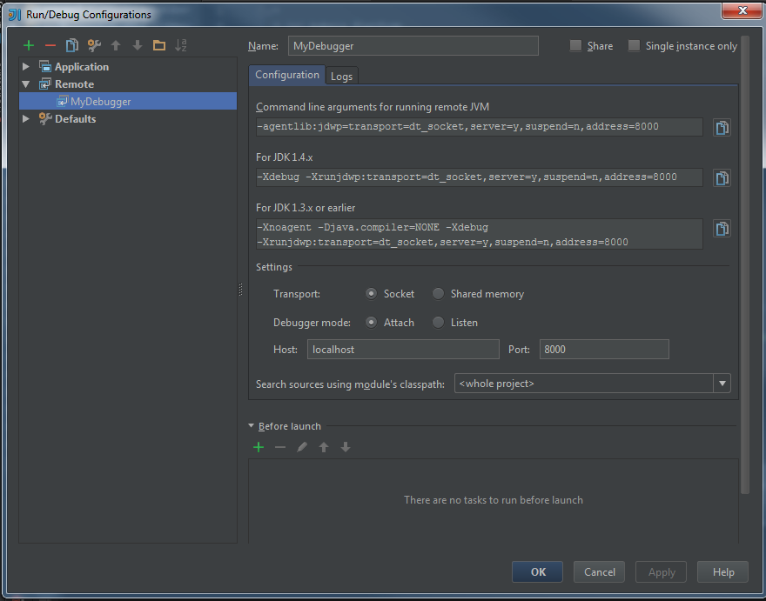
Using evaluator tool

Add a dependency
Right click ${your file}
build path – configure
build path – projects – add

Add to build path
Right click on file – buildpath – configure build path

Add dependency
file – project – structures – modules – dependencies - + - module dependency
add 'requires' tag in extensioninfo.xml

Import into Intellij
file – project structure - + - import module – navigate to ${your file}

General
type 'p' ctrl+j – shortcuts for declaring method types and 'main' method
ctrl+j – code snippets
ctrl+. - inserts selected code completion. Also toggles code placement
run class with main – right click in editor and choose 'run from main'
IDEA automatically compiles classes before running. For manual compiling: use 'build' menu

Solr
https://wiki.hybris.com/display/~john.barrow@hybris.com/Solr+Tutorial

Classification System
https://wiki.hybris.com/display/release5/Classification+Guide
https://wiki.hybris.com/display/release5/Creating+Classification+Systems
https://wiki.hybris.com/display/release5/Classification+Click+Stream+Tutorials
https://wiki.hybris.com/display/release5/Classification+Feature+Value+API
https://wiki.hybris.com/display/release5/Classification+System+API

Command Line
use Console2 for multiple console windows
Search child directories for a file – dir secret.doc /s /p
Go to root – cd \
exit process – ctrl + c
open file from command line – go to directory that holds the file – secret.doc

Spring Bean Resources
http://docs.spring.io/spring/docs/3.1.0.M1/spring-framework-reference/html/index.html
http://docs.spring.io/spring/docs/3.1.0.M1/spring-framework-reference/html/beans.html#beans-beanname
http://docs.spring.io/spring-security/site/docs/3.0.x/reference/ns-config.html
Java beans specification

Beans
A Spring IoC container manages one or more beans. These beans are created with the configuration metadata that you supply to the container, for example, in the form of XML<bean/>definitions.
Within the container itself, these bean definitions are represented asBeanDefinitionobjects, which contain (among other information) the following metadata:
- A package-qualified class name: typically the actual implementation class of the bean being defined.
- Bean behavioral configuration elements, which state how the bean should behave in the container (scope, lifecycle callbacks, and so forth).
- References to other beans that are needed for the bean to do its work; these references are also called collaborators or dependencies.
- Other configuration settings to set in the newly created object, for example, the number of connections to use in a bean that manages a connection pool, or the size limit of the pool.
This metadata translates to a set of properties that make up each bean definition.
Read accoc .xsd file to better understand .xml tags

Every bean has one or more identifiers. These identifiers must be unique within the container that hosts the bean. A bean usually has only one identifier, but if it requires more than one, the extra ones can be considered aliases.

In XML-based configuration metadata, you use the id and/or name attributes to specify the bean identifier(s).

Id is the preferred way to specify a bean. but if you need to use one of these special XML characters, or want to introduce other aliases to the bean, you can also specify them in the name attribute, separated by a comma (,), semicolon (;), or white space.

You are not required to supply a name or id for a bean. If no name or id is supplied explicitly, the container generates a unique name for that bean. However, if you want to refer to that bean by name, through the use of the ref element or Service Location style lookup, you must provide a name. Motivations for not supplying a name are related to using inner beans and autowiring collaborators.

You can give a bean more that one name by using one id attribute and and number of name attributes

A bean definition essentially is a recipe for creating one or more objects. The container looks at the recipe for a named bean when asked, and uses the configuration metadata encapsulated by that bean definition to create (or acquire) an actual object.

In Spring documentation,factory bean refers to a bean that is configured in the Spring container that will create objects through an instance orstatic factory method. By contrast,FactoryBean(notice the capitalization) refers to a Spring-specificFactoryBean.

Ref element references another bean that you've already defined.

Spring-xml – instantiate beans that you have java class. Set properties and references here.

Beans.xml – auto generates source code and bean – no argument constructor

Key tips
In dev it's ok to copy and paste. Don't reinvent the wheel. Focus on debugging skills. Look at what has been done by others to do what you're trying to do.

Learn your patterns.

Read the console logs

Other tips

- Use Chocolatey! It's the apt-get for Windows

- For working with 3rd party libraries: regardless of what your IDE says, as long as the compilation doesn't throw an error, pay attention to types

- For the evaluator tool only evaluate the method part of a line, not the value of a variable when it gets assigned a method.
ex.
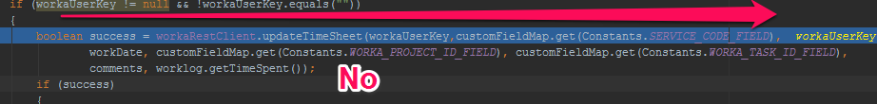

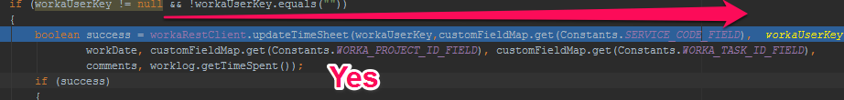

- To test anything involving events and listeners make sure you trigger the event so you can examine the output

- To me, the biggest challenge as a developer is, when starting a new project, is devloping from the essential core out. Starting with the most important features. After initial development is done, the tough part about debugging a new system is getting used to the set up. Set up for each site or piece of software is different, with different user accounts and credentials needed. The only commonality is running the server in debug mode and running the dubugger in Intellij. To debug, different events need to be thrown in different environments in different accounts. For each bug you're assigned, you need to keep track of the expected outcome and actual outcomes. The intellij debugger and evaluation tool helps you keep track of actual variables and let you expriement with different values live. Don't try to think too much on the code. Once you initially understand it fire up that debbugger. Once you get used to the setup the process will go a lot quicker and be less draining.

Navigating destractions: full-sized headphones

Articles
Building Large Java Applications
http://cs.lmu.edu/~ray/notes/largejavaapps/
Web Application Deployment
https://tomcat.apache.org/tomcat-5.5-doc/appdev/deployment.html

Tutorials
https://spring.io/docs

Unsorted Tips
-Don't hard code constant values. Have a seperate file for all of your constant values so you can reference them elsewhere by name.

-Learn to Git rebase, revert, learn to resolve merge conflicts. Practice all of the above.
https://githowto.com/resolving_conflicts

-Always use incognito mode for project work

-Use Google Chrome

-git revert should be used to undo changes on a public branch, and git reset should be reserved for undoing changes on a private branch.

-replicate, don't reinvent the wheel unless you absolutely have to

-Hybris: use cmscockpit to view impex pages when you can't see them from front end

${cartData.paymentTerms.name}

Casting in Java
public class A {
//statements
}

public class B extends A {
public void foo() { }
}

A a=new B();

//To execute **foo()** method.

((B)a).foo();
*casting depends on super classes and subclasses
Must have tools: diff checker in terminal

An object can be cast into its own class type, a super class, a subclass, or an interface

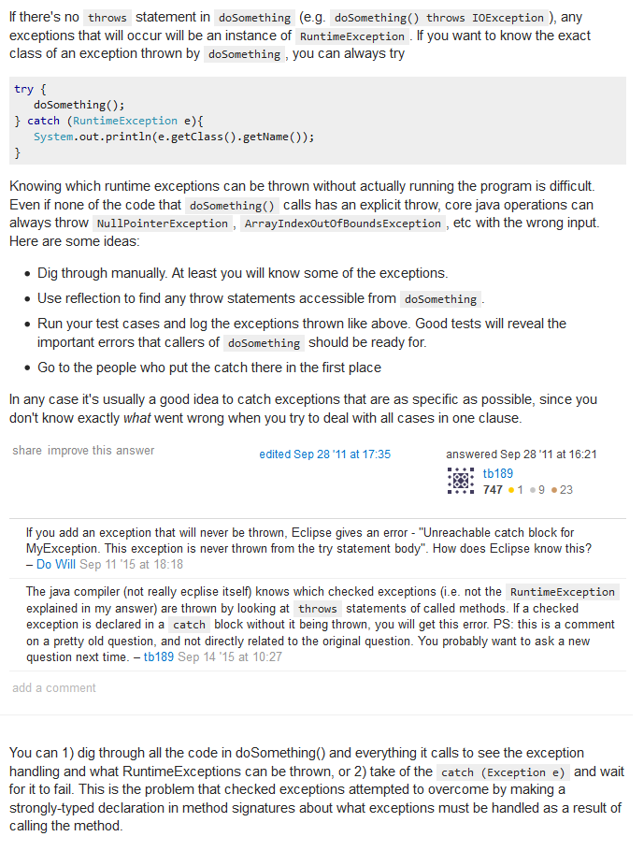
How to know which exceptions to throw?

Digging In
Given a certain method signature – try to guess what it does given the objects
Be able to search for strings throughout your projects to see how certain objects are used
1st think about architecture – Model, View, Controller's
For JSP values, search for where they are loaded into models
For impexes – search for where values originate from
try to figure out what an object/method does not necissarily how it works

Abstraction – what do I need to know right now?
Replicate if possible – key to development

*know your ide shortcuts

debugging – centers around events and throwing events to see what happens when something occurs
*evauation tool
how is it doing something? Vs how do you need it to work?

remember – in Java everything is an object with certain methods

Look for errors in log file and google each one individually

import constants file like any other package

make many small commits when working on a git project

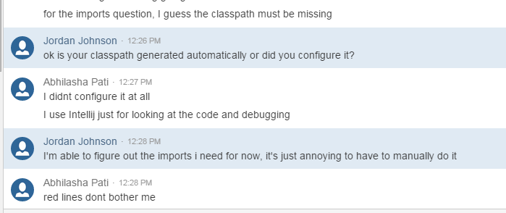

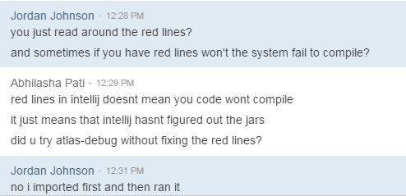

Master classpath
http://kevinboone.net/classpath.html

Dependency Injection w/ Spring – wiring values onto properties

Debugging: when reading a stack trace, look for the exception thrown and in which class, then google the exception

Aspect Oriented Programming
Breaks down program logic into distinct parts – called concerns.
Functions that touch several points in an application are cross-cutting concerns
seperate from business logic
Modules separated into aspects
aspect – module with a set of APIs that provide cross-cutting requirements.
Join-point – point in your application where you can plugin you AOP aspect
Advice – action that gets carried out either before or after method execution
Pointcut – set of one or more join-points where an advice should be executed
Introduction – lets you add new methods or attributes to existing classes
Target object – object being advised by one or more aspects. Will always be proxied object aka advised object
Weaving – process of linking aspects with other application types or objects to create an advised object. Can be done at compile time, load time, or runtime

Database caching – process that generates web pages on-demand by accessing backend databases

Shadowing Notes
day 1
1st 30 min
read bug
gather questions if you have them
ask BA or read documentation to clarify requirements
go over your solution with tech lead before you code
(you can do this right after if solution is pretty straight forward)

day 2
write clean code as fast as possible – refactoring is nice but finishing is the priority
null check each object
use string and collection utils if you can to check and compare collections
you have to find the correct object first (via searching) before you implement the correct logic
look at how the object has previously been used
rule of thumb: average method should be 20-30 lines before refactoring
can you read/debug the code you wrote in a month

extension.info.xml – tells you the extensions you can access. Looking at this file tells you which facades or services you can use

Controller layer – you can use service or facade
Service layer – you can only use other services
Facade layer – you can use either a service or facade
*This varies project by project

intellij - right click – auto-generate getters and setters

encode parameters
return URLEncoder.encode(raw, "UTF-8").replaceAll("\\+", "%20");
If replaceAll() is too slow for you, I guess the alternative is to roll your own encoder...

