SAGE
(Smart Assistant for Group-based Education)
Enhancing Knowledge Through

AI-Powered Gamified E-Learning and Collaboration

A Capstone Project
Presented to the College Department
St. Bridget College Batangas City

In Partial Fulfillment of the Requirements for the Degree
Bachelor of Science in Information Technology

By Cantos, William Jr. T.
Casao, Kim Loyd B.
Melendrez, Jomar C.
Sanchez, Justine C.

January 2026
 | Abstract
Title of Research | : | SAGE: (Smart Assistant for  Group-based Education)  Enhancing Knowledge  Through AI-Powered Gamified  E-Learning and Collaboration
Name of Researchers | : | Cantos, Wlliam Jr., T  Melendrez, Jomar, C  Sanchez, Justine, C
Key Concepts | : | Artificial Intelligence (AI),  Gamification, Collaborative  Learning, Personalized Learning,  Offline Collaboration  (LAN/Hotspot)
Degree | : | Bachelor of Science in  Information Technology
Year | : | 2025
Adviser | : | Mr. Jerome B. Geli

SUMMARY
The project, named SAGE (Smart Assistant for Group-Based Education), is an AI-based learning platform that aims to improve online education by
personalizing learning paths, gamifying tasks, and providing collaborative activities to overcome challenges in e-learning fatigue, reduced engagement, and limited peer interaction in online learning. It provides students with interactive tasks, leaderboards, and intelligent guidance to improve learning, while educators receive performance and group dynamics insights to facilitate adaptive teaching.
In contrast to most existing platforms that only rely on internet access, SAGE provides both online connectivity and offline collaboration via LAN or mobile hotspot for accessibility in low connectivity areas. SAGE ensures continuous learning at anytime and anywhere by combining communication, collaboration, and study on a single platform, eliminating the need for multiple applications.

CHAPTER I
THE PROBLEM AND ITS BACKGROUND

Introduction
The emergence of digital education has significantly changed the global learning environment, providing students with more accessibility and flexibility, but the quick transition to e-learning, particularly during the COVID-19 pandemic, has brought with it a range of issues, such as e-learning fatigue, which encompasses cognitive issues, eye strain, body discomfort, and emotional stress caused by excessive screen time and social isolation. These symptoms have been linked to reduced participation and poor knowledge retention. In addition, most of them are not gamified and interactive to keep the learners engaged, and they tend to be focused on individual learning rather than peer collaboration (Costa et al., 2024). Additionally, most e-learning environments lack smart assistance in real time, and students often switch between multiple applications for communication, learning, and group work, which can be inefficient and distracting (ckeditor.com; Duolingo Case Study, 2024).
Another problem is the absence of facilitation for collaborative learning, which is essential for deep understanding and critical thinking, since many online platforms focus on individual advancement and standardized content that does not take into account learning styles, abilities, or paces and do not have integrated communication and collaboration tools that restrict the possibilities for peer interaction, group problem-solving, and cooperative knowledge construction elements that are crucial to effective learning experiences (Hmelo-Silver, 2023).
To address these challenges, this study proposes SAGE: Smart Assistant for Group-Based Education, an AI-powered application designed to enhance learning through personalized guidance, gamified engagement, and collaborative features. SAGE creates tailored learning paths based on each learner’s abilities and performance, allowing students to progress at their own pace. It also includes gamification featuring badges, leaderboards, and interactive learning activities to improve user engagement and reduce their e-learning fatigue. It also promotes collaboration by allowing for synchronous group discussions, collaborative tasks, and peer-to-peer activities that connect individual learning to social interaction.
Along with its essential functions, SAGE incorporates an intelligent AI assistant that provides direction, individualized resources, and real-time assistance with both individual and group work. Unlike most platforms that rely entirely on internet access, SAGE supports offline collaboration through LAN or mobile hotspots, enabling continuous learning in areas with limited connectivity. By combining intelligent support, adaptive learning paths, and collaborative tools, SAGE aims to deliver a more interactive, engaging, and inclusive digital learning experience that addresses the shortcomings of current e-learning systems.

Statement of the Problem
Despite the growing adoption of digital learning platforms, many students continue to experience low engagement, e-learning fatigue, and limited opportunities for collaboration. Existing e-learning systems often focus on individual learning and lack the necessary features to support interactive, personalized, and group-based activities. Moreover, most platforms require stable internet connectivity, making them inaccessible to learners in areas with poor or inconsistent network conditions. These challenges negatively affect student motivation, knowledge retention, and overall academic performance.

This study seeks to address these issues through the development of SAGE: Smart Assistant for Group-Based Education, an AI-powered, gamified, and collaborative learning platform that supports both online and offline modes.
Specifically, this study aims to answer the following problems:

Specific Problems:
- How can the system provide intelligent support that assists learners in understanding lessons, generating study materials, and receiving real-time feedback?
- How can gamification be effectively integrated to promote continuous participation, improve learning retention, and create a more enjoyable study environment?
- How can the platform enable seamless group-based learning, allowing students to collaborate, communicate, and work on academic tasks together?
- How can offline connectivity through LAN or mobile hotspot be implemented to allow uninterrupted group work and learning in lowconnectivity environments?
- How can the system give educators actionable insights, such as performance trends, participation levels, and group progress, to support better instructional decision-making?

Objectives:
The main objective of this study is to design and develop an intuitive mobile application that supports organized and collaborative study sessions in both local and online settings by integrating gamified and competitive learning features, performance analytics, and AI-powered lesson and quiz generation to improve user engagement, motivation, and learning outcomes.
Specific Objectives:
- To design and implement AI-powered learning support features, including lesson assistance, quiz generation, and real-time feedback, to provide personalized guidance and enhance learners’ understanding of academic content.
- To implement offline collaboration functionality using local area networks (LAN) or mobile hotspots to ensure uninterrupted learning and group interaction in low or unstable internet connectivity environments.
- To implement gamified elements and competitive features such as quizzes, leaderboards, and badges to increase user motivation and engagement during study activities.
- To integrate performance and analytics and review tools that allow users to track progress, identify strengths and weaknesses, and optimize their study strategies.
- To evaluate the effectiveness, usability, and overall performance of the SAGE system in terms of user engagement, learning support, collaboration, and satisfaction based on user feedback and system testing results.

Significance of the Study
This capstone project, titled "SAGE (Smart Assistant for Group-Based
Education) Enhancing Knowledge Through AI-Powered Gamified E-Learning and Collaboration" aims to transform the online learning experience by addressing challenges such as low engagement, e-learning fatigue, and lack of collaboration.
The platform integrates AI-powered assistance, gamification, and group-based learning features to create an interactive, adaptive, and socially rich environment. By consolidating study, communication, and collaboration tools, SAGE enhances both individual learning outcomes and team-based knowledge construction.
Students:
The primary purpose is to support learners by offering personalized learning paths, interactive challenges, and gamified elements such as leaderboards and badges to keep motivation high. Students gain access to real-time AI guidance, helping them with questions, resources, and group tasks while fostering active participation and peer-to-peer collaboration.
Educators:
To assist instructors by providing insights into student performance, participation, and group dynamics. Educators can use SAGE to design adaptive lessons, facilitate discussions, and encourage teamwork, ensuring that learners remain engaged and collaborative.
Developers:
The creators of SAGE play a central role in designing, maintaining, and enhancing the platform’s AI systems, gamified features, and collaborative tools. Their work ensures seamless integration of technology with pedagogy for an effective learning experience.
Institutions/Organizations:
Schools, universities, and training centers can adopt SAGE to deliver holistic online education. The platform provides an all-in-one solution that reduces reliance on multiple applications, improving focus, efficiency, and learning outcomes.

Scope and Limitations
The scope of this project involves creating a collaborative learning platform known as “SAGE: Smart Assistant for Group-Based Education.” This system is designed for students, educators, and training facilitators, aiming to improve the digital learning experience through AI-powered assistance, gamification, and group-based collaboration. SAGE allows learners to follow personalized study paths, earn badges and points through gamified tasks, and work together on projects and activities in real time. Unlike many existing platforms, SAGE supports both online connectivity and offline collaboration via LAN or mobile hotspot, ensuring learning and teamwork can continue even in areas with limited or unstable internet access.
The platform integrates artificial intelligence features powered by the DeepSeek API, specifically utilizing the R1 and V3 models, to provide intelligent tutoring support, content recommendations, automated feedback, and real-time assistance during collaborative tasks. Additionally, SAGE includes features such as real-time group discussions, progress tracking, resource sharing, and role-based classroom management, making it suitable for classrooms, workshops, and training programs.
Nevertheless, the project also has its limitations. While offline collaboration through LAN or hotspot makes SAGE more flexible, it may be constrained by device compatibility, network setup, and physical range, which could affect stability during group sessions. Some advanced features such as cloud backup, cross-campus synchronization, and access to large-scale AI models still require an internet connection and may not function offline.
Another limitation is that the level of engagement depends heavily on user behavior. Students may still choose not to participate actively, and educators may adopt the system inconsistently, leading to varied outcomes across different learning groups.
It is also important to consider practical constraints such as device performance, battery life, and storage, which may affect how well the platform runs, especially during media-heavy activities. Institutional policies on device usage in classrooms may further restrict some interactive features during lectures. In addition, maintaining user privacy and securing data across both online and offline modes is an ongoing challenge. Finally, since personalization and intelligent assistance rely on available learning materials and accumulated usage data, the effectiveness of recommendations may be limited in early stages of implementation until more content and learner interactions are integrated into the system.

Value Proposition
For students and educators struggling with disengagement, inconsistent participation, and the limitations of traditional online learning platforms, this project introduces SAGE: Smart Assistant for Group-Based Education, an AI-powered collaborative learning system designed to enhance digital learning experiences through real-time intelligent assistance, gamification, and offline-ready group collaboration. Targeted at academic institutions, instructors, and learners, the system addresses major gaps in current digital learning environments, particularly the lack of personalization, low engagement, and the absence of structured tools for group-based learning.

Developed with an estimated cost of ______ SAGE provides an affordable yet robust solution for digitally transforming classroom experiences. Despite its lower development cost, the platform is projected to deliver significant improvements in learning outcomes, including up to 40% increased student engagement, higher collaboration rates, and reduced teacher workload due to AIassisted content generation and analytics. By integrating gamified elements, personalized learning paths, and offline LAN collaboration features rarely found together in typical e-learning systems, SAGE offers long-term value for institutions aiming to strengthen digital learning accessibility and student performance, especially in areas with limited internet connectivity.

Estimated Cost Breakdown for SAGE Development
Expense Category | Description |  | Estimated Cost
Software | Mobile app, backend server,  AI integration, UI/UX
AI Tools and Model Setup | Fine-tuning, API usage,  testing
UI/UX Design | Assets Icons, UI kit, screens, branding
Testing and Debugging | User testing, test devices, iteration
Documentation and  Research | Printing, binding, revisions
Network Equipment | Router / test devices for offline mode
Server Hosting | Cloud hosting or local server setup
Miscellaneous Expenses | Transportation, contingency | meetings,
Total Cost
Table 1.1: Estimated Cost
Chapter 2
Review of Related Literature and Studies

Review of Related Literature
This section discusses key concepts, theories, and technologies that form the basis for the proposed project. It reviews relevant literature from various sources, including books, articles, and journals, to establish the theoretical and conceptual background of the study.
Artificial Intelligence (AI) has become a transformative force in education, offering personalized and adaptive learning experiences. AI-driven systems can analyze learner behavior, modify content delivery, and provide real-time feedback to enhance learning outcomes (Gligorea, 2023). AI-powered intelligent assistants have also been developed to guide learning processes, foster discussions, and provide learning resources aligned with curriculum objectives (Sajja et al., 2023). These capabilities are essential in addressing common challenges in digital learning environments, such as limited personalization, lack of motivation, and learner disengagement.
From a theoretical perspective, Cognitive Load Theory explains how adaptive technologies can improve learning by reducing unnecessary mental effort. According to this theory, learners perform better when instructional systems manage the amount of information presented to them. Recent studies show that AI-assisted systems that provide guided feedback and personalized recommendations help learners process information more effectively and prevent cognitive overload, leading to improved retention and comprehension (Mayer & Fiorella, 2022). This supports the use of AI-powered tools in enhancing learning efficiency and reducing e-learning fatigue.
Gamification, defined as the integration of game-like elements such as points, badges, and leaderboards into non-game contexts, has been widely adopted to enhance learner engagement. Gamification transforms routine learning tasks into interactive experiences that encourage participation, persistence, and motivation. Studies indicate that gamified learning environments increase student motivation and foster healthy competition, resulting in improved learning outcomes (Smith, 2024). Platforms such as Duolingo demonstrate the effectiveness of gamification in supporting both receptive and productive knowledge acquisition through continuous engagement and feedback (Du Plooy et al., 2024).
The effectiveness of gamification is further supported by Self-Determination Theory, which emphasizes autonomy, competence, and relatedness as key drivers of intrinsic motivation. Recent research suggests that gamified systems satisfy these psychological needs by allowing learners to control their progress, receive feedback on their performance, and interact with peers, thereby increasing engagement and sustained participation in learning activities (Sailer & Homner, 2020).
Collaboration in education, particularly through peer interaction and shared problem-solving, plays a vital role in deep learning. Constructivist Learning Theory emphasizes that learners actively construct knowledge through interaction, discussion, and experiential activities rather than passive content consumption. Digital learning environments that incorporate collaborative and interactive features enable learners to engage more meaningfully with content, leading to better understanding and retention (Sayaf et al., 2021).
Social Learning Theory further explains the importance of collaboration by suggesting that learning occurs through social interaction, observation, and shared experiences. Recent studies have shown that students participating in group-based digital learning activities demonstrate higher motivation, stronger engagement, and improved critical thinking skills compared to those learning individually (Zhou & Brown, 2022). These findings highlight the importance of integrating collaborative tools such as group discussions, shared tasks, and peer feedback into digital learning platforms.
Despite the advantages of digital learning, challenges such as e-learning fatigue remain prevalent. E-learning fatigue refers to the cognitive, emotional, and physical exhaustion resulting from prolonged screen time and limited interaction. Reed (2022) found that extended exposure to digital platforms without engaging or adaptive features often leads to reduced motivation and performance. Similarly, Ng (2024) emphasized that platforms lacking interactivity and collaboration contribute significantly to learner disengagement. These studies underscore the need for systems that integrate adaptive, interactive, and socially engaging features to sustain learner motivation.
Connectivity also remains a major barrier to effective digital education, particularly in regions with unstable or limited internet access. Research highlights the importance of offline-capable learning solutions that support continuity of education despite connectivity constraints. Technologies such as local area networks (LAN) and hotspot-based collaboration enable learners to participate in synchronous group activities without relying on constant internet access, thereby improving accessibility and inclusivity in digital learning environments.
Overall, the reviewed literature and supporting learning theories demonstrate that the integration of AI-assisted personalization, gamification, and collaborative learning supported by both online and offline connectivity can effectively address challenges related to engagement, motivation, accessibility, and e-learning fatigue. These concepts provide a strong theoretical and empirical foundation for the proposed study.

Review of Related Foreign Studies
Gligorea (2023) conducted a study on the application of artificial intelligence (AI) in adaptive e-learning systems. The research highlighted how AI-driven platforms can track student performance, analyze behavior, and recommend personalized learning paths to address individual needs. The study revealed that learners using AI-supported systems showed higher levels of engagement and improved retention compared to those in traditional digital classrooms. These findings demonstrate the importance of AI in supporting personalized learning experiences that foster inclusivity and academic growth.
In a similar line, Sajja et al. (2023) developed an AI-powered intelligent assistant specifically designed to facilitate discussions and provide real-time support in higher education. The study emphasized the role of adaptive, curriculum-oriented assistants in helping students navigate complex lessons while also offering additional resources tailored to their weaknesses. This approach not only reduced students’ cognitive load but also encouraged more independent and self-regulated learning. Their work illustrates how intelligent systems can go beyond content delivery by actively guiding learners through their academic journey.
Du Plooy et al. (2024) explored the broader role of personalized adaptive learning systems in higher education and found that tailoring content delivery to individual pace and style significantly enhances student outcomes. The study revealed that learners who were given adaptive modules performed better in both formative and summative assessments compared to those who used static materials. Moreover, the research suggested that adaptive learning reduces the frustration caused by “one-size-fits-all” instruction, giving students more confidence in their learning process. This underscores the value of technology in bridging diverse learning preferences.
Smith (2024) evaluated the effectiveness of Duolingo, a gamified language learning platform, in developing receptive and productive knowledge skills. Through longitudinal analysis, the study demonstrated that gamification elements such as streaks, leaderboards, and point-based rewards increased learner motivation and participation. More importantly, the results confirmed that learners improved not only in memorization but also in application of language concepts, proving that gamified systems are powerful tools for sustained engagement. This study supports the integration of game-based mechanics in modern education.
Lastly, Reed (2022) examined the challenges of e-learning fatigue among students in digital learning environments. The study revealed that extended exposure to online platforms without interactive or adaptive features often leads to decreased motivation and reduced performance. Findings highlighted that while digital platforms are convenient, they must integrate engaging and personalized features to combat fatigue and disengagement. Reed’s research is significant because it reminds educational innovators that system design must balance accessibility with human-centered approaches that prioritize student well-being.

Review of Related Local Studies
Costa (2021) studied the shift to online learning in the Philippines during the COVID-19 pandemic. The research revealed that students faced significant barriers such as unstable internet connections, limited access to devices, and the lack of interactive features in existing platforms. Costa emphasized that these issues often led to disengagement and poor performance among learners. The study recommended the development of hybrid systems that combine adaptive
technology, gamification, and offline learning features to meet the unique needs of Filipino students.
Similarly, Cruz et al. (2023) analyzed the use of gamification techniques in local higher education institutions. The findings indicated that students were more motivated to participate in class activities when elements such as quizzes, badges, and leaderboards were introduced. However, the study also noted that gamification alone was not enough to maintain long-term engagement unless paired with adaptive features that personalize the learning experience. This research highlights the need for educational platforms that not only entertain but also respond to the varying learning paces of Filipino students.
Another study by Santos and Reyes (2023) focused on the importance of collaborative learning in Philippine classrooms. Their research found that students who engaged in group-based digital activities developed stronger problem-solving and critical thinking skills compared to those who worked individually. The study concluded that collaboration, when integrated into digital platforms, strengthens both academic performance and social interaction. This suggests that local education systems can benefit greatly from tools that foster teamwork while addressing the challenges of limited connectivity.

Review of Related Systems
In recent years, various digital learning platforms have emerged to address the challenges of motivation, accessibility, and personalization in education. These systems often integrate features such as gamification, AI-powered personalization, and collaborative tools. However, while many of these systems have proven effective in specific contexts, they also reveal limitations that restrict their applicability to broader educational needs. Understanding these systems provides valuable insight into how the proposed project can fill existing gaps and create a more inclusive learning experience.
Some platforms, like Duolingo, demonstrate the power of gamification in sustaining learner engagement, while others like Quizizz and Quizlet emphasize the value of interactive quizzes and flexible study tools. Despite their success, these systems are often limited to specific subject areas or methods of learning, such as memorization or quiz-based interaction. As a result, they lack the holistic adaptability needed to cater to diverse learners across different disciplines.
By reviewing these related systems, it becomes clear that the next generation of educational technology must go beyond single-feature solutions. The proposed system seeks to combine the strengths of existing tools-personalization through AI, motivation through gamification, and accessibility through offline collaborationinto one cohesive platform. This integrated approach addresses both global challenges and local educational needs, ensuring a more sustainable and inclusive digital learning environment.
System Name | Features | Strengths | Weaknesses | Relevance to  Project
Duolingo | Gamified language learning (quizzes, streaks) | Highly engaging, proven effectiveness  (Smith, 2024) | Focused only on languages, not general learning | Demonstrates the potential of gamification in education
Wayground | Gamified quizzes and assessments | Interactive, realtime feedback, customizable | Limited to quizbased formats, lacks in-depth personalization | Highlights the value of gamification and assessment in learning
Quizlet | Flashcards, study sets, and gamified learning | Extensive database of study materials, versatile | Primarily focused on memorization, lacks collaborative features | Shows the importance of adaptive and flexible learning tools
Proposed  SAGE | AI-powered  assistant, gamification, offline LAN | Combines  personalization, engagement, and inclusivity | Internet needed for full features | Integrates AI, gamification, and offline support for a more inclusive system
Table 2.1: Related Systems

Synthesis
The reviewed literature, studies, and related systems collectively highlight the evolving role of digital learning technologies in addressing issues of learner engagement, accessibility, and effectiveness. Both foreign and local studies emphasize that while e-learning platforms offer flexibility and convenience, they often fall short in terms of personalization, sustained motivation, collaboration, and accessibility-particularly in low-connectivity environments.
The literature on Artificial Intelligence in education underscores its potential to provide adaptive learning paths, real-time feedback, and intelligent assistance that cater to individual learner needs. Grounded in Cognitive Load Theory, AI-assisted systems help reduce unnecessary mental effort, improve comprehension, and mitigate e-learning fatigue. These findings support the integration of AI-powered features to enhance learning efficiency and personalization.
Studies on gamification, supported by Self-Determination Theory, consistently show that game elements such as points, badges, and leaderboards significantly improve learner motivation, participation, and retention. However, both foreign and local research indicate that gamification alone is insufficient unless paired with adaptive and meaningful learning support. This highlights the need for a balanced approach that combines engagement with instructional value.
Furthermore, theories and studies on collaborative learning, including Constructivist Learning Theory and Social Learning Theory, stress the importance of social interaction, peer collaboration, and shared problem-solving in achieving deeper learning outcomes. Research confirms that students involved in group-based digital activities demonstrate higher motivation, stronger critical thinking skills, and improved academic performance compared to individual learners.
Local studies conducted in the Philippine context reveal persistent challenges such as unstable internet connectivity, limited access to devices, and the lack of interactive and collaborative features in existing platforms. These findings emphasize the importance of offline-capable learning solutions, such as LAN- or hotspot-based collaboration, to ensure inclusivity and continuity of learning.
A review of existing systems such as Duolingo, Quizlet, and Wayground demonstrates the effectiveness of individual features like gamification and interactive assessments, but also exposes their limitations in providing a comprehensive, collaborative, and offline-capable learning environment.
Overall, the synthesis of related literature, studies, and systems reveals a clear gap in current digital learning platforms: the lack of an integrated solution that combines AI-powered assistance, gamified engagement, collaborative learning, and offline accessibility. These insights provide a strong theoretical and empirical foundation for the development of SAGE: Smart Assistant for Group-Based Education, which aims to address these gaps by delivering a more inclusive, engaging, and effective group-based e-learning platform.

Conceptual Framework
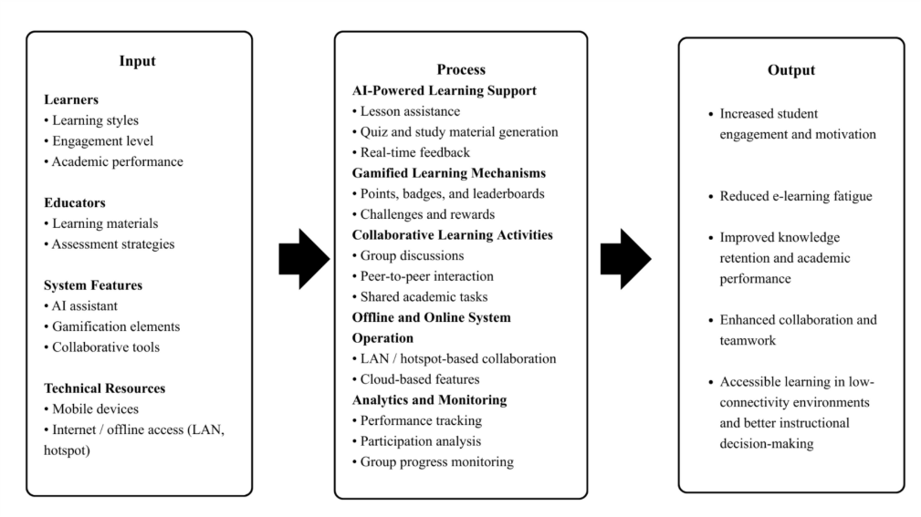

Figure 2.1: Conceptual Framework
As shown in Figure 2.1, the conceptual framework of the study is anchored on the Input-Process-Output (IPO) model, which illustrates how the proposed system, SAGE: Smart Assistant for Group-Based Education, transforms identified inputs into desired learning outcomes.
The input component consists of the learners’ characteristics, educators’ learning materials and assessment strategies, system features such as AI-powered assistance, gamification, collaborative tools, and the available technical resources including mobile devices and network connectivity. These inputs represent the essential elements required for the effective operation of the SAGE platform.
The process component describes how the system utilizes these inputs through AI-powered learning support, gamified learning mechanisms, collaborative learning activities, offline and online system operation, and analytics and monitoring. Through these processes, the system provides personalized guidance, encourages active participation through gamification, enables group-based learning, ensures accessibility in low-connectivity environments, and continuously tracks learner performance and participation.
The output component represents the expected results of the study, which include increased student engagement and motivation, reduced e-learning fatigue, improved knowledge retention and academic performance, enhanced collaboration and teamwork, improved accessibility to learning, and better instructional decision making for educators.
Overall, the conceptual framework demonstrates how the integration of artificial intelligence, gamification, collaboration, and offline connectivity in the SAGE system addresses the limitations of existing e-learning platforms and contributes to a more interactive, inclusive, and effective digital learning environment.

CHAPTER III
DESIGN AND METHODOLOGY

Software Development Methodology
The Waterfall Model was chosen as the development approach for the SAGE system. It is a linear and sequential model that divides the software development process into distinct phases, where each phase must be completed before proceeding to the next (Thesing, Feldmann, & Burchardt, 2021). The choice of this methodology is explicitly justified by the stable and well-defined requirements of the proposed system, as well as the structured timeline inherent in an academic capstone setting. Because the core features of SAGE, such as AI integration, gamification, and offline LAN collaboration were clearly identified and approved during the proposal stage, the Waterfall model ensures that every aspect of the system is thoroughly planned, designed, implemented, and tested before deployment, minimizing the risks associated with scope creep. Given the technical complexity of blending AI tools with local network capabilities, locking in the system architecture early allows the developers to focus entirely on execution rather than continuous redesign. Furthermore, this step-by-step progression provides the thesis adviser and panel with clear, measurable milestones throughout the semester. Ultimately, this approach ensures the team can efficiently manage their time, guaranteeing that a stable, fully functional platform is delivered for final user testing.

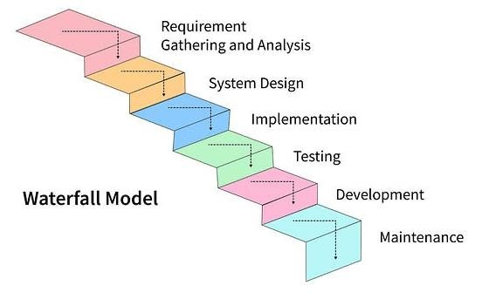

Figure 3.1: Waterfall Model Development Phases

Requirement Analysis
During this phase, the development team will gather and document all functional and non-functional requirements of the system. Information will be collected through surveys, interviews, and consultations with students and educators to understand their needs for collaborative and gamified learning tools. The expected outputs are the Software Requirement Specification (SRS) and the System Requirement Document.

System Design
Based on the gathered requirements, the system architecture, database structure, and interface design will be created. This includes defining the system modules such as AI-powered assistance, gamified learning interface, progress tracking, LAN collaboration, and user management.

Implementation (Coding)
The actual coding and development of the system take place in this phase. Each module will be programmed based on the design specifications. Technologies such as Python (Django) for the backend and React.js for the frontend will be used.
The AI module will be trained using Python’s machine learning libraries.

Testing
After implementation, testing will be conducted to identify and fix errors. Unit testing, integration testing, and user acceptance testing (UAT) will ensure that the system meets user expectations and functions correctly across devices, both online and offline.

Deployment
Once the system has passed all testing stages, it will be deployed to the target environment. The deployment will include installation, configuration, and user orientation.

Maintenance
In this final phase, the team will monitor and maintain the system’s performance. Bug fixes, feature enhancements, and system updates will be handled as part of ongoing maintenance.

Organizational Chart

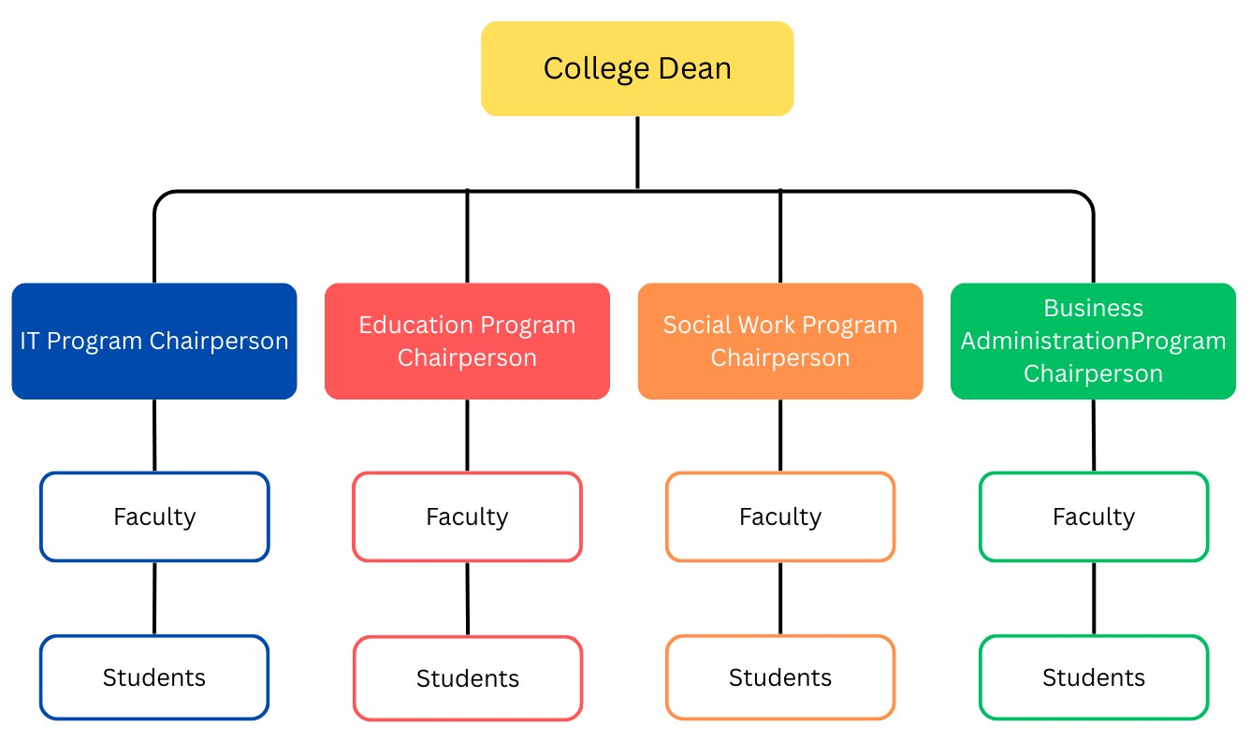

Figure 3.2 Organizational Chart
The organizational chart above illustrates the academic and administrative hierarchy of the target institution, representing the primary stakeholders and system users of the SAGE platform. At the top of the hierarchy is the College Dean, who oversees the various academic programs. Below the Dean are the Program Chairpersons (such as IT, Education, Social Work, and Business Administration), who manage the faculty members within their respective departments.
In the context of the SAGE platform, this academic hierarchy directly defines the system's user roles and access levels. Faculty members act as the primary educators and facilitators; they utilize the system to generate learning materials, monitor group dynamics, and view analytics on student participation. Students, positioned at the base of the organizational structure, are the primary end-users who engage with the AI assistant, participate in gamified tasks, and collaborate within their peer groups. Mapping this organizational structure ensures that SAGE's features particularly its role-based access and performance monitoring are perfectly aligned with the institution's actual daily workflow.

Requirement Analysis
The SAGE system aims to address e-learning fatigue, lack of collaboration, and accessibility limitations. To ensure the system functions exactly as intended, the requirements have been explicitly defined to identify the specific actors (Students, Educators, or the System) and establish measurable criteria for performance, security, and usability.

Functional Requirements
The Functional requirements define the specific behaviors, tasks, and actions that the SAGE platform and its distinct user roles must be able to perform. These requirements are essential for achieving the system's objectives of providing personalized, collaborative, and gamified learning experiences.

Functional  Requirements | Requirement Description
FR-01 | The system shall allow Students and Educators to create, manage, and authenticate their user accounts using RoleBased Access Control (RBAC).
FR-02 | The system shall allow Educators and Students to generate customized quizzes and study materials on-demand using the integrated DeepSeek API.
FR-03 | The system shall automatically award points and badges to Students upon the completion of academic tasks and update the real-time leaderboard accordingly.
FR-04 | The system shall allow Students to join localized group sessions via offline LAN/hotspot, or connect via the cloud internet, for real-time collaborative tasks.
FR-05 | The system shall generate automated performance analytics and participation reports for Educators to monitor individual and group progress.
FR-06 | The system shall allow Students and Educators to communicate via real-time chat and share files within designated virtual study rooms.
FR-07 | The system shall securely synchronize Student learning data between the local SQLite database and the cloud Firebase database using encrypted REST API calls once internet connectivity is restored.

Table 3.1 Functional Requirements

The functional requirements of the SAGE platform are designed to create a cohesive learning environment by integrating five core operational areas:

- User Access Control (FR-01): The system implements Role-Based Access Control (RBAC) to ensure that students and educators interact with the platform through distinct permission sets. This ensures data privacy and allows the interface to dynamically adapt to the user's specific tasks.
- AI-Driven Content Generation (FR-02): By integrating the DeepSeek API, the system automates the creation of study materials and quizzes. This feature provides personalized educational scaffolding, allowing students to receive tailored content based on their specific study topics.
- Gamification Mechanics (FR-03): To combat e-learning fatigue and increase engagement, the system automatically tracks task completion and awards points and badges. These rewards are reflected in realtime leaderboards, fostering a competitive yet collaborative learning atmosphere.
- Hybrid Collaboration Engine (FR-04, FR-06): The system supports synchronous group work through a dual-mode connectivity
architecture. Users can collaborate via traditional cloud-based internet or through localized LAN/hotspot sessions, ensuring that real-time chat and group tasks remain functional even in low-connectivity
areas.
- Data Synchronization and Analytics (FR-05, FR-07): The platform bridges the gap between individual effort and instructional oversight. Automated reports provide educators with actionable insights into group dynamics and student performance. Furthermore, the system employs a robust synchronization protocol that secures data parity between local SQLite storage and the cloud Firebase database upon reconnection.

Use Case
The functional requirements listed above are visually represented in the System Use Case Diagram. As shown in Figure 3.1, the diagram maps the specific interactions between the primary actors—the Student and the Educator—and the internal system processes.
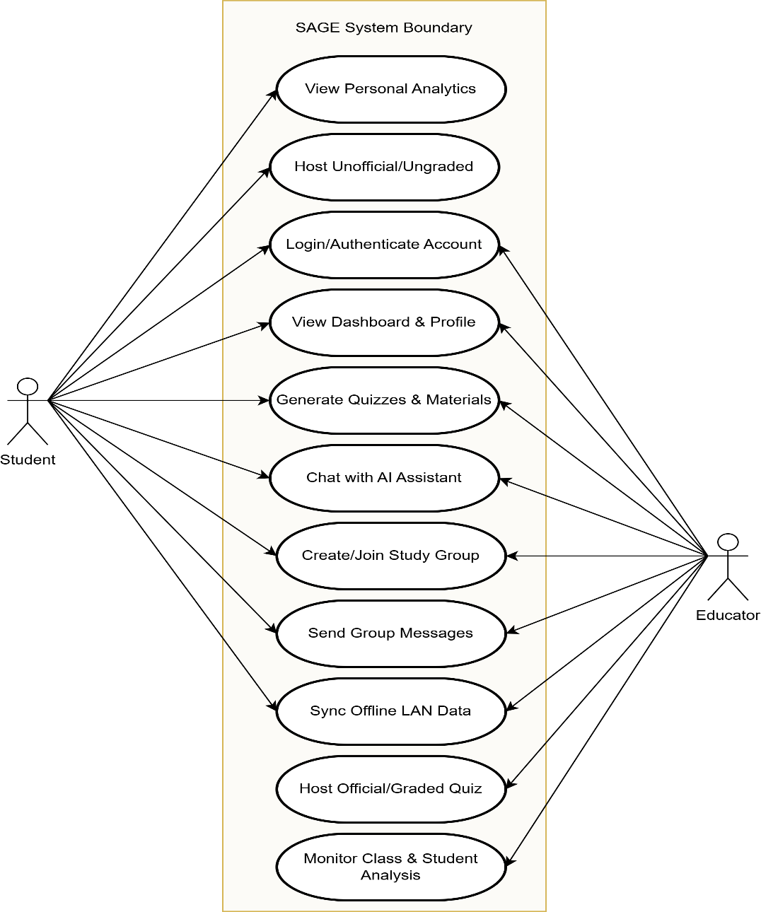

Figure 3.3: Use Case Diagram
The Use Case Diagram illustrates the distinct roles within the SAGE platform. The Student role focuses on interactive tasks such as joining groups, submitting quizzes, and utilizing the AI assistant. The Educator role is provided with administrative oversight, including group creation and the monitoring of class-wide analytics. Both roles share common functionalities like authentication, ensuring a secure and role-based learning environment.

Non-Functional Requirements
Non-functional requirements (NFRs) specify the quality attributes, system constraints, and performance goals that the SAGE platform must satisfy to ensure a seamless user experience. While functional requirements define what the system does, these NFRs define how the system performs under various operational conditions.
Non-  Functional  Requirements | Category | Requirement Description
NFR-01 | Usability | The system interface shall ensure that all primary features (e.g., joining a group, starting a quiz) are accessible to the user within three screen taps.
NFR-02 | Reliability | The system shall automatically cache active learning data locally to the SQLite database every 2 minutes to prevent data loss in the event of a sudden network drop.
NFR-03 | Scalability | The backend architecture shall support at least  500 concurrent online users globally, and up to
 |  | 10 concurrent offline users per localized LAN/hotspot session without noticeable latency.
NFR-04 | Security | The system shall secure user sessions using JSON Web Tokens (JWT) and encrypt all stored passwords and sensitive user data using industry-standard AES-256 encryption.
NFR-05 | Portability | The mobile application shall be fully operational and responsive on Android devices running Android 8.0 or higher, and iOS devices running iOS 13 or higher.

Table 3.2 Non-Functional Requirements
The non-functional requirements for the SAGE platform are categorized into five critical domains to ensure technical robustness:
- Usability: To address the challenge of e-learning fatigue, the system prioritizes interface efficiency. By ensuring that core features are accessible within three screen taps, the platform reduces cognitive load and enhances user retention.
- Reliability: Given the platform's focus on low-connectivity environments, reliability is maintained through a strict local caching protocol. By automatically saving active learning data to the SQLite database every two minutes, the system guarantees that student progress remains intact even during sudden network failures.
- Scalability: The architecture is designed to support growth, accommodating up to 500 concurrent online users globally. Furthermore, the localized LAN/hotspot mode is optimized to handle 10 concurrent users
per session, ensuring stable performance for typical classroom or study group sizes without introducing latency.
- Security: To protect sensitive educational data and user privacy, SAGE implements industry-standard encryption. User sessions are managed via JSON Web Tokens (JWT), while all stored credentials and personal data are protected using AES-256 encryption to prevent unauthorized access.
- Portability: To ensure maximum inclusivity, the application is built using a cross-platform framework that supports a wide range of mobile devices. The system is fully operational on Android 8.0 and iOS 13 or higher, allowing students with older hardware to participate in the digital learning experience without barriers.

Software Development Tools and Environment
The selection of development tools and environments for the SAGE system was driven by the need to support cross-platform mobile accessibility, real-time artificial intelligence integration, and seamless transitions between online and offline states. Rather than relying on a single monolithic environment, the technical stack is distributed to optimize performance for both cloud-based and localized collaborative learning.
Hosting Architecture (Cloud vs. Local Clarification) To support the system’s dual-mode capabilities, the hosting environments are explicitly categorized based on the development phase and operational mode:
Development Phase: The system utilizes Django’s built-in development server running on a local machine (localhost) to allow for rapid iteration, testing, and debugging without relying on live web traffic.
Online Production Mode (Cloud): The central backend API and global database are hosted on a cloud Platform-as-a-Service (such as Render) integrated with Firebase. This provides high availability, scalable data storage, and centralized AI processing when students have stable internet access.
Offline Production Mode (Local/LAN): When internet is unavailable, the system shifts to a localized peer-to-peer or mobile hotspot architecture. The "server" temporarily runs via the local mobile database (SQLite) on the users' devices, allowing group collaboration to continue uninterrupted before securely syncing back to the cloud once connectivity is restored.

Analytical Tool Selection
The primary software technologies were selected based on their specific architectural advantages for this project, as detailed in Table 3.3.

Component | Technology | Analytical Justification
Frontend  Framework | React Native | Selected for its capability to deploy to both Android and iOS from a single codebase, ensuring maximum accessibility for students regardless of their device, while maintaining near-native performance during gamified interactions.
Backend  Framework | Python(Django) | Chosen for its robust, built-in security features and excellent native compatibility with AI, data analytics, and machine learning libraries, which is critical for processing DeepSeek API requests.
Cloud  Database | Firebase | Selected for its highly efficient real-time synchronization capabilities, which are essential for maintaining live leaderboards and instant chat functionality during online collaborative sessions.
Local  Database | SQLite | Utilized due to its lightweight, zeroconfiguration architecture that runs natively on mobile devices. It acts as the critical bridge for the system’s offline mode, caching data locally to prevent data loss during LAN sessions.
AI Integration | Deepseek R1 and V3 API | Chosen over standard natural language processors due to its optimized reasoning models (R1), providing highly accurate, context-aware educational scaffolding and real-time quiz generation at a sustainable computing cost.
Integrated Dev  Environment | Visual Studio  Code | Selected for its extensive extension ecosystem and integrated terminal, allowing developers to manage both the React Native frontend and Django REST backend within a unified, highly efficient workspace.
Version Control | GitHub | Utilized to facilitate secure source code management, continuous integration, and seamless collaborative development among the project team members.
Testing Tool | Postman | Selected for rigorous backend testing, allowing the team to validate the Django REST API endpoints and ensure secure data handoffs before integrating the mobile frontend.

Table 3.3: Software Development Tools and Analytical Justification

Testing and Evaluation
To ensure the SAGE platform functions reliably across its various deployment environments, a rigorous, multi-phase testing strategy will be executed. Rather than simply verifying standard software operations, these testing phases are specifically tailored to address the system's unique AI integration and hybridconnectivity features.
- Unit Testing: During this initial phase, individual software components will be isolated and tested for logical accuracy. Specific test cases will include verifying the DeepSeek API's ability to generate curriculum-appropriate quiz questions, ensuring the gamification engine correctly calculates and assigns points, and validating data input functions within the local SQLite database independently.
- Integration Testing: This phase evaluates how well the independent modules communicate with one another. A critical focus will be placed on the system's datahandoff protocols, specifically testing the secure synchronization process that transfers locally cached offline learning data to the central Firebase cloud server without data loss or duplication.
- System Testing: The fully integrated SAGE application will be evaluated under simulated real-world conditions. Because the platform's core value relies on connectivity flexibility, primary tests will evaluate the network-switching capabilities specifically observing how the system handles abrupt internet disconnections and smoothly transitions to localized LAN or mobile hotspot modes for uninterrupted group collaboration.
- User Acceptance Testing (UAT): The final evaluation will involve deploying the application to a sample group of the target end-users, consisting of actual students and educators. UAT will validate the system against the established Non-Functional Requirements, focusing on interface learnability and task completion rates. User feedback will be collected through standardized questionnaires and direct observation to finalize UI/UX refinements prior to the system's final academic deployment.

System Architecture and Design
The SAGE platform utilizes a multi-layered client-server architecture designed to ensure seamless operation across both cloud-connected and localized offline environments. This architecture is divided into four distinct layers: Presentation, Application, Data, and Integration, all of which work in tandem to process user inputs, manage data synchronization, and deliver AI-driven educational content.

Presentation Layer (Client Side)
The Presentation Layer serves as the primary interface for all users, including students and educators, and is developed using the React Native framework. This approach ensures a responsive, cross-platform mobile experience for both Android and iOS devices. Rather than operating as a static viewing window, this layer actively handles dynamic user interactions, such as login authentication, navigating gamified leaderboards, participating in real-time collaborative chat, and accessing study materials. All user actions are packaged as REST API requests and transmitted to the backend server for processing. Furthermore, while both students and educators access a central dashboard, the system utilizes Role-Based Access Control (RBAC) to conditionally render the User Interface (UI). The frontend dynamically adjusts based on the authenticated role, providing students with immediate access to personal learning analytics and unofficial quiz hosting, while populating the educator's dashboard with class-wide monitoring tools and official assessment controls.

Application Layer (Backend Logic)
Operating as the central processing hub, the Application Layer is built upon the Python Django framework, utilizing the Django REST Framework to manage
API routing. This layer is responsible for executing the core business logic of the SAGE platform. It authenticates user credentials, manages role-based access control, calculates gamification points and achievements, and orchestrates active collaboration sessions. Furthermore, it acts as the secure intermediary that handles data requests between the mobile application, the database, and the external AI services.

Data Layer and Offline-Online Synchronization Flow
To support the system’s hybrid connectivity requirements, the Data Layer employs a dual-database architecture consisting of Firebase for cloud storage and SQLite for local mobile storage.
Online Mode: When an active internet connection is present, the system directly queries and writes to Firebase, centralizing user accounts, real-time leaderboards, and analytics reports.
Offline Mode: When internet access is unavailable and users connect via localized LAN or mobile hotspots, the mobile application seamlessly transitions to utilizing the local SQLite database. During this state, chat histories, quiz results, and shared files are cached locally on the users' devices.
Data Flow and Synchronization: The transition between these states is governed by an automated synchronization protocol. The application continuously listens for network state changes; upon detecting the restoration of internet connectivity, the system triggers a background sync process. The application reads the locally cached data from SQLite, packages it, and pushes it to the Firebase cloud database via secure API calls. Once Firebase confirms a successful write operation, the local SQLite cache is cleared, ensuring that no learning progress is lost and preventing data duplication.

Integration Layer (AI Services)
The Integration Layer is specifically dedicated to the artificial intelligence components, seamlessly connecting the backend server to the DeepSeek R1 and V3 models via API calls. This module receives parsed user inputs and learning progress data from the Application Layer, processes the prompts, and returns context-aware responses. This enables the platform to generate adaptive quizzes, provide personalized study recommendations, and offer real-time feedback during group discussions.

Workflow Diagram

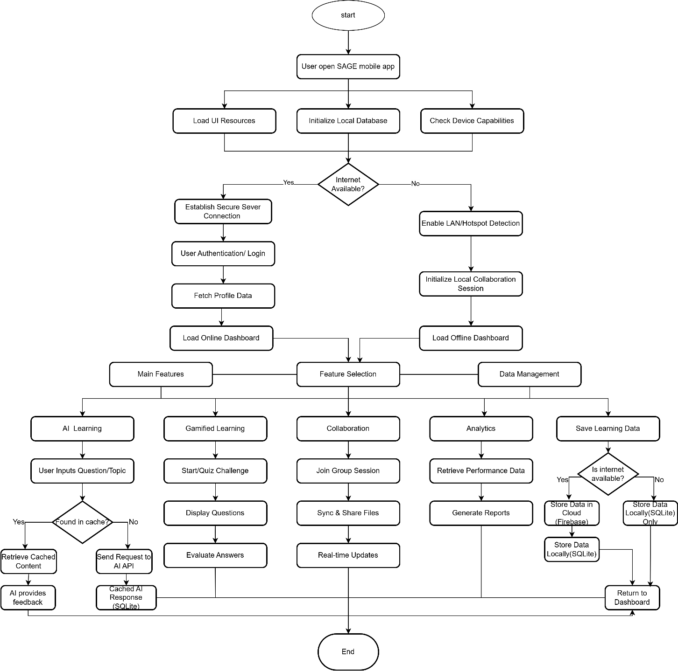

Figure 3.3: System Workflow Diagram

As illustrated in Figure 3.3, the operational workflow of the SAGE mobile application dictates how a user navigates the system from initialization to task completion. Upon launching the application, the system immediately checks device capabilities and network connectivity via a primary decision node. If the internet is available, the user proceeds to standard cloud authentication and the online dashboard. If the user opts for offline mode, the system activates LAN/hotspot detection, initializes a localized collaboration session, and loads the offline dashboard. Once authenticated, the user accesses the main features, branching into AI Learning, Gamified Learning, Collaboration, or Analytics. After a task is completed (e.g., submitting a quiz or retrieving an AI response), the workflow loops the user back to the feature selection dashboard for continuous engagement, while passing the resulting progress to the data management protocol.

Client-Server Architecture
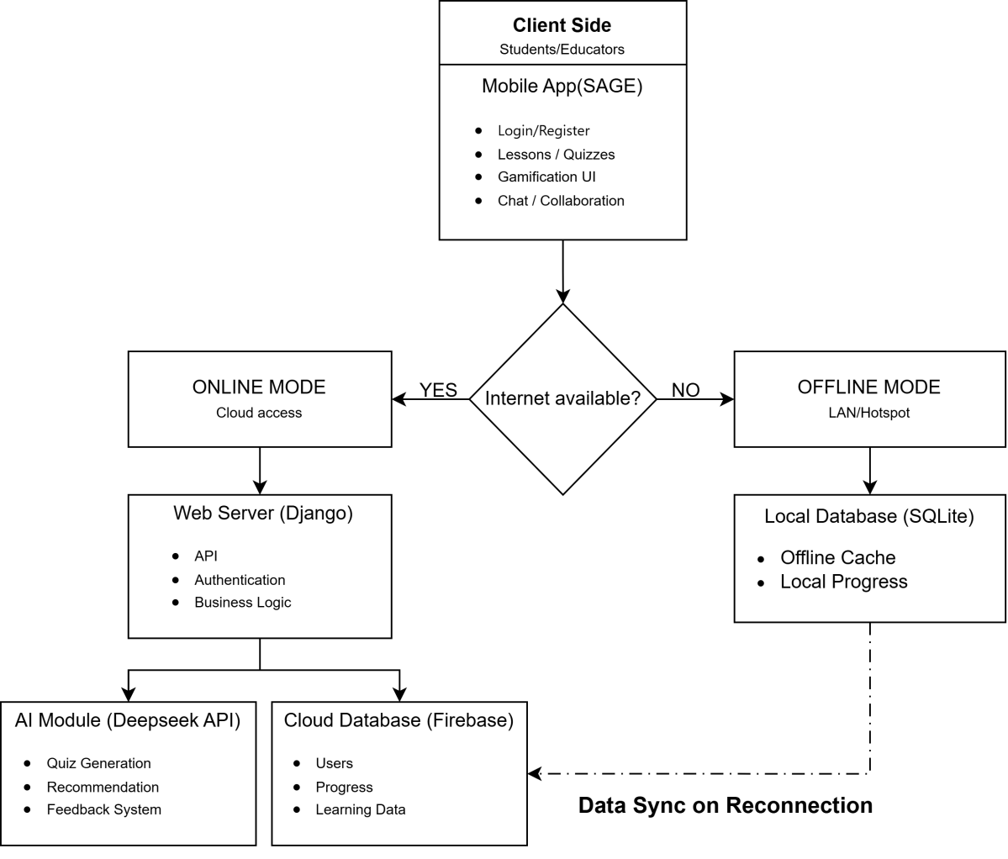

Figure 3.4: Client-Server Architecture
Figure 3.4 details the structural relationship and data flow between the mobile clients and the centralized server systems. The diagram visually represents the system's strict branching logic based on internet availability. When operating in Offline Mode, the architecture bypasses the external cloud servers entirely, interacting solely with the local SQLite database to ensure the DeepSeek AI and cloud databases do not cause system crashes when unreachable. Conversely, in Online Mode, all client requests are routed to the central Django Web Server, which then securely distributes the operations to either the DeepSeek AI Module for content generation or the Firebase Database Server for cloud storage.

System Design
The system design phase defines how each module interacts within the broader architecture. To ensure a cohesive user experience, the SAGE platform is driven by five major integrated modules. The AI Learning Assistant Module generates personalized study recommendations and assists users in navigating lessons and quizzes. Motivation and engagement are managed by the Gamification Module, which handles the dynamic calculation of points, achievements, and leaderboards. To support peer-to-peer learning, the Collaboration Module enables group chat, shared academic tasks, and synchronized study sessions across both localized LAN and internet connections. System security is maintained by the User Management Module, which strictly controls authentication, user roles, and access levels. Finally, the Analytics Module continuously monitors user performance, translating raw data into actionable reports for educators.
Overall, the system architecture follows a multi-layered client-server model. Clients (students and educators) connect to the central server via the internet or a localized mobile hotspot. Learning data is managed through a synchronized dualdatabase system (utilizing local SQLite and cloud-based Firebase), while all primary transactions and AI requests are processed securely using the Django framework.

System Data Flow Analysis
To illustrate the internal logic and transformation of information within
SAGE, a Level 1 Data Flow Diagram (DFD) is presented in Figure 3.5. Utilizing Gane & Sarson notation, this diagram maps the movement of data between external actors, internal processes, and the system's data stores.
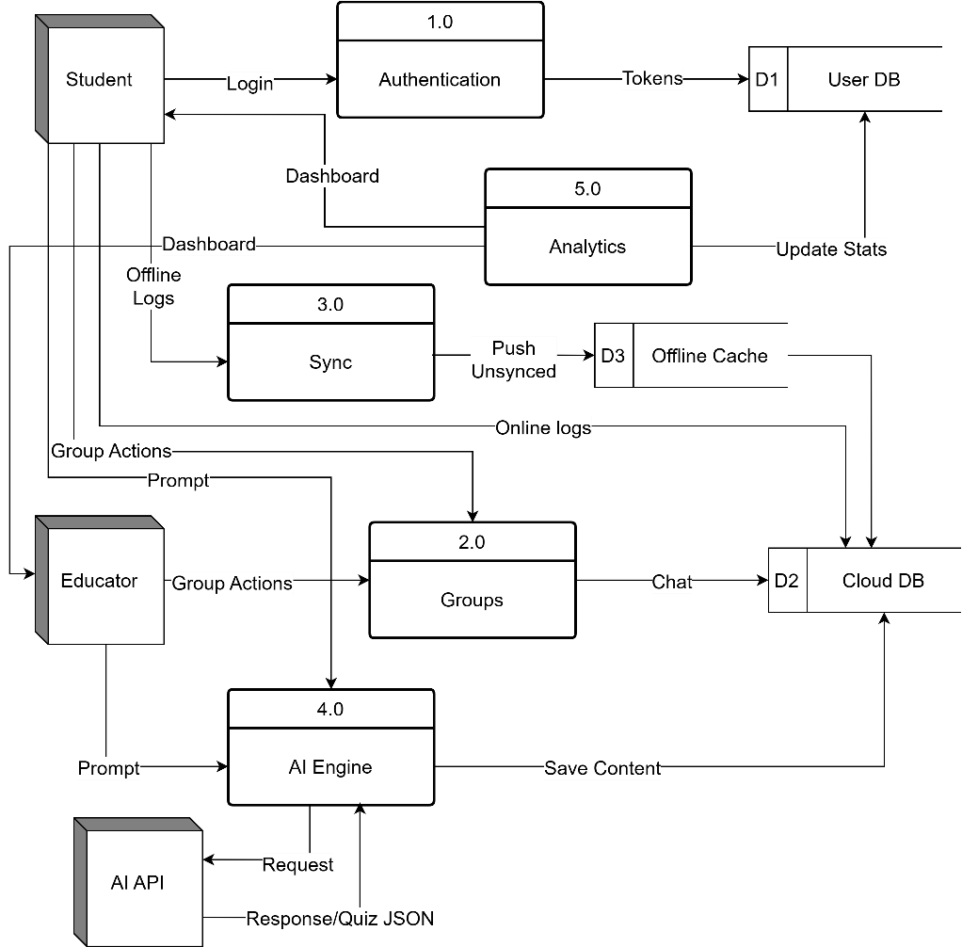

Figure 3.5: Data Flow Diagram

The DFD breaks the system into five core functional processes:
- Authentication: Manages login credentials and roles between users and the User Profile DB.
- 2.0 Group Management: Routes collaboration data, such as join codes and member lists, to the central repository.
- 3.0 Sync Router: This is the critical junction for the system's 'Offline-First' capability. It detects network status to route data either to the D3: Offline Cache or the D2: Cloud DB.
- 4.0 AI Engine: Processes study topics and interacts with the AI API to return context-aware JSON quiz payloads.
- 5.0 Analytics Tracker: Captures triggers from group activities and quizzes to update gamification stats and educator dashboards.

Database Design
The structural foundation of the SAGE backend is defined by the Entity-Relationship Diagram (ERD) shown in Figure 3.6. Using Crow’s Foot notation, this schema illustrates the relational links between the entities required to support gamification, collaboration, and AI-driven learning.
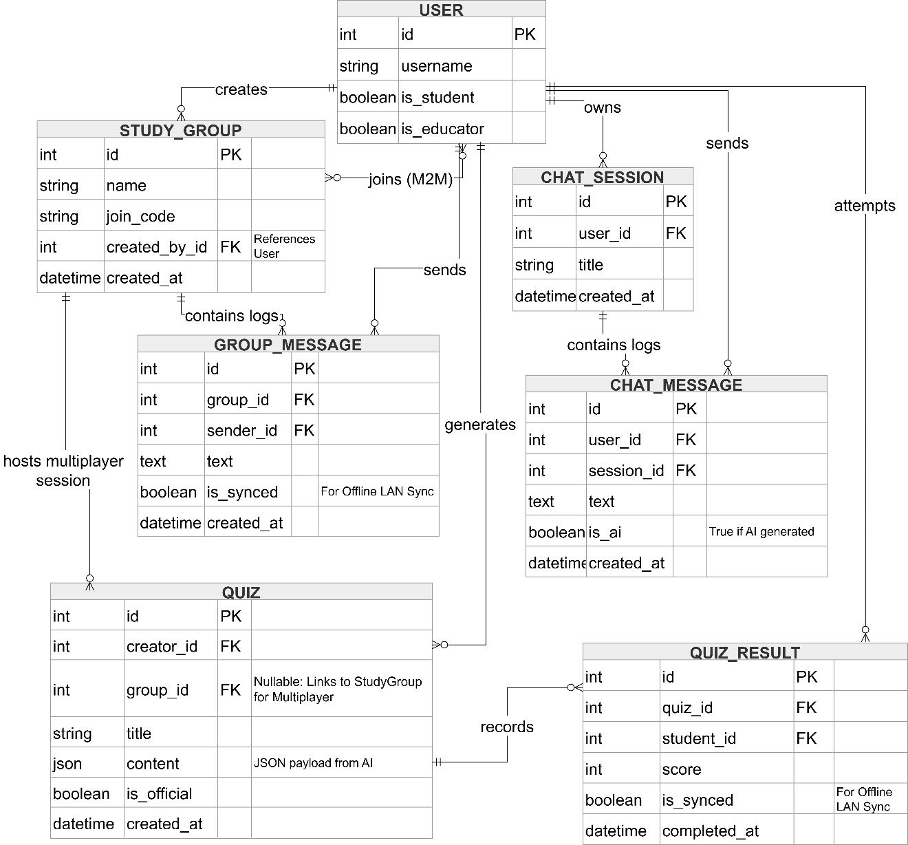

Figure 3.6: Entity-Relationship Diagram
The database architecture is designed to support the system's multi-layered features:
- Core User Entity: Serves as the central anchor for all relational engines, distinguishing between student and educator roles.
- Collaboration Engine: Links users to STUDY_GROUP and GROUP_MESSAGE tables, supporting the real-time sharing of
academic tasks.
- AI & Quiz Engine: Manages the generation and storage of materials through the QUIZ and QUIZ_RESULT tables. The content field in the QUIZ table utilizes a JSON format to handle the dynamic educational payloads returned by the AI API.
- Sync Integrity: Key transactional tables, such as messages and quiz attempts, include an is_synced attribute. This is technically essential for maintaining parity between the local SQLite cache and the Firebase cloud server upon reconnection.

Hardware and Software Requirements
To ensure stable performance and compatibility across multiple platforms without introducing unnecessary development costs, the hardware and software specifications for the SAGE system have been deliberately minimized. The platform is designed primarily for mobile accessibility, ensuring it is functional for users in low-connectivity or low-resource environments.

Server Requirements
A local or cloud-based server is required to host the system database, manage user authentication, and handle data synchronization. Because the platform is intended for small to medium-scale educational environments, it does not require enterprise-grade hardware.
• Processor: Intel Core i5 / AMD Ryzen 5 (or equivalent)

• Memory (RAM): 8GB minimum
- Storage: 256GB Solid State Drive (SSD)
- Operating System: Windows 10 or Ubuntu Linux
These specifications ensure adequate performance for hosting the SAGE web services, API endpoints, and real-time data synchronization during collaborative activities.

Client Devices
The SAGE system is designed to operate primarily on mobile platforms to ensure maximum portability for students and educators. The requirements omit highly specific constraints (such as battery capacity or screen size) to ensure broad compatibility.
- • Operating System: Android 8.0 (Oreo) or higher / iOS 13 or higher
- • Memory (RAM): 3GB minimum
- Storage: 32GB internal storage minimum
- Connectivity: Wi-Fi and Mobile Hotspot functionality (Strictly required to support offline LAN group sessions)

Peripheral Devices
- Networking: A standard wireless router or a mobile device capable of generating a localized hotspot is required to facilitate the offline peer-to-peer collaboration mode.
- Host Management: A standard PC or laptop is used by the educator or system administrator to manage the server, export analytics, and host the local database during offline sessions.

Software Requirements
The comprehensive list of software frameworks, databases, and AI environments required to build, compile, and run the SAGE system has been previously detailed and analytically justified in Table 3.3 (Software Development Tools and Analytical Justification).

References
Costa, R., Tan, Q., Pivot, F., Zhang, X., & Wang, H. (2021). Personalized and adaptive learning: Educational practice and technological impact. Texto Livre:
Linguagem e Tecnologia, 14(3), e33445. https://doi.org/10.35699/1983-
3652.2021.33445
https://www.redalyc.org/journal/3995/399577691013/html
du Plooy, E., Casteleijn, D., & Franzsen, D. (2024). Personalized adaptive learning in higher education: A scoping review of key characteristics and impact on academic performance and engagement. Heliyon, 10(21), e39630. https://doi.org/10.1016/j.heliyon.2024.e39630
Fiorella, L., & Mayer, R. E. (2022). Principles for reducing extraneous processing in multimedia learning. In The Cambridge Handbook of Multimedia Learning (3rd ed., pp. 185–198). Cambridge University Press.
https://doi.org/10.1017/9781108894333.019
Gligorea, I. (2023). Adaptive learning using artificial intelligence in e-learning.
Education Sciences, 13(12), 1216.
https://doi.org/10.3390/educsci13121216
Hmelo-Silver, C. E., & Chinn, C. A. (2016). Collaborative learning. In L. Corno & E. M.
Anderman (Eds.), Handbook of educational psychology (3rd ed., pp. 349–363).
Routledge. https://psycnet.apa.org/record/2016-02743-026
Laura-De La Cruz, K. M., Noa-Copaja, S. J., Turpo-Gebera, O., Montesinos-Valencia, C. C., Bazán-Velasquez, S. M., & Pérez-Postigo, G. S. (2023). Use of gamification in English learning in higher education: A systematic review. Journal of
Technology and Science Education, 13(2), 480–497. https://doi.org/10.3926/jotse.1740.
Reed, H. C. (2022). E-learning fatigue and the cognitive, educational, and emotional impacts on communication sciences and disorders students during COVID-19.
Perspectives of the ASHA Special Interest Groups, 7(6), 1885–1902.
https://doi.org/10.1044/2022_PERSP-22-00049
Sailer, M., & Homner, L. (2020). The gamification of learning: A meta-analysis.
Educational Psychology Review, 32(1), 77–112. https://doi.org/10.1007/s10648-
019-09498-w
Sajja, R., Sermet, Y., Cwiertny, D., & Demir, I. (2023). Platform-independent and curriculum-oriented intelligent assistant for higher education. Educational Technology Research and Development, 71(3), 1259–1278.
https://doi.org/10.1186/s41239-023-00412-7
Santos, J. R., & Reyes, K. M. (2023). Collaborative digital learning in Philippine classrooms: A study on group-based activities. Philippine Journal of Educational Research, 14(1), 101–117. Smith, B. (2024). The effectiveness of Duolingo in developing receptive and productive language knowledge and proficiency.
Journal of Applied Language Studies, 12(2), 75–92. https://scholarspace.manoa.hawaii.edu/bitstreams/ea47a53e-da6e-4419-bd55e72b458294f4/download
Sayaf, A. M., Alamri, M. M., Alqahtani, M. A., & Al-Rahmi, W. M. (2021). Information and communications technology used in higher education: An empirical study on digital learning as sustainability. Sustainability, 13(13), 7074.
https://doi.org/10.3390/su13137074

Thesing, T., Feldmann, C., & Burchardt, M. (2021). Agile versus Waterfall Project Management: Decision Model for Selecting the Appropriate Approach to a
Project. Procedia Computer Science, 181, 746–756.

Wang, Y. (2021). A meta-analysis: Gamification in education (Master’s thesis). Missouri
University of Science and Technology. https://scholarsmine.mst.edu/masters_theses/8070
Zhou, M., & Brown, D. (n.d.). Educational Learning Theories: 2nd Edition. GALILEO
Open Learning Materials. https://oer.galileo.usg.edu/education-textbooks/1/

