REPUBLIC OF THE PHILIPPINES
TECHNOLOGICAL UNIVERSITY OF THE PHILIPPINES
TAGUIG CITY
Km. 14 East Service Road, Western Bicutan, Taguig City 1630
www.tupt.edu.ph | Tel. No.: (632) 8247-5250 to 54
The Technological University of the Philippines shall be a premier state university with recognized excellence
in engineering and technology education at par with the leading universities in the ASEAN region.

HUMAN RESOURCE MANAGEMENT SYSTEM
A Java Swing/AWT Desktop Application Using JDBC and Apache Derby
PROJECT DOCUMENTATION
Submitted in partial fulfillment of the requirements for the course in Information Technology

SUBMITTED BY
Rebanal, Ron Harry
Calaramo, Carl
Pablo, John Clarence
BSIT-T-2B-T
SUBMITTED TO
Ms. Maria Cristina D. Baloloy
2026

ABSTRACT
Organizations that maintain employee information in paper files and disconnected spreadsheets can experience slow record retrieval, duplicate encoding, inconsistent employee details, and time-consuming attendance and leave monitoring. This project presents a Human Resource Management System (HRMS) desktop application designed to centralize employee, department, position, attendance, leave-request, and user-account records. The application is implemented in Java, with Swing and AWT providing the graphical interface, JDBC providing database connectivity, and Apache Derby operating as the embedded relational database. The system includes administrator and HR Staff roles, record-management forms, keyword search, input validation, confirmation dialogs, a dashboard, and read-only reports that can be exported to CSV. The database design uses primary keys, foreign keys, unique constraints, and check constraints to maintain relationships and prevent duplicate attendance entries for the same employee and date.
The application is organized into interface, data-access, model, and utility packages. Reusable DAO logic executes parameterized SQL statements, while the interface provides separate screens for the major HR modules. Passwords are stored as salted PBKDF2-HMAC-SHA256 hashes. The scope is intentionally limited to local desktop HR administration and excludes payroll, tax computation, recruitment, performance evaluation, biometric devices, and web-based employee self-service. Java source compilation and a password-hashing smoke test were completed during preparation of this package. Runtime tests against the embedded Derby engine, complete functional testing, and user-acceptance evaluation remain to be performed in NetBeans; this document therefore does not claim that those tests have passed.
Keywords: Human Resource Management System, Java Swing, Java AWT, JDBC, Apache Derby, employee records, attendance, leave management, CRUD, reporting

TABLE OF CONTENTS
Abstract | 2
Keywords | 2
Chapter 1 - Introduction | 4
1.1 Background of the Study | 4
1.2 System Overview | 4
1.3 Problem Statement | 4
1.4 Objectives | 4
1.5 Scope and Limitations | 5
1.6 Significance of the Project | 5
1.7 Definition of Terms | 5
1.8 System Requirements | 6
Chapter 2 - System Analysis and Design | 7
2.1 Existing System | 7
2.2 Proposed System | 7
2.3 Functional Requirements | 8
2.4 Non-Functional Requirements | 8
2.5 System Users | 9
2.6 Use Case Diagram | 9
2.7 System Flowchart | 11
2.8 Data Flow Diagram | 12
2.9 Entity Relationship Diagram | 13
2.10 Database Design | 14
Chapter 3 - System Development | 15
3.1 Development Tools | 15
3.2 Java Swing | 15
3.3 Java AWT | 15
3.4 JDBC | 15
3.5 Apache Derby | 15
3.6 System Architecture | 16
3.7 Program Structure | 16
3.8 Database Connection | 17
3.9 CRUD Implementation | 17
3.10 GUI and Reports | 17
Chapter 4 - Testing | 18
4.1 Test Plan | 18
4.2 Test Cases | 18
4.3 Security and User Acceptance Testing | 19
Chapter 5 - Conclusion | 20
5.1 Summary | 20
5.2 Conclusions | 20
5.3 Recommendations | 20
5.4 Possible Future Improvements | 20
References | 21
Appendix A - Running the Project | 22
Appendix B - Class Diagram | 23
Appendix C - Table Relationship Diagram | 24
Appendix D - Database Dictionary | 25
Appendix E - SQL Statement Examples | 27
Appendix F - System Interface Screenshots | 28

CHAPTER 1 - INTRODUCTION

1.1 Background of the Study
Organizations depend on accurate employee information to assign responsibilities, monitor attendance, manage leave, and support administrative decisions. In a small office, paper folders and spreadsheets may initially seem adequate; however, repeated encoding, inconsistent copies, manual counting, and slow searching become more difficult as records increase. Human resource management includes maintaining the information needed to administer the employment relationship, and reliable records form a foundation for those activities (Armstrong & Taylor, 2020).
Electronic human resource management (e-HRM) applies information technology to HR processes and can reduce routine transactional work when the selected system is appropriate to the organization’s needs (Bondarouk & Ruël, 2009; Strohmeier, 2007). A small organization or academic prototype does not necessarily need the breadth or cost of a full enterprise HR suite. A focused desktop application can demonstrate the fundamentals of user interfaces, relational database design, validation, access control, and CRUD processing.
This project develops a desktop-based HRMS using Java, Swing/AWT, JDBC, and Apache Derby. Derby is selected because it is a Java-based relational database that can run in embedded mode inside the application; this is consistent with the assignment requirement and the local single-computer scope (Apache Software Foundation, 2022).

1.2 System Overview
The HRMS manages employee profiles, departments, positions, daily attendance, leave requests, and system user accounts. After authentication, a user opens a dashboard with navigation to the authorized modules. Each operational module provides a form, a table of saved records, keyword search, and actions for adding or updating records. Deletion requires Administrator access and a confirmation dialog. Reports display employee, department headcount, attendance, and leave information in read-only tables; the displayed results may be exported as CSV.
The embedded database is stored locally in the project working directory by default. The JDBC URL is equivalent to `jdbc:derby:hrmsdb;create=true`. The application creates missing tables during startup and seeds demonstration accounts and starter departments/positions when the corresponding records do not yet exist. No separate MySQL server or phpMyAdmin installation is used.

1.3 Problem Statement
The project addresses the fragmentation of employee information across paper folders, logbooks, and separate spreadsheets. The specific questions are:
- How can employee records, departments, positions, attendance, and leave requests be stored in one organized database?
- How can repeated encoding and manual counting be reduced through search, database-backed tables, and summary reports?
- How can database relationships prevent orphan records and duplicate daily attendance?
- How can authentication and role-based restrictions separate routine HR work from administrative actions?
- How can the implementation be assessed through functional, data-integrity, error-handling, and user-acceptance testing?

1.4 Objectives
General objective. To design and develop a Java desktop HRMS that centralizes selected HR records, supports controlled record management, and uses JDBC with Apache Derby as required by the course project.
Specific objectives:
1. Analyze the weaknesses of the paper-based and spreadsheet-based process.
2. Design related tables and diagrams for users, departments, positions, employees, attendance, and leave requests.
3. Implement a readable Swing/AWT interface with login, dashboard navigation, management forms, search, reports, and logout.
4. Implement prepared JDBC statements, input validation, error handling, and integrity constraints.
5. Restrict user-account management, record deletion, and leave approval to authorized roles.
6. Prepare a structured test plan and user-acceptance questionnaire, recording actual results only after execution.

1.5 Scope and Limitations
Scope. The system includes login, Administrator and HR Staff roles, employees, departments, positions, attendance, leave requests, user accounts, search, dashboard summaries, and read-only CSV-exportable reports. The database uses the embedded Apache Derby engine and the application uses a local desktop deployment model.
Limitations. The system does not calculate payroll, salaries, taxes, or deductions; manage recruitment or performance evaluation; read biometric/ID hardware; send email/SMS notifications; or provide employee web self-service. It is not designed for concurrent access from multiple computers. The demo credentials must be changed before real data are entered. The project has not been evaluated for production HR privacy, legal, or cybersecurity compliance. Runtime database tests and user-acceptance evaluation remain pending.

1.6 Significance of the Project
HR Staff. Can record and retrieve employee, attendance, and leave data in one desktop workspace instead of searching separate files.
Management. Can review structured employee counts, department distribution, attendance, and pending leave information.
Employees. May benefit indirectly from more organized employee records and leave tracking.
Students and Developers. Can study the practical use of Java Swing/AWT, JDBC, relational design, constraints, CRUD, security controls, and testing.
Future Researchers. Can extend the prototype with leave balances, audit logs, stronger deployment controls, and additional reports.

1.7 Definition of Terms
Term | Definition in this project
HRMS | A desktop application used to organize employee records and selected HR administration tasks.
CRUD | Create, Read, Update, and Delete operations for database records.
Swing | Java GUI toolkit providing windows, panels, tables, buttons, and dialogs.
AWT | Java GUI and event framework used for layouts, fonts, colors, dimensions, and event handling.
JDBC | Java Database Connectivity, the standard Java API for connecting to and querying relational databases.
Apache Derby | A Java-based relational database with an embedded JDBC driver used by this application.
DAO | Data Access Object; a class responsible for executing database operations.
PBKDF2-HMAC-SHA256 | A password-based key derivation method used to store salted password verifiers instead of plain-text passwords.
Primary key | A column or group of columns that uniquely identifies a record.
Foreign key | A constraint linking a column to a record in another table.
UAT | User Acceptance Testing, evaluation by intended users against defined tasks and criteria.

1.8 System Requirements
The following environment is required or recommended to build and run the academic desktop prototype. The application uses embedded Apache Derby and does not require a separate MySQL server, phpMyAdmin, or network database service.
Category | Requirement | Notes
Programming runtime | JDK 17 or newer | Use a Java Development Kit compatible with the Maven project configuration.
IDE / build | Apache NetBeans with Maven support | Open the folder containing pom.xml and allow dependency resolution.
Database | Apache Derby 10.16.1.1 (embedded JDBC) | Created and initialized locally by DatabaseSetup on first launch.
Operating system | Windows, Linux, or macOS with a compatible JDK | Portable at the Java level; this prototype has not been cross-platform tested.
Memory / storage | 4 GB RAM recommended; writable local storage for dependencies and hrmsdb | This is a practical recommendation rather than a measured minimum.
Database administration | No external server or phpMyAdmin required | Back up the generated hrmsdb folder after closing the application.

CHAPTER 2 - SYSTEM ANALYSIS AND DESIGN

2.1 Existing System
The existing process described in the project is a manual or semi-manual HR workflow. Employee details are kept in paper folders and duplicated in spreadsheets. Attendance is written in logbooks, while leave requests are recorded on paper and filed separately. This setup depends on manual checking and does not update related copies automatically.
Area | Existing approach | Observed limitation
Employee records | Paper folders and separate contact spreadsheets | Searching takes time; duplicate details may disagree.
Department / position | Separate lists or spreadsheets | Assignments may be outdated after changes.
Attendance | Record attendance date, AM/PM time in/out, and status; an earlier Time Out is treated as next day; prevent duplicate employee/date rows. | Counting errors and slower summaries.
Leave | Paper request forms and separate absence list | Status and dates are harder to trace.
Reports | Manual counting and compilation | Repeated work and inconsistent totals.
Access | Physical file access | Confidential records may be seen by unauthorized persons.

2.2 Proposed System
The proposed system centralizes these records in a structured embedded relational database accessed by the Java desktop application. Users authenticate before entering the workspace. Data entry is checked before saving, user-provided values are bound through PreparedStatement objects, joined queries show department/position names instead of only identifiers, and database constraints protect record relationships. The application has a light interface with dark readable text, visible labels, standard buttons, searchable tables, and confirmation/error messages.
Module | Main functions
Authentication | Login validation, role-aware navigation, clear/reset, exit, sign out.
Dashboard | Employee totals, active staff, departments, pending leave, today attendance, recently added employees.
Employees | Create, view, update, search, and administrator-authorized deletion; link to department and position.
Departments / Positions | Maintain reference lists used by employee assignments.
Attendance | Record attendance date, AM/PM time in/out, and status; an earlier Time Out is treated as next day; prevent duplicate employee/date rows.
Leave Requests | File/edit request details; Administrator reviews and approves/rejects.
User Accounts | Administrator creates/updates/removes accounts and assigns roles.
Reports | Employee directory, department headcount, attendance register, leave register, pending leave; CSV export.

2.3 Functional Requirements
ID | Functional requirement
FR-01 | Require a username and password and reject invalid credentials before showing the dashboard.
FR-02 | Support Administrator and HR Staff roles with different access rights.
FR-03 | Allow authorized users to add, view, update, search, and maintain employee records.
FR-04 | Allow authorized users to add, view, update, search, and maintain departments.
FR-05 | Allow authorized users to add, view, update, search, and maintain positions.
FR-06 | Associate each employee with one valid department and one valid position.
FR-07 | Record attendance date, time in/out using 12-hour AM/PM input, and status; treat an earlier Time Out as next-day clock-out.
FR-08 | Prevent more than one attendance record for the same employee on the same date.
FR-09 | File leave requests with employee, leave type, start/end dates, reason, status, and filing date.
FR-10 | Restrict leave approval/rejection status changes to the Administrator.
FR-11 | Search employee, attendance, leave, department, position, and user-account records by keyword where relevant.
FR-12 | Validate required fields, date formats, valid AM/PM time values, email format, and leave-date ordering before saving.
FR-13 | Confirm destructive operations; restrict record deletion to the Administrator and protect the active/last Administrator account.
FR-14 | Allow the Administrator to create, update, and delete user accounts subject to safeguards.
FR-15 | Provide login Clear/Reset, Exit, and sign-out controls.
FR-16 | Display useful dashboard summaries from database queries.
FR-17 | Display selected HR reports in a JTable and export displayed data to CSV.
FR-18 | Store and retrieve all application records using JDBC and embedded Apache Derby.

2.4 Non-Functional Requirements
Category | Requirement
Usability | Use a consistent light theme, high-contrast text, clear labels, readable fonts, visible table headers, standard buttons, and organized navigation.
Performance | Complete common CRUD/search/report queries within a reasonable period for the intended academic prototype data size; measure during runtime testing.
Reliability | Persist successful changes in Derby and show actionable messages when database or input errors occur.
Security | Use JPasswordField, salted PBKDF2-HMAC-SHA256 password verification, prepared statements, and role-based controls.
Data integrity | Use primary keys, foreign keys, UNIQUE and CHECK constraints for unique identifiers, roles/status values, and date/time logic.
Portability | Run on a compatible Java 17+ environment with Maven resolving the embedded Derby dependency.
Maintainability | Separate UI, DAO, model, and utility classes; centralize connection/schema setup and reuse CRUD logic.
Error handling | Catch SQL and validation errors and present understandable messages without intentionally terminating the application.

2.5 System Users
User | Responsibilities and access
Administrator | Accesses all modules; manages user accounts; approves/rejects leave; performs record deletion; cannot delete the currently signed-in account or remove/demote the last Administrator.
HR Staff | Maintains employee, department, position, attendance, and leave request details; searches records and views/exports reports. Cannot manage user accounts, delete records, or alter leave approval status.

2.6 Use Case Diagram
The use case diagram summarizes the common tasks available to both user roles and identifies the Administrator-only operations. Authentication is required before a protected function can be accessed.
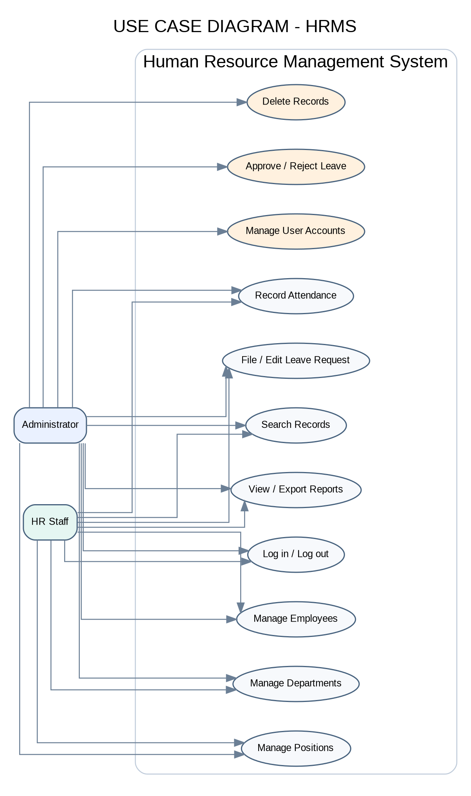
Figure 2.1. Use case model for the HRMS.

2.7 System Flowchart
On startup, the application initializes the local Derby database, creates missing tables, and removes the former same-day attendance-time constraint if it exists in an older database. After authentication, users select a module. The interface validates the input, submits a parameterized JDBC operation when valid, and displays the database result or an error message. For overnight attendance, Time Out earlier than Time In is interpreted as the following day. Logout returns the user to the login screen.
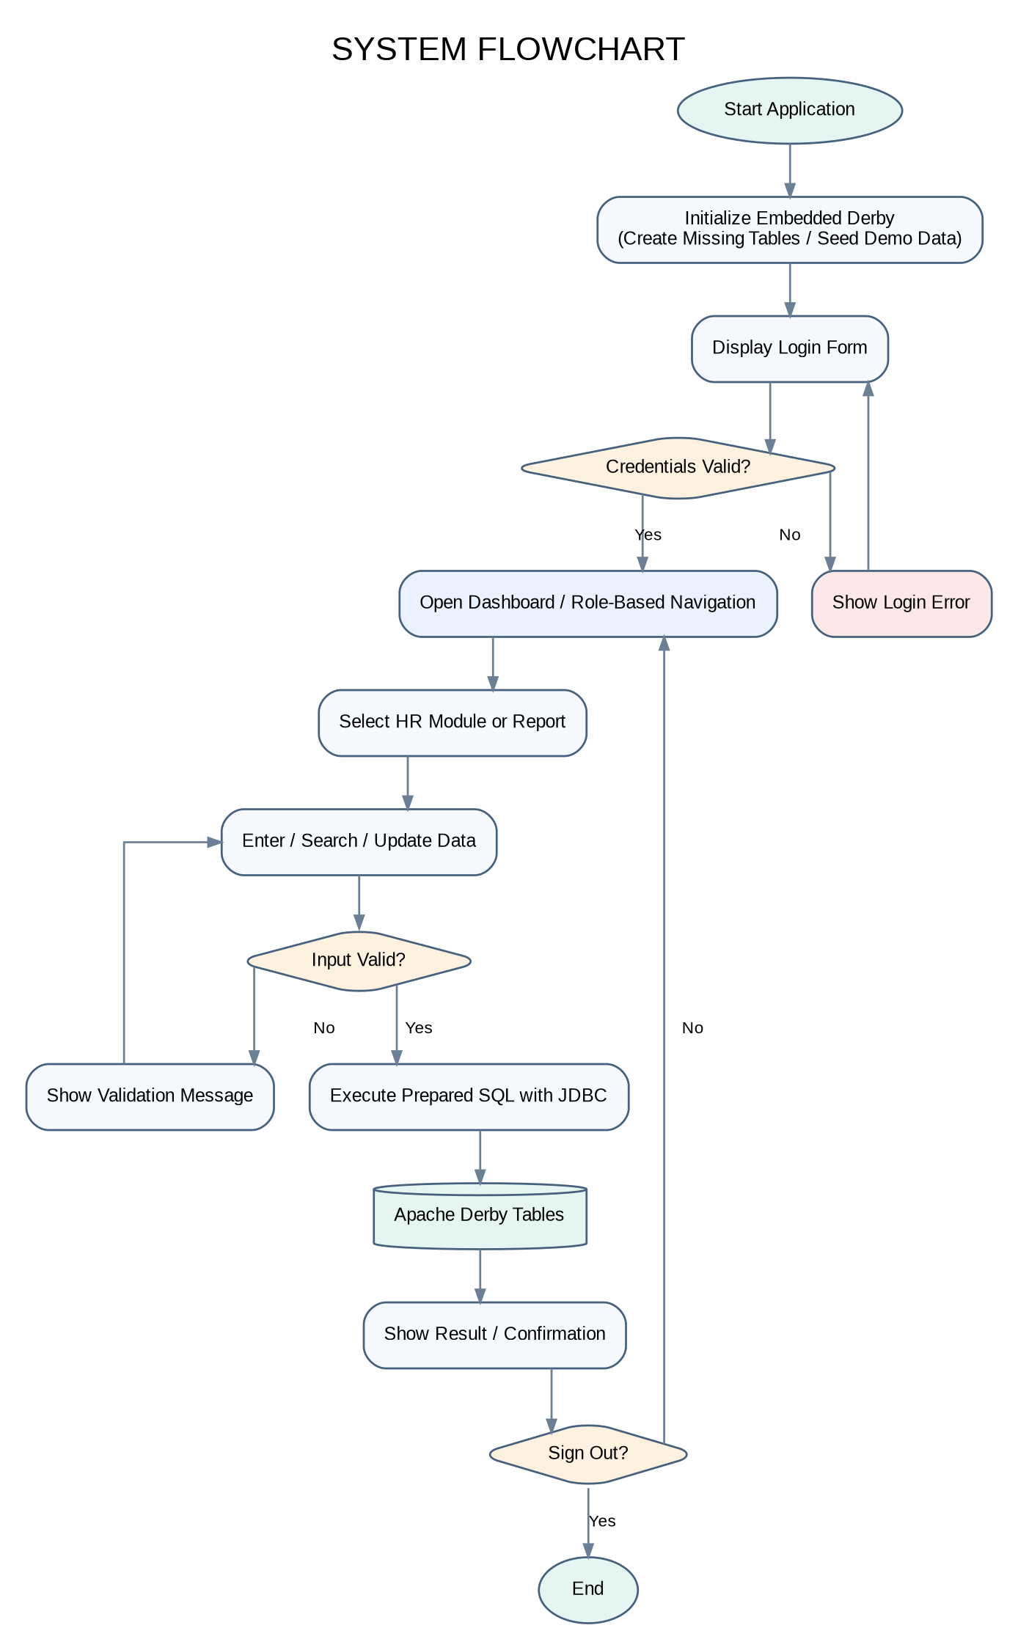
Figure 2.2. Application start-up, authentication, record processing, and logout flow.

2.8 Data Flow Diagram
The context-level data-flow model shows Administrators and HR Staff sending record-management, search, and report requests to the HRMS process. The application reads from and writes to the local Derby database and returns saved records, report rows, confirmations, or validation/database messages.
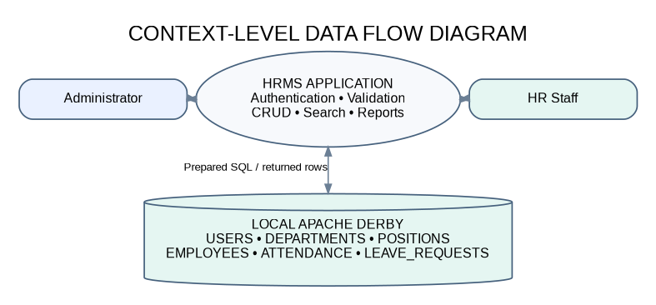
Figure 2.3. Context-level flow between users, application processing, and database storage.

2.9 Entity Relationship Diagram
Departments and positions each have a one-to-many relationship with employees. One employee may have many attendance rows and many leave requests. The users table is separated from employee records because system credentials and role controls have a different purpose.
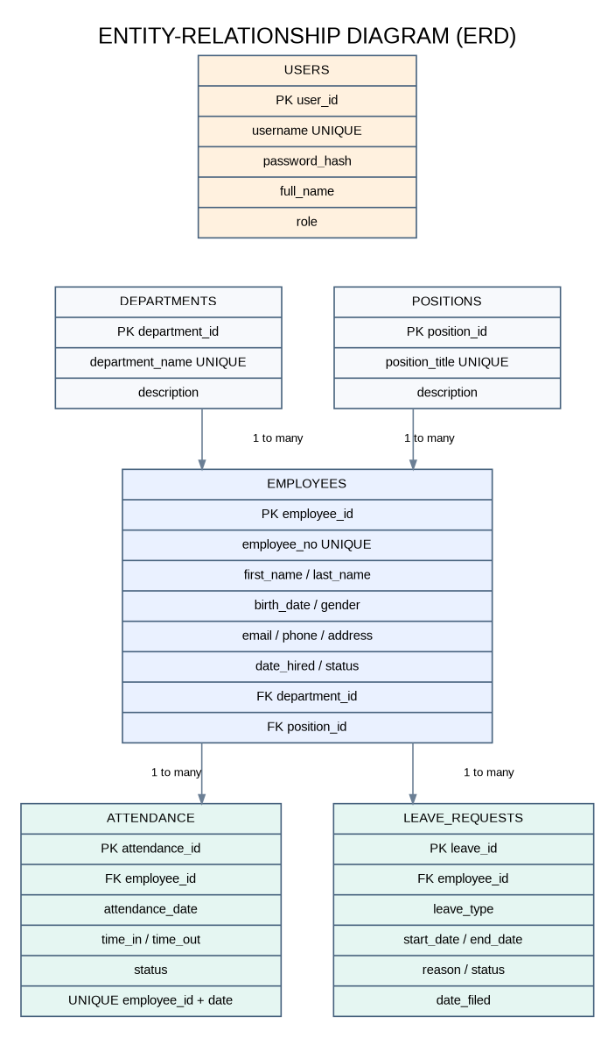
Figure 2.4. HRMS entities, key fields, and relationships.

2.10 Database Design
The schema contains six normalized tables. Auto-generated identity columns serve as primary keys, while foreign keys connect the related records. Employee numbers, usernames, department names, and position titles are unique. Attendance has a composite unique constraint on employee_id and attendance_date. The attendance schema intentionally does not require time_out to be later than time_in because overnight shifts may end on the next calendar day. Leave end dates cannot precede start dates, and check constraints limit roles and status values.
Table | Main fields and constraints | Purpose
USERS | user_id INTEGER PK IDENTITY; username VARCHAR(30) UNIQUE NOT NULL; password_hash VARCHAR(255) NOT NULL; full_name VARCHAR(80) NOT NULL; role VARCHAR(20) CHECK ADMIN/HR_STAFF. | Authentication and role-based access.
DEPARTMENTS | department_id INTEGER PK IDENTITY; department_name VARCHAR(60) UNIQUE NOT NULL; description VARCHAR(150). | Reference department names and descriptions.
POSITIONS | position_id INTEGER PK IDENTITY; position_title VARCHAR(60) UNIQUE NOT NULL; description VARCHAR(150). | Reference job titles and descriptions.
EMPLOYEES | employee_id INTEGER PK IDENTITY; employee_no VARCHAR(15) UNIQUE; first_name/last_name; birth_date DATE; gender; email/phone/address; date_hired DATE; status CHECK; department_id FK; position_id FK. | Personal, contact, and employment details linked to reference records.
ATTENDANCE | attendance_id INTEGER PK IDENTITY; employee_id FK; attendance_date DATE; time_in/time_out TIME; status CHECK; UNIQUE(employee_id, attendance_date); time-order CHECK. | One daily attendance record per employee.
LEAVE_REQUESTS | leave_id INTEGER PK IDENTITY; employee_id FK; leave_type; start_date/end_date; reason; status CHECK PENDING/APPROVED/REJECTED; date_filed DATE; CHECK(end_date >= start_date). | Leave filing and review history.

Referential integrity prevents an employee from referring to a non-existent department or position and prevents attendance/leave rows from referring to a non-existent employee. Referenced parent rows cannot be deleted while child records remain, so the user must correct or remove related records first. The database is created automatically by DatabaseSetup.java. The SQL file in the project ZIP documents the matching Derby DDL; it is a reference/manual setup script for a fresh empty database, not a phpMyAdmin import file.

CHAPTER 3 - SYSTEM DEVELOPMENT

3.1 Development Tools
Tool / Technology | Purpose
Java Development Kit 17+ | Compiles and runs the application.
Apache NetBeans | IDE for opening, running, and debugging the Maven desktop project.
Java Swing | Login, dashboard, forms, tables, menus/buttons, dialogs, and report views.
Java AWT | Layouts, colors, fonts, dimensions, and event support.
JDBC | Connections, PreparedStatement, ResultSet, and SQLException handling.
Apache Derby 10.16.1.1 | Embedded relational database and embedded JDBC driver.
Maven | Project/dependency management and Java compilation/execution configuration.

3.2 Java Swing
Swing provides the principal interface widgets: JFrame windows, JPanel layout containers, JLabel field labels, JTextField/JPasswordField inputs, JComboBox choices, JButton actions, JTable record/report displays, JScrollPane scrolling, JFileChooser export destinations, and JOptionPane feedback. The UI uses a light background, dark readable text, high-contrast buttons, separate page panels, and visible table headings to improve readability.

3.3 Java AWT
AWT supports the layout and visual structure through BorderLayout, GridBagLayout, GridLayout, FlowLayout, Dimension, Color, Font, and event handling. The program is event-driven: button clicks trigger authentication, validation, CRUD actions, report refresh, CSV export, or logout.

3.4 JDBC
JDBC provides the standard interface between Java and Derby. The application obtains Connection objects through a centralized utility, builds PreparedStatement objects for database operations, uses ResultSet to read query results, and handles SQLException failures. User-entered values are bound to placeholders rather than concatenated into SQL text. Dynamic SQL fragments for the generic CRUD panel come from fixed internal entity configurations, not from arbitrary user input.

3.5 Apache Derby
Apache Derby is a relational database implemented in Java. This project uses the embedded driver so the database engine runs inside the application; no external database server has to be installed or started. Derby 10.16.1.1 is used with Java 17 or later. It stores the `hrmsdb` database as a local folder relative to the program working directory by default. This configuration is suitable for a single-computer academic prototype, but it is not a multi-user client/server deployment and is not managed through phpMyAdmin.

3.6 System Architecture
The application separates presentation, validation/action handling, data access, JDBC, and persistent storage. The reusable EntityPanel renders module forms and tables based on a fixed EntityConfig. Entity-specific DAO classes extend GenericDAO; GenericDAO centralizes CRUD/search statement handling, while UserDAO provides the password-verification query. DatabaseSetup owns table creation and demo/reference seeding.
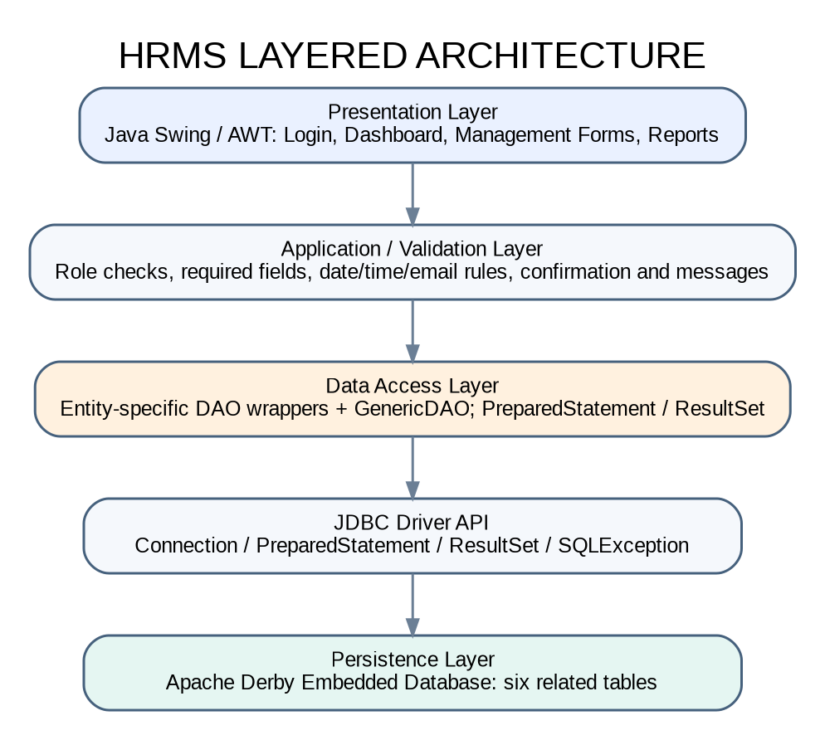
Figure 3.1. Layered architecture of the Human Resource Management System.

3.7 Program Structure
Package / file group | Examples | Responsibility
hrms | Main.java | Initializes Derby and opens the login frame.
hrms.ui | LoginFrame, MainFrame, DashboardPanel, EntityPanel, ReportsPanel, UITheme | Displays the interface, navigation, validation feedback, module forms, and reports.
hrms.ui configuration | EntityConfig, EntityConfigs | Defines fixed table/view SQL, field widgets, required fields, lookups, and searchable expressions.
hrms.model | User, Employee, Department, Position, Attendance, LeaveRequest | Encapsulates core domain data with constructors, fields, and accessors.
hrms.dao | GenericDAO, UserDAO, EmployeeDAO, DepartmentDAO, PositionDAO, AttendanceDAO, LeaveDAO | Executes database CRUD/search functions and authenticates the user.
hrms.util | DBConnection, DatabaseSetup, PasswordUtil, Validator | Centralizes connection setup, schema creation, password hashing/verification, and data validation.

3.8 Database Connection
The connection class centralizes the JDBC URL instead of repeating it across forms. The default URL is `jdbc:derby:hrmsdb;create=true`, with the working directory resolved by the utility. The database path may be overridden with the Java system property `hrms.db.path` or the `HRMS_DB_PATH` environment variable.
private static final String URL = "jdbc:derby:" + normalizePath(DATABASE_PATH) + ";create=true";
public static Connection getConnection() throws SQLException {
return DriverManager.getConnection(URL);
}

At startup, DatabaseSetup checks Derby metadata for each required table and creates a missing table in dependency order. It then creates demonstration account hashes using PasswordUtil and inserts starter department/position records only when those names do not already exist. The schema is therefore initialized by the same program that uses it.

3.9 CRUD Implementation
Each module provides Add, Save Changes, Delete, Clear Form, Search, and Refresh actions according to the role. The EntityConfig definitions specify table names, primary-key columns, display queries, field types, and search expressions. GenericDAO builds SQL from those trusted internal definitions and binds input values with PreparedStatement. Before inserting or updating, the UI checks required fields and applicable format/date/time rules. Database constraints provide a second layer of protection.
String sql = "INSERT INTO departments (department_name, description) VALUES (?, ?)";
try (Connection connection = DBConnection.getConnection();
PreparedStatement statement = connection.prepareStatement(sql)) {
statement.setString(1, departmentName);
statement.setString(2, description);
statement.executeUpdate();
}

Search combines fixed configured expressions with a parameterized keyword pattern. Read queries join employee rows to department and position names, and join attendance/leave records to employees for readable display. Before a delete, the system requires an Administrator role and presents a confirmation dialog. Database integrity errors are converted to an understandable message where possible.

3.10 GUI and Reports
Login includes username/password, show-password, Sign In, Clear/Reset, and Exit. After authentication, the main window provides a light workspace, navy sidebar, current-user label, role-aware navigation, and sign-out. The dashboard queries employee, department, attendance, and pending-leave summaries. Module pages provide validated forms, searchable/sortable tables, and CRUD actions. Reports cover the employee directory, department headcount, attendance, leave, and pending leave requests; they are read-only and export to CSV. Administrators manage accounts, delete records, and review leave, while HR Staff cannot perform those restricted actions. The current account and last Administrator are protected.

CHAPTER 4 - TESTING

4.1 Test Plan
Testing must be conducted in NetBeans using JDK 17+ with the Maven Derby dependency resolved. Use synthetic data. The test plan covers initialization, authentication, CRUD, duplicate and foreign-key constraints, search/sort, field/date/time validation, role restrictions, reporting/export, data persistence, and logout. The Java source compiled successfully with `javac --release 17`, and a separate smoke test confirmed that password hashing produces different salted hashes and verifies correct/incorrect passwords as expected. A live Derby runtime was not available in the preparation environment; database-dependent cases remain pending until run in NetBeans.

4.2 Test Cases
Test ID | Function | Input / Action | Expected result | Runtime status
TC-01 | First-run schema | Start with no `hrmsdb` database folder | Tables and demo/reference data are created. | Pending
TC-02 | Administrator login | admin / admin123 | Administrator dashboard and admin navigation open. | Pending
TC-03 | HR Staff login | hrstaff / hr123 | Dashboard opens; user-account module is hidden. | Pending
TC-04 | Invalid login | Wrong password | Access denied with a useful message. | Pending
TC-05 | Clear / Exit | Use Clear / Reset; then Exit | Fields clear; Exit closes after confirmation. | Pending
TC-06 | CRUD / update | Create and change department, position, employee | Records persist and refreshed tables show changes. | Pending
TC-07 | Required/email validation | Blank required field or malformed email | Save is rejected and validation message appears. | Pending
TC-08 | Search / JOIN | Search employee by number/name | Matching row shows department and position labels. | Pending
TC-09 | Delete control | Sign in as HR Staff | Delete is disabled; handler rejects unauthorized deletion. | Pending
TC-10 | Foreign keys | Delete referenced department/position/employee | Database prevents invalid references and displays an error. | Pending
TC-11 | Duplicate attendance | Repeat employee and attendance date | Unique constraint rejects duplicate. | Pending
TC-12 | Overnight attendance | Date 2026-10-17; Time In 07:00 PM; Time Out 06:00 AM | Record saves; Time Out is displayed as 6:00 AM (next day). | Pending
TC-13 | Leave date order | End date earlier than start date | Validation/database constraint rejects the row. | Pending
TC-14 | Leave approval | HR Staff attempts change; Administrator updates status | Staff status remains protected; Administrator decision persists. | Pending
TC-15 | User account safety | Try deleting self or last Administrator | Application prevents deletion/demotion. | Pending
TC-16 | Reports and CSV | Open each report and export | Rows display in JTable; CSV contains headers and escaped values. | Pending
TC-17 | Persistence/logout | Save records, sign out, close and reopen | Records persist and logout returns to login. | Pending
TC-18 | Error handling | Use invalid DB path or violate a constraint | An understandable startup/operation message is shown. | Pending

The Actual Result and Status fields above are intentionally not marked Passed because the live Derby application and complete user interface have not yet been exercised against a runtime database in this environment. The tester should record observed outcomes, screenshots/evidence, test date, and defects after completing each case.

4.3 Security and User Acceptance Testing
The source implements salted PBKDF2-HMAC-SHA256 password verification, prepared statements, field validation, role-aware navigation and action handlers, and database constraints. These measures require verification through the runtime checklist. The prototype is not yet certified for production use, and security review should include account lifecycle, backup access, sensitive-data handling, and broader deployment controls.
For user-acceptance testing, ask intended HR users to rate the statements below from 1 (Strongly Disagree) to 5 (Strongly Agree). Record the actual number of respondents, scores, average per item, overall mean, comments, and test setting. No user-acceptance scores are supplied because no completed survey was provided.
No. | UAT statement | Mean / Result
1 | Labels, buttons, and navigation are easy to understand. | Pending
2 | Employee details are easy to add and update. | Pending
3 | Search results and joined information are useful. | Pending
4 | Attendance and leave forms are straightforward to use. | Pending
5 | Validation, success, and error messages are clear. | Pending
6 | Reports show useful information and export correctly. | Pending
7 | Administrator-only actions are properly restricted. | Pending
8 | The system supports the HR tasks within its stated scope. | Pending

CHAPTER 5 - CONCLUSION

5.1 Summary
The project presents a Java desktop HRMS that centralizes core employee and HR records in an embedded Apache Derby database. The application source includes a readable Swing/AWT interface, role-aware navigation, a dashboard, management forms, JDBC CRUD/search operations, data-validation rules, foreign-key and uniqueness constraints, a user-account module, and display/export reports. The schema has six related tables and the database is initialized automatically at startup.
The implementation has been brought into alignment with the Java System Project Requirements PDF and the project paper’s Derby-based architecture. It uses Java 17+ and Maven with Apache Derby 10.16.1.1. Passwords are stored using salted PBKDF2-HMAC-SHA256 rather than plain text. Code compilation and password-verification smoke testing were completed; live database functionality and user acceptance remain to be tested in the intended NetBeans environment.

5.2 Conclusions
1. A centralized relational database provides a consistent structure for employees, departments, positions, attendance, leave requests, and users.
2. Swing/AWT, JDBC, and embedded Apache Derby satisfy the technology direction required in the assignment, while the report screen addresses the general requirement to display useful reports.
3. Primary keys, foreign keys, unique constraints, check constraints, prepared statements, validation, and role-specific handlers provide multiple layers of data integrity and access control.
4. The project is a course prototype and should not be described as fully runtime-tested until the provided test matrix and user-acceptance procedure are completed.

5.3 Recommendations
1. Open the project in NetBeans with JDK 17 or newer and let Maven download the embedded Derby dependency.
2. Run every test listed in Chapter 4, record actual results, attach screenshots for important cases, and fix any failure before submission.
3. Change the demonstration credentials before using real employee data and maintain regular backups of the `hrmsdb` folder.
4. Review privacy, access, record retention, and deployment requirements before using the application outside an academic demonstration.
5. Keep the documentation and schema synchronized if any module, field, constraint, or role rule changes.

5.4 Possible Future Improvements
Improvement | Description
Leave balances | Define allowance by leave type and calculate remaining balances.
Payroll | Add salary, deductions, tax, and payslip processes after confirming local rules.
Audit logs | Record who created/updated/deleted records and when.
PDF/Excel reports | Add print layouts and formatted export options beyond CSV.
Employee self-service | Provide a secure interface for employees to review profiles and submit leave requests.
Multi-user deployment | Replace embedded Derby with a suitable server database only if the approved project scope changes.
Accessibility review | Test keyboard navigation, scaling, color contrast, and screen-reader behavior.

REFERENCES
Apache Software Foundation. (2022). Apache Derby 10.16.1.1 release notes. https://db.apache.org/derby/releases/release-10_16_1_1.cgi
Apache Software Foundation. (n.d.). Apache Derby. https://db.apache.org/derby/
Armstrong, M., & Taylor, S. (2020). Armstrong’s handbook of human resource management practice (15th ed.). Kogan Page.
Bondarouk, T. V., & Ruël, H. J. M. (2009). Electronic human resource management: Challenges in the digital era. The International Journal of Human Resource Management, 20(3), 505-514. https://doi.org/10.1080/09585190802707235
Coronel, C., & Morris, S. (2019). Database systems: Design, implementation, & management (13th ed.). Cengage Learning.
Elmasri, R., & Navathe, S. (2016). Fundamentals of database systems (7th ed.). Pearson.
Horstmann, C. S. (2018). Core Java: Volume I - Fundamentals (11th ed.). Prentice Hall.
International Organization for Standardization. (2011). Systems and software engineering - Systems and software quality requirements and evaluation (SQuaRE) - System and software quality models (ISO/IEC 25010:2011).
Kendall, K. E., & Kendall, J. E. (2019). Systems analysis and design (10th ed.). Pearson.
Loy, M., Eckstein, R., Wood, D., Elliott, J., & Cole, J. (2002). Java Swing (2nd ed.). O’Reilly Media.
Oracle. (n.d.). JDBC basics. The Java Tutorials. https://docs.oracle.com/javase/tutorial/jdbc/basics/
Oracle. (n.d.). Creating a GUI with Swing. The Java Tutorials. https://docs.oracle.com/javase/tutorial/uiswing/
Pressman, R. S., & Maxim, B. R. (2020). Software engineering: A practitioner’s approach (9th ed.). McGraw-Hill Education.
Strohmeier, S. (2007). Research in e-HRM: Review and implications. Human Resource Management Review, 17(1), 19-37. https://doi.org/10.1016/j.hrmr.2006.11.002
Valacich, J. S., & George, J. F. (2020). Modern systems analysis and design (9th ed.). Pearson.

APPENDIX A - RUNNING THE PROJECT

A.1 Open in NetBeans
1. Extract `HRMS_NetBeans_Project_Derby.zip` to a writable folder.
2. Install JDK 17 or newer and open Apache NetBeans with Maven support.
3. Choose File > Open Project and select the `hrms_netbeans` directory that contains `pom.xml`.
4. Allow Maven to resolve `org.apache.derby:derby:10.16.1.1` and the configured Maven plugins.
5. Run the project. The application creates `hrmsdb` and the tables automatically on first launch.
6. Use `admin` / `admin123` for Administrator or `hrstaff` / `hr123` for HR Staff during class testing.
7. After testing, change demo passwords and retain only synthetic data in coursework evidence.

A.2 Database Objects
Table | Relationship / integrity rule
USERS | Unique username; role limited to ADMIN or HR_STAFF; password_hash stores salted PBKDF2 verifier.
DEPARTMENTS | Unique department_name; referenced by employees.
POSITIONS | Unique position_title; referenced by employees.
EMPLOYEES | Unique employee_no; requires a department and position foreign key.
ATTENDANCE | References employee; only one row for each employee/date; time_out cannot precede time_in when both are present.
LEAVE_REQUESTS | References employee; end_date cannot precede start_date; status is PENDING, APPROVED, or REJECTED.

The application’s DatabaseSetup.java contains the executable schema initialization logic. The `database/hrms_schema.sql` file in the project source mirrors that schema and is provided for inspection or manual setup against a newly created, empty Derby database. Do not execute it over a database whose tables already exist.

APPENDIX B - CLASS DIAGRAM
The class/package diagram summarizes the primary interface classes, shared metadata configuration, DAO operations, utility classes, model records, and their connection to the embedded Derby database. It is an architectural overview rather than a generated UML export of every field and method in the source code.
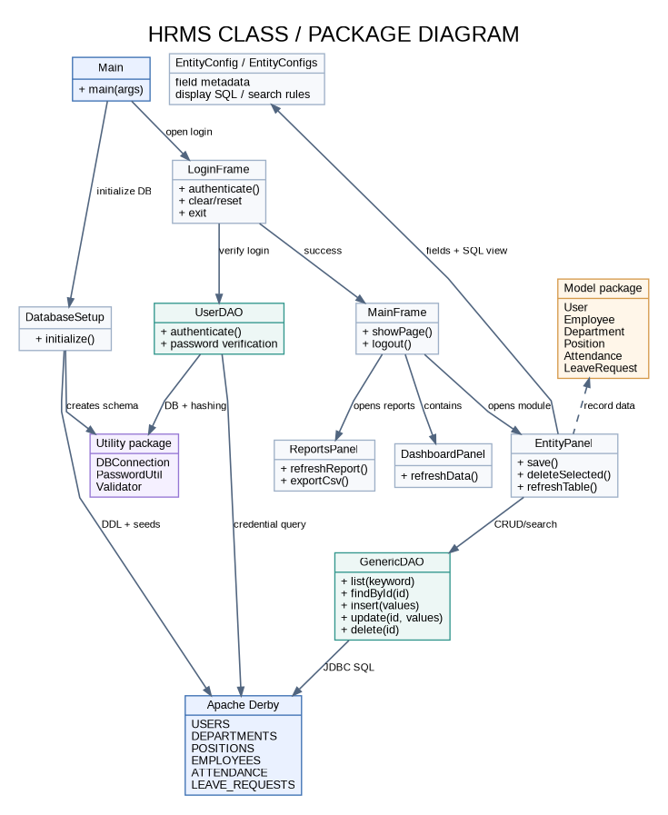
Figure B.1. HRMS class and package overview.

APPENDIX C - TABLE RELATIONSHIP DIAGRAM
Departments and Positions each relate to many Employee records. Each Employee can have multiple Attendance records and multiple Leave Requests, while the database constraint limits Attendance to one record per employee per date. Users are maintained independently for authentication and role management.
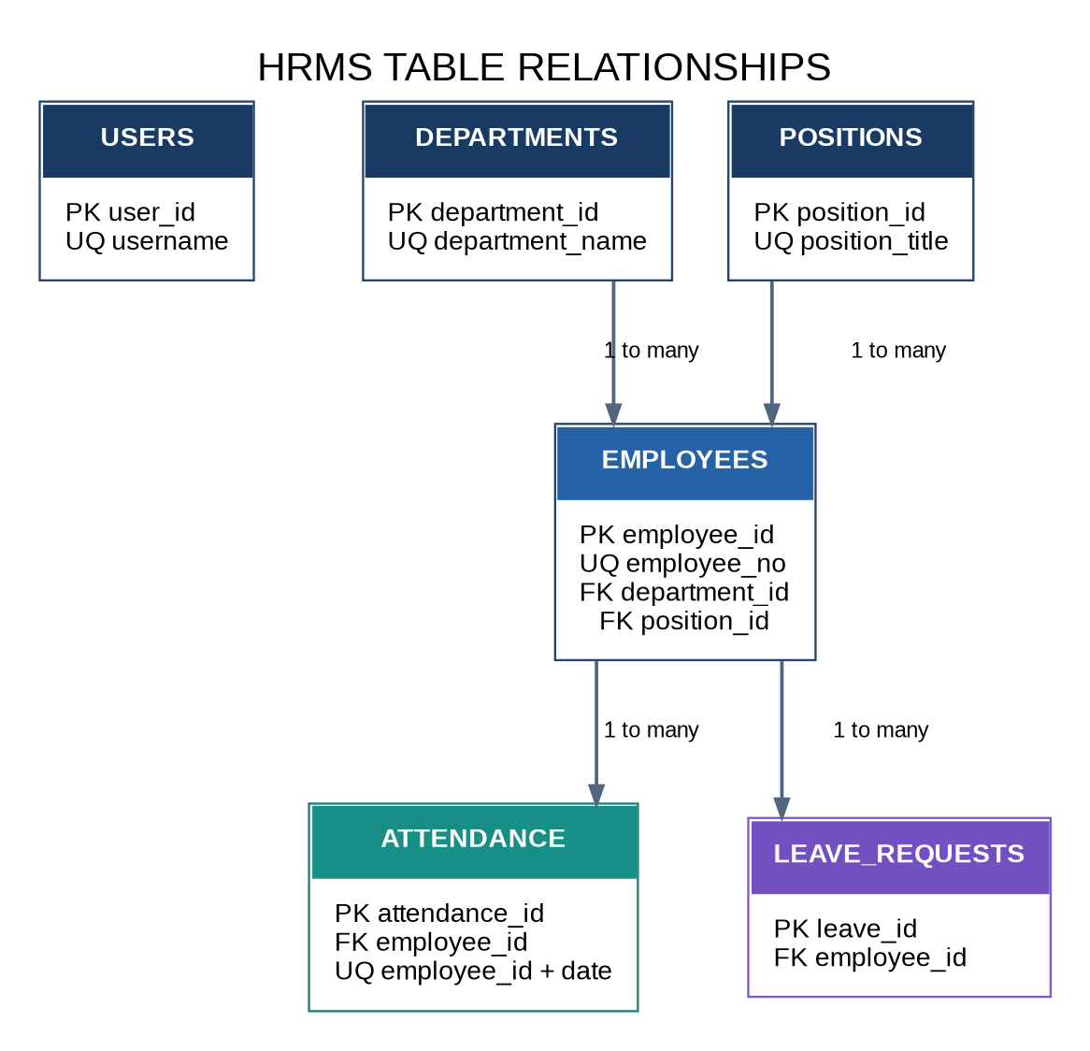
Figure C.1. Primary keys, foreign keys, and one-to-many relationships in the Derby schema.

APPENDIX D - DATABASE DICTIONARY
The dictionary lists the fields and constraints used by DatabaseSetup.java. ID columns are generated identity primary keys. Optional fields may contain NULL; required fields are marked NOT NULL.

D.1 USERS, DEPARTMENTS, and POSITIONS
Table | Field | Data type | Constraint / purpose
USERS | user_id | INTEGER | PK; generated identity.
USERS | username | VARCHAR(30) | NOT NULL; UNIQUE login name.
USERS | password_hash | VARCHAR(255) | NOT NULL; salted PBKDF2 verifier, not plain-text password.
USERS | full_name | VARCHAR(80) | NOT NULL; display name.
USERS | role | VARCHAR(20) | NOT NULL; CHECK ADMIN or HR_STAFF.
DEPARTMENTS | department_id | INTEGER | PK; generated identity.
DEPARTMENTS | department_name | VARCHAR(60) | NOT NULL; UNIQUE department name.
DEPARTMENTS | description | VARCHAR(150) | Optional description.
POSITIONS | position_id | INTEGER | PK; generated identity.
POSITIONS | position_title | VARCHAR(60) | NOT NULL; UNIQUE position title.
POSITIONS | description | VARCHAR(150) | Optional description of duties.

D.2 EMPLOYEES
Field | Data type | Constraint / purpose
employee_id | INTEGER | PK; generated identity.
employee_no | VARCHAR(15) | NOT NULL; UNIQUE office identifier.
first_name | VARCHAR(40) | NOT NULL.
last_name | VARCHAR(40) | NOT NULL.
birth_date | DATE | NOT NULL.
gender | VARCHAR(10) | NOT NULL.
email | VARCHAR(80) | Optional contact email; validated when supplied.
phone | VARCHAR(20) | Optional contact number.
address | VARCHAR(150) | Optional home address.
date_hired | DATE | NOT NULL.
status | VARCHAR(15) | NOT NULL; CHECK ACTIVE, ON LEAVE, or RESIGNED.
department_id | INTEGER | NOT NULL; FK to DEPARTMENTS.department_id.
position_id | INTEGER | NOT NULL; FK to POSITIONS.position_id.

D.3 ATTENDANCE and LEAVE_REQUESTS
Table | Field | Data type | Constraint / purpose
ATTENDANCE | attendance_id | INTEGER | PK; generated identity.
ATTENDANCE | employee_id | INTEGER | NOT NULL; FK to EMPLOYEES.employee_id.
ATTENDANCE | attendance_date | DATE | NOT NULL.
ATTENDANCE | time_in | TIME | Optional arrival time.
ATTENDANCE | time_out | TIME | Optional departure time; cannot precede time_in when both exist.
ATTENDANCE | status | VARCHAR(15) | NOT NULL; CHECK PRESENT, LATE, ABSENT, or ON LEAVE.
ATTENDANCE | employee_id + attendance_date | Composite UNIQUE | Prevents duplicate daily attendance per employee.
LEAVE_REQUESTS | leave_id | INTEGER | PK; generated identity.
LEAVE_REQUESTS | employee_id | INTEGER | NOT NULL; FK to EMPLOYEES.employee_id.
LEAVE_REQUESTS | leave_type | VARCHAR(30) | NOT NULL.
LEAVE_REQUESTS | start_date / end_date | DATE | Both NOT NULL; end_date must be on/after start_date.
LEAVE_REQUESTS | reason | VARCHAR(200) | Optional explanation.
LEAVE_REQUESTS | status | VARCHAR(15) | NOT NULL; DEFAULT PENDING; CHECK PENDING, APPROVED, REJECTED.
LEAVE_REQUESTS | date_filed | DATE | NOT NULL; date request was filed.

The schema is designed around separate entities rather than storing multiple department, position, attendance, or leave values in one employee column. Foreign keys maintain references. The user interface also validates important fields, while database constraints remain the final check for unique values and record relationships.

APPENDIX E - SQL STATEMENT EXAMPLES
The examples below use Derby SQL and PreparedStatement placeholders. In Java code, bind every ? parameter with the appropriate setString, setDate, setTime, or setInt method; do not concatenate user input into SQL statements.

E.1 Search employee records across related tables
SELECT e.employee_id, e.employee_no, e.first_name, e.last_name,
d.department_name, p.position_title, e.status
FROM employees e
JOIN departments d ON d.department_id = e.department_id
JOIN positions p ON p.position_id = e.position_id
WHERE e.employee_no LIKE ? OR e.first_name LIKE ? OR e.last_name LIKE ?
ORDER BY e.last_name, e.first_name

E.2 Add an employee
INSERT INTO employees (employee_no, first_name, last_name, birth_date,
gender, email, phone, address, date_hired, status, department_id, position_id)
VALUES (?, ?, ?, ?, ?, ?, ?, ?, ?, ?, ?, ?)

E.3 Record attendance and protect daily uniqueness
INSERT INTO attendance (employee_id, attendance_date, time_in, time_out, status)
VALUES (?, ?, ?, ?, ?)

The UNIQUE(employee_id, attendance_date) constraint rejects a second record for the same employee/date. Time In and Time Out are entered using a 12-hour clock with an AM or PM checkbox selection and stored as SQL TIME values. When Time Out is earlier than Time In, the system treats the clock-out as occurring on the following calendar day; attendance_date remains the date on which the shift began. The obsolete CK_ATTENDANCE_TIME constraint is removed automatically from an existing local Derby database during startup.

E.4 Department headcount report
SELECT d.department_name,
COUNT(e.employee_id) AS employee_count
FROM departments d
LEFT JOIN employees e ON e.department_id = d.department_id
GROUP BY d.department_name
ORDER BY d.department_name

E.5 Review a leave request
UPDATE leave_requests
SET status = ?
WHERE leave_id = ?

The UI permits this status change only for an Administrator and restricts the new value to APPROVED or REJECTED. Deletion examples should only be executed after authorization and confirmation, and records referenced by foreign keys cannot be deleted until dependencies are handled.

APPENDIX F - SYSTEM INTERFACE SCREENSHOTS
The screenshots below document the intended visual style: a high-contrast light workspace, readable labels, white cards, clear table headings, and navy navigation. The login image is an actual capture of the Swing LoginFrame. The dashboard, employee-management, and reports images are illustrative interface previews using synthetic sample data; they are not evidence of a successful live database session. Capture replacement screenshots in NetBeans after completing the runtime tests in Chapter 4.
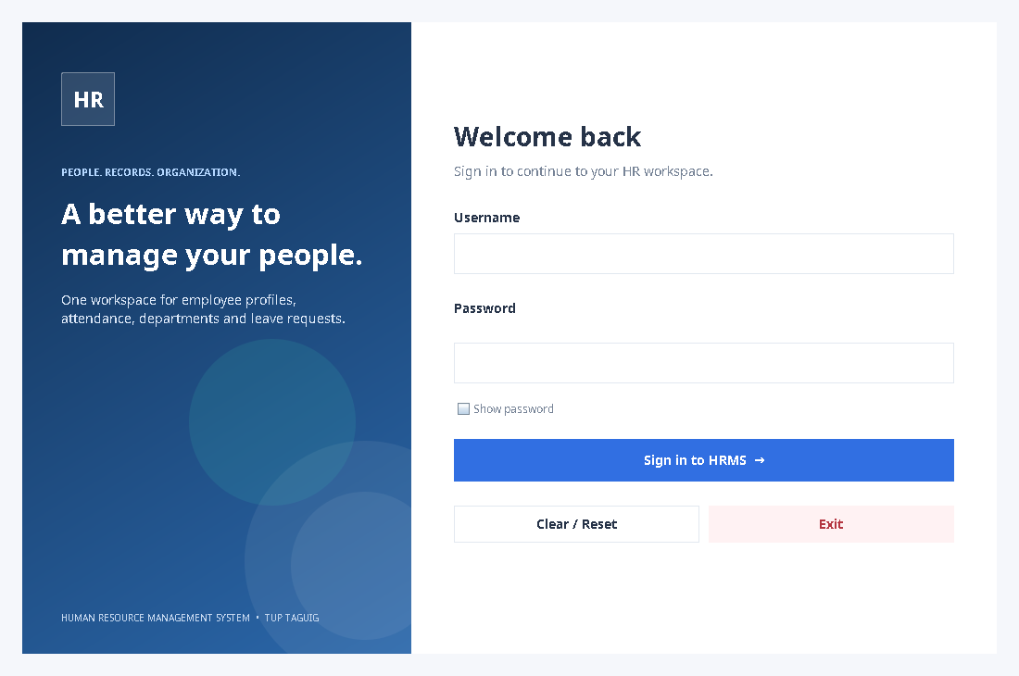
Figure F.1. Login frame, including Sign In, Clear / Reset, Exit, and password visibility controls.

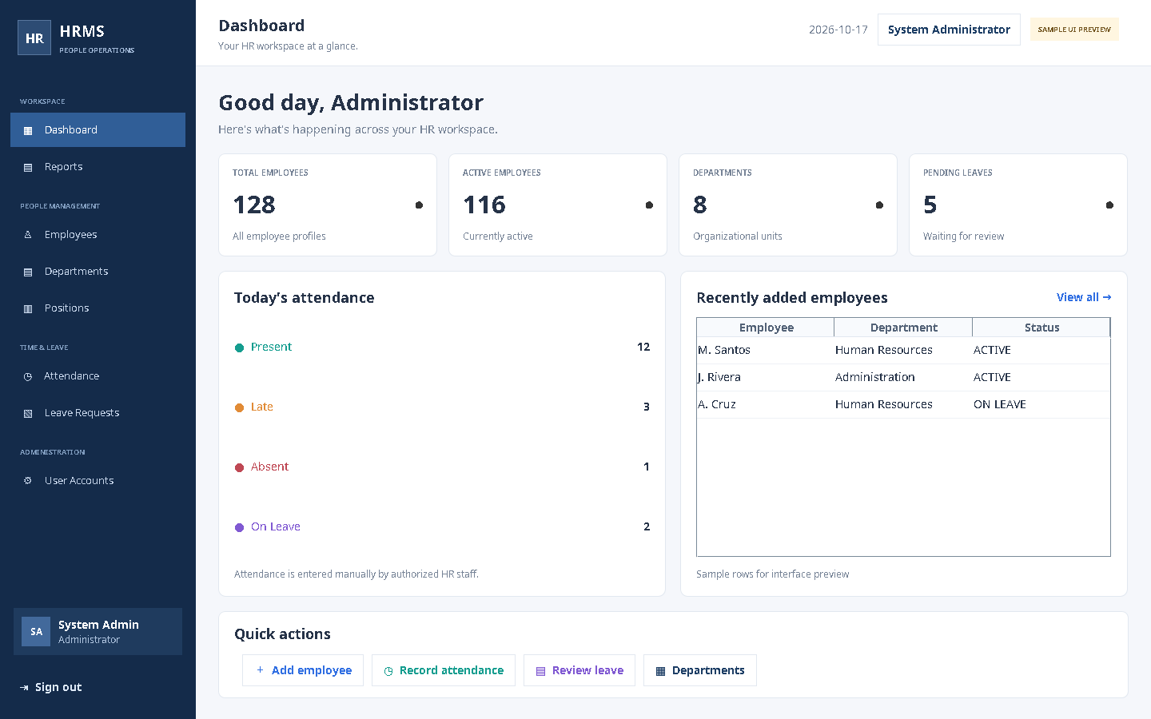
Figure F.2. Dashboard layout preview. All metric and employee rows shown are synthetic illustration data.

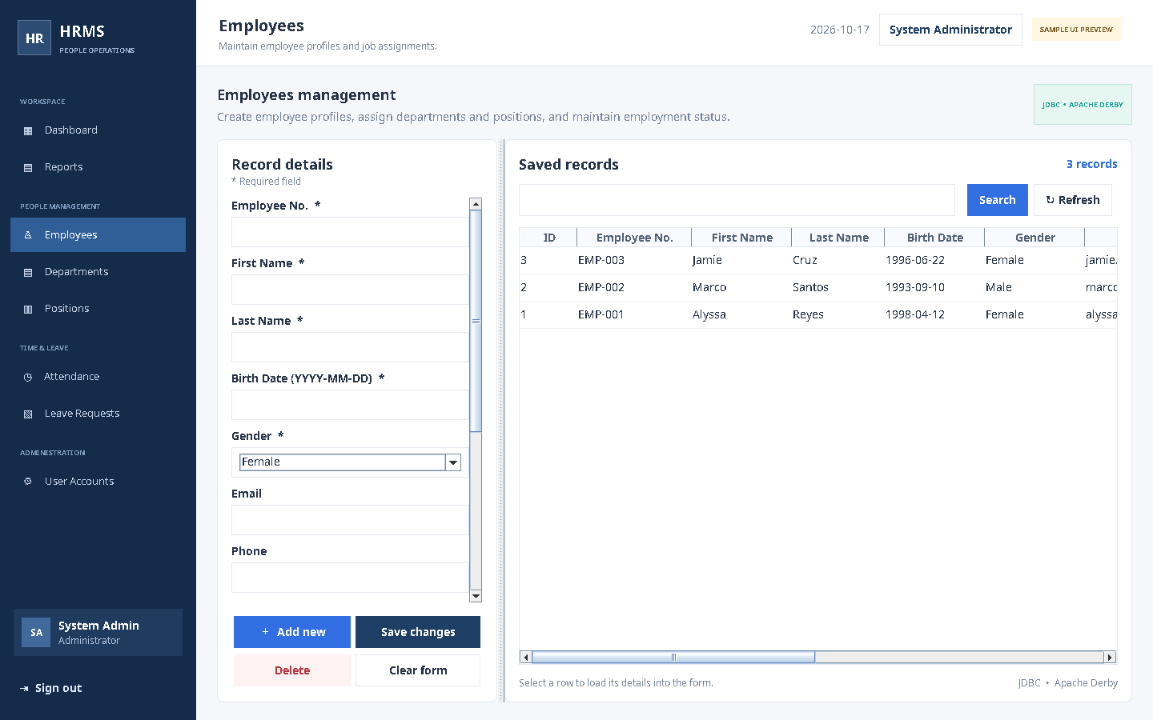
Figure F.3. Employee management form and searchable saved-record table preview using synthetic data.

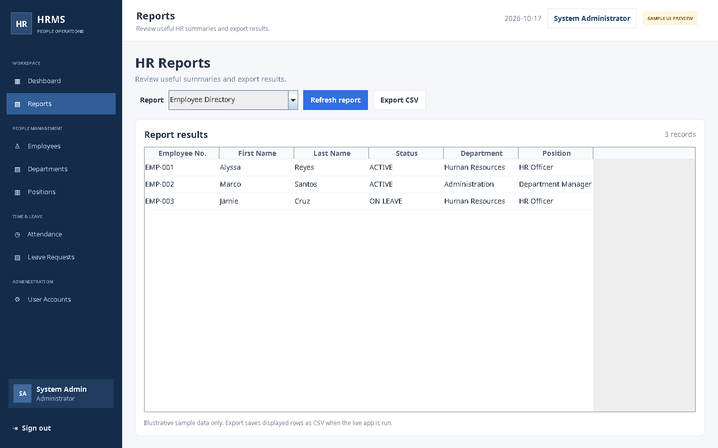
Figure F.4. Read-only report table and CSV export controls preview using synthetic data.
Runtime evidence still required: after opening the project in NetBeans and confirming that Derby initializes, replace or supplement these preview images with screenshots of actual database-backed CRUD, search, constraints, Administrator/HR Staff restrictions, report refresh/export, and logout behavior.

