Supplementary Force-Displacement Curve Figures
Figures S1-S21 show the force-displacement release curves for the liner-sealant pairs tested with the modified FINAT FTM 10-type integration procedure.

Figure S1. Dolpap / C1E
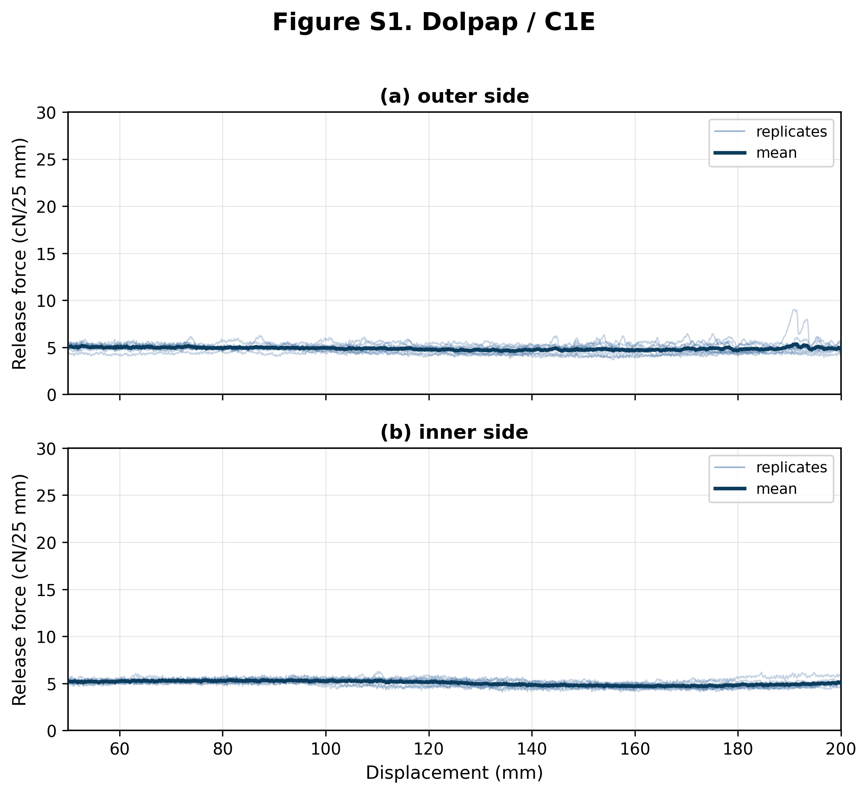
Figure S1. Force-displacement release curves for Dolpap liner tested with C1E butyl sealant. Panel (a) shows the external liner side (n = 10 shown from 10 traces); panel (b) shows the internal liner side (n = 10 shown from 10 traces). Thin blue lines show individual replicates and the dark blue line shows the mean curve where replicate coverage was sufficient. Forces are normalized to cN/25 mm; the displayed range corresponds to the 50-200 mm analysis interval. Both panels use the shared 0-30 cN/25 mm comparison y-axis.

Figure S2. Dolpap / U2E
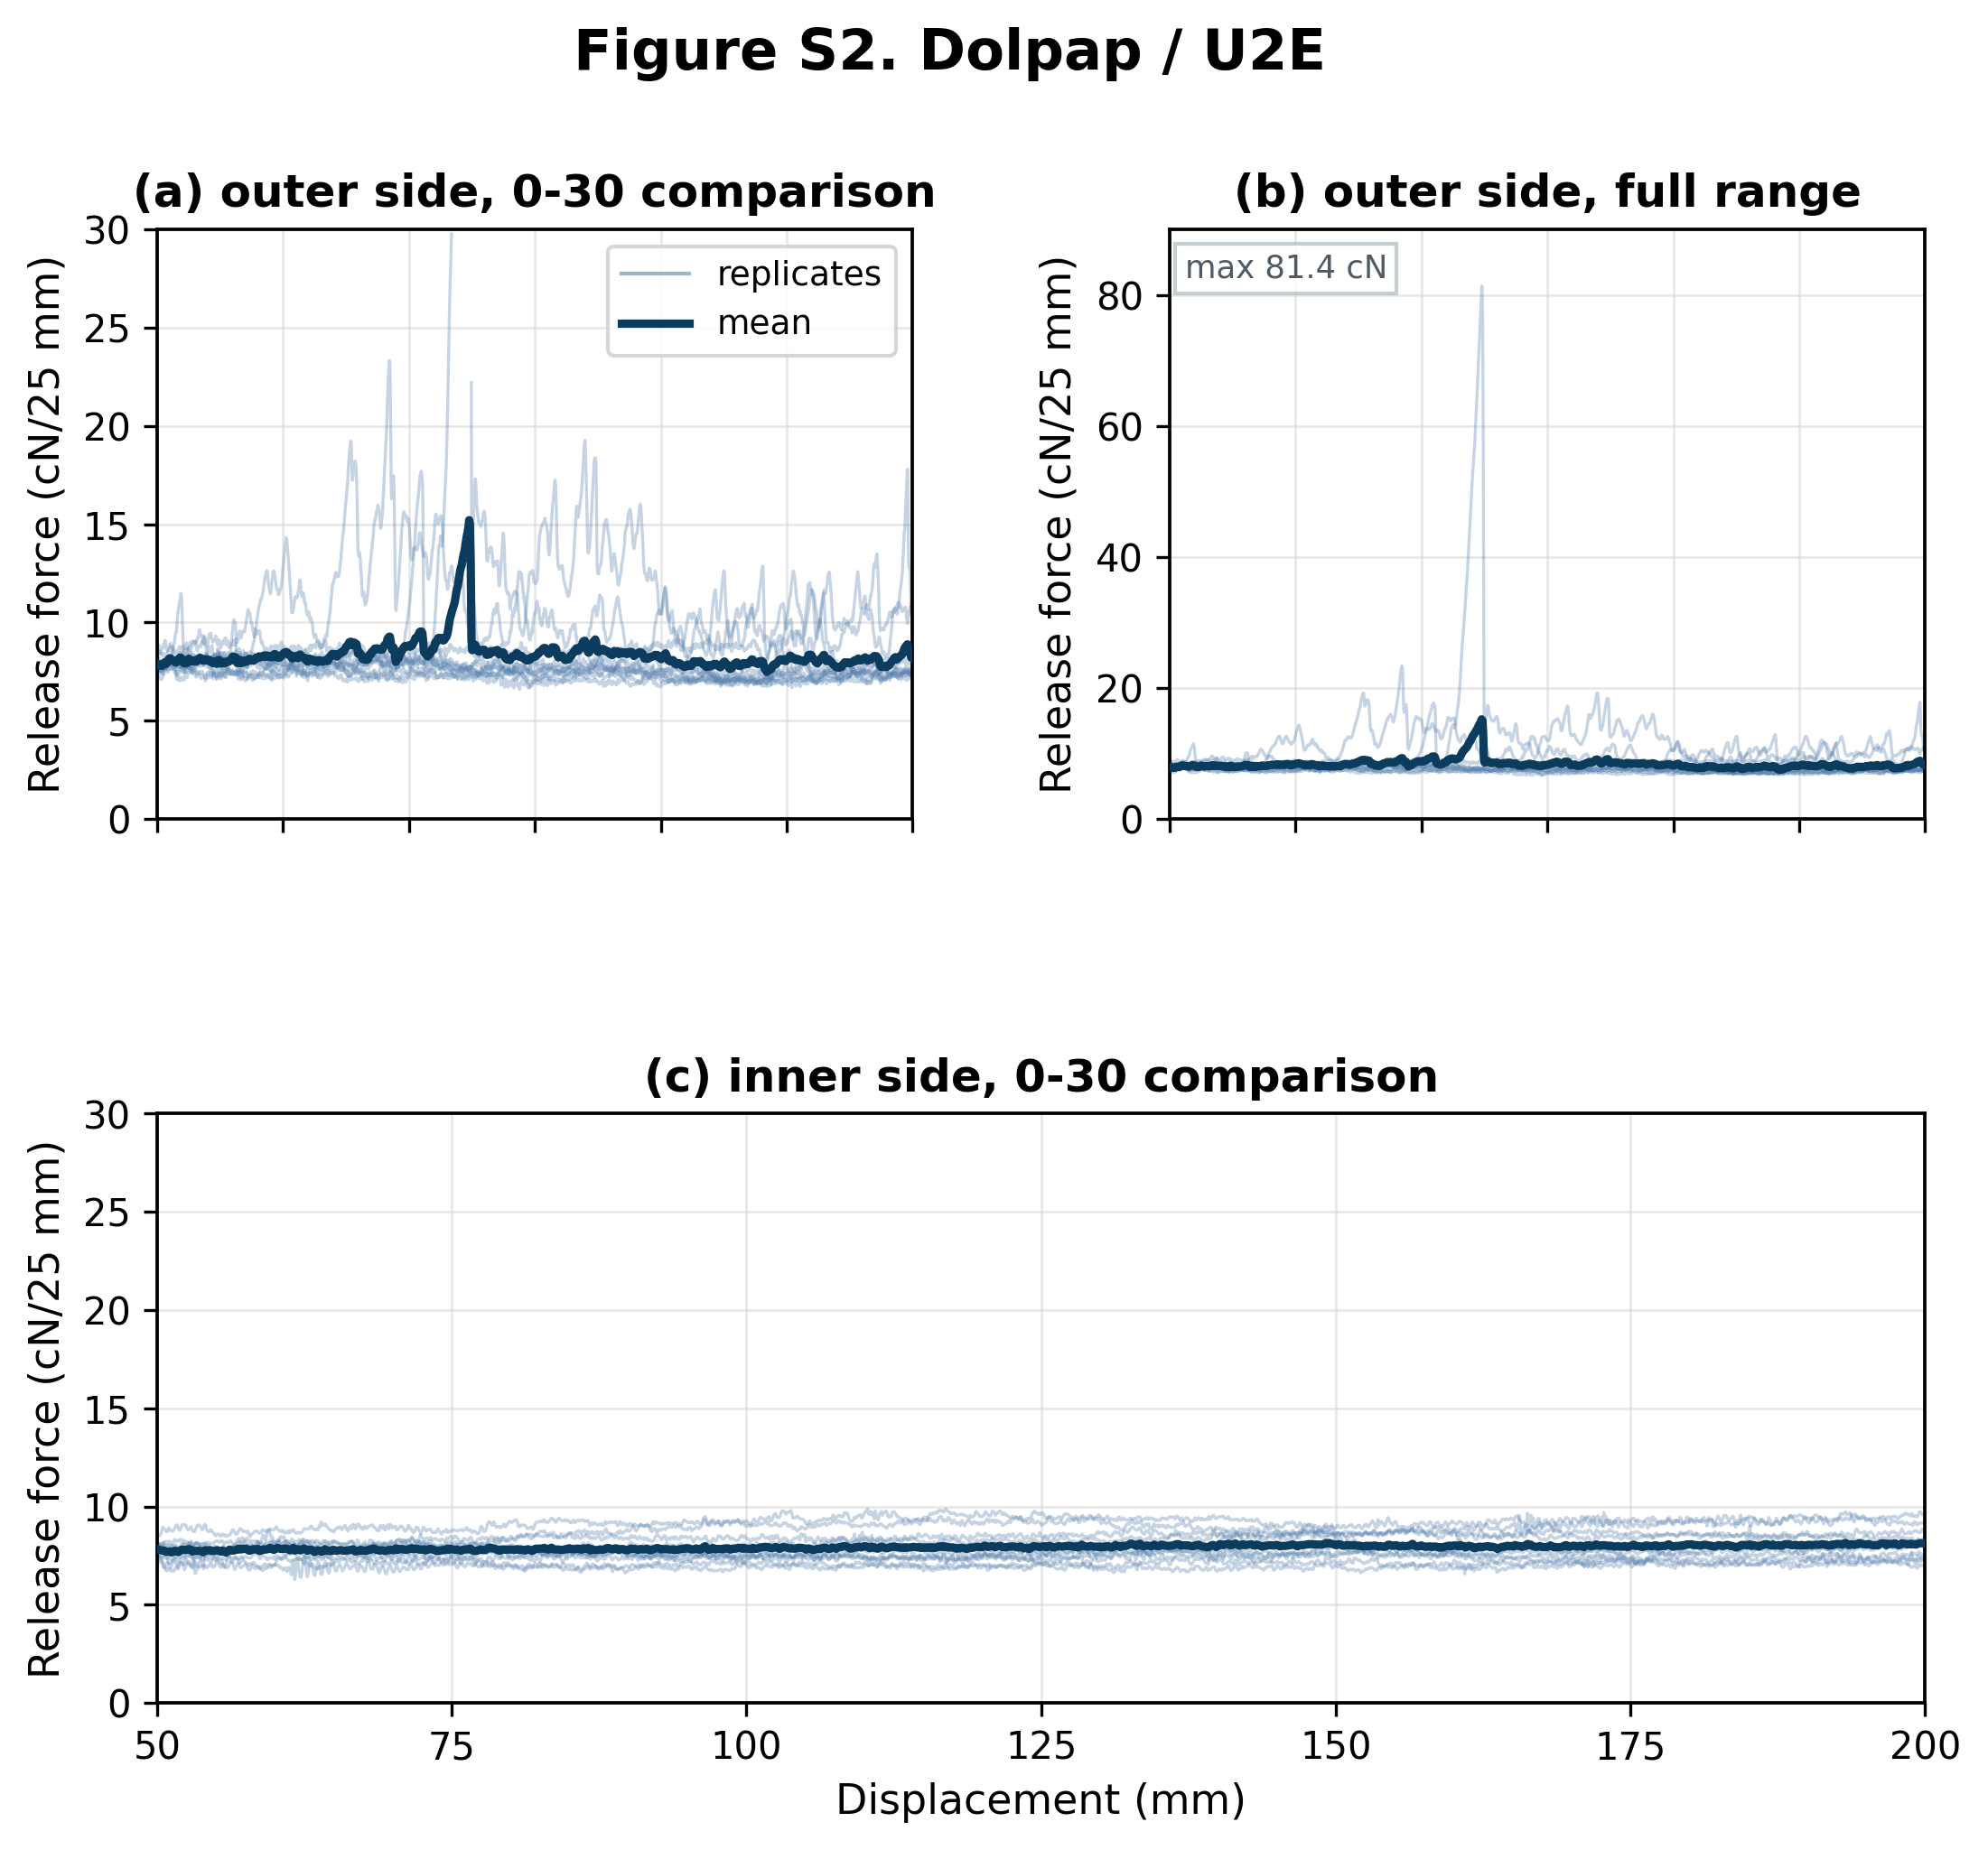
Figure S2. Force-displacement release curves for Dolpap liner tested with U2E butyl sealant. The external liner side (n = 10 shown from 10 traces) is shown as paired 0-30 comparison and full-range panels; the internal liner side (n = 10 shown from 10 traces) is shown as one 0-30 comparison panel. Thin blue lines show individual replicates and the dark blue line shows the mean curve where replicate coverage was sufficient. Forces are normalized to cN/25 mm; the displayed range corresponds to the 50-200 mm analysis interval. Panels marked as 0-30 comparison use a shared 0-30 cN/25 mm y-axis, with values above this range omitted from that comparison view. Full-range panels retain all above-range values. Sides with more than 5% of samples above 30 cN/25 mm are shown only at full range (figure maximum 81.4 cN/25 mm).

Figure S3. Dolpap / T1E
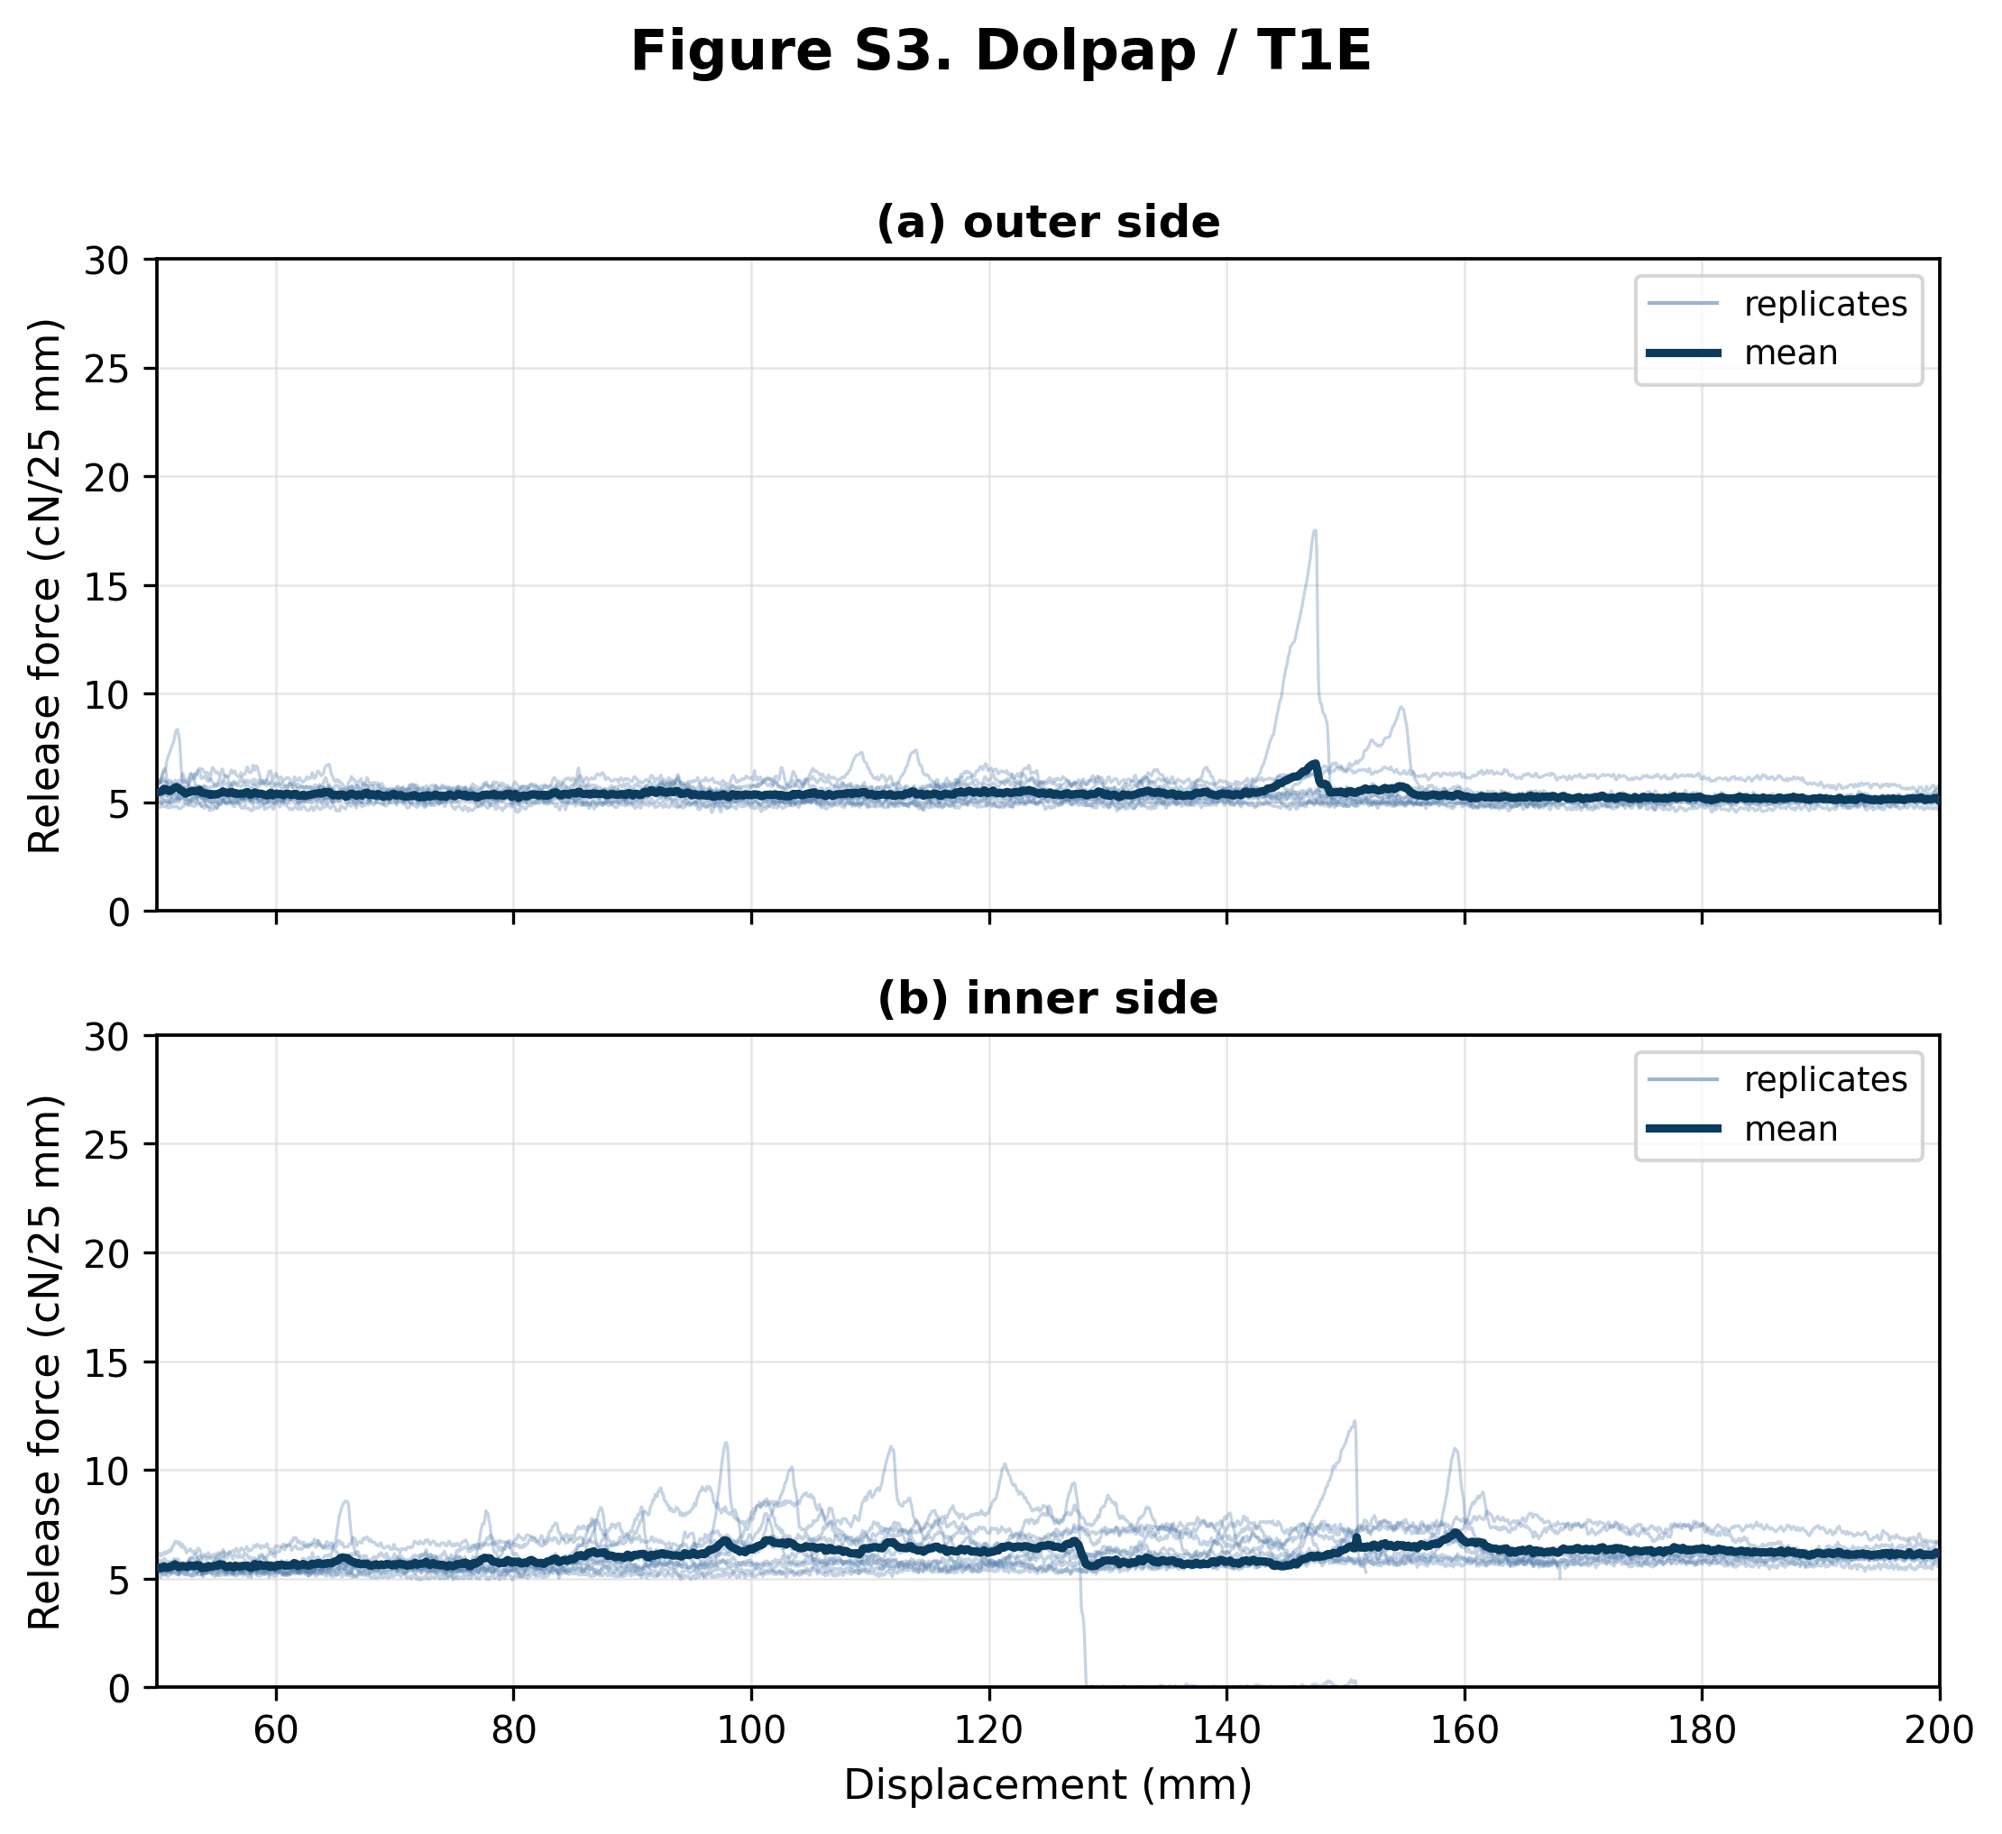
Figure S3. Force-displacement release curves for Dolpap liner tested with T1E butyl sealant. Panel (a) shows the external liner side (n = 10 shown from 10 traces); panel (b) shows the internal liner side (n = 10 shown from 10 traces). Thin blue lines show individual replicates and the dark blue line shows the mean curve where replicate coverage was sufficient. Forces are normalized to cN/25 mm; the displayed range corresponds to the 50-200 mm analysis interval. Both panels use the shared 0-30 cN/25 mm comparison y-axis. 1 external trace ended within 50-200 mm; 3 internal traces ended within 50-200 mm.

Figure S4. Dolpap / T2E
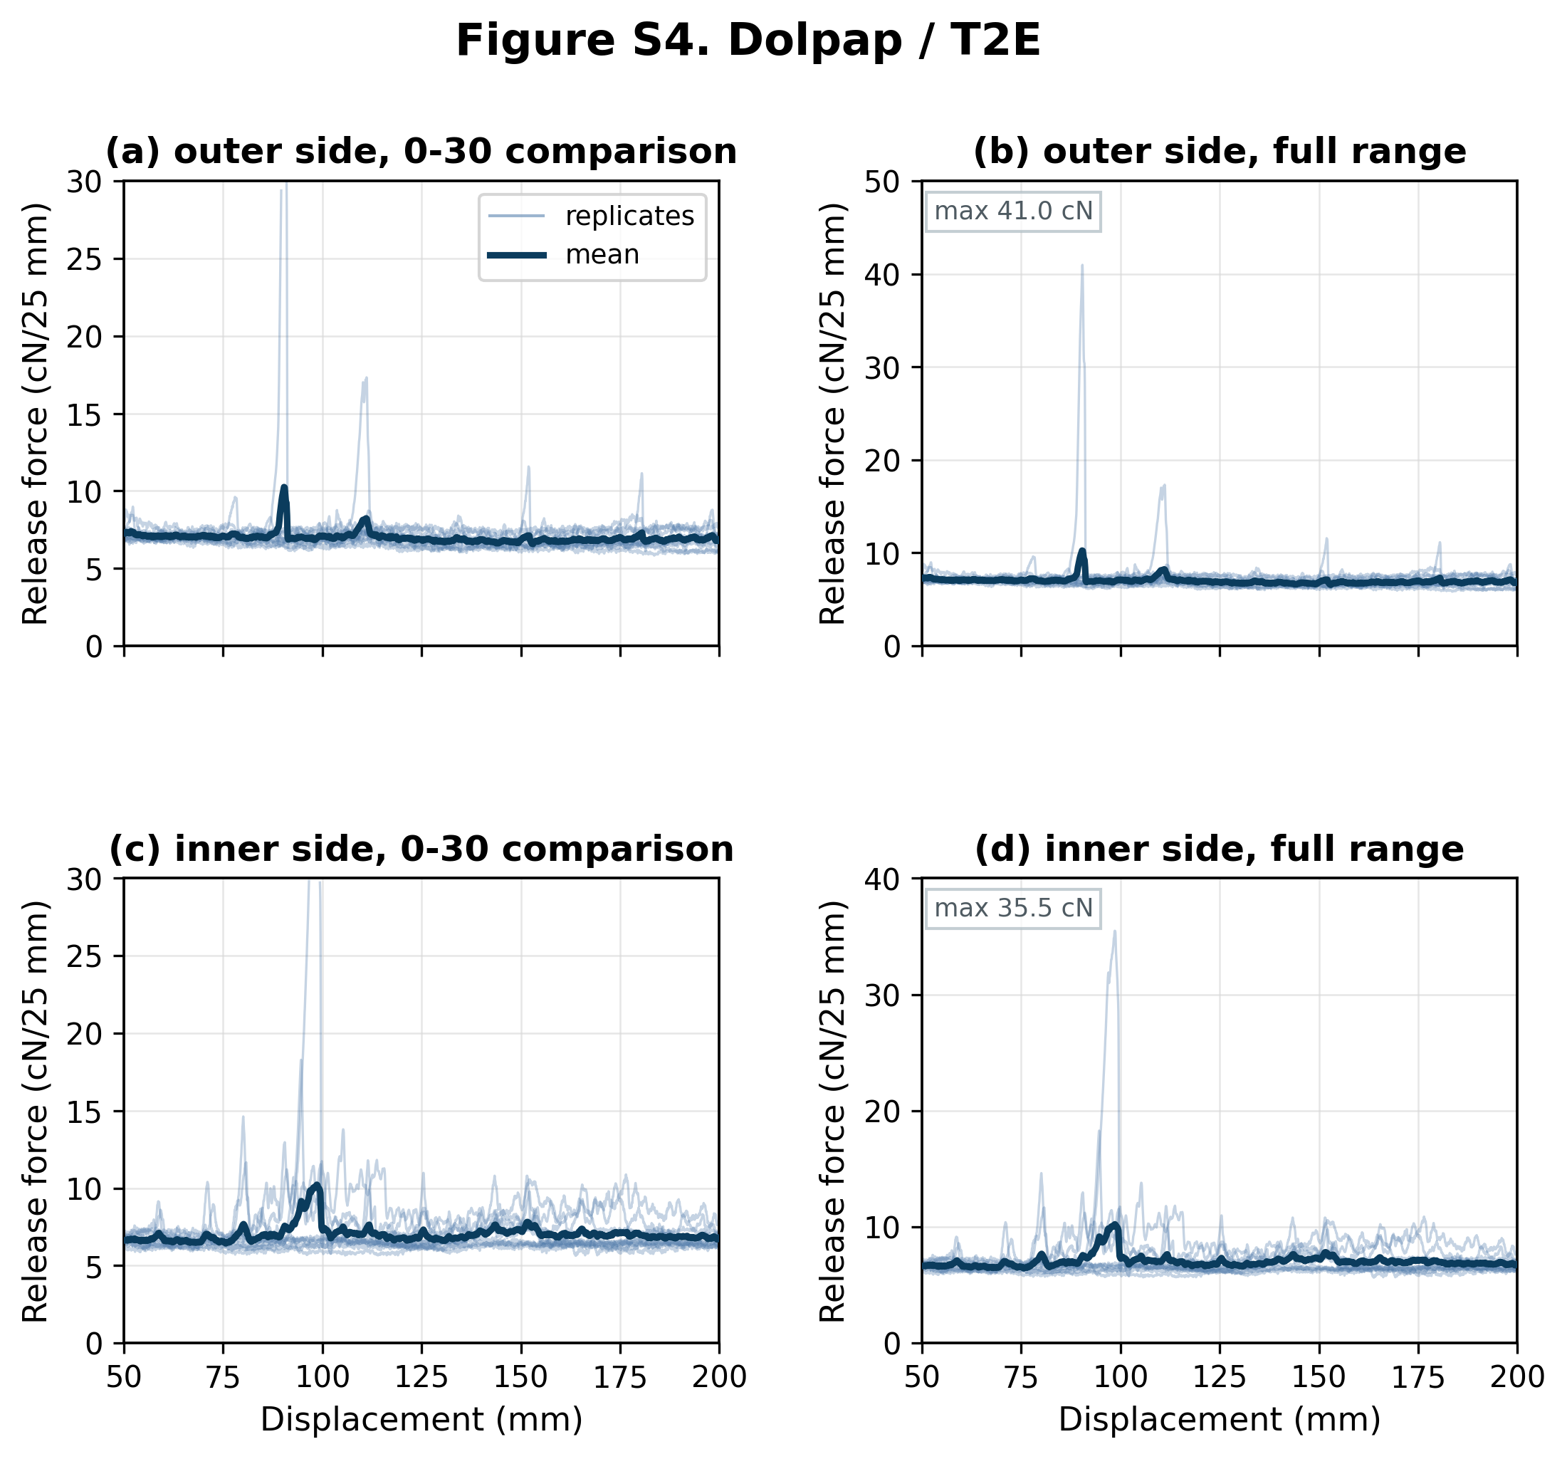
Figure S4. Force-displacement release curves for Dolpap liner tested with T2E butyl sealant. The external liner side (n = 10 shown from 10 traces) is shown as paired 0-30 comparison and full-range panels; the internal liner side (n = 10 shown from 10 traces) is shown as paired 0-30 comparison and full-range panels. Thin blue lines show individual replicates and the dark blue line shows the mean curve where replicate coverage was sufficient. Forces are normalized to cN/25 mm; the displayed range corresponds to the 50-200 mm analysis interval. Panels marked as 0-30 comparison use a shared 0-30 cN/25 mm y-axis, with values above this range omitted from that comparison view. Full-range panels retain all above-range values. Sides with more than 5% of samples above 30 cN/25 mm are shown only at full range (figure maximum 41.0 cN/25 mm).

Figure S5. Dolpap / C1EN
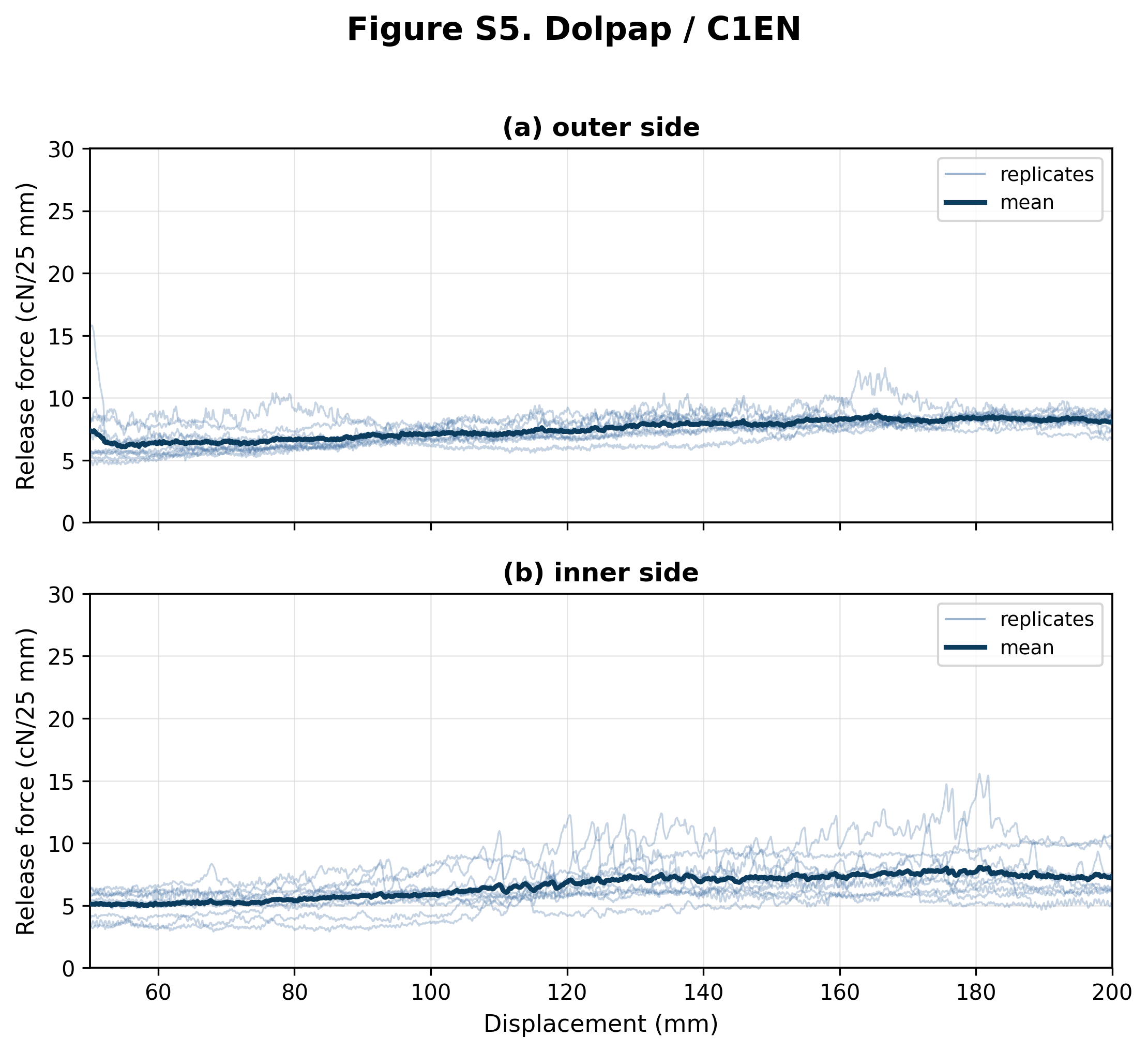
Figure S5. Force-displacement release curves for Dolpap liner tested with C1EN butyl sealant. Panel (a) shows the external liner side (n = 10 shown from 10 traces); panel (b) shows the internal liner side (n = 10 shown from 10 traces). Thin blue lines show individual replicates and the dark blue line shows the mean curve where replicate coverage was sufficient. Forces are normalized to cN/25 mm; the displayed range corresponds to the 50-200 mm analysis interval. Both panels use the shared 0-30 cN/25 mm comparison y-axis. 1 internal trace ended within 50-200 mm.

Figure S6. Dolpap / T1EN
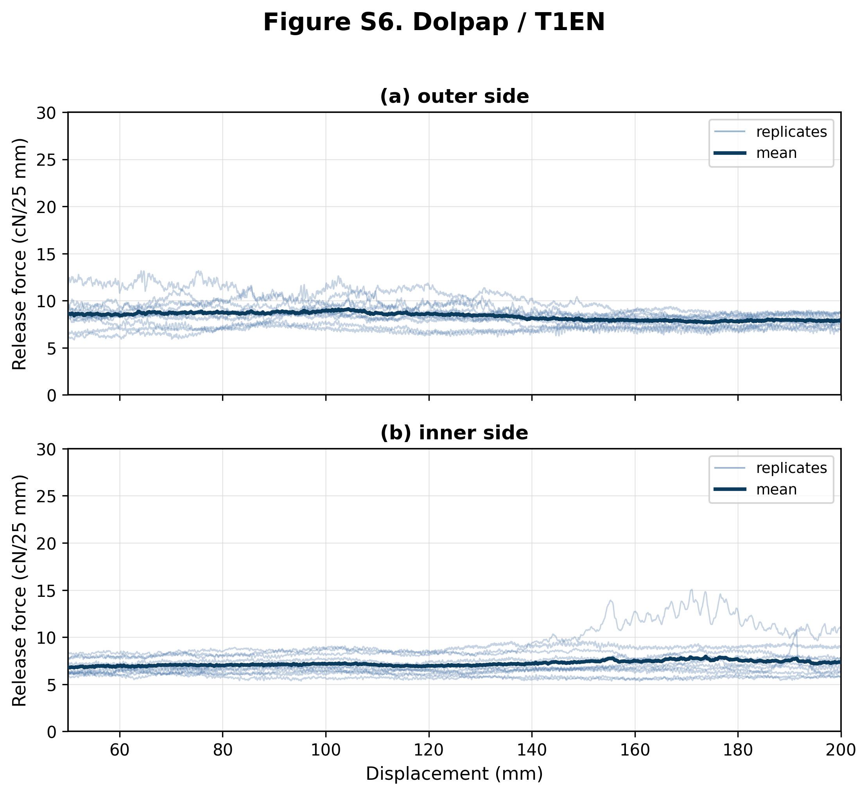
Figure S6. Force-displacement release curves for Dolpap liner tested with T1EN butyl sealant. Panel (a) shows the external liner side (n = 10 shown from 10 traces); panel (b) shows the internal liner side (n = 10 shown from 10 traces). Thin blue lines show individual replicates and the dark blue line shows the mean curve where replicate coverage was sufficient. Forces are normalized to cN/25 mm; the displayed range corresponds to the 50-200 mm analysis interval. Both panels use the shared 0-30 cN/25 mm comparison y-axis.

Figure S7. Dolpap / T2EN
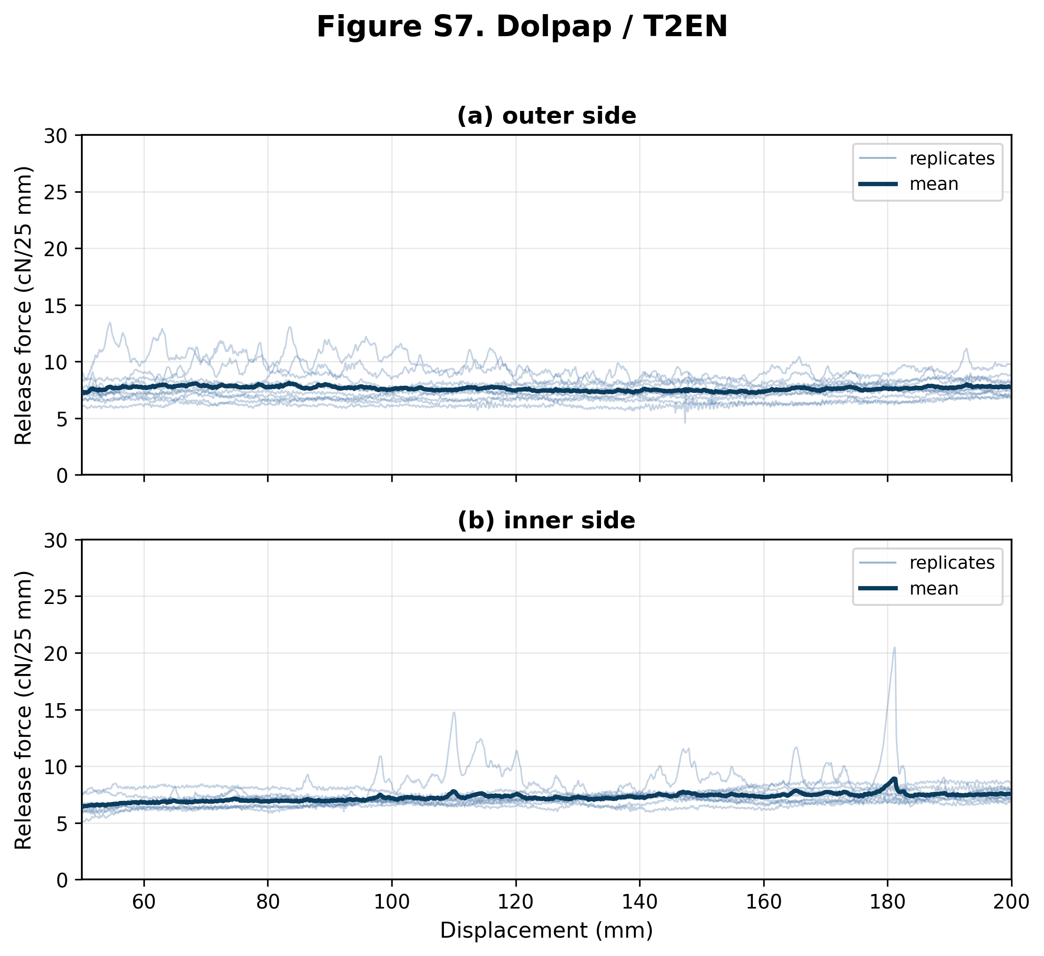
Figure S7. Force-displacement release curves for Dolpap liner tested with T2EN butyl sealant. Panel (a) shows the external liner side (n = 10 shown from 10 traces); panel (b) shows the internal liner side (n = 9 shown from 9 traces). Thin blue lines show individual replicates and the dark blue line shows the mean curve where replicate coverage was sufficient. Forces are normalized to cN/25 mm; the displayed range corresponds to the 50-200 mm analysis interval. Both panels use the shared 0-30 cN/25 mm comparison y-axis.

Figure S8. Rossella / C1E
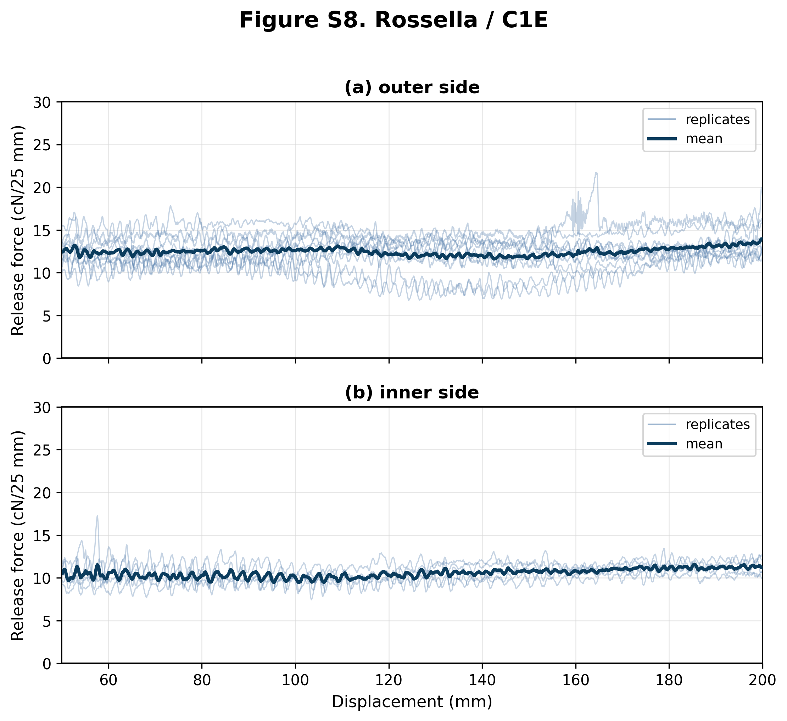
Figure S8. Force-displacement release curves for Rossella liner tested with C1E butyl sealant. Panel (a) shows the external liner side (n = 10 shown from 12 traces); panel (b) shows the internal liner side (n = 5 shown from 10 traces). Thin blue lines show individual replicates and the dark blue line shows the mean curve where replicate coverage was sufficient. Forces are normalized to cN/25 mm; the displayed range corresponds to the 50-200 mm analysis interval. Both panels use the shared 0-30 cN/25 mm comparison y-axis. 2 external traces ended before 50 mm; 5 internal traces ended before 50 mm.

Figure S9. Rossella / U2E
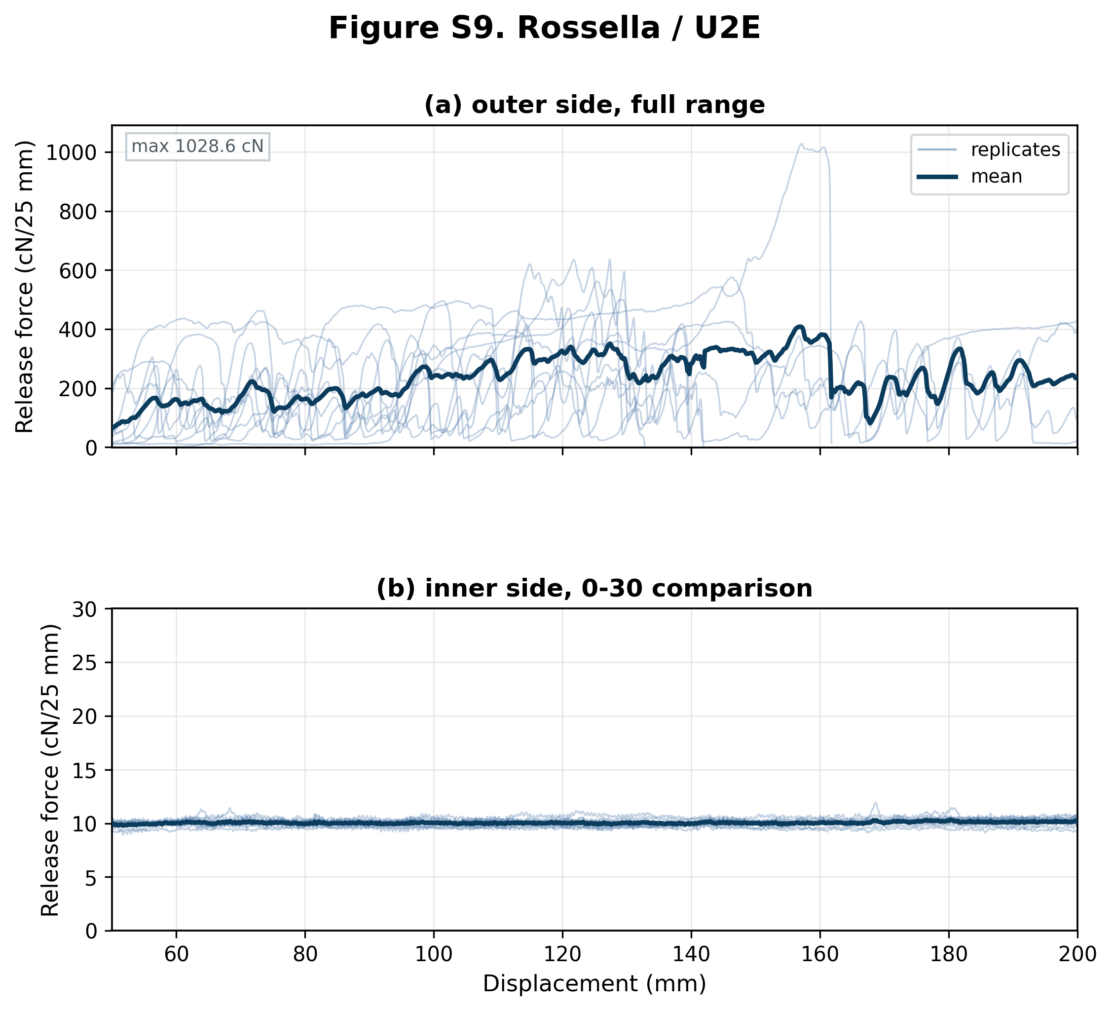
Figure S9. Force-displacement release curves for Rossella liner tested with U2E butyl sealant. The external liner side (n = 10 shown from 10 traces) is shown as one full-range panel; the internal liner side (n = 10 shown from 10 traces) is shown as one 0-30 comparison panel. Thin blue lines show individual replicates and the dark blue line shows the mean curve where replicate coverage was sufficient. Forces are normalized to cN/25 mm; the displayed range corresponds to the 50-200 mm analysis interval. Panels marked as 0-30 comparison use a shared 0-30 cN/25 mm y-axis, with values above this range omitted from that comparison view. Full-range panels retain all above-range values. Sides with more than 5% of samples above 30 cN/25 mm are shown only at full range (figure maximum 1028.6 cN/25 mm). 6 external traces ended within 50-200 mm.

Figure S10. Rossella / T1E
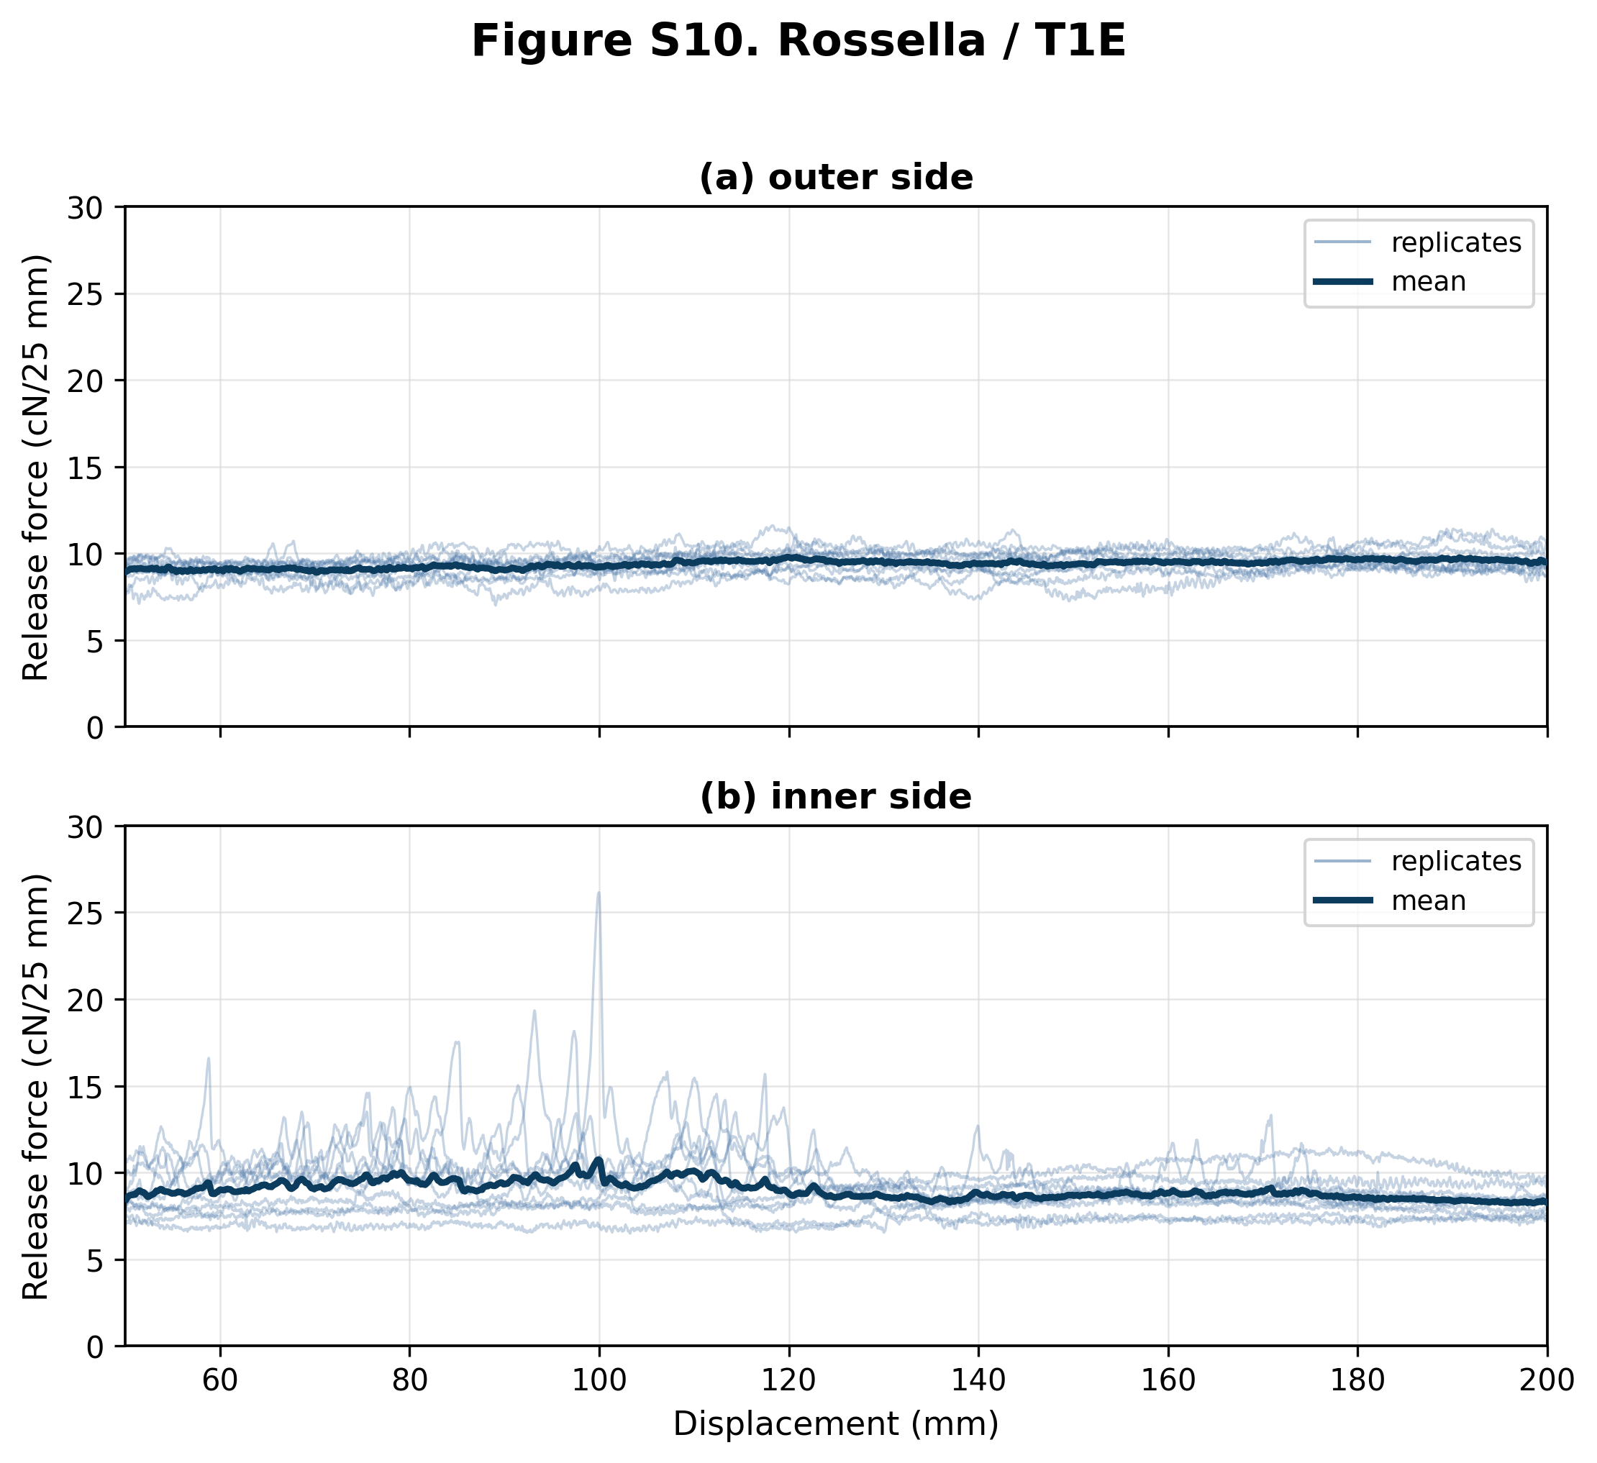
Figure S10. Force-displacement release curves for Rossella liner tested with T1E butyl sealant. Panel (a) shows the external liner side (n = 10 shown from 10 traces); panel (b) shows the internal liner side (n = 10 shown from 10 traces). Thin blue lines show individual replicates and the dark blue line shows the mean curve where replicate coverage was sufficient. Forces are normalized to cN/25 mm; the displayed range corresponds to the 50-200 mm analysis interval. Both panels use the shared 0-30 cN/25 mm comparison y-axis.

Figure S11. Rossella / T2E
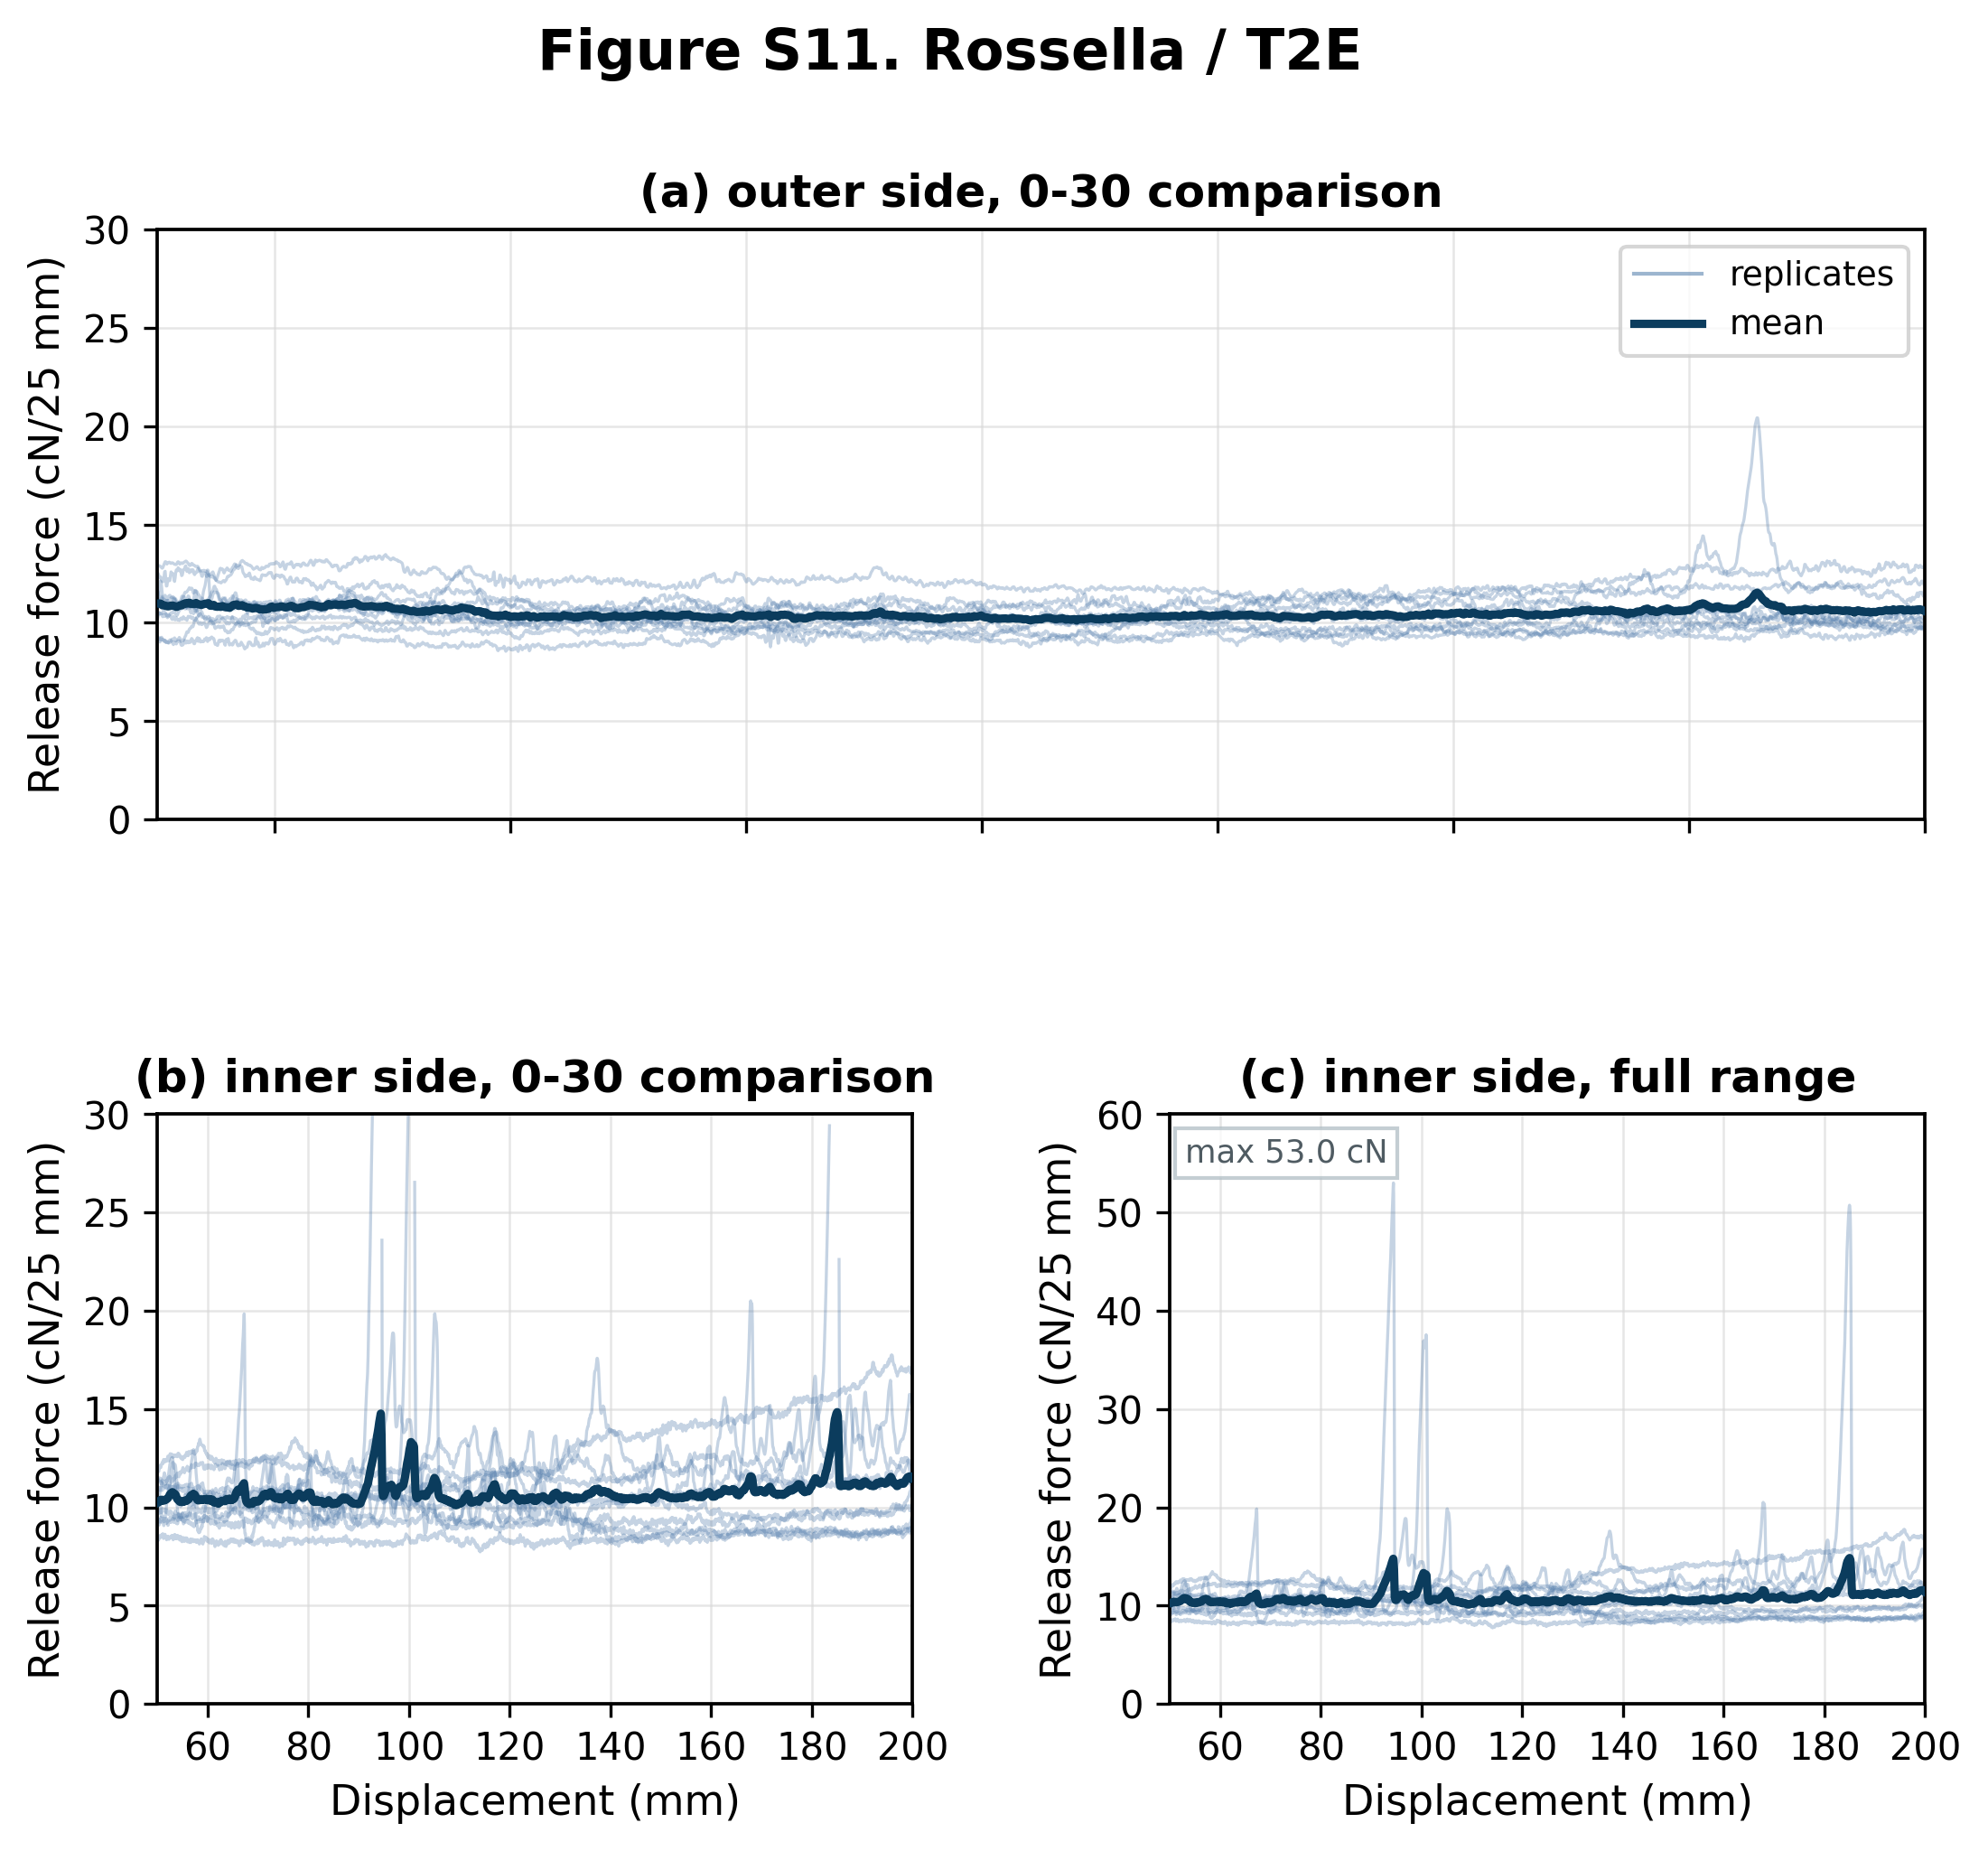
Figure S11. Force-displacement release curves for Rossella liner tested with T2E butyl sealant. The external liner side (n = 10 shown from 10 traces) is shown as one 0-30 comparison panel; the internal liner side (n = 10 shown from 10 traces) is shown as paired 0-30 comparison and full-range panels. Thin blue lines show individual replicates and the dark blue line shows the mean curve where replicate coverage was sufficient. Forces are normalized to cN/25 mm; the displayed range corresponds to the 50-200 mm analysis interval. Panels marked as 0-30 comparison use a shared 0-30 cN/25 mm y-axis, with values above this range omitted from that comparison view. Full-range panels retain all above-range values. Sides with more than 5% of samples above 30 cN/25 mm are shown only at full range (figure maximum 53.0 cN/25 mm).

Figure S12. Rossella / C1EN
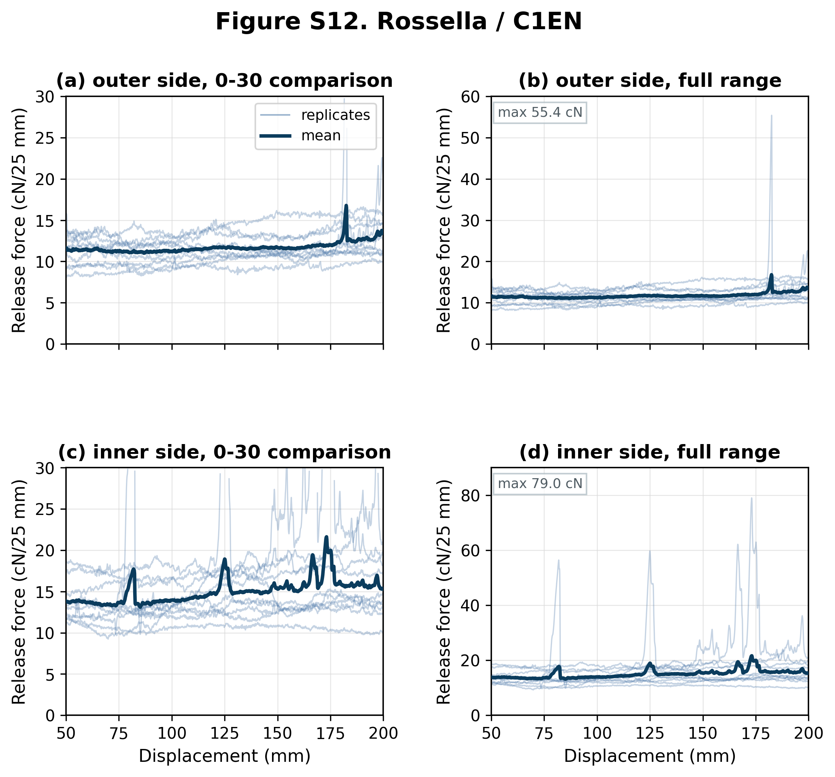
Figure S12. Force-displacement release curves for Rossella liner tested with C1EN butyl sealant. The external liner side (n = 10 shown from 10 traces) is shown as paired 0-30 comparison and full-range panels; the internal liner side (n = 10 shown from 10 traces) is shown as paired 0-30 comparison and full-range panels. Thin blue lines show individual replicates and the dark blue line shows the mean curve where replicate coverage was sufficient. Forces are normalized to cN/25 mm; the displayed range corresponds to the 50-200 mm analysis interval. Panels marked as 0-30 comparison use a shared 0-30 cN/25 mm y-axis, with values above this range omitted from that comparison view. Full-range panels retain all above-range values. Sides with more than 5% of samples above 30 cN/25 mm are shown only at full range (figure maximum 79.0 cN/25 mm).

Figure S13. Rossella / T1EN
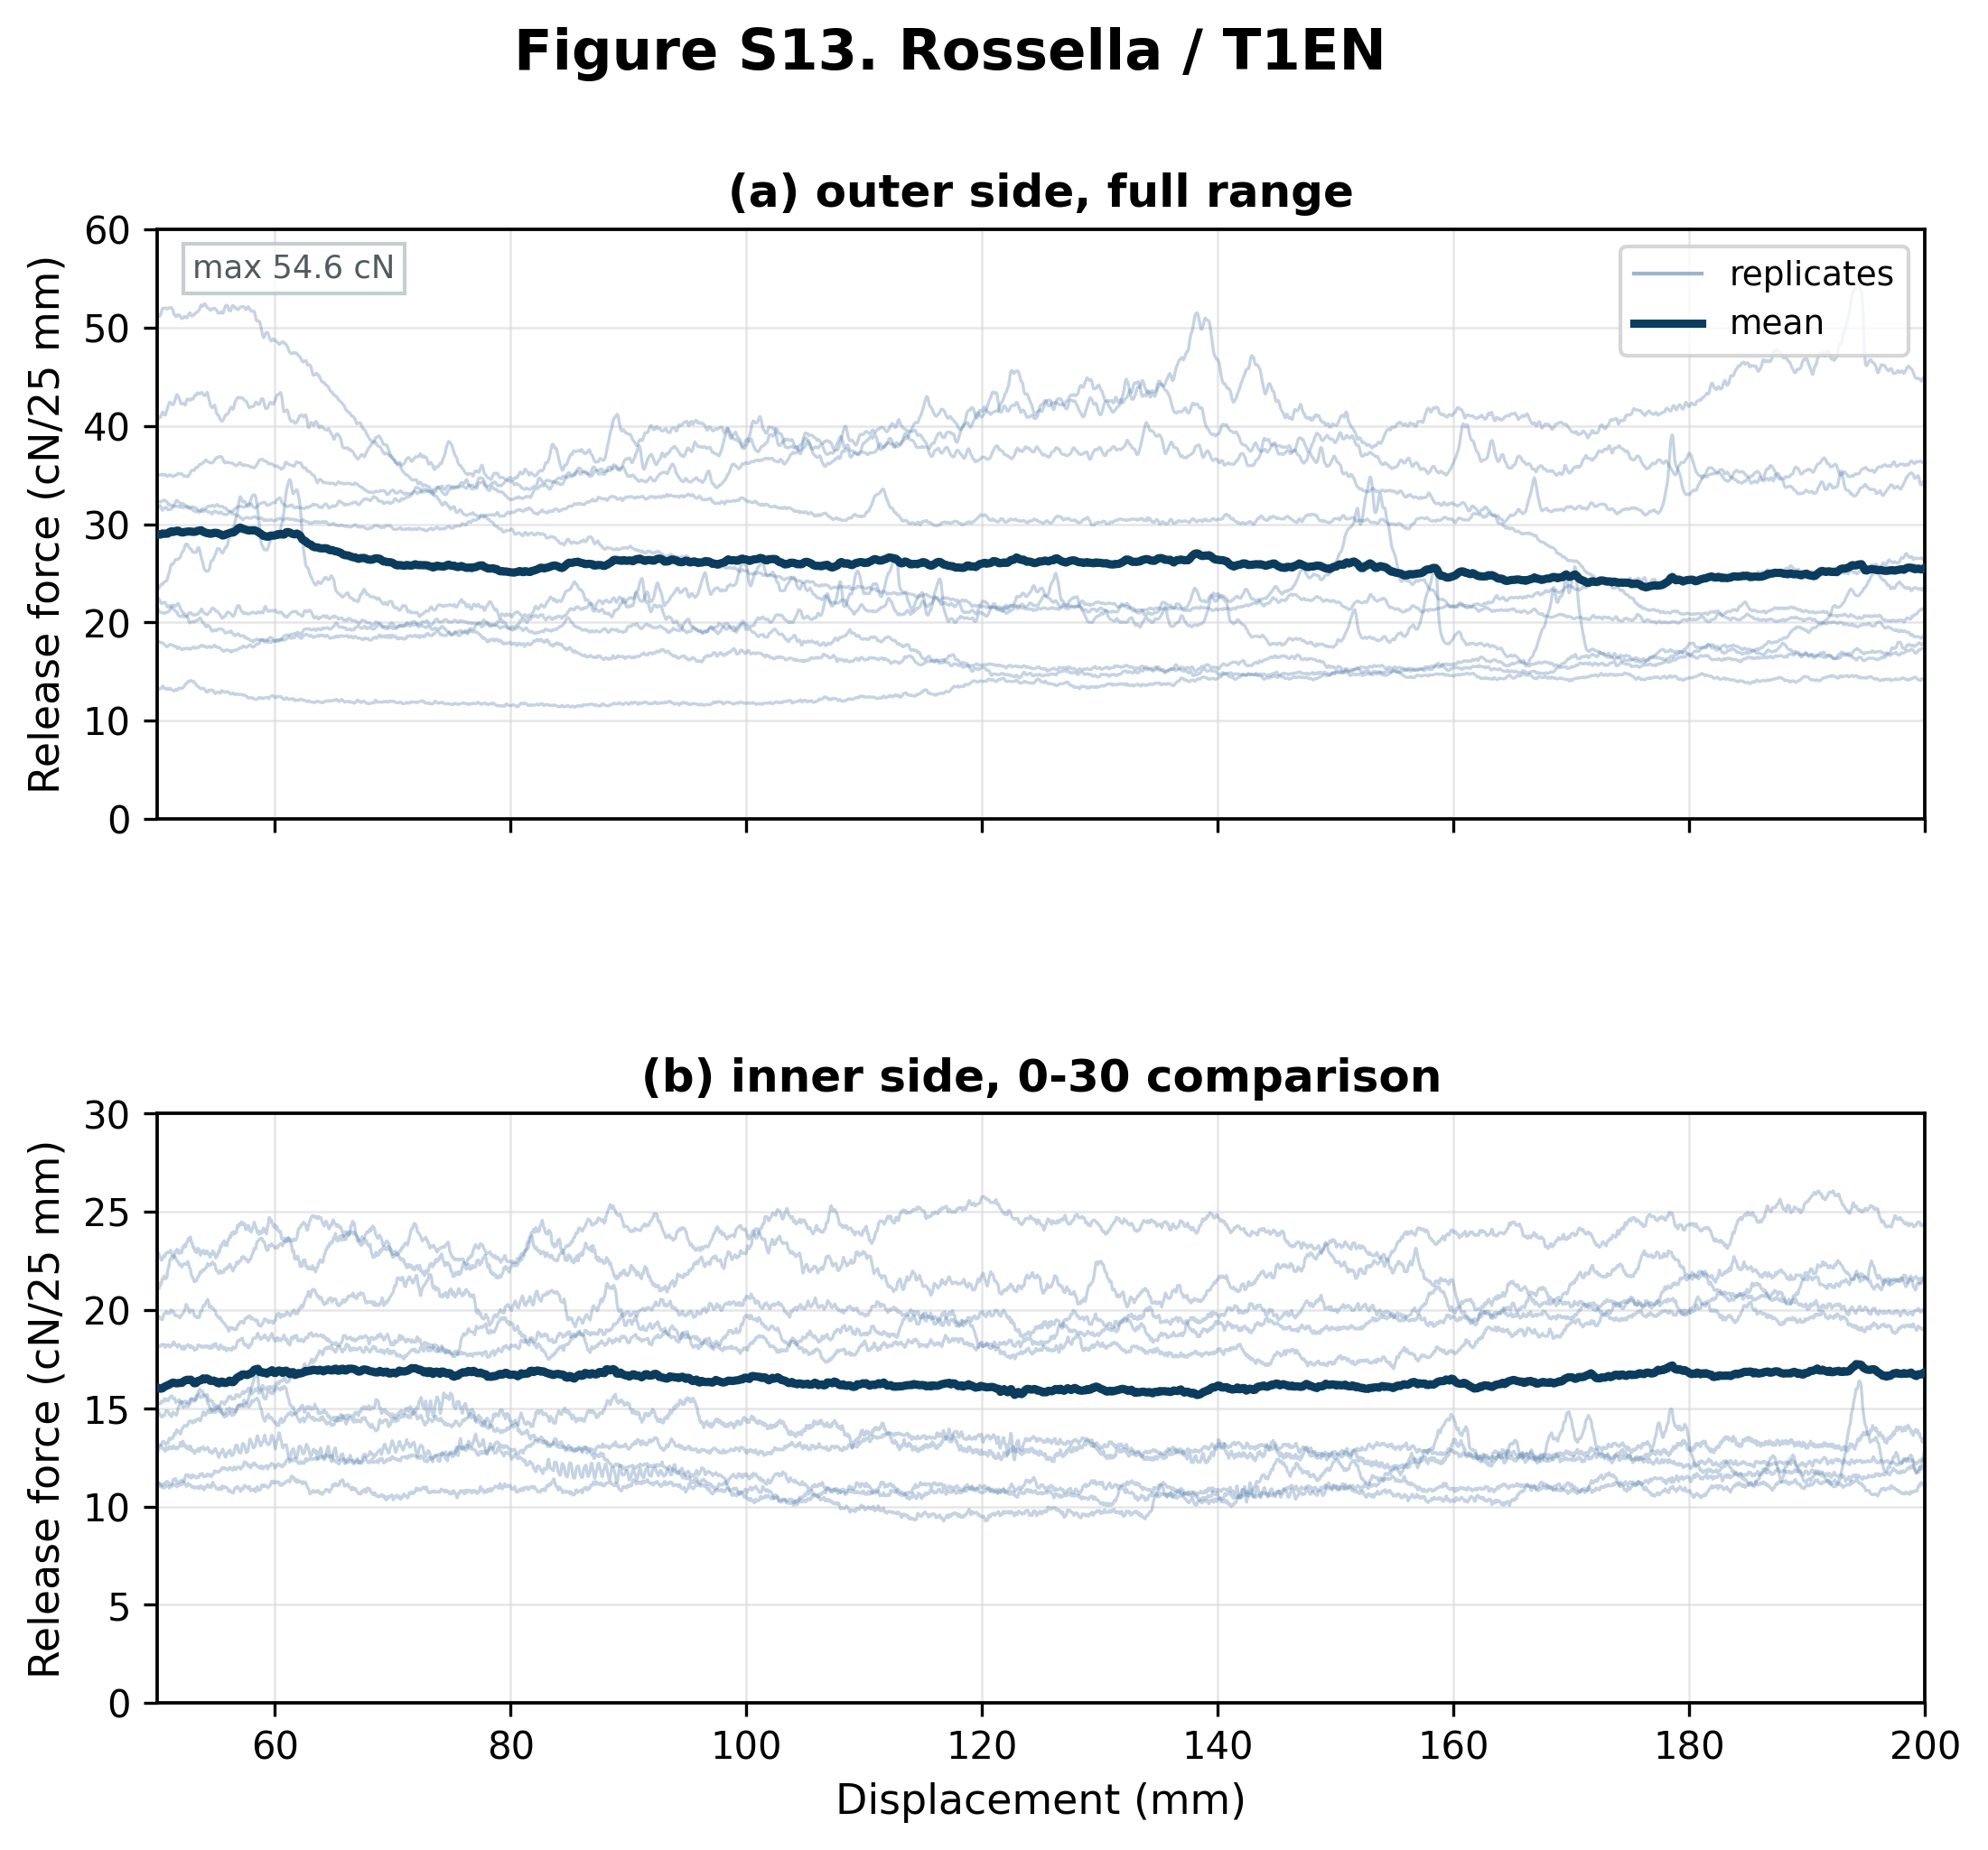
Figure S13. Force-displacement release curves for Rossella liner tested with T1EN butyl sealant. The external liner side (n = 10 shown from 10 traces) is shown as one full-range panel; the internal liner side (n = 10 shown from 10 traces) is shown as one 0-30 comparison panel. Thin blue lines show individual replicates and the dark blue line shows the mean curve where replicate coverage was sufficient. Forces are normalized to cN/25 mm; the displayed range corresponds to the 50-200 mm analysis interval. Panels marked as 0-30 comparison use a shared 0-30 cN/25 mm y-axis, with values above this range omitted from that comparison view. Full-range panels retain all above-range values. Sides with more than 5% of samples above 30 cN/25 mm are shown only at full range (figure maximum 54.6 cN/25 mm).

Figure S14. Rossella / T2EN
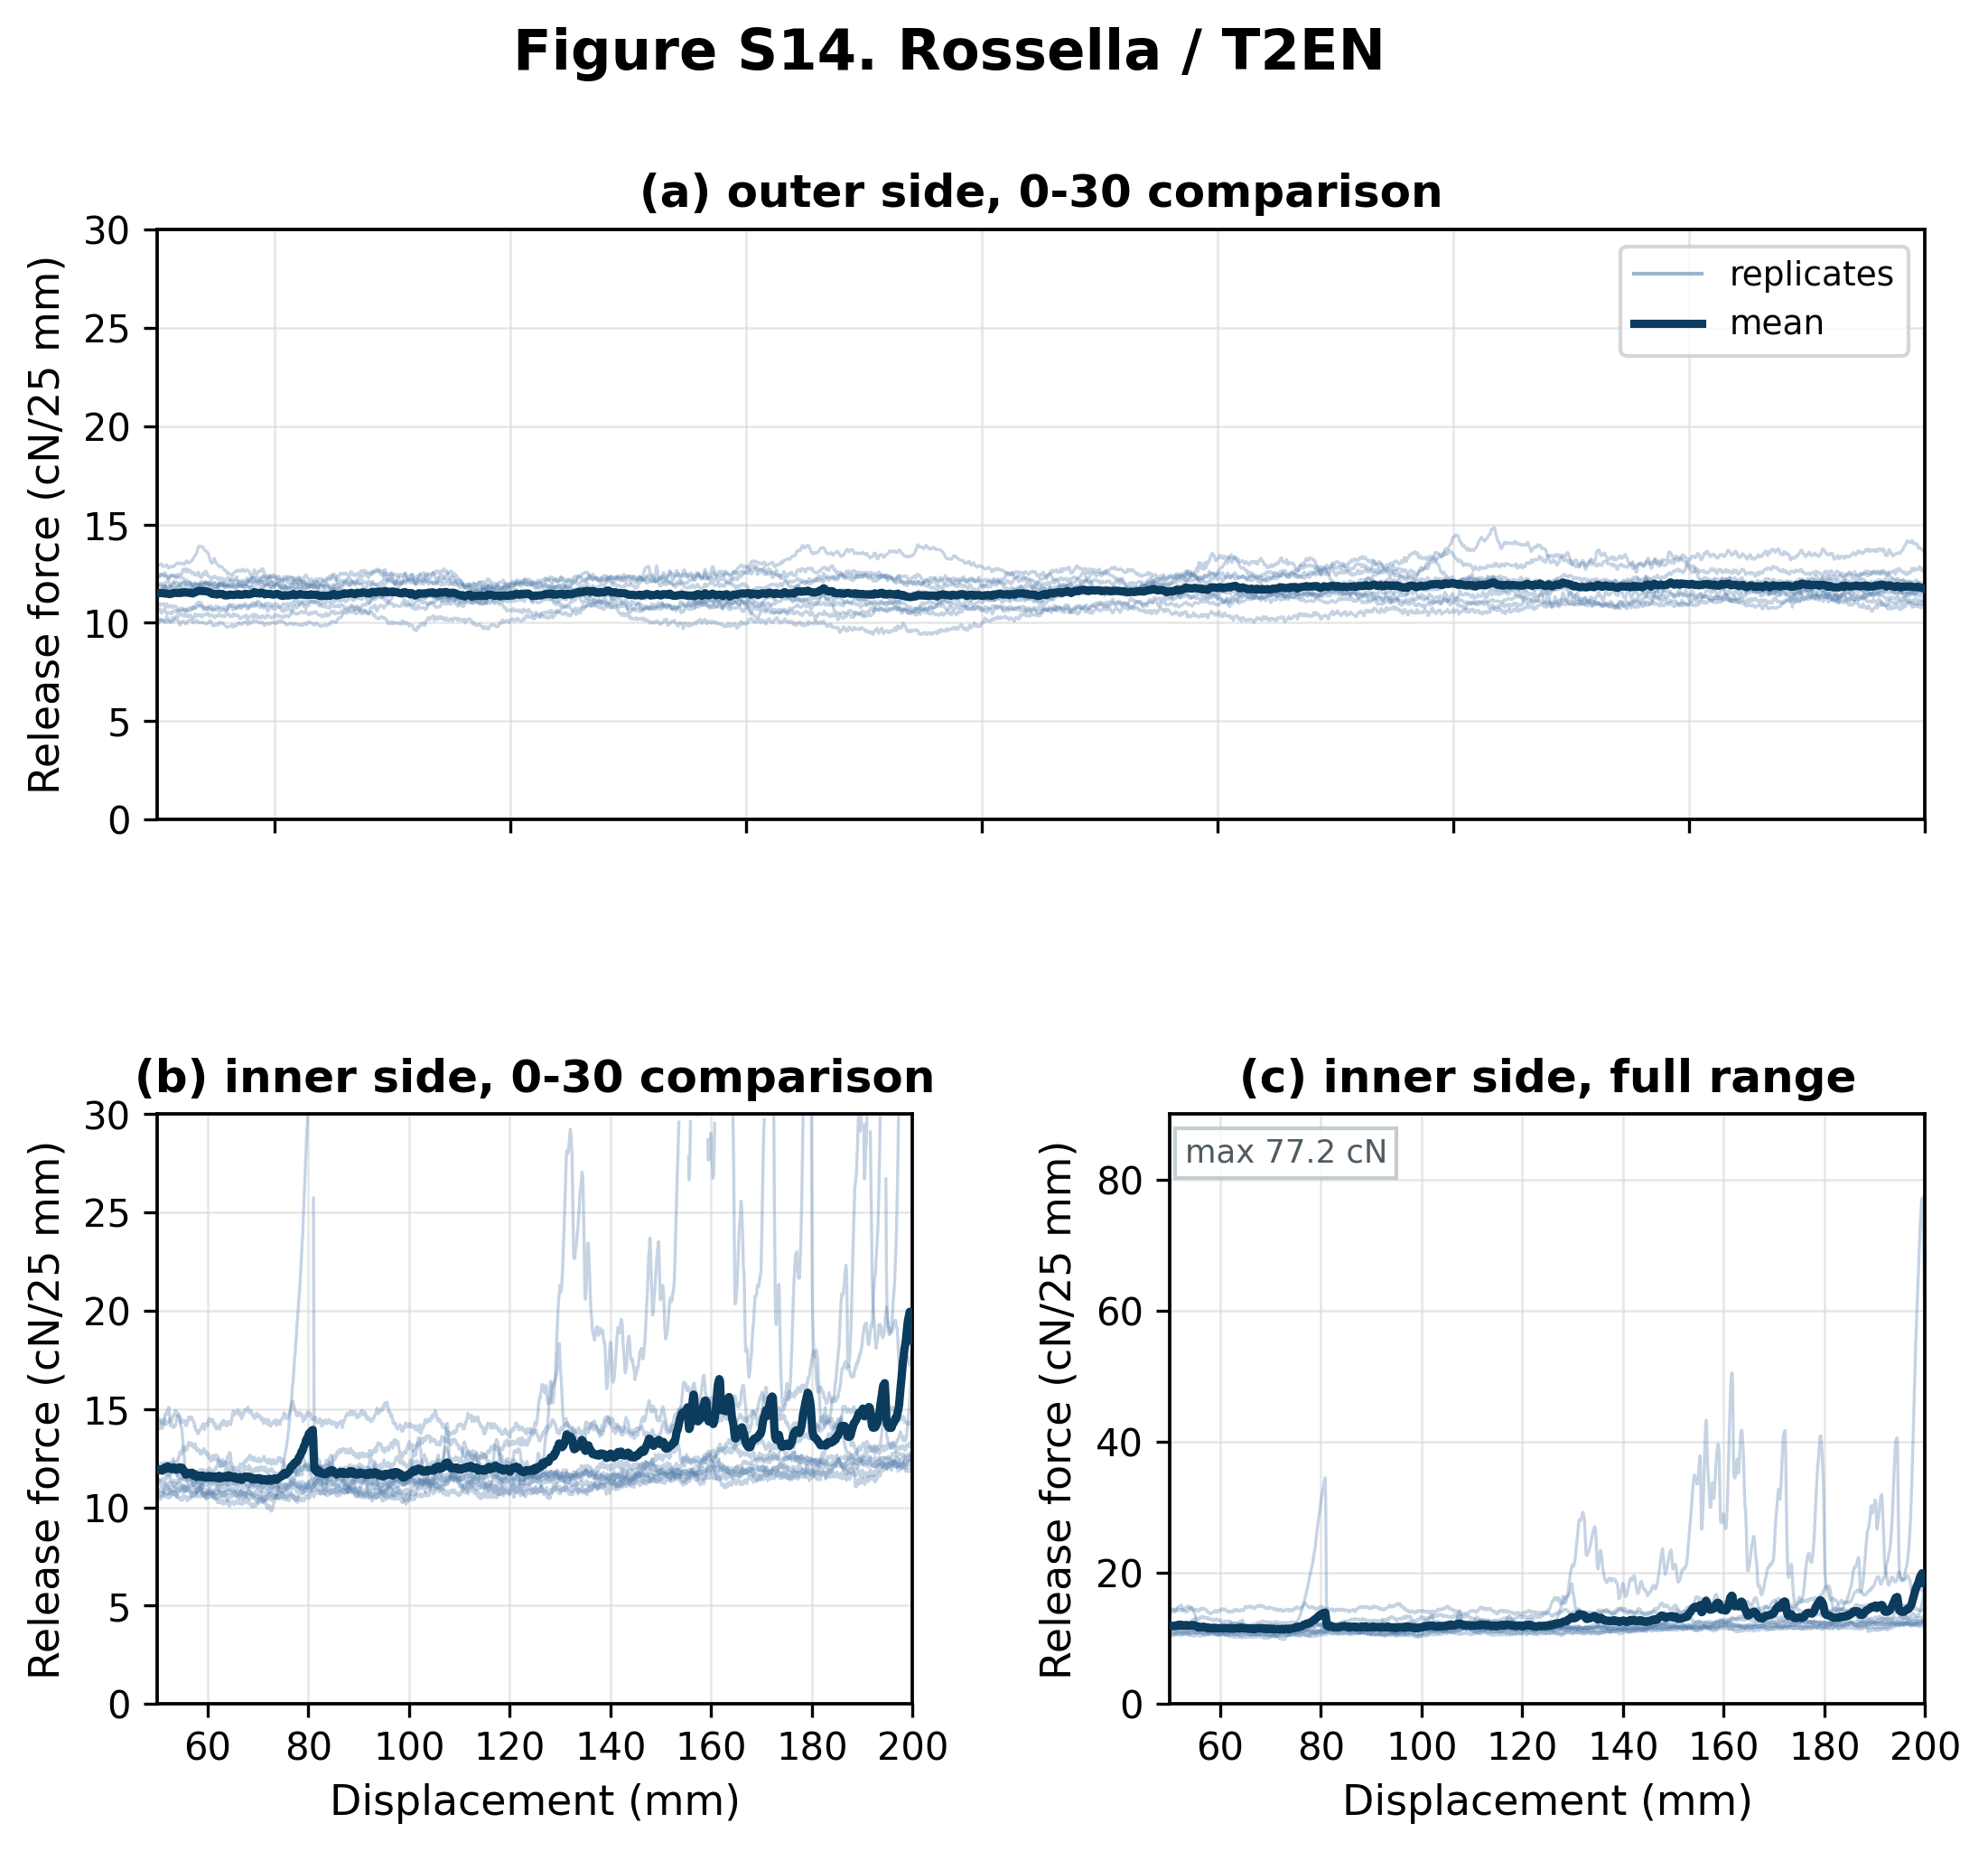
Figure S14. Force-displacement release curves for Rossella liner tested with T2EN butyl sealant. The external liner side (n = 10 shown from 10 traces) is shown as one 0-30 comparison panel; the internal liner side (n = 10 shown from 10 traces) is shown as paired 0-30 comparison and full-range panels. Thin blue lines show individual replicates and the dark blue line shows the mean curve where replicate coverage was sufficient. Forces are normalized to cN/25 mm; the displayed range corresponds to the 50-200 mm analysis interval. Panels marked as 0-30 comparison use a shared 0-30 cN/25 mm y-axis, with values above this range omitted from that comparison view. Full-range panels retain all above-range values. Sides with more than 5% of samples above 30 cN/25 mm are shown only at full range (figure maximum 77.2 cN/25 mm).

Figure S15. Crosil 42 / C1E
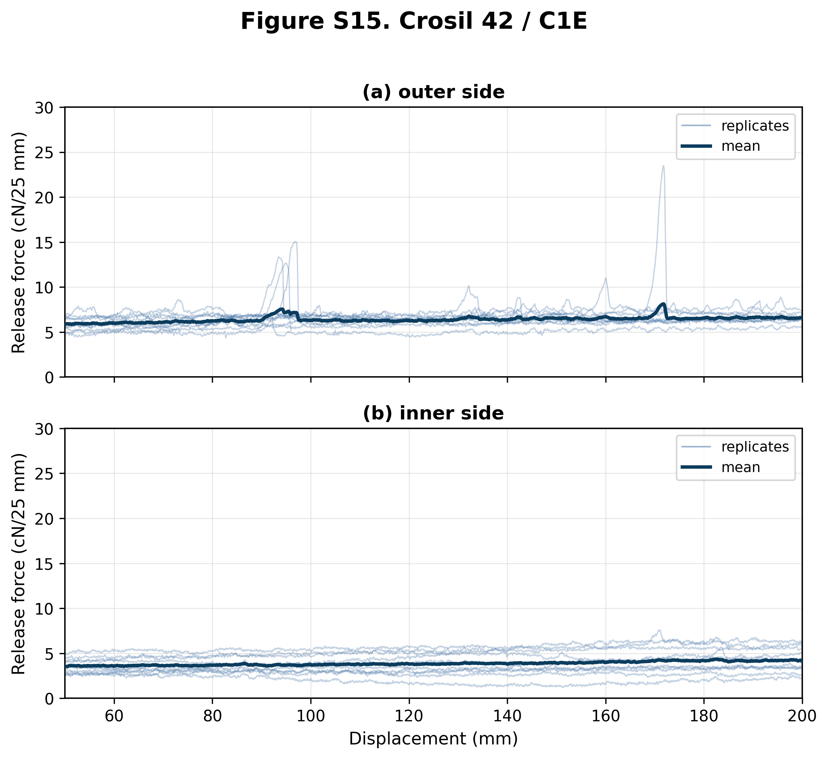
Figure S15. Force-displacement release curves for Crosil 42 liner tested with C1E butyl sealant. Panel (a) shows the external liner side (n = 11 shown from 12 traces); panel (b) shows the internal liner side (n = 10 shown from 10 traces). Thin blue lines show individual replicates and the dark blue line shows the mean curve where replicate coverage was sufficient. Forces are normalized to cN/25 mm; the displayed range corresponds to the 50-200 mm analysis interval. Both panels use the shared 0-30 cN/25 mm comparison y-axis. 1 external trace ended before 50 mm; 2 external traces ended within 50-200 mm.

Figure S16. Crosil 42 / U2E
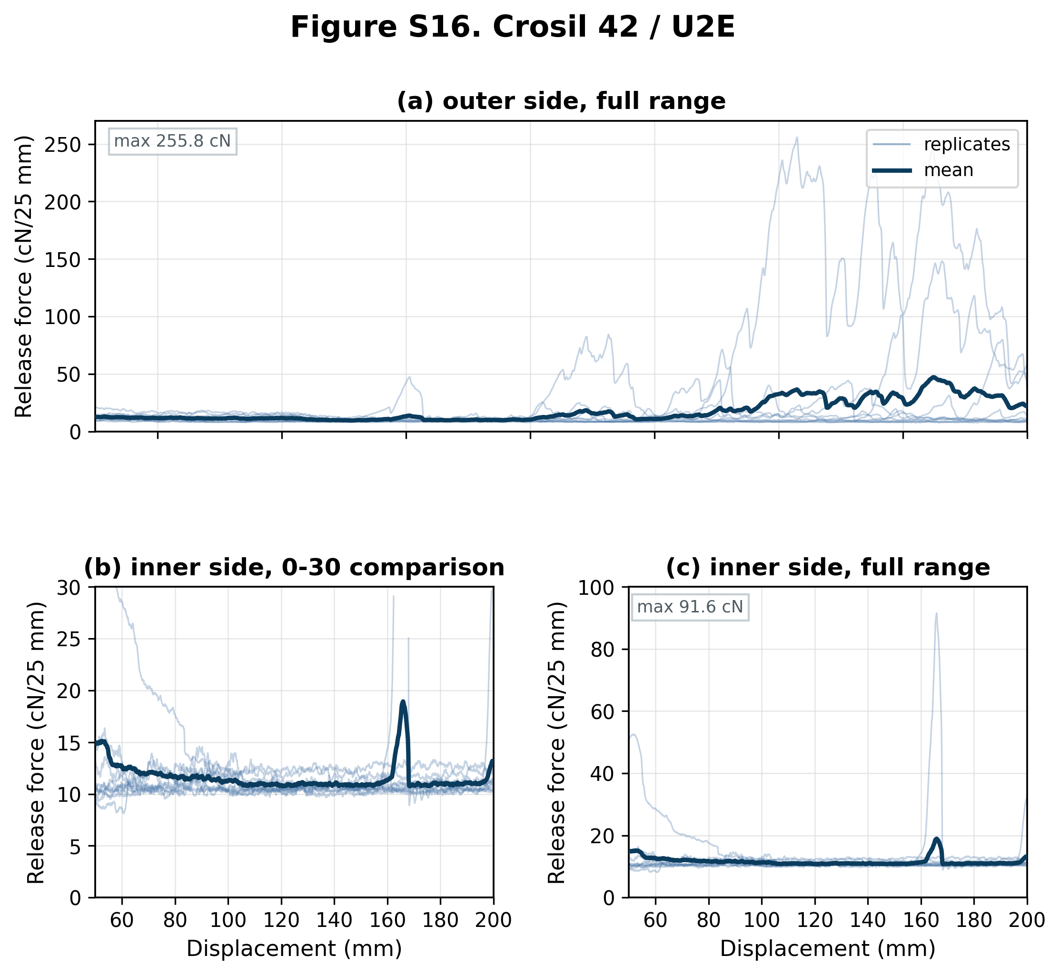
Figure S16. Force-displacement release curves for Crosil 42 liner tested with U2E butyl sealant. The external liner side (n = 10 shown from 10 traces) is shown as one full-range panel; the internal liner side (n = 10 shown from 10 traces) is shown as paired 0-30 comparison and full-range panels. Thin blue lines show individual replicates and the dark blue line shows the mean curve where replicate coverage was sufficient. Forces are normalized to cN/25 mm; the displayed range corresponds to the 50-200 mm analysis interval. Panels marked as 0-30 comparison use a shared 0-30 cN/25 mm y-axis, with values above this range omitted from that comparison view. Full-range panels retain all above-range values. Sides with more than 5% of samples above 30 cN/25 mm are shown only at full range (figure maximum 255.8 cN/25 mm).

Figure S17. Crosil 42 / T1E
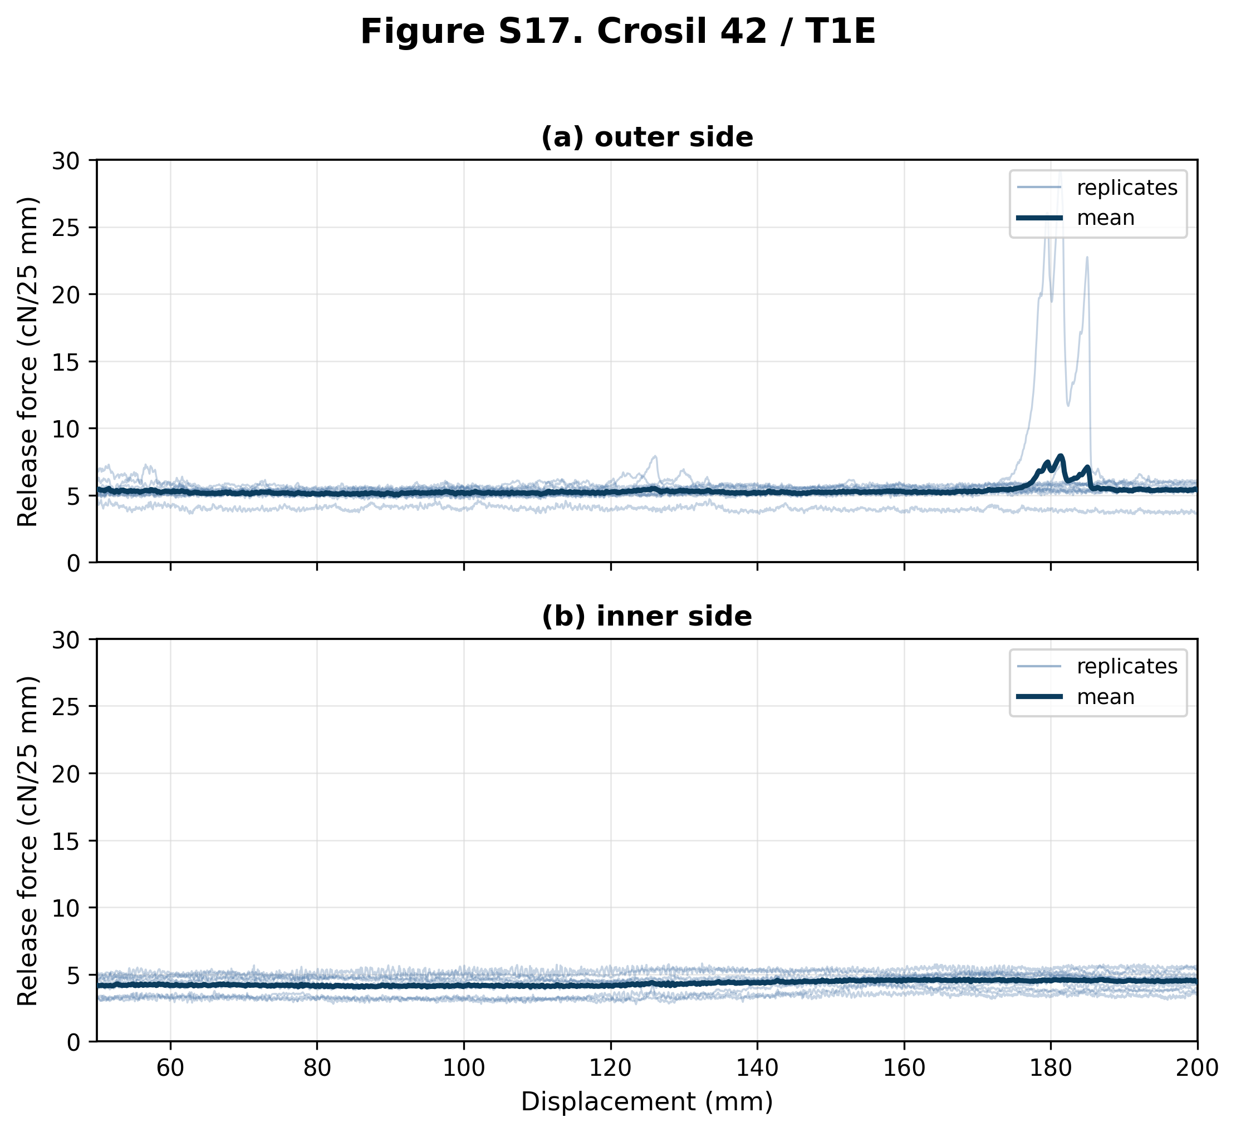
Figure S17. Force-displacement release curves for Crosil 42 liner tested with T1E butyl sealant. Panel (a) shows the external liner side (n = 10 shown from 10 traces); panel (b) shows the internal liner side (n = 10 shown from 10 traces). Thin blue lines show individual replicates and the dark blue line shows the mean curve where replicate coverage was sufficient. Forces are normalized to cN/25 mm; the displayed range corresponds to the 50-200 mm analysis interval. Both panels use the shared 0-30 cN/25 mm comparison y-axis. 1 external trace ended within 50-200 mm.

Figure S18. Crosil 42 / T2E
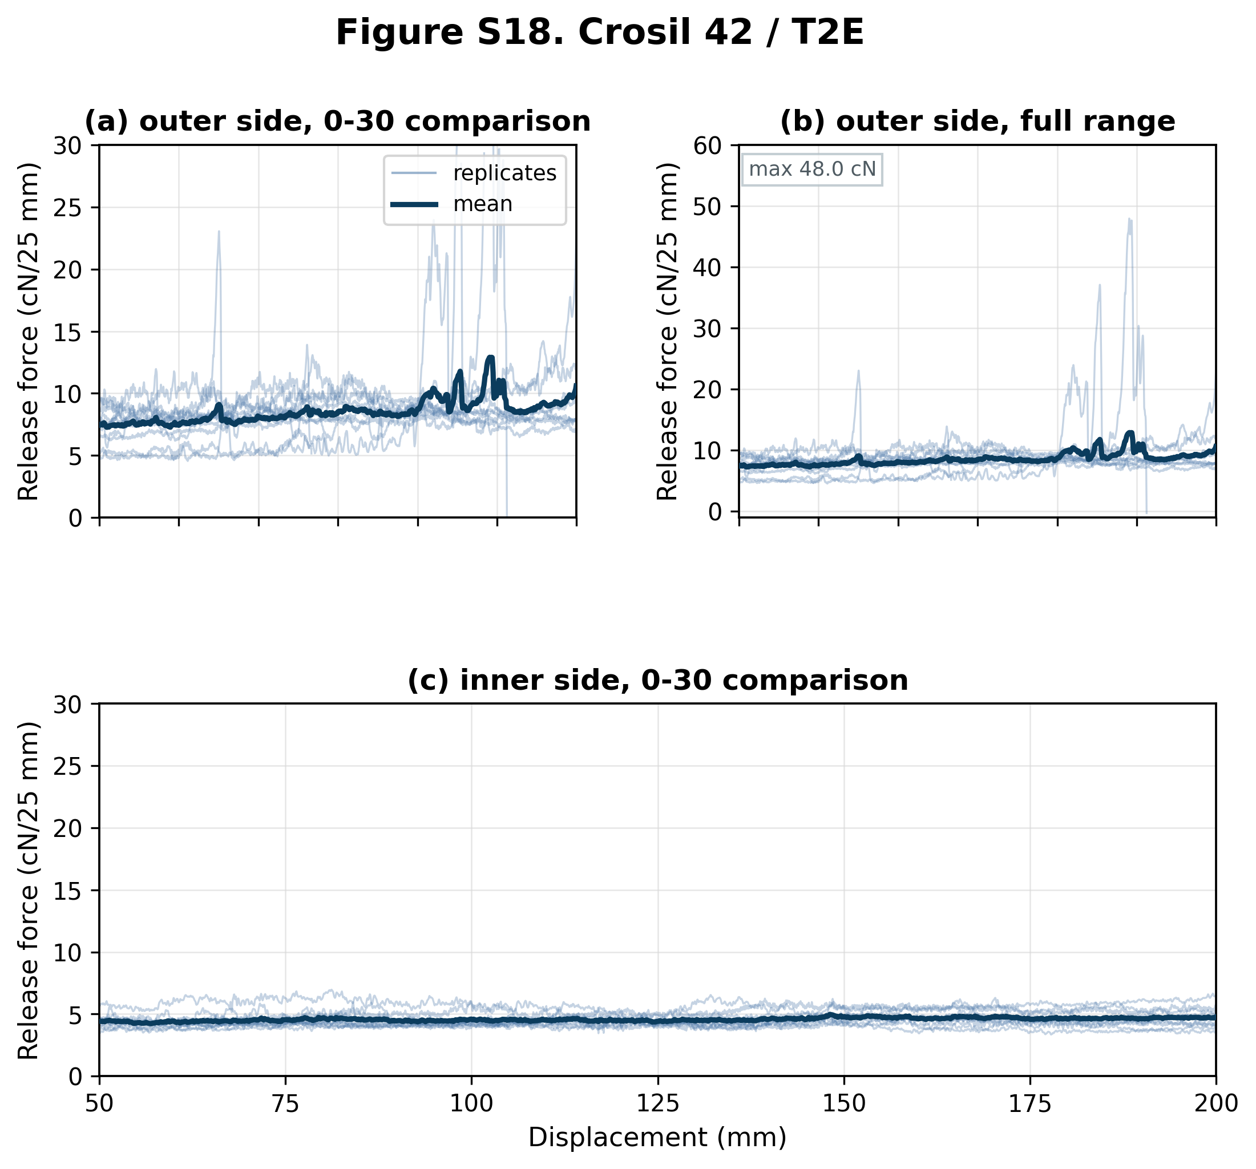
Figure S18. Force-displacement release curves for Crosil 42 liner tested with T2E butyl sealant. The external liner side (n = 11 shown from 11 traces) is shown as paired 0-30 comparison and full-range panels; the internal liner side (n = 10 shown from 10 traces) is shown as one 0-30 comparison panel. Thin blue lines show individual replicates and the dark blue line shows the mean curve where replicate coverage was sufficient. Forces are normalized to cN/25 mm; the displayed range corresponds to the 50-200 mm analysis interval. Panels marked as 0-30 comparison use a shared 0-30 cN/25 mm y-axis, with values above this range omitted from that comparison view. Full-range panels retain all above-range values. Sides with more than 5% of samples above 30 cN/25 mm are shown only at full range (figure maximum 48.0 cN/25 mm). 3 external traces ended within 50-200 mm.

Figure S19. Crosil 42 / C1EN
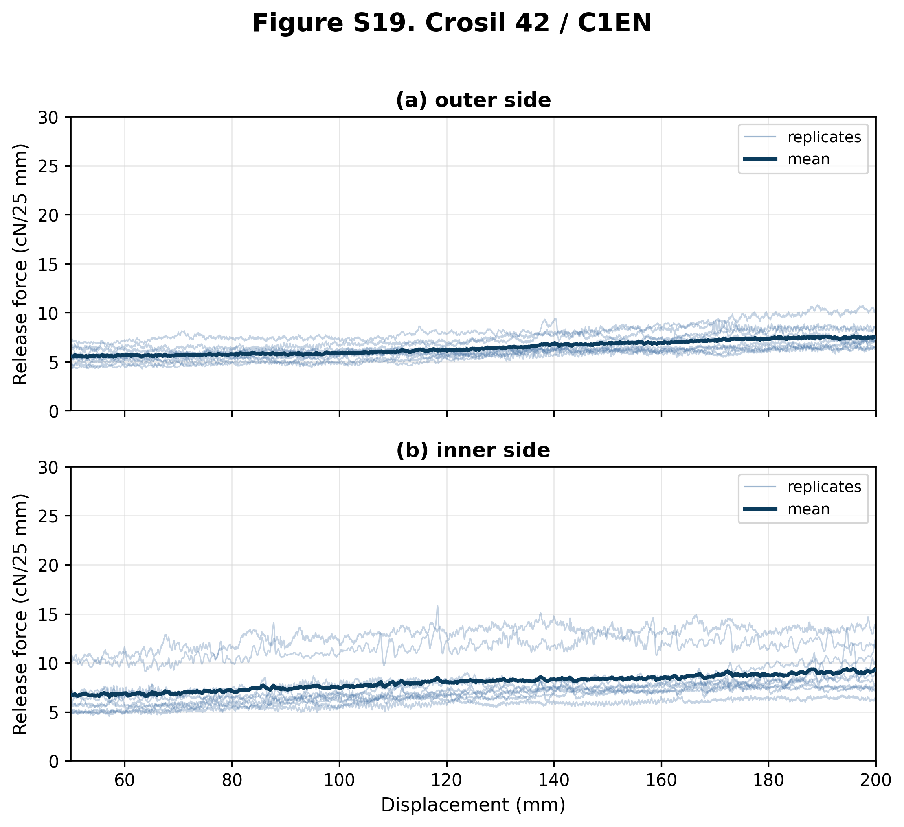
Figure S19. Force-displacement release curves for Crosil 42 liner tested with C1EN butyl sealant. Panel (a) shows the external liner side (n = 10 shown from 10 traces); panel (b) shows the internal liner side (n = 10 shown from 10 traces). Thin blue lines show individual replicates and the dark blue line shows the mean curve where replicate coverage was sufficient. Forces are normalized to cN/25 mm; the displayed range corresponds to the 50-200 mm analysis interval. Both panels use the shared 0-30 cN/25 mm comparison y-axis.

Figure S20. Crosil 42 / T1EN
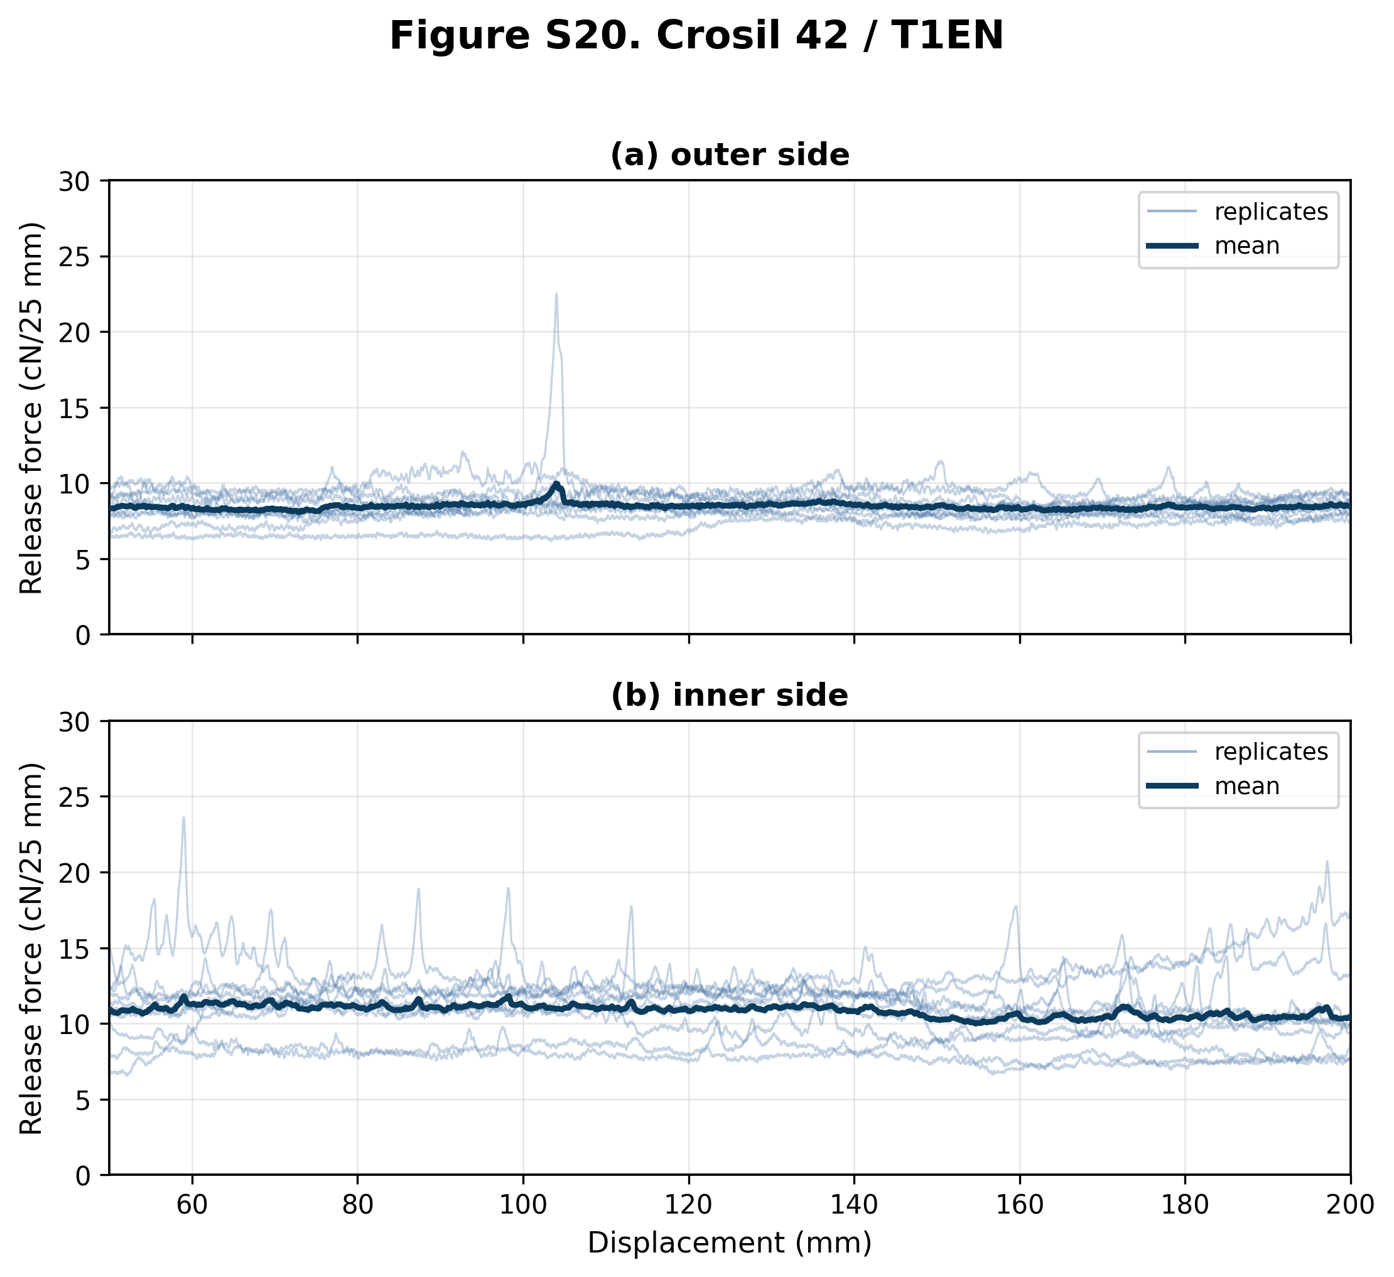
Figure S20. Force-displacement release curves for Crosil 42 liner tested with T1EN butyl sealant. Panel (a) shows the external liner side (n = 10 shown from 10 traces); panel (b) shows the internal liner side (n = 10 shown from 10 traces). Thin blue lines show individual replicates and the dark blue line shows the mean curve where replicate coverage was sufficient. Forces are normalized to cN/25 mm; the displayed range corresponds to the 50-200 mm analysis interval. Both panels use the shared 0-30 cN/25 mm comparison y-axis.

Figure S21. Crosil 42 / T2EN
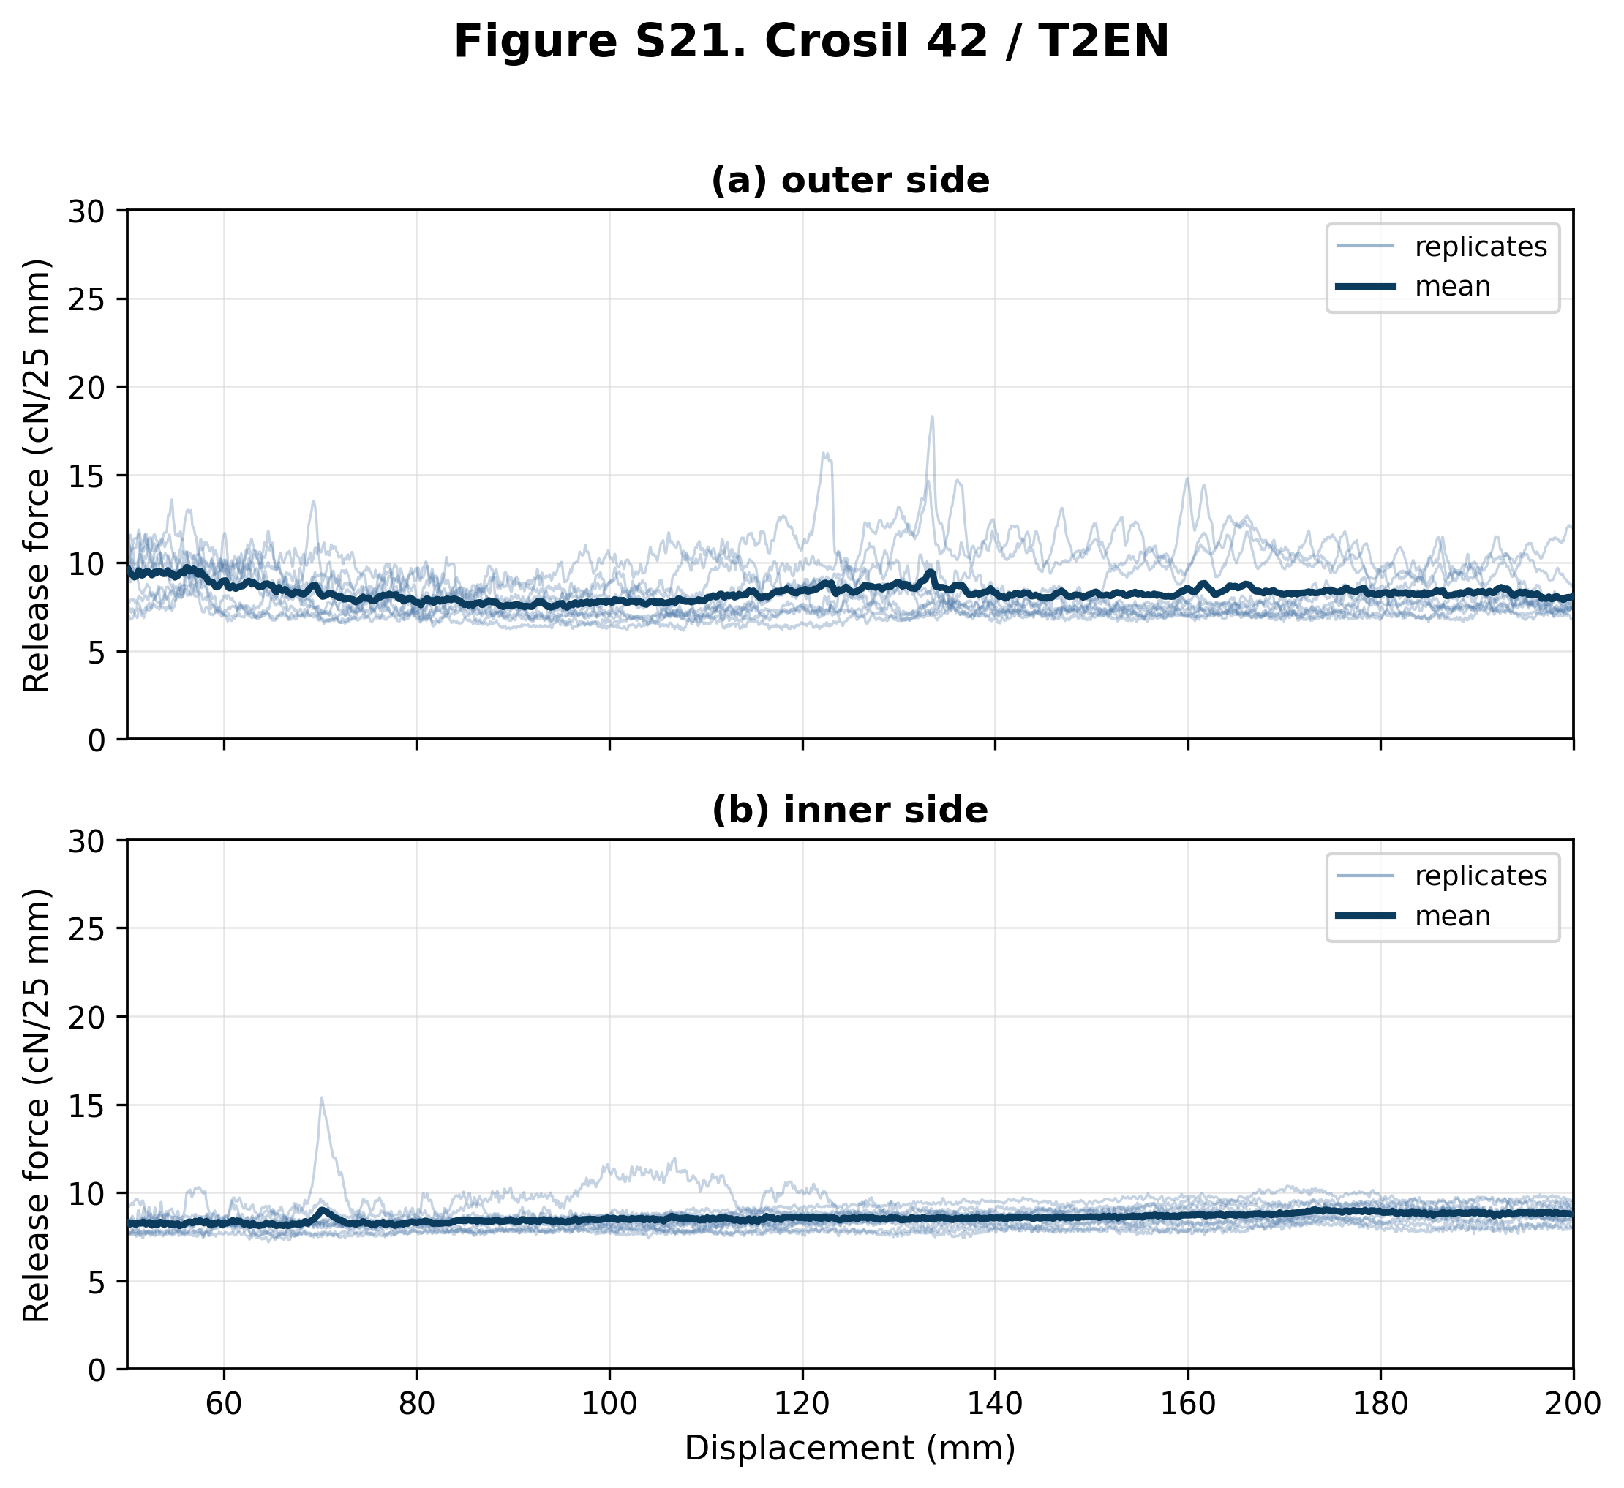
Figure S21. Force-displacement release curves for Crosil 42 liner tested with T2EN butyl sealant. Panel (a) shows the external liner side (n = 10 shown from 10 traces); panel (b) shows the internal liner side (n = 10 shown from 10 traces). Thin blue lines show individual replicates and the dark blue line shows the mean curve where replicate coverage was sufficient. Forces are normalized to cN/25 mm; the displayed range corresponds to the 50-200 mm analysis interval. Both panels use the shared 0-30 cN/25 mm comparison y-axis.

