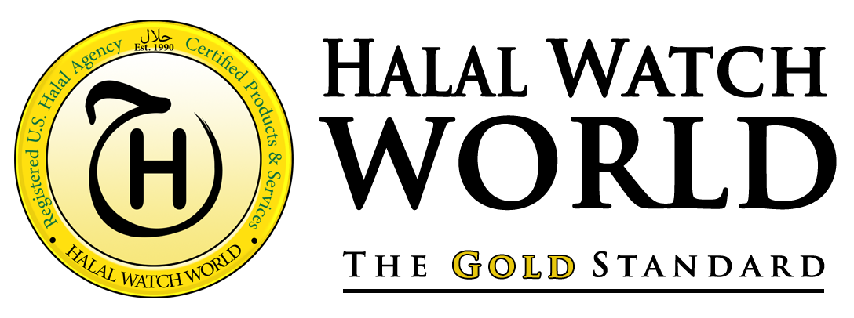



**DOCUMENT SUBMISSION REPORT**

${CLIENTNAME}

Table of Contents

CERTIFICATION CONSIDERATIONS 4

1. Is the product/ingredient Halal Aslan (by default)? 4

2. Is the product/ingredient Halal certified via another organization? 4

3. What is the Risk Assessment of the Facility? 4

HiRF: High Risk Facility 5

MeRF: Medium Risk Facility 5

LoRF: Low Risk Facility 5

4. Are there any contents in the product that contain impermissible ingredients? 5

Client Details: ${ClientName} 6

FACILITY PROFILE 6

PRODUCT INFORMATION 6

PRODUCT PROFILE 7

${ProductName} 7

CLEANING METHOD 9

PRODUCT & SUPPLIER ASSESSMENT 10

Supplier 1 10

Supplier 2 10

Supplier 3 10

TESTING METHOD 10

DOCUMENTATION 11

CONCLUSION 12

**COMPANY BACKGROUND**

**Halal Watch World LLC** is a halal certification limited liability corporation based in the state of New York, and has operated in the certification industry since 1990. HWW is an organization that stands upon the trust of the Muslim public, and believes that it is imperative that their trust never be jeopardized. We maintain standards to the highest degree of scrutiny and perform regular audits for the protection of our constituents.

Halal Watch World understands that halal certification is a communal obligation (فرض كفاية), meaning, at least one person of the community must uphold it. If no one takes up this responsibility, the entire community bears a burden of sin. Therefore, we must be extra diligent with this effort. We realize the seriousness of the matter and understand the dire consequences of not filling this duty to the fullest capacity. God explains this to us in the Holy Quran by His statement:

***“ And say not concerning that which your tongue says falsely: 'This is Halal and this is Haram,' so as to invent lies against Allah. Verily, those who invent lies against Allah will never prosper...A passing brief enjoyment (will be theirs), but they will have a painful torment.”*** *[Al Quran] 16:116-117*

HWW ensures to the best of its ability a high level of authenticity is upheld. This allows them to gain the trust of the Muslim community, and garner strong relationships with companies who produce, process, and distribute halal products at all levels. By this, they are able to offer halal producing company’s guidance and consultation on the direction of their processes and products, while ensuring that Islamic dietary standards are always maintained and monitored. Muslims can use this information in order to make well informed decisions about what they choose to eat.

**Legal Filings:** Halal Watch World holds registered trademark number 4728733, and Department of State (New York) number 4814343. Halal Watch World is also a registered halal certifying organization with The Department of Agriculture and Markets of New York State (See supporting documentation).

We begin in the name of God SWT

1

CERTIFICATION CONSIDERATIONS

There are 4 main factors taken into consideration when determining the halal status of a product:

1. Is the product/ingredient Halal Aslan (by default)?

If the product is Halal by default, then there will be no ingredient investigation conducted. An audit of the HPF (Halal Product Facility), facility related documents and product identification documentation will however, still be required.

1. Is the product/ingredient Halal certified via another organization?

If another organization certifies the product as Halal, then it is incumbent upon us to perform a *tahqeeq* (verification)certification of the establishment. We must be able to ascertain that the certifying body is competent and capable of determining the status of such products. In the event that we are unable to gain this information, our organization must inspect the location of production before certifying.

1. What is the Risk Assessment of the Facility?

Each HPF (Halal Product Facility) must be assessed and assigned an appropriate level of risk. Each facility is graded according to assessed risk. As risk increases, guidelines, restrictions, and measures become more stringent. Risk is determined according to the products present in the facility, product and process management, and the equipment utilized for processing. Any product/s made with or derived from the items mentioned below would be considered Haram:

1. Human derived ingredients

2. Pork

3. Donkey (excluding the Onager)

4. Animals with fangs or talons (Carnivorous)

(Excluding Hyena and Fox according to

school of thought)

5. Animals not slaughtered according to

Islamic ritual rites

6. Carrion

7. All forms of filth (Najis) i.e. Urine,

Excrement, Blood, Pus, Vomit, etc

8. Insects (other than locusts)

9. Animals fed with more than 50% of any of

the above without being fed on a pure diet

for a stipulated number of days (The

Jallaalah)

10. Any intoxicants

11. Anything toxic or harmful to the body (such

as cigarettes)

12. Anything processed, made, produced,

manufactured, and/or stored using utensils,

equipment, and/or machinery in contact with

any of the above that have not been cleansed

according to standards which remove

contaminants.

### HiRF: High Risk Facility

Any facility that utilizes item/s listed above or a derivative thereof within the HPF and

processes both halal and haram products using indifferent tools, machinery, or utensils. Thus, HiRF’s by nature involve contaminants in some way in its processing.

### MeRF: Medium Risk Facility

Any facility that processes both halal and haram products using segregated tools, machinery, or utensils to the exclusion of items listed above. Facilities that process any of these items, even if segregation methods are employed, are to be deemed HiRF’s.

### LoRF: Low Risk Facility

Any facility that does not process haram products on or inside of the premises.

As mentioned earlier, in relation to each risk level there are guidelines, restrictions and measures in place for the avoidance of contamination. Before any facility or any product made in said facility can be considered Halal suitable or certified Halal, these guidelines will have to be strictly adhered to.

Regarding contamination, products cannot be cooked upon or within the same utensils without proper cleansing. This means that any liquid substance that interacts with non-halal products becomes contaminated. This includes oil, and other wet cooking surfaces. Thus, if a vat of oil is used to cook non-halal products (which is considered as filth), it cannot be used to cook Halal products without contaminating it.

1. Are there any contents in the product that contain impermissible ingredients?

We refer to the list of impermissible consumables on the previous pages. If the product under audit is found to contain any of the ingredients on the ban list, these products cannot be considered as halal, unless said ingredients are replaced with halal suitable alternatives.

Client Details: ${CLIENTNAME}

FACILITY PROFILE

${CompanyDescription}



PRODUCT INFORMATION



PRODUCT PROFILE

${ProductName}



**INSERT PRODUCT NAME** (Item ########)

A high-quality CBD isolate combined with essential oils from Young Living. It provides all of the benefits of pure, potent CBD combined with the best essential oils in the marketplace.

Ingredient Status

Ingredient 1: – **Halal** (Aslan) [Enter the ingredient description and include a source from your research]

Ingredient 2: – **Halal** (Aslan) [Enter the ingredient description and include a source from your research]

Ingredient 3: – **Halal** (Aslan) [Enter the ingredient description and include a source from your research]

Concerns – CBD comes from the cannabis plant family, which naturally contains Tetrahydrocannabinol (THC). THC is the principal psychoactive constituent of cannabis, which is impermissible to utilize due to the intoxicating effect on humans. This oil does not contain any THC, which is tested at third party labs for verification. Therefore, CBD in this product does carry any intoxicating properties when utilized.

PROCESSING OVERVIEW



CLEANING METHOD

Description: Prior to use of rooms, whether it be first use of the day or following a previous production run, line clearance must be performed. In addition to checking equipment condition and status, work surfaces, small equipment contact surfaces, vessels, etc. must be thoroughly sanitized with 70% isopropyl alcohol and completely dried with

lint free paper towels.

Frequency: Prior to use of rooms, whether it be first use of the day or following a previous production run, line clearance must be performed. In addition to checking equipment condition and status, work surfaces, small equipment contact surfaces, vessels, etc. must be thoroughly sanitized with 70% isopropyl alcohol and completely dried with lint free paper towels.

PRODUCT & SUPPLIER ASSESSMENT

Supplier 1



Supplier 2

Supplier 3

TESTING METHOD

The following tests are performed for the production facility: Cleaning Validation, Green Scientific Labs, Pesticide Analysis, Microbial, Mycotoxin Analysis.

DOCUMENTATION



CONCLUSION

Client was cooperative and compliant with all relevant documentation requests. All documentation has been analysed during this review. ${CLIENTNAME}’s product/s are deemed to be Halal compliant and suitable.

**Based upon this information, the review team hereby recommends Halal certification for all products mentioned in this report.**

My signature below is a testimony that the information provided herein is factual to the best of my knowledge.

**REVIEW AGENT:**

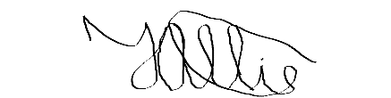

**_______________________________**

**Tameem Allie**

**Technical Review Analyst**

**APPROVED BY:**

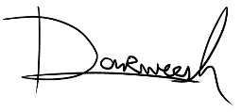

**_______________________________**

**Sh. Darweesh Muhammad**

**Certification Committee Chair**

**Date: Wednesday, 06 September 2023**